Supplementary Information

A chromosome-level genome assembly of yellow stem borer (Scirpophaga incertulas)
Sicong Zhou^{1#}, Guanghua Luo^{1#}, Qiong Yang², Yangchun Han^{1, 3}, Kaili Yuan¹, Rui Ji^{1, 4}* & Jichao Fang¹*
¹Institute of Plant Protection, Jiangsu Academy of Agricultural Sciences, Jiangsu Key Laboratory for Food and Safety-State Key Laboratory Cultivation Base of Ministry of Science and Technology, Nanjing 210014, China. ²Bio21 Institute, School of BioSciences, University of Melbourne, Parkville, Victoria 3010, Australia. ³Integrated Technical Service Center of Jiangyin Customs, Jiangyin 214441, China. ⁴Jiangsu Collaborative Innovation Center of Regional Modern Agriculture & Environmental Protection, Huaiyin Normal University, Huaian 223300, China. #These authors contributed equally: Sicong Zhou, Guanghua Luo. *Corresponding authors: Rui Ji, jirui@jaas.ac.cn; Jichao Fang, fangjc@jaas.ac.cn.

Contents

Title | Page
Supplementary Figure 1 | 2
Supplementary Table 1 | 3
Supplementary Table 2 | 4
Supplementary Table 3 | 5
Supplementary Table 4 | 8

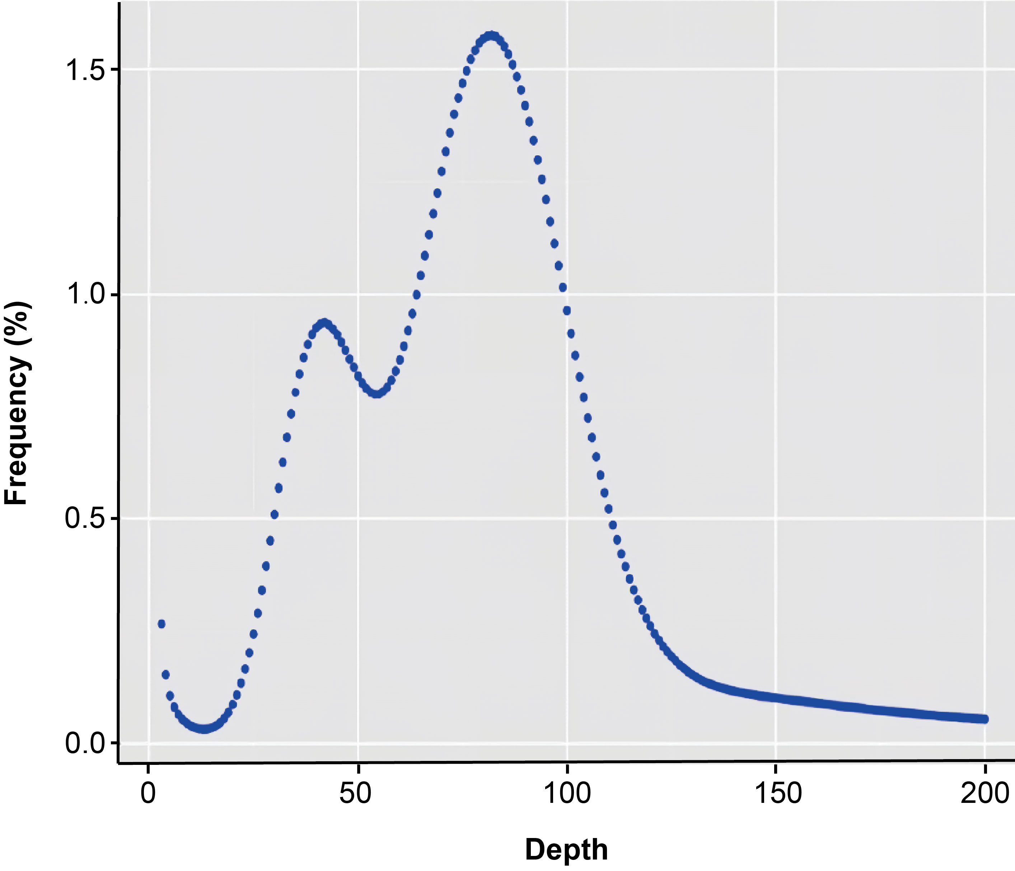
Supplementary Figure 1 k-mer distribution (K = 19) of the S. incertulas genome. The x-axis is the k-mer depth, and the y-axis represents the corresponding frequency of the k-mer at a given depth.

Supplementary Table 1 Source of protein sequences of 21 insects. Except for S. incertulas (this study), the protein sequences of the remaining 20 insects were downloaded from InsectBase 2.0 (http://v2.insect-genome.com/).

Species | Order | Accession
Scripophage incertulas | Lepidoptera | /
Manduca sexta | Lepidoptera | IBG_00533
Bombyx mori | Lepidoptera | IBG_00145
Chilo suppressalis | Lepidoptera | IBG_00177
Plutella xylostella | Lepidoptera | IBG_00646
Heliconius melpomene | Lepidoptera | IBG_00434
Danaus plexippus | Lepidoptera | IBG_00230
Spodoptera litura | Lepidoptera | IBG_00716
Spodoptera frugiperda | Lepidoptera | IBG_00715
Helicoverpa armigera | Lepidoptera | IBG_00442
Amyelois transitella | Lepidoptera | IBG_00027
Nilaparvata lugens | Hemiptera | IBG_00572
Laodelphax striatellus | Hemiptera | IBG_00477
Acyrthosiphon pisum | Hemiptera | IBG_00009
Bemisia tabaci | Hemiptera | IBG_00110
Myzus persicae | Hemiptera | IBG_00561
Apis mellifera | Hymenoptera | IBG_00083
Nasonia vitripennis | Hymenoptera | IBG_00564
Bombus terrestris | Hymenoptera | IBG_00138
Drosophila melanogaster | Diptera | IBG_00296
Anopheles gambiae | Diptera | IBG_00050

Supplementary Table 2 Evaluation results of the genome set using the Core Eukaryotic Genes Mapping Approach database.

 | Number# | Percentage (%)*
458 core eukaryotic genes (CEGs) | 403 | 87.99
248 highly conserved CEGs | 179 | 72.18
# The number of CEGs identified in the assembly
* Percentage of CEGs present in the assembly
Supplementary Table 3 Gene Ontology enrichment of significantly expanded genes in S. incertulas, (p-adjusted < 0.05, hypergeometric test, false discovery rate (FDR)-adjusted). GeneRatio indicated the ratio of significantly expanded genes that are annotated in the GO term. BgRatio indicated the ratio of all genes that are annotated in the GO term.
GO ID | Description | GeneRatio | BgRatio | pvalue | p-adjusted
GO:0140097 | catalytic activity, acting on DNA | 38/110 | 164/6266 | 0 | 0
GO:0003676 | nucleic acid binding | 82/1175 | 164/6266 | 0 | 0
GO:0004518 | nuclease activity | 22/80 | 164/6266 | 0 | 0
GO:0004519 | endonuclease activity | 22/52 | 164/6266 | 0 | 0
GO:0003964 | RNA-directed DNA polymerase activity | 38/47 | 164/6266 | 0 | 0
GO:0034061 | DNA polymerase activity | 38/58 | 164/6266 | 1.11E-16 | 4.63E-16
GO:0140640 | catalytic activity, acting on a nucleic acid | 38/311 | 164/6266 | 1.11E-16 | 4.63E-16
GO:0003723 | RNA binding | 37/211 | 164/6266 | 2.22E-16 | 6.94E-16
GO:0016779 | nucleotidyltransferase activity | 40/117 | 164/6266 | 2.22E-16 | 6.94E-16
GO:0016772 | transferase activity, transferring phosphorus-containing groups | 40/540 | 164/6266 | 6.82E-10 | 1.70E-09
GO:0003796 | lysozyme activity | 6/8 | 164/6266 | 7.87E-09 | 1.79E-08
GO:0061783 | peptidoglycan muralytic activity | 6/11 | 164/6266 | 1.22E-07 | 2.53E-07
GO:0016740 | transferase activity | 50/1044 | 164/6266 | 6.44E-06 | 1.24E-05
GO:0016798 | hydrolase activity, acting on glycosyl bonds | 13/120 | 164/6266 | 1.30E-05 | 2.32E-05
GO:0005488 | binding | 119/3554 | 164/6266 | 1.60E-05 | 2.66E-05
GO:0097159 | organic cyclic compound binding | 82/2140 | 164/6266 | 1.65E-05 | 2.58E-05
GO:0016788 | hydrolase activity, acting on ester bonds | 22/316 | 164/6266 | 2.16E-05 | 3.18E-05
GO:0004553 | hydrolase activity, hydrolyzing O-glycosyl compounds | 6/93 | 164/6266 | 0.0344898 | 0.0479026
GO:0006278 | RNA-templated DNA biosynthetic process | 37/45 | 100/5239 | 0 | 0
GO:0046483 | heterocycle metabolic process | 76/1118 | 100/5239 | 0 | 0
GO:0043170 | macromolecule metabolic process | 86/1978 | 100/5239 | 0 | 0
GO:0090304 | nucleic acid metabolic process | 76/916 | 100/5239 | 0 | 0
GO:0034641 | cellular nitrogen compound metabolic process | 76/1347 | 100/5239 | 0 | 0
GO:0008152 | metabolic process | 97/073 | 100/5239 | 0 | 0
GO:0071897 | DNA biosynthetic process | 37/52 | 100/5239 | 0 | 0
GO:0006259 | DNA metabolic process | 76/249 | 100/5239 | 0 | 0
GO:0006139 | nucleobase-containing compound metabolic process | 76/1078 | 100/5239 | 0 | 0
GO:1901360 | organic cyclic compound metabolic process | 76/1155 | 100/5239 | 1.11E-16 | 8.55E-16
GO:0006725 | cellular aromatic compound metabolic process | 76/1132 | 100/5239 | 2.22E-16 | 1.55E-15
GO:0071704 | organic substance metabolic process | 86/2615 | 100/5239 | 2.18E-14 | 1.40E-13
GO:0044237 | cellular metabolic process | 76/2181 | 100/5239 | 1.86E-12 | 1.10E-11
GO:0044238 | primary metabolic process | 81/477 | 100/5239 | 2.49E-12 | 1.37E-11
GO:0006807 | nitrogen compound metabolic process | 76/2224 | 100/5239 | 6.03E-12 | 3.10E-11
GO:0034654 | nucleobase-containing compound biosynthetic process | 37/618 | 100/5239 | 4.05E-11 | 1.95E-10
GO:0019438 | aromatic compound biosynthetic process | 37/651 | 100/5239 | 1.89E-10 | 8.58E-10
GO:0018130 | heterocycle biosynthetic process | 37/657 | 100/5239 | 2.48E-10 | 1.06E-09
GO:1901362 | organic cyclic compound biosynthetic process | 37/671 | 100/5239 | 4.59E-10 | 1.86E-09
GO:0009987 | cellular process | 94/3745 | 100/5239 | 1.18E-08 | 4.52E-08
GO:0019835 | cytolysis | 5/6 | 100/5239 | 1.36E-08 | 4.97E-08
GO:0071554 | cell wall organization or biogenesis | 5/8 | 100/5239 | 1.23E-07 | 4.29E-07
GO:0044036 | cell wall macromolecule metabolic process | 5/8 | 100/5239 | 1.23E-07 | 4.29E-07
GO:0016998 | cell wall macromolecule catabolic process | 5/8 | 100/5239 | 1.23E-07 | 4.29E-07
GO:0044271 | cellular nitrogen compound biosynthetic process | 37/933 | 100/5239 | 3.35E-06 | 1.03E-05
GO:0009059 | macromolecule biosynthetic process | 37/1072 | 100/5239 | 8.66E-05 | 2.47E-04
GO:0042742 | defense response to bacterium | 5/36 | 100/5239 | 5.40E-04 | 0.0014855
GO:0009617 | response to bacterium | 5/38 | 100/5239 | 6.98E-04 | 0.0018528
GO:0098542 | defense response to other organism | 6/75 | 100/5239 | 0.0028931 | 0.0074255
GO:0009607 | response to biotic stimulus | 6/77 | 100/5239 | 0.0033038 | 0.0079499
GO:0043207 | response to external biotic stimulus | 6/77 | 100/5239 | 0.0033038 | 0.0079499
GO:0051707 | response to other organism | 6/77 | 100/5239 | 0.0033038 | 0.0079499
GO:0044419 | biological process involved in interspecies interaction between organisms | 6/79 | 100/5239 | 0.0037567 | 0.0082647
GO:0006952 | defense response | 6/81 | 100/5239 | 0.0042542 | 0.0088533
GO:0044249 | cellular biosynthetic process | 37/1306 | 100/5239 | 0.0045631 | 0.0090092
GO:1901576 | organic substance biosynthetic process | 37/1330 | 100/5239 | 0.0062855 | 0.0118046
GO:0009058 | biosynthetic process | 37/1351 | 100/5239 | 0.0082236 | 0.0150765
GO:0008150 | biological process | 100/5032 | 100/5239 | 0.0170656 | 0.0298648

Supplementary Table 4 Gene Ontology enrichment of significantly contracted genes in S. incertulas (p-adjusted < 0.05, hypergeometric test, FDR-adjusted). GeneRatio indicated the ratio of significantly contracted genes that are annotated in the GO term. BgRatio indicated the ratio of all genes that are annotated in the GO term.
GO ID | Description | GeneRatio | BgRatio | pvalue | p-adjusted
GO:0008010 | structural constituent of chitin-based larval cuticle | 14/42 | 14/6777 | 0 | 0
GO:0005198 | structural molecule activity | 14/421 | 14/6777 | 0 | 0
GO:0005214 | structural constituent of chitin-based cuticle | 14/47 | 14/6777 | 2.22E-16 | 3.70E-16
GO:0042302 | structural constituent of cuticle | 14/47 | 14/6777 | 2.22E-16 | 3.70E-16
GO:0031012 | extracellular matrix | 14/146 | 14/7444 | 0 | 0
GO:0030312 | external encapsulating structure | 14/156 | 14/7444 | 0 | 0
GO:0044421 | obsolete extracellular region part | 14/617 | 14/7444 | 2.22E-16 | 5.18E-16
GO:0005576 | extracellular region | 14/904 | 14/7444 | 1.38E-13 | 2.42E-13
GO:0071944 | cell periphery | 14/2127 | 14/7444 | 2.35E-08 | 3.28E-08
GO:0040003 | chitin-based cuticle development | 14/111 | 14/7717 | 0 | 0
GO:0042335 | cuticle development | 14/192 | 14/7717 | 0 | 0
GO:0007275 | multicellular organism development | 14/3663 | 14/7717 | 2.91E-05 | 6.79E-05
GO:0048856 | anatomical structure development | 14/3916 | 14/7717 | 7.42E-05 | 1.30E-04
GO:0032502 | developmental process | 14/4109 | 14/7717 | 1.46E-04 | 2.04E-04
GO:0032501 | multicellular organismal process | 14/4655 | 14/7717 | 8.38E-04 | 9.78E-04

