This document outlines the steps needed to freely access the BraTS Pre-operative Meningioma Dataset.

- Click on either of the following links, which will direct you to the Synapse hosting site.
  - https://doi.org/10.7303/syn51514106
  - https://www.synapse.org/#!Synapse:syn51514106

- Click on the “key” symbol next to “Access” to login to Synapse.
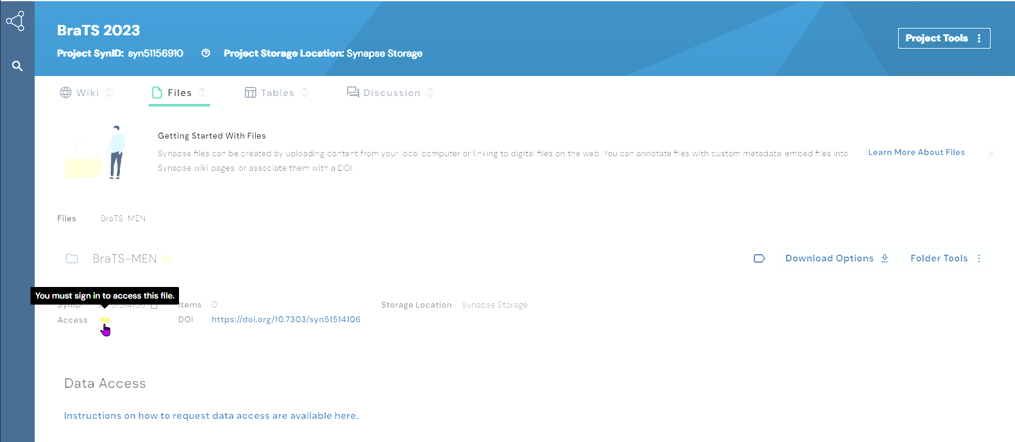

- Either login to your previously created account or create an account.
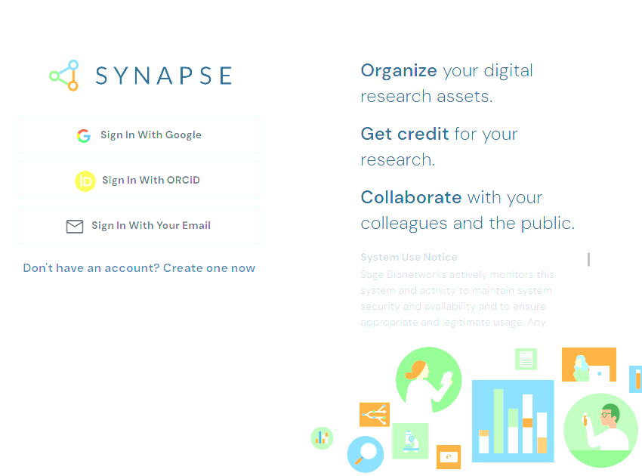

- After logging in, the “key” will change to a green “unlocked” symbol.
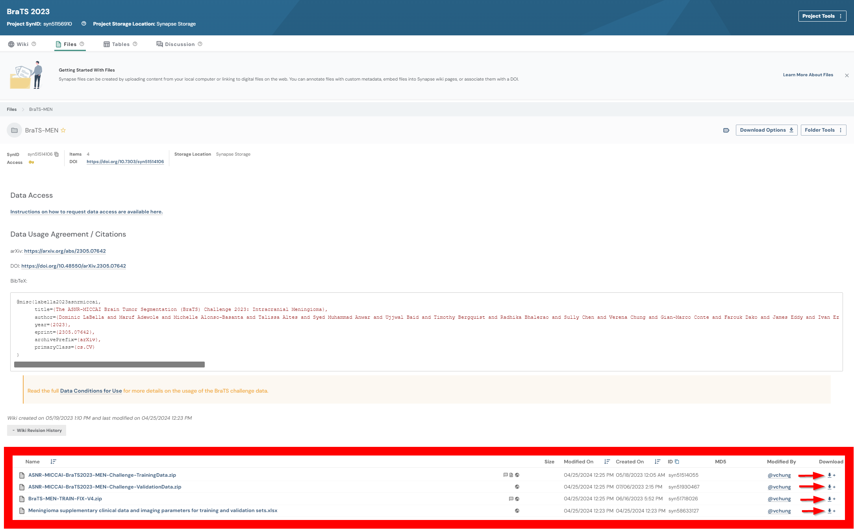

- Click on the download button for any of the respective folders. Then, click on the “View Download Link”.
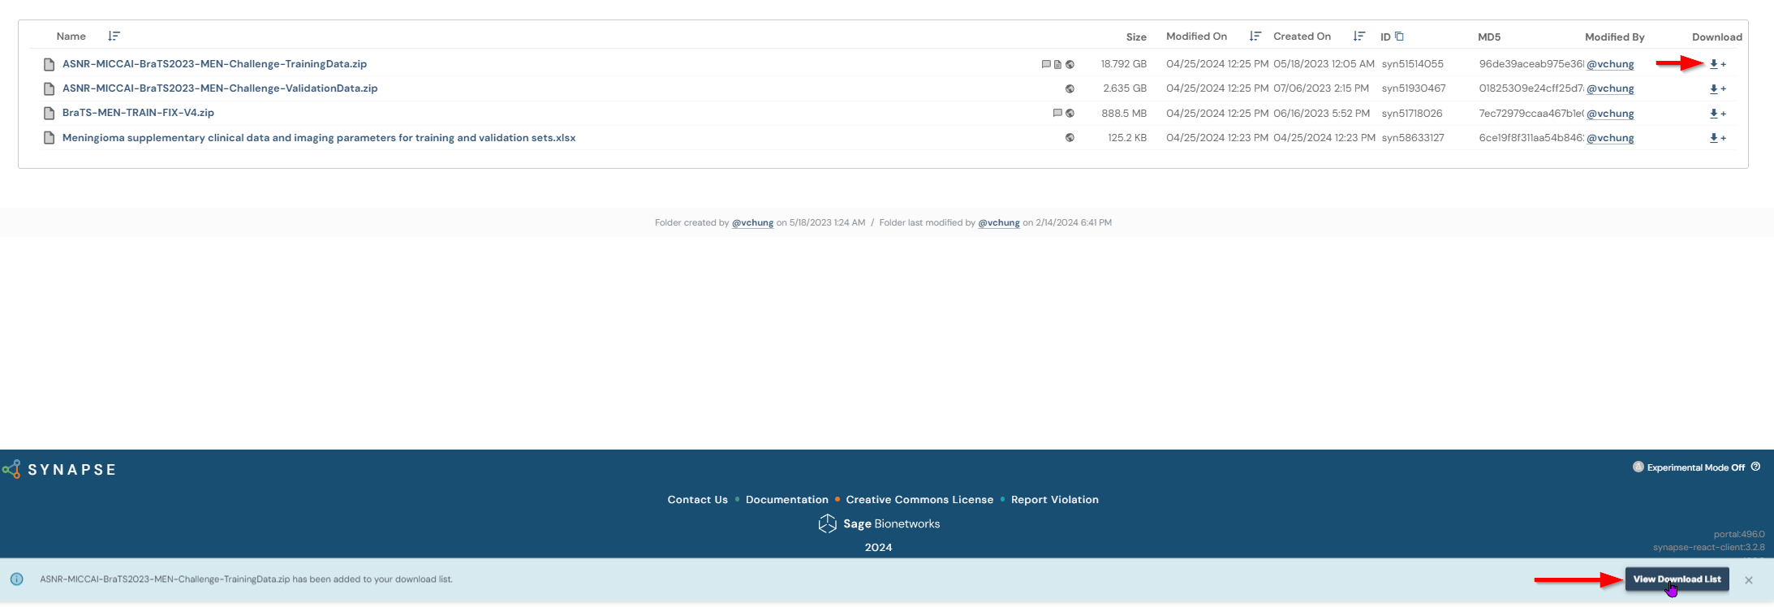

- This will take you to the download cart. At which point you can click on the download button to download the data.
