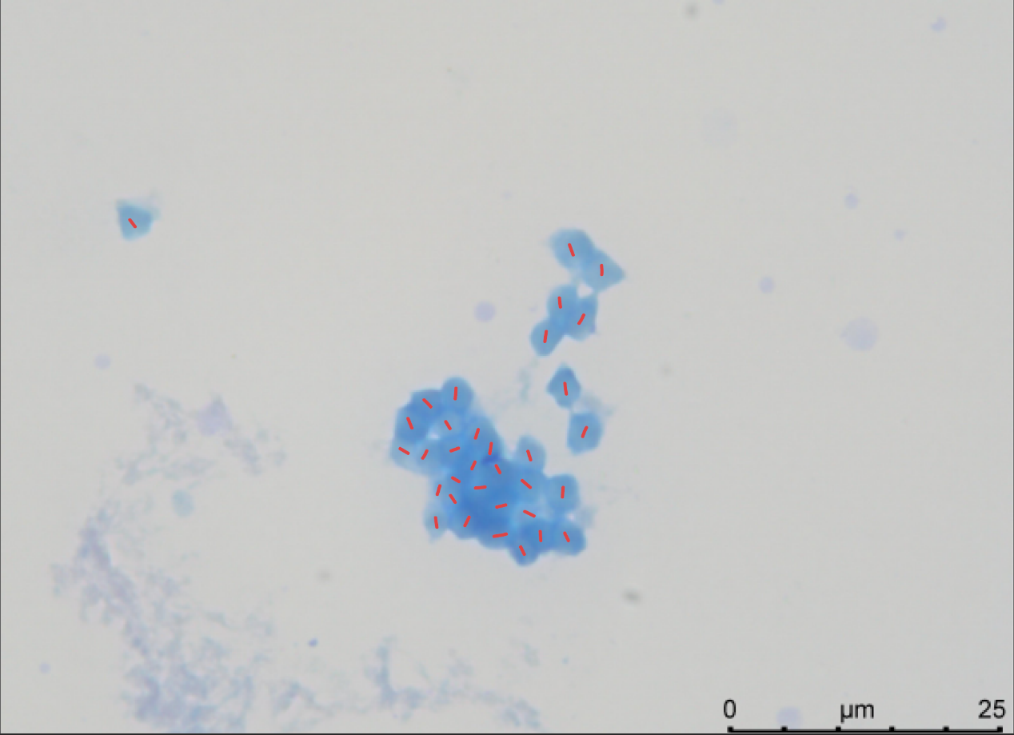
Fig. S1. The chromosome karyotype of Slavum lentiscoides determined by Giemsa staining.

