Supplementary information for
  - A Large-Scale Reaction Dataset of Mechanistic Pathways of Organic Reactions
  - Shuan Chen, Ramil Babazade, Taewan Kim, Sunkyu Han, Yousung Jung

Correspondence: yousung.jung@snu.ac.kr & sunkyu.han@kaist.ac.kr)

Contents

RT extension 2
List of special groups used in RT extension 3
RT-MT many-to-one correspondence 4
RT-MT one-to-many correspondence 5
Mechanism derivation beyond RT 6
Top-100 RTs 8
Labeled data MT distribution table 11
Manual evaluation of 100 randomly sampled reactions 12
Example reaction mechanism evaluated by chemists 13
Added reagents 14

S1. RT extension
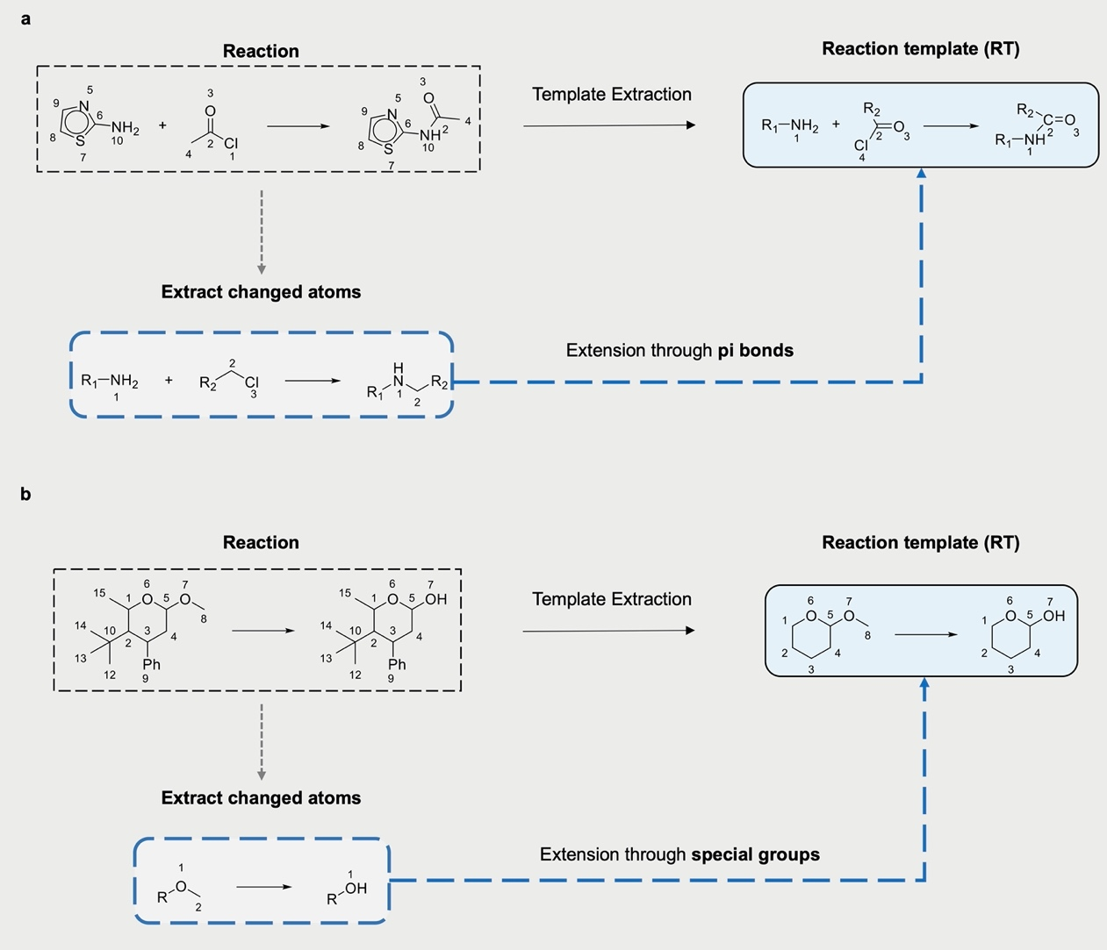
Figure S1. Examples to illustrate the process of obtaining RT. As mentioned in the main text, we extend the original templates comprising changed atoms for mechanism derivation purposes to capture the surrounding environment. Extensions are done through either pi bonds or special groups. (a) Originally, we extract the changed atoms. Since the changed carbon atom is connected to an oxygen through double bond, we include it in the final RT. (b) Changed oxygen atom is one of the special groups we have defined, so whole group THP group is included in the final RT.

S2. List of special groups used in RT extension
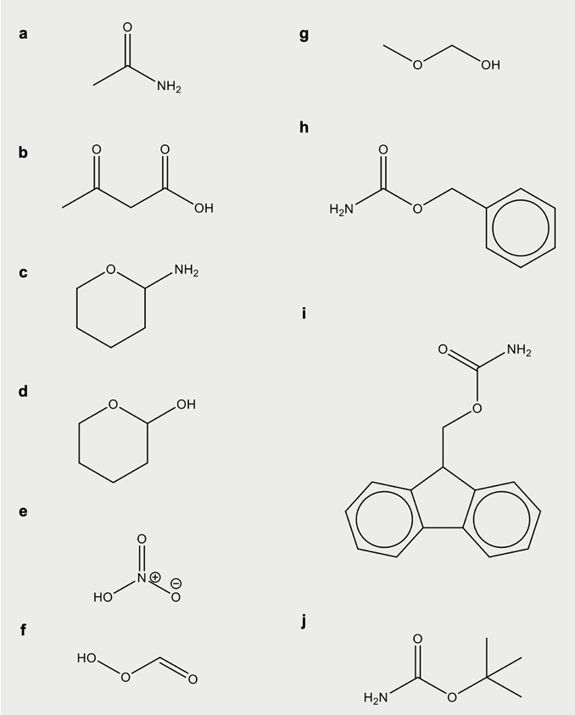
Figure S2. List of special groups used in the extension of originally extracted template to RT. If any changed atom is detected to be part of one of these groups, whole group is included in the RT with respective template atom-map numbers.

S3. RT-MT many-to-one correspondence
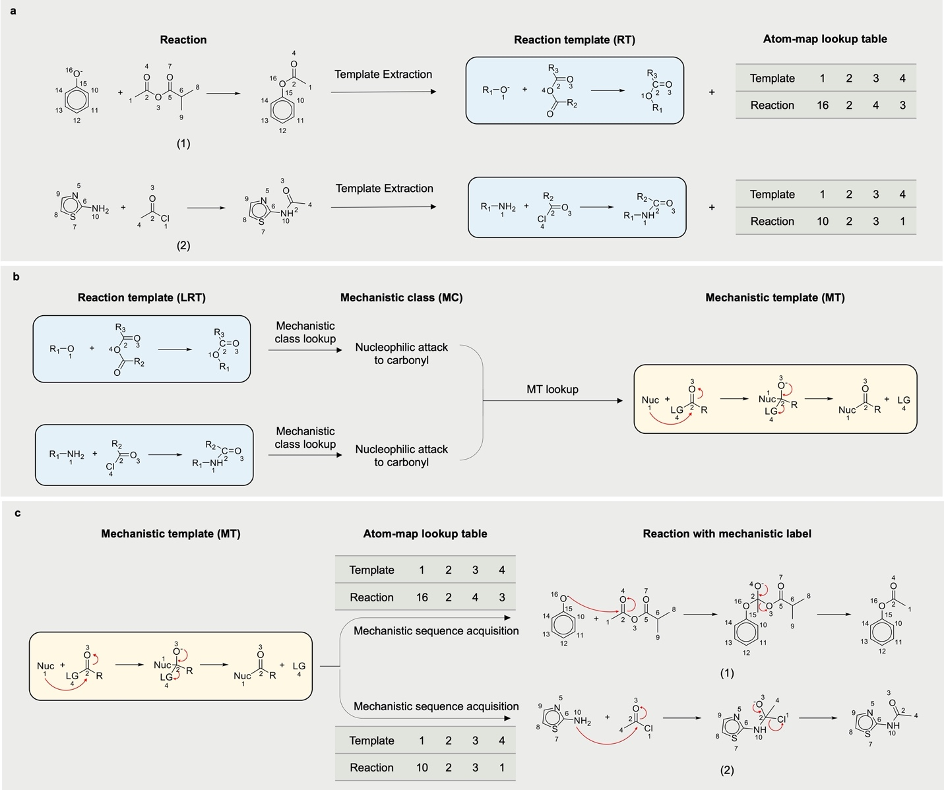
Figure S3. The framework of mechanistic label acquisition. (a) Pair of reactions that follow the same mechanistic pathway is shown as an example to demonstrate the many-to-one correspondence between RTs and an MT. (b) Determination of an MT for extracted RTs. Even though the extracted RTs for both reactions are distinct, the mechanistic sequence that leads to products is the same. Each mechanistic class and MT are unique and there is a one-to-one match between them. c) Final step in labeling procedure. We convert the MT which shows electron movement in terms of template map numbers to a mechanistic label of the reaction based on the atom-map lookup table.

S4. RT-MT one-to-many correspondence
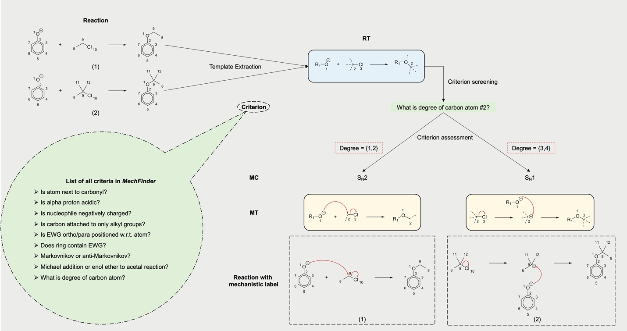
Figure S4. Illustration of one-to-many relationship between extracted RT and labeled MT using two reactions sharing the same RT as examples. For both reactions, RT clearly shows the movement of electrons according to nucleophilic substitution (S_{N}). Nonetheless, the classification into uni- or bi-molecular types within the S_{N} class is determined by the degree of electrophilic carbon (atom #2 in the RT) on a high level. Upon extraction of RT, we screen it to assess the applicability of various criteria. Subsequently, we assign the corresponding MT guided by the results of the criterion evaluation. In this case, criterion result {1,2} assign the first reaction into S_{N}2 MT, whereas the result {3,4} assigns the second reaction into S_{N}1 MT. These criteria range from examining the presence of certain neighboring functional groups to addressing discreet questions such as whether attached proton is acidic or not. List of all criteria is provided in the green circle. Note that, not all RTs are subject to criterion assessment as the majority of RTs within the labeled dataset exhibit one-to-one correspondence with MTs.

S5. Mechanism derivation beyond RT
Atoms and bonds that must be included in the mechanism but are not present in the RT are introduced based on specific criteria applied to the original reactant molecules. These atom map numbers are denoted by specific placeholders within the MT and are subsequently replaced during the acquisition of the mechanistic sequence. The framework is illustrated in Fig. S5a.
This distinctive feature empowers our method to capture and elucidate crucial mechanistic nuances, such as delocalizations and tautomerization phenomena, which often play pivotal roles in organic reactions. Two illustrative examples, depicted in Fig. S5b and 5c, showcasing the efficacy of our method. These instances, namely nucleophilic aromatic substitution reactions (4.4% of whole dataset) and aldol condensations (0.9% of the whole dataset) prominently feature the vital participation of additional moieties for a comprehensible mechanistic delineation given the RT focusing on narrower reaction center
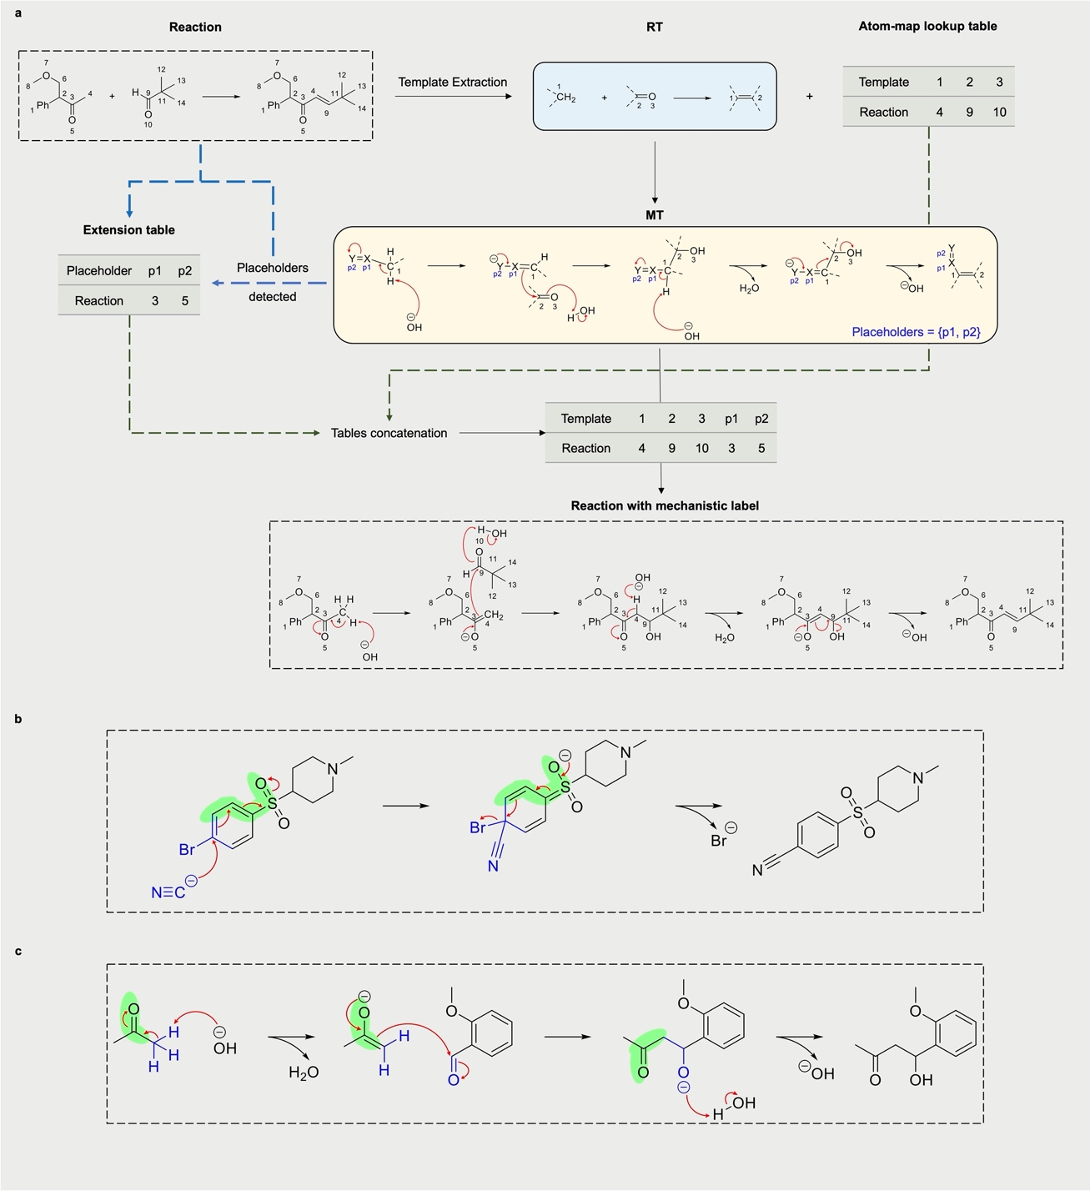
Figure S5. (a) Demonstration of technical manipulation to incorporate functional groups beyond the core atoms in the extracted RT. Once the MT is identified for the reaction, presence of the specific placeholders within the MT is detected which dictates the construction of extension table. Construction process involves the replacement of these placeholders by the respective atom-map numbers of the atoms present in the original reactant molecule. In this case, upon detection of the presence of p1 and p2, the extension table is built in order to incorporate the respective atom-map numbers in the original reaction. We use original reactant molecules to retrieve corresponding atom-map numbers. The resulting table is then concatenated with the atom-map lookup table generated during RT extraction. This provides complete template map number – reaction map number pairings facilitating the acquisition of mechanistic label for given reaction. (b) Nucleophilic aromatic substitution with cyanide as a nucleophile, bromide as a leaving group and para-positioned sulfonyl group on the benzene ring. The extracted RT for this reaction comprises the nucleophile, leaving group and immediate electrophilic center only (shown in blue). However, the underlying addition-elimination mechanism necessitates electron flow from the ring into the anion-stabilizing sulfonyl group (highlighted in green). Our method captures this pivotal mechanistic element, incorporating it into the resultant label without being constrained by RT limitations. The derived pathway comprehensively includes all requisite atoms and bonds. b) Base-catalyzed aldol condensation. The extracted RT covers the nucleophilic carbon and carbonyl group subject to attack (shown in blue). Nevertheless, the nucleophilicity of the carbon is influenced by the adjacent carbonyl group and should be present in the obtained pathway. The preservation of the enolate intermediate formation is manifested in the mechanism (highlighted in green), notwithstanding the absence of these atoms and bonds in the RT.

S6. Top 100 RTs
Table S1. List of all RTs in SMARTS format along with the number of reactions belonging to each RT.
Reaction Template | Number of reactions
[N:1].[O:4]-[C:2]=[O:3]>>[N:1]-[C:2]=[O:3] | 5505
[N:1].[C:2]-[X:3]>>[N:1]-[C:2] | 2331
[N:1].[X:4]-[C:2]=[O:3]>>[N:1]-[C:2]=[O:3] | 2286
[O:1].[C:2]-[X:3]>>[O:1]-[C:2] | 2124
[C:2]-[C:3](-[C:4])(-[C:5])-[O:6]-[C:7](-[N:1])=[O:8]>>[N:1] | 1881
[N:1].[C:2]=[O:3]>>[N:1]-[C:2] | 1661
[C:1]-[X:5].[a:3]:[n:2]:[a:4]>>[C:1]-[n:2](:[a:3]):[a:4] | 1078
[N:1].[O:3]=[S:2](=[O:4])-[X:5]>>[N:1]-[S:2](=[O:3])=[O:4] | 1027
[N:1].[X:5]-[c:2](:[a:3]):[a:4]>>[N:1]-[c:2](:[a:3]):[a:4] | 1022
[C:1]=[O:2]>>[C:1]-[O:2] | 657
[C:1]-[O:2]>>[C:1]=[O:2] | 550
[N:1].[C:2]=[O:3]>>[N:1]=[C:2] | 522
[C:2]-[O:1]>>[O:1] | 510
[O:1].[C:2]-[O:3]>>[O:1]-[C:2] | 461
[O:1].[X:5]-[c:2](:[a:3]):[a:4]>>[O:1]-[c:2](:[a:3]):[a:4] | 412
[N:4].C-C(-C)(-C)-[O:6]-[C:7](=O)-[O:8]-[C:3](=[O:5])-[O:2]-[C:1]>>[C:1]-[O:2]-[C:3](-[N:4])=[O:5] | 401
[O:1].[X:4]-[C:2]=[O:3]>>[O:1]-[C:2]=[O:3] | 380
[N:1].C-C-[O:4]-[C:2]=[O:3]>>[N:1]-[C:2]=[O:3] | 373
[N:1].[N:3]=[C:2]=[O:4]>>[N:1]-[C:2](-[N:3])=[O:4] | 342
[N:1].C-[O:4]-[C:2]=[O:3]>>[N:1]-[C:2]=[O:3] | 342
[O:1].[O:4]-[C:2]=[O:3]>>[O:1]-[C:2]=[O:3] | 320
[C:1].[C:2]=[O:3]>>[C:1]=[C:2] | 319
C-[O:3]-[C:1]=[O:2]>>[C:1]-[O:2] | 285
[S:1].[C:2]-[X:3]>>[S:1]-[C:2] | 267
[N:1]-[C:2](=[O:3])-[O:4]-[C:5]-[a:6]1:[a:7]:[a:8]:[a:9]:[a:10]:[a:11]:1>>[N:1] | 262
C-C-[O:3]-[C:1]=[O:2]>>[C:1]-[O:2] | 241
[O:1].[O:3]=[S:2](=[O:4])-[X:5]>>[O:1]-[S:2](=[O:3])=[O:4] | 240
[C:1]#[N:2]>>[C:1]-[N:2] | 225
[N:1].C-C(=O)-[O:4]-[C:2]=[O:3]>>[N:1]-[C:2]=[O:3] | 214
C-C(-C)(-C)-[Si:2](-C)(-C)-[O:1]>>[O:1] | 198
C-[C:2](-[O:1])=[O:3]>>[O:1] | 195
[N:1].[C:2]-[O:3]>>[N:1]-[C:2] | 188
[C:1]=[O:3].[C:2]-[P:4](-c1:c:c:c:c:c:1)(-c1:c:c:c:c:c:1)-c1:c:c:c:c:c:1>>[C:1]=[C:2] | 176
[N:3].[N:1]=[C:2]=[O:4]>>[N:1]-[C:2](-[N:3])=[O:4] | 173
[N:1]=[N:2]=[N:3]>>[N:1] | 165
[C:1]-[C:2](-[N:3])=[O:4]>>[C:1]-[C:2]-[N:3] | 159
[C:1]-[Mg:4].[C:2]=[O:3]>>[C:1]-[C:2]-[O:3] | 153
[C:2]-[C:3](-[N:1])=[O:4]>>[N:1] | 144
[O:2]=[C:3]1-[N:1]-[C:4](=[O:5])-[a:6]2:c:c:c:c:[a:7]:2-1>>[N:1] | 140
[N:1].C-S(=O)(=O)-[O:3]-[C:2]>>[N:1]-[C:2] | 139
[S:1].Cl-c1:c:c:c:c(-[C:3](=[O:4])-[O:5]-[O:2]):c:1>>[S:1]=[O:2] | 127
[X:6]-[C:2]=[O:1].[a:4]:[c:3]:[a:5]>>[O:1]=[C:2]-[c:3](:[a:4]):[a:5] | 121
[N:1].[N:3]=[C:2]=[S:4]>>[N:1]-[C:2](-[N:3])=[S:4] | 116
[O:3].[O:1]=[S:2](=[O:4])-[X:5]>>[O:1]=[S:2](-[O:3])=[O:4] | 113
[C:1]=[O:3].C-C-O-[P:4](-[C:2])(=[O:5])-O-C-C>>[C:1]=[C:2] | 111
[O:1].[C:2]=[C:3]>>[O:1]-[C:2]-[C:3] | 104
[O:4].[O:1]=[S:2](=[O:3])-[X:5]>>[O:1]=[S:2](=[O:3])-[O:4] | 98
[N:1].[N:3].[O:4]-[C:2]=[O:5]>>[n:1]:[c:2]:[n:3] | 92
[N:1].F-C(-F)(-F)-C(=O)-[O:4]-[C:2]=[O:3]>>[N:1]-[C:2]=[O:3] | 91
[a:4]:[c:3]:[a:5].C-[N:6](-C)-[C:2]=[O:1]>>[O:1]=[C:2]-[c:3](:[a:4]):[a:5] | 87
[S:1].[X:5]-[c:2](:[a:3]):[a:4]>>[S:1]-[c:2](:[a:3]):[a:4] | 87
[C:1]=[O:2]>>[C:1] | 86
[C:1]-[X:4].[N:2]=[N:3]>>[C:1]-[N:2]=[N:3] | 85
[N:2]-[C:1]=[S:5].[X:6]-[C:4]-[C:3]=[O:7]>>[c:1]1:[n:2]:[c:3]:[c:4]:[s:5]:1 | 72
F-[C:2](-F)(-F)-[C:3](-[N:1])=[O:4]>>[N:1] | 71
[C:1]-[O:3].Br-[C:4](-Br)(-Br)-[Br:2]>>[C:1]-[Br:2] | 70
[O:1].C-S(=O)(=O)-[O:3]-[C:2]>>[O:1]-[C:2] | 66
[a:5]:[n:4]:[a:6].[O:1]=[S:2](=[O:3])-[X:7]>>[O:1]=[S:2](=[O:3])-[n:4](:[a:5]):[a:6] | 65
[O:3].[N:1]=[C:2]=[O:4]>>[N:1]-[C:2](-[O:3])=[O:4] | 61
[X:6]-[C:2]=[O:1].[a:4]:[n:3]:[a:5]>>[O:1]=[C:2]-[n:3](:[a:4]):[a:5] | 58
[N:3]-[C:2](=[O:4])-[a:1]>>[a:1]-[C:2]#[N:3] | 56
[a:3]:[n:2]:[a:4].Cl-c1:c:c:c:c(-[C:5](=[O:6])-[O:7]-[O:1]):c:1>>[O:1]-[n:2](:[a:3]):[a:4] | 55
[a:3]:[n:2]:[a:4].C-S(=O)(=O)-[O:5]-[C:1]>>[C:1]-[n:2](:[a:3]):[a:4] | 55
[O:1].[O:3].[C:2]=[O:4]>>[O:1]-[C:2]-[O:3] | 55
[N:1].C-C(-C)(-C)-[O:4]-[C:2]=[O:3]>>[N:1]-[C:2]=[O:3] | 53
[a:6]:[n:5]:[a:7].C-C(-C)(-C)-[O:8]-[C:9](=O)-[O:10]-[C:3](=[O:4])-[O:2]-[C:1]>>[C:1]-[O:2]-[C:3](=[O:4])-[n:5](:[a:6]):[a:7] | 53
[N:3].[N:1]=[C:2]=[S:4]>>[N:1]-[C:2](-[N:3])=[S:4] | 52
[N:1]-[C:2]=[S:3].[X:6]-[C:4]-[C:5]=[O:7]>>[n:1]1:[c:2]:[s:3]:[c:4]:[c:5]:1 | 50
[N:1]-[C:2](=[O:4])-[a:3]>>[N:1]-[C:2]-[a:3] | 48
[C:1]=[N:2]>>[C:1]-[N:2] | 46
[C:1]=[O:3].[C:2]=[P:4](-c1:c:c:c:c:c:1)(-c1:c:c:c:c:c:1)-c1:c:c:c:c:c:1>>[C:1]=[C:2] | 45
[a:5]:[n:4]:[a:6].[X:7]-[c:2](:[a:1]):[a:3]>>[a:1]:[c:2](:[a:3])-[n:4](:[a:5]):[a:6] | 45
[N:1]-[N:2].[O:6]=[C:3]-[C:4]-[C:5]=[O:7]>>[n:1]1:[n:2]:[c:3]:[c:4]:[c:5]:1 | 43
[C:1]-[X:4].[C:2]#[N:3]>>[C:1]-[C:2]#[N:3] | 43
[S:1].[O:2]-[O:3]>>[S:1]=[O:2] | 42
[N:1].[O:6]=[C:2]-[C:3]-[C:4]-[C:5]=[O:7]>>[n:1]1:[c:2]:[c:3]:[c:4]:[c:5]:1 | 40
[C:2]-[O:3]-[C:4]-[O:1]>>[O:1] | 40
[C:1]-[C:2](-[N:3])=[O:4]>>[C:1]-[C:2]#[N:3] | 39
[N:1].[C:2]=[O:6].[a:4]:[c:3]:[a:5]>>[N:1]-[C:2]-[c:3](:[a:4]):[a:5] | 39
[C:1]=[C:2].Cl-c1:c:c:c:c(-[C:4](=[O:5])-[O:6]-[O:3]):c:1>>[C:1]1-[C:2]-[O:3]-1 | 37
[N:2]=[N:3].C-S(=O)(=O)-[O:4]-[C:1]>>[C:1]-[N:2]=[N:3] | 37
[C:4]-[C:5](-[C:6])(-[C:7])-[O:8]-[C:9](=[O:10])-[n:2](:[a:1]):[a:3]>>[a:1]:[n:2]:[a:3] | 37
[C:2]=[O:1].[Mg:6]-[c:3](:[a:4]):[a:5]>>[O:1]-[C:2]-[c:3](:[a:4]):[a:5] | 36
[N:2].[C:1]-[X:4].[C:3]-[X:5]>>[C:1]-[N:2]-[C:3] | 36
[N:3]-[C:2]=[S:1].[X:6]-[C:5]-[C:4]=[O:7]>>[s:1]1:[c:2]:[n:3]:[c:4]:[c:5]:1 | 36
[O:1]-[C:2]1-[C:3]-[C:4]-[C:5]-[C:6]-[O:7]-1>>[O:1] | 34
[a:1]:[n:2]:[a:3].[X:7]-[c:4](:[a:5]):[a:6]>>[a:1]:[n:2](:[a:3])-[c:4](:[a:5]):[a:6] | 33
[C:1].[C:2]=[O:3]>>[C:1]-[C:2]-[O:3] | 31
[C:1]-[X:10].[C:7]-[C:6](-[C:8])(-[C:9])-[O:5]-[C:3](-[N:2])=[O:4]>>[C:1]-[N:2]-[C:3](=[O:4])-[O:5]-[C:6](-[C:7])(-[C:8])-[C:9] | 29
[a:1]:[n:2](:[a:3])-[C:4]1-[C:5]-[C:6]-[C:7]-[C:8]-[O:9]-1>>[a:1]:[n:2]:[a:3] | 29
[N:1]-[C:2](=[O:3])-[O:4]-[C:5]-[C:6]1-[a:7]2:[a:8]:[a:9]:[a:10]:[a:11]:[a:12]:2-[a:13]2:[a:14]:[a:15]:[a:16]:[a:17]:[a:18]:2-1>>[N:1] | 28
[C:1]-[O:2]-[C:3]1-[C:4]-[C:5]-[C:6]-[C:7]-[O:8]-1>>[C:1]-[O:2] | 28
[C:1]-[O:5].[a:3]:[n:2]:[a:4]>>[C:1]-[n:2](:[a:3]):[a:4] | 27
[C:1]-[Mg:5].C-O-[N:6](-C)-[C:2](=[O:3])-[a:4]>>[C:1]-[C:2](=[O:3])-[a:4] | 27
[C:2]=[O:1].[C:3]#[C:4]>>[O:1]-[C:2]-[C:3]#[C:4] | 27
[N:1]-[C:2](=[O:3])-[a:4]1:c:c:c:c:c:1>>[N:1] | 25
[O:1].[C:2]=[N:3]=[N:4]>>[O:1]-[C:2] | 25
[N:1].[S:3]=[C:2](-[X:4])-[X:5]>>[N:1]=[C:2]=[S:3] | 24
[N:1].F-C(-F)(-F)-S(=O)(=O)-[O:5]-[c:2](:[a:3]):[a:4]>>[N:1]-[c:2](:[a:3]):[a:4] | 21
[C:2]#[N:1].[X:6]-[c:3](:[a:4]):[a:5]>>[N:1]#[C:2]-[c:3](:[a:4]):[a:5] | 9

S7. Distribution of mechanistic classes in mech-USPTO-31K dataset
Table S2. Distribution of reactions across mechanistic classes in the labeled dataset.
Mechanistic Class | Number of reactions | Mechanistic Class | Number of reactions
DCC condensation | 5816 | (hemi)acetal (aminal) hydrolysis | 131
Nucleophilic attack to (thio)carbonyl | 4963 | Sulfide oxidation | 127
S_{N}2 reaction | 3956 | Friedel Crafts acylation | 121
S_{N}2 reaction with alcohol(thiol) | 2191 | Horner Wadsworth Emmons reaction | 111
Boc deprotection | 1918 | Primary amide dehydration | 95
Reductive amination | 1661 | Imidazole synthesis | 92
Alcohol attack to carbonyl or sulfonyl | 892 | Vilsmeier formylation | 87
Nucleophilic attack to iso(thio)cyanate | 683 | Wolff Kishner reduction | 86
Carbonyl reduction | 647 | Appel reaction | 70
S_{N}Ar reaction (ortho) | 599 | Acetal formation from enol ether | 64
S_{N}Ar reaction (para) | 548 | Acetal formation | 55
Ester reduction | 526 | Amine oxidation | 55
Imine formation | 522 | Imine reduction | 46
O-demethylation | 510 | Wittig reaction with ylide | 45
Mitsunobu reaction | 488 | Knorr pyrazole synthesis | 43
Swern oxidation | 322 | Sulfide oxidation by peroxide | 42
Aldol condensation | 319 | Paal Knorr pyrrole synthesis | 40
S_{N}1 reaction | 305 | Mannich reaction | 39
S_{N}Ar reaction with alcohol (para) | 300 | Alkene epoxidation | 37
Cbz deprotection | 262 | Double S_{N}2 reaction | 36
Carboxylic acid derivative hydrolysis or formation | 240 | Aldol addition | 31
Jones oxidation | 228 | Fmoc deprotection | 28
Nitrile reduction | 225 | Alkynyl attack to carbonyl | 27
Amide reduction | 207 | Weinreb ketone synthesis | 27
Base catalyzed ester hydrolysis | 195 | Markovnikov addition | 26
Grignard reaction | 189 | Methyl ester synthesis | 25
S_{N}2 reaction with tosylate | 182 | Isothiocyanate synthesis | 24
S_{N}Ar reaction with alcohol (ortho) | 182 | Michael addition | 14
Wittig reaction | 176 | Lactone reduction | 10
Staudinger reaction | 165 | Intramolecular lactonization | 9
Hantzsch thiazole synthesis | 158 | S_{N}1 reaction with tosylate | 6
Ing Manske | 140

S8. Expert evaluation of 100 randomly sampled reactions
We present the evaluation results of 100 randomly sampled reactions from the mech-USPTO-31K dataset by 11 chemists, detailed in the supplementary material. The average score for these MechFinder-generated mechanisms is 0.986 out of 1, confirming that the MechFinder produces chemically reasonable mechanistic pathways.

S9. Example reaction mechanism evaluated by chemists
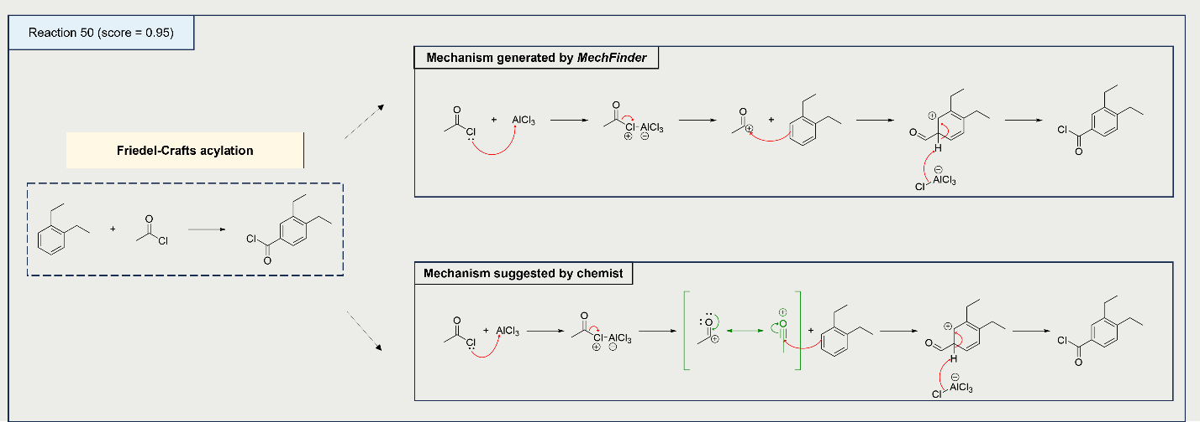
Figure S6. An illustrative example of a reaction with a marginally lower average score. The lower score from a single chemist is due to the absence of a more stable resonance structure for the acylium ion; the part missing from the mechanism is shown in green.

S10. Additional reagents
Table S3. Manually recovered reagents across mechanistic classes in the labeled dataset
Mechanistic Class | Added reagents | Mechanistic Class | Added reagents
DCC condensation | DCC | Ing Manske | N₂H₄
S_{N}2 reaction with alcohol(thiol) | NaH | (hemi)acetal (aminal) hydrolysis | H₂O / H⁺
Boc deprotection | H⁺ | Friedel Crafts acylation | AlCl₃
Reductive amination | NaBH₃CN | Horner Wadsworth Emmons reaction | OH⁻
Alcohol attack to carbonyl or sulfonyl | NaH | Primary amide dehydration | SOCl₂
Carbonyl reduction | NaBH₄ / MeOH | Imidazole synthesis | CDI
Ester reduction | LiAlH₄ | Vilsmeier formylation | POCl₃ / H₂O
Imine formation | H+ | Wolff Kishner reduction | N₂H₄ / H⁺ / OH⁻
O-demethylation | BBr₃ / H₂O | Appel reaction | PPh₃
Mitsunobu reaction | PPh₃ / DEAD | Acetal formation from enol ether | H⁺
Swern oxidation | (COCl)₂ / DMSO / Et₃N | Acetal formation | H⁺
Aldol condensation | OH⁻ | Imine reduction | NaBH₄ / MeOH
S_{N}Ar reaction with alcohol (para) | NaH | Knorr pyrazole synthesis | H⁺
Cbz deprotection | HBr | Paal Knorr pyrrole synthesis | H⁺
Carboxylic acid derivative hydrolysis or formation | H₂O / H⁺ | Mannich reaction | H⁺
Jones oxidation | H₂CrO₄ | Aldol addition | NaOH
Nitrile reduction | LiAlH₄ / H₂O | Fmoc deprotection | Et₃N
Amide reduction | 2 x LiAlH₄ | Alkynyl attack to carbonyl | NaNH₂
Base catalyzed ester hydrolysis | 2 x OH⁻ | Weinreb ketone synthesis | H⁺
Grignard reaction | H₂O | Markovnikov addition | H⁺
S_{N}2 reaction with tosylate | TsCl | Michael addition | NaOH
S_{N}Ar reaction with alcohol (ortho) | NaH | Intramolecular lactonization | H⁺
Wittig reaction | OH⁻ | S_{N}1 reaction with tosylate | TsCl
Staudinger reaction | PPh₃ / H₂O

Reference
1. Bradshaw, J., Kusner, M. J., Paige, B., Segler, M. H. S. & Hernández-Lobato, J. M. A Generative Model For Electron Paths. ArXiv180510970 Phys. Stat (2019).

