Supplementary Information to A global dataset of 7 billion individuals with socio-economic characteristics

S1 LIS and DHS original data categories
Table S1. Variables used to create the global synthetic database and the original categories in the LIS and DHS databases
Education | LIS: highest completed education level (educlev) | DHS: educational attainment completed (HV109) | Synthetic population
Education | 110 – less than primary | None | 1: Less than primary
Education | 110 – less than primary | Incomplete primary | 1: Less than primary
Education | 120 – primary | Complete primary | 2: Primary completed
Education | 100 – low, less than upper secondary | Incomplete secondary | 3: Less than secondary
Education | 200 – medium, upper secondary and post-secondary non-tertiary | Complete secondary | 4: Secondary completed
Education | 300 – high, tertiary | Higher education | 5: Higher
Education | 310 – BA, MA or equivalent, short-cycle tertiary | Higher education | 5: Higher
Education | 320 – doctorate or equivalent | Higher education | 5: Higher
Education | Missing | Missing | Entire household removed
Age | LIS: age in years (age) | DHS: age in years (HV105)
Age | 0-4 | 0-4 | 1: 0-4
Age | 5-14 | 5-14 | 2: 5-14
Age | 15-24 | 15-24 | 3: 15-24
Age | 25-34 | 25-34 | 4: 25-34
Age | 35-44 | 35-44 | 5: 35-44
Age | 45-54 | 45-54 | 6: 45-54
Age | 55-64 | 55-64 | 7: 55-64
Age | 65+ | 65+ | 8: 65+
Age | Missing | 999 – Missing | Entire household removed
Gender | LIS: gender (sex) | DHS: gender (HV104)
Gender | 1 – male | Male | 1: Male
Gender | 2 – female | Female | 0: Female
Gender | Missing | Missing | Entire household removed
Income | LIS: Disposable household income (dhi)
Income | Percentile 0-20 |  | 1: Poorest 20%
Income | Percentile 20-40 |  | 2: Poorer 20%
Income | Percentile 40-60 |  | 3: Middle 20%
Income | Percentile 60-80 |  | 4: Richer 20%
Income | Percentile 80-100 |  | 5: Richest 20%
Wealth |  | DHS: Wealth index (HV270)
Wealth |  | Poorest | 1: Poorest 20%
Wealth |  | Poorer | 2: Poorer 20%
Wealth |  | Middle | 3: Middle 20%
Wealth |  | Richer | 4: Richer 20%
Wealth |  | Richest | 5: Richest 20%
Household type | LIS: Household composition (hhtype) | DHS: Created by logical constraints
Household type | 100 – one person household |  | 1: single
Household type | 210 – couple without children |  | 2: couple
Household type | 220 – couple with children |  | 3: couple with children
Household type | 230 – one parent with children |  | 4: one parent with children
Household type | 310 – couple without children and relatives |  | 5: couple without children, but with relatives and/or nonrelatives
Household type | 510 – couple without children and non-relatives
Household type | 610 – couple without children and relatives and nonrelatives
Household type | 910 – couple without children and other
Household type | 320 – couple with children and relatives |  | 6: couple with children and relatives and/or nonrelatives
Household type | 520 – couple with children and nonrelatives |  | 6: couple with children and relatives and/or nonrelatives
Household type | 620 – couple with children and relatives and nonrelatives |  | 6: couple with children and relatives and/or nonrelatives
Household type | 920 – couple with children and other |  | 6: couple with children and relatives and/or nonrelatives
Household type | 330 – one parent with children and relatives |  | 7: one parent with children and relatives and/or nonrelatives
Household type | 530 – one parent with children and nonrelatives
Household type | 630 – one parent with children and relatives and nonrelatives
Household type | 930 – one parent with children and other
Household type | 400 – relatives living together |  | 8: Other
Household type | 700 – relatives and nonrelatives living together |  | 8: Other
Household type | 800 – nonrelatives living together |  | 8: Other
Household type | 900 – head and other |  | 8: Other
Household size | LIS: number of household members (nhhmem) | DHS: number of household members (HV009)
Household size | 1 | 1 | 1: 1
Household size | 2 | 2 | 2: 2
Household size | 3-4 | 3-4 | 3: 3-4
Household size | 5-6 | 5-6 | 4: 5-6
Household size | 7-10 | 7-10 | 5: 7-10
Household size | 10+ | 10+ | 6: 10+
Settlement type (rural/urban) | SMOD-GHS: Settlement classes | Marginals
Settlement type (rural/urban) | 11 – Very low density rural | 1 – Rural
Settlement type (rural/urban) | 12 – Low density rural | 1 – Rural
Settlement type (rural/urban) | 13 – Rural cluster | 1 – Rural
Settlement type (rural/urban) | 21 – Suburban or peri-urban | 0 – Urban
Settlement type (rural/urban) | 22 – Semi-dense urban cluster | 0 – Urban
Settlement type (rural/urban) | 23 – Dense urban cluster | 0 – Urban
Settlement type (rural/urban) | 30 – Urban centre | 0 – Urban
Settlement type (rural/urban) | LIS: rural area (rural) | DHS: Urban-rural status (HV025)
Settlement type (rural/urban) | 1 – rural | Rural | 1: Rural
Settlement type (rural/urban) | 0 – not rural | Urban | 0: Urban
Settlement type (rural/urban) | Missing | Missing | Entire household removed
Ownership of agricultural land |  | DHS: owns land for agriculture (HV244)
Ownership of agricultural land |  | No | 0: No
Ownership of agricultural land |  | Yes | 1: Yes
Relationship to household head | LIS: relationship to household head (relation) | DHS: relationship to household head (HV101)
Relationship to household head | 1000 – head | 1 - Head | 1: Head
Relationship to household head | 2000 – spouse/partner | 2 - Wife or husband | 2: Partner
Relationship to household head | 2100 – spouse | 2 - Wife or husband | 2: Partner
Relationship to household head | 2200 – cohabiting partner | 9 - Co-spouse | 2: Partner
Relationship to household head | 3000 – child | 3 – Son/daughter | 3: Child
Relationship to household head | 3100 – own child (incl adopted) | 3 – Son/daughter | 3: Child
Relationship to household head | 3200 – step-child | 11 – Adopted/foster child | 3: Child
Relationship to household head | 3300 – foster child | 11 – Adopted/foster child | 3: Child
Relationship to household head | 4110 spouse/partner of child | 4 – Son/daughter in law | 3: Child
Relationship to household head | 4120 – grandchild or greatgrandchild (incl in-laws) | 5 - Grandchild | 3: Child
Relationship to household head | 4100 – other relative | 10 – Other relative | 4: Relative
Relationship to household head | 4130, 4131, 4132 – parent/grandparent/ascendant | 6 - Parent | 4: Relative
Relationship to household head | 4140 – siblings (incl in-laws) | 7 – Parent-in-law | 4: Relative
Relationship to household head | 4150 – aunt/uncle | 8 – Brother/sister | 4: Relative
Relationship to household head | 4160 – newphew/niece | 13 – Niece/nephew by blood | 4: Relative
Relationship to household head | 4170 – cousin | 14 – Niece/nephew by marriage | 4: Relative
Relationship to household head | 4200 – other non-relative | 12 – Not related | 5: Non-relative
Relationship to household head | 4210 – housemate/roommate | 12 – Not related | 5: Non-relative
Relationship to household head | 4220 – domestic employee and his/her family | 12 – Not related | 5: Non-relative
Relationship to household head | 4230 – guest/visitor/boarder/lodger | 12 – Not related | 5: Non-relative
Relationship to household head | 4000 – other | 12 – Not related | 5: Non-relative

S2 LIS sample size
Table S2. Number of individuals and households in LIS samples
Country | liscode | Nr of individuals | Nr of households
Austria | at15 | 13049 | 6000
Belgium | be15 | 13773 | 5905
Brazil | br16 | 447122 | 148199
Canada | ca15 | 59730 | 25825
Chile | cl15 | 266713 | 83887
China | cn13 | 61162 | 17890
Ivory Coast | ci15 | 47490 | 12899
Colombia | co15 | 783131 | 232219
Czech Republic | cz13 | 18210 | 8053
Denmark | dk16 | 187596 | 89245
Estonia | ee16 | 15320 | 6155
France | fr15 | 114910 | 51144
Germany | de15 | 36950 | 14426
Georgia | ge15 | 9318 | 2783
Greece | gr16 | 54041 | 22743
Hungary | hu15 | 6237 | 2772
Ireland | ie15 | 13182 | 5218
Italy | it14 | 19366 | 8156
Japan | jp13 | 7276 | 2352
Lithuania | lt15 | 10905 | 4808
Mexico | mx14 | 73508 | 19479
Peru | pe15 | 118882 | 32188
Paraguay | py15 | 30806 | 8229
Poland | pl15 | 101076 | 37148
Russia | ru15 | 138387 | 60000
Serbia | rs16 | 17893 | 6457
Slovakia | sk15 | 16507 | 5738
Spain | es16 | 34911 | 13740
Switzerland | ch15 | 17881 | 7762
United States | us15 | 184980 | 69484
Uruguay | uy15 | 121442 | 45391
Vietnam | vn13 | 36060 | 9393
Sweden | se15 | 14058 | 5787
United Kingdom | uk15 | 43678 | 19322
Israel | il15 | 28819 | 8550
Luxembourg | lu15 | 10159 | 3836
Palestine | ps17 | 20175 | 3736

S3 Merging household members in LIS data
Figure S1. Flowchart of merging household members in LIS data
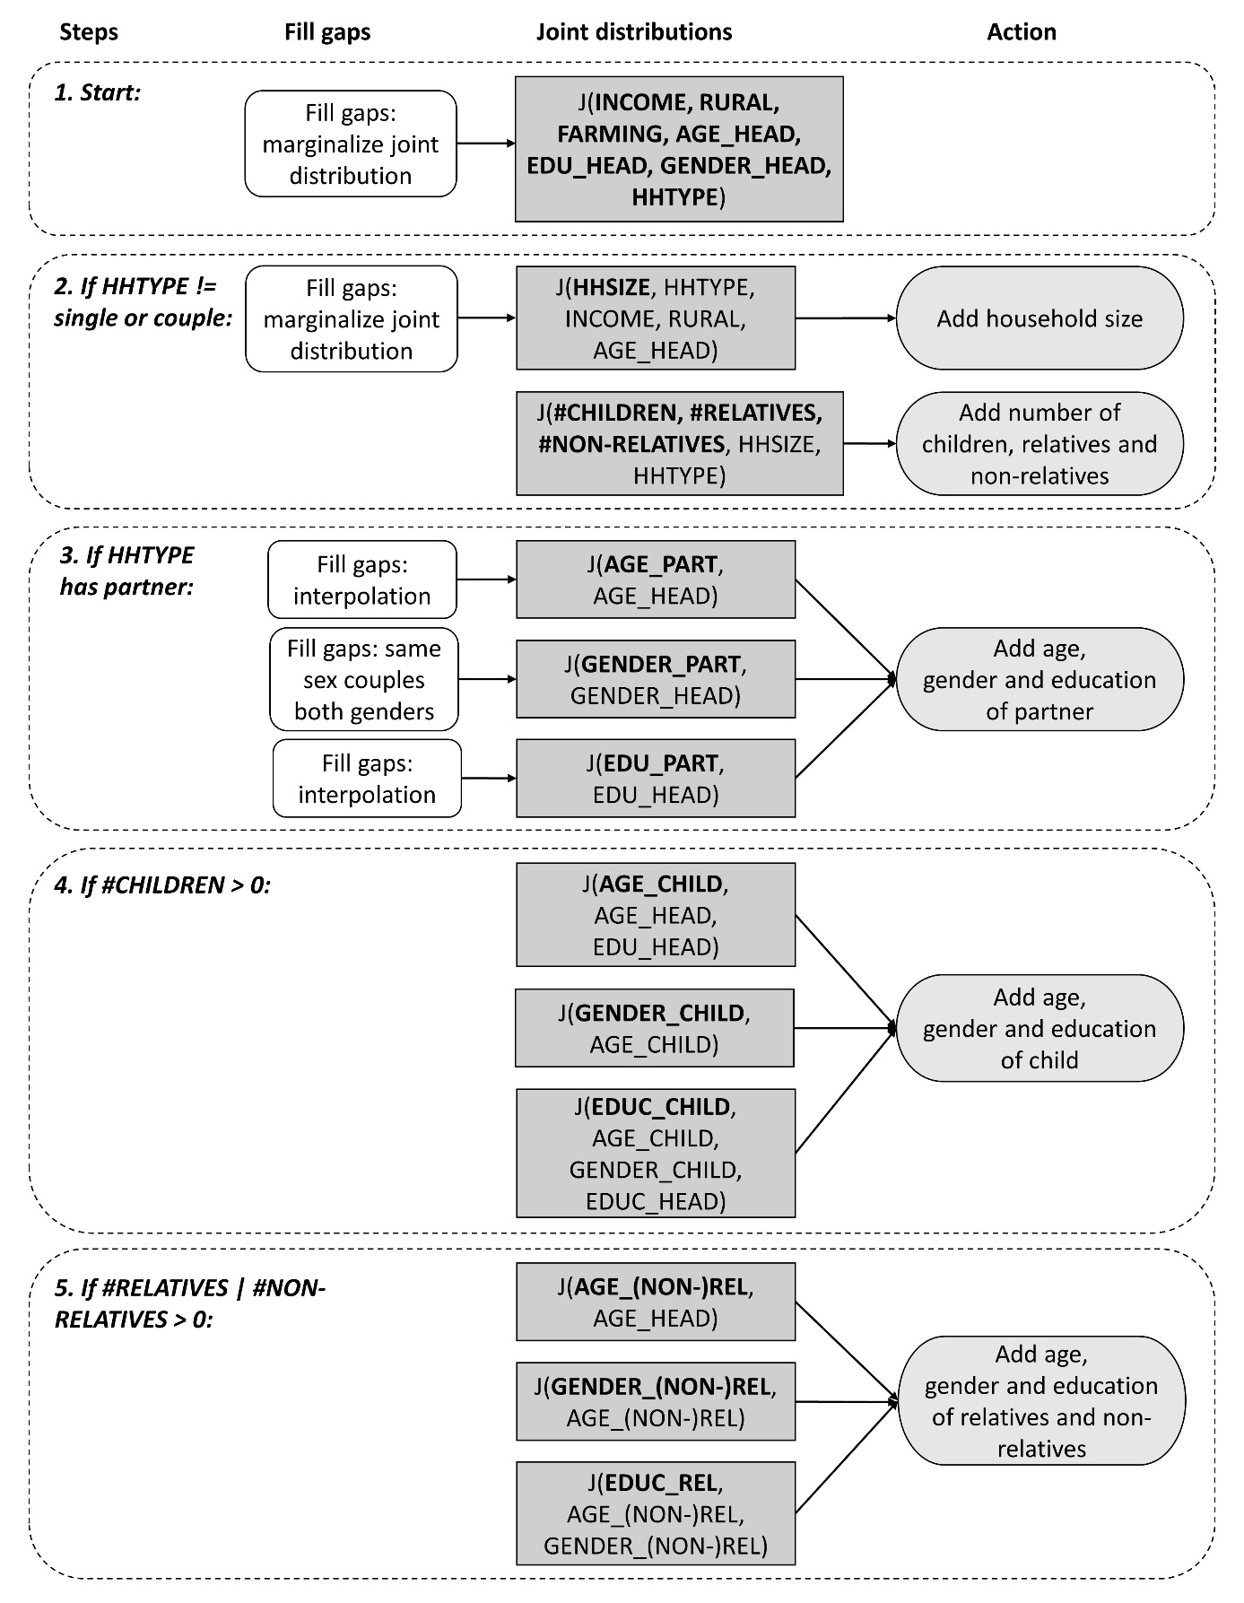

In step 1, for each country in the LIS, we extract the joint distribution of income, rural, farming, household type and the age, education and gender of the household head. As there is a restriction on the size of the table that can be printed on the LIS server, we did not include household size in this joint distribution. In step 2, we merge household size to the joint distribution based on the household type, rural/urban indicator, and age of the household head. We could have chosen another variable to merge in the second step but picked household size because this variable is also reflected in the household type. Next, we add the number of children, relatives and non-relatives to each household based on the joint distribution of household size, household type, and the number of children, relatives and non-relatives. In step 3, we merge the partner’s characteristics into the household, starting with age. However, before we merge the partner’s age to the household, we fill gaps in the joint distribution of the age of the partner and the head. Especially when the sample size is small, there may be no couples present in the sample with a large age difference, but they most likely do exist in the true population. To fill the gaps, we reduce the joint distribution to a smaller contingency table containing the probabilities that the head of household’s age is equal to the partner’s age and 1, 2, 3, 4 and 5 categories higher and lower than the partner’s age. This step reduces the size of the frequency table from 36 values to 11 values. Then, if, for example, there is zero probability of the head of household’s age being category 4, and the partner’s age being category 2, we impute this zero by the probability that the head of household’s age is 2 categories higher than the partner’s age. In the event that there are gaps in the smaller table, for example, if there are no couples with an age difference of 4 categories or higher, then we fit a polynomial regression model on the non-missing values and predict the missing values. Next, we add the partner’s gender to the household. We account for same-sex couples, therefore, the joint distribution table contains four numbers. When there are no same-sex couples present in the sample data, we do not impute these zeros. We only impute a zero when there are same-sex couples present in the data, but all of them are either male or female couples. In this case, we copy the number of two-men or two-women households to the other same-sex households and divide both by two so that the total number of same-sex couples stays the same. Lastly, we add the partner’s education to the household. We have considered merging the partner’s education on more variables than the household head’s education, but this resulted in many gaps in the joint distribution, therefore, we kept the joint distribution table small. We impute zeros in the joint distribution in the same way as the gaps in the partner’s age joint distribution. In step 4, we add the children’s characteristics to the household. We merge the age of the child based on the age and education of the household head because there is a strong link between the education of the parent(s) and the timing of first births.⁴⁸ Next, we add the gender of the child to the household based on the child’s age, because in many countries, male children tend to live with their parents for a longer period of time than female children.⁴⁹ Then, we merge the child’s education based on its age and gender as well as the education of the household’s head, because these three variables significantly influence a child’s education.⁵⁰ In step 5, we add relatives and non-relatives to the household, which can be grandparents, siblings, nieces and nephews, grandchildren, roommates, etc. Age is merged based on the age of the household head. As we want to allow for dependencies between the (non)-relative’s gender and age, we then merge gender based on age. Lastly, we add education based on the (non-)relative’s age and gender.

48. Mills, M., Rindfuss, R.R, McDonald, P., Te Velde, E. & on behalf of the ESHRE Reproduction and Society Task Force. Why Do People Postpone Parenthood? Reasons and Social Policy Incentives. Human Reproduction Update 17(6), 848–60 (2011). https://doi.org/10.1093/humupd/dmr026
49. Chiuri, M.C., & Del Boca, D. Home-Leaving Decisions of Daughters and Sons. Review of Economics of the Household 8(3), 393–408 (2010). https://doi.org/10.1007/s11150-010-9093-2
50. Björklund, A., & Salvanes, K.G. Chapter 3 - Education and Family Background: Mechanisms and Policies. In E.A. Hanushek, S. Machin & L. Woessmann (Eds.), Handbook of the Economics of Education (3rd ed., p201–247). Elsevier. (2011). https://doi.org/10.1016/B978-0-444-53429-3.00003-X.

S4 Relative errors
Figure S2. Relative errors for countries with LIS data under different conditions
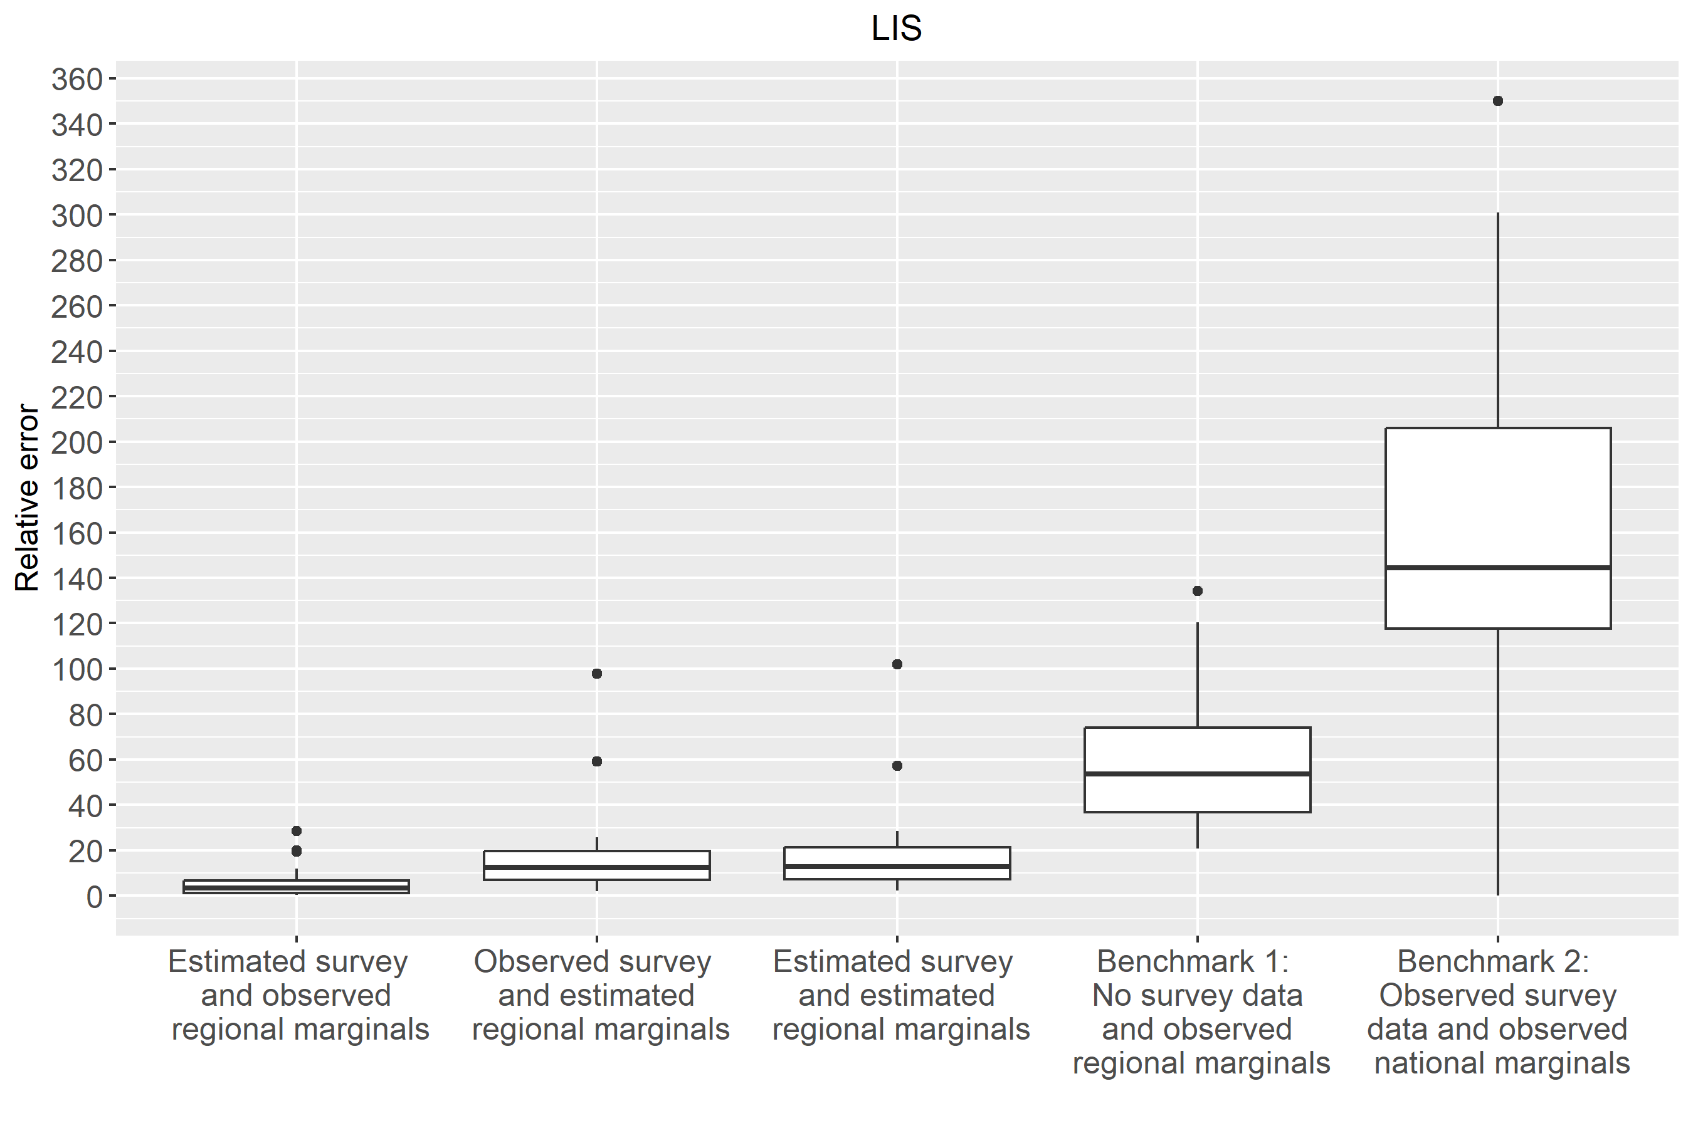

Figure S3. Relative errors for countries with DHS data under different conditions
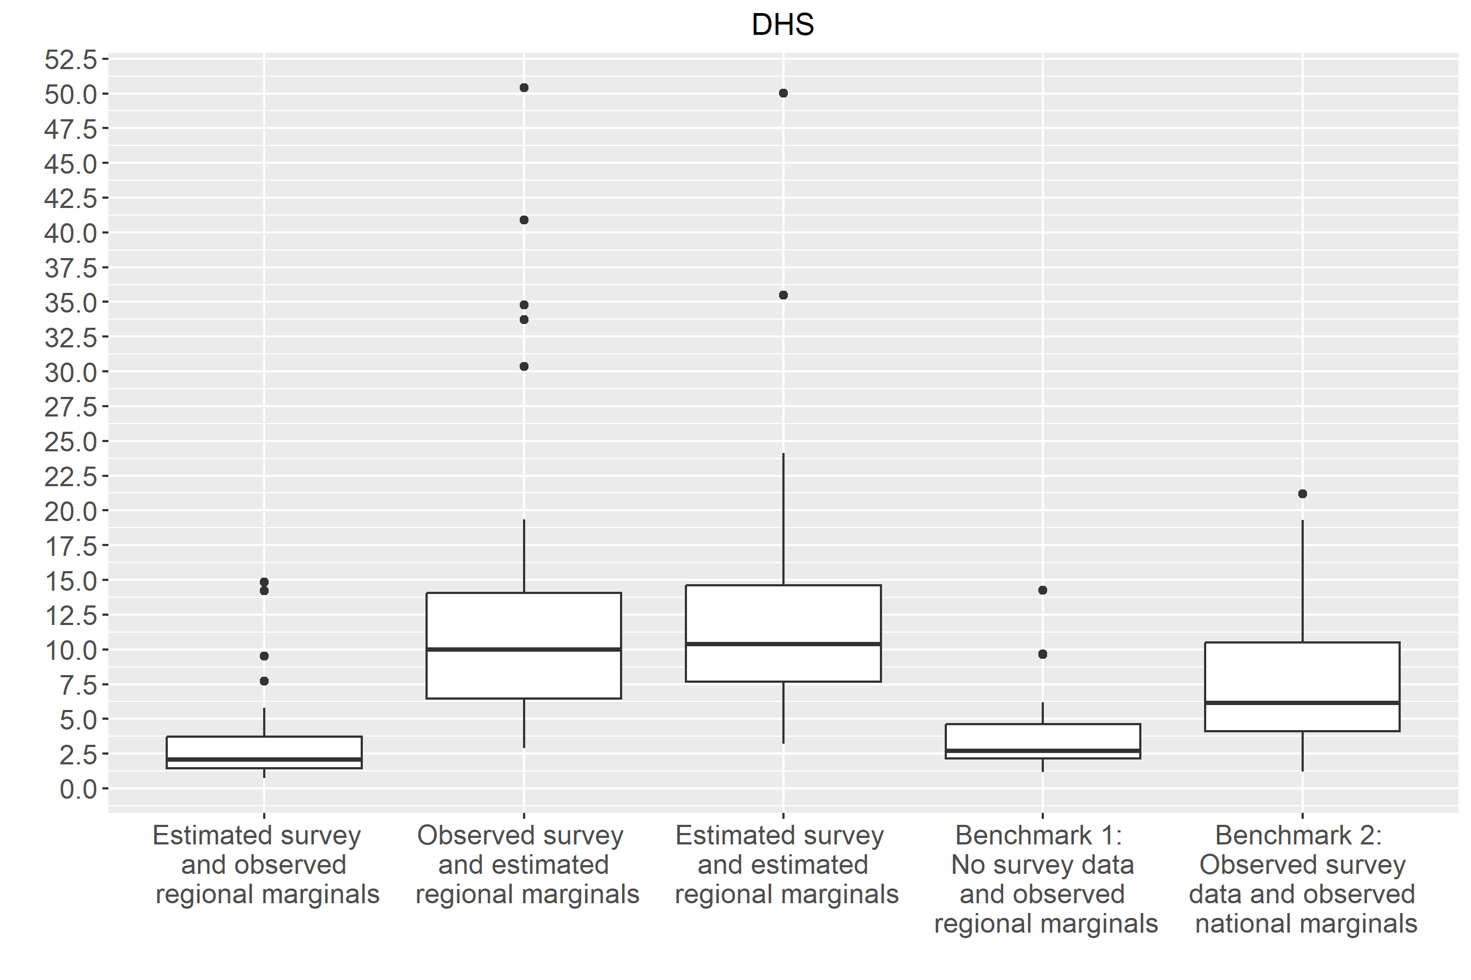

S5 Optimal number of regions, k, and groups, n, for constructing the marginals
Table S3. Optimal number of regions
Attribute | Optimal k LIS | Optimal k DHS
Age | 268 | 89
Gender | 98 | 120
Education | 243 | 59
Household type | 194 | 238
Household size | 87 | 227

Table S4. Optimal number of groups
Attribute | Optimal n LIS | Optimal n DHS
Income | 6 | -
Wealth | - | 9

