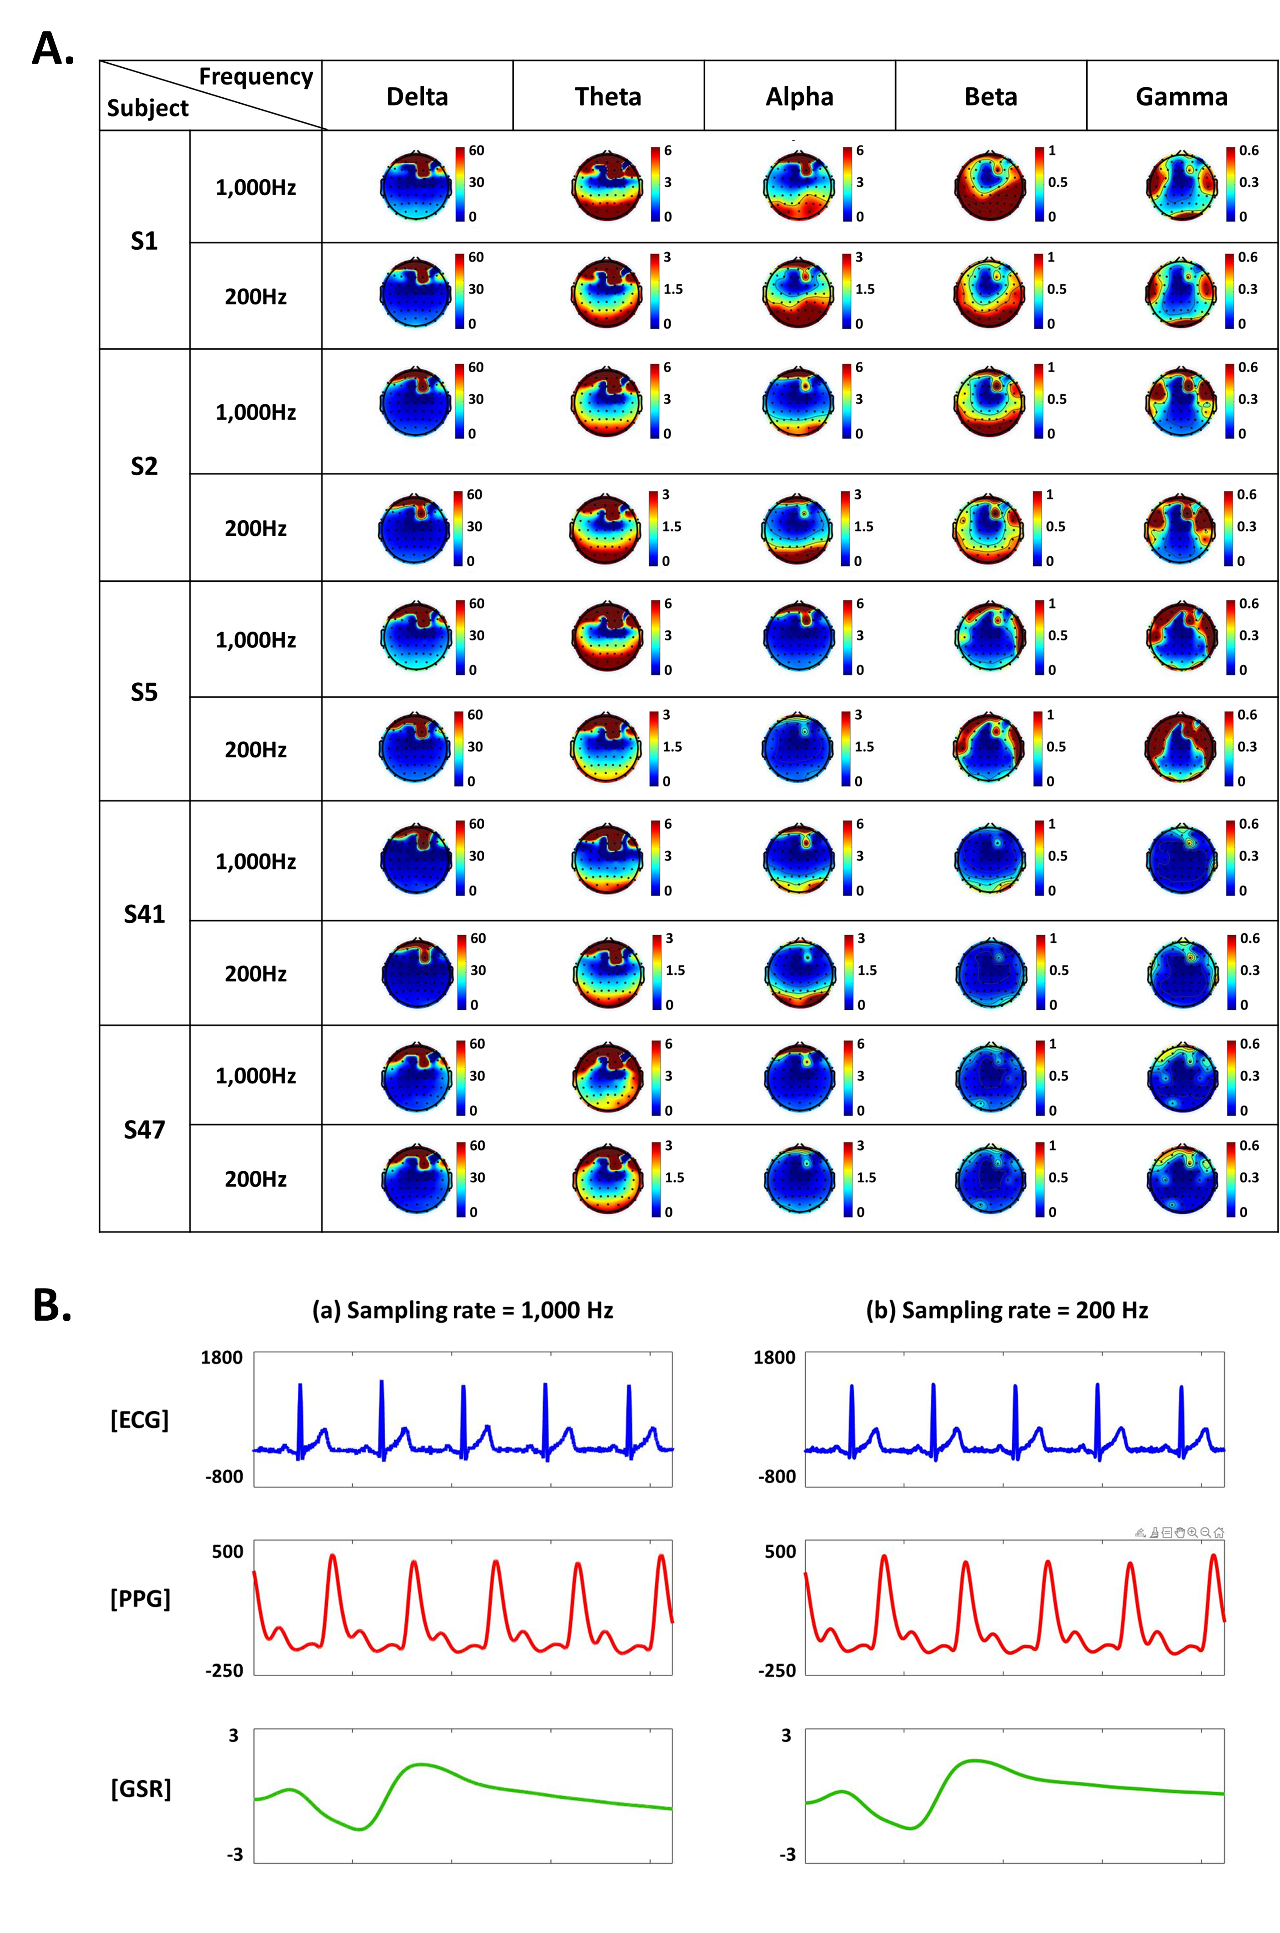
Figure 1. Signal comparison based on sampling rate: (A) spectral topographic maps according to the frequency band for five selected subjects, (B) examples of physiological data of a representative subject in figure 8. The fundamental trends remain consistent, suggesting that downsampling does not significantly alter the overarching patterns.

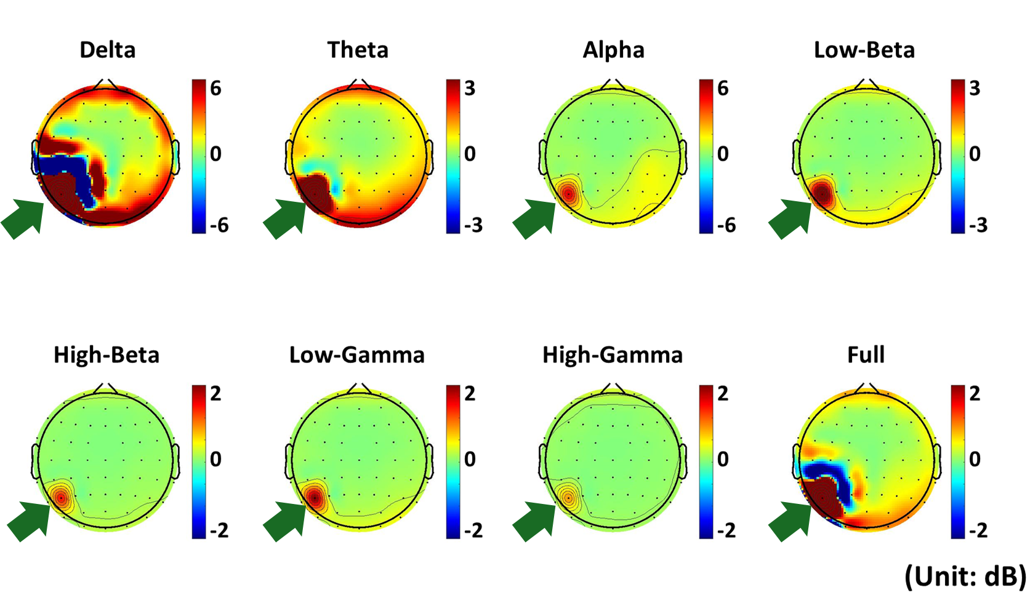
Figure 2. Spectral topographic maps of representative subjects for each frequency band. We empirically identified bad channels showing abnormally high activation (green arrows).

