Sample | K-mer Number | K-mer Depth | Genome Size (Mb) | Revised Genome Size (Mb) | Heterozygous Ratio (%) | Repeat (%)
Misgurnus anguillicaudatus | 216,747,902,623 | 93 | 2,331 | 2,315 | 1.38 | 78.96
Table s1. 17-kmer analysis for estimation of the autotetraploid Misgurnus anguillicaudatus genome size. We survey the two sets of genome data of autotetraploid M. anguillicaudatus genomes.

Sample name | Mapping rate (%) | Paired mapping rate (%) | Average sequencing depth | Coverage (%) | Coverage at least 4X (%) | Coverage at least 10X (%) | Coverage at least 20X (%)
Misgurnus anguillicaudatus | 99.85 | 98.96 | 53.06 | 99.83 | 99.57 | 99.10 | 97.89
Sample name | Mapping rate (%) |  | Average sequencing depth | Coverage (%) | Coverage at least 4X (%) | Coverage at least 10X (%) | Coverage at least 20X (%)
Misgurnus anguillicaudatus | 100.00 |  | 19.50 | 99.98 | 99.24 | 96.51 | 49.72
Table s2. The analysis of the completeness of the genome assembly using the Illumina short reads (upper) and the Pacbio long reads (lower), respectively.

 | RepBase TEs |  | TE proteins (bp) |  | De novo |  | Combined TEs
 | Length (bp) | % in Genome | Length (bp) | % in Genome | Length (bp) | % in Genome | Length (bp) | % in Genome
DNA | 976,544,060 | 20.51 | 66,926,175 | 1.41 | 1,377,525,134 | 28.94 | 1,831,876,416 | 38.48
LINE | 122,615,683 | 2.58 | 86,547,256 | 1.82 | 122,322,117 | 2.57 | 197,468,895 | 4.15
SINE | 18,179,209 | 0.38 | 0 | 0.00 | 27,324,652 | 0.57 | 40,137,349 | 0.84
LTR | 166,031,632 | 3.49 | 112,130,515 | 2.36 | 384,319,827 | 8.07 | 494,064,751 | 10.38
Satellite | 48,434,432 | 1.02 | 0 | 0.00 | 34,659,953 | 0.73 | 82,041,002 | 1.72
Simple repeat | 0 | 0.00 | 0 | 0.00 | 4,378,193 | 0.09 | 4,378,193 | 0.09
Other | 4,676 | 0.00 | 177 | 0.00 | 0 | 0.00 | 4,853 | 0.00
Unknown | 11,024,181 | 0.23 | 19,149 | 0.00 | 410,466,413 | 8.62 | 418,668,072 | 8.79
Total | 1,297,708,345 | 27.26 | 265,538,410 | 5.58 | 2,310,441,468 | 48.53 | 2,905,257,703 | 61.03
Table s3. Statistics of repeated sequence classification of the autotetraploid Misgurnus anguillicaudatus genome.

Gene set | Protein coding gene number | Average gene length (bp) | Average CDS length (bp) | Average exon per gene | Average exon length (bp) | Average intron length (bp)
denovo/Genscan | 109,590 | 26,168 | 1,592 | 8.30 | 191.81 | 3,368
denovo/AUGUSTUS | 91,085 | 15,189 | 1,420 | 8.11 | 175.18 | 1,937
homo/Sinocyclocheilus rhinocerous | 165,987 | 15,693 | 1,328 | 7.18 | 185.10 | 2,326
homo/Danio rerio | 146,385 | 15,678 | 1,405 | 7.25 | 193.69 | 2,282
homo/Carassius auratus | 171,743 | 16,147 | 1,374 | 6.96 | 197.30 | 2,478
homo/Cyprinus carpio | 163,589 | 15,580 | 1,354 | 7.07 | 191.46 | 2,342
trans.orf/RNAseq | 32,390 | 19,529 | 1,629 | 10.35 | 257.43 | 1,804
BUSCO | 9,585 | 15,861 | 1,778 | 12.13 | 146.63 | 1,266
MAKER | 92,652 | 21,726 | 1,666 | 9.44 | 217.12 | 2,332
Table s4. Statistics of gene annotation of autotetraploid Misgurnus anguillicaudatus genome.

Type |  | Copy | Average length (bp) | Total length (bp) | % of genome
miRNA |  | 5,742 | 88 | 507,717 | 0.010665
tRNA |  | 38,281 | 76 | 2,891,601 | 0.060739
rRNA | rRNA | 31,484 | 119 | 3,747,247 | 0.078712
 | 18S | 0 | 0 | 0 | 0.000000
 | 28S | 0 | 0 | 0 | 0.000000
 | 5.8S | 264 | 153 | 40,468 | 0.000850
 | 5S | 31,220 | 119 | 3,706,779 | 0.077862
snRNA | snRNA | 7,918 | 156 | 1,236,953 | 0.025983
 | CD-box | 938 | 145 | 136,266 | 0.002862
 | HACA-box | 308 | 150 | 46,216 | 0.000971
 | splicing | 6,617 | 158 | 1,042,766 | 0.021904
 | scaRNA | 55 | 213 | 11,705 | 0.000246
Table s5. Statistics of non-coding RNAs annotation of autotetraploid Misgurnus anguillicaudatus genome.

 |  |  |  | Number
Total |  |  |  | 92,500
 | Annotated |  | 91,485 | 98.90
 |  | InterPro | 83,300 | 90.05
 |  | GO | 63,534 | 68.69
 |  | KEGG_ALL | 89,495 | 96.75
 |  | KEGG_KO | 54,293 | 58.70
 |  | Swissprot | 78,971 | 85.37
 |  | TrEMBL | 90,392 | 97.72
 |  | TF | 14,262 | 15.42
 |  | Pfam | 79,950 | 86.43
 |  | NR | 91,062 | 98.45
 |  | KOG | 73,390 | 79.34
 | Unannotated |  | 1,015 | 1.10
Table s6. Statistics of gene functional annotation of autotetraploid Misgurnus anguillicaudatus genome.

Type | Annotation
 | Proteins | Percentages
Complete BUSCOs | 3,581 | 98.4
Complete Single-Copy BUSCOs | 120 | 3.3
Complete Duplicated BUSCOs | 3,461 | 95.1
Fragmented BUSCOs | 12 | 0.3
Missing BUSCOs | 47 | 1.3
Total BUSCO groups searched | 3,640 | 100.0
Table s7. The BUSCO assessment of gene annotation of autotetraploid Misgurnus anguillicaudatus genome.

Tissues | SRR id | Annotation
Brain | SRR13107393 | T_18_3_B
Brain | SRR13107398 | T_18_2_B
Brain | SRR13107402 | T_18_1_B
Muscle | SRR13107390 | T_18_3_M
Muscle | SRR13107394 | T_18_2_M
Muscle | SRR13107399 | T_18_1_M
Liver | SRR13107391 | T_18_3_L
Liver | SRR13107395 | T_18_2_L
Liver | SRR13107400 | T_18_1_L
Ovary | SRR13107392 | T_18_3_G
Ovary | SRR13107397 | T_18_2_G
Ovary | SRR13107401 | T_18_1_G
Table s8. The SRR numbers of the tissues used in the transcriptional expression analysis.
The raw data of the muscle, brain, muscle, liver, and ovary tissues of female autotetraploid loach were downloaded from NCBI database (accession number PRJNA678824).

Fig. s1. The composition of gene elements in the autotetraploid Misgurnus anguillicaudatus genome to other species. Comparison of Gene length distribution (a), CDS length distribution (b), Exon length distribution (c), Intron length distribution (d), among M. anguillicaudatus and other species.

Fig. s2. The consensus gene tree from diploid and autotetraploid loach genome. Mis represents the diploid loach chromosome. Chr01.1-1, chr01.1-2, chr01.2-1, chr01.2-2 represents the four haplotype chromosome.

Fig. s3. Collinearity analysis between diploid and autotetraploid loach genome.

Fig. s4. Circos plot of the haplotype-1 (h1) genome assembly. The circos plot showing the 25 chromosomes in h1 genome. From the outer to the inner layers: GC content, gene density, repeat coverage, LTR (long terminal repeats), LINE (long interspersed nuclear elements), DNA-TE (DNA-transposable elements).

Fig. s5. Circos plot of the haplotype-2 (h2) genome assembly. The circos plot showing the 25 chromosomes in h2 genome. From the outer to the inner layers: GC content, gene density, repeat coverage, LTR (long terminal repeats), LINE (long interspersed nuclear elements), DNA-TE (DNA-transposable elements).

Fig. s6. Circos plot of the haplotype-3 (h3) genome assembly. The circos plot showing the 25 chromosomes in h3 genome. From the outer to the inner layers: GC content, gene density, repeat coverage, LTR (long terminal repeats), LINE (long interspersed nuclear elements), DNA-TE (DNA-transposable elements).

Fig. s7. Circos plot of the haplotype-4 (h4) genome assembly. The circos plot showing the 25 chromosomes in h4 genome. From the outer to the inner layers: GC content, gene density, repeat coverage, LTR (long terminal repeats), LINE (long interspersed nuclear elements), DNA-TE (DNA-transposable elements).
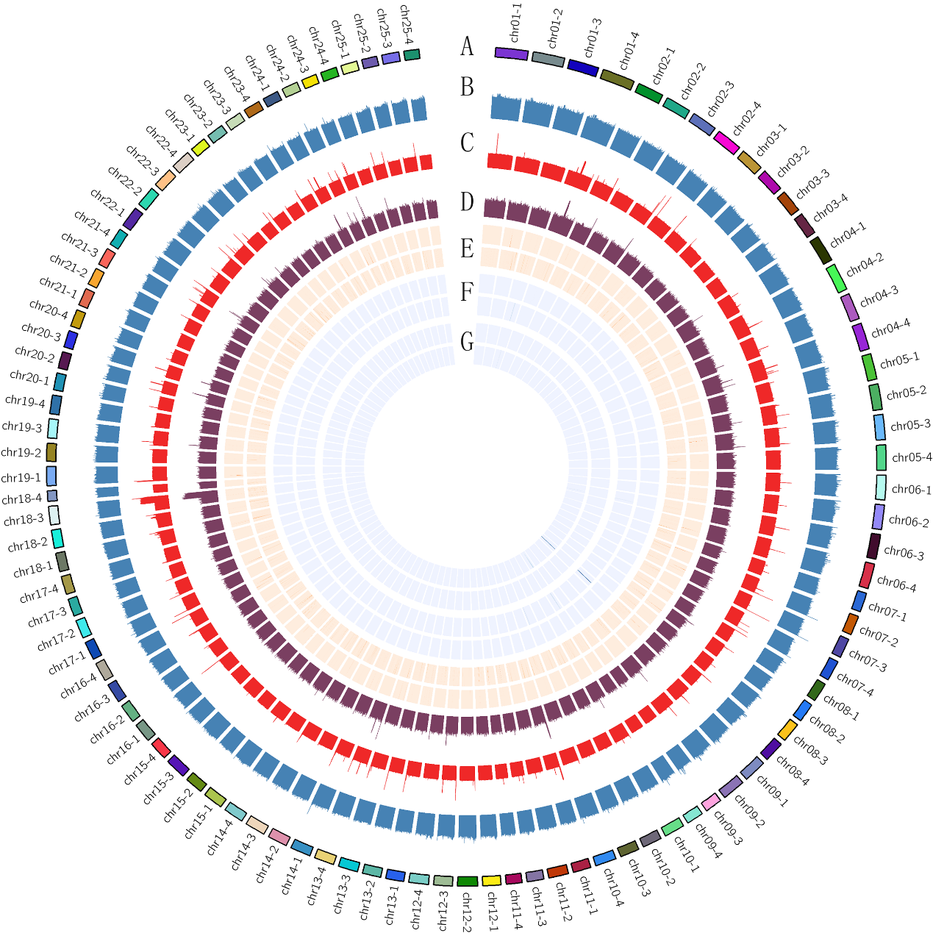
Fig. s8. Genome assembly evaluation. Genome information (A), GC content distribution (B), Short-read depth distribution (C), Long-read depth distribution (D), Distribution of complete BUSCO genes on the genome, with single-copy BUSCOs in the outer ring and duplicated BUSCOs in the inner ring (E), Homozygous snp density distribution in the outer ring and heterozygous snp density distribution in the inner ring (F), Homozygous indel density distribution in the outer ring and heterozygous indel density distribution in the inner ring (G).
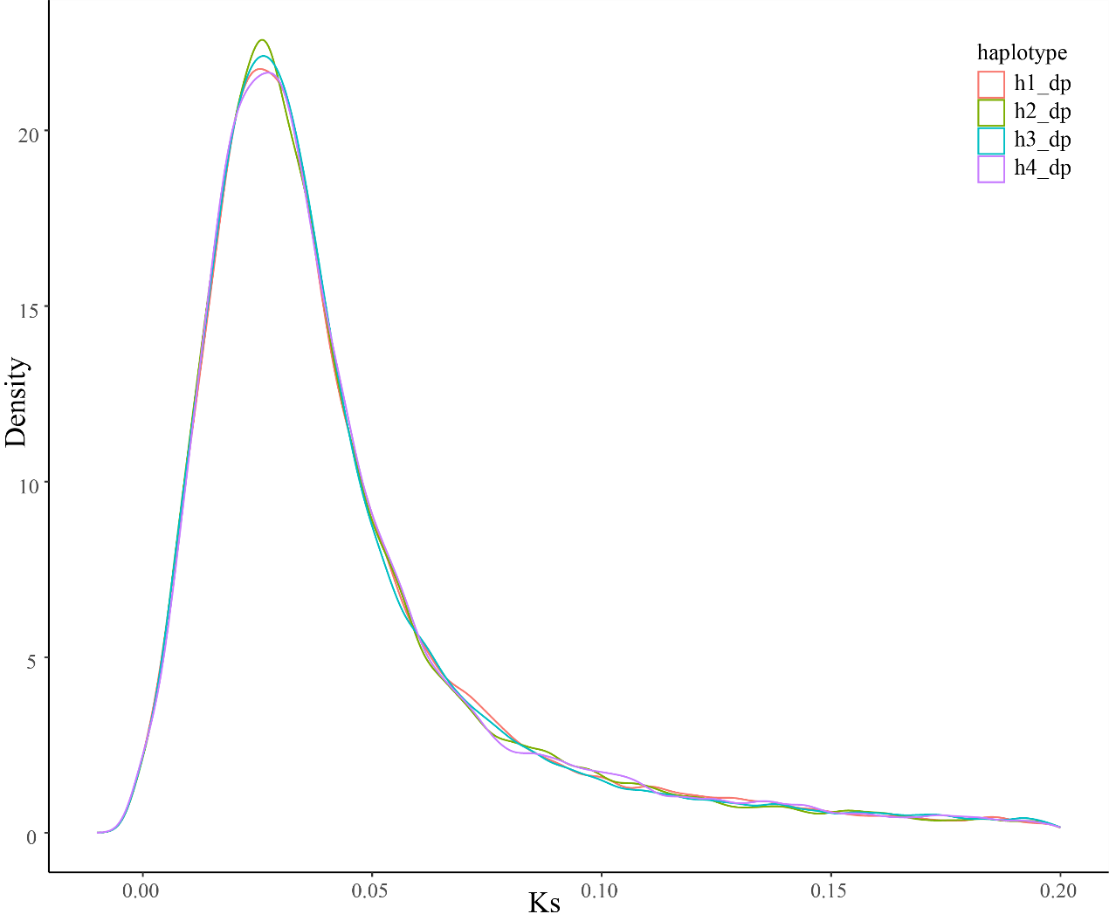
Fig. s9. Evaluated the degree of differentiation between haplotypes 1-4 and diploid loach through Ks analysis. Distribution of synonymous substitution rates (Ks) between haplotypes 1-4 and diploid. Numbers at distribution peaks indicate median Ks values.

Fig. s10. Haplotype structural variation detection. h1, h2, h3 and h4 indicated the four haplotypes.

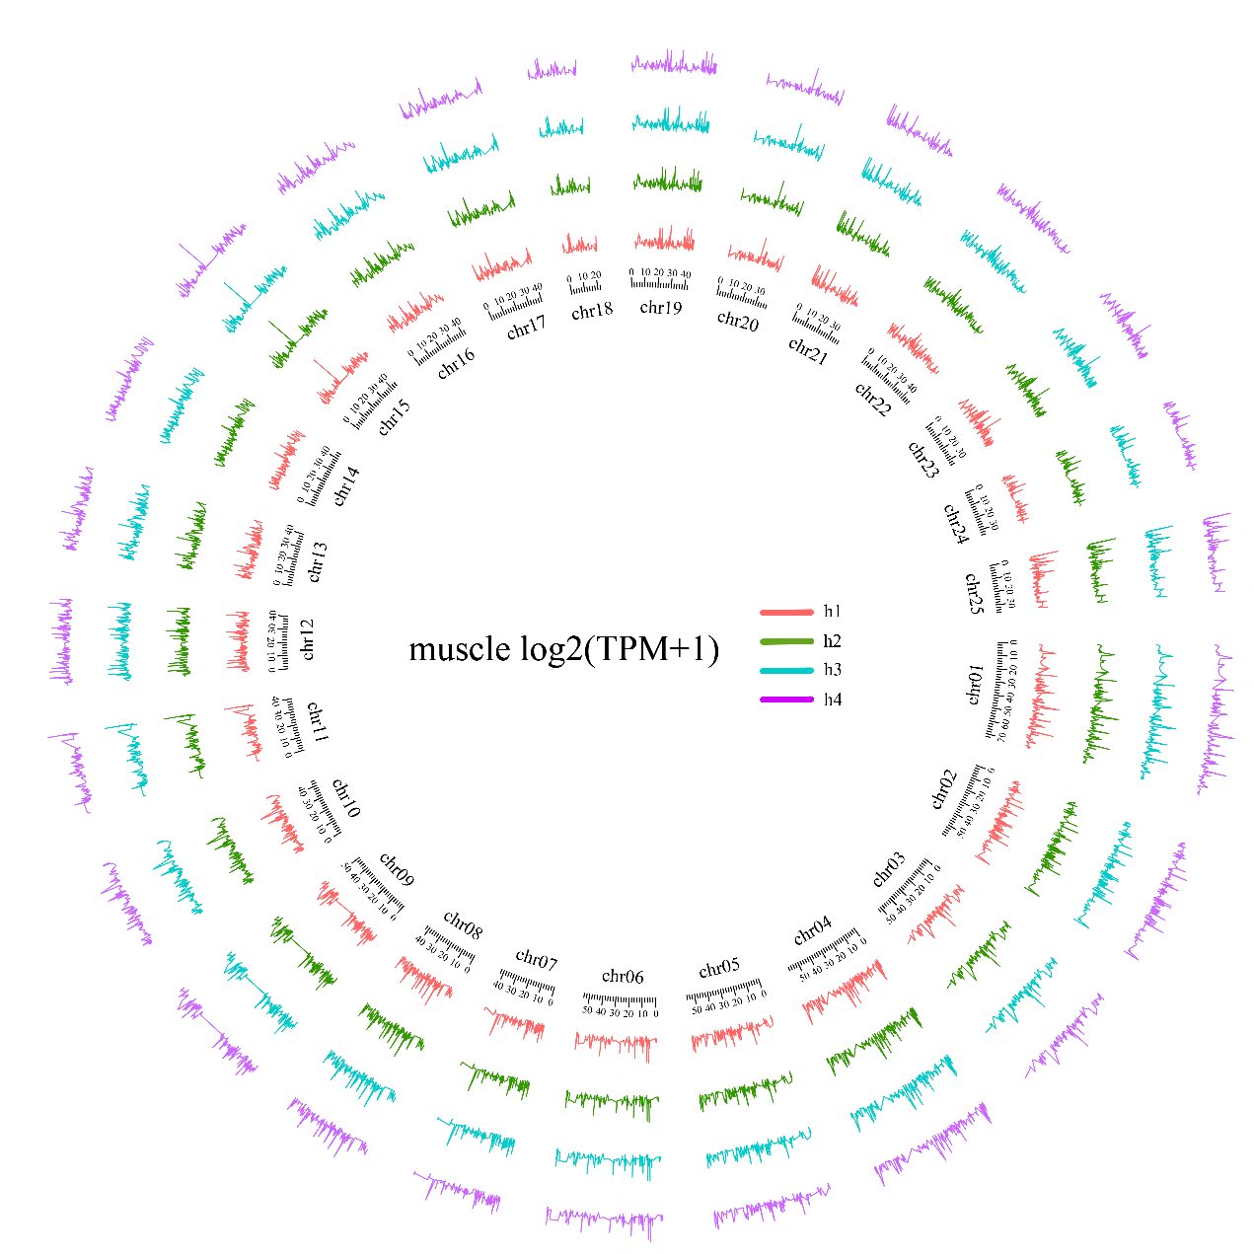
Fig. s11. Circos plot of the haplotype1-4 (h1-h4) transcript expression in female muscle. The circos plot showing the expression level of four haplotypes’ homologous alleles in each 10 kb window, different colors representing different haplotypes, h1 as a scale in Circos. with three biological replicates of each sample, the average of three replicates was considered the expression value of the gene. h1, h2, h3 and h4 indicated the four haplotypes.

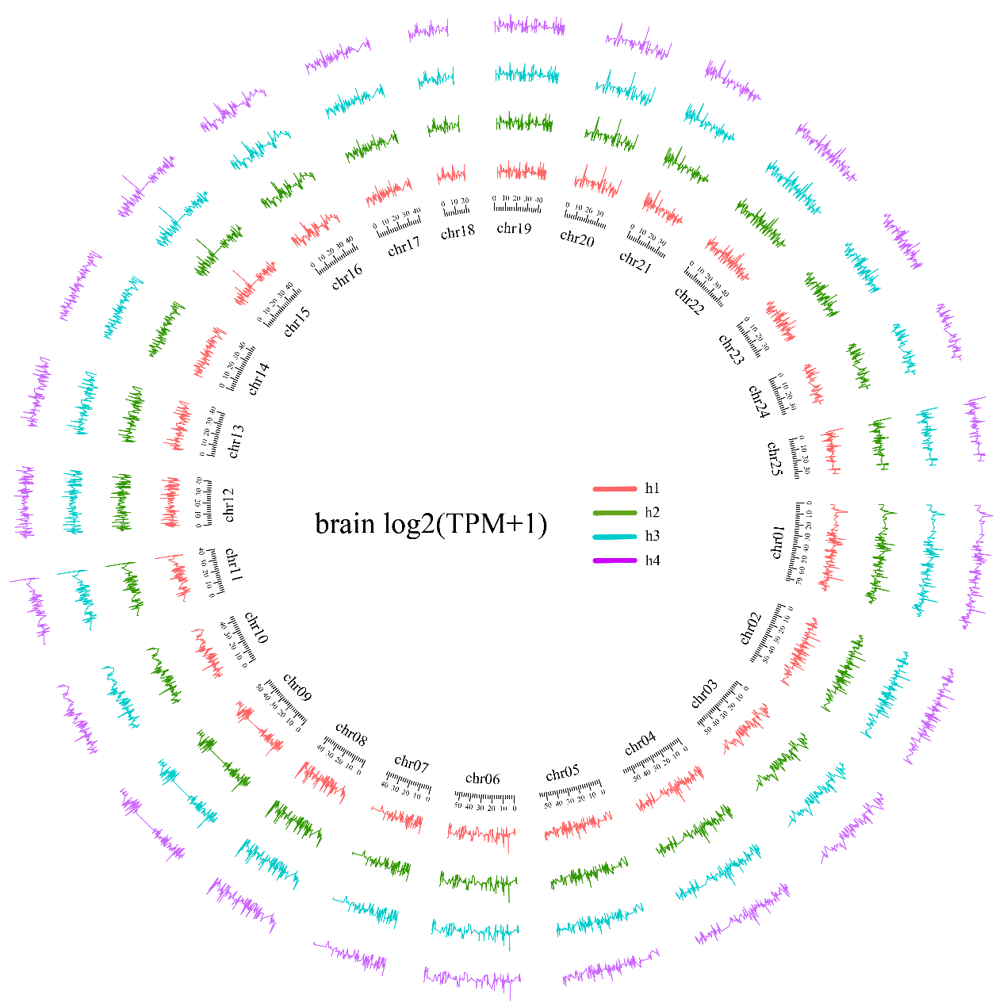
Fig. s12. Circos plot of the haplotype1-4 (h1-h4) transcript expression in female brain. The circos plot showing the expression level of four haplotypes’ homologous alleles in each 10 kb window, different colors representing different haplotypes, h1 as a scale in Circos. with three biological replicates of each sample, the average of three replicates was considered the expression value of the gene. h1, h2, h3 and h4 indicated the four haplotypes.

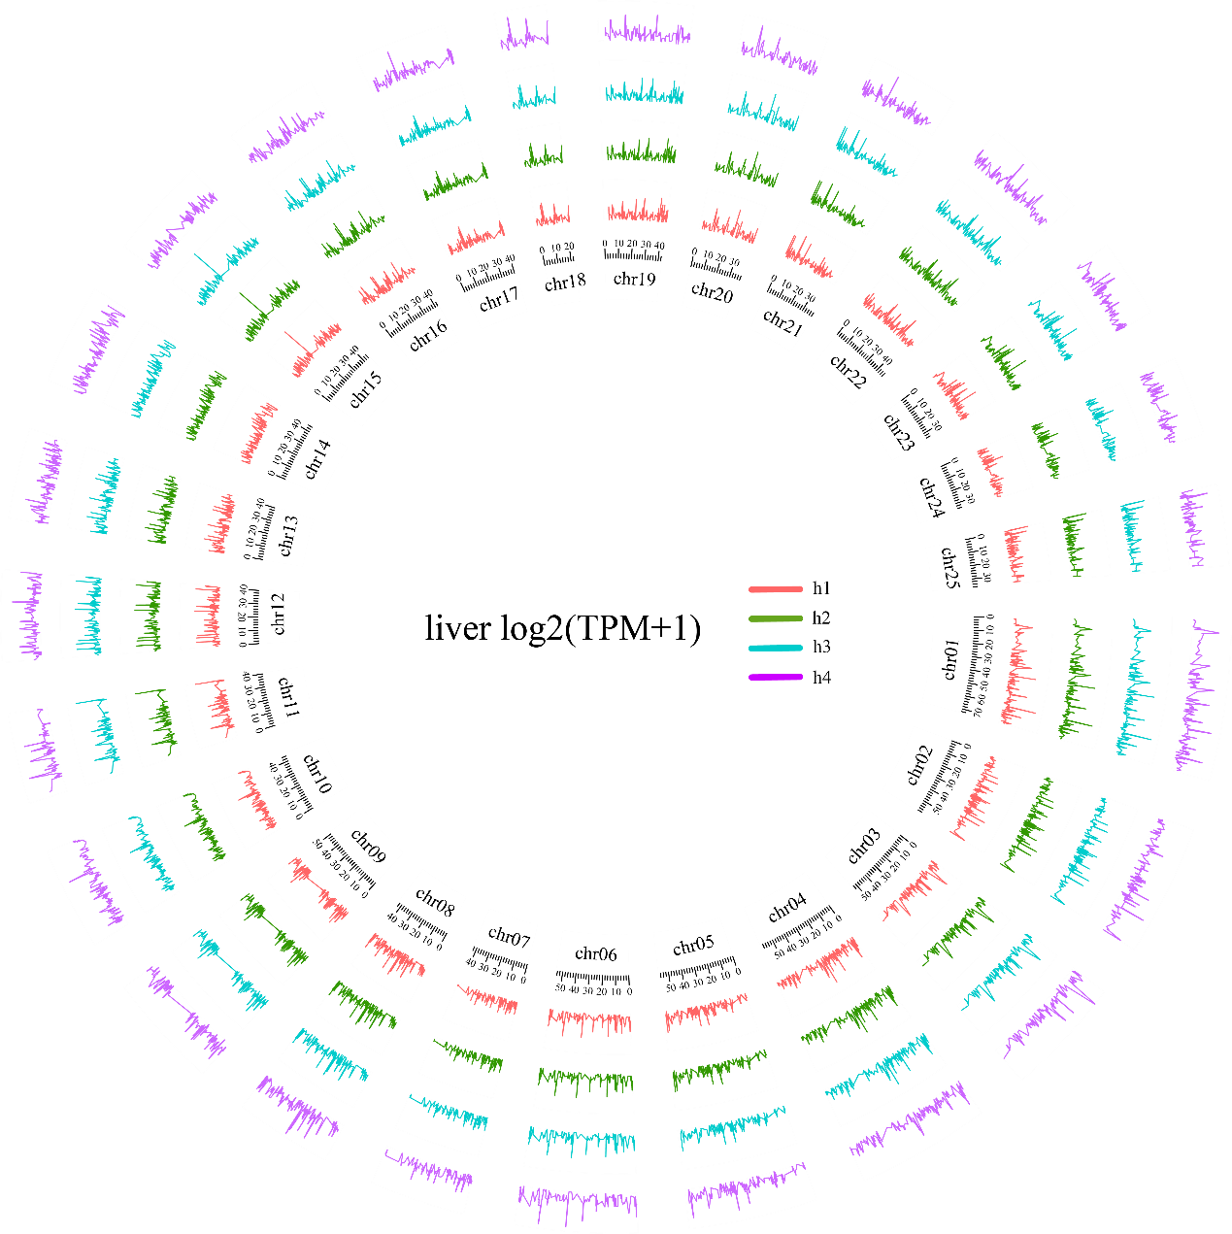
Fig. s13. Circos plot of the haplotype1-4 (h1-h4) transcript expression in female liver. The circos plot showing the expression level of four haplotypes’ homologous alleles in each 10 kb window, different colors representing different haplotypes, h1 as a scale in Circos. with three biological replicates of each sample, the average of three replicates was considered the expression value of the gene. h1, h2, h3 and h4 indicated the four haplotypes.

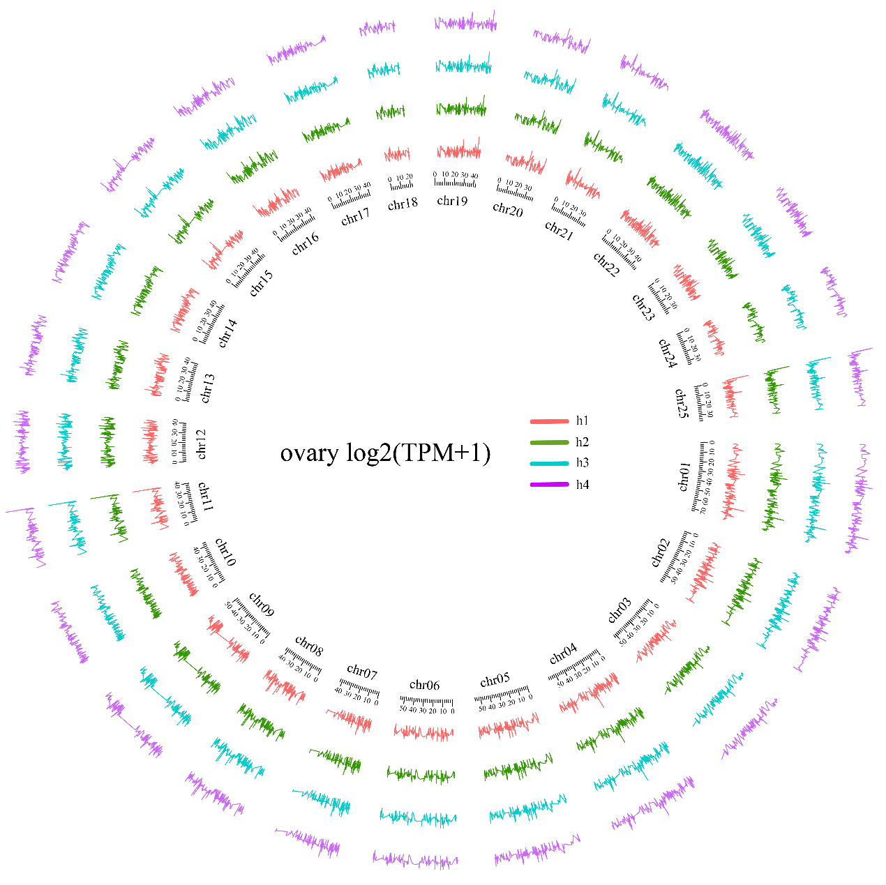 Fig. s14. Circos plot of the haplotype1-4 (h1-h4) transcript expression in female ovary. The circos plot showing the expression level of four haplotypes’ homologous alleles in each 10 kb window, different colors representing different haplotypes, h1 as a scale in Circos. with three biological replicates of each sample, the average of three replicates was considered the expression value of the gene. h1, h2, h3 and h4 indicated the four haplotypes.

