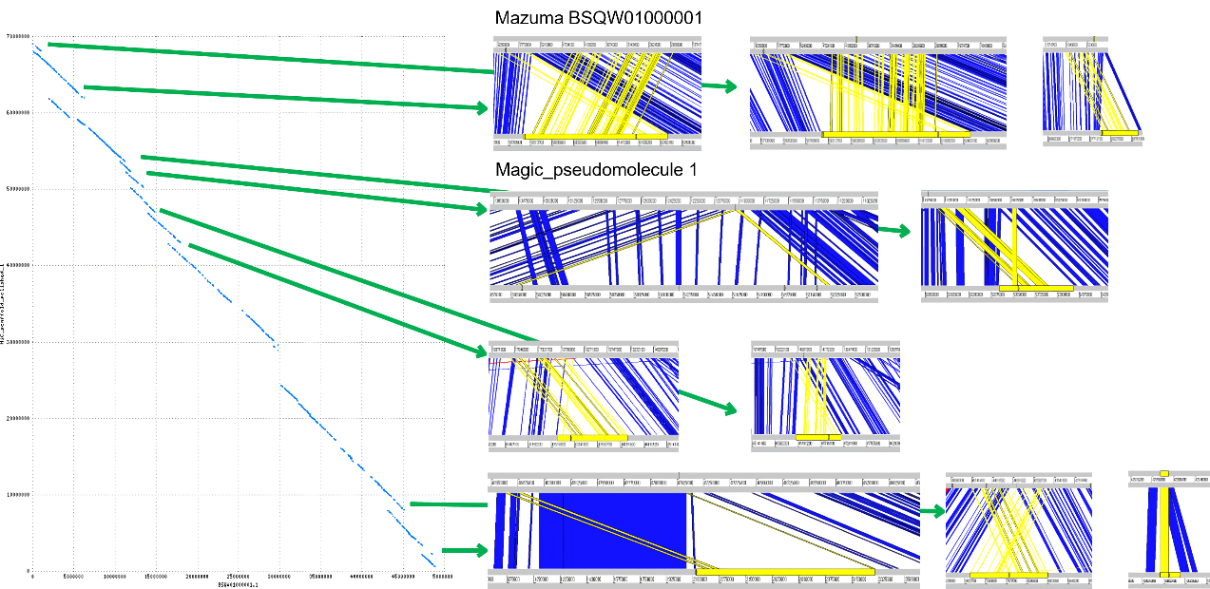
Supplementary Figure 1a

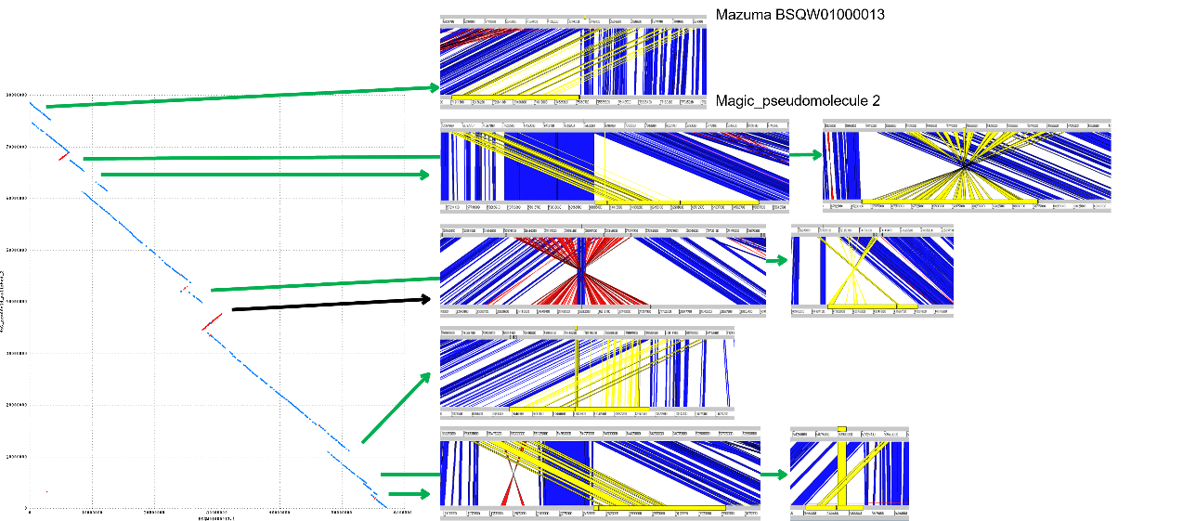
Supplementary Figure 1b

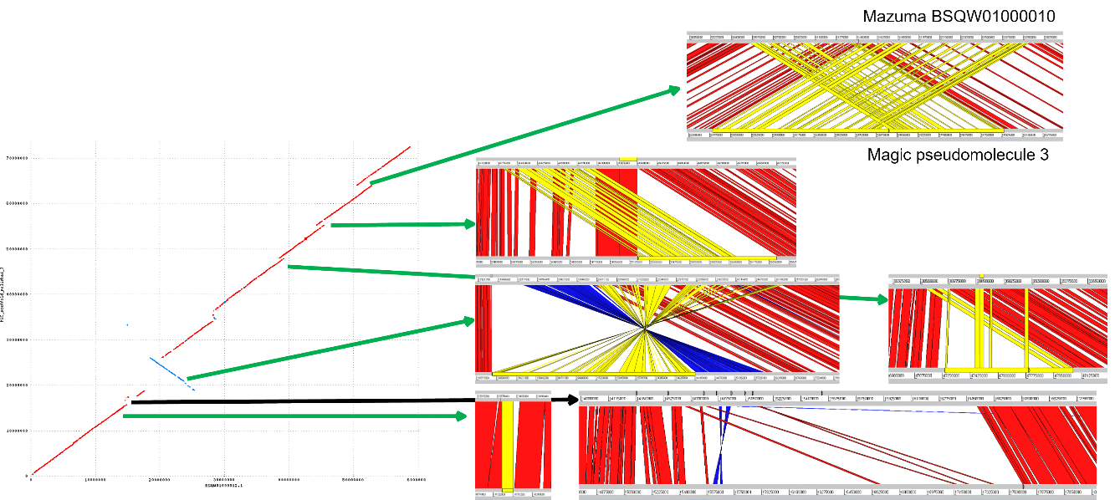
Supplementary Figure 1c

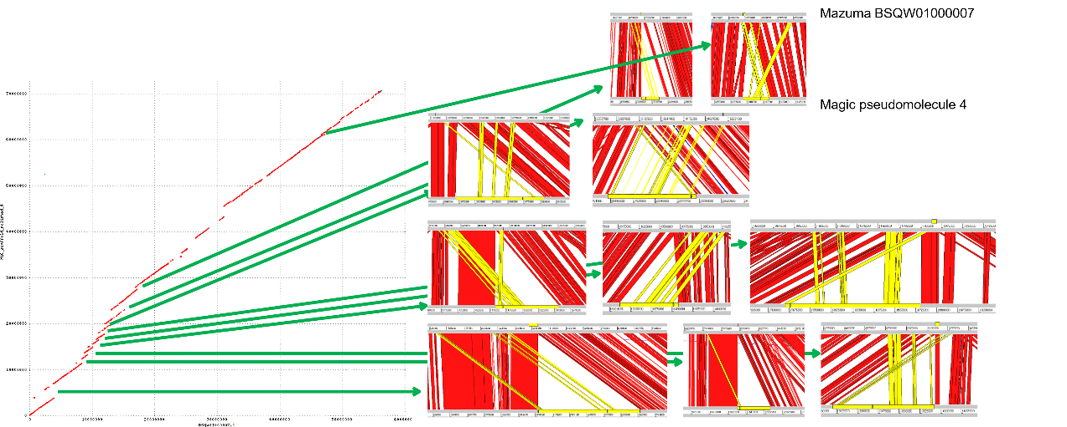
Supplementary Figure 1d

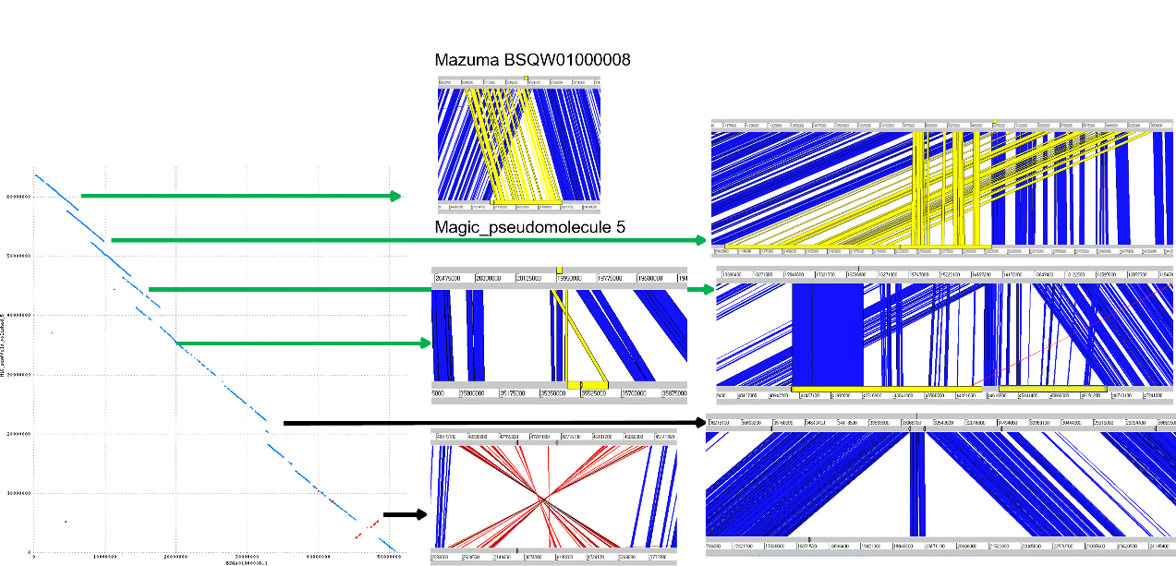
Supplementary Figure 1e

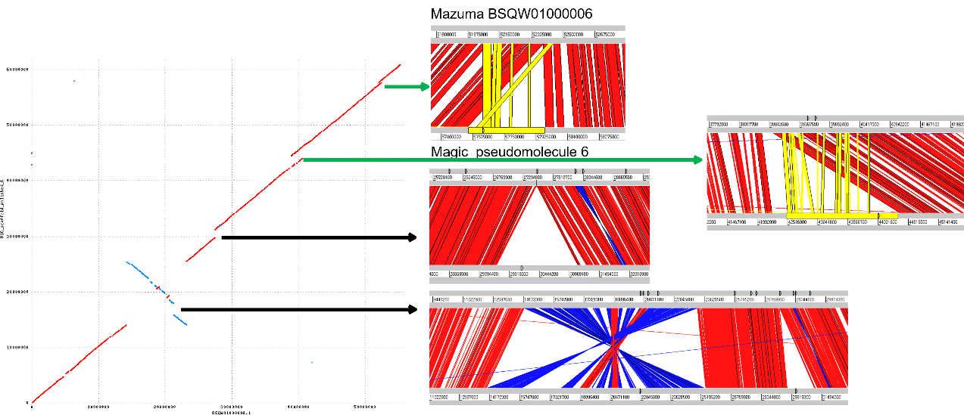
Supplementary Figure 1f

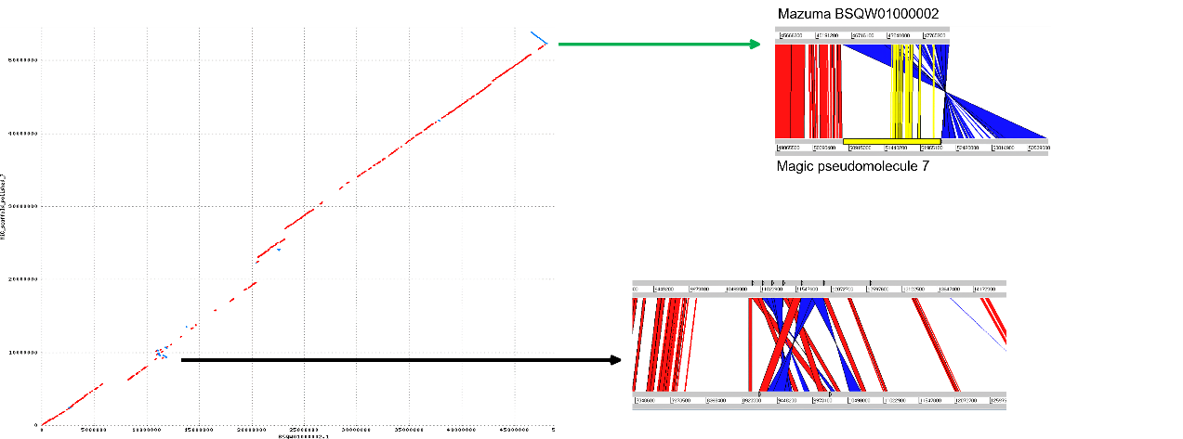
Supplementary Figure 1g

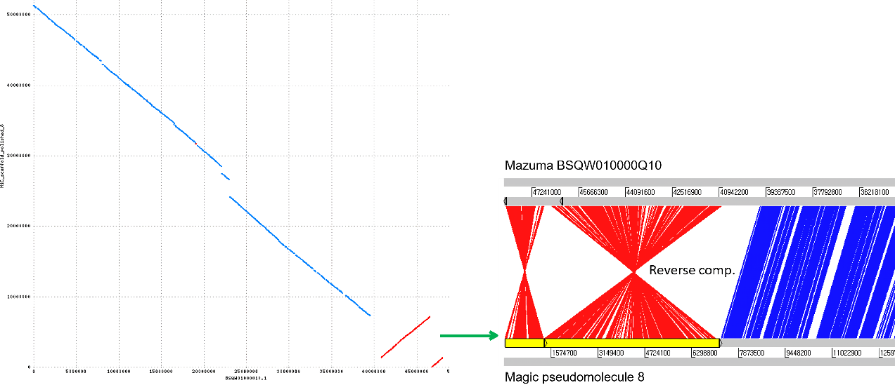
Supplementary Figure 1h

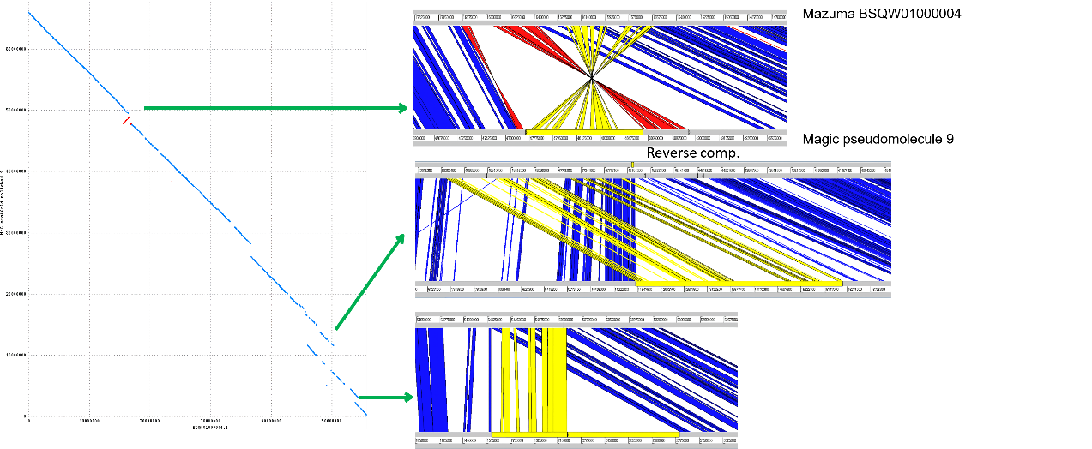
Supplementary Figure 1i

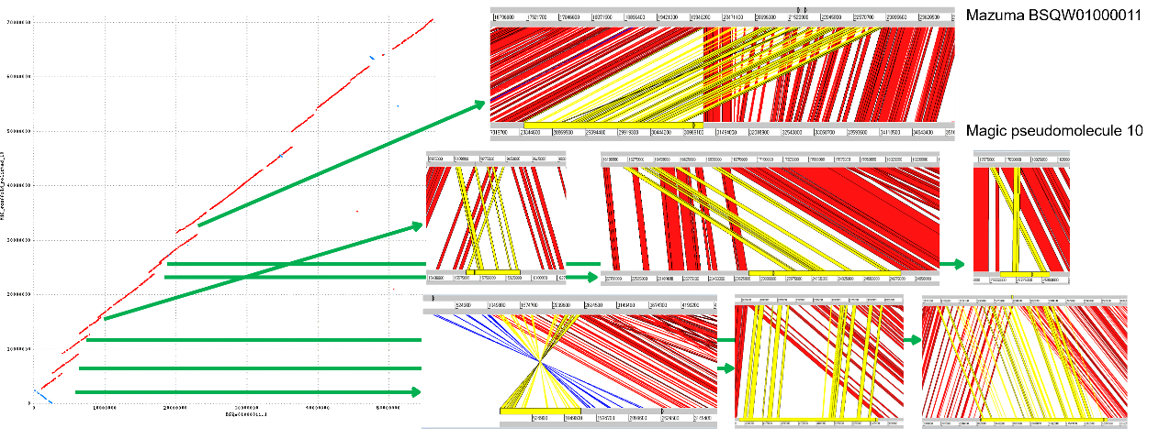
Supplementary Figure 1j

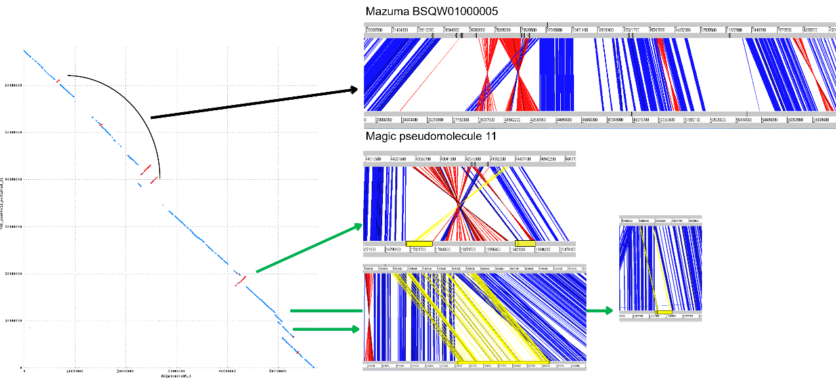
Supplementary Figure 1k

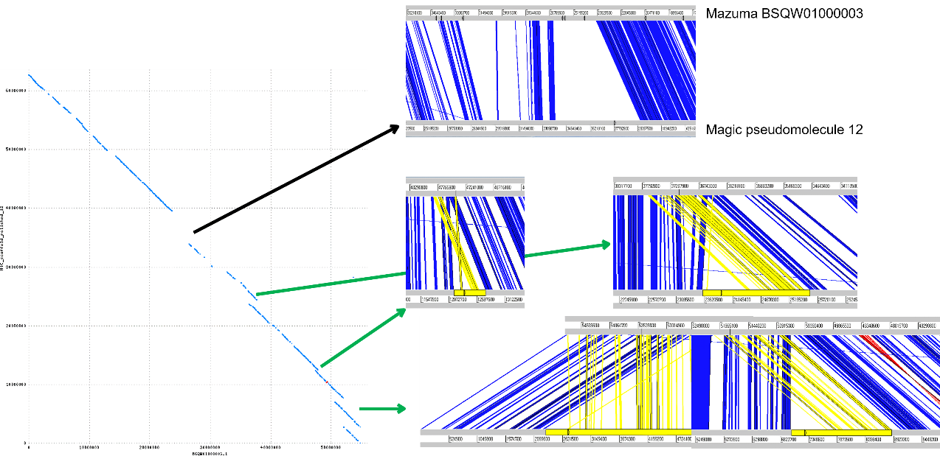
Supplementary Figure 1l

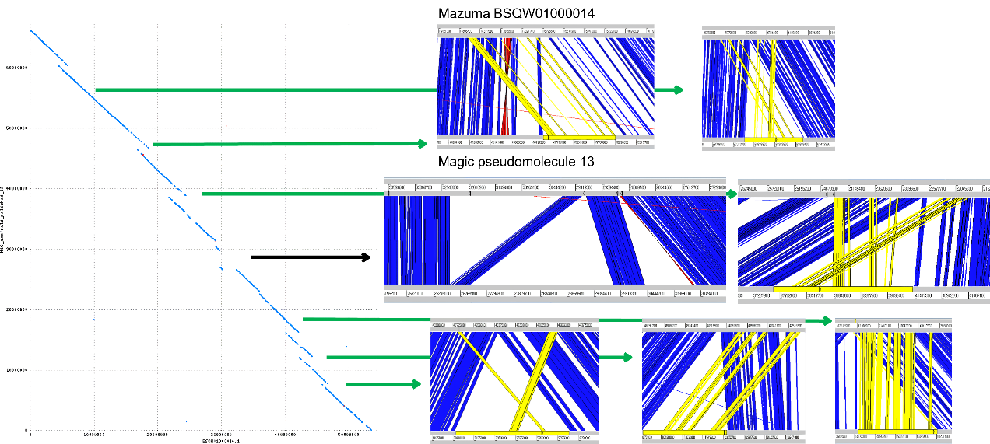
Supplementary Figure 1m

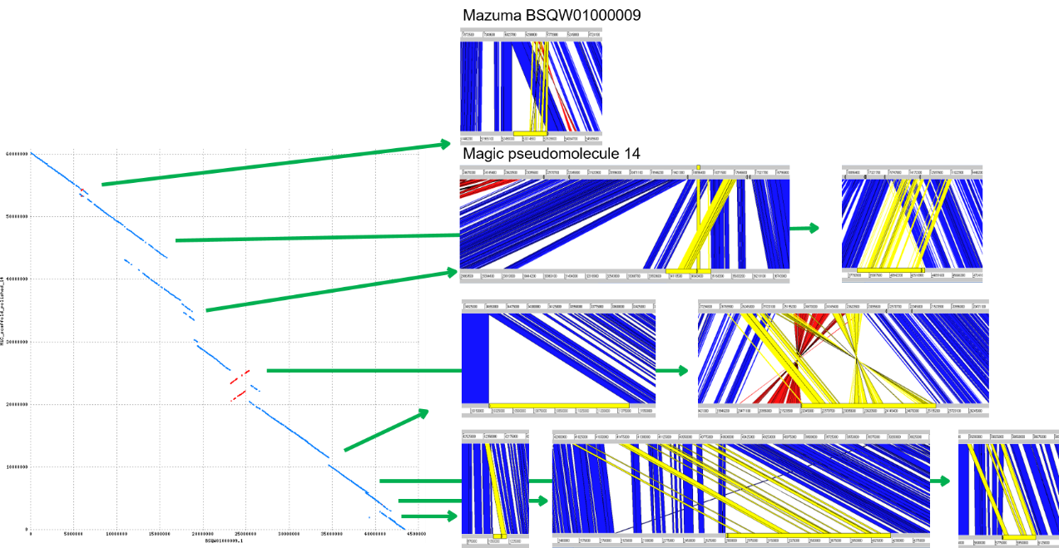
Supplementary Figure 1n

Supplementary Figure 1 a-n. The comparison of sequences between E. japonicum cultivars 'Mazuma' and 'Magic' identified and removed an unnecessary inserted region around the assembly gap in the pseudomolecule of ‘Magic.’ In the dot plot on the left, the horizontal axis represents the assembly of 'Mazuma,' while the vertical axis represents the assembly area of 'Magic.' Overlapping regions, which were unnecessarily duplicated, are indicated by green arrows on the right. The top section of the ACT comparison on the right shows the chromosome of 'Mazuma', while the bottom section shows the pseudomolecule of 'Magic.' The yellow lines highlight the sequences that were removed. Each section, labeled (a)-(n), corresponds to specific chromosomes within the diagram. This process helps in refining the genome assembly by removing redundant sequences, improving the accuracy and quality of the 'Magic' assembly.

Table S1 Based on Nucmer dotplot and ACT comparison results, several unnecessary sequences were identified and removed from various pseudomolecules in the E. japonicum genome assembly. The total length of the removed sequences is 119,469,484 bp. This cleanup process helps in refining the genome assembly by eliminating redundant or misassembled regions, thus improving the overall quality and accuracy of the assembly.
No | Start | End | Length
Pseudomolecule1_1 | 2,120,247 | 3,305,651 | 1,185,405
Pseudomolecule1_2 | 6,968,092 | 8,932,830 | 1,964,739
Pseudomolecule1_3 | 10,853,790 | 10,909,198 | 55,409
Pseudomolecule1_4 | 29,431,162 | 30,146,866 | 715,705
Pseudomolecule1_5 | 42,645,252 | 44,250,236 | 1,604,985
Pseudomolecule1_6 | 46,132,296 | 47,207,432 | 1,075,137
Pseudomolecule1_7 | 50,112,461 | 52,290,842 | 2,178,382
Pseudomolecule1_8 | 53,405,760 | 54,039,586 | 633,827
Pseudomolecule1_9 | 59,141,038 | 62,659,406 | 3,518,369
Pseudomolecule1_10 | 67,972,537 | 68,715,735 | 743,199
Pseudomolecule2_1 | 2,528,103 | 3,544,712 | 1,016,610
Pseudomolecule2_2 | 4,564,821 | 5,029,495 | 464,675
Pseudomolecule2_3 | 9,350,031 | 13,004,601 | 3,654,571
Pseudomolecule2_4 | 41,872,816 | 44,224,672 | 2,351,857
Pseudomolecule2_5 | 61,007,008 | 65,250,256 | 4,243,249
Pseudomolecule2_6 | 67,294,251 | 68,814,801 | 1,520,551
Pseudomolecule2_7 | 71,885,168 | 75,269,662 | 3,384,495
Pseudomolecule3_1 | 14,158,480 | 14,192,029 | 33,550
Pseudomolecule3_2 | 18,772,615 | 24,178,361 | 5,405,747
Pseudomolecule3_3 | 47,267,353 | 48,071,675 | 804,323
Pseudomolecule3_4 | 55,188,403 | 56,426,939 | 1,238,537
Pseudomolecule3_5 | 62,497,724 | 64,956,172 | 2,458,449
Pseudomolecule4_1 | 3,753,749 | 6,903,797 | 3,150,049
Pseudomolecule4_2 | 11,308,378 | 12,258,124 | 949,747
Pseudomolecule4_3 | 13,084,425 | 13,954,570 | 870,146
Pseudomolecule4_4 | 14,751,911 | 15,447,194 | 695,284
Pseudomolecule4_5 | 16,006,810 | 16,506,929 | 500,120
Pseudomolecule4_6 | 17,628,779 | 18,772,004 | 1,143,226
Pseudomolecule4_7 | 19,035,901 | 20,001,805 | 965,905
Pseudomolecule4_8 | 20,927,876 | 23,025,475 | 2,097,600
Pseudomolecule4_9 | 27,473,693 | 28,042,921 | 569,229
Pseudomolecule4_10 | 60,851,737 | 61,155,800 | 304,064
Pseudomolecule5_1 | 35,467,865 | 35,641,986 | 174,121
Pseudomolecule5_2 | 41,210,831 | 44,558,199 | 3,347,368
Pseudomolecule5_3 | 45,312,075 | 46,599,833 | 1,287,758
Pseudomolecule5_4 | 51,025,907 | 52,987,832 | 1,961,925
Pseudomolecule5_5 | 57,653,653 | 59,318,037 | 1,664,384
Pseudomolecule6_1 | 42,520,277 | 44,475,371 | 1,955,094
Pseudomolecule6_2 | 57,544,453 | 57,979,002 | 434,549
Pseudomolecule7_1 | 50,814,860 | 52,270,357 | 1,455,497
Pseudomolecule8_1 | 1 | 1,335,186 | Reverse_complement
Pseudomolecule8_2 | 1,335,687 | 7,212,579 | Reverse_complement
Pseudomolecule9_1 | 1,607,877 | 3,011,709 | 1,403,833
Pseudomolecule9_2 | 11,500,499 | 16,169,504 | 4,669,006
Pseudomolecule9_3_1 | 47,733,801 | 48,617,510 | 883,710
Pseudomolecule9_3_2 | 48,617,511 | 48,945,240 | Reverse comp.
Pseudomolecule9_3_3 | 48,945,241 | 49,526,826 | 581,586
Pseudomolecule10_1_1 | 1 | 1,310,681 | 1,310,681
Pseudomolecule10_1_2 | 1,310,682 | 2,626,203 | Reverse comp.
Pseudomolecule10_2 | 4,122,510 | 5,511,832 | 1,389,323
Pseudomolecule10_3 | 9,034,212 | 12,658,814 | 3,624,603
Pseudomolecule10_4 | 15,666,088 | 16,013,729 | 347,642
Pseudomolecule10_5 | 23,713,001 | 24,764,211 | 1,051,211
Pseudomolecule10_6 | 25,613,429 | 25,959,105 | 345,677
Pseudomolecule10_7 | 28,386,154 | 31,293,502 | 2,907,349
Pseudomolecule11_1 | 6,402,992 | 9,713,564 | 3,310,573
Pseudomolecule11_2 | 11,196,582 | 11,751,366 | 554,785
Pseudomolecule11_3_1 | 17,226,383 | 17,794,707 | 568,325
Pseudomolecule11_3_2 | 17,794,708 | 19,406,486 | Reverse comp.
Pseudomolecule11_3_3 | 19,406,487 | 19,941,618 | 535,132
Pseudomolecule12_1 | 2,282,516 | 5,109,183 | 2,826,667
Pseudomolecule12_2 | 7,007,278 | 8,881,120 | 1,873,842
Pseudomolecule12_3 | 12,158,555 | 12,765,404 | 606,849
Pseudomolecule12_4 | 23,579,305 | 25,585,279 | 2,005,974
Pseudomolecule13_1 | 7,013,414 | 7,977,925 | 964,512
Pseudomolecule13_2 | 10,012,067 | 12,180,970 | 2,168,904
Pseudomolecule13_3 | 14,228,158 | 16,294,906 | 2,066,749
Pseudomolecule13_4 | 37,646,653 | 40,404,282 | 2,757,630
Pseudomolecule13_5 | 46,459,372 | 48,287,179 | 1,827,808
Pseudomolecule13_6 | 59,601,080 | 61,078,952 | 1,477,873
Pseudomolecule14_1 | 1,088,898 | 1,208,280 | 119,383
Pseudomolecule14_2 | 2,799,955 | 4,193,295 | 1,393,341
Pseudomolecule14_3 | 5,834,211 | 6,113,577 | 279,367
Pseudomolecule14_4 | 10,302,101 | 11,480,310 | 1,178,210
Pseudomolecule14_5 | 22,059,928 | 25,437,397 | 3,377,470
Pseudomolecule14_6 | 34,027,343 | 35,184,160 | 1,156,818
Pseudomolecule14_7 | 38,450,664 | 43,689,063 | 5,238,400
Pseudomolecule14_8 | 52,750,300 | 53,638,713 | 888,414
Total removed length |  |  | 119,469,484

Table S2 The comparison of final assembly statistics between the 'Mazuma' and 'Magic' varieties of E. japonicum shows that 'Magic' has a total genome length of 794,581,038 bp with a GC content of 38.2% and 49,000 N bases. 'Mazuma' has a shorter genome length of 746,491,570 bp, the same GC content of 38.2%, but more N bases at 89,000. 'Magic' generally has longer chromosomes with fewer gaps compared to 'Mazuma,' indicating a more complete and contiguous assembly.

Magic | length | GC | N | Mazuma | length | GC | N
chr1_A1 | 55,369,015 | 37.9 | 5,500 | chr1_A1 | 49,153,602 | 37.8 | 6,000
chr1_B1 | 55,240,842 | 37.9 | 5,000 | chr1_B1 | 50,855,574 | 37.9 | 5,500
chr2_A1 | 52,381,477 | 38.1 | 1,500 | chr2_A1 | 48,156,547 | 38.3 | 12,000
chr2_B1 | 46,563,067 | 38.1 | 4,500 | chr2_B1 | 43,458,156 | 38.1 | 3,500
chr3_A1 | 55,381,966 | 38.3 | 3,000 | chr3_A1 | 54,892,164 | 38.3 | 4,000
chr3_B1 | 51,309,188 | 38.1 | 1,000 | chr3_B1 | 48,159,580 | 38 | 6,000
chr4_A1 | 58,487,512 | 38.2 | 3,000 | chr4_A1 | 55,987,404 | 38.2 | 4,000
chr4_B1 | 60,079,781 | 38.5 | 3,500 | chr4_B1 | 56,882,097 | 38.5 | 6,000
chr5_A1 | 62,492,898 | 38.1 | 2,500 | chr5_A1 | 57,422,630 | 38.1 | 8,500
chr5_B1 | 62,494,807 | 38.7 | 3,500 | chr5_B1 | 59,087,211 | 38.4 | 9,000
chr6_A1 | 58,458,533 | 38.1 | 2,500 | chr6_A1 | 55,289,133 | 38 | 8,500
chr6_B1 | 61,909,718 | 38.3 | 4,000 | chr6_B1 | 57,173,498 | 38.2 | 8,000
chr7_A1 | 59,384,864 | 38.2 | 5,500 | chr7_A1 | 56,374,407 | 38.1 | 2,500
chr7_B1 | 55,027,370 | 38.2 | 4,000 | chr7_B1 | 53,599,567 | 38.4 | 5,500
Total | 794,581,038 | 38.2 | 49,000 |  | 746,491,570 | 38.2 | 89,000

