Table of Contents
Supplementary Figure 1. The training process of LAIDN. 2
Supplementary Figure 2. Spatial Distribution of Vegetation improvement or degradation from 2025 to 2050. 2
Supplementary Figure 3. Spatial Distribution of Vegetation improvement or degradation from 2050 to 2100. 3
Supplementary Figure 4. Vegetation Risk Area Distribution in China from 2025 to 2100. 3
Supplementary Figure 5. The result of attempting downscaling GPP. 4
Supplementary Figure 6. The result of attempting downscaling NPP. 5

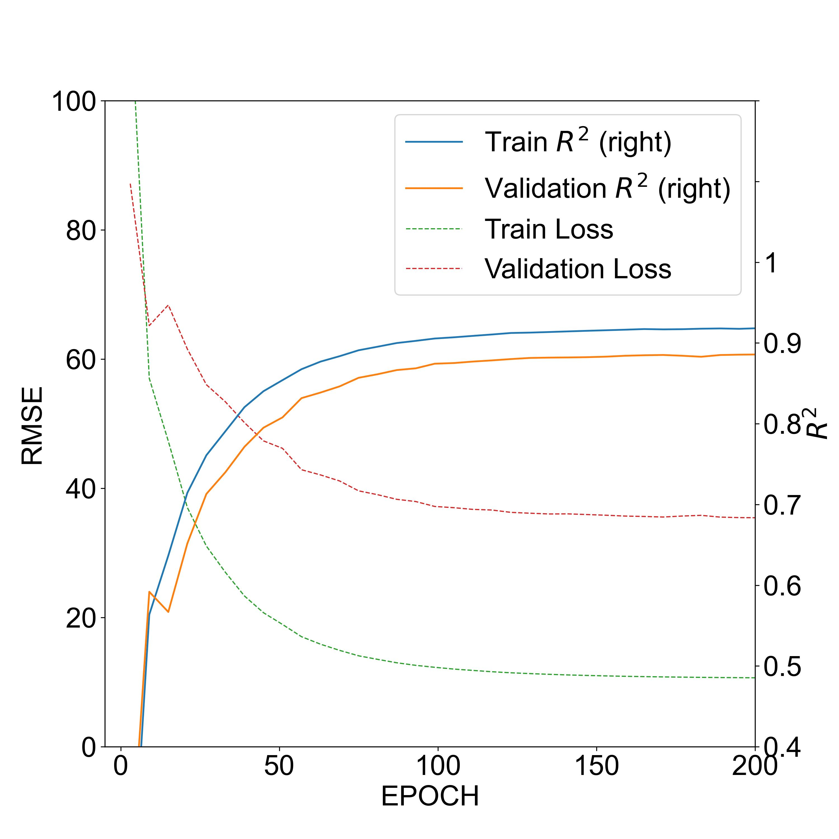
Supplementary Figure 1. The training process of LAIDN. All data has been smoothed by moving averaging of window 3. The x-axis represents the training process. The solid lines are the R² value through the training process, aligning to the right y-axis. The dotted lines are the Loss (MSE) value through the process, aligning to the left y-axis.
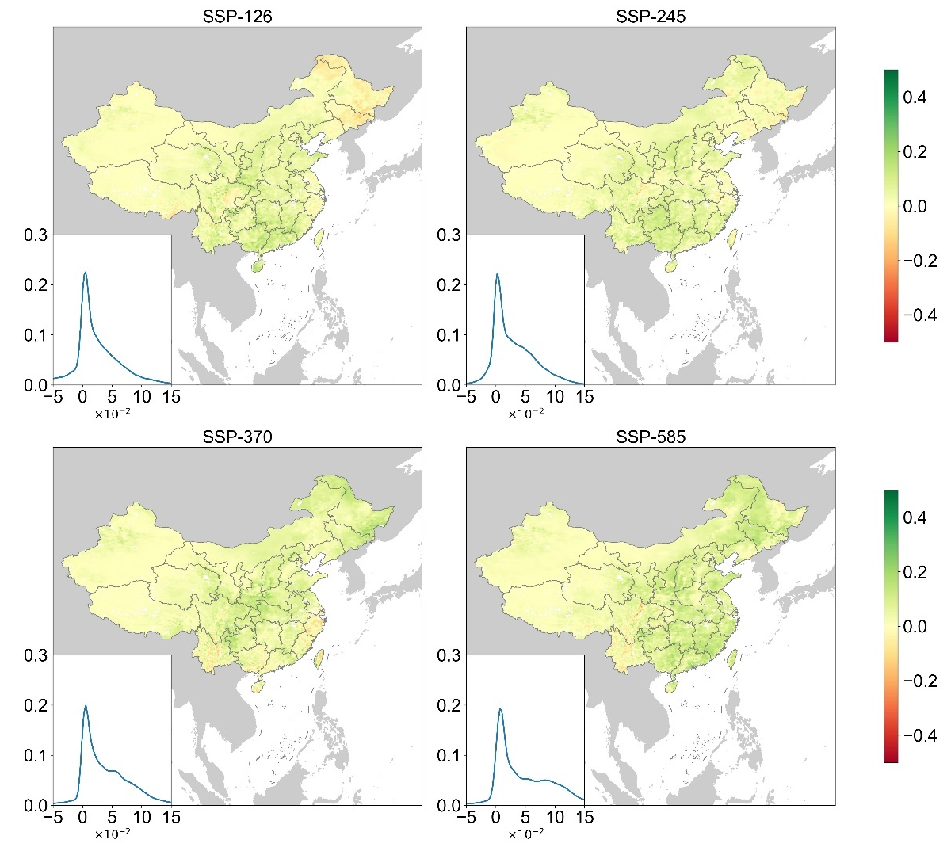
Supplementary Figure 2. Spatial Distribution of Vegetation improvement or degradation from 2025 to 2050. The scenario of each map is marked on the top of it. The smaller chart in the left-bottom corner is the KDE curve of increasing value. The green trend will be more significant if the peak locates righter.

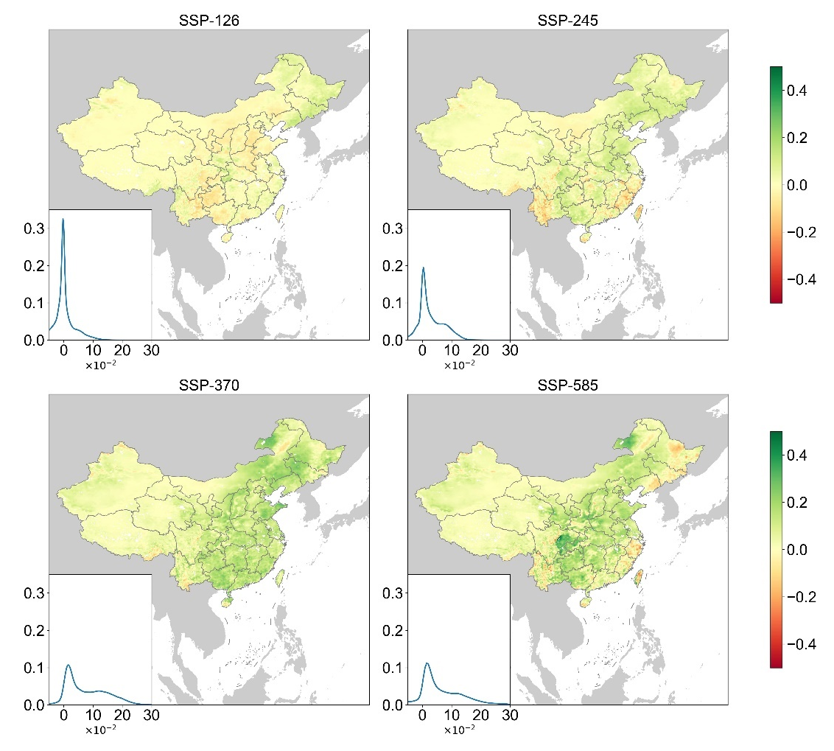
Supplementary Figure 3. Spatial Distribution of Vegetation improvement or degradation from 2050 to 2100. The scenario of each map is marked on the top of it. The smaller chart in the left-bottom corner is the KDE curve of increasing value. The green trend will be more significant if the peak locates righter.
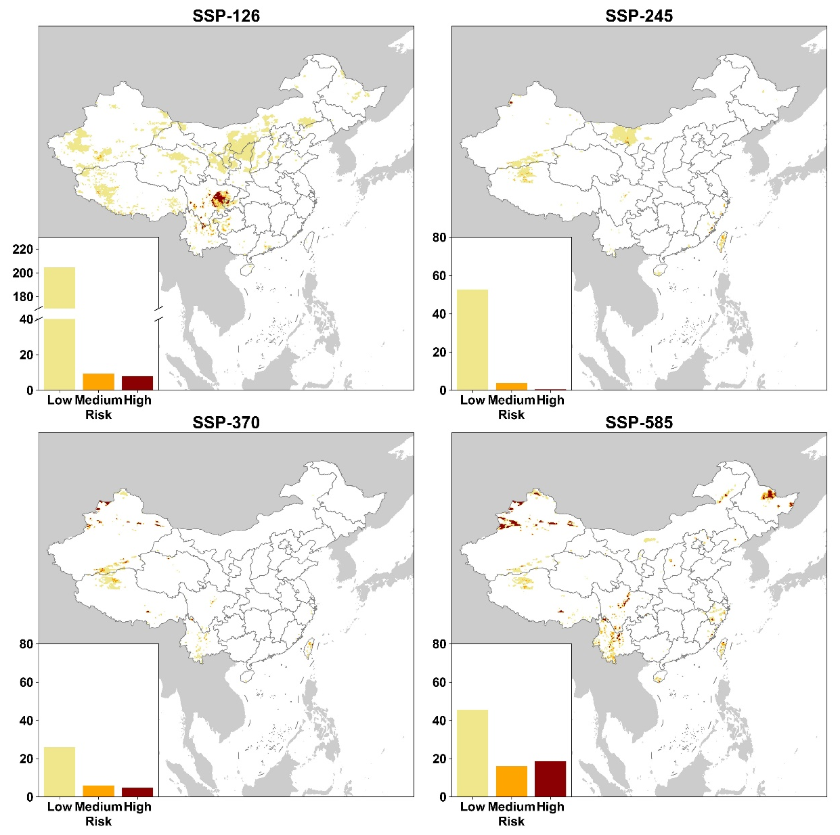
Supplementary Figure 4. Vegetation Risk Area Distribution in China from 2025 to 2100. Dark red represents high risk, orange represents medium risk, and yellow represents low risk. The smaller chart in the left-bottom corner is the area of each risk level in each scenario.
Supplementary Figure 5. The result of attempting downscaling GPP using LAIDN. All data are selected from the test set. The first row is the GPP data after downscaling, while the second row is the GLASS GPP data. The third row is the scatter plots which show the accuracy of downscaling. Each column is a representation of GPP in a season.
Supplementary Figure 6. The result of attempting downscaling NPP using LAIDN. All data are selected from the test set. The first row is the NPP data after downscaling, while the second row is the GLASS NPP data. The third row is the scatter plots which show the accuracy of downscaling. Each column is a representation of NPP in a season.

