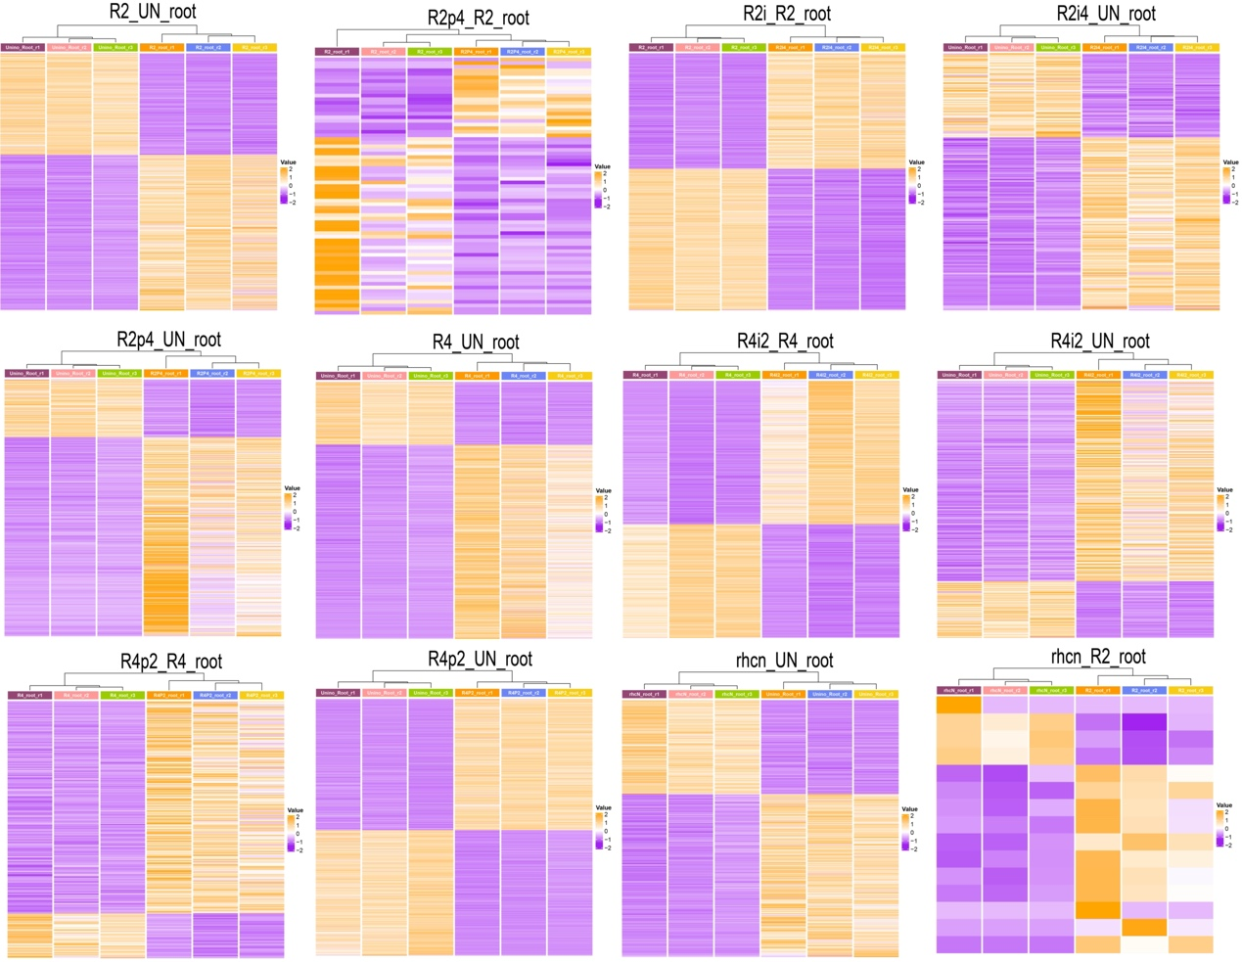
Supplementary Figure 1. The expression profiles of differentially expressed genes in uninoculated roots and roots inoculated with strains of Sinorhizobium fredii carrying different variants of NopI and NopP. The expression levels of genes [Log₂(FPKM+1)] were presented in different colors based on the color key. R2 and R4 are two wildtype strains of S. fredii with different host compatibilities. R2p4, R2 with NopP from R4 swapped in; R2i4, R2 with NopI from R4 swapped in; R4p2, R4 with NopP from R2 swapped in; R4i2, R4 with NopI from R2 swapped in; rhcN, R2 T3SS mutant; Unino/UN, uninoculated; r1, r2 and r3, biological replicates 1, 2 and 3.

