Table S1. Bowtie2 Alignment Rate of HaplotypA and HaplotypB.
 | Overall alignment rate | Unique alignments number (rate) | Multiple alignments number (rate) | PE unmapping | SE alignments | Aligned discordantly 1 time | Mates | Aligned 0 times
HapA | 97.11% | 119131798 (60.14%) | 63438481 (32.03%) | 15513226 | 2955903 | 25112846 | 11460830 (45.64%) | 5294251 (21.08%)
HapB | 97.15% | 119243204 (60.20%) | 63445698 (32.03%) | 15393703 | 2951523 | 24884360 | 11296989 (45.40%) | 5276491 (21.20%)

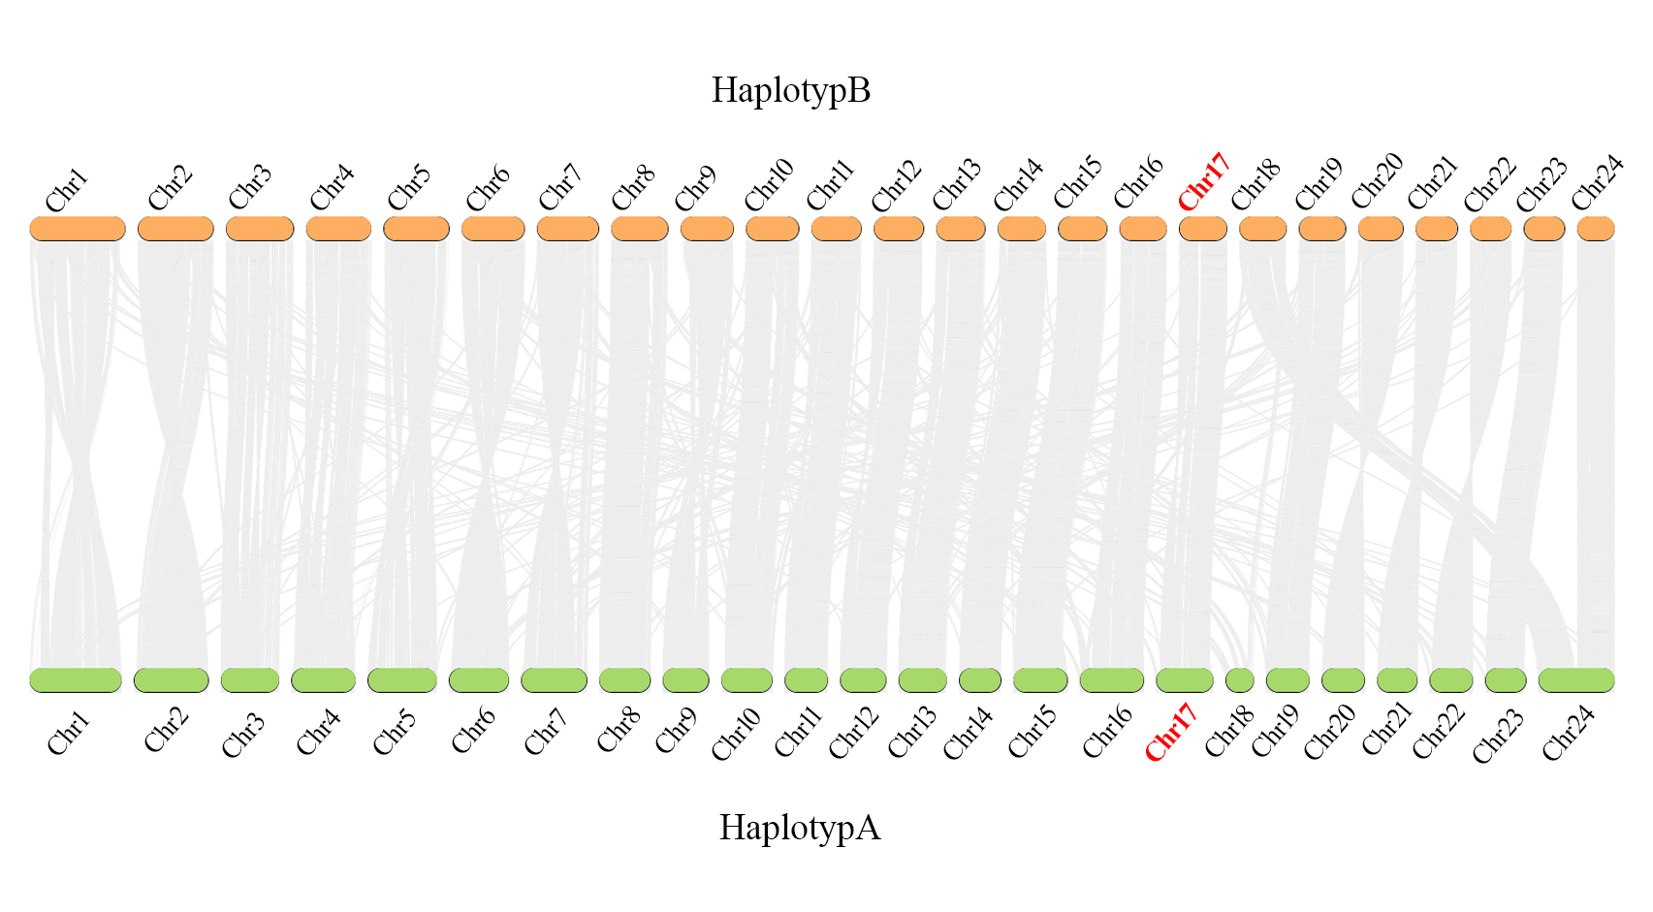
Figure S1. Haplotype A and Haplotype B chromosome-level genome collinearity analysis.

