Supplementary File

Appendix 1 Methods
Fig. S1 Taylor diagrams based on the outputs of DC downscaled results of five basic variables to compare the differences using simulation of 1991~2014 and 1991~2020. A. tas; B. tasmax; C. tasmin; D. pr; E. sunp.

Table S1 The evaluation of resampled results using three methods during DC downscaling
Variable | Model | Bilinear |  |  | Cubic spline |  |  | Thin-plate spline
Variable | Model | RMSE | MAE | R² | RMSE | MAE | R² | RMSE | MAE | R²
tas | ACCESS-CM2 | 0.125 | 0.075 | 0.984 | 0.125 | 0.075 | 0.984 | 0.125 | 0.075 | 0.984
tas | BCC-CSM2-MR | 0.128 | 0.078 | 0.984 | 0.127 | 0.077 | 0.984 | 0.128 | 0.078 | 0.984
tas | CMCC-ESM2 | 0.121 | 0.073 | 0.985 | 0.121 | 0.072 | 0.985 | 0.121 | 0.073 | 0.985
tas | GFDL-ESM4 | 0.126 | 0.077 | 0.984 | 0.126 | 0.077 | 0.984 | 0.126 | 0.078 | 0.984
tas | INM-CM5-0 | 0.123 | 0.071 | 0.985 | 0.123 | 0.071 | 0.985 | 0.123 | 0.072 | 0.985
tas | IPSL-CM6A-LR | 0.121 | 0.072 | 0.985 | 0.121 | 0.072 | 0.985 | 0.122 | 0.072 | 0.985
tas | MIROC6 | 0.122 | 0.073 | 0.985 | 0.122 | 0.072 | 0.985 | 0.122 | 0.073 | 0.985
tas | MPI-ESM1-2-HR | 0.122 | 0.072 | 0.985 | 0.122 | 0.072 | 0.985 | 0.122 | 0.072 | 0.985
tas | MRI-ESM2-0 | 0.122 | 0.073 | 0.985 | 0.122 | 0.073 | 0.985 | 0.122 | 0.073 | 0.985
tas | Ensemble | 0.119 | 0.067 | 0.986 | 0.118 | 0.067 | 0.986 | 0.119 | 0.067 | 0.986
tasmax | ACCESS-CM2 | 0.385 | 0.286 | 0.851 | 0.385 | 0.285 | 0.852 | 0.386 | 0.286 | 0.851
tasmax | BCC-CSM2-MR | 0.397 | 0.294 | 0.842 | 0.397 | 0.294 | 0.842 | 0.398 | 0.294 | 0.842
tasmax | CMCC-ESM2 | 0.372 | 0.274 | 0.862 | 0.372 | 0.274 | 0.862 | 0.372 | 0.274 | 0.862
tasmax | GFDL-ESM4 | 0.389 | 0.288 | 0.849 | 0.389 | 0.288 | 0.849 | 0.389 | 0.288 | 0.848
tasmax | INM-CM5-0 | 0.380 | 0.278 | 0.855 | 0.380 | 0.278 | 0.855 | 0.380 | 0.278 | 0.855
tasmax | IPSL-CM6A-LR | 0.371 | 0.270 | 0.862 | 0.371 | 0.270 | 0.862 | 0.371 | 0.270 | 0.862
tasmax | MIROC6 | 0.367 | 0.268 | 0.866 | 0.366 | 0.268 | 0.866 | 0.367 | 0.268 | 0.865
tasmax | MPI-ESM1-2-HR | 0.378 | 0.278 | 0.857 | 0.378 | 0.278 | 0.857 | 0.378 | 0.278 | 0.857
tasmax | MRI-ESM2-0 | 0.379 | 0.279 | 0.857 | 0.378 | 0.278 | 0.857 | 0.379 | 0.279 | 0.856
tasmax | Ensemble | 0.377 | 0.276 | 0.858 | 0.377 | 0.276 | 0.858 | 0.377 | 0.276 | 0.858
tasmin | ACCESS-CM2 | 0.211 | 0.154 | 0.955 | 0.211 | 0.154 | 0.956 | 0.211 | 0.154 | 0.955
tasmin | BCC-CSM2-MR | 0.207 | 0.150 | 0.957 | 0.207 | 0.149 | 0.957 | 0.207 | 0.150 | 0.957
tasmin | CMCC-ESM2 | 0.212 | 0.155 | 0.955 | 0.211 | 0.155 | 0.955 | 0.212 | 0.155 | 0.955
tasmin | GFDL-ESM4 | 0.212 | 0.155 | 0.955 | 0.212 | 0.155 | 0.955 | 0.213 | 0.155 | 0.955
tasmin | INM-CM5-0 | 0.212 | 0.153 | 0.955 | 0.212 | 0.153 | 0.955 | 0.212 | 0.153 | 0.955
tasmin | IPSL-CM6A-LR | 0.212 | 0.153 | 0.955 | 0.212 | 0.153 | 0.955 | 0.212 | 0.153 | 0.955
tasmin | MIROC6 | 0.211 | 0.154 | 0.955 | 0.211 | 0.153 | 0.955 | 0.211 | 0.154 | 0.955
tasmin | MPI-ESM1-2-HR | 0.206 | 0.150 | 0.957 | 0.206 | 0.150 | 0.957 | 0.206 | 0.150 | 0.957
tasmin | MRI-ESM2-0 | 0.210 | 0.152 | 0.956 | 0.210 | 0.152 | 0.956 | 0.210 | 0.152 | 0.956
tasmin | Ensemble | 0.209 | 0.151 | 0.957 | 0.209 | 0.151 | 0.957 | 0.209 | 0.151 | 0.957
pr | ACCESS-CM2 | 0.376 | 0.192 | 0.858 | 0.370 | 0.189 | 0.863 | 0.379 | 0.193 | 0.856
pr | BCC-CSM2-MR | 0.341 | 0.183 | 0.884 | 0.337 | 0.182 | 0.887 | 0.344 | 0.185 | 0.882
pr | CMCC-ESM2 | 0.372 | 0.192 | 0.862 | 0.370 | 0.191 | 0.863 | 0.374 | 0.193 | 0.860
pr | GFDL-ESM4 | 0.333 | 0.178 | 0.889 | 0.332 | 0.176 | 0.890 | 0.335 | 0.179 | 0.888
pr | INM-CM5-0 | 0.327 | 0.186 | 0.893 | 0.325 | 0.184 | 0.894 | 0.330 | 0.188 | 0.891
pr | IPSL-CM6A-LR | 0.348 | 0.194 | 0.879 | 0.343 | 0.190 | 0.883 | 0.345 | 0.191 | 0.881
pr | MIROC6 | 0.330 | 0.179 | 0.891 | 0.328 | 0.178 | 0.892 | 0.333 | 0.181 | 0.889
pr | MPI-ESM1-2-HR | 0.374 | 0.203 | 0.860 | 0.371 | 0.201 | 0.862 | 0.377 | 0.204 | 0.858
pr | MRI-ESM2-0 | 0.333 | 0.178 | 0.889 | 0.330 | 0.177 | 0.891 | 0.336 | 0.180 | 0.887
pr | Ensemble | 0.310 | 0.165 | 0.904 | 0.310 | 0.165 | 0.904 | 0.310 | 0.165 | 0.904
sunp | ACCESS-CM2 | 0.399 | 0.304 | 0.841 | 0.395 | 0.301 | 0.844 | 0.402 | 0.306 | 0.838
sunp | BCC-CSM2-MR | 0.350 | 0.268 | 0.877 | 0.348 | 0.267 | 0.879 | 0.352 | 0.270 | 0.876
sunp | CMCC-ESM2 | 0.380 | 0.295 | 0.856 | 0.378 | 0.294 | 0.857 | 0.381 | 0.296 | 0.855
sunp | GFDL-ESM4 | 0.381 | 0.291 | 0.855 | 0.379 | 0.290 | 0.856 | 0.383 | 0.292 | 0.853
sunp | INM-CM5-0 | 0.510 | 0.329 | 0.740 | 0.500 | 0.325 | 0.750 | 0.522 | 0.332 | 0.728
sunp | IPSL-CM6A-LR | 0.345 | 0.266 | 0.881 | 0.341 | 0.263 | 0.883 | 0.348 | 0.267 | 0.879
sunp | MIROC6 | 0.332 | 0.256 | 0.889 | 0.331 | 0.255 | 0.890 | 0.334 | 0.257 | 0.889
sunp | MPI-ESM1-2-HR | 0.374 | 0.287 | 0.860 | 0.372 | 0.286 | 0.862 | 0.375 | 0.288 | 0.859
sunp | MRI-ESM2-0 | 0.342 | 0.262 | 0.883 | 0.341 | 0.261 | 0.884 | 0.343 | 0.263 | 0.882
sunp | Ensemble | 0.309 | 0.234 | 0.905 | 0.308 | 0.234 | 0.905 | 0.309 | 0.234 | 0.904

Appendix 2 Results and evaluation
Table S2. The evaluation of ANUSPLIN interpolated results in different regions
Study area | Criteria | Variable
Study area | Criteria | tas | tasmax | tasmin | pr | sunp
China | RMSE | 0.324 | 0.614 | 1.058 | 8.779 | 2.146
China | MAE | 0.233 | 0.434 | 0.764 | 3.844 | 1.560
China | R² | 0.999 | 0.995 | 0.994 | 0.987 | 0.978
Northeast | RMSE | 0.355 | 0.633 | 1.265 | 3.472 | 2.181
Northeast | MAE | 0.255 | 0.451 | 0.942 | 1.863 | 1.622
Northeast | R² | 0.999 | 0.996 | 0.992 | 0.995 | 0.922
Southeast | RMSE | 0.300 | 0.617 | 0.844 | 12.032 | 2.134
Southeast | MAE | 0.218 | 0.437 | 0.606 | 6.024 | 1.537
Southeast | R² | 0.998 | 0.989 | 0.992 | 0.980 | 0.971
Northwest | RMSE | 0.306 | 0.490 | 1.142 | 1.400 | 1.774
Northwest | MAE | 0.221 | 0.345 | 0.860 | 0.795 | 1.253
Northwest | R² | 0.999 | 0.998 | 0.994 | 0.997 | 0.947
Tibetan Plateau | RMSE | 0.340 | 0.598 | 1.115 | 2.961 | 2.537
Tibetan Plateau | MAE | 0.241 | 0.405 | 0.827 | 1.799 | 1.831
Tibetan Plateau | R² | 0.998 | 0.993 | 0.990 | 0.995 | 0.961

Table S3. Comparison of dataset in this study with other products and previous studies
Dataset | Method | Source | Resolution | Reference
This study | ANUSPLIN interpolation | Station records | 0.01°
MonthlyChina1km | Reanalysis | CRU | 0.0083° | Peng et al., 2019
Chelsa | Reanalysis | ERA-Interim | 0.0083° | Karger et al., 2017
GPCC | GPCC interpolation | Station records | 0.25° | Schneider et al., 2022
GPRChinaTemp1km | Machine learning | Station records | 0.0089° | He et al., 2022

Table S4. Evaluation of other products and previous studies
Variable | Reference | Criteria | Month
Variable | Reference | Criteria | 1 | 2 | 3 | 4 | 5 | 6 | 7 | 8 | 9 | 10 | 11 | 12
tas | Peng et al., 2019 | RMSE | 0.817 | 0.801 | 0.768 | 0.720 | 0.694 | 0.701 | 0.671 | 0.696 | 0.696 | 0.726 | 0.736 | 0.786
tas | Peng et al., 2019 | MAE | 0.583 | 0.559 | 0.528 | 0.491 | 0.475 | 0.487 | 0.474 | 0.513 | 0.507 | 0.520 | 0.524 | 0.561
tas | Peng et al., 2019 | R² | 0.992 | 0.990 | 0.985 | 0.978 | 0.971 | 0.964 | 0.969 | 0.969 | 0.976 | 0.984 | 0.990 | 0.992
tas | Karger et al., 2017 | RMSE | 1.278 | 1.237 | 1.135 | 1.071 | 0.937 | 0.880 | 0.875 | 0.843 | 0.905 | 0.962 | 1.116 | 1.259
tas | Karger et al., 2017 | MAE | 0.870 | 0.854 | 0.793 | 0.809 | 0.707 | 0.668 | 0.678 | 0.644 | 0.724 | 0.764 | 0.781 | 0.873
tas | Karger et al., 2017 | R² | 0.980 | 0.977 | 0.968 | 0.953 | 0.948 | 0.943 | 0.946 | 0.954 | 0.961 | 0.972 | 0.978 | 0.980
tas | He et al., 2022 | RMSE | 0.972 | 0.982 | 0.914 | 0.820 | 0.716 | 0.624 | 0.569 | 0.545 | 0.556 | 0.611 | 0.682 | 0.862
tas | He et al., 2022 | MAE | 0.574 | 0.539 | 0.484 | 0.443 | 0.415 | 0.375 | 0.362 | 0.355 | 0.374 | 0.409 | 0.451 | 0.543
tas | He et al., 2022 | R² | 0.988 | 0.985 | 0.979 | 0.972 | 0.970 | 0.971 | 0.977 | 0.981 | 0.985 | 0.989 | 0.992 | 0.990
tasmax | Karger et al., 2017 | RMSE | 10.215 | 11.049 | 12.173 | 11.049 | 9.260 | 7.604 | 6.789 | 6.515 | 8.239 | 9.537 | 10.071 | 9.864
tasmax | Karger et al., 2017 | MAE | 9.824 | 10.619 | 11.780 | 10.571 | 8.847 | 7.309 | 6.458 | 6.190 | 7.866 | 9.042 | 9.581 | 9.412
tasmax | Karger et al., 2017 | R² | -0.788 | -1.760 | -6.040 | -9.424 | -6.187 | -3.844 | -2.882 | -2.441 | -4.296 | -5.254 | -2.562 | -1.179
tasmax | He et al., 2022 | RMSE | 1.562 | 1.577 | 1.288 | 1.300 | 1.331 | 1.219 | 1.091 | 1.149 | 1.188 | 1.058 | 1.256 | 1.430
tasmax | He et al., 2022 | MAE | 1.009 | 1.054 | 0.890 | 0.852 | 0.905 | 0.804 | 0.761 | 0.771 | 0.786 | 0.710 | 0.860 | 0.948
tasmax | He et al., 2022 | R² | 0.958 | 0.944 | 0.921 | 0.853 | 0.850 | 0.875 | 0.899 | 0.893 | 0.890 | 0.923 | 0.945 | 0.954
tasmin | Chelsa | RMSE | 7.280 | 7.593 | 8.435 | 8.436 | 8.230 | 7.112 | 5.522 | 7.026 | 8.088 | 8.964 | 9.797 | 9.740
tasmin | Chelsa | MAE | 6.599 | 6.878 | 7.804 | 8.073 | 7.890 | 6.770 | 5.195 | 6.505 | 7.661 | 8.489 | 9.144 | 9.138
tasmin | Chelsa | R² | 0.654 | 0.584 | 0.295 | -0.283 | -0.560 | -0.494 | -0.061 | -0.268 | -0.331 | -0.125 | 0.186 | 0.273
tasmin | He et al., 2022 | RMSE | 2.578 | 2.225 | 2.259 | 1.988 | 1.829 | 1.578 | 1.287 | 1.268 | 1.610 | 1.876 | 2.263 | 2.626
tasmin | He et al., 2022 | MAE | 1.581 | 1.447 | 1.381 | 1.183 | 1.221 | 1.022 | 0.828 | 0.897 | 1.102 | 1.312 | 1.458 | 1.692
tasmin | He et al., 2022 | R² | 0.956 | 0.964 | 0.949 | 0.928 | 0.922 | 0.926 | 0.942 | 0.958 | 0.947 | 0.950 | 0.956 | 0.947
pr | Peng et al., 2019 | RMSE | 9.939 | 8.261 | 14.724 | 12.830 | 19.974 | 32.041 | 34.941 | 30.888 | 22.768 | 19.258 | 12.431 | 8.953
pr | Peng et al., 2019 | MAE | 5.794 | 4.244 | 8.004 | 8.326 | 12.380 | 20.299 | 23.362 | 19.748 | 14.002 | 9.255 | 5.613 | 3.768
pr | Peng et al., 2019 | R² | 0.886 | 0.938 | 0.932 | 0.956 | 0.935 | 0.897 | 0.721 | 0.798 | 0.813 | 0.781 | 0.832 | 0.871
pr | Schneider et al., 2022 | RMSE | 6.329 | 6.057 | 7.399 | 8.116 | 13.894 | 21.404 | 24.706 | 24.922 | 17.041 | 13.773 | 9.797 | 8.657
pr | Schneider et al., 2022 | MAE | 2.551 | 2.648 | 4.034 | 4.713 | 7.858 | 12.348 | 14.389 | 14.210 | 8.649 | 5.318 | 3.319 | 2.281
pr | Schneider et al., 2022 | R² | 0.958 | 0.968 | 0.983 | 0.982 | 0.969 | 0.954 | 0.861 | 0.871 | 0.903 | 0.905 | 0.918 | 0.906
pr | Karger et al., 2017 | RMSE | 6.400 | 7.276 | 10.359 | 13.502 | 19.189 | 27.411 | 27.115 | 26.969 | 17.472 | 13.710 | 9.747 | 7.571
pr | Karger et al., 2017 | MAE | 3.067 | 3.632 | 5.459 | 7.618 | 11.163 | 16.940 | 17.489 | 16.880 | 10.133 | 6.234 | 4.362 | 2.754
pr | Karger et al., 2017 | R² | 0.957 | 0.954 | 0.966 | 0.951 | 0.940 | 0.924 | 0.832 | 0.850 | 0.898 | 0.905 | 0.919 | 0.928
sunp | Karger et al., 2017 | RMSE | 22.638 | 18.568 | 15.756 | 13.764 | 11.911 | 11.619 | 12.153 | 13.764 | 16.836 | 18.426 | 19.968 | 23.043
sunp | Karger et al., 2017 | MAE | 20.861 | 16.800 | 14.017 | 11.761 | 10.089 | 10.314 | 10.424 | 12.448 | 15.626 | 17.182 | 18.780 | 21.535
sunp | Karger et al., 2017 | R² | -0.430 | 0.025 | 0.218 | 0.115 | 0.144 | 0.037 | -0.889 | -1.918 | -1.026 | -0.594 | -0.859 | -0.973

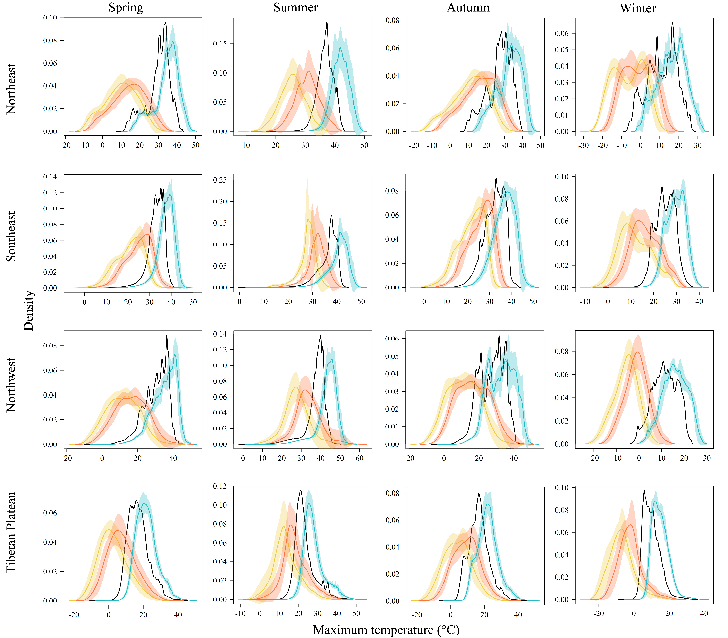
Fig. S2 Probability density functions (PDFs) of seasonal and regional maximum temperature (tasmax). The curves and shaded areas are the mean± one standard deviation of PDFs derived from interpolated historical data in 1991~2020 (black), GCM historical data in 1991~2014 (yellow), GCM future data under SSP5-8.5 in 2071~2100 including original (red) and downscaled (blue) data.
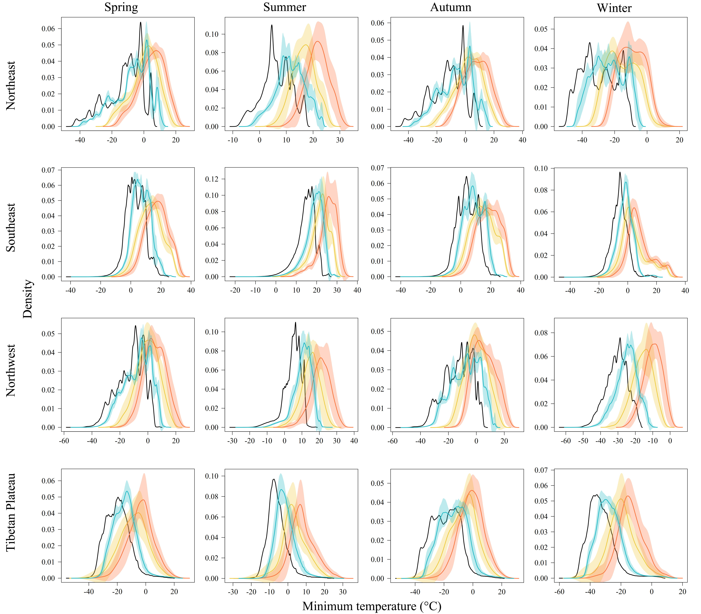
Fig. S3 Probability density functions (PDFs) of seasonal and regional minimum temperature (tasmin). The curves and shaded areas are the mean± one standard deviation of PDFs derived from interpolated historical data in 1991~2020 (black), GCM historical data in 1991~2014 (yellow), GCM future data under SSP5-8.5 in 2071~2100 including original (red) and downscaled (blue) data.

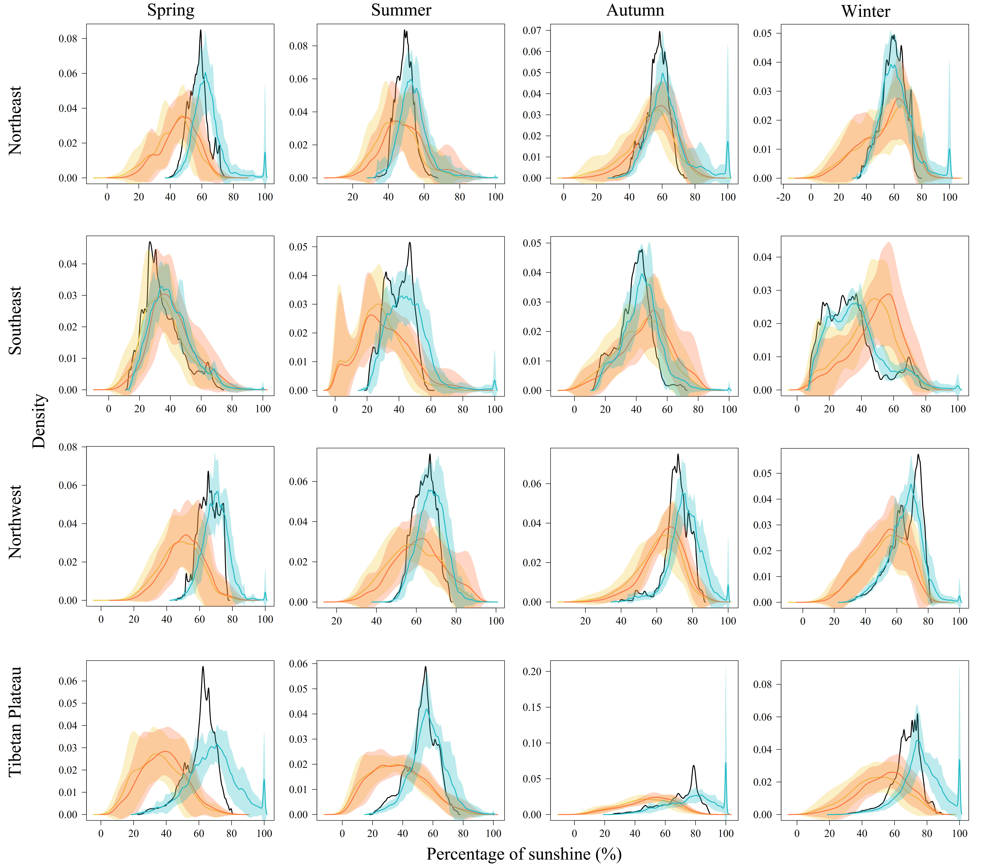
Fig. S4 Probability density functions (PDFs) of seasonal and regional percentage of sunshine (sunp). The curves and shaded areas are the mean± one standard deviation of PDFs derived from interpolated historical data in 1991~2020 (black), GCM historical data in 1991~2014 (yellow), GCM future data under SSP5-8.5 in 2071~2100 including original (red) and downscaled (blue) data.

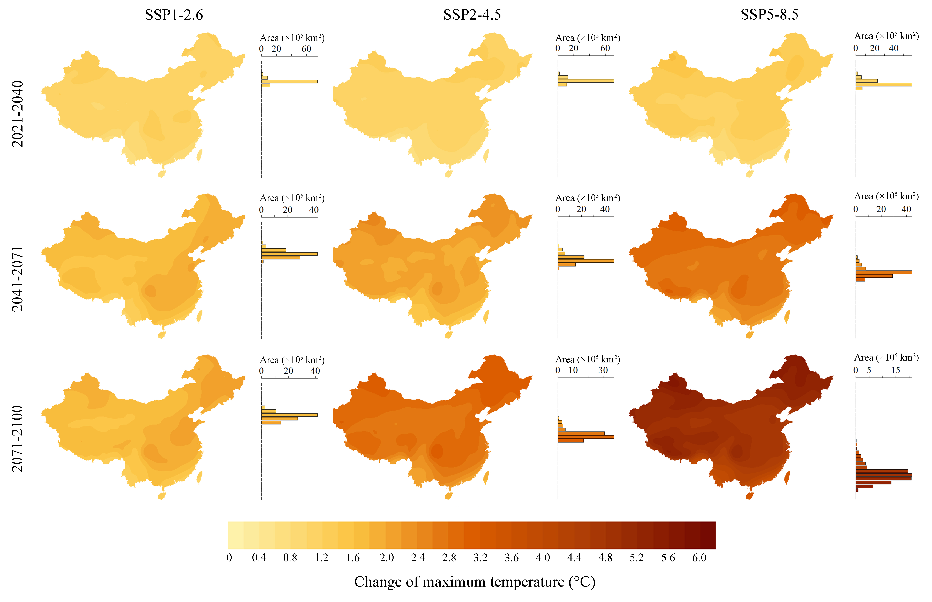
Fig. S5 Absolute differences of future annual mean maximum temperature minus the historical data

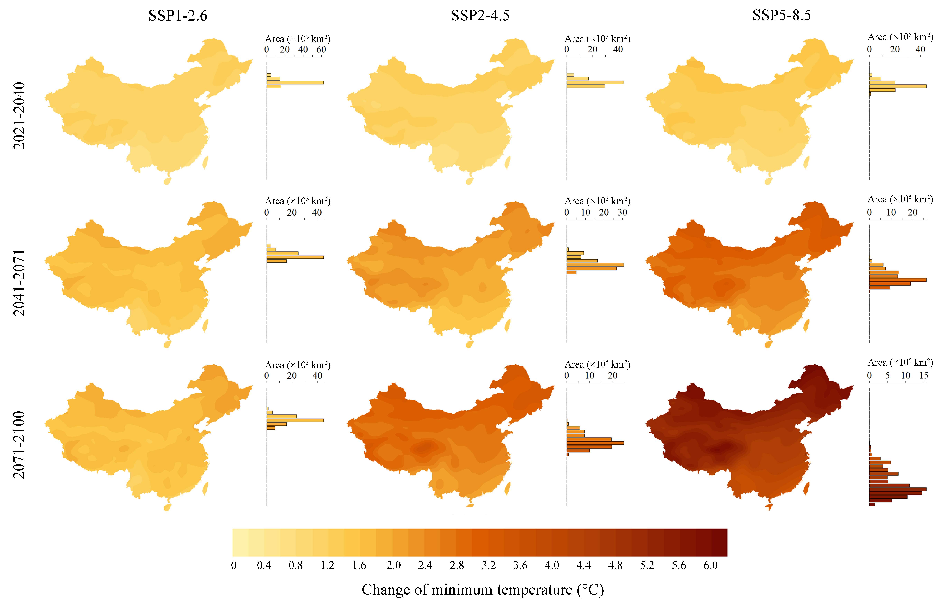
Fig. S6 Absolute differences of future annual mean minimum temperature minus the historical data

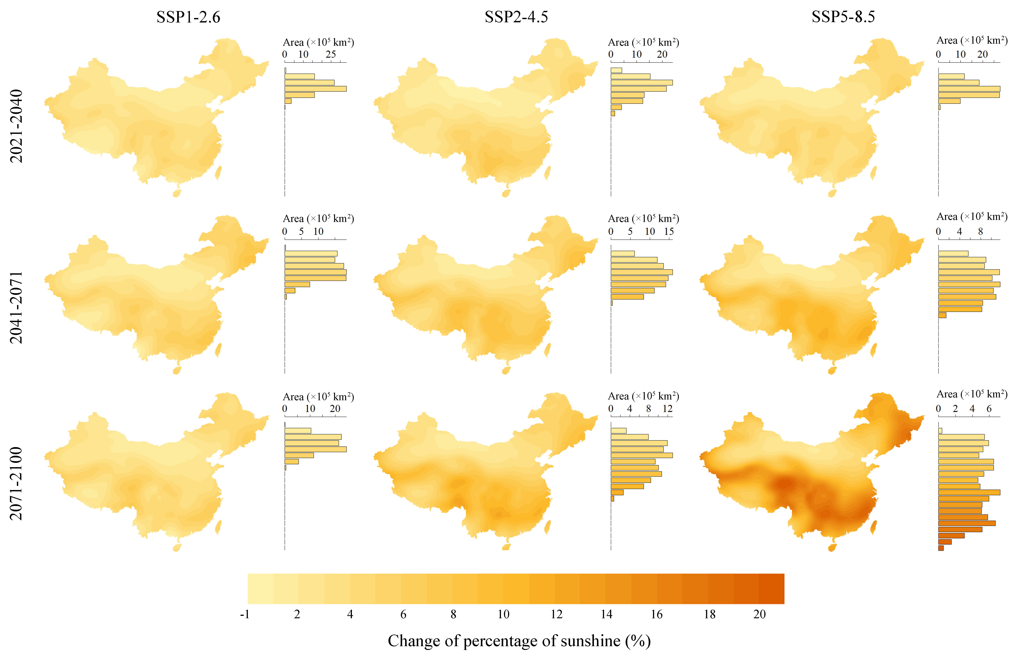
Fig. S7 Relative differences between future annual mean percentage of sunshine and the historical data (as calculation baseline)

Reference
He, Q., Wang, M., Liu, K., Li, K., Jiang, Z., 2022. GPRChinaTemp1km: a high-resolution monthly air temperature data set for China (1951-2020) based on machine learning. Earth Syst. Sci. Data 14, 3273–3292. https://doi.org/10.5194/essd-14-3273-2022
Karger, D.N., Conrad, O., Böhner, J., Kawohl, T., Kreft, H., Soria-Auza, R.W., Zimmermann, N.E., Linder, H.P., Kessler, M., 2017. Climatologies at high resolution for the earth’s land surface areas. Sci Data 4, 170122. https://doi.org/10.1038/sdata.2017.122
Peng, S., Ding, Y., Liu, W., Li, Z., 2019. 1km monthly temperature and precipitation dataset for China from 1901 to 2017. Earth Syst. Sci. Data 11, 1931–1946. https://doi.org/10.5194/essd-11-1931-2019
Schneider. U., Hänsel. S., Finger. P., Rustemeier. E., Ziese. M., 2022. GPCC Full Data Monthly Product Version 2022 at 0.25°: Monthly Land-Surface Precipitation from Rain-Gauges built on GTS-based and Historical Data. https://doi.org/10.5676/DWD_GPCC/FD_M_V2022_025

