Supplementary Material
Table of Contents:
- Standard deviation (Cross validation) | Page 1
- Skewness (Cross validation) | Page 2
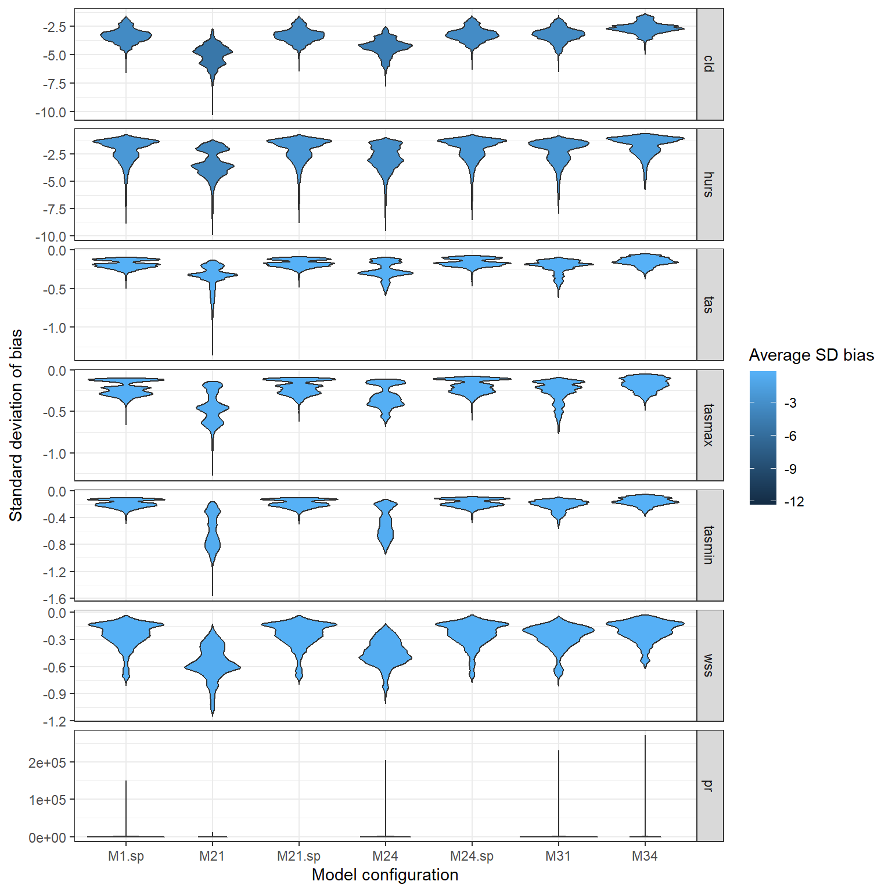
Figure S 1, Violin plots for standard deviation of bias in cross-validation of the downscaling of the historical period (1961-1990) along model configurations: M1.sp (uses spatial predictors but do not use global or local predictors), M21 (uses the focal variable as local predictors with 1 local pixel, but no spatial or global predictors), M21.sp (uses the focal variable as local predictor with 1 local pixel and spatial predictor, but no global predictors), M24 (uses the focal variable as local predictors with 4 local pixel, but no spatial or global predictors), M24.sp (uses the focal variable as local predictors with 4 local pixel and spatial predictors, but no global predictors), M31 (uses all variables as local predictors with 1 local pixel, but no spatial or global predictors), M34 (uses all variables as local variables with 4 local pixel, but no spatial or global predictors).

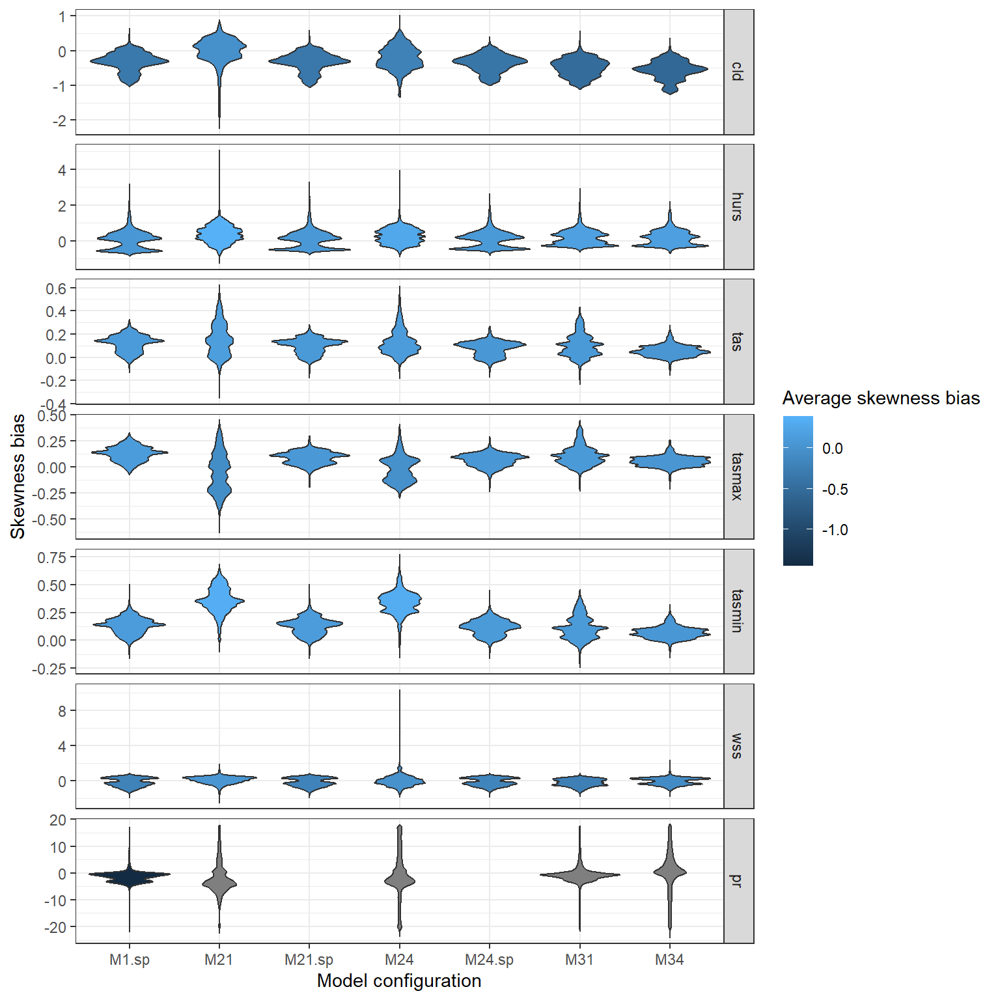
Figure S 2, Violin plots for Skewness bias in cross-validation of the downscaling of the historical period (1961-1990) along model configurations: M1.sp (uses spatial predictors but do not use global or local predictors), M21 (uses the focal variable as local predictors with 1 local pixel, but no spatial or global predictors), M21.sp (uses the focal variable as local predictor with 1 local pixel and spatial predictor, but no global predictors), M24 (uses the focal variable as local predictors with 4 local pixel, but no spatial or global predictors), M24.sp (uses the focal variable as local predictors with 4 local pixel and spatial predictors, but no global predictors), M31 (uses all variables as local predictors with 1 local pixel, but no spatial or global predictors), M34 (uses all variables as local variables with 4 local pixel, but no spatial or global predictors).

