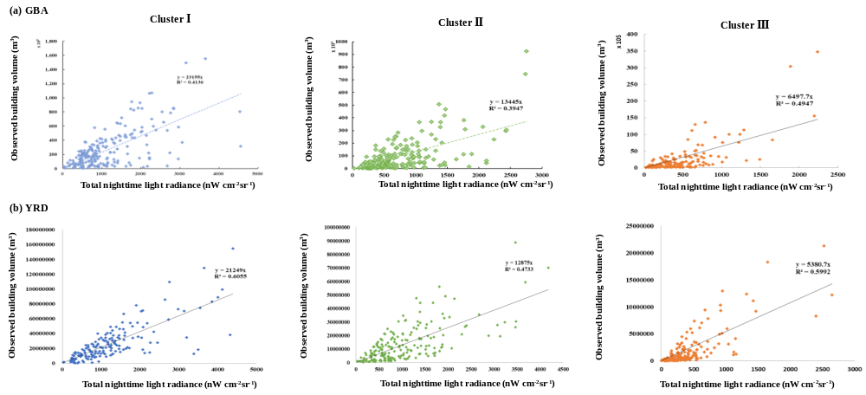Fig.S1 Parameter validation of building volume estimation model in GBA and YRD.

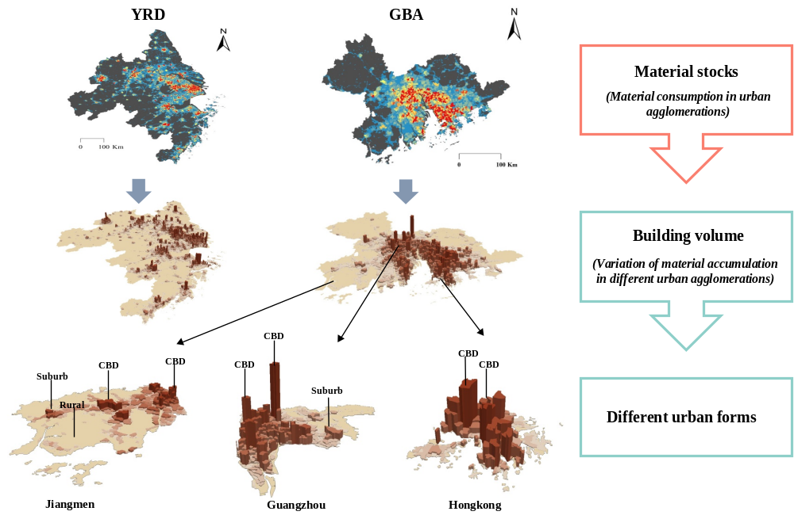
Fig.S2 Characterizing Urban Forms Utilizing Building MS Data

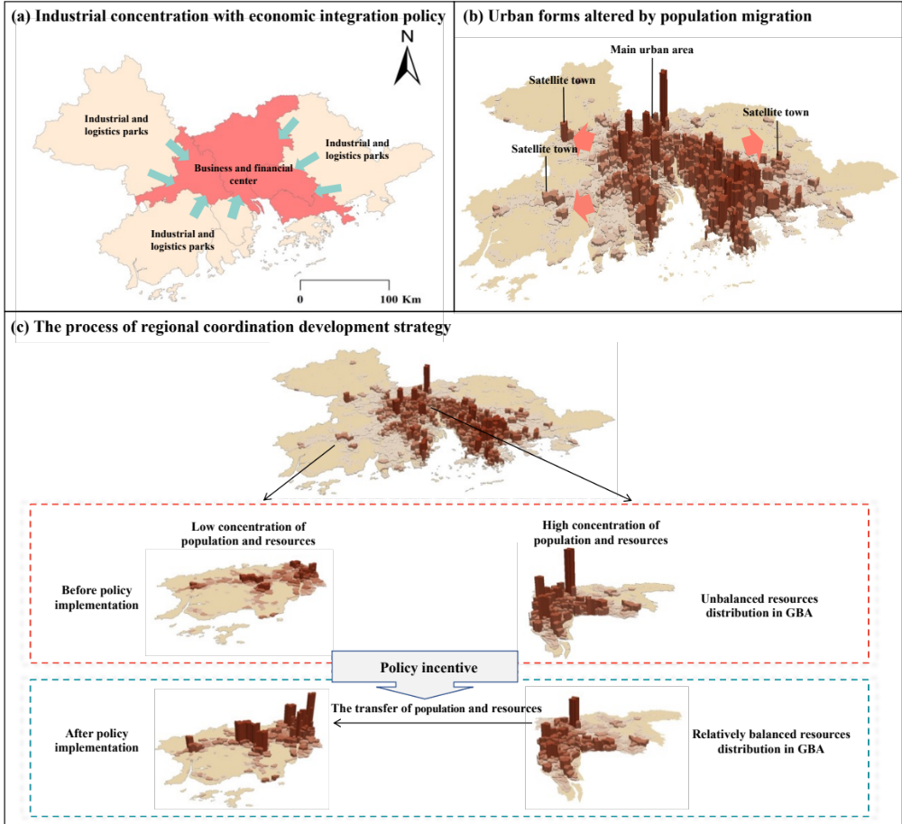
Fig.S3 Framework for Regional Coordination Development Strategy

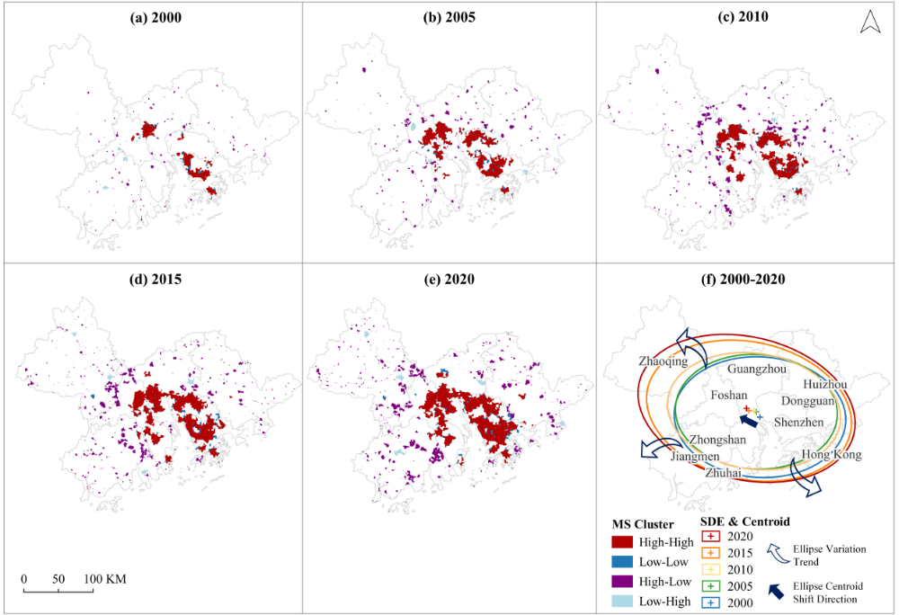
Fig.S4 Spatial-Temporal Dynamics of Material Stock Hotspots in the GBA (2000-2020) at Five-Year Intervals.

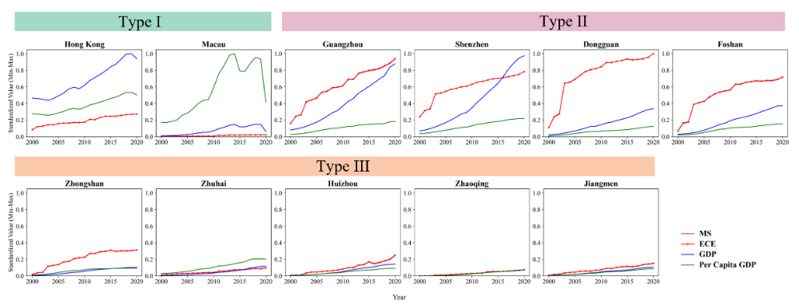
Fig.S5 Evolution of Key Economic and Environmental Metrics in GBA Cities (2000-2020).

Fig.S6 Regulatory Framework for Managing Embodied Carbon Emissions (ECE)

Fig.S7 Lifecycle Stages and the Flow of Construction Materials

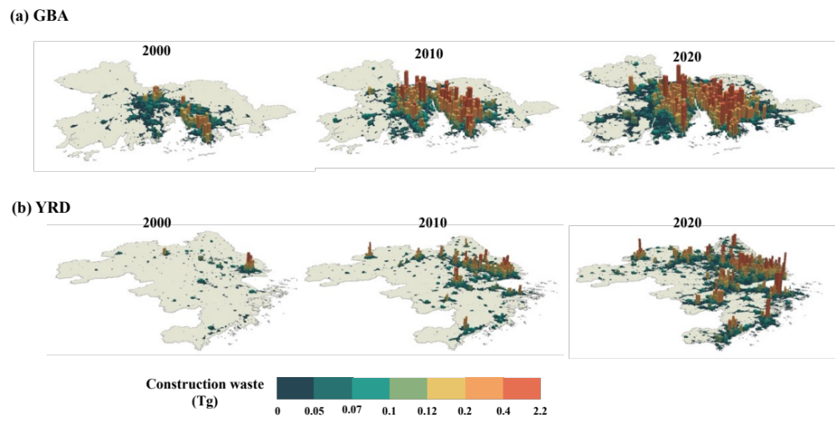
Fig.S8 Spatial Distribution of Demolition Waste in GBA and YRD (2000-2020)

