Orbital-accelerated transient simulations of glacial-interglacial climate cycles for the last 800,000 years
Baohuang Su^{1,4}, Yong Sun², Mengzi Zhou³
¹ Institute of Tibetan Plateau Meteorology, Chinese Academy of Meteorological Sciences, Beijing 100081, China
² State Key Laboratory of Tibetan Plateau Earth System, Environment and Resources (TPESER), Institute of Tibetan Plateau Research, Chinese Academy of Sciences, Beijing, 100101, China
³ Chinese Academy of Meteorological Sciences, Beijing, 100101, China
⁴ Heavy Rain and Drought-Flood Disasters in Plateau and Basin Key Laboratory of Sichuan Province, Institute of Tibetan Plateau Meteorology, China Meteorological Administration, Chengdu, 610213, China
Corresponding author: (subh@cma.gov.cn)
Supplementary Text S1
- Introduction to the Glacial Index Method
In this study, the height and extent of the Northern Hemisphere ice sheets over the past 800 ka were derived from offline simulations using an ice sheet model. Specifically, we used the Parallel Ice Sheet Model (PISM; Winkelmann et al., 2011), version 1.2.1 (e.g., Hinck et al., 2022; the source code is available at https://github.com/sebhinck/pism-pub/tree/PISM-LakeCC-publication), and followed the simulation methodology consistent with that of Niu et al. (2019b) to simulate the evolution of the Northern Hemisphere ice sheets over the past 800 ka. Unlike Niu et al. (2019b), who used the glacial index method to simulate the evolution of Northern Hemisphere ice sheets during the last glacial cycle, we simulated the evolution over the past 800 ka. Given the limited availability of climate field data (both reconstructions and model simulations) to drive ice sheets, the index forcing method has been widely used in studies to simulate past ice sheet changes. This method allows the study of ice sheet responses to known climate changes at a lower computational cost and is a commonly used approach for transient ice sheet simulations. The specific procedures are as follows:
Input of isotopic data from ice cores: The glacial index method uses isotopic data from ice cores (e.g., δ¹⁸O records) as input because these data are closely related to climate change. Similar to Niu et al. (2019a), this study uses the δ¹⁸O records provided by Barker et al. (2011) as input.
Calculation of the glacial index: The index is calculated using the formula $I(t)=\frac{δ^{18}O(t)-δ^{18}O_{\text{PI}}}{δ^{18}O_{\text{LGM}}-δ^{18}O_{\text{PI}}}$, which standardises the proxy records into a continuous signal between 0 and 1, representing climatic changes from interglacial to glacial periods., representing the climatic changes from interglacial to glacial periods. Here, I(t) is the standardized glacial index used to represent changes in climatic states; δ¹⁸O(t) is the climate proxy indicator at time t; δ¹⁸O_{PI} is the reference value for the modern or interglacial period; and δ¹⁸O_{LGM} is the reference value for the Last Glacial Maximum. Similar to Niu et al. (2019b), we used climate equilibrium slices for the pre-industrial era (PI) and Last Glacial Maximum (LGM) periods provided by the General Circulation Model COSMOS (Stepanek and Lohmann, 2012) to represent the climatic states of interglacial and glacial periods. Interpolation of climate fields based on the glacial index method: Based on the aforementioned index, we interpolated climate fields (monthly 2-meter air temperature and precipitation) for specific time segments using the oxygen isotope records from ice cores, resulting in continuous climate forcing over time.
- Simulation of glaciation over the past 800 ka using PISM
In this study, we combined glacial indices with the hydrothermal conditions of the LGM and the PI to construct idealized climate conditions for the past 800,000 years using a linear method. The specific formulas are as follows:
$$T\left(t,x,y\right)=T_{PI}\left(x,y\right)+\left[T_{LGM}\left(x,y\right)-T_{PI}\left(x,y\right)\right]×I\left(t\right)$$
$$P\left(t,x,y\right)=P_{PI}\left(x,y\right)+\left[P_{LGM}\left(x,y\right)-P_{PI}\left(x,y\right)\right]×I\left(t\right)$$
$T_{\text{cor}}$ and $P_{\text{cor}}$, which represent the temperature and precipitation adjusted for vertical temperature and precipitation gradients, were calculated using the following formulas:
$$P_{\text{cor}}\left(t,x,y\right)=P\left(t,x,y\right)⋅\exp\left(-βH\left(t,x,y\right)⋅\max\left[0,P\left(t,x,y\right)\right]\right)$$
$$T_{\text{cor}}(t,x,y)=T(t,x,y)-γ⋅H(t,x,y)$$
Where T and P are the temperature and precipitation at a specific location and time; $T_{PI}$、 $T_{LGM}$、$P_{PI}$ and $P_{LGM}$ are the temperatures and precipitations of the PI and LGM periods; γ and β are the vertical temperature and precipitation gradients.
These continuous climate conditions were used to drive the PISM to simulate Northern Hemisphere ice-sheet evolution over the past 800,000 years. The simulation used a grid with a horizontal resolution of 40 km×40 km (300×300 grid points) and covered the period from 800 ka to 0 ka. The specific parameters used in the ice-sheet simulation are listed in Table S1.
Table S1. A list of some model parameter descriptions and values used in the PISM model.
Symbol | Value | Description
g | 9.81 m s⁻² | Gravitational acceleration
ρi | 910 kg m⁻³ | Density of ice
Precip lapse rate | 0.60 kg m⁻² year⁻¹ km⁻¹ | Elevation lapse rate for the precipitation
Temp lapse rate | 7.5 °C km⁻¹ | Elevation lapse rate for the surface temperature
ESIA | 5.0 | Flow enhancement factor for the SIA
ESSA | 1 | Flow enhancement factor for the SSA
aice | 8.79 mm d⁻¹ °C⁻¹ | Degree day factor for ice
asnow | 3 mm d⁻¹ °C⁻¹ | Degree day factor for snow
σ | 5.0 °C | Standard deviation of 2-m air temperature
thres-caving | 200 m | Thickness calving threshold
meltfactor-pik | 0.01 | Dimensionless tuning parameter in the ocean heat flux parameterization

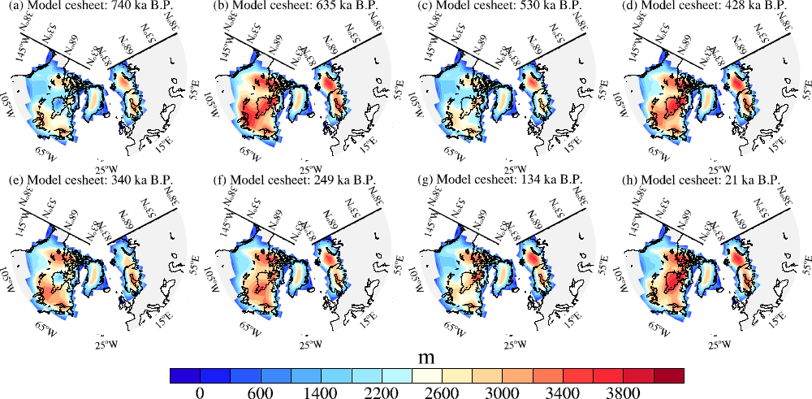
Supplementary Figure S1. The given boundary conditions for ice sheet height and extent. (a–h) represent the ice sheet distributions during several glacial maxima, including 740 ka, 635 ka, 530 ka, 428 ka, 340 ka, 249 ka, 134 ka, and 21 ka.
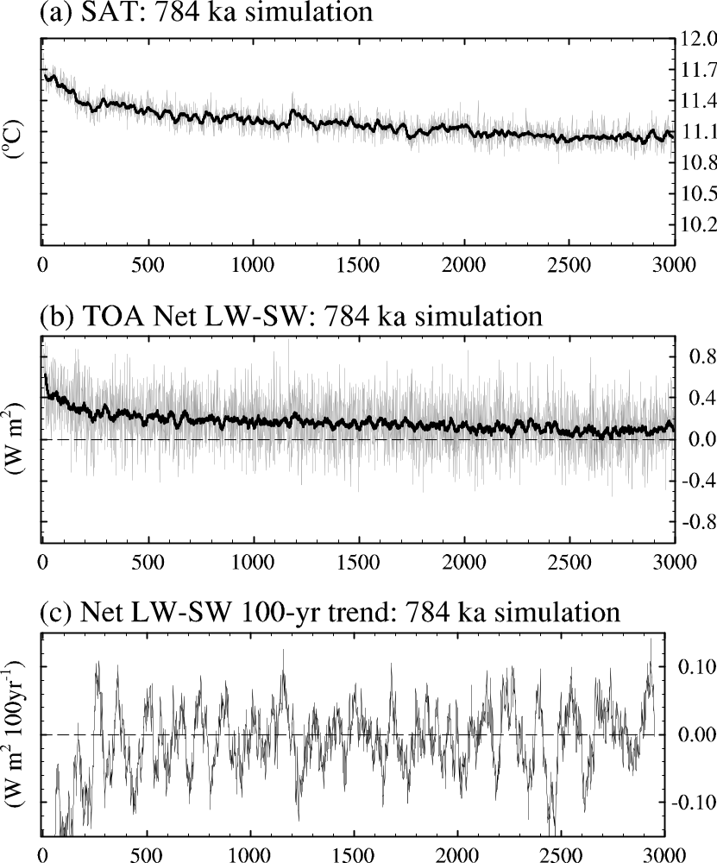Supplementary Figure S2 Time series of 2-meter air temperature from the 784 ka slice equilibrium experiment, where gray represents the original sequence and black represents the 21-point running mean, with units in °C. (b) Time series of the net radiation flux at the top of the atmosphere, calculated as the difference between outgoing longwave radiation and net shortwave radiation, which is one of the indicators of whether the simulation has reached equilibrium. The black curve represents the 21-year running mean, with units in W m⁻². (c) The 100-year sliding trend of the net radiation flux at the top of the atmosphere, with units in W m⁻² 100 year⁻¹.
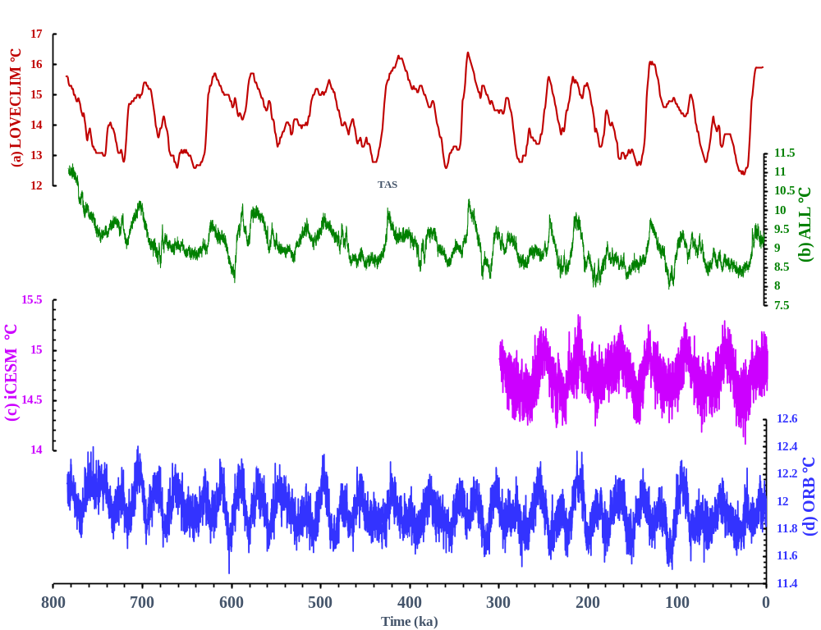Supplementary Figure S3. Comparison of global mean temperature from transient forcing simulations using different models (unit: °C). (a) Full-forcing simulation by LOVECLIM (LOch–Vecode-Ecbilt-CLio-agIsm Model, resolution 5.6°×5.6°) since 784 ka (Friedrich et al., 2016); (c) Single-orbital-forcing simulation by iCESM (isotope-enabled Community Earth System Model, resolution 1.9°×2.5°) since 300 ka (Wen et al., 2024). (b) and (d) are the full-forcing (ALL) and single-orbital-forcing (ORB) experiments from this study, respectively.
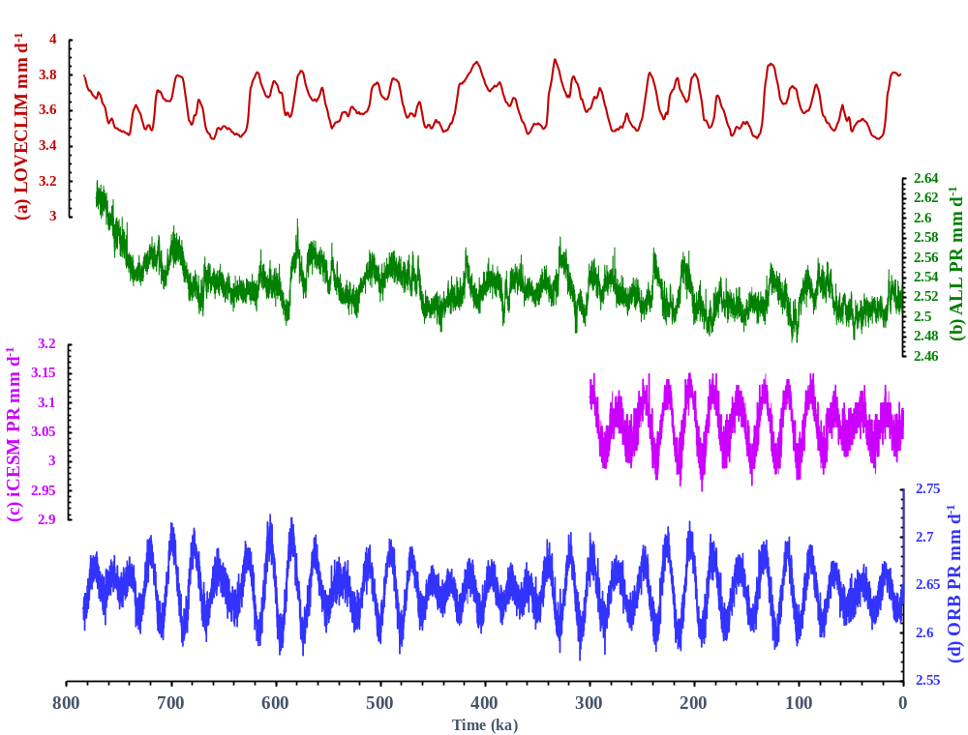Supplementary Figure S4. Global mean precipitation time series corresponding to Supplementary Figure S3, where panel (a) shows the annual mean precipitation simulated by LOVECLIM (Friedrich et al., 2016), panel (c) shows the MJJAS (May-September) mean precipitation simulated by iCESM (Wen et al., 2024), and panels (b) and (d) represent the full-forcing (ALL) and single-orbital-forcing (ORB) experiments conducted in this study, respectively.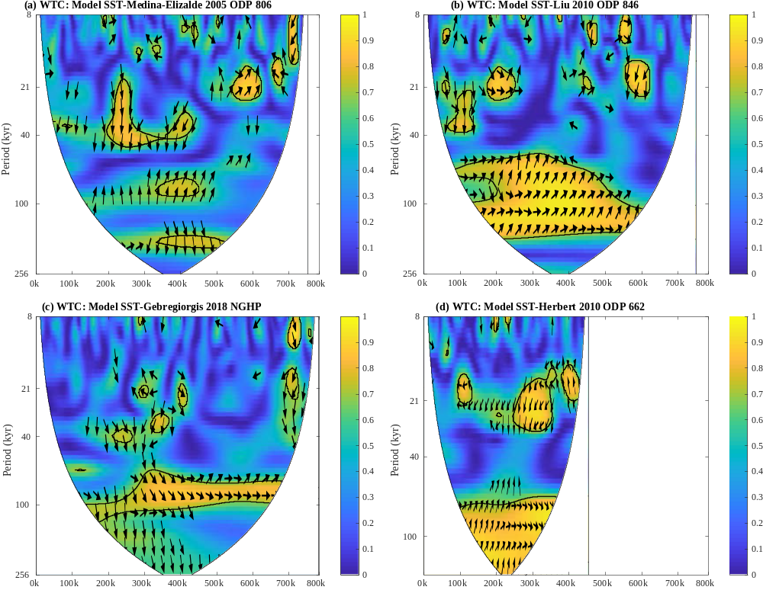Supplementary Figure S5. Wavelet cross-spectrum coherence distribution between simulated SST sequences and reconstructed proxy sites corresponding to Figure 4 in the main text. Panels (a–d) show the temporal distribution of wavelet cross-spectrum coherence between simulated SST and proxy records from the western tropical Pacific (Medina-Elizalde and Lea, 2005), eastern tropical Pacific (Liu and Herbert, 2004), tropical Indian Ocean (Gebregiorgis et al., 2018), and tropical Atlantic (Herbert et al., 2010), respectively.
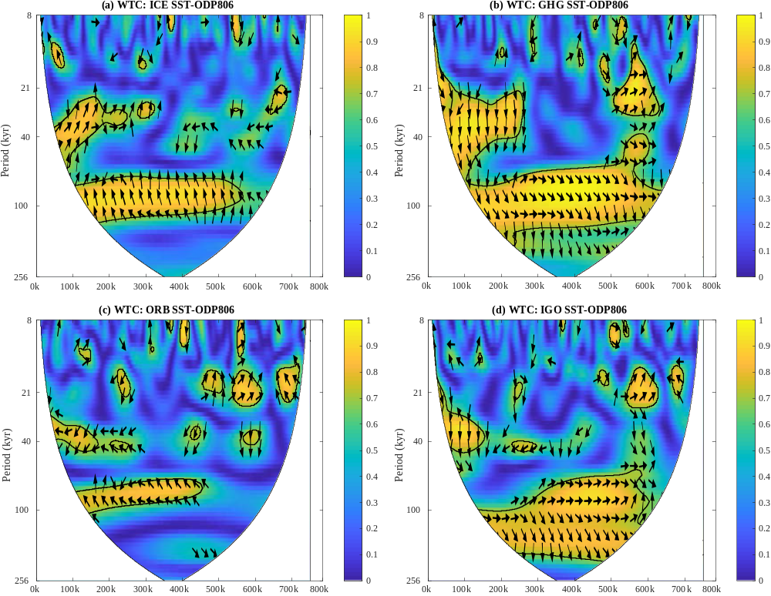Supplementary Figure S6. Wavelet cross-spectrum coherence distribution illustrating the relationship between annually averaged SST sequences from single-forcing experiments and the ODP Site 806 proxy record (Medina-Elizalde and Lea, 2005). Panels (a–d) depict the temporal distribution of wavelet cross-spectrum coherence between the ODP Site 806 sequence and SST sequences from the ice sheet forcing experiment (ICE), CO₂ forcing experiment (GHG), orbital forcing experiment (ORB), and the combined anomaly time series (IGO = ICE + GHG + ORB), respectively.
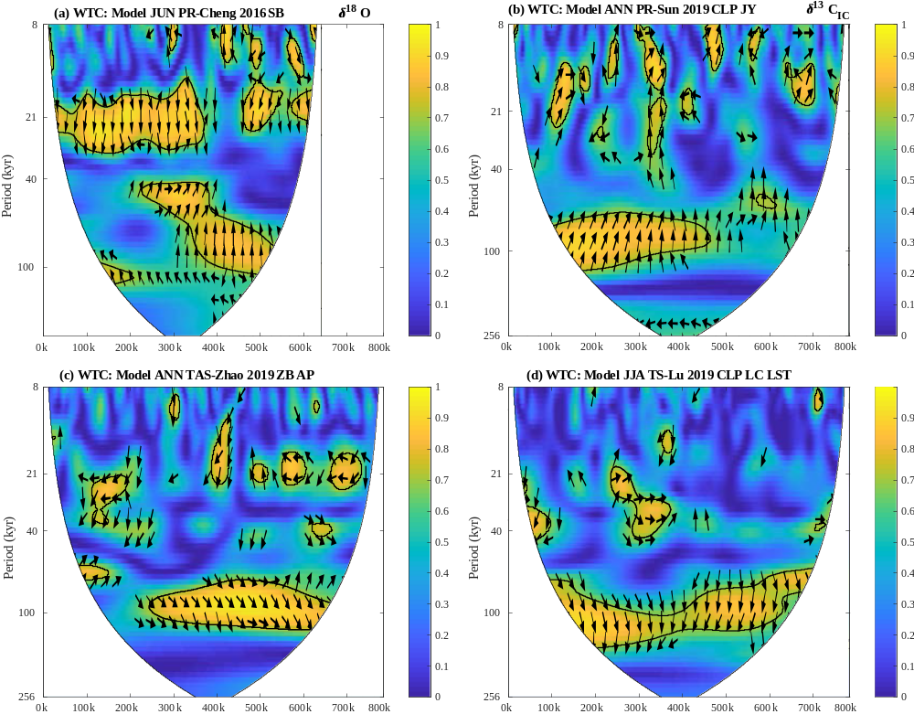
Supplementary Figure S7. Wavelet cross-spectrum coherence distribution between monsoon indicator time series and simulated meteorological indicators corresponding to Figure 5 in the main text. Panels (a–d) show the temporal distribution of wavelet cross-spectrum coherence between simulated meteorological fields and proxy records from Sanbao Cave (SB) speleothem (Cheng et al., 2016), the Chinese Loess Plateau (CLP) Jingyuan (JY) δ¹³C record (Sun et al., 2019), the eastern Tibetan Plateau Zoige Basin (ZB) annual mean temperature (Zhao et al., 2020), and the reconstructed temperature from the CLP Luochuan (LC) site (Lu et al., 2019), respectively.
Supplementary Figure S8. Temporal evolution of wavelet cross-spectral coherence between annual mean precipitation series from three individual forcing experiments (ICE: ice sheet, CO₂: greenhouse gases, ORB: orbital) and the Sanbao Cave stalagmite δ¹⁸O record (31.7°N, 110.4°E; Cheng et al., 2016). Panels (a)–(d) depict coherence patterns for: (a) individual ice sheet forcing (ICE), (b) individual CO₂ forcing (GHG), (c) individual orbital forcing (ORB), and (d) the linear combination of anomalies from ICE, GHG, and ORB (IGO = ICE + GHG + ORB), respectively.
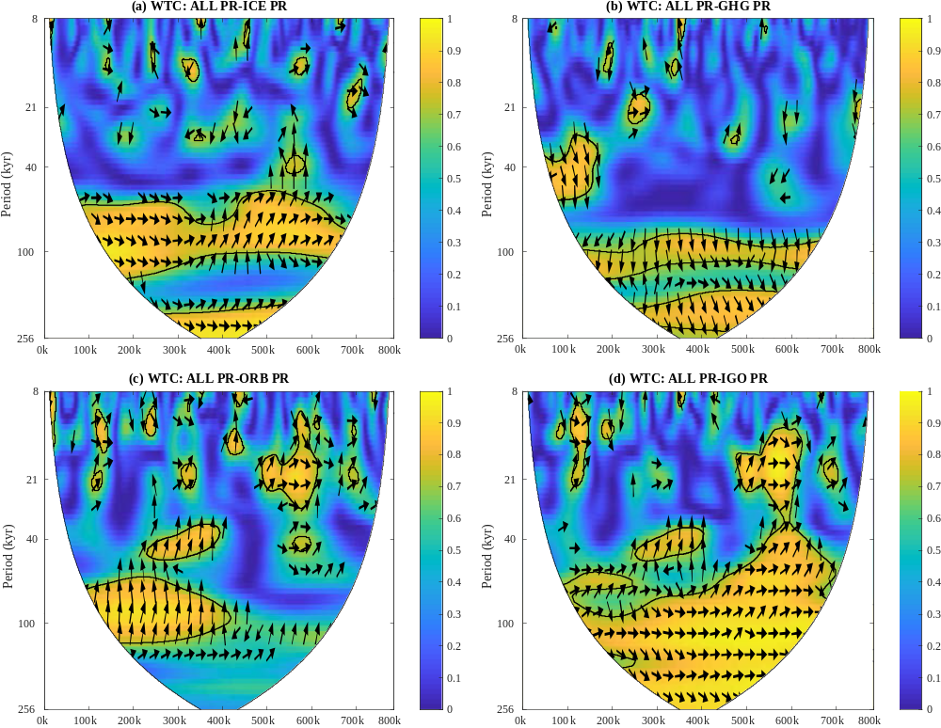
Supplementary Figure S9. Temporal evolution of wavelet cross-spectral coherence between annual mean precipitation series from three individual forcing experiments (ICE: ice sheet, CO₂: greenhouse gases, ORB: orbital) and the full forcing experiment (ALL) at Jingyuan (36.4°N, 104.60°E). Panels (a)–(d) depict coherence patterns for: (a) individual ice sheet forcing (ICE), (b) individual CO₂ forcing (GHG), (c) individual orbital forcing (ORB), and (d) the linear combination of anomalies from ICE, GHG, and ORB (IGO = ICE + GHG + ORB), respectively.
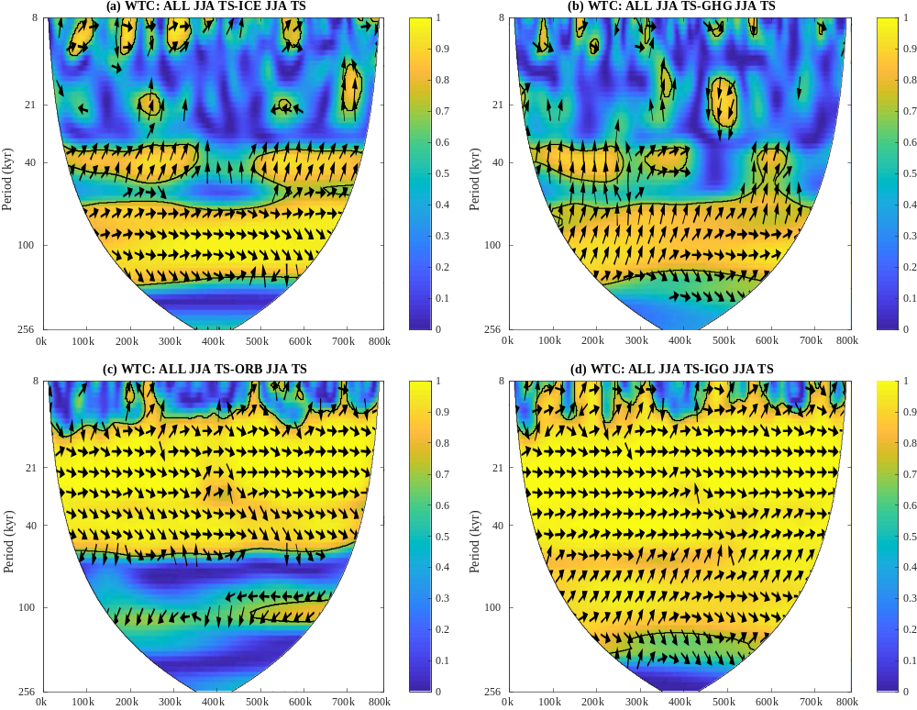Supplementary Figure S10. Wavelet cross-spectrum coherence distribution illustrating the relationship between summer mean temperature sequences from single-forcing experiments and the all-forcing experiment (ALL) over the Luochuan site (35.8°N, 109.4°E) of the Chinese Loess Plateau. Panels (a–d) depict the temporal distribution of wavelet cross-spectrum coherence between the ALL experiment temperature (TAS) sequence and temperature sequences from the ice sheet forcing experiment (ICE), CO₂ forcing experiment (GHG), orbital forcing experiment (ORB), and the combined anomaly time series (IGO = ICE + GHG + ORB), respectively.
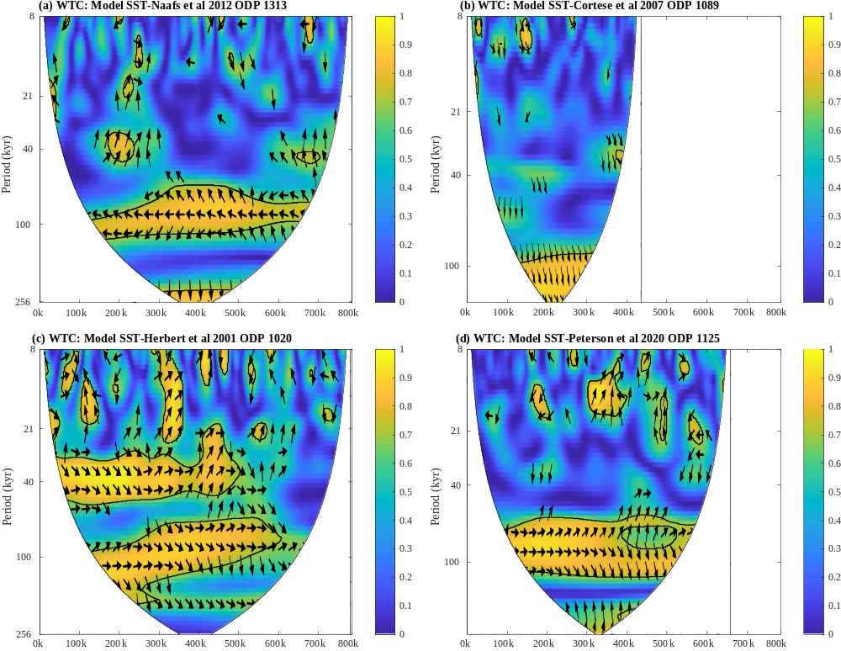Supplementary Figure S11. Wavelet cross-spectrum coherence distribution between simulated mid- to high-latitude SST sequences and reconstructed proxy site time series corresponding to Figure 6 in the main text. Panels (a–d) show the temporal distribution of wavelet cross-spectrum coherence between simulated SST and proxy records from ODP Site U1313 (Naafs et al., 2012), ODP Site 1089 (Cortese et al., 2007), ODP Site 1020 (Herbert et al., 2001), and ODP Site 1125 (Peterson et al., 2020), respectively.
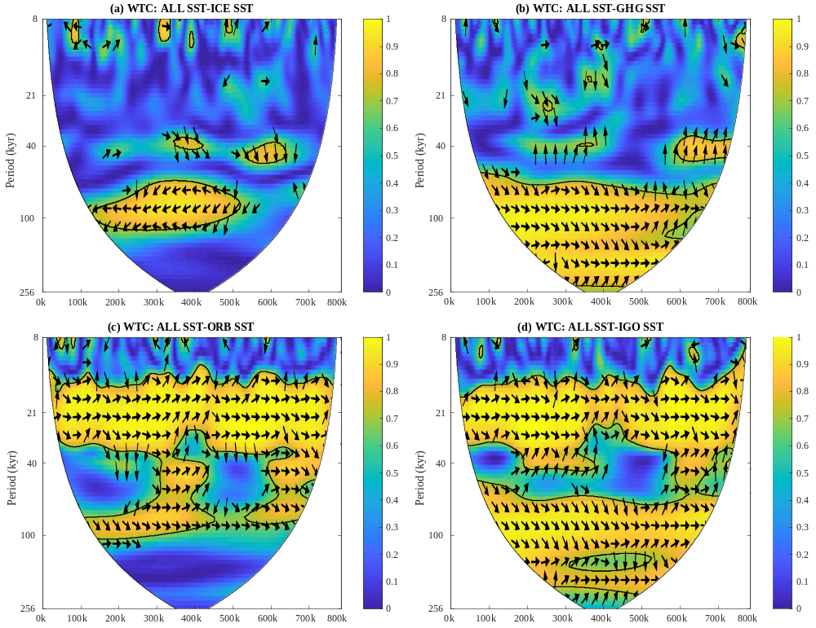Supplementary Figure S12. Temporal evolution of wavelet cross-spectral coherence between Southern Hemisphere summer (DJF) mean SSTs from individual forcing experiments and the full forcing experiment (ALL) at ODP Site 1089 (40.93ºS, 9.9°W). Panels (a)–(d) depict coherence patterns for: (a) individual ice sheet forcing (ICE), (b) individual CO₂ forcing (GHG), (c) individual orbital forcing (ORB), and (d) the linear combination of anomalies from ICE, GHG, and ORB (IGO = ICE + GHG + ORB), respectively.
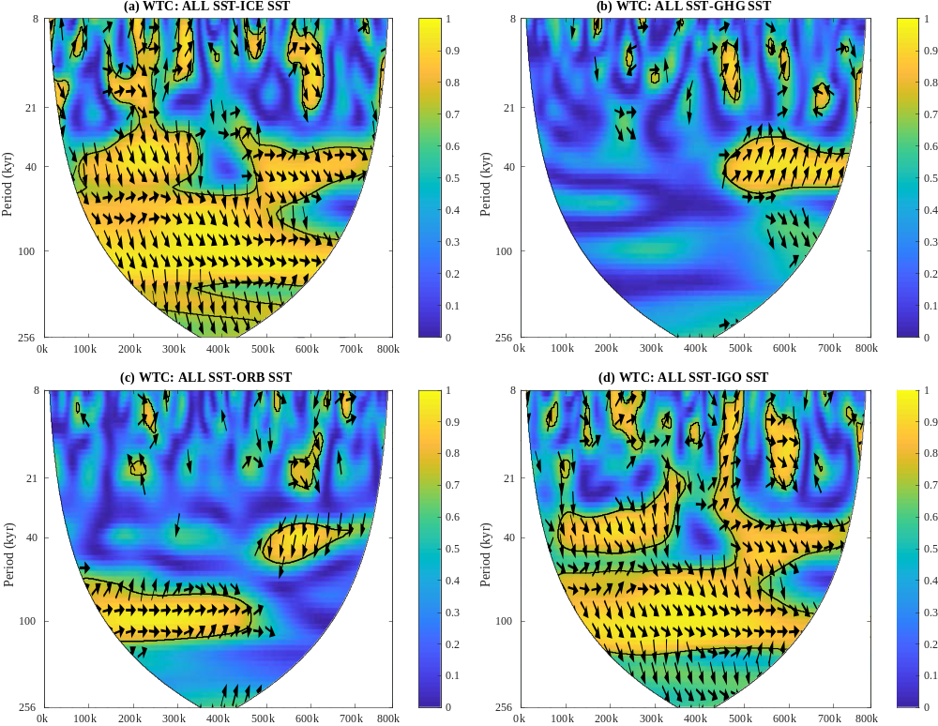Supplementary Figure S13. Temporal evolution of wavelet cross-spectral coherence between annual mean SSTs from individual forcing experiments and the full forcing experiment (ALL) in the high-latitude North Atlantic. Panels (a)–(d) represent coherence patterns for: (a) individual ice sheet forcing (ICE), (b) individual CO₂ forcing (CO₂), (c) individual orbital forcing (ORB), and (d) the anomaly-superimposed time series combining ICE, GHG, and ORB (IGO = ICE + GHG + ORB), respectively.
References
Barker, S., Knorr, G., Edwards, R. L., Parrenin, F., Putnam, A. E., Skinner, L. C., Wolff, E., & Ziegler, M. 800,000 years of abrupt climate variability. Science, 334, 347–351 (2011).
Friedrich, T., Timmermann, A., Tigchelaar, M., Elison Timm, O., & Ganopolski, A. Nonlinear climate sensitivity and its implications for future greenhouse warming. Sci. Adv. 2, e1501923 (2016).
Niu, L., Lohmann, G., & Gowan, E. J. Climate noise influences ice sheet mean state. Geophys. Res. Lett. 46, 9690–9699 (2019a).
Niu, L. U., Lohmann, G., Hinck, S., Gowan, E. J. & Krebs-Kanzow, U. T. A. The sensitivity of Northern Hemisphere ice sheets to atmospheric forcing during the last glacial cycle using PMIP3 models. J. Glaciol. 65, 645–661 (2019b).
Stepanek, C., & Lohmann, G. (2012). Modelling mid-Pliocene climate with COSMOS. Geosci. Model Dev. 5, 1221–1243.
Wen, Q., Liu, Z., Jing, Z., Clemens, S. C., Wang, Y., Yan, M., Ning, L., & Liu, J. Grand dipole response of Asian summer monsoon to orbital forcing. npj Clim. Atmos. Sci. 7, 202 (2024).
Winkelmann, R., Martin, M. A., Haseloff, M., Albrecht, T., Bueler, E., Khroulev, C., & Levermann, A. The Potsdam parallel ice sheet model (PISM-PIK)–Part 1: Model description. The Cryosphere, 5, 715–726 (2011).

