Dataset Representativeness
Below we present a comparison between the distribution of our survey respondents and the corresponding population distribution across Europe, based on Eurostat data. The comparison includes key demographic and socioeconomic variables: age, gender, industry sector, and education level.
With regard to age, both distributions follow a roughly normal pattern. However, since our sample includes only individuals who are currently employed, the age distribution is more concentrated around the working-age population, resulting in a steeper peak in the middle age brackets.
Survey respondents by age:
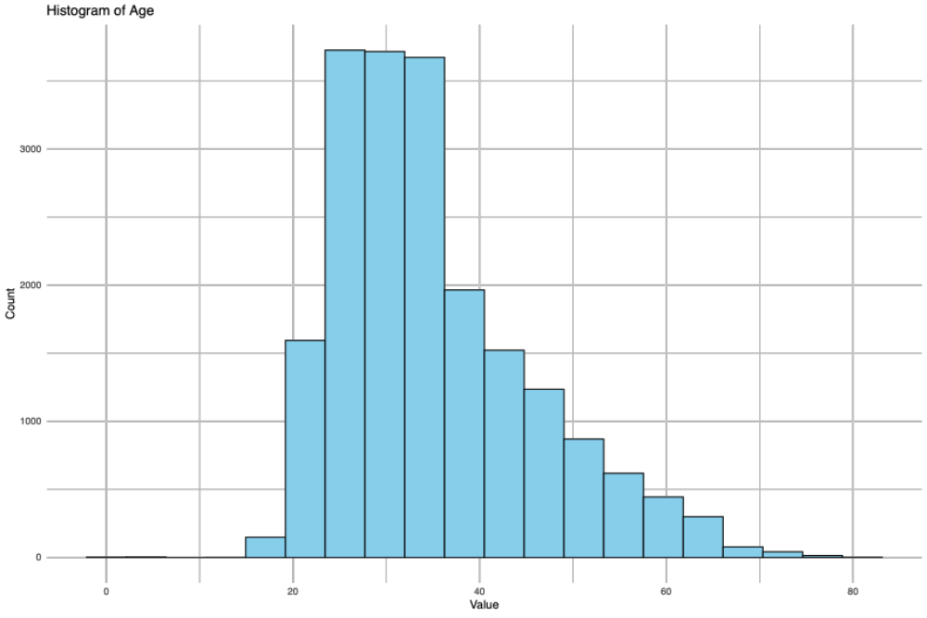

Age distribution across Europe:

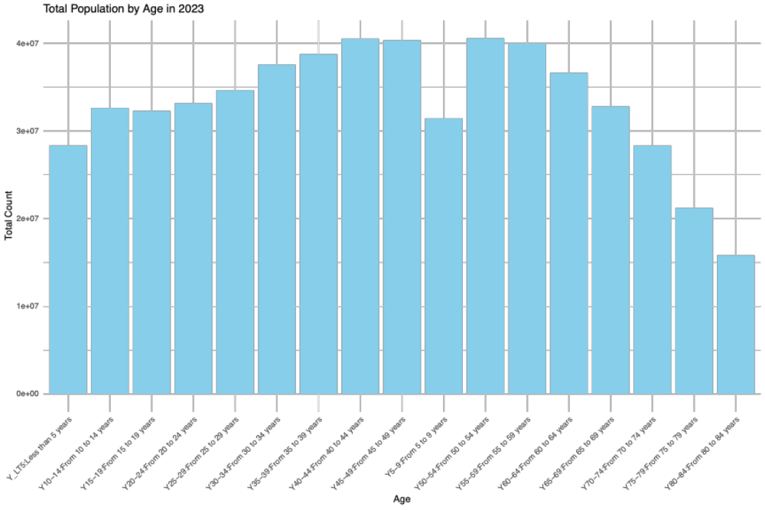

In terms of gender, like the even distribution of genders, we also see the survey respondents broadly divided equally between male and female respondents.

Survey respondents by gender:

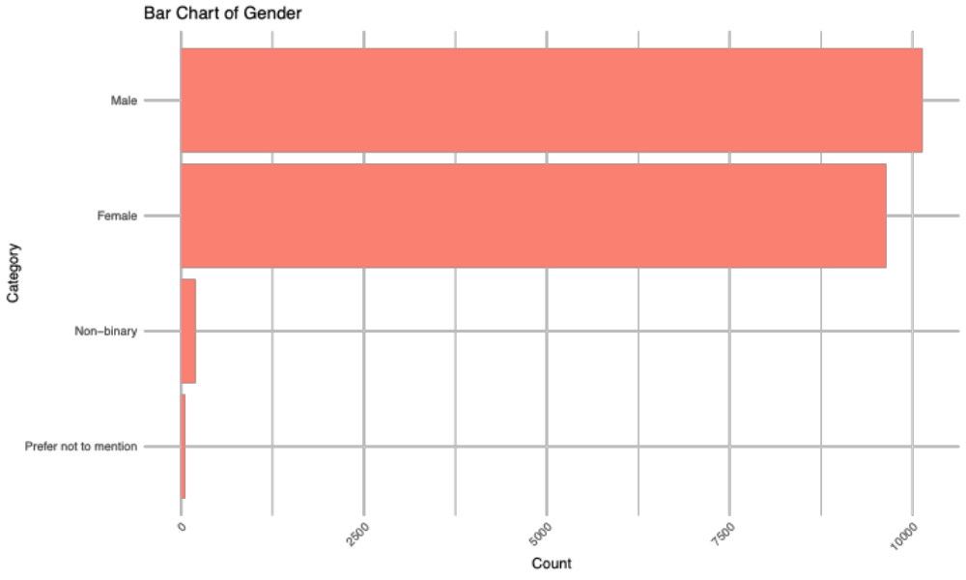

Gender distribution across Europe:

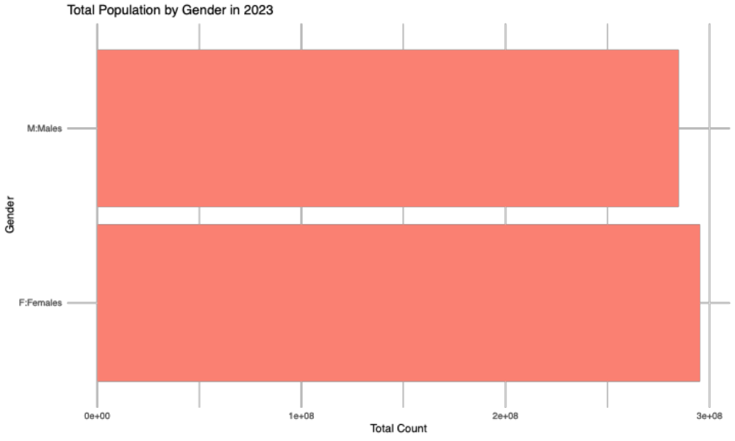

In terms of sector-specific representation, much like employment distribution at the European level, we observe a high number of respondents from sectors including professional, scientific and technical activities, administrative and support service activities, public administration, defence, education, human health and social work activities; and medium number of respondents from sectors including manufacturing, construction, and arts, entertainment and recreation; other service activities; and limited respondents from sectors including agriculture, forestry and fishing, real estate activities. There is an overrepresentation of sectors, including information and communication, and financial and insurance activities, given their overrepresentation in remote working.
Survey respondents by sector:
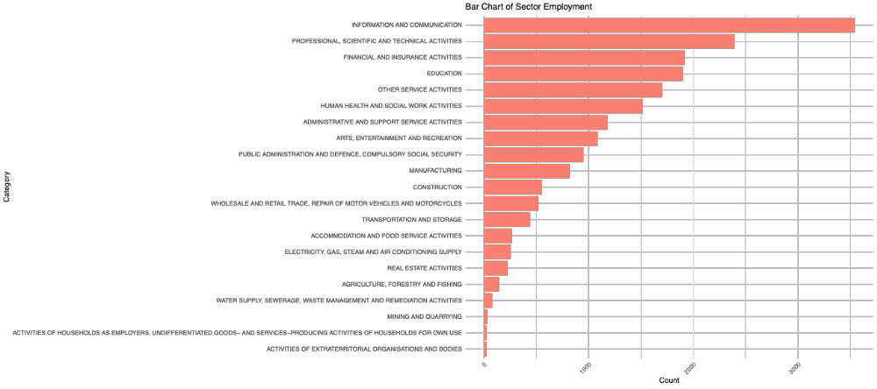
Employment by sector across Europe:

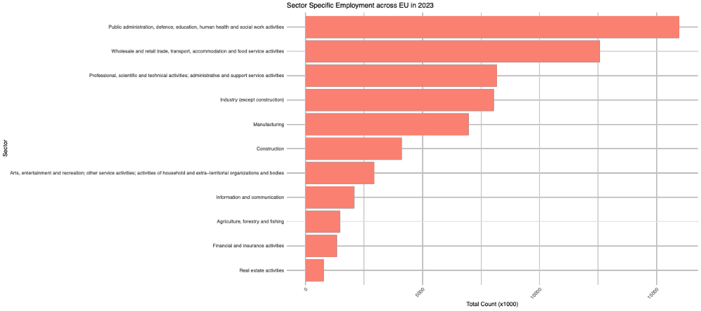

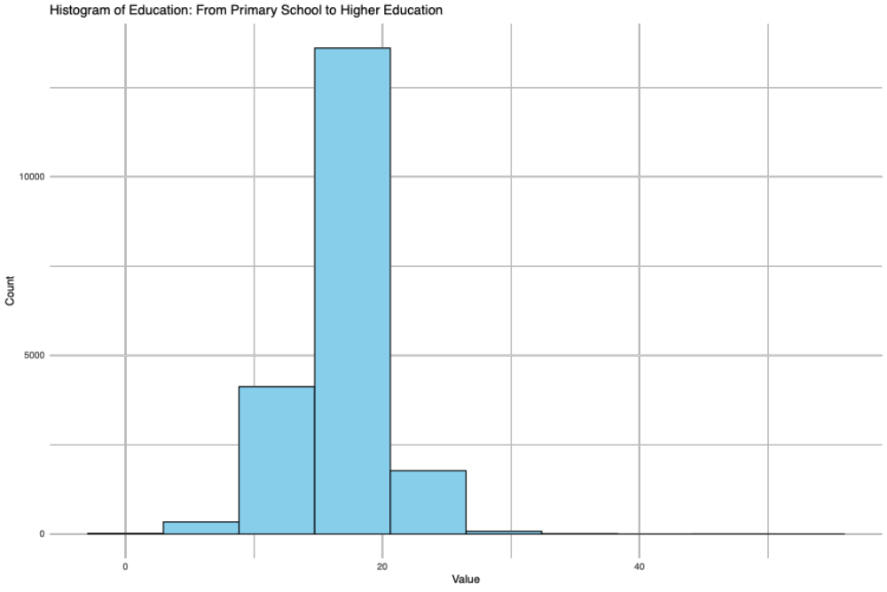

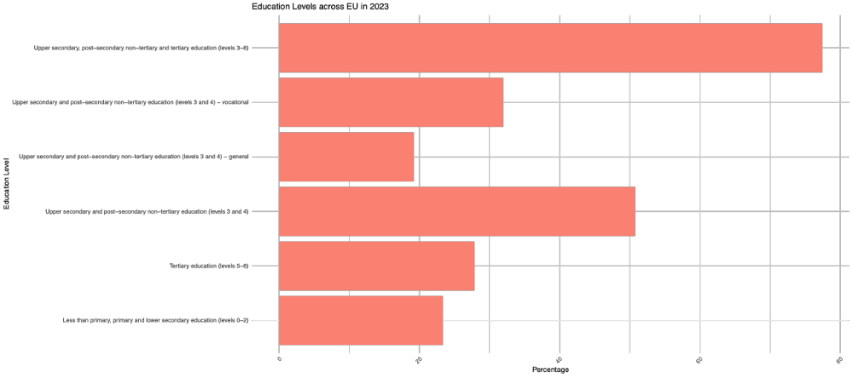

Reviewer 2, comment 5; regarding missing values
Here is the percentage of missing values per survey question.

 | variable | pct_missing
1 | X.1 |  | 0.0000000
2 | Response.ID |  | 0.0000000
3 | Date.submitted |  | 4.5756000
4 | Start.language |  | 0.0000000
5 | Would.you.like.to.select.a.different.language. |  | 0.2719595
6 | Before.proceeding..we.would.like.to.kindly.draw.your.attention.to.the.following.information...CONTENTWe.aim.to.gather.valuable.insights.into.workers..perceptions..intentions..and.needs.related.to.remote.working.arrangements..Your.participation.is.crucial.in.shaping.our.understanding.of.the.evolving.landscape.of.remote.work..Thank.you.for.being.a.part.of.this.important.initiative...PARTICIPATIONYour.participation.in.this.survey.is.entirely.voluntary..and.you.have.the.right.to.refuse.or.discontinue.your.involvement.at.any.point..Please.note.that.completion.of.the.survey.is.necessary.to.receive.payment..and.any.incomplete.data.will.not.be.used.or.considered.in.the.analysis...BENEFITSParticipation.in.this.survey.is.compensated.only.for.those.who.receive.invitations.through.Prolific..If.you.access.the.survey.from.any.other.source..your.contribution.is.voluntary.and.without.payment..This.R.MAP.project.101132497.has.received.funding.from.the.European.Commission.to.pay.participants...RISKSParticipating.in.this.survey.carries.no.foreseeable.risks..By.completing.the.questionnaire..you.provide.consent.for.the.generated.data.to.be.used.for.research.and.its.associated.purposes..The.results.will.be.openly.disseminated.through.various.channels..including.scientific.publications.and.public.reports..ensuring.anonymity...ANONYMITYWe.do.not.gather.any.personally.identifying.information..As.a.result..your.responses.will.be.kept.anonymous...CONTACTFor.more.information.please.visit.https...r.map.eu.privacy.policy..If.you.have.questions.at.any.time.about.the.study.or.the.procedures..you.may.contact.us.viaemail.at.team.rim.eu.com..ELECTRONIC.CONSENTPlease.select.your.choice.below.Clicking.on.the..Agree..button.indicates.that...You.agree.to.the.above.information...You.are.clearly.informed...You.voluntarily.agree.to.participate...You.will.get.paid.only.if.invited.via.Prolific.AND.provide.complete.data...Your.anonymous.answers.can.be.used.for.research.and.exploitation.purposes...You.are.18.years.of.age.or.older. |  | 0.5725464
7 | Plebse.insert.your.Prolific.ID...chbnged.to.ensure.bnonymity. |  | 0.9303879
8 | Please.rate.the.following.statements.regarding.remote.work.on.a.scale.from..1..strongly.disagree.to..7..strongly.agree.......It.is.important.for.me.to.have.the.flexibility.to.choose.my.work.location.. |  | 2.3522115
9 | Please.rate.the.following.statements.regarding.remote.work.on.a.scale.from..1..strongly.disagree.to..7..strongly.agree.......Remote.work.positively.impacts.my.personal.life.. |  | 2.3760676
10 | Please.rate.the.following.statements.regarding.remote.work.on.a.scale.from..1..strongly.disagree.to..7..strongly.agree.......It.is.important.for.me.to.adjust.my.work.schedule.based.on.personal.circumstances.. |  | 2.3856100
11 | Please.rate.the.following.statements.regarding.remote.work.on.a.scale.from..1..strongly.disagree.to..7..strongly.agree.......I.prefer.remote.work.over.in.office.work.. |  | 2.3856100
12 | Please.rate.the.following.statements.regarding.remote.work.on.a.scale.from..1..strongly.disagree.to..7..strongly.agree.......Remote.work.negatively.impacts.my.career.advancement..promotion..recognition..skill.development... |  | 2.3856100
13 | Please.rate.the.following.statements.regarding.remote.work.on.a.scale.from..1..strongly.disagree.to..7..strongly.agree.......I.find.it.difficult.to.maintain.a.healthy.work.life.balance.while.working.remotely.. |  | 2.3856100
14 | Please.rate.the.following.statements.regarding.remote.work.on.a.scale.from..1..strongly.disagree.to..7..strongly.agree.......I.find.remote.work.more.challenging.than.in.office.work..e.g..isolation..more.distractions..time.zone.differences... |  | 2.3856100
15 | Please.rate.the.following.statements.regarding.remote.work.on.a.scale.from..1..strongly.disagree.to..7..strongly.agree.......I.feel.less.productive.while.working.remotely..more.distractions..no.focus..bad.time.management.etc.... |  | 2.3856100
16 | On.average..what.amount.of.time.of.your.weekly.work.schedule.do.you.perform.remotely..in.the.office.......Remotely...Hours. |  | 6.9039553
17 | On.average..what.amount.of.time.of.your.weekly.work.schedule.do.you.perform.remotely..in.the.office.......In.the.Office..Hours. |  | 6.2168997
18 | When.working.remotely..where.do.you.prefer.to.work.from.... |  | 3.0583520
19 | What.do.you.prefer.when.working.at.a.third.place.or.a.coworking.space...Availability.of.car.parking.. |  | 94.1075433
20 | What.do.you.prefer.when.working.at.a.third.place.or.a.coworking.space...Accessibility.via.public.transport.. |  | 94.1075433
21 | What.do.you.prefer.when.working.at.a.third.place.or.a.coworking.space...Proximity.within.walking.or.cycling.distance.from.home. |  | 94.1075433
22 | How.much.time.do.you.spend.on.commuting.to.work..in.minutes.per.commute.. |  | 3.2730569
23 | How.do.you.usually.commute.to.work..please.pick.all.that.apply....On.foot. |  | 0.0000000
24 | How.do.you.usually.commute.to.work..please.pick.all.that.apply....Bicycle. |  | 0.0000000
25 | How.do.you.usually.commute.to.work..please.pick.all.that.apply....Scooter.Motorcycle.. |  | 0.0000000
26 | How.do.you.usually.commute.to.work..please.pick.all.that.apply....Public.transport..Bus..Metro..Tram..Ferry..Train.. |  | 0.0000000
27 | How.do.you.usually.commute.to.work..please.pick.all.that.apply....Car..personal... |  | 0.0000000
28 | How.do.you.usually.commute.to.work..please.pick.all.that.apply....Car..shared.. |  | 0.0000000
29 | How.do.you.usually.commute.to.work..please.pick.all.that.apply....Not.applicable. |  | 0.0000000
30 | When.working.remotely..do.you.currently.have.access.to.the.following.amenities.within.a.15.minute.walk..If.so..please.indicate.whether.they.are.important.to.you....Childcare...Schools. |  | 3.4543633
31 | When.working.remotely..do.you.currently.have.access.to.the.following.amenities.within.a.15.minute.walk..If.so..please.indicate.whether.they.are.important.to.you....Restaurants..Cafes. |  | 3.4543633
32 | When.working.remotely..do.you.currently.have.access.to.the.following.amenities.within.a.15.minute.walk..If.so..please.indicate.whether.they.are.important.to.you....Grocery.store..Retail..e.g...laundry..stationary.shops.etc... |  | 3.4543633
33 | When.working.remotely..do.you.currently.have.access.to.the.following.amenities.within.a.15.minute.walk..If.so..please.indicate.whether.they.are.important.to.you....Park..Green.spaces. |  | 3.4591345
34 | When.working.remotely..do.you.currently.have.access.to.the.following.amenities.within.a.15.minute.walk..If.so..please.indicate.whether.they.are.important.to.you....Healthcare.facilities. |  | 3.4543633
35 | When.working.remotely..do.you.currently.have.access.to.the.following.amenities.within.a.15.minute.walk..If.so..please.indicate.whether.they.are.important.to.you....Leisure.activities..e.g...cinemas..theatres..shopping.. |  | 3.4543633
36 | When.working.remotely..do.you.currently.have.access.to.the.following.amenities.within.a.15.minute.walk..If.so..please.indicate.whether.they.are.important.to.you....Sports.facilities. |  | 3.4543633
37 | When.working.remotely..do.you.currently.have.access.to.the.following.amenities.within.a.15.minute.walk..If.so..please.indicate.whether.they.are.important.to.you....Public.transport.connections. |  | 3.4543633
38 | Did.you.change.your.geographic.place.of.work.since.2020..... |  | 3.5020755
39 | In.which.world.region.was.your.last.place.of.employment. |  | 66.2531609
40 | In.which.country.was.your.last.place.of.employment. |  | 98.7356267
41 | In.which.country.was.your.last.place.of.employment..1 |  | 99.5419629
42 | In.which.country.was.your.last.place.of.employment..2 |  | 97.3710578
43 | In.which.country.was.your.last.place.of.employment..3 |  | 74.3308364
44 | In.which.country.was.your.last.place.of.employment..4 |  | 96.2927621
45 | Please.provide.the.municipality.of.your.last.place.of.work..Please.be.as.specific.as.possible. |  | 66.4535522
46 | Have.you.changed.your.place.of.living.due.to.favourable.remote.working.arrangements.since.2020..... |  | 3.7549501
47 | In.which.world.region.was.your.last.place.of.living. |  | 79.1736247
48 | In.which.country.was.your.last.place.of.living. |  | 99.4131399
49 | In.which.country.was.your.last.place.of.living..1 |  | 97.1372680
50 | In.which.country.was.your.last.place.of.living..2 |  | 97.2470061
51 | In.which.country.was.your.last.place.of.living..3 |  | 85.5575171
52 | In.which.country.was.your.last.place.of.living..4 |  | 99.8186936
53 | Please.provide.the.municipality.of.your.last.place.of.living..Please.be.as.specific.as.possible. |  | 79.2547354
54 | Name.the.5.most.important.reasons.that.led.to.your.place.of.living.relocation.from.the.following.list...Affordable.housing.options.. |  | 0.0000000
55 | Name.the.5.most.important.reasons.that.led.to.your.place.of.living.relocation.from.the.following.list...Living.expenses. |  | 0.0000000
56 | Name.the.5.most.important.reasons.that.led.to.your.place.of.living.relocation.from.the.following.list...Housing.size. |  | 0.0000000
57 | Name.the.5.most.important.reasons.that.led.to.your.place.of.living.relocation.from.the.following.list...Change.in.Workplace..different.employer..enterprise..etc.... |  | 0.0000000
58 | Name.the.5.most.important.reasons.that.led.to.your.place.of.living.relocation.from.the.following.list...Change.in.employee.services. |  | 0.0000000
59 | Name.the.5.most.important.reasons.that.led.to.your.place.of.living.relocation.from.the.following.list...Retirement. |  | 0.0000000
60 | Name.the.5.most.important.reasons.that.led.to.your.place.of.living.relocation.from.the.following.list...Schooling.for.children. |  | 0.0000000
61 | Name.the.5.most.important.reasons.that.led.to.your.place.of.living.relocation.from.the.following.list...Health.reasons. |  | 0.0000000
62 | Name.the.5.most.important.reasons.that.led.to.your.place.of.living.relocation.from.the.following.list...Proximity.to.workplace.area...co.working.spaces. |  | 0.0000000
63 | Name.the.5.most.important.reasons.that.led.to.your.place.of.living.relocation.from.the.following.list...Working.conditions.and.working.environment. |  | 0.0000000
64 | Name.the.5.most.important.reasons.that.led.to.your.place.of.living.relocation.from.the.following.list...Proximity.to.nature.. |  | 0.0000000
65 | Name.the.5.most.important.reasons.that.led.to.your.place.of.living.relocation.from.the.following.list...Quality.of.life. |  | 0.0000000
66 | Name.the.5.most.important.reasons.that.led.to.your.place.of.living.relocation.from.the.following.list...Safety.. |  | 0.0000000
67 | Name.the.5.most.important.reasons.that.led.to.your.place.of.living.relocation.from.the.following.list...Digital.infrastructure.. |  | 0.0000000
68 | Name.the.5.most.important.reasons.that.led.to.your.place.of.living.relocation.from.the.following.list...Proximity.to.family.and.friends. |  | 0.0000000
69 | Name.the.5.most.important.reasons.that.led.to.your.place.of.living.relocation.from.the.following.list...Proximity.to.urban.area. |  | 0.0000000
70 | Name.the.5.most.important.reasons.that.led.to.your.place.of.living.relocation.from.the.following.list...Proximity.to.rural.area. |  | 0.0000000
71 | Name.the.5.most.important.reasons.that.led.to.your.place.of.living.relocation.from.the.following.list...Cultural.immersion. |  | 0.0000000
72 | Name.the.5.most.important.reasons.that.led.to.your.place.of.living.relocation.from.the.following.list...Access.to.a.like.minded.community..remote.workers..digital.nomads.. |  | 0.0000000
73 | Please.share.your.employment.status. |  | 3.9171716
74 | In.which.world.region.do.you.currently.work. |  | 4.3274965
75 | In.which.country.do.you.currently.work. |  | 22.9209409
76 | In.which.country.do.you.currently.work..1 |  | 99.3081731
77 | In.which.country.do.you.currently.work..2 |  | 95.4625698
78 | In.which.country.do.you.currently.work..3 |  | 98.9407892
79 | In.which.country.do.you.currently.work..4 |  | 87.7331934
80 | Please.provide.the.municipality.of.your.current.place.of.work..Please.be.as.specific.as.possible. |  | 4.2273009
81 | Please.indicate.the.industry.sector.you.work.in. |  | 6.5890548
82 | In.which.world.region.do.you.currently.live. |  | 4.2225297
83 | In.which.country.do.you.currently.live. |  | 22.7205496
84 | In.which.country.do.you.currently.live..1 |  | 95.4387137
85 | In.which.country.do.you.currently.live..2 |  | 99.3511141
86 | In.which.country.do.you.currently.live..3 |  | 98.9455604
87 | In.which.country.do.you.currently.live..4 |  | 87.7999905
88 | Please.provide.the.municipality.of.your.current.place.of.living..Please.be.as.specific.as.possible. |  | 4.4515483
89 | What.is.your.gender. |  | 4.4181497
90 | Please.share.the.following...Your.age.in.years.. |  | 4.5088029
91 | Please.share.the.following...Total.years.of.full.time.education..from.primary.school.to.higher.education... |  | 4.7855337
92 | Please.share.the.following...Total.years.of.professional.working.life..count.part.time.work.as.a.fraction..e.g...0.5.for.half.time.work... |  | 13.1113126
93 | X |  | 64.5402930
94 | Remote.Office.Work |  | 1.0401260
95 | Ethnicity.Simplified |  | 1.0401260
96 | Country.of.Residence |  | 1.0401260
97 | Nationality |  | 1.0401260
98 | Student.Status |  | 1.0401260
99 | Employment.Status |  | 1.0401260
100 | last_place_of_work |  | 79.3740159
101 | country_of_last_place_of_work |  | 79.3692447
102 | typology_last_place_of_work |  | 79.3692447
103 | last_place_of_living |  | 86.8075767
104 | country_of_last_place_of_living |  | 86.8075767
105 | typology_last_place_of_living |  | 86.8171191
106 | current_place_of_work |  | 36.2278735
107 | country_of_current_place_of_work |  | 36.2278735
108 | typology_current_place_of_work |  | 36.2278735
109 | current_place_of_living |  | 48.7904957
110 | country_of_current_place_of_living |  | 48.7761821
111 | typology_current_place_of_living |  | 48.7761821

