Supplementary Information
Global monthly CMIP6-downscaled high-resolution (1 km) near-surface air temperature dataset (1950–2100)

Xuewen Lei^{1,2}, Qingyan Meng^{1,2,3}, Ming Luo⁵, Linlin Zhang^{1,2,3}, Mijia Yin^{2,6}, Longfei Liu⁷, Qikang Zhao^{1,4}
1. Aerospace Information Research Institute, Chinese Academy of Sciences, Beijing, 100094, China
2. University of Chinese Academy of Sciences, Beijing, 100049, China
3. Key Laboratory of Earth Observation of Hainan Province, Hainan Aerospace Information Research Institute, Sanya, 572029, China
4. State Key Laboratory of Internet of Things for Smart City and Department of Ocean Science and Technology, University of Macau, Macau, 999078, China
5. School of Geography and Planning, Sun Yat-sen University, Guangzhou 510006, China
6. Institute of Geographic Sciences and Natural Resources Research, Chinese Academy of Sciences, Beijing, 100101, China
7. National Disaster Reduction Center of China, Beijing, 100124, China
corresponding author(s): Qingyan Meng (mengqy@radi.ac.cn), Linlin Zhang (zhangll@aircas.ac.cn), Qikang Zhao (yc27963@umac.mo)

Supplementary Figures
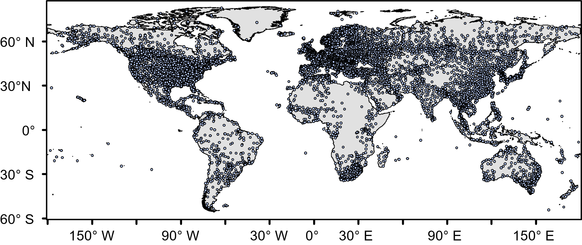
Fig. 1 Spatial distribution of GSOD stations

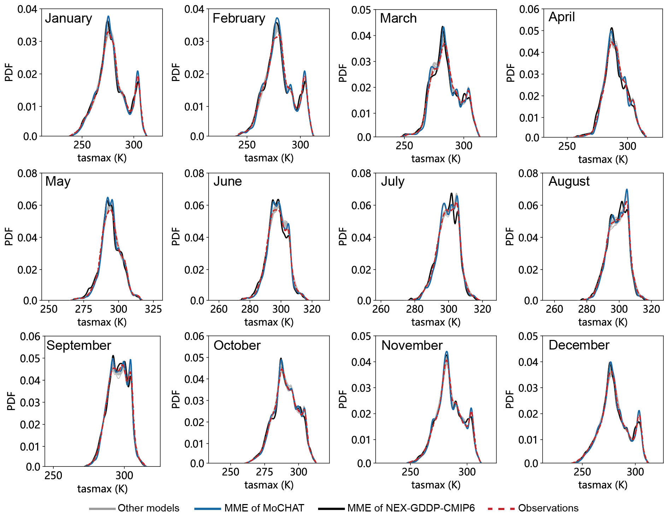
Fig. 2 Probability density of monthly tasmax of NEX-GDDP-CMIP6 and MoCHAT in comparison with observations. The continuous lines is probability density for all MoCHAT models (gray), MME of MoCHAT (blue) and MME of NEX-GDDP-CMIP6 (black). Red dotted line is probability density for GSOD data.

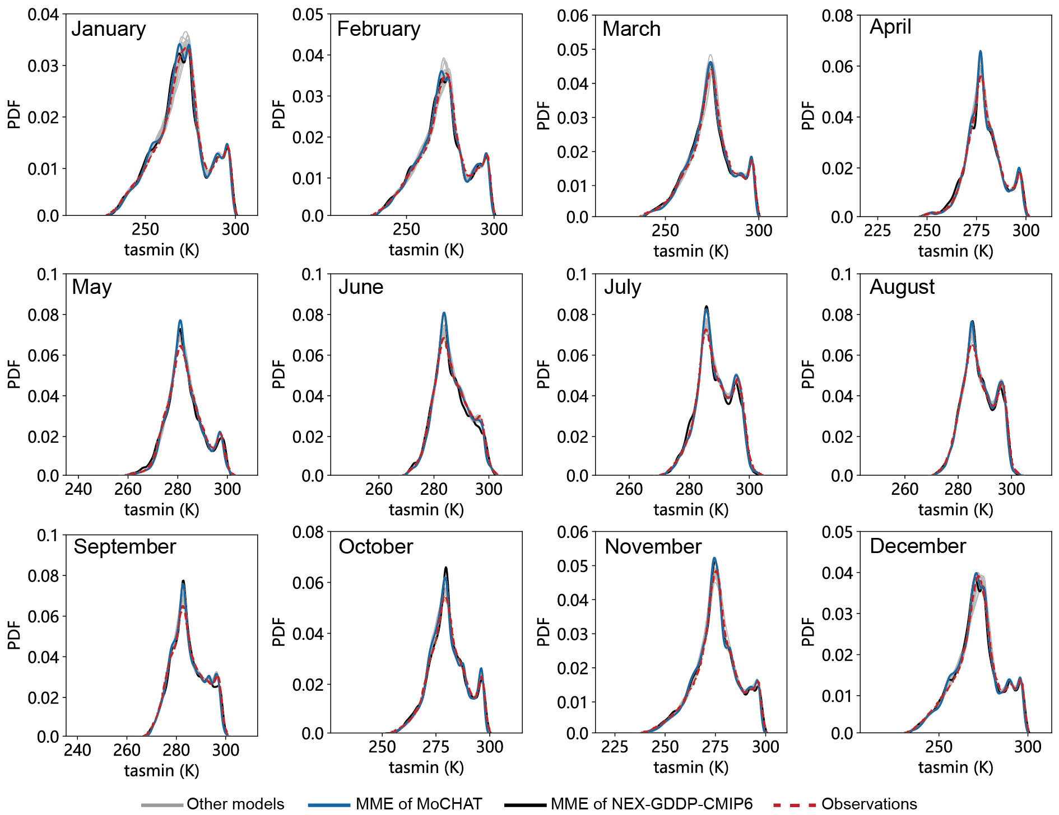
Fig. 3 Probability density of monthly tasmin of NEX-GDDP-CMIP6 and MoCHAT in comparison with observations. The continuous lines is probability density for all MoCHAT models (gray), MME of MoCHAT (blue) and MME of NEX-GDDP-CMIP6 (black). Red dotted line is probability density for GSOD data.

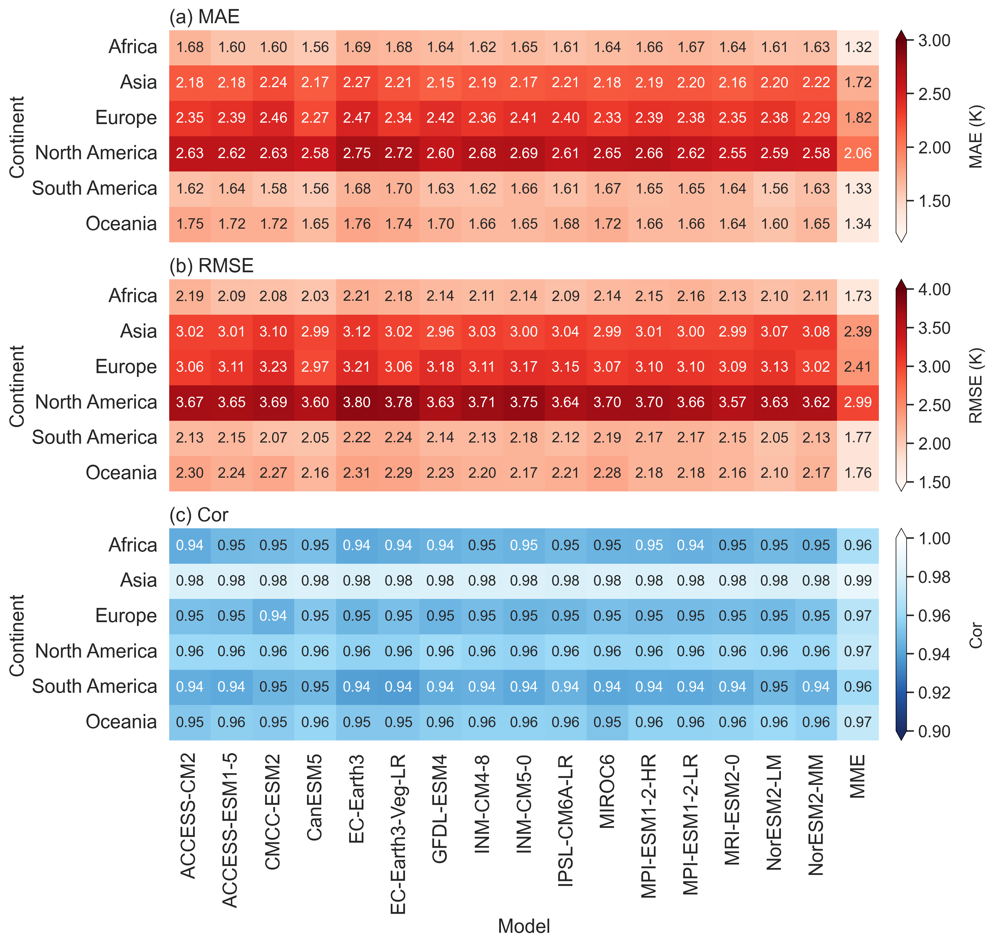
Fig. 4 Annual accuracy of tasmax of MoCHAT over each individual continent during 1950–2014: (a) MAE, (b) RMSE, (c)Cor. ‘Cor’ refers to Pearson’s correlation coefficient, hereafter.
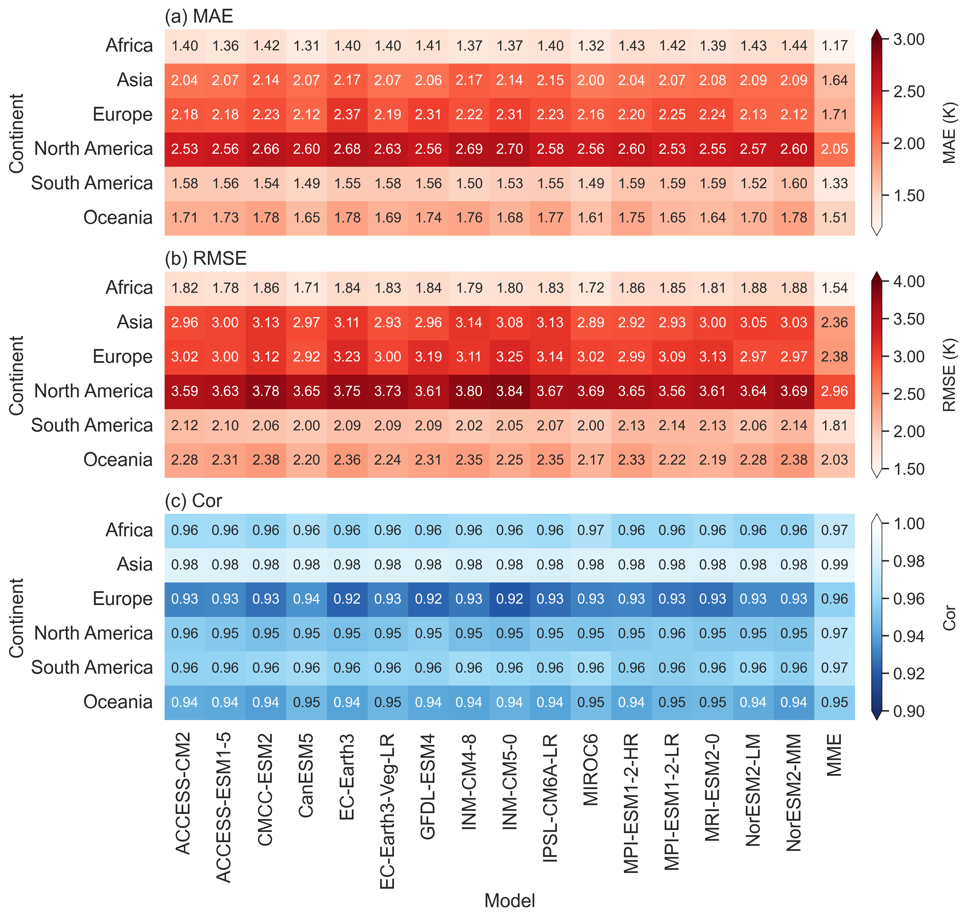
Fig. 5 Annual accuracy of tasmin of MoCHAT over each individual continent during 1950–2014: (a) MAE, (b) RMSE, (c) Cor.

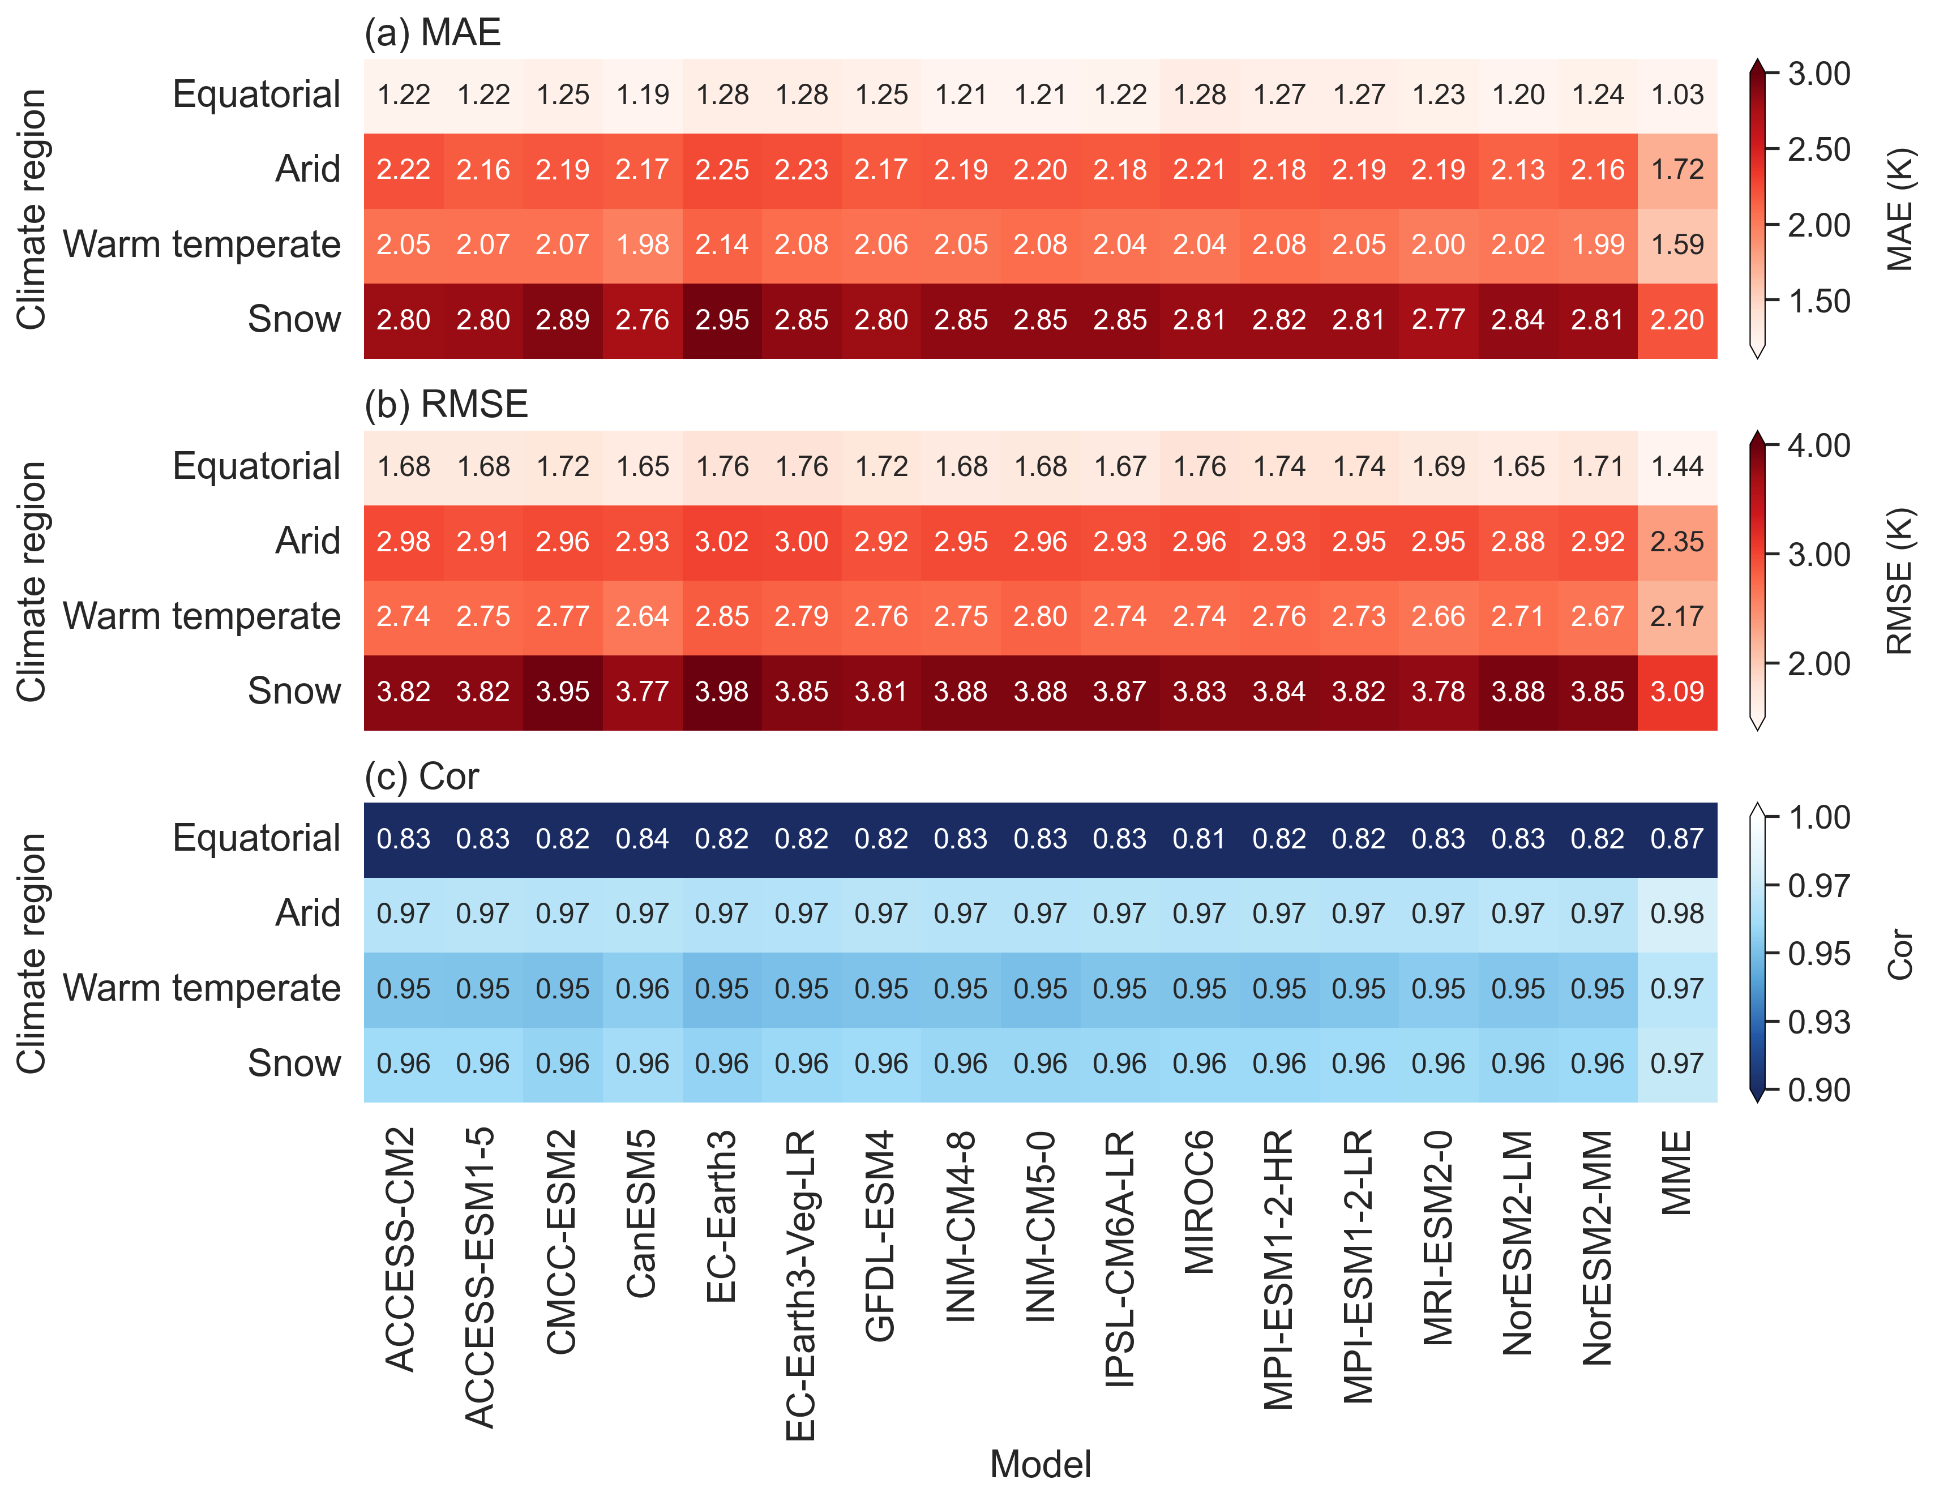
Fig. 6 Annual accuracy of tasmax of MoCHAT over Köppen-Geiger climate type during 1950–2014: (a) MAE, (b) RMSE, (c) Cor.

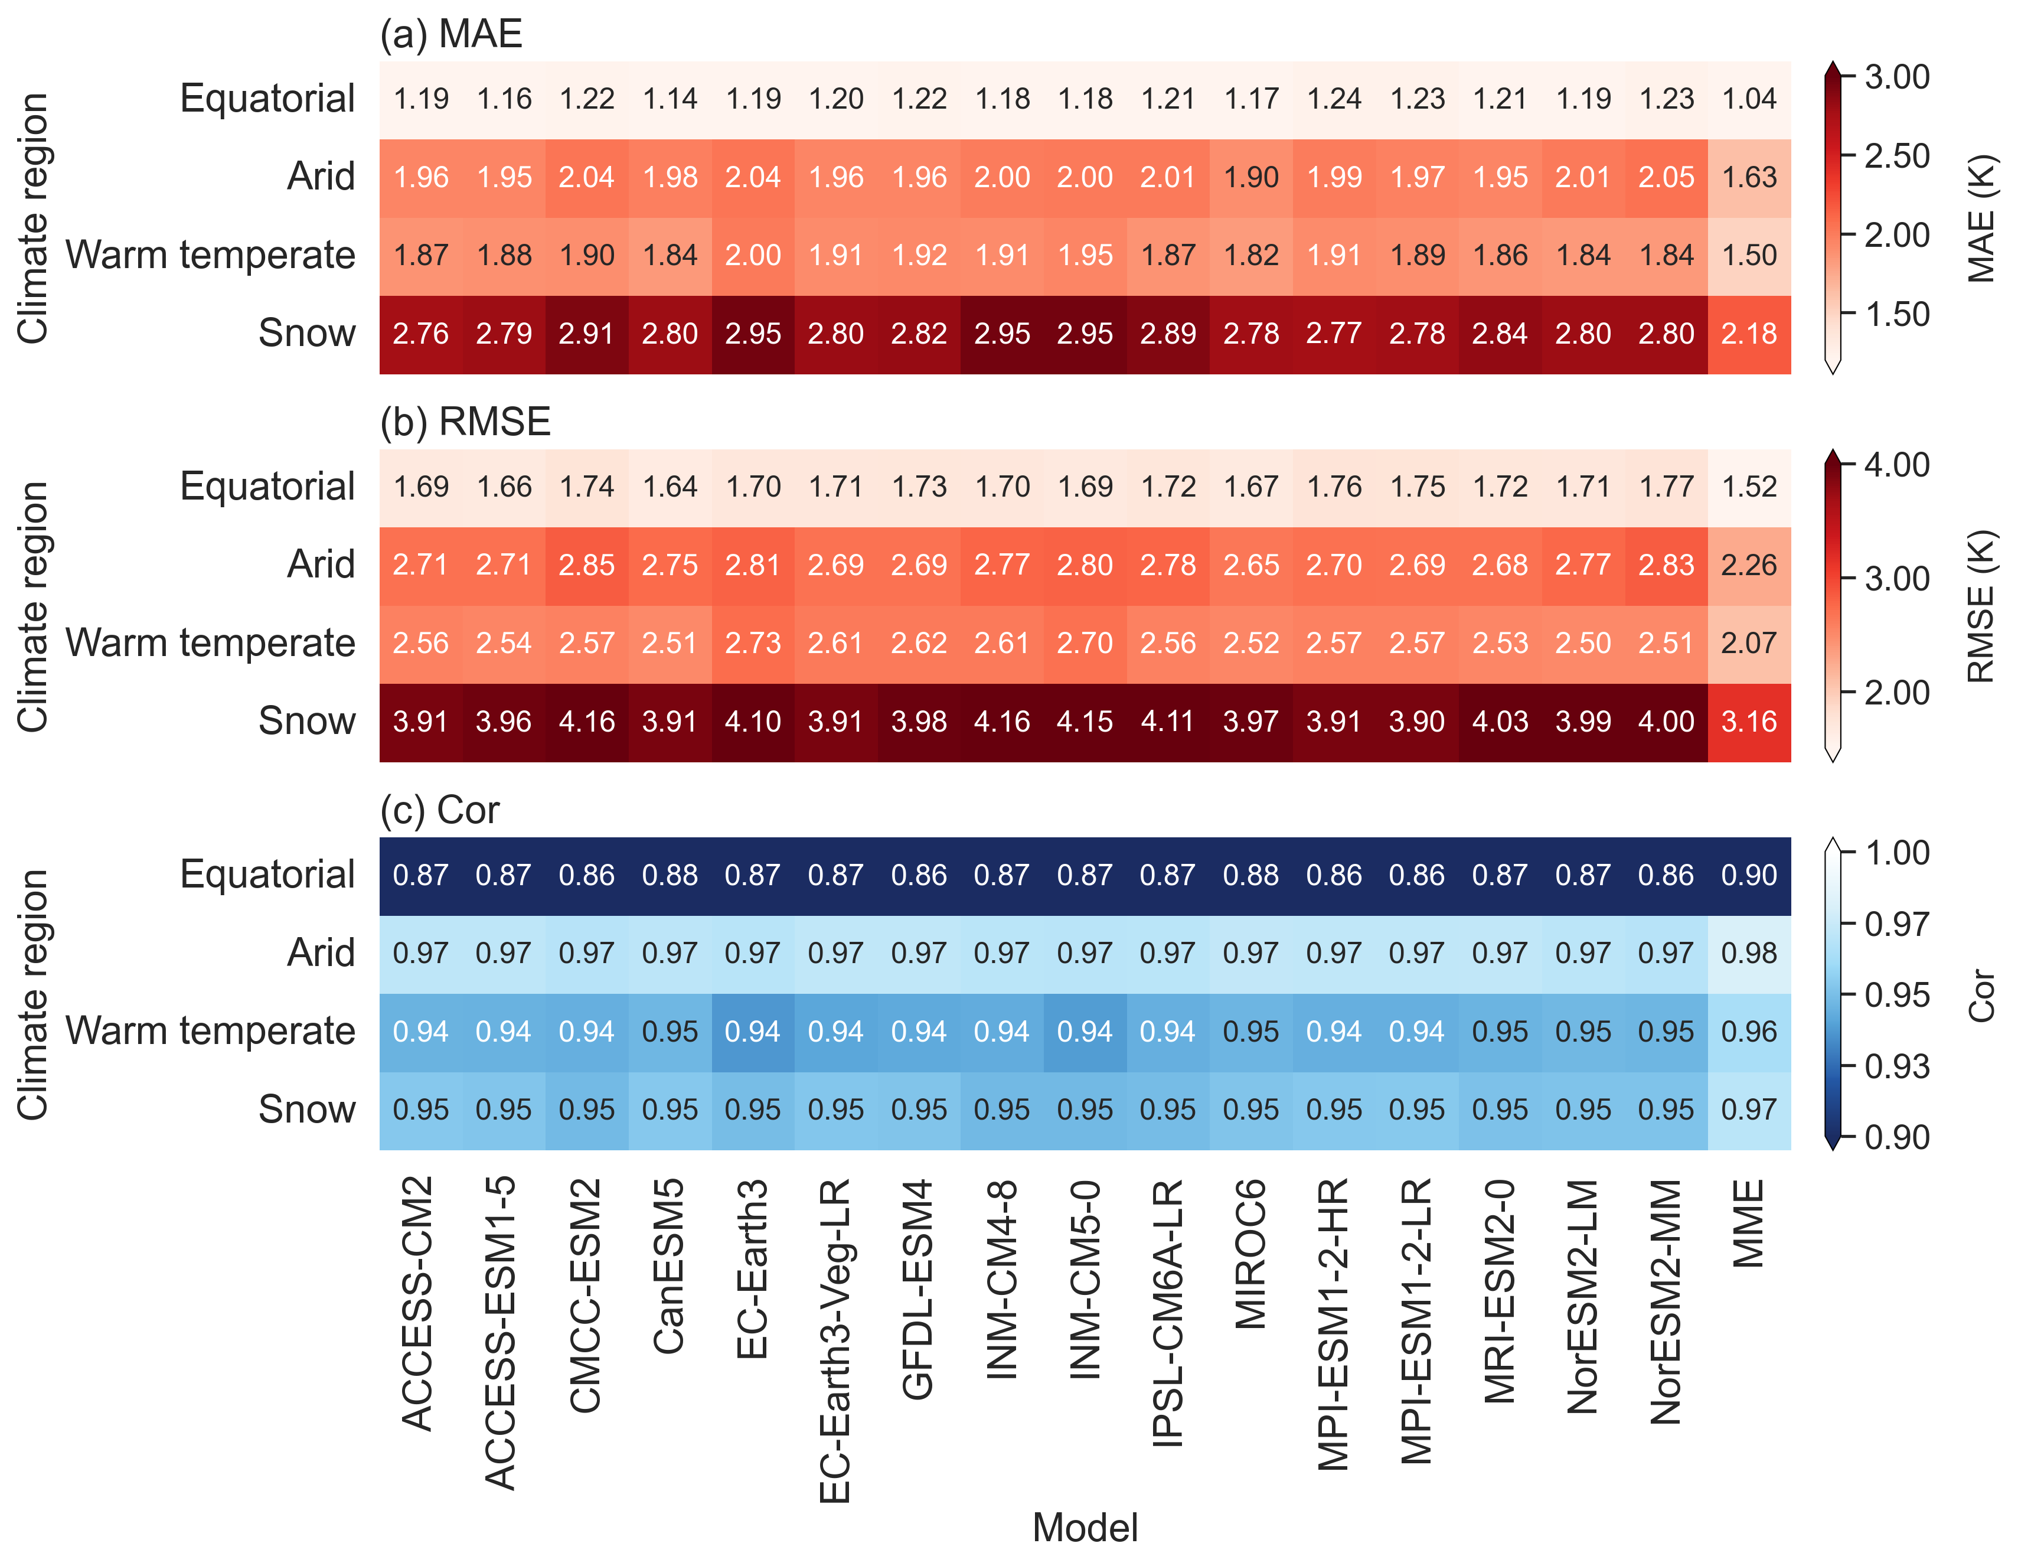
Fig. 7 Annual accuracy of tasmin of MoCHAT over Köppen-Geiger climate type during 1950–2014: (a) MAE, (b) RMSE, (c) Cor.

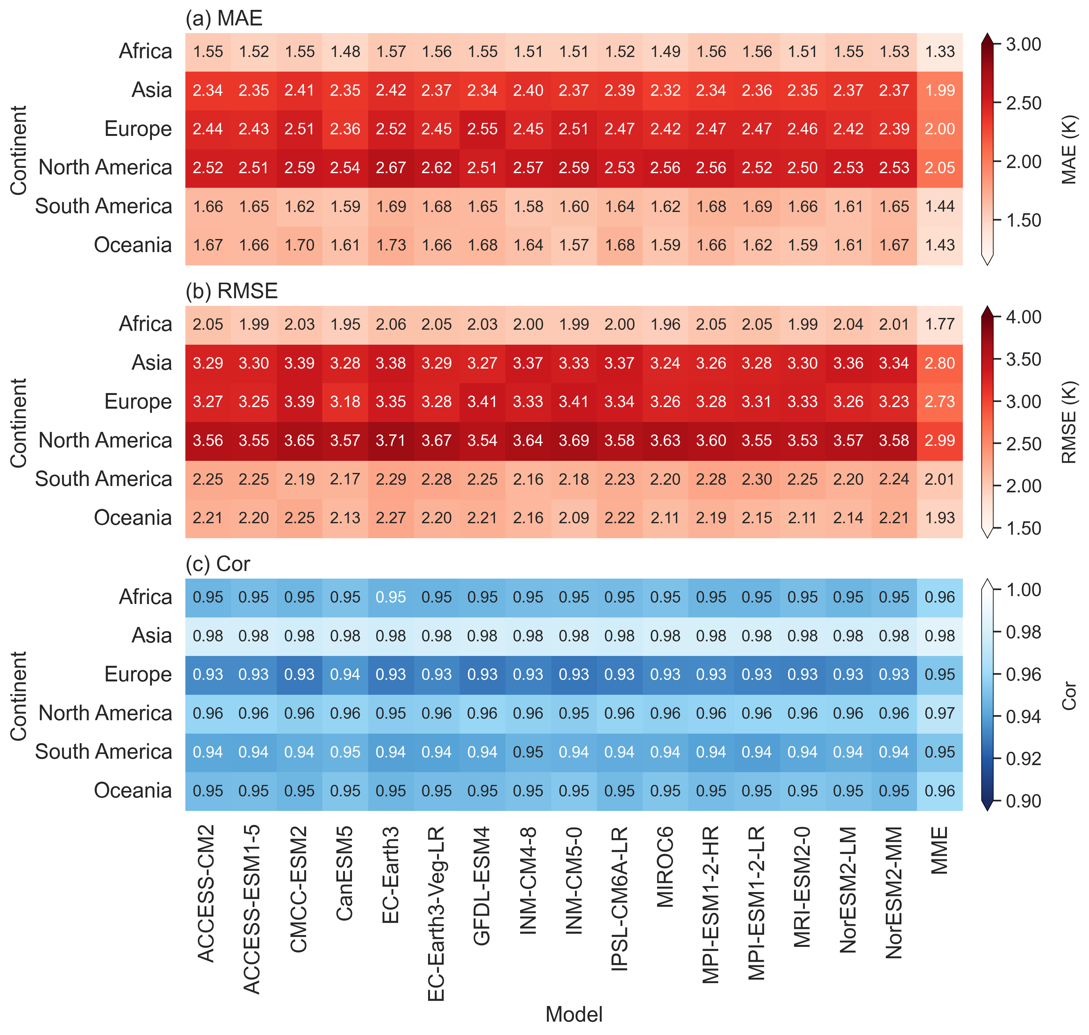
Fig. 8 Annual accuracy of tas of NEX-GDDP-CMIP6 over each individual continent during 1950–2014: (a) MAE, (b) RMSE, (c) Cor.

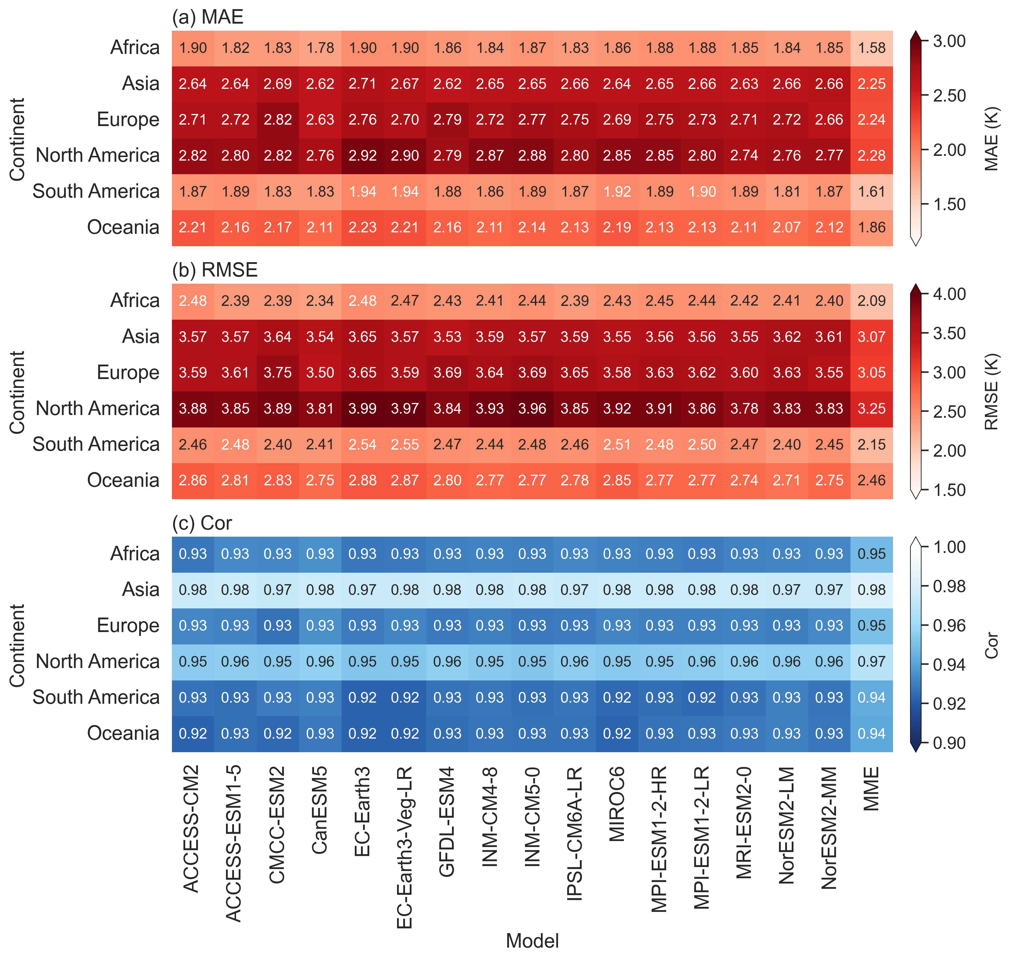
Fig. 9 Annual accuracy of tasmax of NEX-GDDP-CMIP6 over each individual continent during 1950–2014: (a) MAE, (b) RMSE, (c) Cor.

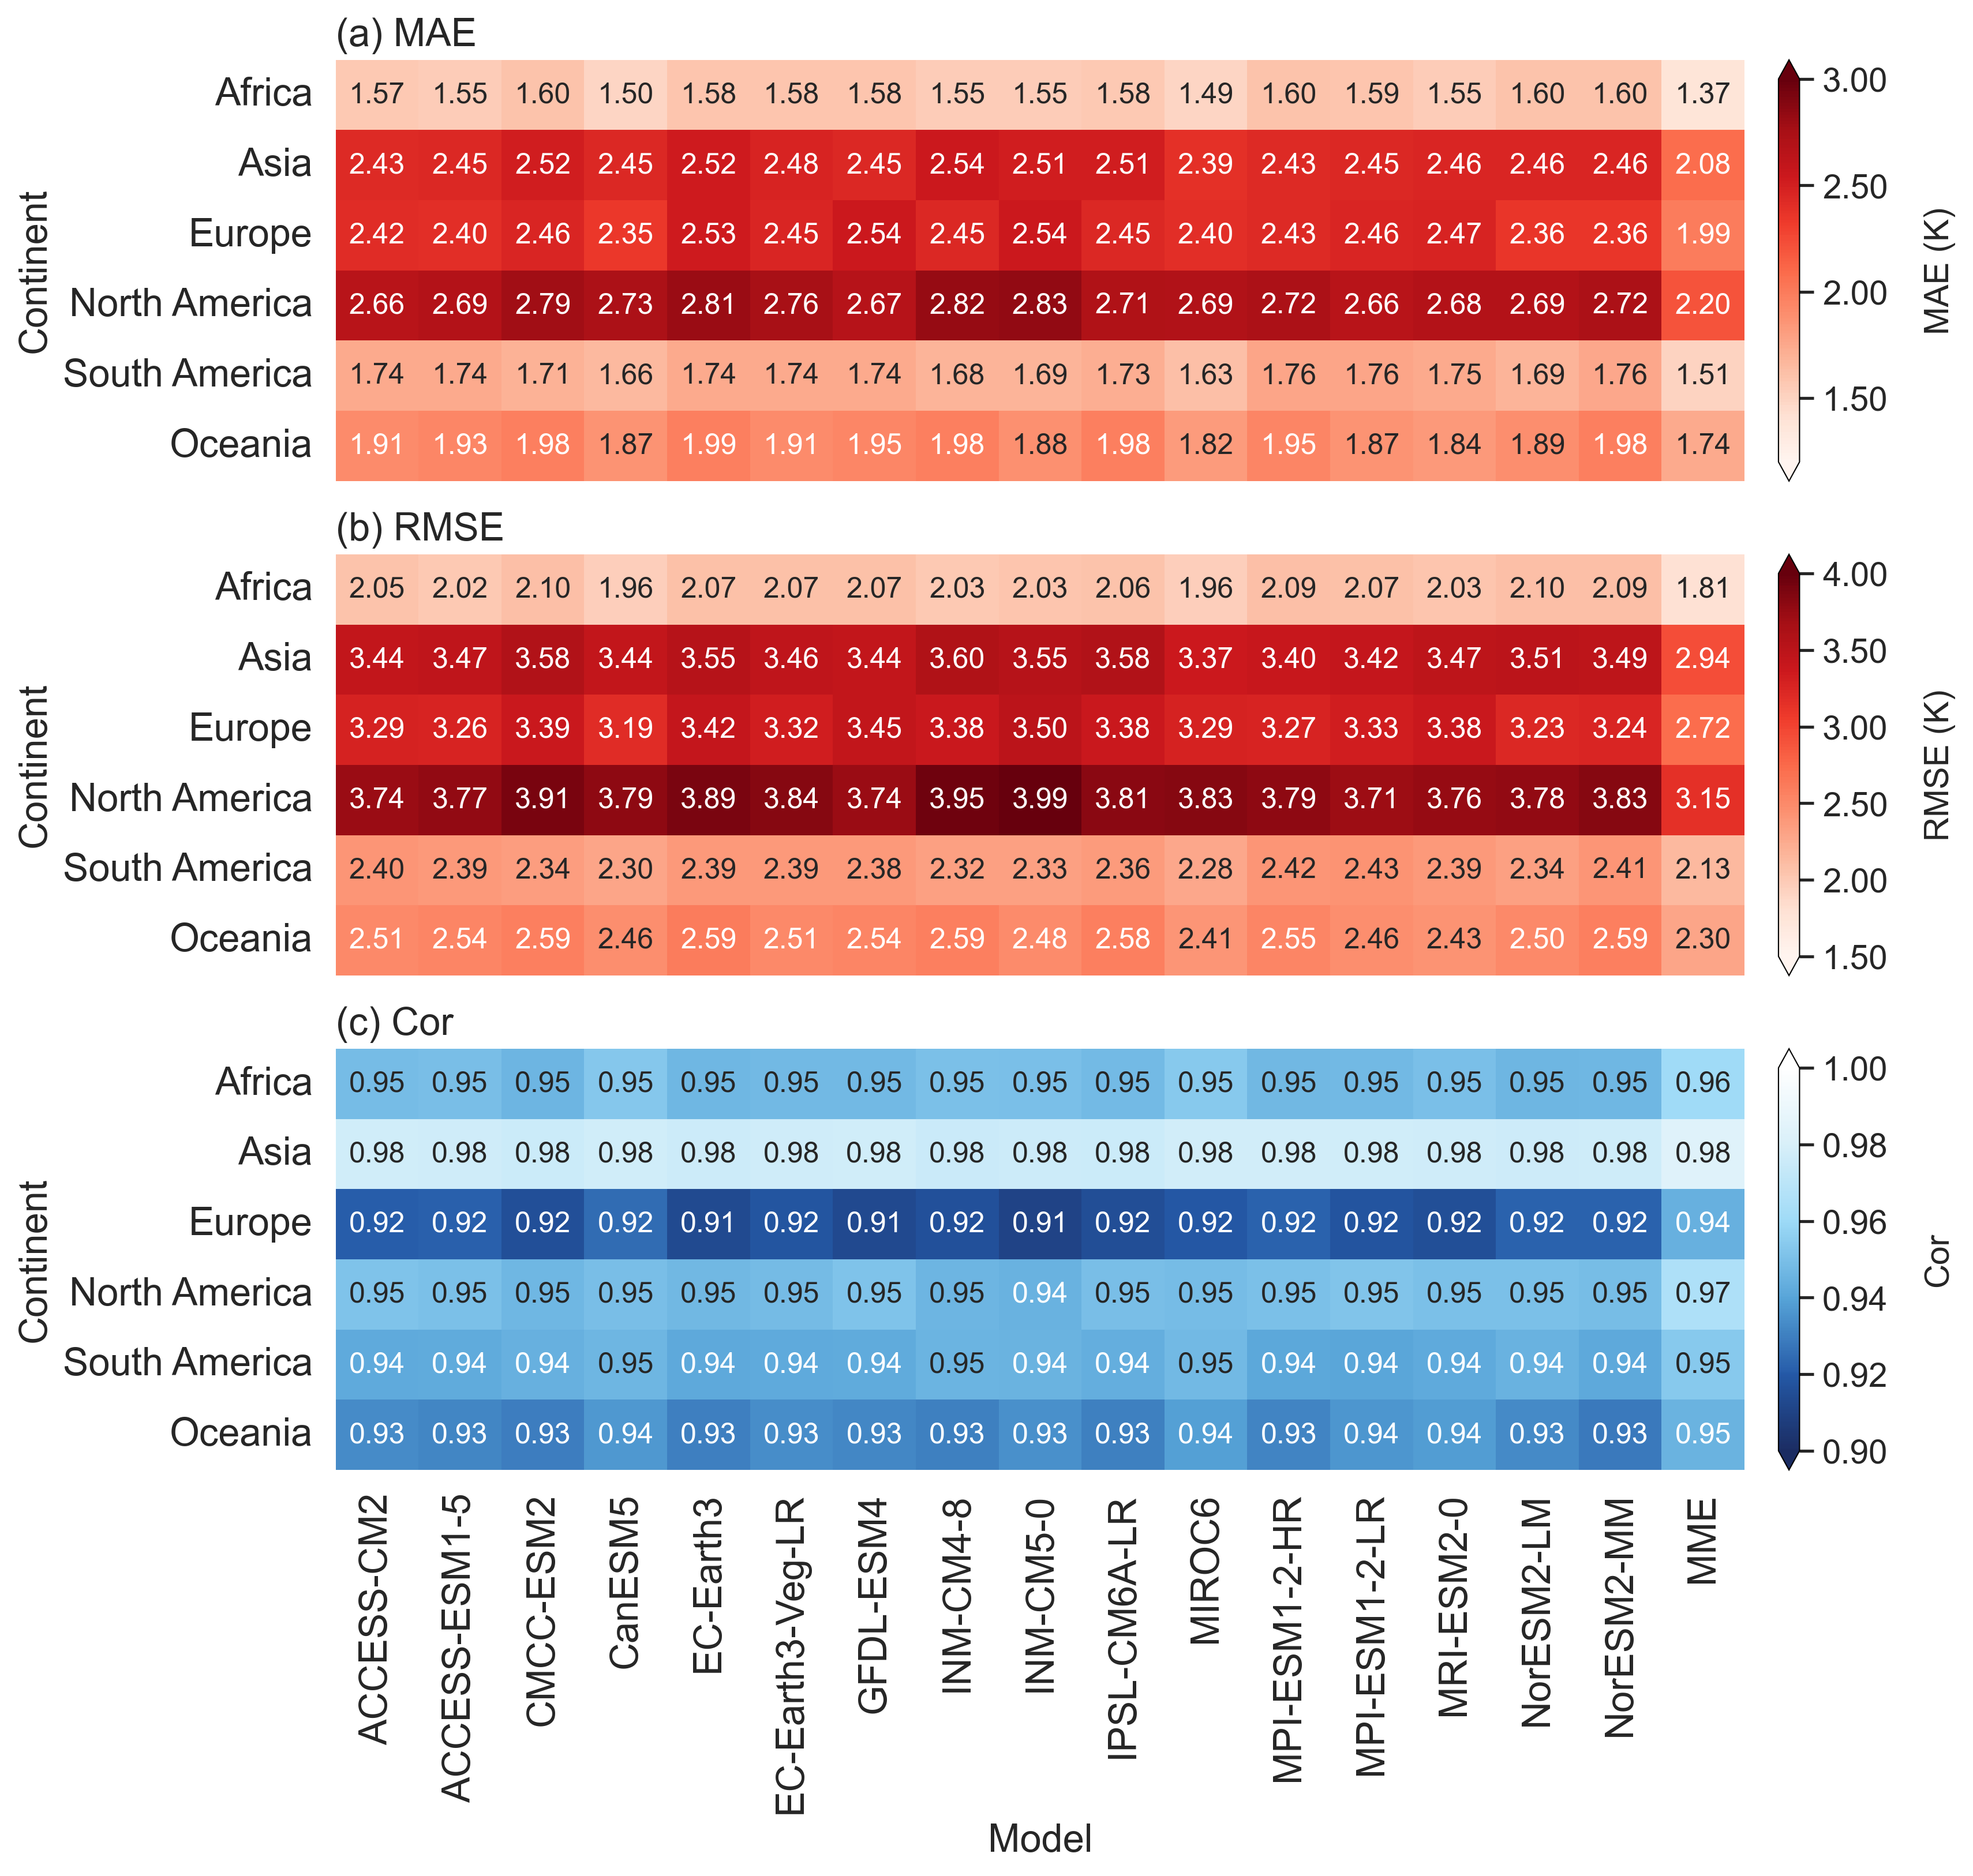
Fig. 10 Annual accuracy of tasmin of NEX-GDDP-CMIP6 over each individual continent during 1950–2014: (a) MAE, (b) RMSE, (c) Cor.

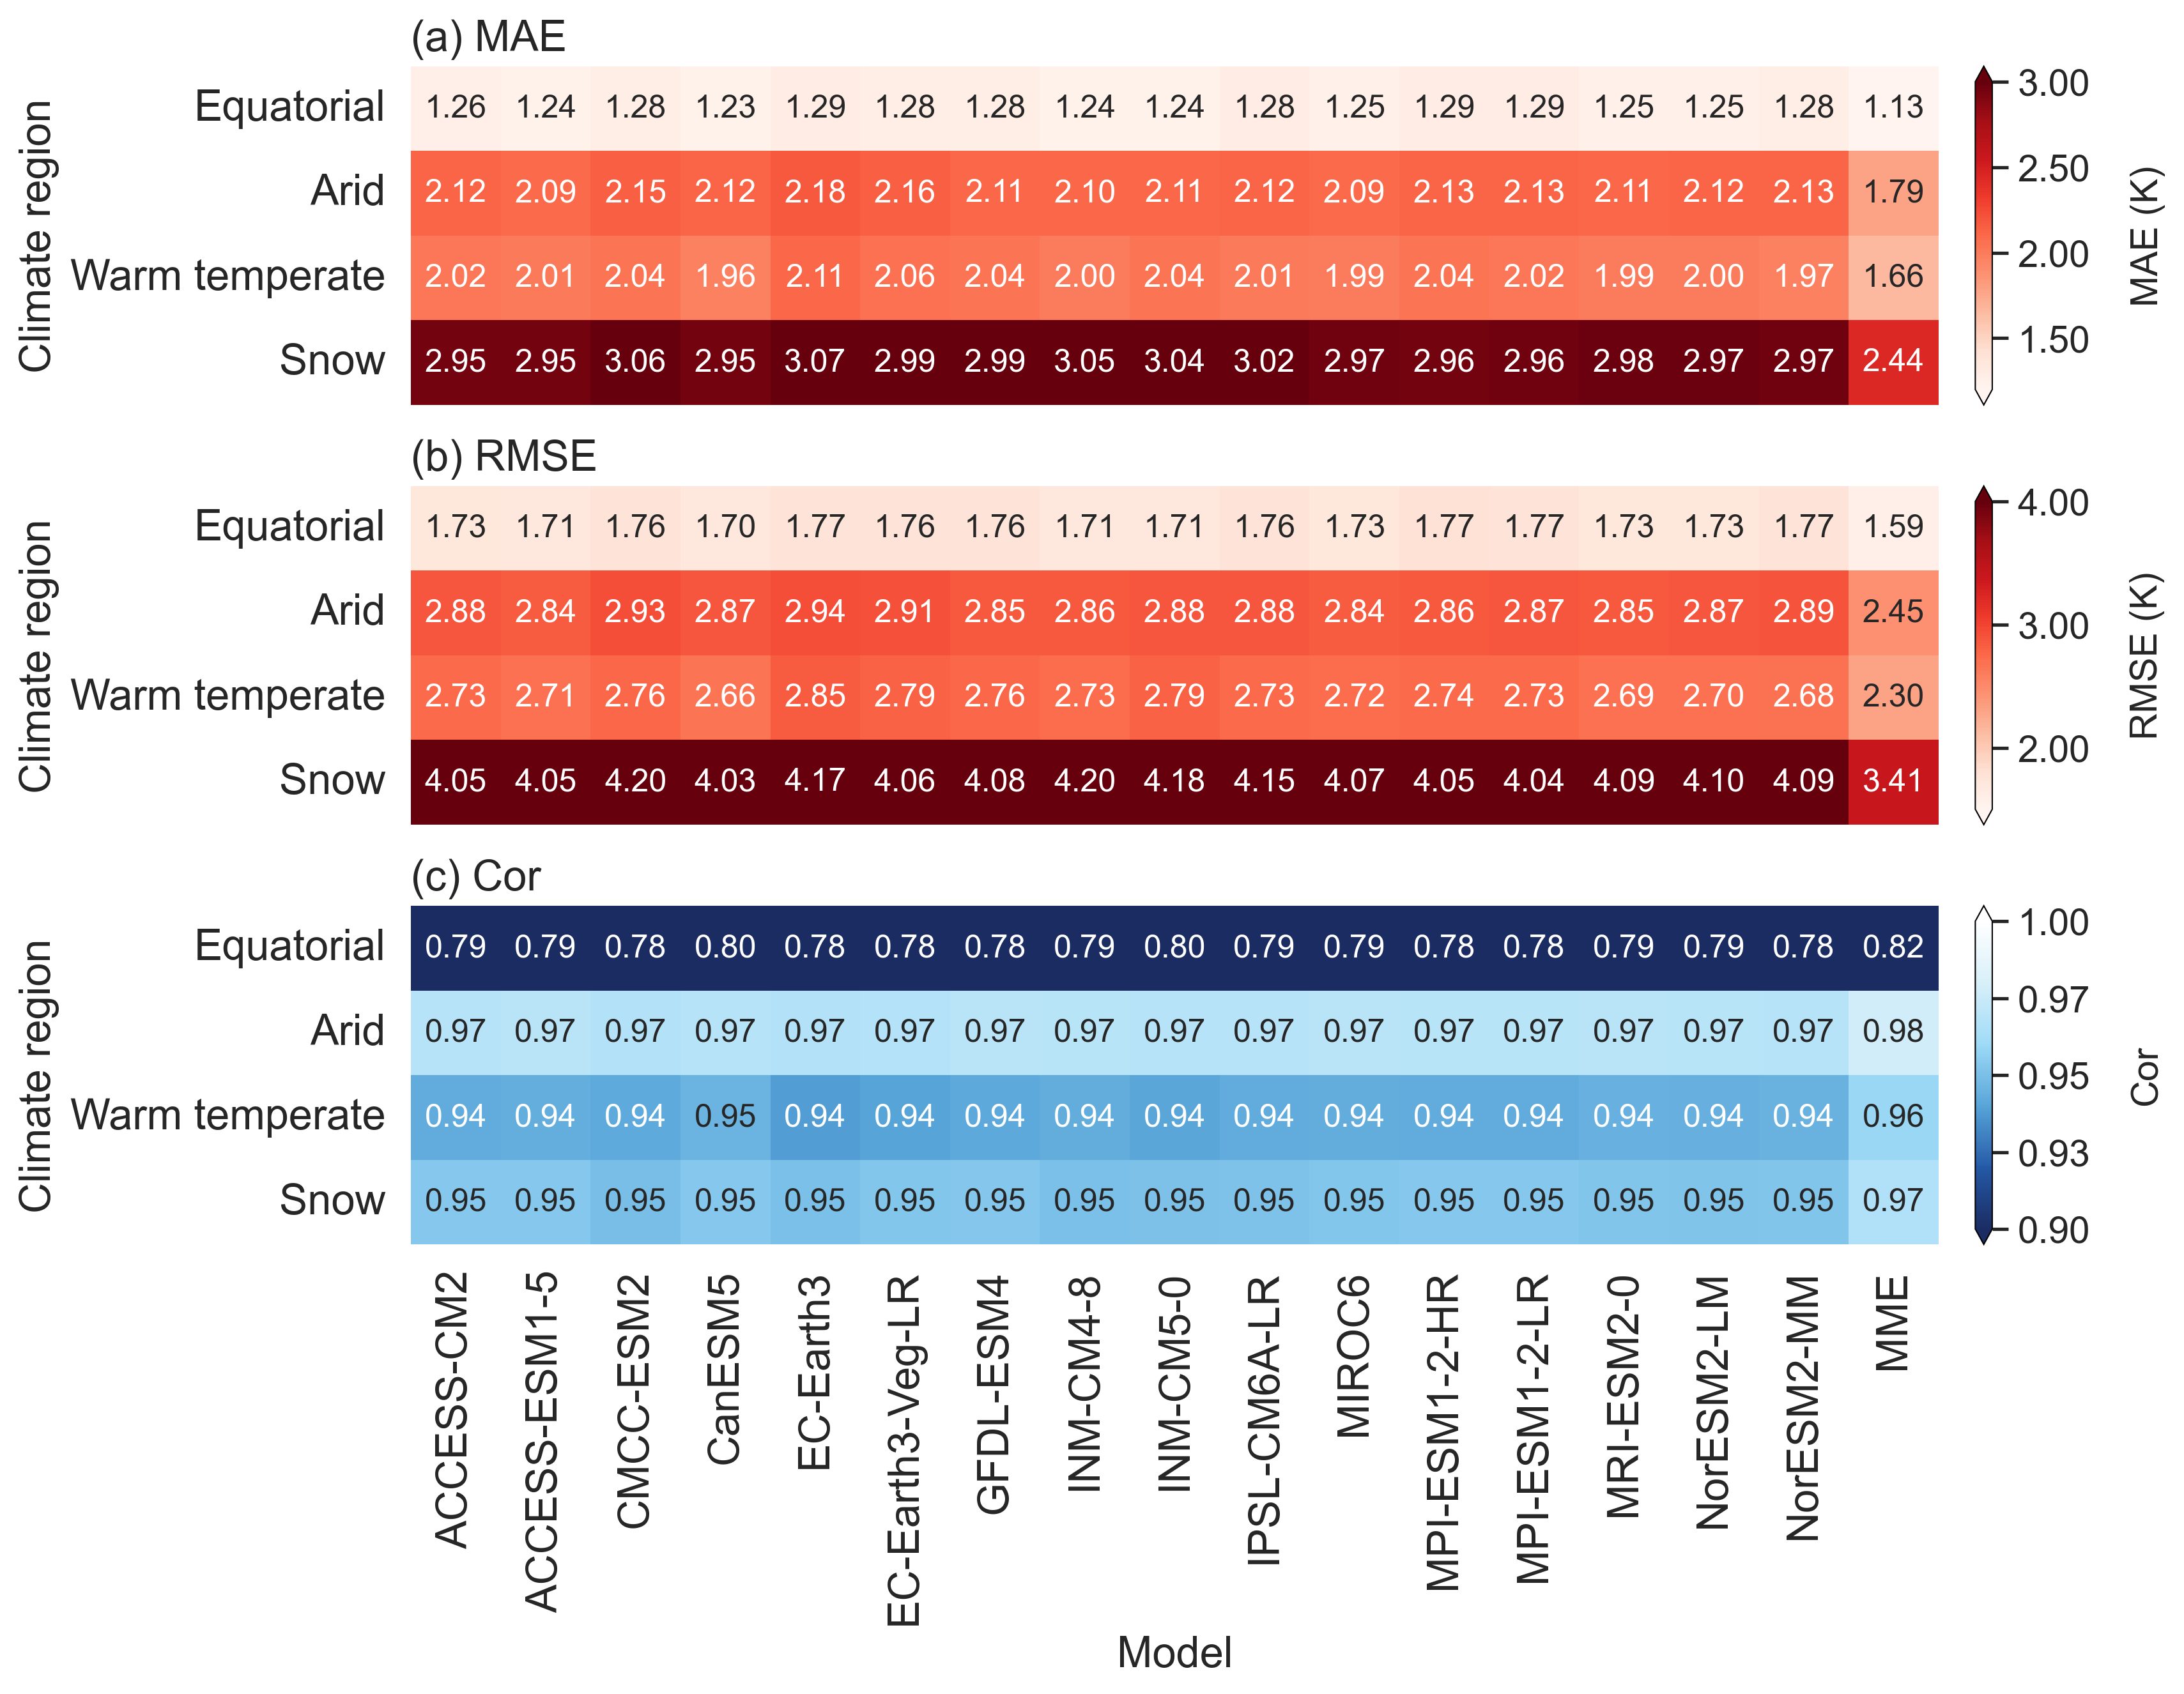
Fig. 11 Annual accuracy of tas of NEX-GDDP-CMIP6 over Köppen-Geiger climate type during 1950–2014: (a) MAE, (b) RMSE, (c) Cor.

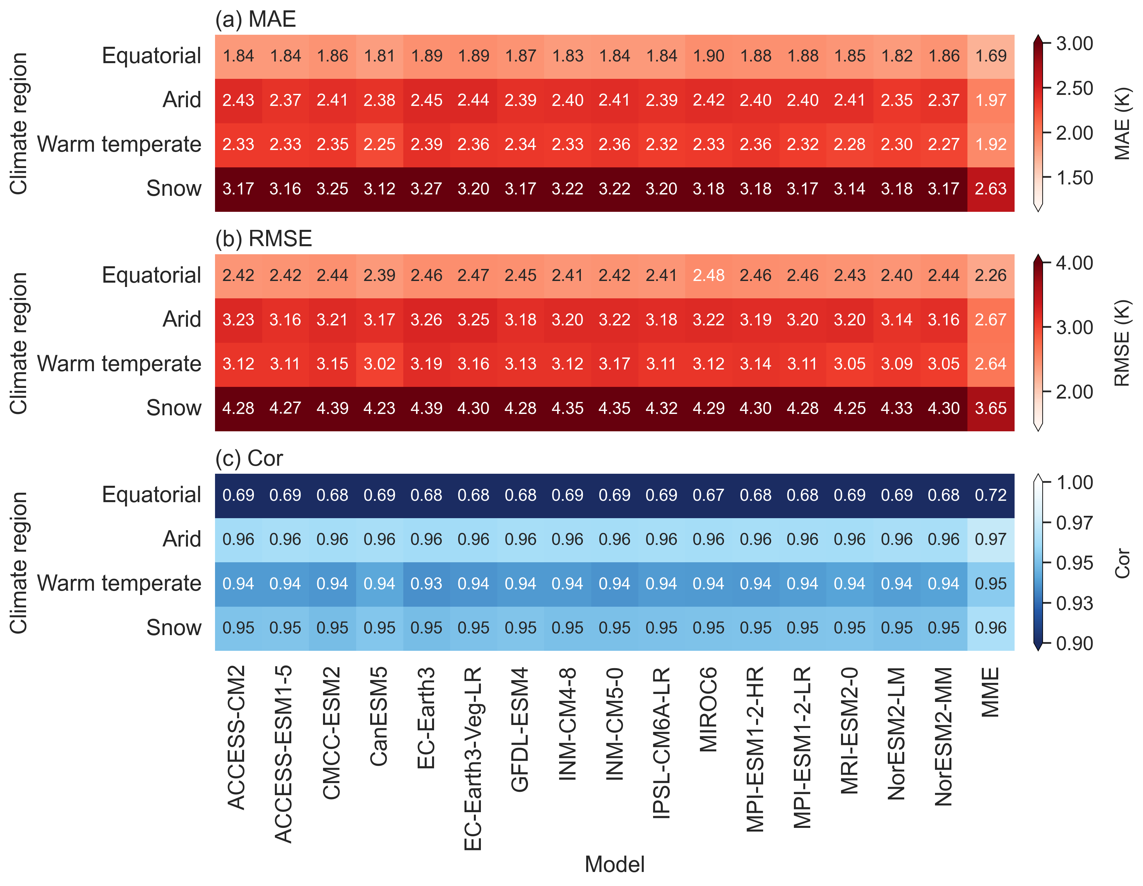
Fig. 12 Annual accuracy of tasmax of NEX-GDDP-CMIP6 over Köppen-Geiger climate type during 1950–2014: (a) MAE, (b) RMSE, (c) Cor.

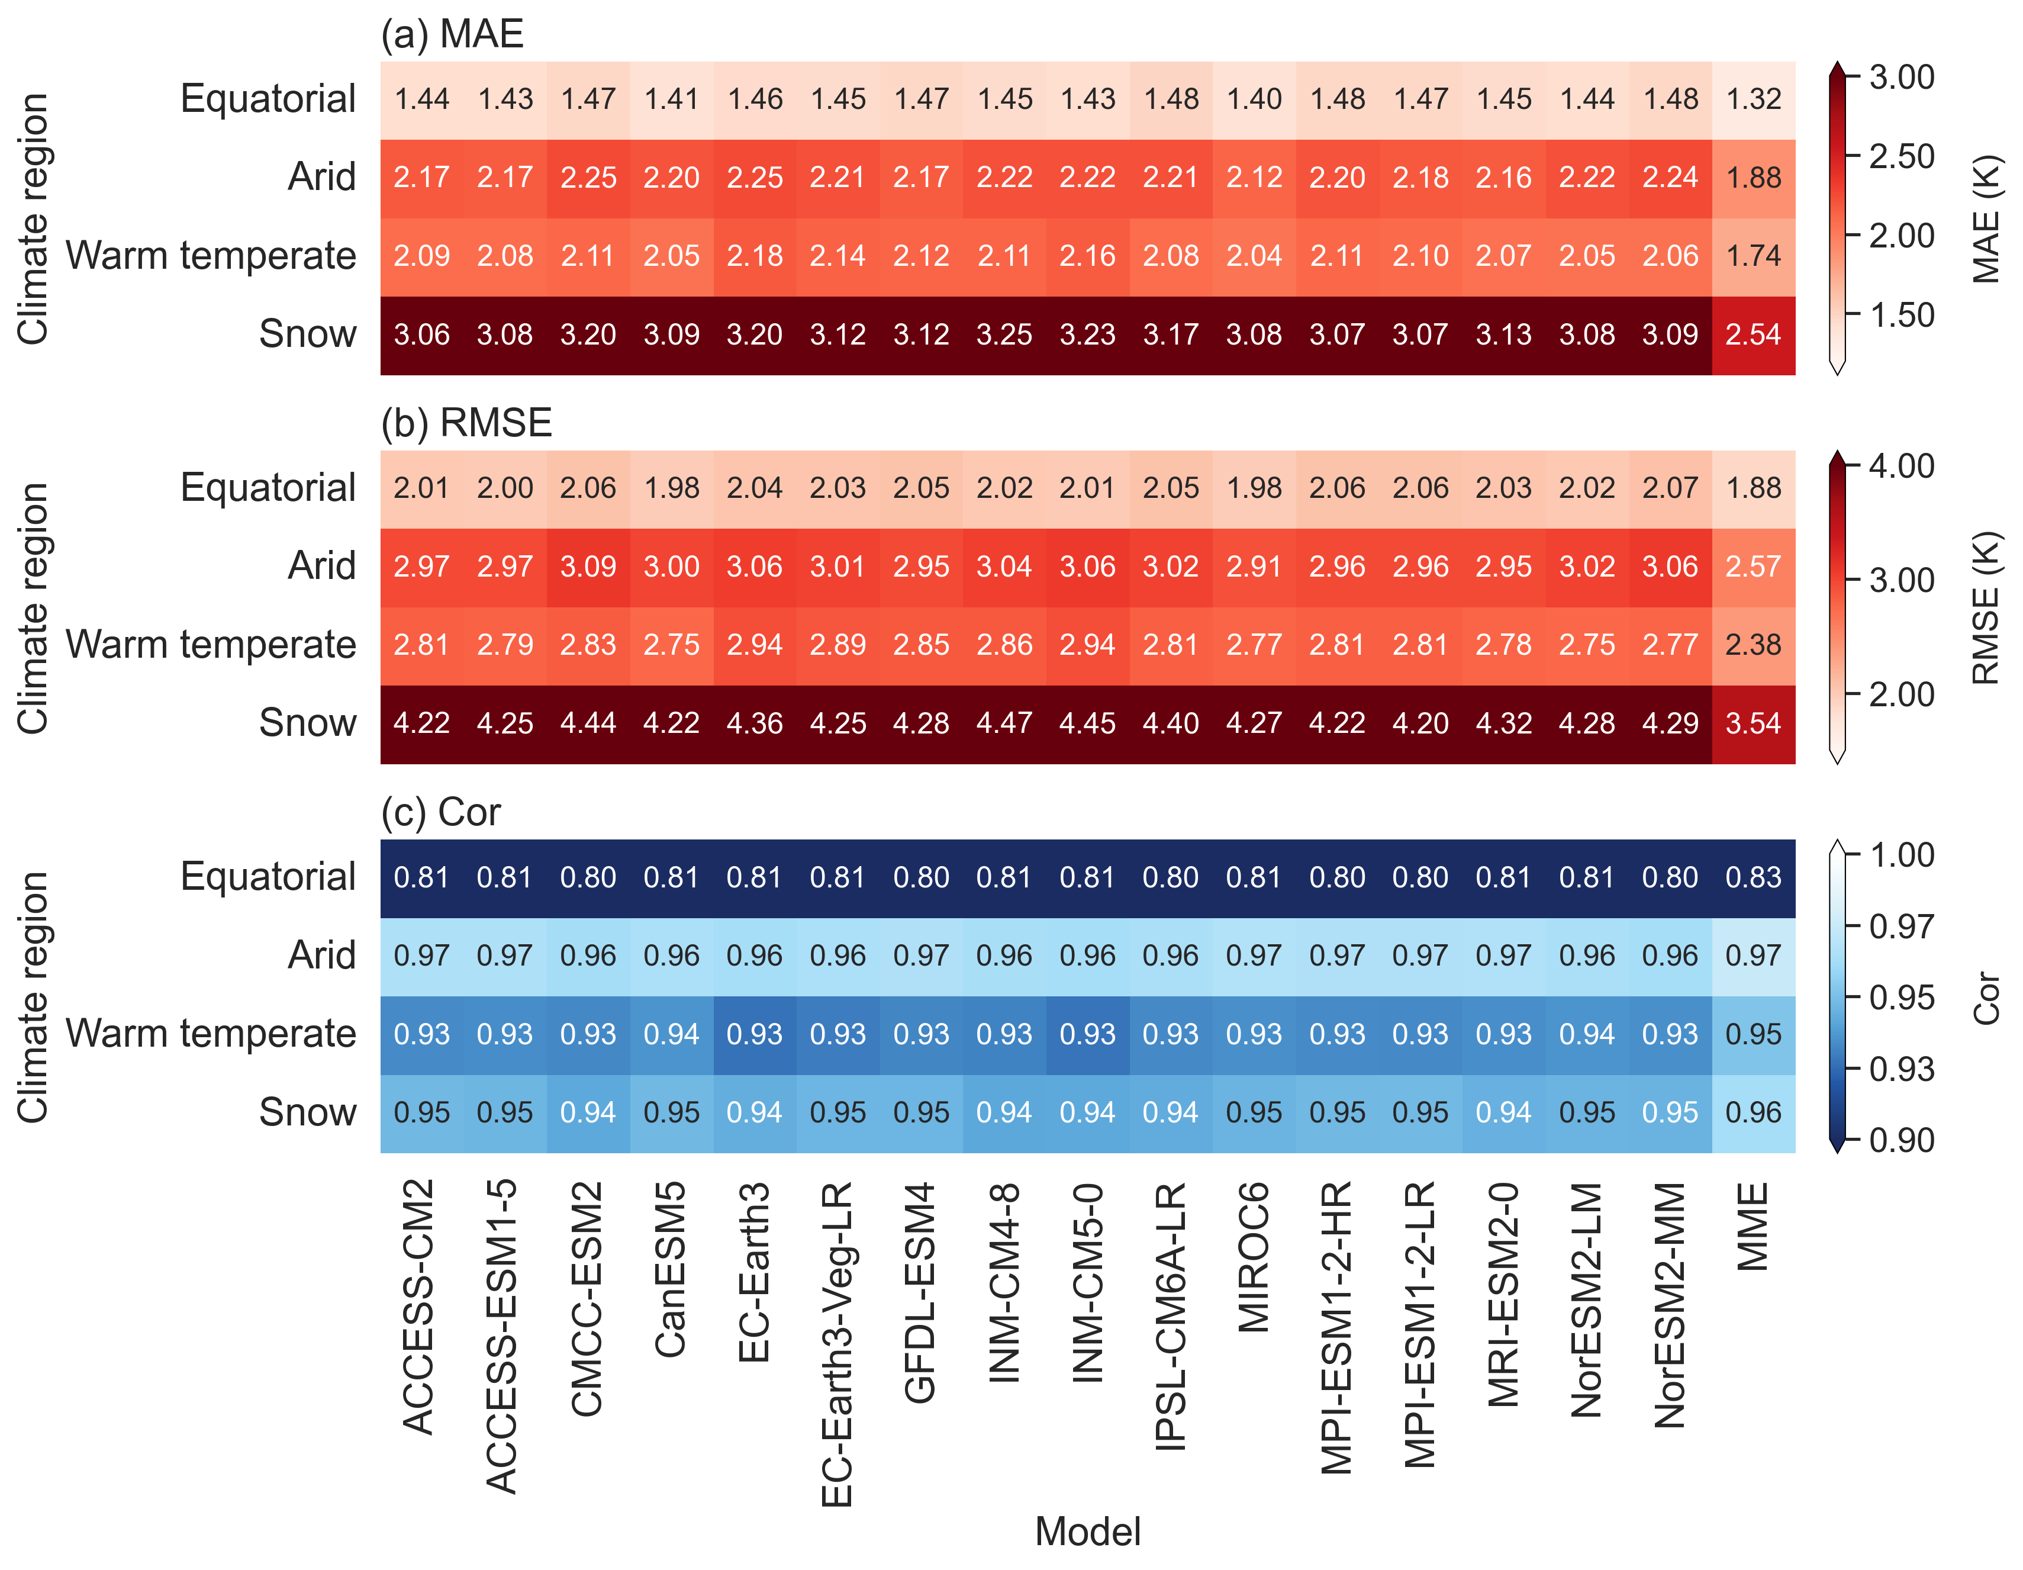
Fig. 13 Annual accuracy of tasmin of NEX-GDDP-CMIP6 over Köppen-Geiger climate type during 1950–2014: (a) MAE, (b) RMSE, (c) Cor.

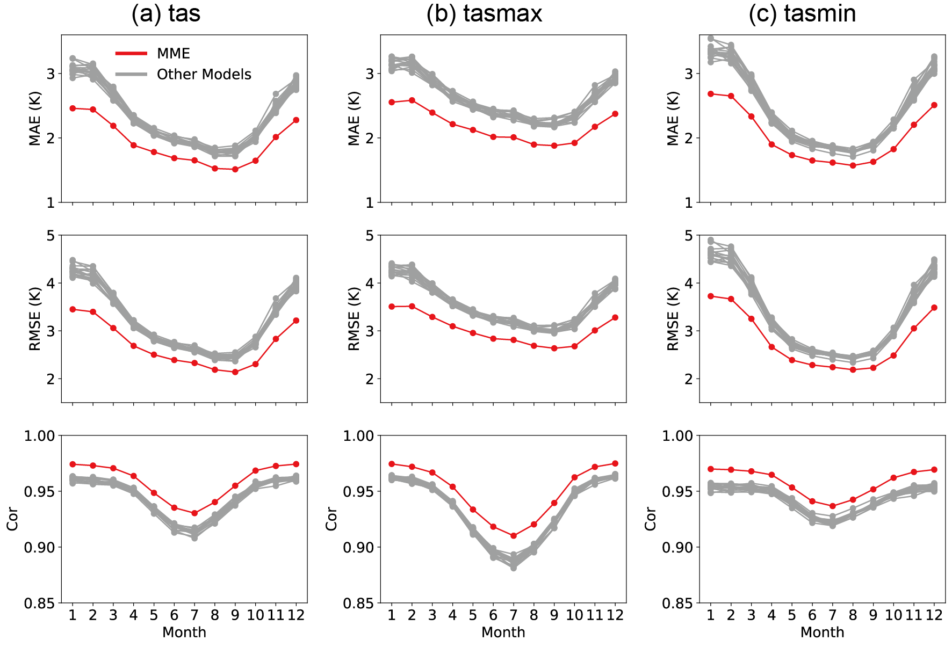
Fig. 14 Statistical metrics used to measure the performance of downscaled data in monthly mean (1950–2014) of tas, tasmax, and tasmin.
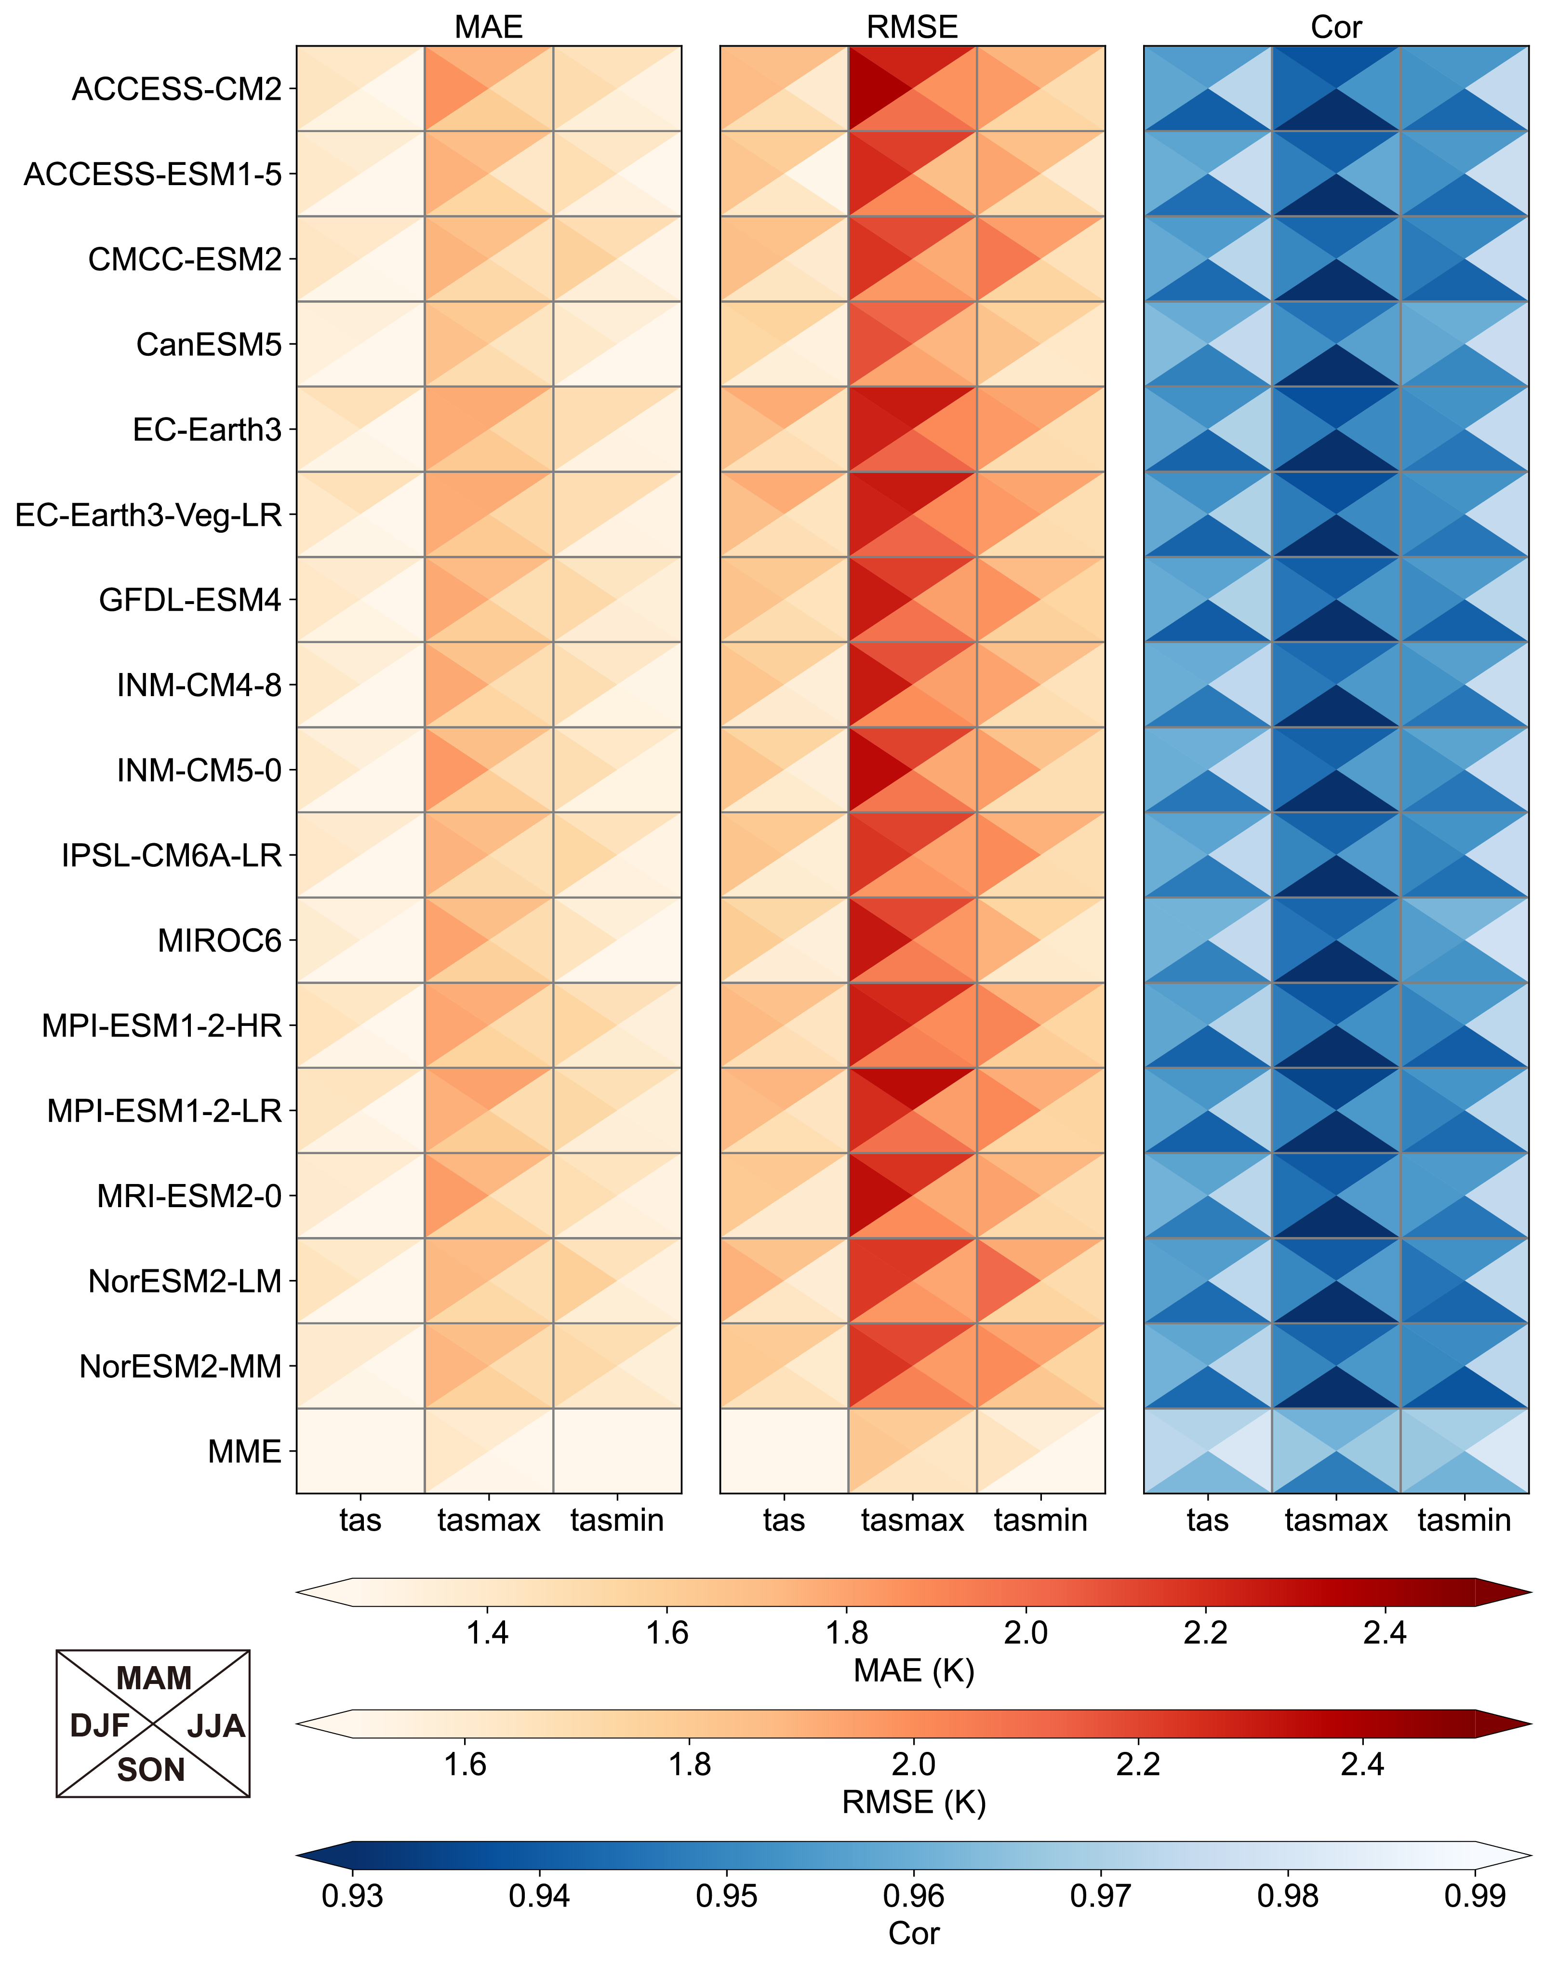
Fig. 15 Seasonal accuracy of tas, tasmax, tasmin of MoCHAT at Africa during 1950–2014. Results from all GCMs are evaluated against GSOD data. DJF: December-January-February; MAM: March-April-May; JJA: June-July-August; SON: September-October-November.
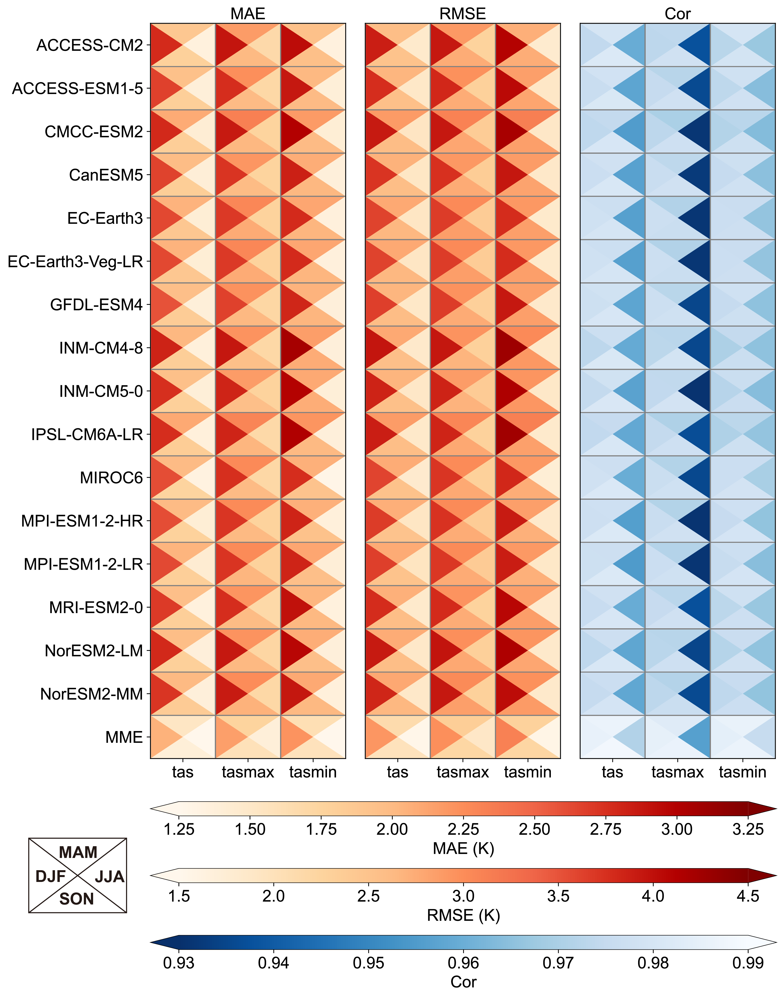
Fig. 16 Seasonal accuracy of tas, tasmax, tasmin of MoCHAT at Asia during 1950–2014. Results from all GCMs are evaluated against GSOD data. DJF: December-January-February; MAM: March-April-May; JJA: June-July-August; SON: September-October-November.
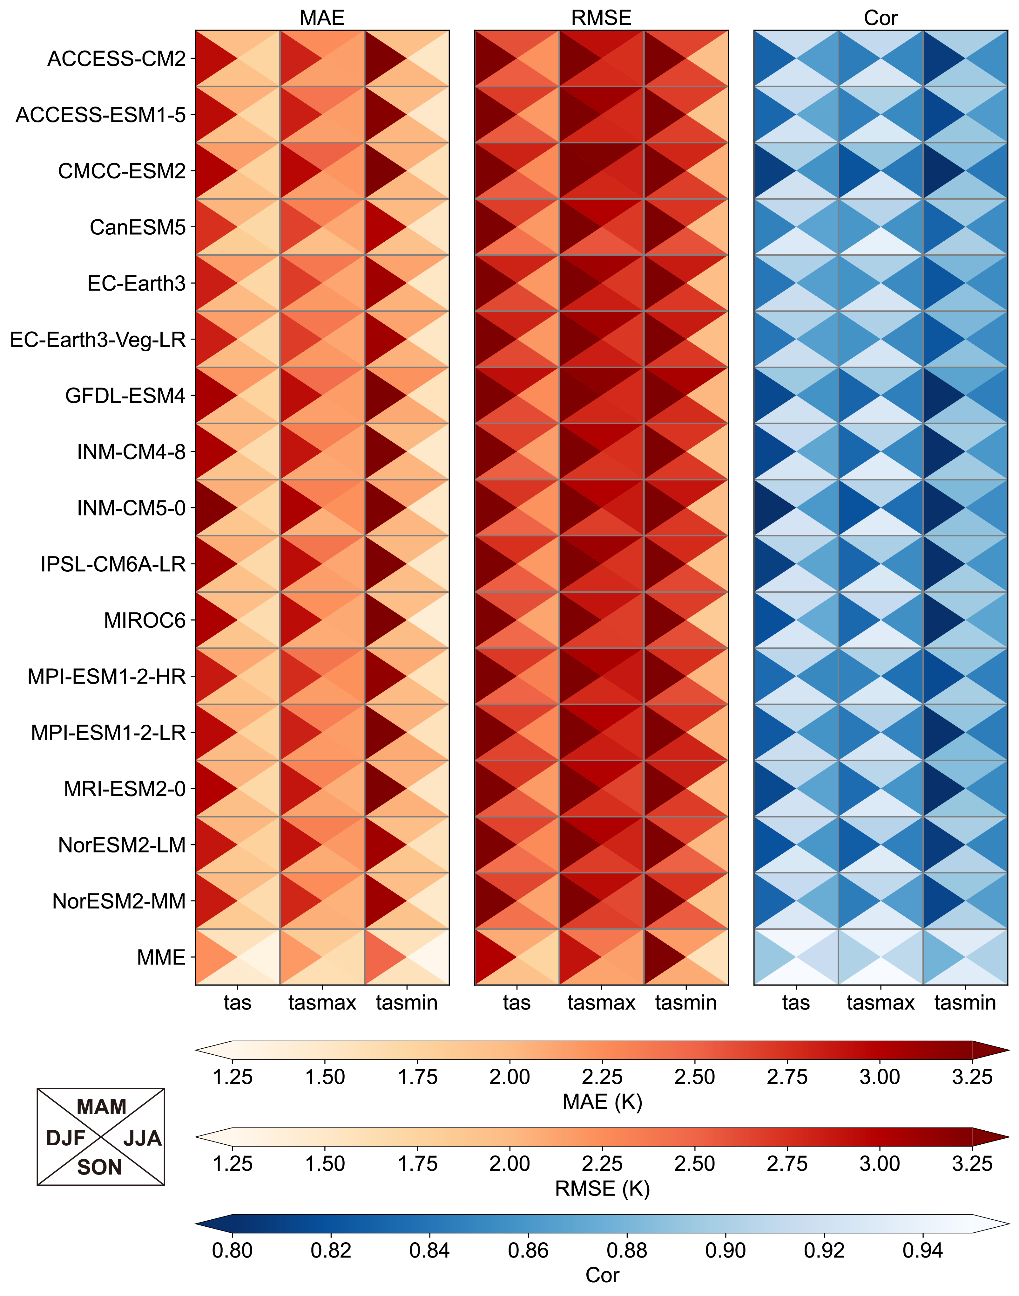
Fig. 17 Seasonal accuracy of tas, tasmax, tasmin of MoCHAT at Europe during 1950–2014. Results from all GCMs are evaluated against GSOD data. DJF: December-January-February; MAM: March-April-May; JJA: June-July-August; SON: September-October-November.

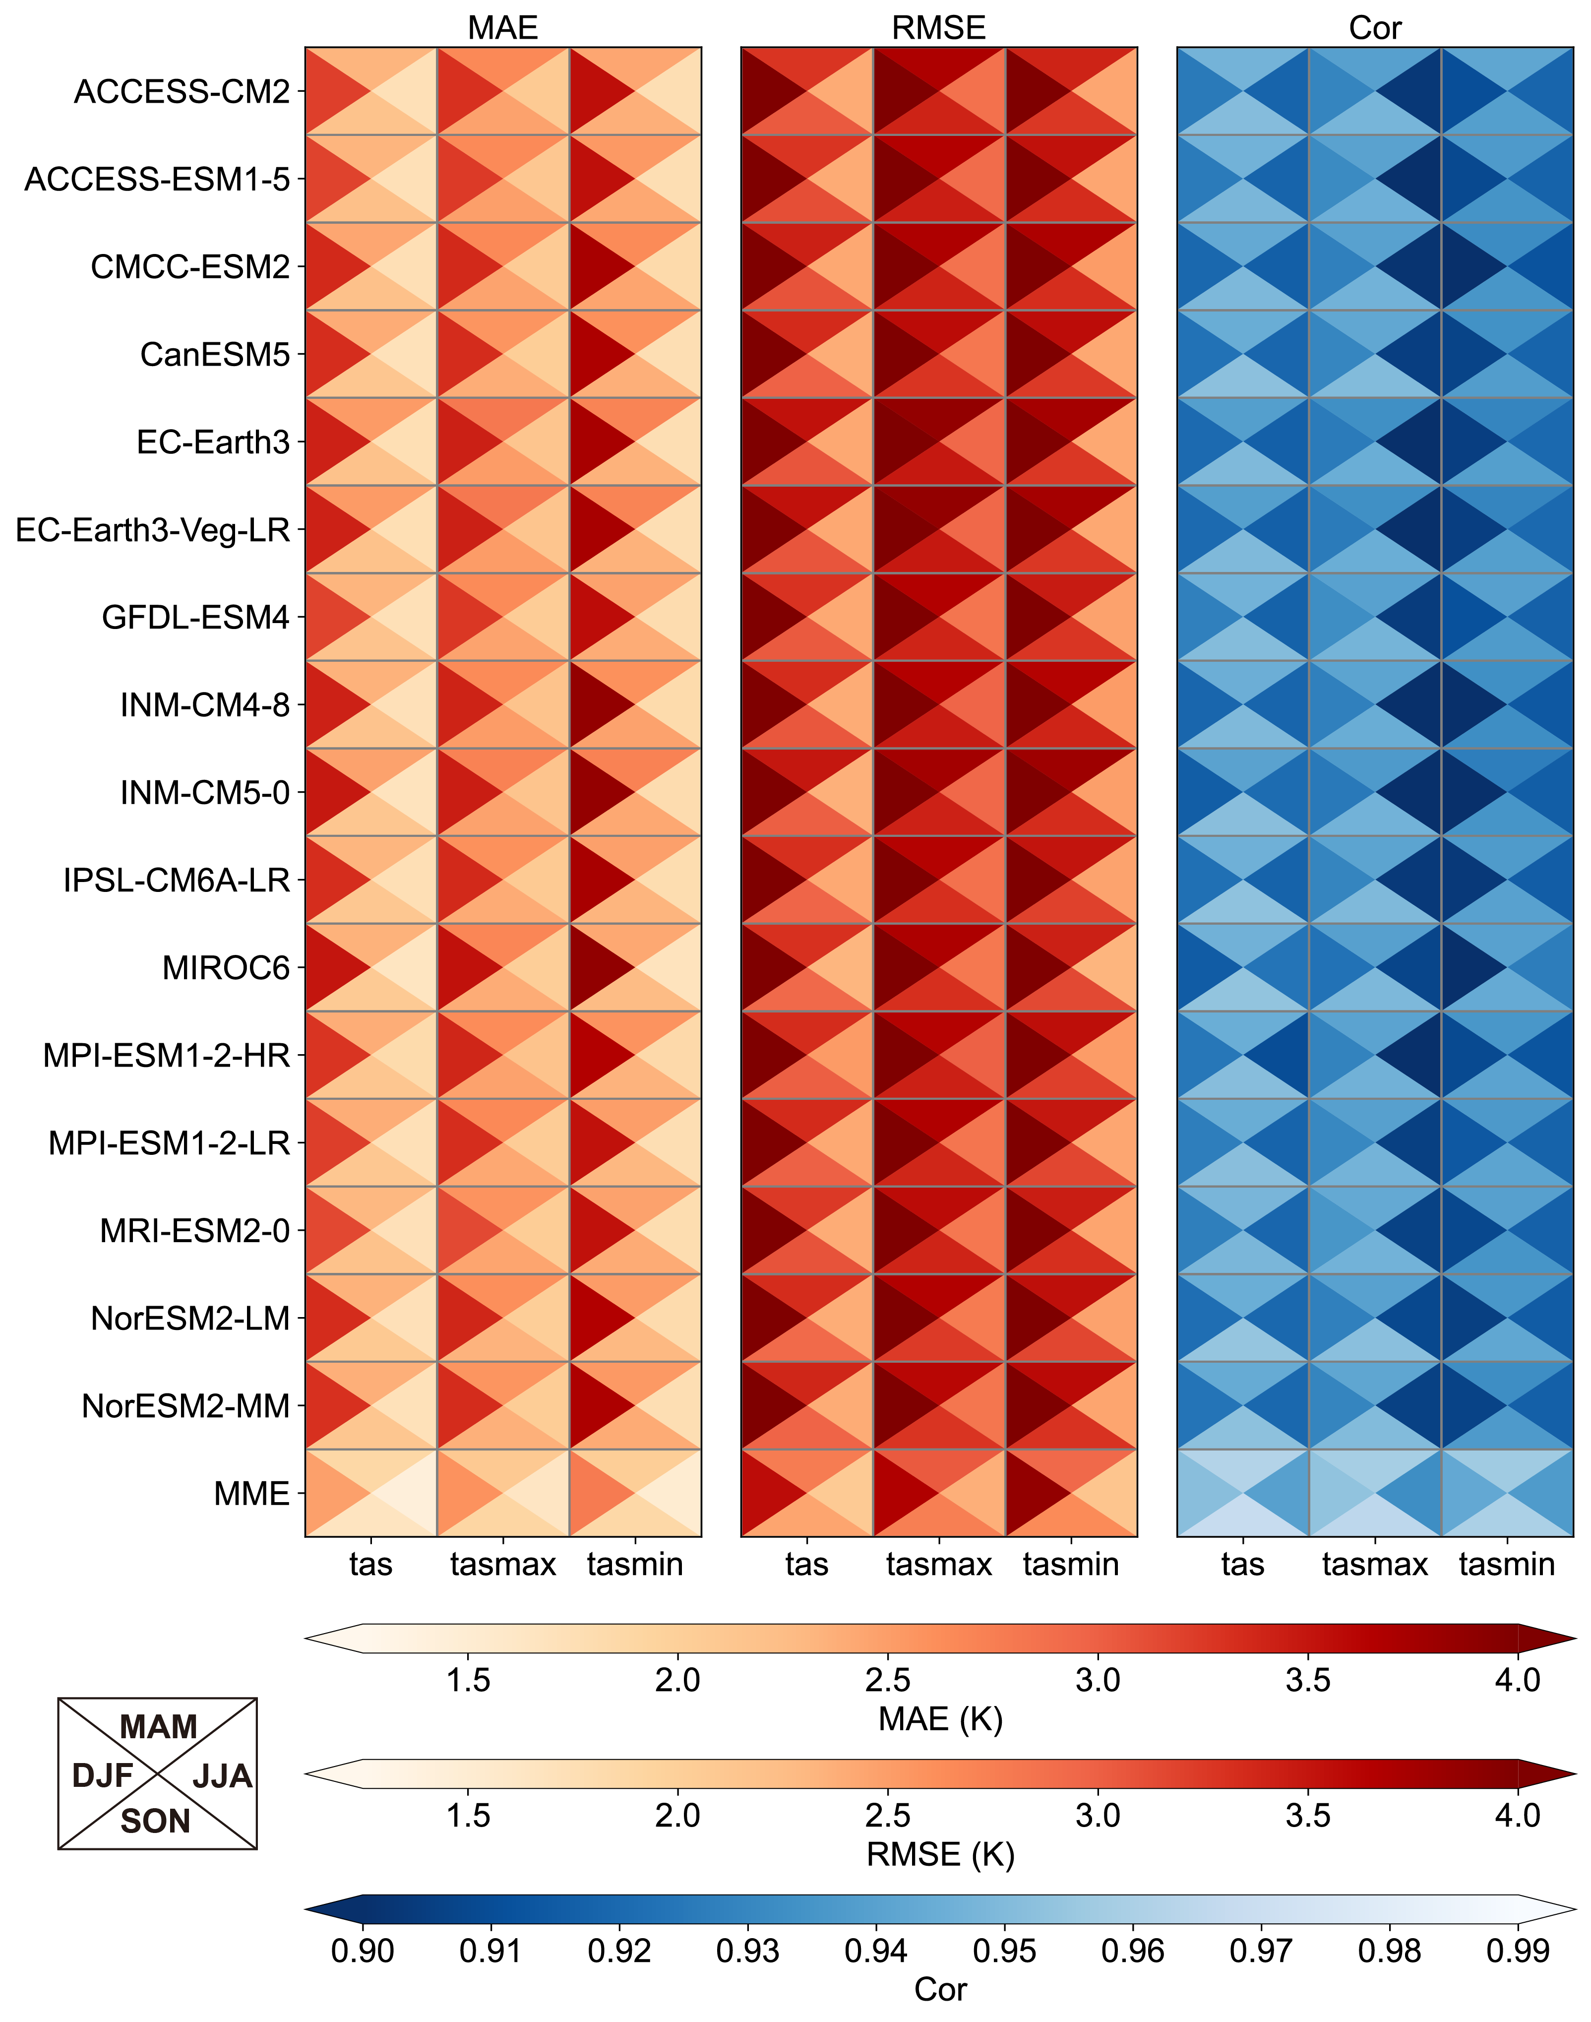
Fig. 18 Seasonal accuracy of tas, tasmax, tasmin of MoCHAT at North America during 1950–2014. Results from all GCMs are evaluated against GSOD data. DJF: December-January-February; MAM: March-April-May; JJA: June-July-August; SON: September-October-November.
Fig. 19 Seasonal accuracy of tas, tasmax, tasmin of MoCHAT at South America during 1950–2014. Results from all GCMs are evaluated against GSOD data. DJF: December-January-February; MAM: March-April-May; JJA: June-July-August; SON: September-October-November.
Fig. 20 Seasonal accuracy of tas, tasmax, tasmin of MoCHAT at Oceania during 1950–2014. Results from all GCMs are evaluated against GSOD data. DJF: December-January-February; MAM: March-April-May; JJA: June-July-August; SON: September-October-November.
Fig. 21 Annual mean bias for tasmax of the 16 GCMs over the global land surface and each continent during 1980–2014. GLO: Global, AF: Africa, AS: Asia, EU: Europe, NA: North America, SA: South America, OA: Oceania.
Fig. 22 Annual mean bias for tasmin of the 16 GCMs over the global land surface and each continent during 1980–2014. GLO: Global, AF: Africa, AS: Asia, EU: Europe, NA: North America, SA: South America, OA: Oceania.
Fig. 23 Spatial distribution of annual bias (GCM minus CHELSA) for tasmax of the 16 GCMs and MME over the global land surface during 1980–2014. GLO: Global, AF: Africa, AS: Asia, EU: Europe, NA: North America, SA: South America, OA: Oceania.
Fig. 24 Spatial distribution of annual bias (GCM minus CHELSA) for tasmin of the 16 GCMs and MME over the global land surface during 1980–2014. GLO: Global, AF: Africa, AS: Asia, EU: Europe, NA: North America, SA: South America, OA: Oceania.

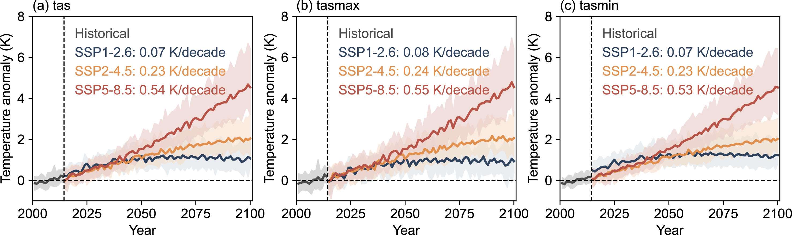
Fig. 25 Temporal evolutions of annual temperature anomalies for MME from 2001 to 2100. (a) tas, (b) tasmax, (c) tasmin. Shaded areas are the spreads of the 5th to the 95th percentiles of the annual temperature anomalies for 16 GCMs.

