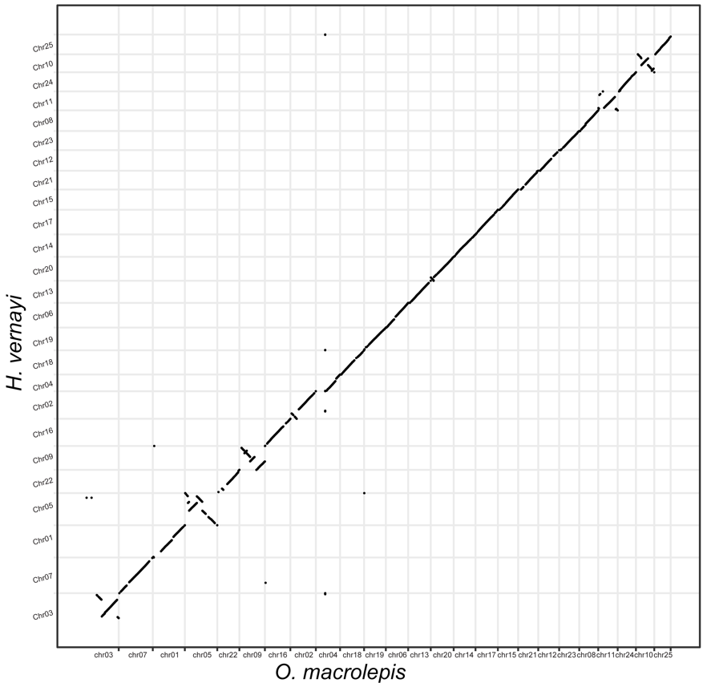
Supplementary Fig. 1: the dotplot between H. vernayi and O. macrolepis.

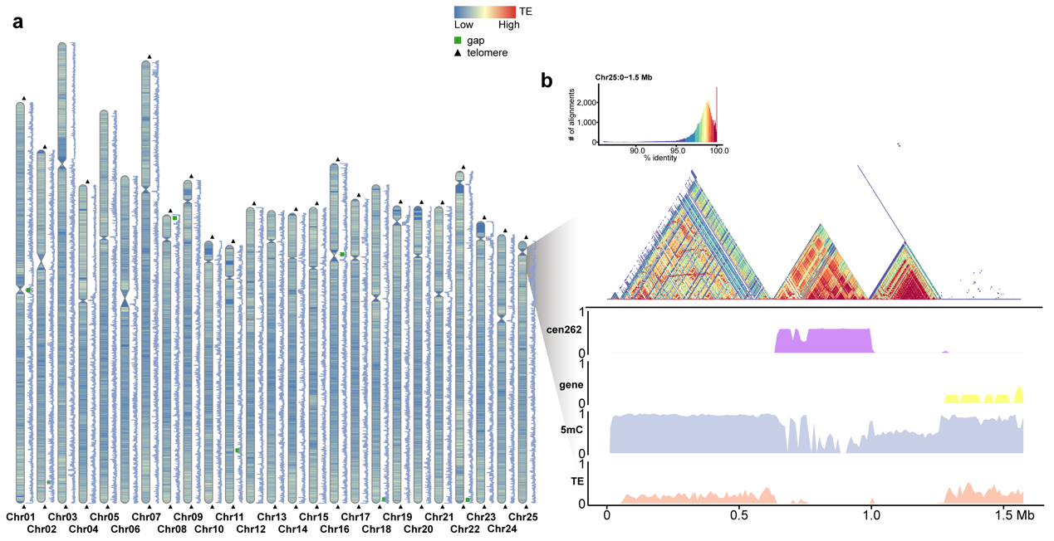
Supplementary Fig. 2: The (a) The distribution of centromeres, telomeres, gap, TE density, and methylation level (blue line) in the second haplotype genome. TE and methylation density are visualized in 10 Kb widows. (b) Visualization of centromere region of Chr25 suggesting the distribution of CEN262, gene density, 5mC methylation level, and TE density in 10 Kb windows, where ranges are normalized to 0~1. The triangle heatmaps represent pairwise sequence identity between 1.5 Mb sequences.

