Supplementary materials

Bin Zhang^{1,2}†, Hongyu Mu^{3,4}†*, Hua Li^{1,2}, Siqi Gao^{1,5}, Yalan Zhou³, Wei An^{1,2,}*

¹ National Engineering Research Center of Industrial Wastewater Detoxication and Resource Recovery, Research Center for Eco-Environmental Sciences, Chinese Academy of Sciences, Beijing, 100085, China.
² College of Resources and Environment, University of Chinese Academy of Sciences, Beijing, China, 100190.
³ Key Laboratory of Nutrient Use and Management, College of Resources and Environmental Sciences; National Academy of Agriculture Green Development; National Observation and Research Station of Agriculture Green Development (Quzhou, Hebei), China Agricultural University, Beijing, China, 100193.
⁴ Soil Physics and Land Management Group, Wageningen University & Research, 6700 AA Wageningen, the Netherlands.
⁵ State Key Laboratory for Ecological Security of Regions and Cities, Research Center for Eco-Environmental Sciences, Chinese Academy of Sciences, Beijing, China, 100085.

* Corresponding author
† These authors contributed equally to this work

Supplementary Text

Text S1 Detailed Theoretical Elaboration of the Order-Dependent Relationship
Within a single crop production cycle, multiple AIs typically exhibit a stable ordering or relatively constant ratio of usage, giving rise to what we term an “order-dependent relationship.” This concept can be further understood through several key theoretical frameworks from economics, ecology, and system dynamics.

In this study, we proposed that the usage of multiple active ingredients (AIs) tends to follow a relatively stable order and a constant ratio within a single crop production cycle, forming a predictable usage pattern. We refer to this phenomenon as the "order-dependent relationship". This hypothesis arises from the integration of multiple theories, including: (i) based on Partial Equilibrium and General Equilibrium theories, economic constraints and price signals limited the growth of annual AI inputs, which facilitate stable shares for each AI (1, 2) (Text S1.1); (ii) ecological drivers such as the dynamics in pest populations and their resistance to pesticides constraint the demand for each AI (3-7) (Text S1.2); and (iii) system dynamics feedbacks indicated that changes in inputs of certain AIs can result in proportional shifts in inputs for other AIs until forming a near-steady-state input pattern (8-11) (Text S1.3).

S1.1 Economic Constraints and Equilibrium Theory
From both general and partial equilibrium perspectives (1, 2), market prices, supply-demand dynamics, and profit-maximization behavior impose natural constraints on how much a single pesticide can be used. These economic forces encourage farmers to adjust their allocations of different AIs, often resulting in a relatively stable combination over time. Once a usage pattern is established, external factors such as policy changes or cost fluctuations may shift the usage of one AI, leading to compensatory adjustments in the usage of others. This self-regulating mechanism, driven by market forces and economic constraints, reinforces the predictability of relative AI usage patterns.

S1.2 Ecological and Bioeconomic Drivers
Ecological and bioeconomic factors play a crucial role in shaping pesticide usage patterns (3-7). Over-reliance on a single AI can accelerate resistance development in pest populations, which forces farmers to adopt integrated pest management (IPM) strategies that involve rotation or mixing of multiple AIs. Through repeated crop cycles, farmers tend to optimize their pesticide usage to balance effectiveness, cost, and resistance management objectives. This optimization often converges to a consistent sequence or ratio in which each AI's contribution remains proportionate to its role in pest control and resistance mitigation. Consequently, the order in which AIs are chosen and applied becomes reasonably predictable under stable agronomic and market conditions.

S1.3 Feedback Loops in System Dynamics
System dynamics models emphasize both positive (reinforcing) and negative (balancing) feedback loops (8-11), which are instrumental in understanding pesticide usage stability. For example, a highly effective AI may experience rapid initial adoption due to positive feedback, but resistance development, regulatory pressures, or cost increases introduce negative feedback, which subsequently limits its usage. These balancing influences prevent extreme fluctuations over extended periods, leading to a near-steady-state usage pattern. Within this equilibrium, if the usage of one AI is known, the corresponding usage levels of other AIs can often be inferred with reasonable accuracy.

S1.4 Limitations
Despite the theoretical and empirical support for the order-dependent relationship, several limitations must be considered:

S1.4.1 Temporal and spatial variability under external influences
The stability of AI usage patterns observed in specific regions or within short time frames may not hold across longer periods or broader geographic scales. Factors such as climate change, evolving pest pressures, influence of government policies, subsidies, and international trade regulations, and the introduction of new pesticide products may disrupt established patterns.

S1.4.2 Data Limitations
The availability and reliability of pesticide usage data can be a limiting factor in validating the order-dependent relationship. Data inconsistencies, underreporting, and the lack of long-term observational studies may impact the accuracy of empirical findings.

Text S2 Estimation of Active Ingredient Coverage in Surveys
In actual farming practices, the choice of certain AIs depends on multiple factors, including effectiveness and accessibility. Nationwide studies have frequently identified knowledge gaps among farmers, such as the effectiveness of pesticides and risk awareness. Therefore, interviews with farmers regarding pesticide use can be interpreted as a random sampling process, where each interview serves as an independent sample.

S2.1 Correlations between the pesticide application rates and the probability of being picked for the first time
The probability of the selection for each AI (i.e., the probability of the pesticide being picked for the first time by pesticide sprayers) differs and ultimately reflects spatial variances in pesticide use. Commonly used pesticides tend to be more frequently selected in the repeated sampling processes, indicating a positive correlation between pesticide usage frequencies in field conditions and their probabilities of being picked for the first time. Pearson correlation was performed to the potential linkage between the estimated application rates (per hectare per year) of pesticides under different crops and their probability of being firstly picked. The analysis revealed strong positive correlations for major crop systems with correlation coefficients ranging from 0.63 to 0.85.

S2.2 Using limited number of AIs to predict pesticide input mass
At present, thousands of pesticide products are used by farmers, which makes it highly challenging to estimate the pesticide input mass by summing up the input of every single AI. Alternatively, the aggregated mass can be estimated by calculating the inputs of a limited number of most commonly used AIs. To this end, the minimum number of AIs needed for the estimation, which is the minimum sampling frequency (N) to cover a large enough number of AIs, needs to be further examined.

Considering the positive correlations between application rates and the possibility of being firstly picked, the possibility of a certain AI being covered by the random sampling procedure is mainly subjected to N. Thereby, we examined if the sampling frequency used in this study (over 1000 interview cases) can include a large enough number of AIs for a robust pesticide input estimation. Stochastic simulations were carried out to examine the possibility of an AI with low application rates being picked and included in a random sampling procedure repeated 1000 times. The simulation was performed as following steps:
- The possibility for a certain AI being picked is p. The ergodic process was performed with a range of p from 0.00001 to 0.02 at a step length of 0.0001.
2) For all possible p values, calculate the cumulative possibility of a certain AI being picked in the random sampling with N equal to 1000. The calculation was conducted as follows (equation S1).
$$\begin{aligned}\operatorname{Pr}\left(N≤1000\right)= \sum_{k=1}^{1000}{{(1-p)}^{k-1}∙p}\#\left(S1\right)\end{aligned}$$
3) Determining a minimum p value for a certain AI being included in this sampling process (when the cumulative p is lower than 0.99).

The results showed that a relatively low possibility was exhibited when the p value was lower than 0.0007 (Fig. S3). Meanwhile, the AI can be included in the sampling process (at a cumulative possibility of 99%) when the p value is higher than 0.0046. Therefore, the random sampling procedure with a sampling frequency of 1000 can include almost all commonly used AIs.

S2.3 Sampling frequency and the probability of AIs being picked for the first time
Based on our analysis, A certain AI could be easily picked in a repeated random sampling process when its probability of being picked for the first time is higher than 0.5. In contrast, it is difficult to deduce if a certain AI could be picked in a repeated random sampling process when its p value in range from 0.0046 to 0.5. In this case, the probability of the AI being picked is highly correlated with N. Thereby, the correlations between N and the probability of a certain AI being picked for the first time were further examined following a three-step procedure.
- Find all possible p values in a range between 0.0046 and 0.5 with a step length of 0.001. In total, 496 possible p values were identified.
- Calculate the Pr (cumulative possibilities of a certain AI with different p values being picked in a repeated random sampling) under different p values (from 0.0046 to 0.5) and sampling frequencies (from 50 to 1000).
- Compare the estimated and real p.

The results indicated large deviations between the estimated and real p value when N was lower than 200 (Fig. S4). Minor errors between estimated and real p value were observed when N increased to 1000(Fig. S5), indicating stable and robust p estimations.

Text S3 Data-driven procedure

S3.1 Mathematical assumptions
The key information in quantifying the order-dependent relationship lies in the usage and types of AIs. Given that detailed pesticide application data was obtained throughout field surveys, we further conducted an analysis to examine the relationship between sample size of field surveys and the coverage of commonly used AIs. Notably, in a random sampling survey of pesticide usage among farmers, the number of sampling attempts required before a particular pesticide is first observed follows a geometric distribution. Based on this principle, we conducted simulation studies to estimate the relationship between the number of surveyed farmers, the coverage of pesticide types, and the probability of first detection of a given AI. The results indicate that if the probability of first occurrence of a particular AI exceeds 0.46%, it is highly likely to be captured in our survey sample (Text S4). Consequently, the sample size of field survey enables the inclusion of almost all commonly used AIs.

S3.2 Model development

S3.2.1 Data harmonization
This study used pesticide application data from field surveys for the quantitation of crop-specific pesticide input patterns. Harmonized datasets were developed based on pesticide application rates collected from field surveys conducted between 2012 and 2024. These surveys included over 1181 respondents from 7 provinces, covering major farming regions across China (Fig. S1). Each respondent was interviewed with questions focusing on pesticide application details, including active ingredients used, % of active substance, applied dosages, frequencies, and treated area, were interviewed. In total 12 crop systems were included in the field survey, such as wheat, maize, rice, vegetables, temperate fruits, fiber crops, tuber crops, soybean, oil crops, groundnut, tea and pulses, with the harvested area accounting for 86% of the national mass (12). Specifically, surveys for staple crops (wheat, maize, and rice) were primarily conducted between 2012 and 2013 (13), while surveys for other crop systems were mainly carried out between 2019 and 2024. Consequently, pesticide application data for staple and non-staple crops were averaged to create baseline datasets, reflecting the average pesticide input levels for the years 2012 and 2022, respectively. The baseline datasets were organized according to different crop systems, and the detailed calculation methods can be found in the supporting materials (Text S2.1).

Datasets of pesticide application intensities were built for each farming system. The annual input of a single AI was calculated based on the applied dosage, application frequency, treated area as follows (equation S2 and S3).
$${Application rate}_{p,i}={\left({Applied dose}_{p,i}×{Application frequency}_{p,i}\right)}/{{Treated area}_{p,i}} \left(S2\right)$$

$$\begin{aligned}{Annual input}_{p,i}={Application rate}_{p,i}×{HA}_{i}×\% of use\#\left(S3\right)\end{aligned}$$

where i represents a specified crop, p represents a certain AI used for that crop. Annual input (t yr⁻¹) denotes the yearly usage of p. ${Application rate}_{p,i}$ represents the calculated application rate (g ha⁻¹ yr⁻¹). Applied dose represents the average applied dosage (g or mL) of p by farmers in the cropping system i. Application frequency represents the number of field spray of p in crop i. ${HA}_{i}$ (ha) represents the harvested area of the crop system i. % of use represents the percentage of field area in cop system i treated by the certain AI. The calculated application rates for each AI in the crop-specific baseline dataset can be found in Table S1.

S3.2.2 Reorganizing and rescaling data
The baseline datasets were further used to calculate the annual pesticide application rates by integrating pesticide registration / forbidden information, and pesticide use factors. Given that field surveys for staple crops and other crops were mainly conducted in 2012 and from 2019 to 2024, pesticide application rates baseline datasets of staple crops and other crops were recognized as the baseline level of pesticide application rates in 2012 and 2022, respectively. Sequentially, data reorganization was performed for each data entry by collecting the registration / forbidden durations of active ingredients (AIs) from China Pesticide Information Network (CPIN) (14). Therefore, paired AI-application rate-crop-application mode-registration/forbidden duration information was harmonized for each data entry for further polynomial regression of temporal trends in pesticide application rates from 2001 to 2022. To make application rates of different AIs comparable, we introduced Exceedance Index (EI) by calculating the ratios between the application rates and the maximum value of recommended application dosage. Particularly, six scenarios were developed based on pesticide type (insecticides, herbicides, and fungicides) and the application mode (knapsack and vehicle-mounted pumps) for approved AIs, across different years. Polynomial regression was performed to quantify the temporal trends in annual pesticide application rates and EIs with the registration / forbidden durations (Fig. S6). Data quality was examined by validating application data with retailers and calculating Cook’s D and hat values for data entries in each scenario for identification of outliers. Therefore, annual crop-specific datasets were established, reflecting the temporal evolution of AI usage across different cropping systems.

S3.2.3 Estimations of pesticide inputs
In this work, we applied the temporal trends in pesticide application rates for each scenario to the baseline datasets for the quantitation of annual datasets of crop-specific pesticide application patterns. Sequentially, we obtained pesticide input datasets from 2001 to 2022 by performing a data-driven procedure with regression analysis and multi-object optimization for annual datasets of pesticide application rates. Further, we merged baseline datasets and created a generalized dataset of crop-specific pesticide input to represent the average level of pesticide input from a near-present context. With the generalized dataset, we estimated riverine concentrations of AIs and further compared with measurements in the same timeframe for validation of the data processing procedure. On the basis of pesticide input and riverine concentration estimates, we proposed a pre-warning procedure for pesticide pollution in rivers.

S3.2.4 Quantify the order-dependent relationship based on the AIs usage datasets
To quantify the order-dependent relationship, we then fitted the rank (x) of each AI and its corresponding Relative Input Level (RIL) (y). Specifically, negative exponential functions were fitted using quantile regression for each dataset. The bootstrap process obtained highly consistent fitting results, indicating the accuracy of the chosen model. Detailed calculation methods can be found in the supporting materials by taking generalized dataset as an example.
The rankings (x) of AIs and their corresponding Relative Input Levels (RILs) (y) were then fitted to quantify the correlations between rankings and ratios of annual inputs. To this end, the paired ranking-annual data input in each subset was randomly allocated into training and validation datasets for further fitting and validation, with sample sizes accounting for 70 and 30%, respectively (Fig. 2). Quantile regression was then applied to fit the negative exponential functions separately for each training set (equation 4).
$$\begin{aligned}y=e^{ax}+b\#\left(S4\right)\end{aligned}$$
where x and y represent the ranking and RILs of certain AI in the farming system, a and b were the descriptive parameters of the fitted curves.

Subset allocation and fitting processes were repeated 10 times following the bootstrap method to examine the stability and suitability of the fitted curve. Given that highly homogeneous fitting results were observed in the bootstrap process, overall fitting, with all paired ranking-annual input data in the dataset included, was then performed to obtain RIL_{QR} (Fig. S7 and Table S2).

S3.4 Sensitivity analysis
Sensitivity analysis was performed to evaluate the uncertainty of the input estimates. The bootstrap procedure was conducted 2000 times for training sets in each subset and the curves were fitted by quantile regression (Fig. 3). The relative ranges (range / mean value) of parameters a and b were calculated as the indicator of sensitivity (Fig. S8). The results showed that parameter b is more sensitive to the collected data, indicating that errors might occur when the fitting result is applied to different provinces in China. Thus, calibration procedure was needed to reduce the prediction error.

S3.5 Multi-object optimization

S3.5.1 Estimations of pesticide input mass at provincial level
Multi-object optimization was performed by minimizing the prediction error of pesticide input in each province with official statistics of pesticide input mass at provincial level, serving as constrictive conditions. Briefly, the procedure followed a two-step approach: 1) predicting the pesticide input mass for each province by summing up the aggregated pesticide input in each farming system, and 2) performing an multi-object optimization process that minimizes the errors between the predicted values and the official statistics by allocating errors to the crop-specific fitting results of each province. Building on the original fitted functions, the multi-objective optimization further refined the function parameters for each crop system in every province. Based on the adjusted fitted equations and the grid-level harvested area data provided by SPAM, we ultimately established the annual pesticide usage dataset.

The pesticide inputs in each farming system were estimated separately under restrictive conditions to predict the input mass at the provincial level. Briefly, the annual input mass of each province, which is the sum of the annual input of all AIs in all major farming systems, was calculated based on the application rates and harvesting area (from equation S5 to S7).
$$\begin{aligned}{Annual input}_{b,i,s}={Application rate}_{b,i}∙{HA}_{i,s}\#\left(S5\right)\end{aligned}$$
$$\begin{aligned}{Annual input}_{o,i,s}={Annual input}_{b,i,s}∙{RIL}_{o,i}\#\left(S6\right)\end{aligned}$$
$$\begin{aligned}{Annual input}_{s}=\sum_{i}^{12}{\left({Annual input}_{b,i,s}+\sum_{o}{{Annual input}_{o,i,s}}\right)} \\ or \\ {Annual input}_{s}=\sum_{i}^{12}{({Annual input}_{b,i,s}∙\sum_{x}{y_{i}\left(x\right)})}\#\left(S7\right)\end{aligned}$$

where b represents the benchmark component. s represents the province s. $Application rate$ (g ha⁻¹ yr⁻¹) refers to the annual pesticide input per hectare. o denotes the AI other than the benchmark component. ${RIL}_{o,i}$ refers to the RILs for o in the cropping system i. HA_{i,s} (at 5 arcmin) refers to the harvesting area (ha) of crop i in province s derived from the latest Spatial Production Allocation Model (SPAM) database (12).

S3.5.2 Minimizing errors between the predicted values and the official statistics
Multi-object optimization was carried out by minimizing the deviations between the predicted values (${Annual input}_{s}$) and the official statistics ($B_{s}$) for each province(15). To this end, the error between predicted and statistical values were calculated at provincial level and reallocated to the predicted values following the input-weighted ratios of pesticides among farming systems. Further, a constant parameter c was introduced to the fitting function for each farming system at provincial level to minimize the errors (Eq. S8).
$$\begin{aligned}y_{i,s}^{'}\left(x, c_{i,s}\right)={y_{i}\left(x\right)+c_{i,s}=e}^{a_{i}x}+b_{i}+c_{i,s}\#\left(S8\right)\end{aligned}$$
where $y_{i}^{'}\left(x, c_{i}\right)$ represents the RIL_{C}s calibrated by adding parameter c (RIL_{QR}s) for AI x. To reduce the complexity of further calculation, c was set as a fixed value. Meanwhile, the partitioning factor $f_{i}$ was introduced to fitting function for the major farming systems, which produces error minimization equation (f(c)) (Eq. S9 and S10). The optimal value of c for each province-crop combination was derived by obtaining the minimization solution. Subsequently, the total provincial error was allocated to individual AI used within that province. The allocation was achieved by applying a scaling factor f to proportionally adjust the original fitted function (y_{i}(x)) for each AI. The scaling factor f was defined based on the ratio of each AI’s annual input, ensuring that AIs with higher usage amount received a proportionally larger share of the adjustment. This methodology ensures that the parameter c is specific to both the AI and the province. Based on multi-object optimization, crop-specific fitting function for pesticide input at provincial level were obtained (Table S3).
$$\begin{aligned}f_{i,s}={{Annual input}_{i,s}}/{{Annual input}_{s}}\#\left(S9\right)\end{aligned}$$
$$\begin{aligned}f\left(c_{i,s}\right)=\left(B_{s}-{Annual input}_{s}\right)∙f_{i,s}-c_{i,s}∙{Annual input}_{b,i,s} \\ =\left(B_{s}-\sum_{i}^{12}{{Annual input}_{b,i,s}∙\sum_{x}{y_{i}\left(x\right)}}\right)∙f_{i}^{s}-c_{i,s}∙{Annual input}_{b,i,s}\# \\ c_{i,s}=\frac{\left(B_{s}-\sum_{i}^{12}{{Annual input}_{b,i,s}∙\sum_{x}{y_{i}\left(x\right)}}\right)∙f_{i,s}}{{Annual input}_{b,i,s}}\#\left(S10\right)\end{aligned}$$

where $f_{i,s}$ represent the proportion of annual inputs in staple crop i in province s. $n_{i}$ represents the sample size of the subset for each crop type.

Given the absence of aggregated pesticide input statistics at provincial level, we estimated provincial statistics of pesticide inputs from 2001 to 2023 based on statistics of pesticide product input masses and aggregated pesticide input statistics, following equation S11 and S12.
$$\begin{aligned}k_{y}=\frac{U_{y}^{\text{nat }}}{A_{y}^{\text{nat }}}\#\left(S11\right)\end{aligned}$$
$$\begin{aligned}A_{s,y}=\frac{U_{s,y}}{k_{y}} \#\left(S12\right)\end{aligned}$$
Where k_{y} refers to ratios of input masses between aggregated pesticide inputs (U^{nat}_{y}) and pesticide product input (A^{nat}_{y}). A_{s,y} refers to aggregated pesticide input for province s at year y, U_{s,y} represents statistics of input masses of pesticide products in province s at year y.

Text S4 Pesticide determination

S4.1 Pesticide extraction and determination by LC-MS/MS
Water samples (2L) were collected and passed through 0.7 μm glass fiber filters. Water samples were then passed through tandem solid phase extraction columns activated by 10 mL acetonitrile, methanol and ultrapure water with the HLB and activated carbon columns connected top to bottom. The flow rate of water samples was in a range of 5-10 mL min⁻¹. Sequentially, the HLB and activated carbon columns were cleaned up by 10 mL acetonitrile and 10 mL methanol with 20 mmol/L ammonium acetate, respectively. The solvent was collected with KD concentration tubes. The elution solvent was dried under a nitrogen stream in a 40 ° C water bath to a volume of 0.5 mL. In the end, the solvent was filtered by 0.2 μm PSF GHP for further analysis.

All measurements were performed using liquid chromatography coupled with a triple quadrupole mass spectrometer (LC-MS/MS, ACQUITY UPLC-TQD, Waters, USA). A Waters ACQUITY UPLC BEH C18 column (1.7 μm×100 mm×2.1 mm) was used and the temperature kept at 40 °C for separation. Electrospray ionization (ESI) was used as the ion source. The capillary voltage was 3.10 kV. The ion source temperature was 120 ° C; The cone gas flow rate was 50 L/hr. The desolvation gas temperature was 400 ° C and the flow rate was 850 L/hr. The analyzed compounds were separated in a mobile phase consisting of eluent A (Methanol+0.1% formic acid) and B (Water/methanol (98:2) + 0.1% formic acid). The precursor and corresponding product ions for multi-reaction monitoring detection of each target compound are presented in Table S4. Gradient elution was optimized at a flow rate of 0.45 mL min^{‒1} as follows: 0–0.25 min 95% A, 0.2–7.75 min from 95% to 0% A, 7.75–8.5 min 0% A, 8.51–10 min 95% A. The injection volume was 10 μL.

S4.2 Pesticide extraction and determination by GC-MS
Samples were collected in amber glass bottles and maintained at a temperature of 10 °C during transportation to the lab. Ascorbic acid (20 mg/L) was added to the supply water samples to quench any chlorine residue after collection. The water samples were filtered through 0.45 μm glass fiber filters and stored at 4 °C until analysis. Pesticide concentrations were determined by solid phase extraction (SPE)-gas chromatography mass spectrometry (GC-MS). The detailed procedure was as follows: firstly, a 1 L water sample was concentrated and enriched by a series of C18 (Sep-Pak®, 500 mg sorbent, 6 mL capacity) and HLB (Oasis®, 500 mg sorbent, 6 mL capacity) solid phase extraction columns at a loading rate of approximately 10 mL/min while the C18 cartridges were kept wet. Both the C18 and HLB solid phase extraction columns were preconditioned with 6 mL of dichloromethane, 6 mL of methanol and 6 mL of ultrapure water in advance. Then, the C18 and HLB columns were dried for about 10 minutes under vacuum and eluted in reverse order with 10 mL of dichloromethane. The eluate was combined and dried under a gentle nitrogen stream, then redissolved with 1 mL of n-hexane for analysis by GC-MS (GC/MS-QP2010 Plus, Shimadzu, Japan).

The mass spectrometer portion of the GC-MS instrument was operated in the electron impact (EI) ionization mode with an ionizing energy of 70 eV and a DB-5MS capillary column (60 m × 0. 25 mm ID × 0. 25 μm) was used for the pesticide analysis. Helium (99.999%) was used as the carrier gas with an inlet pressure of 19.44 psi corresponding to a flow rate of 1 mL/min. The oven temperature started at 80 ℃, was held for 2 min, programmed to 290 ℃ at 6 ℃/min, and held for 18 min at 290 ℃. The injector and detector temperatures were 290 ℃. Samples were injected in splitless injection mode and the injection volume was 1 μL. The EI source temperature was maintained at 230 °C. Quantitative analysis was performed using the selected ion monitoring (SIM) mode, and the fragment ions were selected according to the most abundant molecular ions in each pesticide. Other information can be can be found in GB/T 19648-2006(16).

S4.3 Quality assurance and quality control
Blank sample and standard spiked samples were analyzed before each batch of samples (6-8 samples) and a solvent blank was injected after each batch of samples as the blank control. The standard samples were matrix-matched spiked to eliminate the matrix influence. The identification of pesticides was based on the matrix-matched chromatographic retention time (deviation < 2%) and abundance ratio of two characteristic ions (deviation < 20%). Matrix-matched calibration curves were established for quantification of target pesticides in the pure water matrix. The calibration standards were measured at 0, 0.05, 0.1, 0.2 and 0.5 mg/L and the linearities of the calibration curves (r²) were >0.95. The recoveries of the pesticides ranged from 71.3 % to 146 % in pure water, from 64.8 % to 149.6 % in supply water, and from 60.3 % to 162.2 % in source water, respectively. The LOQs were from 2.1 ng/L to 167.8 ng/L, which were calculated from the valid lowest acceptable matrix-matched calibration standard and the recoveries in pure water. The quantification was based on a matrix-matched external calibration method and corrected for the recovery of the target pesticide.

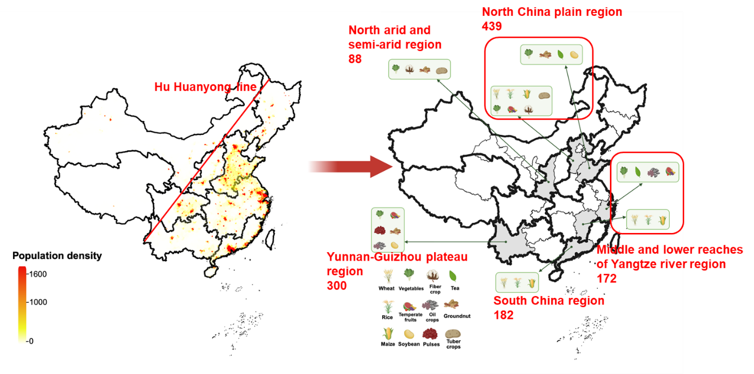

Fig. S1 Sampling map of nationwide field surveys with sample sizes

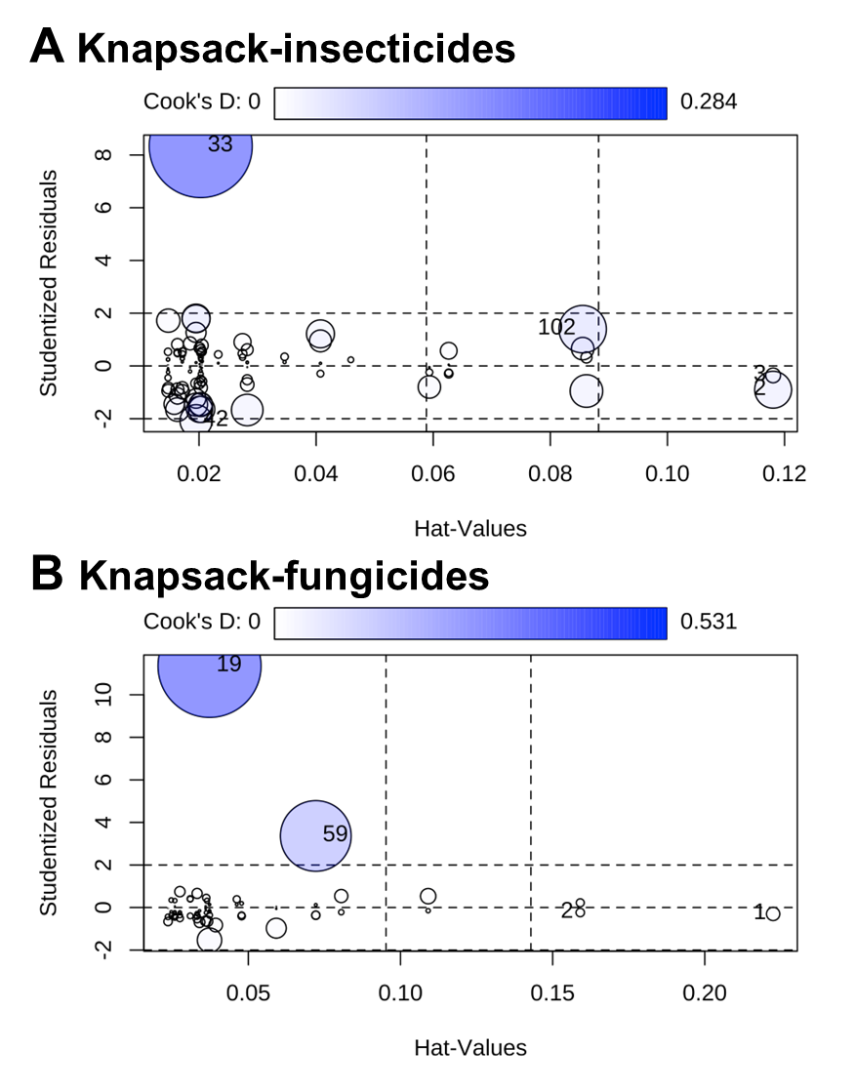

Fig. S2 Cook’ D and hat values of insecticides (A) and fungicides (B) data entries under knapsack mode

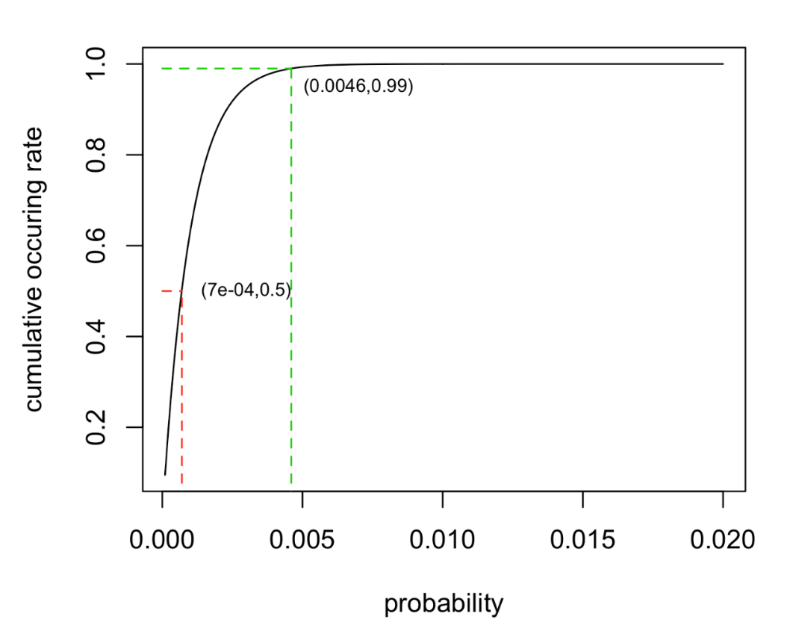

Fig. S3 The possibility of a certain AI being picked in a repeated random sampling when N equals to 1000 (Pr (N≤1000)) with different p.

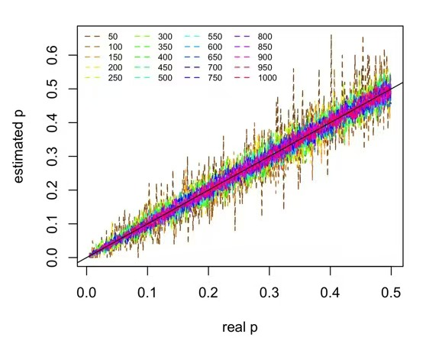

Fig. S4 Comparisons between estimated and real p for different N

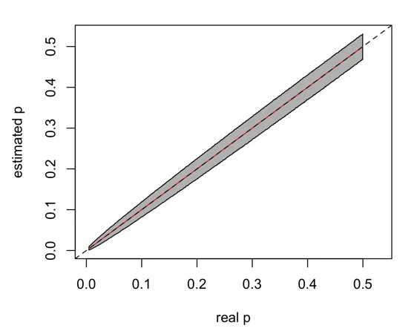

Fig. S5 Comparison of the estimated and real p when N equals 1000. The simulation was randomly performed 10000 times. The read line and grey area represent the average value of estimated p and the 95% confidence interval.

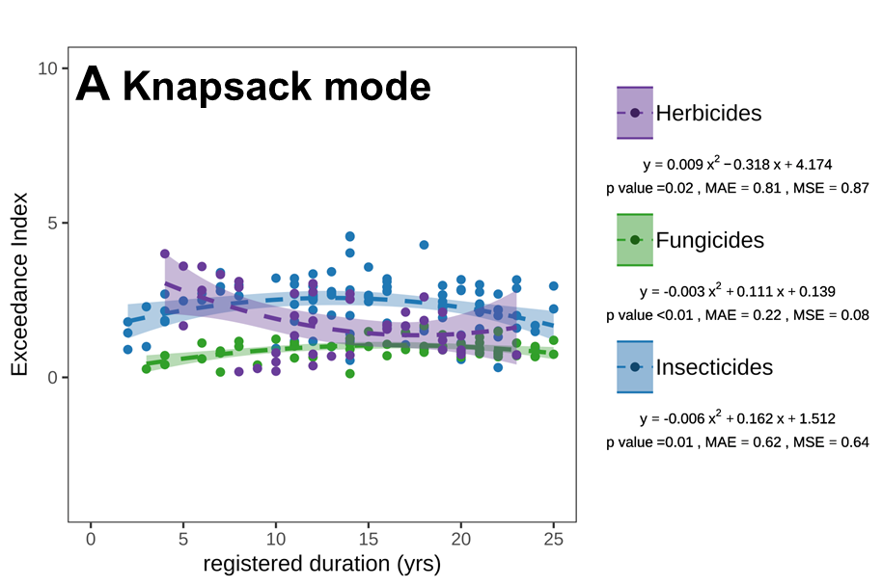
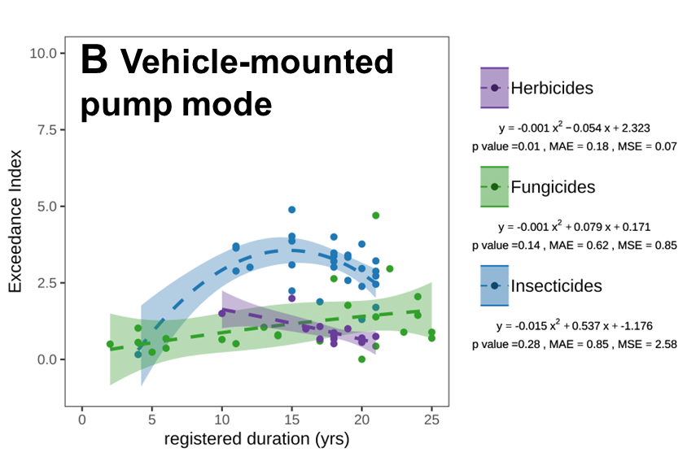
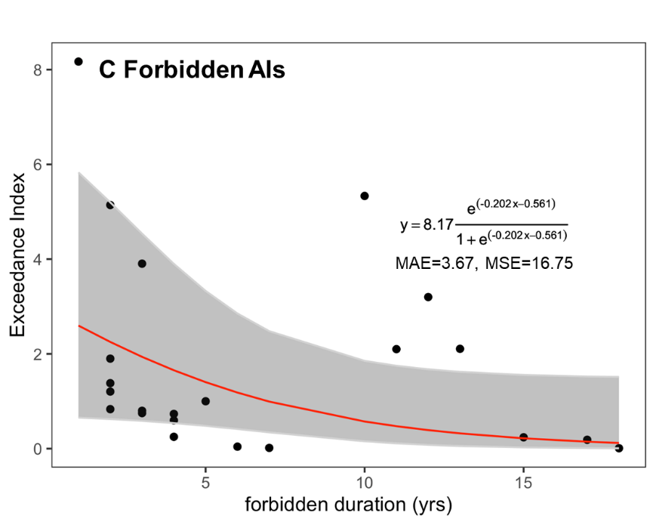

Fig. S6 Temporal trends in exceedance index (EI) of approved and forbidden AIs under different application modes. A, approved AIs under knapsack mode. B, approved AIs under vehicle-mounted pump mode. C, forbidden AIs.

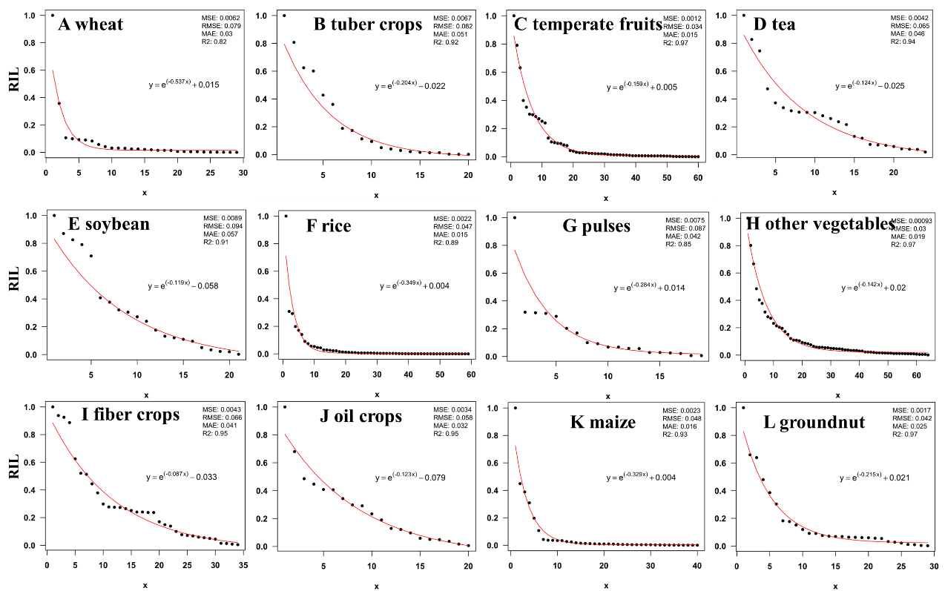

Fig. S7 Overall fit by quantile regression major farming systems
Note: MSE, mean standard error; RMSE, root mean square error; MAE, mean absolute error.

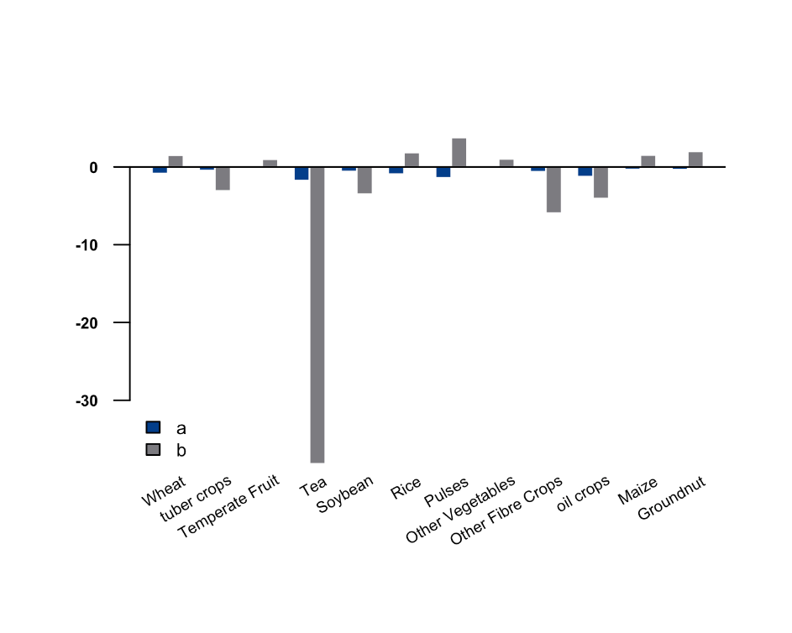

Fig. S8 Sensitivity analysis

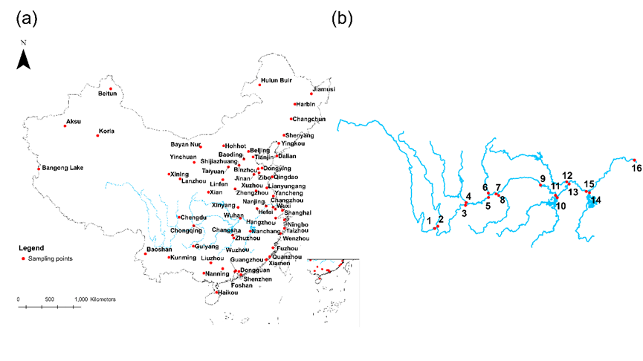

Fig. S9 Sampling sites of the (a) long-term national water quality monitoring network and the monitoring sites in the (b) Yangtze River basin

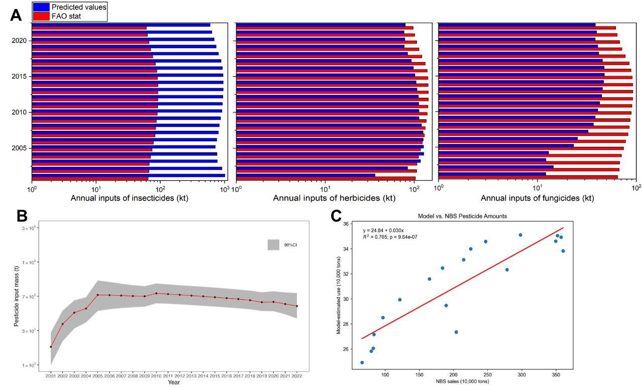

Fig. S10 Validation of predicted pesticide inputs with statistics. A, comparisons of aggregated pesticide inputs between FAO stat and predicted values. B, Predicted pesticide inputs in China from 2001 to 2022 and the 90% CI. C, linear regression between predicted pesticide inputs and sales.

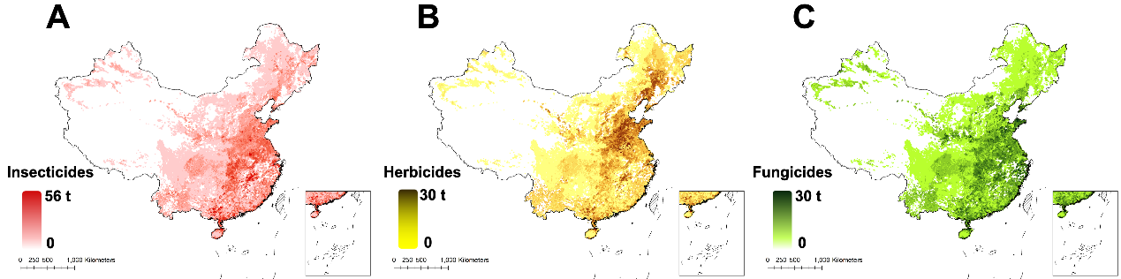

Fig. S11 The annual input of (A) fungicides, (B) herbicides and (C) insecticides in China

Table S1 The estimated application rates of pesticide active ingredients (AIs) in major cropping systems
Pesticides | % of use | Estimated application rate（g/ha/yr）
Wheat
Omethoate | 51.3 | 887.04
Imidacloprid | 27.6 | 176.04
Acetamiprid | 21.1 | 177.76
Dimethoate | 19.7 | 991.62
Tribenuron-methyl | 18.4 | 204.68
Paraquat | 15.8 | 503.52
Triadimefon | 14.5 | 267.24
Beta-cypermethrin | 14.5 | 138.72
Lambda-cyhalothrin | 11.8 | 50.38
Abamectin | 7.9 | 16.56
Cyhalothrin | 6.6 | 156.3
Cypermethrin | 6.6 | 56.4
Thiram | 5.3 | 393.9
Diniconazole | 3.9 | 284.44
Pyridaben | 3.9 | 21.19
Clofentezine | 3.9 | 10.53
Fenvalerate | 2.6 | 550
Carbendazim | 2.6 | 396.9
Atrazine | 2.6 | 450
2. 4-D butylate | 2.6 | 448.95
Malathion | 2.6 | 235.5
Myclobutanil | 2.6 | 182.25
Phorate | 1.3 | 1980
Chlorpyrifos | 1.3 | 771.4
Propisochlor | 1.3 | 600
2. D-D-ethylhexyl | 1.3 | 180
Acephate | 1.3 | 180
Fluoroglycofen-ethyl | 1.3 | 28.8
Fenpropathrin | 1.3 | 45
Deltamethrin | 1.3 | 11.6
Maize
Atrazine | 60.3 | 1690.52
Paraquat | 50.0 | 1628.48
Acetochlor | 41.4 | 1067.64
Beta-cypermethrin | 28.4 | 187.72
Alachlor | 27.6 | 192.96
Cypermethrin | 22.4 | 100.10
Abamectin | 17.2 | 32.70
Propisochlor | 15.5 | 1777.32
Lambda-cyhalothrin | 13.8 | 66.43
Acetamiprid | 12.9 | 287.84
Omethoate | 12.1 | 1097.60
Phoxim | 9.5 | 480.70
Dimethoate | 8.6 | 595.56
Imidacloprid | 8.6 | 122.64
Malathion | 7.8 | 1241.28
Nicosulfuron | 6.9 | 27.20
Mesotrione | 6.0 | 300.19
Trifluralin | 5.2 | 10920.00
Butachlor | 5.2 | 251.16
Chlorpyrifos | 4.3 | 394.60
Fenvalerate | 3.4 | 2910.19
Pyridaben | 3.4 | 150.28
Emamectin benzoate | 3.4 | 48.20
Glyphosate | 1.7 | 1332.50
Phorate | 1.7 | 631.20
Deltamethrin | 1.7 | 270.45
Bifenthrin | 1.7 | 16.90
Monosultap | 0.9 | 1542.90
Bisultap | 0.9 | 800.00
Isoprocarb | 0.9 | 576.00
Endosulfan | 0.9 | 450.00
Spirodiclofen | 0.9 | 384.00
Spodopteralitura NPV | 0.9 | 1312.50
Methomyl | 0.9 | 480.00
Diniconazole | 0.9 | 1172.00
Trichlorfon | 0.9 | 360.00
2. 4-D butylate | 0.9 | 129.60
Carbosulfan | 0.9 | 64.30
Cyhalothrin | 0.9 | 9.40
Dithioether | 0.9 | 8.60
Fenpyroximate | 0.9 | 8.40
Rice
Abamectin | 67.0 | 209.99
Bisultap | 54.1 | 4884.18
Chlorpyrifos | 25.4 | 4112.88
Jingangmycin | 25.4 | 1652.05
Paraquat | 21.1 | 1068.72
Imidacloprid | 21.1 | 1058.49
Bensulfuron-methyl | 19.1 | 74.8
Emamectin benzoate | 16.3 | 112
Butachlor | 12.0 | 524.2
Hexaflumuron | 12.0 | 69.94
Acephate | 11.0 | 4233.96
Pymetrozine | 10.5 | 314.7
Dichlorvos | 10.0 | 3466.54
Profenofos | 9.6 | 730.08
Acetamiprid | 9.1 | 712.05
Glyphosate | 8.6 | 8989
Bacillus thuringiensis | 8.1 | 2416.2
Metolcarb | 6.7 | 451.6
Thifensulfuron-methyl | 6.7 | 121.99
Buprofezin | 5.7 | 262.34
Pretilachlor | 5.3 | 150.3
Phoxim | 4.8 | 2381.4
Triazophos | 3.8 | 5653.5
Isoprocarb | 3.8 | 733.81
Beta-cypermethrin | 3.8 | 71.89
Cypermethrin | 3.3 | 385.84
Deltamethrin | 2.4 | 869.4
Kasugamycin | 2.4 | 52.7
Heliothisarmigera NPV | 1.9 | 2812.5
Acetochlor | 1.9 | 571.74
Lambda-cyhalothrin | 1.9 | 42.45
Fenpropathrin | 1.9 | 23.92
Carbendazim | 1.4 | 2613.26
Pyridaben | 1.4 | 1251.2
Malathion | 1.4 | 91.2
Isoprothiolane | 1.0 | 1235.25
Chlorothalonil | 1.0 | 815.6
Hymexazol | 1.0 | 405
Iprobenfos | 1.0 | 660
Bismerthiazol | 1.0 | 257.1
Chlorbenzuron | 1.0 | 250
Alpha-cypermethrin | 1.0 | 61.95
Fenvalerate | 1.0 | 23.1
Matrine | 1.0 | 3.2
Phorate | 0.5 | 9240
Tebufenozide | 0.5 | 1800
Tricyclazole | 0.5 | 1546.9
Haloxyfop-P-methyl | 0.5 | 777.6
Carbofuran | 0.5 | 760
Mancozeb | 0.5 | 515.6
Beauveria | 0.5 | 1883.2
Isocarbophos | 0.5 | 301.9
Streptomycin | 0.5 | 115.7
Hexaconazole | 0.5 | 108
Chlorantraniliprole | 0.5 | 210
Famoxadone | 0.5 | 51.6
Prochloraz | 0.5 | 90
Pyrazosulfuron-ethyl | 0.5 | 15
Methomyl | 0.5 | 5.6
Vegetables
Imidacloprid | 39 | 492
Emamectin Benzoate | 36 | 157
abamectin | 27 | 170
acetamiprid | 25 | 855
Cypermethrin | 23 | 617
omethoate | 9 | 1800
Dimethoate | 9 | 1547
Chlorfenapyr | 9 | 300
Tebuconazole | 7 | 711
Dinotefuran | 7 | 275
Triadimefon | 6 | 593
Dichlorvos | 5 | 553
Carbendazim | 5 | 1596
Chlorothalonil | 5 | 1445
Thiamethoxam | 5 | 675
Trifluralin | 4 | 3000
Pendimethalin | 4 | 707
Beta-Cyfluthrin | 4 | 295
Difenoconazole | 4 | 282
Beta cypermethrin | 4 | 253
Azoxystrobin | 4 | 217
Benzoate | 4 | 45
Mancozeb | 3 | 1360
Fluorochloridone | 3 | 5040
Triadimenol | 3 | 3440
Isofenphos-methyl | 3 | 386
Lufenuron | 3 | 185
Chlorpyrifos | 2 | 3600
Spiromesifen | 2 | 1440
Fentin acetate | 2 | 1406
Bifenazate | 2 | 864
Moroxydine | 2 | 675
Ningnanmycin | 2 | 414
Indoxacarb | 2 | 216
Fluopyram | 2 | 210
Methamidophos | 1 | 3000
Dicofol | 1 | 2628
Atrazine | 1 | 2625
Clothianidin | 1 | 2250
Iprodione | 1 | 1800
Glyphosate | 1 | 1800
Metalaxyl | 1 | 1553
Thiophanate-methyl | 1 | 1548
Deltamethrin | 1 | 900
Thiacloprid | 1 | 738
Pyraclostrobin | 1 | 720
Boscalid | 1 | 612
Mesotrione | 1 | 525
Pymetrozine | 1 | 375
Validamycin | 1 | 338
Fipronil | 1 | 45
Fludioxonil | 1 | 23
Temperate fruits
Carbendazim | 52,2 | 2884
Mancozeb | 32,8 | 2807
Tebuconazole | 14,9 | 4599
Cypermethrin | 32,8 | 589
Acetamiprid | 28,4 | 612
Chlorpyrifos | 6,0 | 1973
Thiophanate-methyl | 16,4 | 663
Imidacloprid | 19,4 | 434
Dimethomorph | 3,0 | 2190
Emamectin Benzoate | 19,4 | 296
Fluorochloridone | 7,5 | 720
Zhongshengmycin | 29,9 | 1054
Thiamethoxam | 3,0 | 1643
Paraquat | 7,5 | 615
Fentin acetate | 3,0 | 1530
Fluopyram | 1,5 | 2025
Chlorfenapyr | 3,0 | 975
Difenoconazole | 7,5 | 389
Abamectin | 11,9 | 237
Oxathiapiprolin | 3,0 | 946
Carboxin | 1,5 | 1800
Spiromesifen | 4,5 | 600
Mancozeb + Zineb | 1,5 | 1650
Glyphosate | 3,0 | 720
Beta-Cyfluthrin | 3,0 | 720
Pyraclostrobin | 4,5 | 460
Fipronil | 4,5 | 406
Diquat | 1,5 | 900
Spirodiclofen | 1,5 | 720
Hexythiazox | 1,5 | 720
Dichlorvos | 1,5 | 720
Beta-Cyfluthrin | 1,5 | 720
Atrazine | 1,5 | 720
Phoxim | 1,5 | 720
Triadimefon | 1,5 | 600
Fluoxastrobin | 1,5 | 600
Propargite | 1,5 | 345
Tribenuron-methyl | 1,5 | 180
Carfentrazone-ethyl | 1,5 | 108
Nicosulfuron | 1,5 | 90
Pendimethalin | 1,5 | 36
Cartap | 3,0 | 11
Fenitrothion | 1,5 | 18
Thiacloprid | 1,5 | 11
Tricyclazole | 1,5 | 11
Ningnanmycin | 1,5 | 11
Deltamethrin | 1,5 | 11
Chlorothalonil | 1,5 | 11
Isofenphos-methyl | 1,5 | 5
Tea
Diquat | 22,2 | 3450
Moroxydine | 22,2 | 1800
Metalaxyl hydrochloride | 11,1 | 1980
Beta-Cyfluthrin | 11,1 | 1500
Trifluralin | 11,1 | 731
Beta-Cyfluthrin | 33,3 | 194
Chlorfenapyr | 11,1 | 300
Imidacloprid | 33,3 | 88
Emamectin Benzoate | 44,4 | 45
Benzoate | 33,3 | 30
Fibre crops
Imidacloprid | 50,0 | 742
Carbendazim | 30,0 | 720
Thiodicarb | 10,0 | 2160
Chlorfenapyr | 20,0 | 830
Glyphosate | 10,0 | 1530
Abamectin | 50,0 | 294
Fentin acetate | 20,0 | 731
Triadimefon | 20,0 | 720
Copper quinolate | 10,0 | 844
Chlorothalonil | 10,0 | 720
Thiamethoxam | 10,0 | 675
Indoxacarb | 20,0 | 316
Emamectin Benzoate | 40,0 | 99
Omethoate | 10,0 | 360
Validamycin | 10,0 | 360
Acetamiprid | 20,0 | 167
Phoxim | 10,0 | 300
Iprodione | 10,0 | 300
Boscalid | 10,0 | 270
Spiromesifen | 10,0 | 225
Beta-Cyfluthrin | 10,0 | 90
Kasugamycin | 10,0 | 84
Cypermethrin | 10,0 | 28
Oil crops
Tebuconazole | 54,5 | 1500
Azoxystrobin | 54,5 | 750
Thiazole zinc | 27,3 | 700
Beta-Cyfluthrin | 18,2 | 300
Moroxydine | 9,1 | 450
Benzoate | 9,1 | 30
Emamectin Benzoate | 9,1 | 30
Groundnut
Imidacloprid | 45,5 | 591
Pyraclostrobin | 4,5 | 1800
Amitraz | 13,6 | 331
Pendimethalin | 4,5 | 990
Chlorfenapyr | 9,1 | 450
Thiamethoxam | 9,1 | 450
Pyraclostrobin | 4,5 | 900
Indoxacarb | 13,6 | 299
Chlorantraniliprole | 4,5 | 750
Cypermethrin | 13,6 | 226
Dichlorvos | 4,5 | 675
Metalaxyl-M | 4,5 | 630
Chlorothalonil | 4,5 | 630
Pymetrozine | 4,5 | 600
Acetamiprid | 13,6 | 197
Bifenthrin | 13,6 | 178
Beta-Cyfluthrin | 4,5 | 504
Emamectin Benzoate | 40,9 | 50
Cyromazine | 4,5 | 432
Carfentrazone-ethyl | 4,5 | 405
Fipronil | 4,5 | 315
Ningnanmycin | 4,5 | 270
Thiacloprid | 4,5 | 92
Abamectin | 13,6 | 23
Lufenuron | 4,5 | 18
Soybean
Trifluralin | 29,4 | 2438
Imidacloprid | 64,7 | 799
Cypermethrin | 35,3 | 813
Acetochlor | 29,4 | 900
Dimethoate | 29,4 | 780
Beta-Cyfluthrin | 35,3 | 428
Omethoate | 23,5 | 600
Thiamethoxam | 5,9 | 2250
Ethephon | 5,9 | 1519
Emamectin Benzoate | 11,8 | 540
Mancozeb | 5,9 | 230
Pulses
Omethoate | 7,3 | 1480
Imidacloprid | 61,0 | 170
Moroxydine | 9,8 | 900
2,4-D Ethyl Ester | 4,9 | 1125
Ethephon | 4,9 | 1125
Dinotefuran | 14,6 | 293
Diquat | 14,6 | 268
Chlorfenapyr | 14,6 | 220
Carbendazim | 2,4 | 900
Thiamethoxam | 12,2 | 179
Emamectin Benzoate | 36,6 | 56
Beta-Cyfluthrin | 7,3 | 275
Difenoconazole | 14,6 | 129
Moroxydine Hydrochloride | 2,4 | 540
Lufenuron | 7,3 | 150
Abamectin | 9,8 | 93
Triadimefon | 2,4 | 338
Dimethoate | 2,4 | 281
Benzoate | 12,2 | 43
Fluopyram | 2,4 | 210
Fludioxonil | 12,2 | 14
Potato
Trifluralin | 26,7 | 2438
Glufosinate | 33,3 | 900
Trichlorfon | 6,7 | 2700
Beta-Cyfluthrin | 40,0 | 428
Imidacloprid | 66,7 | 165
Ethephon | 6,7 | 1519
Moroxydine | 6,7 | 900
Paraquat | 6,7 | 750
Chlorfenapyr | 6,7 | 323
Dimethoate | 6,7 | 300
Emamectin Benzoate | 33,3 | 49
2,4-D Ethyl Ester | 6,7 | 169
Benzoate | 26,7 | 38
Abamectin | 13,3 | 56
Thiamethoxam | 6,7 | 111
Difenoconazole | 6,7 | 12
Fludioxonil | 6,7 | 12

Note: Number of cases represents the number of farmers who claimed to use the specific active ingredient.

Table S2 Fitted curves and the associated descriptive statistics for the bootstrap and overall fitting
Maize
Sample sequence | a (p＜0.01) | b (p<0.05) | MSE | RMSE | MAE | R2
1 | -0.3288332 | 0.00402937 | 0.00057746 | 0.02403047 | 0.01162366 | 0.97507852
2 | -0.3187524 | 0.00373443 | 0.00077049 | 0.02775765 | 0.0137785 | 0.94800387
3 | -0.3192783 | 0.00374563 | 0.00018053 | 0.01343603 | 0.00647332 | 0.93458528
4 | -0.349427 | 0.00384608 | 0.00717115 | 0.08468263 | 0.03100429 | 0.90417352
5 | -0.3785319 | 0.00345762 | 0.0089001 | 0.09434034 | 0.04080676 | 0.88416311
6 | -0.3198034 | 0.00495183 | 0.00059848 | 0.02446389 | 0.01330896 | 0.81480978
7 | -0.3193254 | 0.0037611 | 6.4325E-05 | 0.00802029 | 0.00511664 | 0.97715723
8 | -0.381535 | 0.0053005 | 0.00098173 | 0.03133257 | 0.01511472 | 0.94149324
9 | -0.3791166 | 0.0038192 | 0.00052067 | 0.02281827 | 0.01294778 | 0.95907527
10 | -0.3188218 | 0.00359735 | 0.00034066 | 0.01845697 | 0.00950286 | 0.58104186
Overall fitting | -0.3285863 | 0.00379078 | 0.00226741 | 0.04761733 | 0.01612771 | 0.93057364
Groundnut
Sample sequence | a (p＜0.01) | b (p<0.05) | MSE | RMSE | MAE | R2
1 | -0.2291007 | 0.02667086 | 0.0041735 | 0.06460262 | 0.03999411 | 0.951824
2 | -0.2109221 | 0.02094094 | 0.00046254 | 0.0215068 | 0.01960599 | 0.9740666
3 | -0.2291007 | 0.02667085 | 0.00084077 | 0.02899607 | 0.02564781 | 0.9641118
4 | -0.2339854 | 0.03281922 | 0.00191795 | 0.04379436 | 0.03003391 | 0.95994888
5 | -0.2006484 | 0.01917033 | 0.00128523 | 0.03585011 | 0.03178295 | 0.97563632
6 | -0.2129519 | 0.02435572 | 0.00113598 | 0.03370432 | 0.02402778 | 0.98137723
7 | -0.2291007 | 0.02667046 | 0.000911 | 0.03018271 | 0.0253349 | 0.96238062
8 | -0.2261084 | 0.02287471 | 0.0006367 | 0.02523285 | 0.02180904 | 0.97121074
9 | -0.2291007 | 0.02667087 | 0.00539299 | 0.073437 | 0.04823473 | 0.95191373
10 | -0.2160008 | 0.02941221 | 0.00047768 | 0.02185588 | 0.0205185 | 0.98930711
Overall fitting | -0.2146536 | 0.02148302 | 0.00172994 | 0.04159253 | 0.02522291 | 0.96874973
Wheat
Sample sequence | a (p＜0.01) | b (p<0.05) | MSE | RMSE | MAE | R2
1 | -0.5365352 | 0.01519206 | 0.00012188 | 0.01103975 | 0.01065326 | 0.84075578
2 | -0.5420468 | 0.01894081 | 0.01801271 | 0.13421145 | 0.05798221 | 0.81112703
3 | -0.5208508 | 0.0188717 | 0.00185708 | 0.04309385 | 0.02617821 | -0.6147845
4 | -0.5110439 | 0.01515484 | 0.00035712 | 0.01889757 | 0.01506856 | 0.96903883
5 | -0.5347885 | 0.01399535 | 0.00013071 | 0.01143279 | 0.0101285 | 0.239498
6 | -0.3644726 | 0.00474054 | 0.0100672 | 0.10033546 | 0.05964577 | 0.09154028
7 | -0.5365352 | 0.01519206 | 0.00022863 | 0.01512045 | 0.01223274 | 0.66452659
8 | -0.3656292 | 0.0053702 | 0.00856877 | 0.09256763 | 0.05411464 | 0.21804426
9 | -0.6150835 | 0.01402559 | 0.02269212 | 0.15063904 | 0.06904031 | 0.76220832
10 | -0.5347885 | 0.01399535 | 0.00034487 | 0.01857065 | 0.01416958 | 0.4195922
Overall fitting | -0.5365039 | 0.01517061 | 0.00619184 | 0.07868822 | 0.02990745 | 0.8237039
oil crops
Sample sequence | a (p＜0.01) | b (p<0.05) | MSE | RMSE | MAE | R2
1 | -0.1199295 | -0.0851486 | 0.00069135 | 0.0262936 | 0.01869369 | 0.97035657
2 | -0.1194686 | -0.0900184 | 0.00692905 | 0.08324094 | 0.04105523 | 0.94507922
3 | -0.1233947 | -0.0782774 | 0.00906271 | 0.09519828 | 0.05903609 | 0.91888431
4 | -0.1064709 | -0.1280782 | 0.00928086 | 0.0963372 | 0.05308569 | 0.91149913
5 | -0.1253728 | -0.0750421 | 0.00086425 | 0.02939815 | 0.02201534 | 0.92174905
6 | -0.1146526 | -0.095837 | 0.00707211 | 0.08409582 | 0.04358418 | 0.94196813
7 | -0.1022912 | -0.1348625 | 0.00967564 | 0.09836482 | 0.05591024 | 0.90860776
8 | -0.1205527 | -0.0832438 | 0.000117 | 0.01081676 | 0.00810944 | 0.99782838
9 | -0.1071206 | -0.1270238 | 0.00923954 | 0.0961225 | 0.05274834 | 0.90825049
10 | -0.1199299 | -0.0851475 | 0.000163 | 0.0127672 | 0.01072962 | 0.98734068
Overall fitting | -0.1230837 | -0.0791905 | 0.00338698 | 0.05819776 | 0.03150773 | 0.94503404
Other Fibre Crops
Sample sequence | a (p＜0.01) | b (p<0.05) | MSE | RMSE | MAE | R2
1 | -0.0808548 | -0.0457121 | 0.00218002 | 0.04669067 | 0.0318334 | 0.97477701
2 | -0.096741 | -0.0111352 | 0.00231558 | 0.04812044 | 0.03622591 | 0.96972519
3 | -0.0879934 | -0.0269673 | 0.00526661 | 0.07257143 | 0.03889246 | 0.93459232
4 | -0.0887595 | -0.0273174 | 0.00155054 | 0.03937692 | 0.02540828 | 0.97886884
5 | -0.0852915 | -0.0383218 | 0.00119343 | 0.0345461 | 0.02618193 | 0.95306077
6 | -0.0857794 | -0.0356239 | 0.0033874 | 0.05820138 | 0.0424356 | 0.94686068
7 | -0.0829931 | -0.0475941 | 0.0086703 | 0.09311446 | 0.07087284 | 0.93738922
8 | -0.0957603 | -0.0110113 | 0.00098677 | 0.03141296 | 0.02625373 | 0.89681016
9 | -0.0841047 | -0.0438518 | 0.01060075 | 0.10295993 | 0.06772433 | 0.92533939
10 | -0.0892609 | -0.0243489 | 0.00484559 | 0.06961025 | 0.0359096 | 0.91580445
Overall fitting | -0.0867291 | -0.0327592 | 0.00429869 | 0.06556437 | 0.04087913 | 0.94622352
Other Vegetables
Sample sequence | a (p＜0.01) | b (p<0.05) | MSE | RMSE | MAE | R2
1 | -0.1407688 | 0.01858498 | 0.00176869 | 0.04205577 | 0.0259833 | 0.96547782
2 | -0.1404454 | 0.01736623 | 0.00067514 | 0.02598336 | 0.01734941 | 0.98025212
3 | -0.1412486 | 0.01958766 | 0.00022862 | 0.01512031 | 0.01306833 | 0.99043669
4 | -0.1408255 | 0.0154902 | 0.0007211 | 0.02685337 | 0.02157869 | 0.9850806
5 | -0.1320678 | 0.0143884 | 0.00295888 | 0.05439562 | 0.03555438 | 0.95060566
6 | -0.1338477 | 0.01732187 | 0.0018906 | 0.043481 | 0.02849773 | 0.95204196
7 | -0.1417471 | 0.01980218 | 0.00093647 | 0.03060187 | 0.01779817 | 0.96558232
8 | -0.1550815 | 0.02097871 | 0.00039128 | 0.01978071 | 0.01653975 | 0.99143216
9 | -0.1448866 | 0.02142114 | 0.00033521 | 0.01830879 | 0.01382884 | 0.99292133
10 | -0.1550837 | 0.02098341 | 0.00048755 | 0.02208061 | 0.01920131 | 0.98945266
Overall fitting | -0.1421021 | 0.01991738 | 0.00092527 | 0.0304182 | 0.01874625 | 0.97443995
tuber crops
Sample sequence | a (p＜0.01) | b (p<0.05) | MSE | RMSE | MAE | R2
1 | -0.223149 | -0.0132013 | 0.02207869 | 0.148589 | 0.12073187 | 0.82484168
2 | -0.204279 | -0.0219092 | 0.01048671 | 0.10240463 | 0.07706505 | 0.91690724
3 | -0.21052 | -0.0189361 | 0.00757662 | 0.08704378 | 0.05144742 | 0.85712817
4 | -0.1713434 | -0.0418593 | 0.00764146 | 0.08741543 | 0.05704823 | 0.94128487
5 | -0.2149382 | -0.0153335 | 0.00682249 | 0.08259834 | 0.05430955 | 0.92024265
6 | -0.1775415 | -0.0438089 | 0.01174729 | 0.10838493 | 0.08082777 | 0.92492117
7 | -0.2059659 | -0.0193008 | 0.01004942 | 0.10024679 | 0.06339778 | 0.90482323
8 | -0.17503 | -0.0403206 | 0.00159546 | 0.03994315 | 0.03300675 | 0.89300564
9 | -0.2014861 | -0.0257818 | 0.00160065 | 0.04000814 | 0.02733886 | 0.93102966
10 | -0.1935319 | -0.0251133 | 0.00318216 | 0.05641065 | 0.0514757 | 0.9331692
Overall fitting | -0.2039521 | -0.0224139 | 0.00667492 | 0.08170018 | 0.05090344 | 0.92411381
Tea
Sample sequence | a (p＜0.01) | b (p<0.05) | MSE | RMSE | MAE | R2
1 | -0.1795918 | 0.03049527 | 0.00851734 | 0.09228946 | 0.0821843 | 0.80227064
2 | -0.1181364 | -0.0282389 | 0.00286042 | 0.05348288 | 0.0381211 | 0.8875237
3 | -0.1421178 | -0.0002605 | 0.00289507 | 0.05380584 | 0.04111178 | 0.93902644
4 | -0.1235967 | -0.0253668 | 0.00124608 | 0.03529981 | 0.02312103 | 0.97784703
5 | -0.1130817 | -0.0456587 | 0.00740826 | 0.08607128 | 0.05855223 | 0.94654662
6 | -0.122803 | -0.0277236 | 0.00723377 | 0.08505155 | 0.06818187 | 0.62506628
7 | -0.1512669 | 0.00696105 | 0.00482602 | 0.06946956 | 0.05791859 | 0.89499007
8 | -0.1389392 | -0.0030499 | 0.00348945 | 0.05907153 | 0.04094753 | 0.79557563
9 | -0.1118264 | -0.0490098 | 0.01172178 | 0.10826715 | 0.09050504 | 0.88812969
10 | -0.1537782 | 0.01289145 | 0.00560712 | 0.07488071 | 0.0662099 | 0.93423797
Overall fitting | -0.1235969 | -0.025366 | 0.0042139 | 0.06491456 | 0.04649449 | 0.93520584
Soybean
Sample sequence | a (p＜0.01) | b (p<0.05) | MSE | RMSE | MAE | R2
1 | -0.122882 | -0.0465405 | 0.0087818 | 0.09371125 | 0.05093887 | 0.85440544
2 | -0.1322674 | -0.0253728 | 0.02226251 | 0.14920626 | 0.11942497 | 0.84715458
3 | -0.1144937 | -0.0646333 | 0.00517677 | 0.07194977 | 0.04037603 | 0.95726123
4 | -0.1181653 | -0.0600062 | 0.00593296 | 0.07702572 | 0.04513571 | 0.90764358
5 | -0.1256062 | -0.0385602 | 0.0003764 | 0.01940114 | 0.01718512 | 0.97027688
6 | -0.1267837 | -0.0394133 | 0.00052158 | 0.02283822 | 0.02110131 | 0.97586597
7 | -0.1055537 | -0.1069632 | 0.02551901 | 0.15974669 | 0.11855613 | 0.7663809
8 | -0.1077935 | -0.0900277 | 0.01232326 | 0.11101018 | 0.06951093 | 0.9196731
9 | -0.1201096 | -0.054812 | 0.00581161 | 0.07623392 | 0.04263261 | 0.91362762
10 | -0.1159023 | -0.0731694 | 0.02356202 | 0.15349926 | 0.11235872 | 0.80581239
Overall fitting | -0.119064 | -0.058014 | 0.00885507 | 0.09410141 | 0.05681727 | 0.90869705
Pulses
Sample sequence | a (p＜0.01) | b (p<0.05) | MSE | RMSE | MAE | R2
1 | -0.3076992 | 0.01805251 | 0.01081271 | 0.10398419 | 0.05991377 | 0.90980529
2 | -0.276541 | 0.0119646 | 0.02082923 | 0.14432335 | 0.08650779 | 0.83548966
3 | -0.4153661 | 0.05098968 | 0.01571891 | 0.12537508 | 0.07988157 | 0.86588798
4 | -0.2624728 | 0.0092886 | 0.02563993 | 0.16012475 | 0.12124083 | 0.72845029
5 | -0.2752812 | 0.01051547 | 0.01224547 | 0.11065926 | 0.05564515 | 0.24233671
6 | -0.3055228 | 0.01549862 | 0.00028009 | 0.0167359 | 0.01428776 | 0.92890011
7 | -0.414245 | 0.02601314 | 0.02125199 | 0.14578061 | 0.10186258 | 0.80754527
8 | -0.3076896 | 0.01804097 | 0.01040394 | 0.10199973 | 0.06208773 | 0.22562947
9 | -0.2623568 | 0.00916876 | 0.00434476 | 0.06591482 | 0.04106232 | 0.67621522
10 | -0.2615216 | 0.00822986 | 0.02195387 | 0.14816837 | 0.09713381 | 0.79076128
Overall fitting | -0.2838031 | 0.0138574 | 0.00748736 | 0.08652953 | 0.04195954 | 0.85208697
Rice
Sample sequence | a (p＜0.01) | b (p<0.05) | MSE | RMSE | MAE | R2
1 | -0.3576718 | 0.00387065 | 4.6307E-05 | 0.00680494 | 0.00504316 | 0.89432375
2 | -0.4074812 | 0.00237272 | 0.00654409 | 0.08089556 | 0.03197646 | 0.87167575
3 | -0.4095354 | 0.00397649 | 0.00625262 | 0.07907352 | 0.02572855 | 0.87894451
4 | -0.4094722 | 0.00392696 | 0.00022376 | 0.01495854 | 0.00931327 | 0.86152212
5 | -0.3295198 | 0.00184143 | 0.00072341 | 0.02689626 | 0.01379093 | 0.8765168
6 | -0.3491122 | 0.00358159 | 0.00025876 | 0.01608592 | 0.00836376 | 0.94282704
7 | -0.3574737 | 0.00369538 | 2.3832E-05 | 0.00488181 | 0.00373435 | 0.9140461
8 | -0.3490377 | 0.0035212 | 0.00213793 | 0.04623776 | 0.01615665 | 0.56561488
9 | -0.3315476 | 0.00351587 | 0.00068358 | 0.02614545 | 0.01295869 | 0.88609353
10 | -0.326873 | 0.00383434 | 0.0033822 | 0.05815666 | 0.02577818 | 0.64992928
Overall fitting | -0.3491839 | 0.00361002 | 0.00224413 | 0.04737225 | 0.015442 | 0.88669507
Temperate Fruit
Sample sequence | a (p＜0.01) | b (p<0.05) | MSE | RMSE | MAE | R2
1 | -0.1632666 | 0.00510059 | 0.00073505 | 0.02711183 | 0.01447911 | 0.97254348
2 | -0.159392 | 0.00503624 | 0.00051454 | 0.02268351 | 0.01088972 | 0.93365647
3 | -0.1594206 | 0.005102 | 0.00029826 | 0.01727013 | 0.00849946 | 0.95532818
4 | -0.1595058 | 0.0051045 | 0.00090321 | 0.03005346 | 0.01614736 | 0.97608174
5 | -0.1595443 | 0.00539037 | 0.0023632 | 0.04861274 | 0.02224916 | 0.95843114
6 | -0.157221 | 0.00490896 | 0.00163404 | 0.04042331 | 0.02347451 | 0.95949312
7 | -0.1605961 | 0.00542663 | 0.0016544 | 0.04067426 | 0.02019184 | 0.95917983
8 | -0.1595775 | 0.00510539 | 0.00126795 | 0.03560822 | 0.0159423 | 0.9670134
9 | -0.1514409 | 0.00465763 | 0.0031772 | 0.05636667 | 0.03000337 | 0.95511483
10 | -0.1689397 | 0.00575538 | 0.0010512 | 0.0324222 | 0.01977458 | 0.97209807
Overall fitting | -0.1594206 | 0.00510199 | 0.00117263 | 0.0342437 | 0.01540118 | 0.96853661
Other Fibre Crops
Sample sequence | a (p＜0.01) | b (p<0.05) | MSE | RMSE | MAE | R2
1 | -0.0808548 | -0.0457121 | 0.00218002 | 0.04669067 | 0.0318334 | 0.97477701
2 | -0.096741 | -0.0111352 | 0.00231558 | 0.04812044 | 0.03622591 | 0.96972519
3 | -0.0879934 | -0.0269673 | 0.00526661 | 0.07257143 | 0.03889246 | 0.93459232
4 | -0.0887595 | -0.0273174 | 0.00155054 | 0.03937692 | 0.02540828 | 0.97886884
5 | -0.0852915 | -0.0383218 | 0.00119343 | 0.0345461 | 0.02618193 | 0.95306077
6 | -0.0857794 | -0.0356239 | 0.0033874 | 0.05820138 | 0.0424356 | 0.94686068
7 | -0.0829931 | -0.0475941 | 0.0086703 | 0.09311446 | 0.07087284 | 0.93738922
8 | -0.0957603 | -0.0110113 | 0.00098677 | 0.03141296 | 0.02625373 | 0.89681016
9 | -0.0841047 | -0.0438518 | 0.01060075 | 0.10295993 | 0.06772433 | 0.92533939
10 | -0.0892609 | -0.0243489 | 0.00484559 | 0.06961025 | 0.0359096 | 0.91580445
Overall fitting | -0.0867291 | -0.0327592 | 0.00429869 | 0.06556437 | 0.04087913 | 0.94622352
Other Vegetables
Sample sequence | a (p＜0.01) | b (p<0.05) | MSE | RMSE | MAE | R2
1 | -0.1407688 | 0.01858498 | 0.00176869 | 0.04205577 | 0.0259833 | 0.96547782
2 | -0.1404454 | 0.01736623 | 0.00067514 | 0.02598336 | 0.01734941 | 0.98025212
3 | -0.1412486 | 0.01958766 | 0.00022862 | 0.01512031 | 0.01306833 | 0.99043669
4 | -0.1408255 | 0.0154902 | 0.0007211 | 0.02685337 | 0.02157869 | 0.9850806
5 | -0.1320678 | 0.0143884 | 0.00295888 | 0.05439562 | 0.03555438 | 0.95060566
6 | -0.1338477 | 0.01732187 | 0.0018906 | 0.043481 | 0.02849773 | 0.95204196
7 | -0.1417471 | 0.01980218 | 0.00093647 | 0.03060187 | 0.01779817 | 0.96558232
8 | -0.1550815 | 0.02097871 | 0.00039128 | 0.01978071 | 0.01653975 | 0.99143216
9 | -0.1448866 | 0.02142114 | 0.00033521 | 0.01830879 | 0.01382884 | 0.99292133
10 | -0.1550837 | 0.02098341 | 0.00048755 | 0.02208061 | 0.01920131 | 0.98945266
Overall fitting | -0.1421021 | 0.01991738 | 0.00092527 | 0.0304182 | 0.01874625 | 0.97443995
tuber crops
Sample sequence | a (p＜0.01) | b (p<0.05) | MSE | RMSE | MAE | R2
1 | -0.223149 | -0.0132013 | 0.02207869 | 0.148589 | 0.12073187 | 0.82484168
2 | -0.204279 | -0.0219092 | 0.01048671 | 0.10240463 | 0.07706505 | 0.91690724
3 | -0.21052 | -0.0189361 | 0.00757662 | 0.08704378 | 0.05144742 | 0.85712817
4 | -0.1713434 | -0.0418593 | 0.00764146 | 0.08741543 | 0.05704823 | 0.94128487
5 | -0.2149382 | -0.0153335 | 0.00682249 | 0.08259834 | 0.05430955 | 0.92024265
6 | -0.1775415 | -0.0438089 | 0.01174729 | 0.10838493 | 0.08082777 | 0.92492117
7 | -0.2059659 | -0.0193008 | 0.01004942 | 0.10024679 | 0.06339778 | 0.90482323
8 | -0.17503 | -0.0403206 | 0.00159546 | 0.03994315 | 0.03300675 | 0.89300564
9 | -0.2014861 | -0.0257818 | 0.00160065 | 0.04000814 | 0.02733886 | 0.93102966
10 | -0.1935319 | -0.0251133 | 0.00318216 | 0.05641065 | 0.0514757 | 0.9331692
Overall fitting | -0.2039521 | -0.0224139 | 0.00667492 | 0.08170018 | 0.05090344 | 0.92411381
Tea
Sample sequence | a (p＜0.01) | b (p<0.05) | MSE | RMSE | MAE | R2
1 | -0.1795918 | 0.03049527 | 0.00851734 | 0.09228946 | 0.0821843 | 0.80227064
2 | -0.1181364 | -0.0282389 | 0.00286042 | 0.05348288 | 0.0381211 | 0.8875237
3 | -0.1421178 | -0.0002605 | 0.00289507 | 0.05380584 | 0.04111178 | 0.93902644
4 | -0.1235967 | -0.0253668 | 0.00124608 | 0.03529981 | 0.02312103 | 0.97784703
5 | -0.1130817 | -0.0456587 | 0.00740826 | 0.08607128 | 0.05855223 | 0.94654662
6 | -0.122803 | -0.0277236 | 0.00723377 | 0.08505155 | 0.06818187 | 0.62506628
7 | -0.1512669 | 0.00696105 | 0.00482602 | 0.06946956 | 0.05791859 | 0.89499007
8 | -0.1389392 | -0.0030499 | 0.00348945 | 0.05907153 | 0.04094753 | 0.79557563
9 | -0.1118264 | -0.0490098 | 0.01172178 | 0.10826715 | 0.09050504 | 0.88812969
10 | -0.1537782 | 0.01289145 | 0.00560712 | 0.07488071 | 0.0662099 | 0.93423797
Overall fitting | -0.1235969 | -0.025366 | 0.0042139 | 0.06491456 | 0.04649449 | 0.93520584
Soybean
Sample sequence | a (p＜0.01) | b (p<0.05) | MSE | RMSE | MAE | R2
1 | -0.122882 | -0.0465405 | 0.0087818 | 0.09371125 | 0.05093887 | 0.85440544
2 | -0.1322674 | -0.0253728 | 0.02226251 | 0.14920626 | 0.11942497 | 0.84715458
3 | -0.1144937 | -0.0646333 | 0.00517677 | 0.07194977 | 0.04037603 | 0.95726123
4 | -0.1181653 | -0.0600062 | 0.00593296 | 0.07702572 | 0.04513571 | 0.90764358
5 | -0.1256062 | -0.0385602 | 0.0003764 | 0.01940114 | 0.01718512 | 0.97027688
6 | -0.1267837 | -0.0394133 | 0.00052158 | 0.02283822 | 0.02110131 | 0.97586597
7 | -0.1055537 | -0.1069632 | 0.02551901 | 0.15974669 | 0.11855613 | 0.7663809
8 | -0.1077935 | -0.0900277 | 0.01232326 | 0.11101018 | 0.06951093 | 0.9196731
9 | -0.1201096 | -0.054812 | 0.00581161 | 0.07623392 | 0.04263261 | 0.91362762
10 | -0.1159023 | -0.0731694 | 0.02356202 | 0.15349926 | 0.11235872 | 0.80581239
Overall fitting | -0.119064 | -0.058014 | 0.00885507 | 0.09410141 | 0.05681727 | 0.90869705
Pulses
Sample sequence | a (p＜0.01) | b (p<0.05) | MSE | RMSE | MAE | R2
1 | -0.3076992 | 0.01805251 | 0.01081271 | 0.10398419 | 0.05991377 | 0.90980529
2 | -0.276541 | 0.0119646 | 0.02082923 | 0.14432335 | 0.08650779 | 0.83548966
3 | -0.4153661 | 0.05098968 | 0.01571891 | 0.12537508 | 0.07988157 | 0.86588798
4 | -0.2624728 | 0.0092886 | 0.02563993 | 0.16012475 | 0.12124083 | 0.72845029
5 | -0.2752812 | 0.01051547 | 0.01224547 | 0.11065926 | 0.05564515 | 0.24233671
6 | -0.3055228 | 0.01549862 | 0.00028009 | 0.0167359 | 0.01428776 | 0.92890011
7 | -0.414245 | 0.02601314 | 0.02125199 | 0.14578061 | 0.10186258 | 0.80754527
8 | -0.3076896 | 0.01804097 | 0.01040394 | 0.10199973 | 0.06208773 | 0.22562947
9 | -0.2623568 | 0.00916876 | 0.00434476 | 0.06591482 | 0.04106232 | 0.67621522
10 | -0.2615216 | 0.00822986 | 0.02195387 | 0.14816837 | 0.09713381 | 0.79076128
Overall fitting | -0.2838031 | 0.0138574 | 0.00748736 | 0.08652953 | 0.04195954 | 0.85208697
Rice
Sample sequence | a (p＜0.01) | b (p<0.05) | MSE | RMSE | MAE | R2
1 | -0.3576718 | 0.00387065 | 4.6307E-05 | 0.00680494 | 0.00504316 | 0.89432375
2 | -0.4074812 | 0.00237272 | 0.00654409 | 0.08089556 | 0.03197646 | 0.87167575
3 | -0.4095354 | 0.00397649 | 0.00625262 | 0.07907352 | 0.02572855 | 0.87894451
4 | -0.4094722 | 0.00392696 | 0.00022376 | 0.01495854 | 0.00931327 | 0.86152212
5 | -0.3295198 | 0.00184143 | 0.00072341 | 0.02689626 | 0.01379093 | 0.8765168
6 | -0.3491122 | 0.00358159 | 0.00025876 | 0.01608592 | 0.00836376 | 0.94282704
7 | -0.3574737 | 0.00369538 | 2.3832E-05 | 0.00488181 | 0.00373435 | 0.9140461
8 | -0.3490377 | 0.0035212 | 0.00213793 | 0.04623776 | 0.01615665 | 0.56561488
9 | -0.3315476 | 0.00351587 | 0.00068358 | 0.02614545 | 0.01295869 | 0.88609353
10 | -0.326873 | 0.00383434 | 0.0033822 | 0.05815666 | 0.02577818 | 0.64992928
Overall fitting | -0.3491839 | 0.00361002 | 0.00224413 | 0.04737225 | 0.015442 | 0.88669507
Temperate Fruit
Sample sequence | a (p＜0.01) | b (p<0.05) | MSE | RMSE | MAE | R2
1 | -0.1632666 | 0.00510059 | 0.00073505 | 0.02711183 | 0.01447911 | 0.97254348
2 | -0.159392 | 0.00503624 | 0.00051454 | 0.02268351 | 0.01088972 | 0.93365647
3 | -0.1594206 | 0.005102 | 0.00029826 | 0.01727013 | 0.00849946 | 0.95532818
4 | -0.1595058 | 0.0051045 | 0.00090321 | 0.03005346 | 0.01614736 | 0.97608174
5 | -0.1595443 | 0.00539037 | 0.0023632 | 0.04861274 | 0.02224916 | 0.95843114
6 | -0.157221 | 0.00490896 | 0.00163404 | 0.04042331 | 0.02347451 | 0.95949312
7 | -0.1605961 | 0.00542663 | 0.0016544 | 0.04067426 | 0.02019184 | 0.95917983
8 | -0.1595775 | 0.00510539 | 0.00126795 | 0.03560822 | 0.0159423 | 0.9670134
9 | -0.1514409 | 0.00465763 | 0.0031772 | 0.05636667 | 0.03000337 | 0.95511483
10 | -0.1689397 | 0.00575538 | 0.0010512 | 0.0324222 | 0.01977458 | 0.97209807
Overall fitting | -0.1594206 | 0.00510199 | 0.00117263 | 0.0342437 | 0.01540118 | 0.96853661
Note: MSE, mean standard error; RMSE, root mean square error; MAE, mean absolute error.

Table S3 The crop-specific fitting function of pesticide input for each province by taking subset of groundnut for 2001 as an example
Province | Imidacloprid | Pyridaben | Fipronil | Indoxacarb | Dichlorvos | Zeta-cypermethrin | chlorothalonil | abamectin
Shanghai | y=exp(-0.391x)+1.53107 | y=exp(-0.391x)+1.01022 | y=exp(-0.391x)+0.65807 | y=exp(-0.391x)+0.41998 | y=exp(-0.391x)+0.25899 | y=exp(-0.391x)+0.15015 | y=exp(-0.391x)+0.07656 | y=exp(-0.391x)+0.02680
Yunnan | y=exp(-0.391x)+0.04962 | y=exp(-0.391x)+0.02534 | y=exp(-0.391x)+0.00893 | y=exp(-0.391x)-0.00217 | y=exp(-0.391x)-0.00968 | y=exp(-0.391x)-0.01475 | y=exp(-0.391x)-0.01818 | y=exp(-0.391x)-0.02050
Inner Mongolia | y=exp(-0.391x)-0.41392 | y=exp(-0.391x)-0.28283 | y=exp(-0.391x)-0.19419 | y=exp(-0.391x)-0.13426 | y=exp(-0.391x)-0.09374 | y=exp(-0.391x)-0.06635 | y=exp(-0.391x)-0.04782 | y=exp(-0.391x)-0.03530
Beijing | y=exp(-0.391x)+0.35137 | y=exp(-0.391x)+0.22595 | y=exp(-0.391x)+0.14115 | y=exp(-0.391x)+0.08381 | y=exp(-0.391x)+0.04505 | y=exp(-0.391x)+0.01884 | y=exp(-0.391x)+0.00112 | y=exp(-0.391x)-0.01086
Jilin | y=exp(-0.391x)-0.15091 | y=exp(-0.391x)-0.10797 | y=exp(-0.391x)-0.07894 | y=exp(-0.391x)-0.05931 | y=exp(-0.391x)-0.04604 | y=exp(-0.391x)-0.03707 | y=exp(-0.391x)-0.03100 | y=exp(-0.391x)-0.02690
Sichuan | y=exp(-0.391x)+0.03623 | y=exp(-0.391x)+0.01644 | y=exp(-0.391x)+0.00306 | y=exp(-0.391x)-0.00599 | y=exp(-0.391x)-0.01210 | y=exp(-0.391x)-0.01624 | y=exp(-0.391x)-0.01904 | y=exp(-0.391x)-0.02093
Tianjin | y=exp(-0.391x)-0.03215 | y=exp(-0.391x)-0.02902 | y=exp(-0.391x)-0.02691 | y=exp(-0.391x)-0.02547 | y=exp(-0.391x)-0.02451 | y=exp(-0.391x)-0.02385 | y=exp(-0.391x)-0.02341 | y=exp(-0.391x)-0.02311
Ningxia | y=exp(-0.391x)-0.02281 | y=exp(-0.391x)-0.02281 | y=exp(-0.391x)-0.02281 | y=exp(-0.391x)-0.02281 | y=exp(-0.391x)-0.02281 | y=exp(-0.391x)-0.02281 | y=exp(-0.391x)-0.02281 | y=exp(-0.391x)-0.02281
Anhui | y=exp(-0.391x)+0.44120 | y=exp(-0.391x)+0.28567 | y=exp(-0.391x)+0.18051 | y=exp(-0.391x)+0.10941 | y=exp(-0.391x)+0.06134 | y=exp(-0.391x)+0.02884 | y=exp(-0.391x)+0.00686 | y=exp(-0.391x)-0.00800
Shandong | y=exp(-0.391x)+1.32049 | y=exp(-0.391x)+0.87023 | y=exp(-0.391x)+0.56580 | y=exp(-0.391x)+0.35997 | y=exp(-0.391x)+0.22080 | y=exp(-0.391x)+0.12671 | y=exp(-0.391x)+0.06309 | y=exp(-0.391x)+0.02008
Shanxi | y=exp(-0.391x)+0.16581 | y=exp(-0.391x)+0.10259 | y=exp(-0.391x)+0.05984 | y=exp(-0.391x)+0.03094 | y=exp(-0.391x)+0.01140 | y=exp(-0.391x)-0.00182 | y=exp(-0.391x)-0.01075 | y=exp(-0.391x)-0.01679
Guangdong | y=exp(-0.391x)+1.05299 | y=exp(-0.391x)+0.69239 | y=exp(-0.391x)+0.44859 | y=exp(-0.391x)+0.28374 | y=exp(-0.391x)+0.17229 | y=exp(-0.391x)+0.09694 | y=exp(-0.391x)+0.04599 | y=exp(-0.391x)+0.01154
Guangxi | y=exp(-0.391x)+0.22769 | y=exp(-0.391x)+0.14372 | y=exp(-0.391x)+0.08695 | y=exp(-0.391x)+0.04857 | y=exp(-0.391x)+0.02262 | y=exp(-0.391x)+0.00507 | y=exp(-0.391x)-0.00679 | y=exp(-0.391x)-0.01481
Xinjiang | y=exp(-0.391x)-0.12750 | y=exp(-0.391x)-0.09241 | y=exp(-0.391x)-0.06869 | y=exp(-0.391x)-0.05264 | y=exp(-0.391x)-0.04180 | y=exp(-0.391x)-0.03446 | y=exp(-0.391x)-0.02951 | y=exp(-0.391x)-0.02615
Jiangsu | y=exp(-0.391x)+0.72560 | y=exp(-0.391x)+0.47474 | y=exp(-0.391x)+0.30513 | y=exp(-0.391x)+0.19045 | y=exp(-0.391x)+0.11292 | y=exp(-0.391x)+0.06049 | y=exp(-0.391x)+0.02505 | y=exp(-0.391x)+0.00108
Jiangxi | y=exp(-0.391x)+0.20797 | y=exp(-0.391x)+0.13062 | y=exp(-0.391x)+0.07831 | y=exp(-0.391x)+0.04295 | y=exp(-0.391x)+0.01904 | y=exp(-0.391x)+0.00288 | y=exp(-0.391x)-0.00805 | y=exp(-0.391x)-0.01544
Hebei | y=exp(-0.391x)+0.56998 | y=exp(-0.391x)+0.37128 | y=exp(-0.391x)+0.23694 | y=exp(-0.391x)+0.14611 | y=exp(-0.391x)+0.08470 | y=exp(-0.391x)+0.04317 | y=exp(-0.391x)+0.01510 | y=exp(-0.391x)-0.00388
Henan | y=exp(-0.391x)+0.63491 | y=exp(-0.391x)+0.41445 | y=exp(-0.391x)+0.26539 | y=exp(-0.391x)+0.16461 | y=exp(-0.391x)+0.09647 | y=exp(-0.391x)+0.05040 | y=exp(-0.391x)+0.01925 | y=exp(-0.391x)-0.00181
Zhejiang | y=exp(-0.391x)+0.94001 | y=exp(-0.391x)+0.61728 | y=exp(-0.391x)+0.39908 | y=exp(-0.391x)+0.25155 | y=exp(-0.391x)+0.15180 | y=exp(-0.391x)+0.08436 | y=exp(-0.391x)+0.03876 | y=exp(-0.391x)+0.00793
Hainan | y=exp(-0.391x)+0.82265 | y=exp(-0.391x)+0.53926 | y=exp(-0.391x)+0.34765 | y=exp(-0.391x)+0.21811 | y=exp(-0.391x)+0.13052 | y=exp(-0.391x)+0.07130 | y=exp(-0.391x)+0.03126 | y=exp(-0.391x)+0.00418
Hubei | y=exp(-0.391x)+1.03476 | y=exp(-0.391x)+0.68028 | y=exp(-0.391x)+0.44060 | y=exp(-0.391x)+0.27855 | y=exp(-0.391x)+0.16899 | y=exp(-0.391x)+0.09491 | y=exp(-0.391x)+0.04482 | y=exp(-0.391x)+0.01096
Hunan | y=exp(-0.391x)+0.40364 | y=exp(-0.391x)+0.26070 | y=exp(-0.391x)+0.16405 | y=exp(-0.391x)+0.09871 | y=exp(-0.391x)+0.05453 | y=exp(-0.391x)+0.02466 | y=exp(-0.391x)+0.00446 | y=exp(-0.391x)-0.00919
Gansu | y=exp(-0.391x)+0.04482 | y=exp(-0.391x)+0.02215 | y=exp(-0.391x)+0.00682 | y=exp(-0.391x)-0.00354 | y=exp(-0.391x)-0.01055 | y=exp(-0.391x)-0.01528 | y=exp(-0.391x)-0.01849 | y=exp(-0.391x)-0.02065
Fujian | y=exp(-0.391x)+1.27001 | y=exp(-0.391x)+0.83667 | y=exp(-0.391x)+0.54368 | y=exp(-0.391x)+0.34559 | y=exp(-0.391x)+0.21165 | y=exp(-0.391x)+0.12109 | y=exp(-0.391x)+0.05986 | y=exp(-0.391x)+0.01847
Tibet | y=exp(-0.391x)+0.75783 | y=exp(-0.391x)+0.49617 | y=exp(-0.391x)+0.31925 | y=exp(-0.391x)+0.19964 | y=exp(-0.391x)+0.11876 | y=exp(-0.391x)+0.06408 | y=exp(-0.391x)+0.02711 | y=exp(-0.391x)+0.00211
Guizhou | y=exp(-0.391x)-0.40101 | y=exp(-0.391x)-0.27424 | y=exp(-0.391x)-0.18853 | y=exp(-0.391x)-0.13058 | y=exp(-0.391x)-0.09140 | y=exp(-0.391x)-0.06491 | y=exp(-0.391x)-0.04700 | y=exp(-0.391x)-0.03489
Liaoning | y=exp(-0.391x)+0.41918 | y=exp(-0.391x)+0.27103 | y=exp(-0.391x)+0.17086 | y=exp(-0.391x)+0.10314 | y=exp(-0.391x)+0.05735 | y=exp(-0.391x)+0.02639 | y=exp(-0.391x)+0.00545 | y=exp(-0.391x)-0.00870
Chongqing | y=exp(-0.391x)+0.07425 | y=exp(-0.391x)+0.04171 | y=exp(-0.391x)+0.01972 | y=exp(-0.391x)+0.00485 | y=exp(-0.391x)-0.00521 | y=exp(-0.391x)-0.01201 | y=exp(-0.391x)-0.01660 | y=exp(-0.391x)-0.01971
Shaanxi | y=exp(-0.391x)-0.30370 | y=exp(-0.391x)-0.20955 | y=exp(-0.391x)-0.14589 | y=exp(-0.391x)-0.10285 | y=exp(-0.391x)-0.07375 | y=exp(-0.391x)-0.05408 | y=exp(-0.391x)-0.04077 | y=exp(-0.391x)-0.03178
Qinghai | y=exp(-0.391x)-0.02281 | y=exp(-0.391x)-0.02281 | y=exp(-0.391x)-0.02281 | y=exp(-0.391x)-0.02281 | y=exp(-0.391x)-0.02281 | y=exp(-0.391x)-0.02281 | y=exp(-0.391x)-0.02281 | y=exp(-0.391x)-0.02281
Heilongjiang | y=exp(-0.391x)-0.33123 | y=exp(-0.391x)-0.22785 | y=exp(-0.391x)-0.15796 | y=exp(-0.391x)-0.11070 | y=exp(-0.391x)-0.07875 | y=exp(-0.391x)-0.05714 | y=exp(-0.391x)-0.04253 | y=exp(-0.391x)-0.03266

Table S4 Instrumental conditions of pesticide analysis
Pesticides | Retention time (min) | Precursor ion (m/z) | Product ion (m/z) |  | Cone voltage (V) | Collision energy (eV)
Tricyclazole | 3.94 | 190 | 163* | 136 | 41 | 22 | 27
Trichlorfon | 3.31 | 257 | 109* | 79 | 28 | 18 | 30
Triadimefon | 5.94 | 294.1 | 69.3 | 197.2* | 31 | 20 | 15
Thifensulfuron-methyl | 4.54 | 388 | 167 | 56.0* | 36 | 15 | 40
Tebufenozide | 6.43 | 353.1 | 133* | 297.1 | 19 | 20 | 8
Spirodiclofen | 7.57 | 411.1 | 71.2* | 313 | 31 | 13 | 13
Pyridaben | 7.71 | 365.1 | 147.1* | 309.1 | 28 | 24 | 12
Phoxim | 6.69 | 299 | 129* | 153 | 22 | 13 | 7
Omethoate | 1.76 | 214.1 | 125.1 | 183.1* | 26 | 22 | 11
Myclobutanil | 6.08 | 289.1 | 70.2* | 125.1 | 34 | 18 | 32
Metolachlor | 6.33 | 284.1 | 176.1 | 252.1* | 26 | 25 | 15
Methomyl | 2.34 | 163 | 88* | 106 | 26 | 10 | 10
Metalaxyl | 5.35 | 280.1 | 220.1* | 192.1 | 26 | 13 | 17
Malathion | 5.95 | 331 | 127 | 99* | 20 | 12 | 24
Isoprocarb | 5.22 | 194.1 | 95.1* | 137.1 | 24 | 14 | 8
Imidacloprid | 3.08 | 256.1 | 175.1* | 209.1 | 34 | 20 | 15
Fenpyroximate | 7.53 | 422.2 | 366.1* | 138.1 | 32 | 15 | 32
Fenpropathrin | 7.51 | 350.1 | 125* | 97 | 24 | 14 | 34
Dimethoate | 3.32 | 230.1 | 125 | 199* | 24 | 20 | 10
Dichlorvos | 4.53 | 221 | 109* | 79 | 34 | 22 | 34
Deltamethrin | 7.64 | 505.9 | 280.9* | 93.2 | 28 | 12 | 46
Clothianidin | 3.1 | 250 | 169* | 132 | 24 | 12 | 18
Chlorpyrifos | 7.35 | 349.9 | 97* | 198 | 36 | 32 | 20
Carbofuran | 4.63 | 222.1 | 165.1* | 123 | 34 | 16 | 16
Carbendazim | 2.2 | 192.1 | 160.1 | 132.1* | 33 | 18 | 28
Butachlor | 7.17 | 312.2 | 57.3 | 238.2 | 26 | 22 | 12
Buprofezin | 6.96 | 306.1 | 201* | 57.4 | 31 | 12 | 20
Atrazine | 5.2 | 216.1 | 174.1 | 96.1* | 39 | 18 | 23
Alachlor | 6.3 | 271.1 | 162.1 | 238.1* | 28 | 20 | 11
Acetamiprid | 3.41 | 223 | 126* | 56.1 | 34 | 20 | 15
Acephate | 1.47 | 184.1 | 143* | 125.1 | 17 | 8 | 18
Abamectin | 7.82 | 890.7 | 305.1* | 567.2 | 24 | 22 | 10

Table S5 Sources of parameters from the SFIL model
Parameters | Abbreviation |  | Sources | Institutes / Type | Reference
The daily water erosion amount (mm/day) | Q | Soil texture | https://www.resdc.cn/data.aspx?DATAID=260 | Institute of Geographic Sciences and Natural Resources Research, CAS | (17)
The daily water erosion amount (mm/day) | Q | The daily precipitation | ftp://ftp.ncdc.noaa.gov/pub/data/noaa/isd-lite/ | National Climatic Data Center, USA | (18)
The daily water erosion amount (mm/day) | Q | Classification | http://www.oecd.org/chemicalsafety/pesticides-biocides/2078678.pdf | Organization for Economic Cooperation and Development, OECD | (19)
The daily precipitation (mm/day) | P |  | ftp://ftp.ncdc.noaa.gov/pub/data/noaa/isd-lite/ | National Climatic Data Center, USA | (18)
The slope factor | f1 |  | https://www.gscloud.cn/sources/accessdata/307?pid=1 | Geospatial data cloud | (20)
Plant interception factor | f2 |  | Environmental prioritization of pesticide in the Upper Citarum River Basin, Indonesia, using predicted and measured concentrations | Article | (21)
Buffer zone factor | f3 |  | https://www.gscloud.cn/sources/accessdata/307?pid=1 | Geospatial data cloud | (20)
Average number of days between rainfall (day) | x |  | ftp://ftp.ncdc.noaa.gov/pub/data/noaa/isd-lite/ | National Climatic Data Center, USA | (18)
Average flow during the sampling period (L) | Qstream * △T |  | http://cjw.gov.cn/zwzc/bmgb/; https://www.resdc.cn/data.aspx?DATAID=260;  https://cstr.cn/18406.11.Atmos.tpdc.272864 | Institute of Geographic Sciences and Natural Resources Research, CAS; ChangJiang Water Resources Commission of the Ministry of Water Resources, CHN; CNRDv1.0: the China natural runoff dataset version 1.0（1961-2018） | (17, 22, 23)

Table S6 DT50soil and Kd
Pesticides | DT50soil (days, typical) | Kd (L/Kg) | Sources | Institutes / Type | Reference
Carbosulfan | 21 | 3 | Adsorption of pesticide by salorthids and cambothids of Punjab, Pakistan | Article | (24)
Hexaconazole | 122 | 2.54 | Adsorption-Desorption of Hexaconazole in Soils with Respect to Soil Properties, Temperature, and pH | Article | (25)
Tebuconazole | 63 | 4.2 | Adsorption-Desorption of Tebuconazole in Three Soils | Article | (26)
Trifluralin | 133.7 | 200 | Determination of solid-liquid partition coefficients (Kd) for the herbicides isoproturon and trifluralin in five UK agricultural soils | Article | (27)
Bisultap | 4 | 1.61 | Dissipation kinetics, residues and distribution of high dose Bisultap granular formulation in the soil of sugarcane fields in South China | Article | (28)
Phoxim | 6 | 26.8 | Environmental behaviors of phoxim with two formulations in bamboo forest under soil surface mulching | Article | (29)
Isoprocarb | 11.5 | 952.4 | Preparation of Isoprocarb Surface Molecular-Imprinted Materials and Its Recognition Character | Article | (30)
Pymetrozine | 5 | 27.9 | Sorption and desorption of pymetrozine on six Chinese soils | Article | (31)
Prochloraz | 120 | 221 | Sorption Behavior of Prochloraz in Different Soils | Article | (32)
Fipronil | 142 | 9.6 | Sorption of fipronil and its metabolites on soils from South Australia | Article | (33)
Pyrazosulfuron-ethyl | 15 | 0.624 | Sorption of pyrazosulfuron-ethyl by soils of different agro- climatic zones of Southern Karnataka | Article | (34)
Abamectin | 1 | 124.5 | Sorption of selected antiparasitics in soils and sediments | Article | (35)
Dichlorvos | 2 | 0.08 | Stage-dependent tolerance of the German cockroach, Blattella germanica for dichlorvos and propoxur | Article | (36)
Clothianidin | 545 | 3.58 | Clothianidin decomposition in Missouri wetland soils | Article | (37)
Nicosulfuron | 26 | 2 | Sorption–Desorption of Rimsulfuron, Nicosulfuron, and Metabolites in Soils from Argentina and the USA | Article | (38)
Tebufenozide | 400 | 0.49 | Effect of Organic Matter on Adsorption and Persistence of Thiram Fungicide in Different Soils | Article | (39)
Pretilachlor | 30 | 15.8 | Behavior of Pretilachlor and Dimethametryn in Water of Flooded Rice Fields | Article | (40)
Butachlor | 56 | 29.07 | Adsorption of Herbicide Butachlor in Cultivated Soils of Golestan Province, Iran | Article | (41)
Tricyclazole | 450 | 13 | Fate and Transport of Nursery-Box-Applied Tricyclazole and Imidacloprid in Paddy Fields | Article | (42)
Bensulfuron-methyl | 24 | 14 | Environmental fate of bensulfuron-methyl and MCPA in aerobic and anaerobic rice-cropping systems | Article | (43)
Alachlor | 14 | 21.5 | Evaluating the Adsorption Potential of Alachlor and Its Subsequent Removal from Soils via Activated Carbon | Article | (44)
Carbofuran | 29 | 22.4 | https://www.cdpr.ca.gov/docs/risk/rcd/carbofuran.pdf | California Department of Pesticide Regulation, USA | (45)
Imidacloprid | 191 | 2.568 | http://cues.cfans.umn.edu/old/pollinators/pdf-pesticides/BaceyEnvironmentalFate.pdf | Center for Urban Ecology and Sustainability | (46)
Profenofos | 7 | 46.95 | https://archive.epa.gov/pesticides/chemicalsearch/chemical/foia/web/pdf/111401/111401-052.pdf | Environmental Protection Agency, USA | (47)
Fenpropathrin | 34 | 3.73E-06 | https://downloads.regulations.gov/EPA-HQ-OPP-2010-0422-0025/content.pdf | Environmental Protection Agency, USA | (47)
Spirodiclofen | 7 | 4.39 | https://www.thebeeyard.org/wp-content/uploads/2010/03/plugin-spirotetramat.pdf | Environmental Protection Agency, USA | (47)
Atrazine | 75 | 1547 | https://www3.epa.gov/pesticides/chem_search/cleared_reviews/csr_PC-080803_22-Apr-93_215.pdf | Environmental Protection Agency, USA | (47)
Clofentezine | 69.8 | 23 | https://www3.epa.gov/pesticides/chem_search/cleared_reviews/csr_PC-125501_20-Feb-08_a.pdf | Environmental Protection Agency, USA | (47)
Boscalid | 484.4 | 15.15 | https://www3.epa.gov/pesticides/chem_search/cleared_reviews/csr_PC-128008_23-Dec-10_a.pdf | Environmental Protection Agency, USA | (47)
Myclobutanil | 560 | 1.19 | https://www3.epa.gov/pesticides/chem_search/cleared_reviews/csr_PC-128857_23-Feb-90_073.pdf | Environmental Protection Agency, USA | (47)
Cyhalothrin | 57 | 2770 | https://www3.epa.gov/pesticides/chem_search/cleared_reviews/csr_PC-128897_6-Feb-01_a.pdf | Environmental Protection Agency, USA | (47)
Pyridaben | 55 | 0.05 | https://www3.epa.gov/pesticides/chem_search/hhbp/D323411.pdf | Environmental Protection Agency, USA | (47)
Acetamiprid | 1.6 | 4.1 | https://www3.epa.gov/pesticides/chem_search/reg_actions/registration/fs_PC-099050_15-Mar-02.pdf | Environmental Protection Agency, USA | (47)
Malathion | 0.17 | 3.4 | https://www3.epa.gov/pesticides/Malathion-Human-Health-Draft-Risk-Assessment-for-Registration-Review.pdf | Environmental Protection Agency, USA | (47)
Emamectin benzoate | 211 | 1128 | https://comptox.epa.gov/dashboard/;  Ecological risk assessment for emamectin benzoate use as a tree injection insecticide to control arthropod pests | Artcle; Environmental Protection Agency, USA | (48, 49)
Phorate | 63 | 0.89 | https://comptox.epa.gov/dashboard/;  https://sitem.herts.ac.uk/aeru/ppdb/en/atoz.htm | Environmental Protection Agency, USA; Pesticide Properties DataBase | (48, 50)
Fenvalerate | 40 | 13.11 | https://comptox.epa.gov/dashboard/;  https://sitem.herts.ac.uk/aeru/ppdb/en/atoz.htm | Environmental Protection Agency, USA; Pesticide Properties DataBase | (48, 50)
Trifloxystrobin | 7 | 43.5 | https://comptox.epa.gov/dashboard/;  https://sitem.herts.ac.uk/aeru/ppdb/en/atoz.htm | Environmental Protection Agency, USA; Pesticide Properties DataBase | (48, 50)
Hexaflumuron | 57 | 736.5 | https://www.echa.europa.eu/documents/10162/02c698f5-a682-7707-0768-5a4e95dd76d0 | European Chemicals Agency, EU | (51)
Hymexazol | 30 | 1.1 | https://efsa.onlinelibrary.wiley.com/doi/pdf/10.2903/j.efsa.2010.1653 | European Food Safety Authority, EU | (52)
Propisochlor | 13 | 1.88 | https://efsa.onlinelibrary.wiley.com/doi/pdf/10.2903/j.efsa.2010.1769 | European Food Safety Authority, EU | (53)
Fenpyroximate | 135.1 | 279.4 | https://publications.gc.ca/collections/collection_2016/sc-hc/H113-9-2016-1-eng.pdf | Health Canada, CA | (54)
Methomyl | 7 | 4.26 | https://www.canada.ca/en/health-canada/services/consumer-product-safety/reports-publications/pesticides-pest-management/decisions-updates/reevaluation-decision/2018/methomyl.html | Health Canada, CA | (55)
Thiram | 4.89 | 676.08 | https://pubchem.ncbi.nlm.nih.gov/compound/5455#section=Environmental-Bioconcentration | National Library of Medicine, USA | (56)
Carbendazim | 40 | 8.1 | https://pubchem.ncbi.nlm.nih.gov/compound/Carbendazim#section=Soil-Adsorption-Mobility | National Library of Medicine, USA | (56)
Dimethoate | 2.5 | 0.065 | https://pubchem.ncbi.nlm.nih.gov/compound/Dimethoate | National Library of Medicine, USA | (56)
Iprobenfos | 15 | 181.97 | https://pubchem.ncbi.nlm.nih.gov/compound/Iprobenfos#section=Environmental-Bioconcentration | National Library of Medicine, USA | (56)
Paraquat | 3000 | 693 | https://pubchem.ncbi.nlm.nih.gov/compound/Paraquat#section=Soil-Adsorption-Mobility | National Library of Medicine, USA | (56)
Triadimefon | 26 | 8.33 | https://pubchem.ncbi.nlm.nih.gov/compound/Triadimefon#section=Soil-Adsorption-Mobility | National Library of Medicine, USA | (56)
Triazophos | 44 | 45 | https://pubchem.ncbi.nlm.nih.gov/compound/Triazophos#section=Non-Human-Toxicity-Excerpts | National Library of Medicine, USA | (56)
Endosulfan | 50 | 78 | https://pubmed.ncbi.nlm.nih.gov/18543928/ | National Library of Medicine, USA | (57)
Beta-cypermethrin | 27.1 | 8976 | https://www.oekotoxzentrum.ch/media/195582/0_cypermethrin_may2022.pdf | Oekotoxzentrum - centre ecotox | (58)
Acephate | 3 | 1.6 | https://sitem.herts.ac.uk/aeru/ppdb/en/atoz.htm | Pesticide Properties DataBase | (50)
Acetochlor | 14 | 3.21 | https://sitem.herts.ac.uk/aeru/ppdb/en/atoz.htm | Pesticide Properties DataBase | (50)
Alpha-cypermethrin | 23 | 3308 | https://sitem.herts.ac.uk/aeru/ppdb/en/atoz.htm | Pesticide Properties DataBase | (50)
Bifenthrin | 26 | 3567 | https://sitem.herts.ac.uk/aeru/ppdb/en/atoz.htm | Pesticide Properties DataBase | (50)
Buprofezin | 50 | 103 | https://sitem.herts.ac.uk/aeru/ppdb/en/atoz.htm | Pesticide Properties DataBase | (50)
Chlorantraniliprole | 597 | 3.18 | https://sitem.herts.ac.uk/aeru/ppdb/en/atoz.htm | Pesticide Properties DataBase | (50)
Chlorothalonil | 3.53 | 42.99 | https://sitem.herts.ac.uk/aeru/ppdb/en/atoz.htm | Pesticide Properties DataBase | (50)
Chlorpyrifos | 386 | 126.6 | https://sitem.herts.ac.uk/aeru/ppdb/en/atoz.htm | Pesticide Properties DataBase | (50)
Cypermethrin | 22.1 | 5435 | https://sitem.herts.ac.uk/aeru/ppdb/en/atoz.htm | Pesticide Properties DataBase | (50)
Famoxadone | 41.1 | 52.2 | https://sitem.herts.ac.uk/aeru/ppdb/en/atoz.htm | Pesticide Properties DataBase | (50)
Glyphosate | 16.11 | 209.4 | https://sitem.herts.ac.uk/aeru/ppdb/en/atoz.htm | Pesticide Properties DataBase | (50)
Lambda-cyhalothrin | 175 | 3709 | https://sitem.herts.ac.uk/aeru/ppdb/en/atoz.htm | Pesticide Properties DataBase | (50)
Mesotrione | 19.6 | 1.62 | https://sitem.herts.ac.uk/aeru/ppdb/en/atoz.htm | Pesticide Properties DataBase | (50)
Omethoate | 0.1 | 0.53 | https://sitem.herts.ac.uk/aeru/ppdb/en/atoz.htm | Pesticide Properties DataBase | (50)
Thifensulfuron-methyl | 1.39 | 0.74 | https://sitem.herts.ac.uk/aeru/ppdb/en/atoz.htm | Pesticide Properties DataBase | (50)
Tribenuron-methyl | 9.1 | 1.1 | https://sitem.herts.ac.uk/aeru/ppdb/en/atoz.htm | Pesticide Properties DataBase | (50)
Azoxystrobin | 78 | 8.93 | https://sitem.herts.ac.uk/aeru/ppdb/en/atoz.htm | Pesticide Properties DataBase | (50)
Pendimethalin | 182.3 | 228 | https://sitem.herts.ac.uk/aeru/ppdb/en/atoz.htm | Pesticide Properties DataBase | (50)
Pyraclostrobin | 41.9 | 160 | https://sitem.herts.ac.uk/aeru/ppdb/en/atoz.htm | Pesticide Properties DataBase | (50)
Thiamethoxam | 50 | 4.57 | https://sitem.herts.ac.uk/aeru/ppdb/en/atoz.htm | Pesticide Properties DataBase | (50)
Deltamethrin | 58.2 | 3000 | https://www.co.thurston.wa.us/health/ehipm/pdf_insect/insecticide%20actives/deltamethrin.pdf | Thurston County Public Health and Social Services | (59)
Trichlorfon | 18 | 0.38 | https://www.co.thurston.wa.us/health/ehipm/pdf_insect/insecticide%20actives/trichlorfon.pdf | Thurston County Public Health and Social Services | (59)
Azocyclotin | 27 | 837.9 | Simultaneous determination of organotin pesticides by HPLC-ICP-MS and their sorption, desorption, and transformation in freshwater sediments | Article | (60)
Procymidone | 7 | 1.71 | Leaching of Imidacloprid and Procymidone in a Greenhouse of Southeast of Spain | Article | (61)
Cyazofamid | 10 | 18.14 | https://www3.epa.gov/pesticides/chem_search/reg_actions/registration/fs_PC-085651_01-Sep-04.pdf | Environmental Protection Agency, USA | (47)
Metalaxyl-M | 6.64 | 0.9 | https://www3.epa.gov/pesticides/chem_search/cleared_reviews/csr_PC-113501_8-Jul-94_a.pdf | Environmental Protection Agency, USA | (47)
Thiophanate-methyl | 0.5 | 6.64 | https://www3.epa.gov/pesticides/chem_search/cleared_reviews/csr_PC-102001_undated_001.pdf | Environmental Protection Agency, USA | (47)
Methamidophos | 3.5 | 0.029 | https://www3.epa.gov/pesticides/chem_search/cleared_reviews/csr_PC-101201_30-Oct-98_114.pdf | Environmental Protection Agency, USA | (47)
Lufenuron | 16.3 | 1056 | https://www.fda.gov/files/animal%20%26%20veterinary/published/Lufenuron-Import-Tolerance---Finding-of-No-Significant-Impact.pdf | The Center for Veterinary Medicine | (62)
Propargite | 56 | 226.17 | https://www.fao.org/fileadmin/user_upload/IPM_Pesticide/JMPR/Evaluations/2002/propargiteeval.pdf | Environmental Protection Agency, USA | (63)
Diquat | 2345 | 5357.5 | https://www.fao.org/fileadmin/templates/agphome/documents/Pests_Pesticides/JMPR/Evaluation94/diquat.pdf | Environmental Protection Agency, USA | (64)
Propamocarb | 14 | 7.77 | https://www.bvl.bund.de/SharedDocs/Downloads/04_Pflanzenschutzmittel/01_zulassungsberichte/008464-00-00.pdf?__blob=publicationFile&v=4 | National Assessment Federal Republic of Germany | (65)
Prometryn | 41 | 7 | https://pubchem.ncbi.nlm.nih.gov/compound/Prometryn#section=Soil-Adsorption-Mobility | National Library of Medicine, USA | (56)
Fludioxonil | 164 | 187 | https://pubchem.ncbi.nlm.nih.gov/compound/Fludioxonil#section=Soil-Adsorption-Mobility | National Library of Medicine, USA | (56)
Dinotefuran | 82 | 0.22 | https://nepis.epa.gov/Exe/ZyNET.exe/P100BIDI.txt?ZyActionD=ZyDocument&Client=EPA&Index=2000%20Thru%202005&Docs=&Query=%28Kd%29%20OR%20FNAME%3D%22P100BIDI.txt%22%20AND%20FNAME%3D%22P100BIDI.txt%22&Time=&EndTime=&SearchMethod=1&TocRestrict=n&Toc=&TocEntry=&QField=&QFieldYear=&QFieldMonth=&QFieldDay=&UseQField=&IntQFieldOp=0&ExtQFieldOp=0&XmlQuery=&File=D%3A%5CZYFILES%5CINDEX%20DATA%5C00THRU05%5CTXT%5C00000028%5CP100BIDI.txt&User=ANONYMOUS&Password=anonymous&SortMethod=h%7C-&MaximumDocuments=1&FuzzyDegree=0&ImageQuality=r85g16/r85g16/x150y150g16/i500&Display=hpfr&DefSeekPage=x&SearchBack=ZyActionL&Back=ZyActionS&BackDesc=Results%20page&MaximumPages=1&ZyEntry=62&SeekPage=b | Environmental Protection Agency, USA | (47)
Haloxyfop-P-methyl | 0.5 | 0.95 | https://efsa.onlinelibrary.wiley.com/doi/pdf/10.2903/j.efsa.2014.3931 | European Food Safety Authority, EU | (52)
Chlorfenapyr | 1.4 | 101.57 | https://echa.europa.eu/documents/10162/cf3a1fbf-5098-29c3-4b2b-00ee68c25a1c | European Chemicals Agency, EU | (51)
Cyromazine | 93 | 35.8 | https://davar.gouv.nc/sites/default/files/atoms/files/2016_ue_assessment_report_cyromazine.pdf | oooooo
Ametoctradin | 1.8 | 41.15 | Environmental fate determination of the EPA sanctioned fungicidal agent Ametoctradin (M650F), stemming from triazolopyrimidine progeny | Article | (66)
Diniconazole | 1566 | 39.7 | Calculating pesticide sorption coefficients (Kd) using selected soil properties | Article | (67)
Indoxacarb | 113.2 | 5.25 | Behaviour Study of Four Insecticides using different Mathematical Modeling | Article | (68)
Nitenpyram | 8 | 0.96 | Adsorption and degradation of neonicotinoid insecticides in agricultural soils | Article | (69)
Dimethomorph | 72.7 | 6.88 | PPDB | Pesticide Properties DataBase | (50)

Table S7 Descriptive statistics of calculated and measured pesticide concentrations (µg L⁻¹) in the Yangtze River basin.
Pesticides | LOQ | Calculated concentrations |  |  |  |  | Measured concentrations
Pesticides | LOQ | Detection rate (%) | Mean | Minimum value | Maximum value |  | Detection rate (%) | Mean | Minimum value | Maximum value
Abamectin | 0.1204 | 0.00% | <LOQ | <LOQ | <LOQ |  | 0.00% | <LOQ | <LOQ | <LOQ
Acephate | 0.00147 | 57.14% | 0.00804 | <LOQ | 0.02564 |  | 0.00% | <LOQ | <LOQ | <LOQ
Acetamiprid | 0.00023 | 85.71% | 0.00068 | <LOQ | 0.00114 |  | 85.71% | 0.00185 | <LOQ | 0.00456
Acetochlor | 0.00088 | 100.00% | 0.00289 | 0.00122 | 0.00662 |  | 35.71% | 0.00469 | <LOQ | 0.02134
Alachlor | 0.00028 | 0.00% | <LOQ | <LOQ | <LOQ |  | 0.00% | <LOQ | <LOQ | <LOQ
Atrazine | 0.00008 | 100.00% | 0.01266 | 0.00096 | 0.03207 |  | 100.00% | 0.03620 | 0.00116 | 0.13819
Azoxystrobin | 0.00021 | 57.14% | 0.00021 | <LOQ | 0.00049 |  | 50.00% | 0.00630 | <LOQ | 0.04455
Bifenthrin | 0.00006 | 0.00% | <LOQ | <LOQ | <LOQ |  | 0.00% | <LOQ | <LOQ | <LOQ
Boscalid | 0.00045 | 0.00% | <LOQ | <LOQ | <LOQ |  | 0.00% | <LOQ | <LOQ | <LOQ
Buprofezin | 0.00041 | 0.00% | <LOQ | <LOQ | <LOQ |  | 0.00% | <LOQ | <LOQ | <LOQ
Butachlor | 0.00025 | 14.29% | 0.00005 | <LOQ | 0.00037 |  | 21.43% | 0.00271 | <LOQ | 0.02405
Carbendazim | 0.00006 | 100.00% | 0.00034 | 0.00015 | 0.00049 |  | 92.86% | 0.00534 | <LOQ | 0.01727
Carbofuran | 0.00228 | 0.00% | <LOQ | <LOQ | <LOQ |  | 0.00% | <LOQ | <LOQ | <LOQ
Carbosulfan | 0.00014 | 14.29% | 0.00002 | <LOQ | 0.00016 |  | 0.00% | <LOQ | <LOQ | <LOQ
Chlorothalonil | 0.00043 | 0.00% | <LOQ | <LOQ | <LOQ |  | 0.00% | <LOQ | <LOQ | <LOQ
Chlorpyrifos | 0.00067 | 42.86% | 0.00047 | <LOQ | 0.00151 |  | 0.00% | <LOQ | <LOQ | <LOQ
Clothianidin | 0.01098 | 0.00% | <LOQ | <LOQ | <LOQ |  | 0.00% | <LOQ | <LOQ | <LOQ
Cypermethrin | 0.00496 | 0.00% | <LOQ | <LOQ | <LOQ |  | 14.29% | 0.00350 | <LOQ | 0.02520
Deltamethrin | 0.00117 | 0.00% | <LOQ | <LOQ | <LOQ |  | 0.00% | <LOQ | <LOQ | <LOQ
Dichlorvos | 0.0004 | 100.00% | 0.00904 | 0.00047 | 0.02734 |  | 0.00% | <LOQ | <LOQ | <LOQ
Dimethoate | 0.00155 | 42.86% | 0.00159 | <LOQ | 0.00687 |  | 0.00% | <LOQ | <LOQ | <LOQ
Endosulfan | 0.00155 | 0.00% | <LOQ | <LOQ | <LOQ |  | 0.00% | <LOQ | <LOQ | <LOQ
Famoxadone | 0.00066 | 0.00% | <LOQ | <LOQ | <LOQ |  | 0.00% | <LOQ | <LOQ | <LOQ
Fenpropathrin | 0.00396 | 0.00% | <LOQ | <LOQ | <LOQ |  | 0.00% | <LOQ | <LOQ | <LOQ
Fenpyroximate | 0.00021 | 0.00% | <LOQ | <LOQ | <LOQ |  | 0.00% | <LOQ | <LOQ | <LOQ
Fipronil | 0.00025 | 0.00% | <LOQ | <LOQ | <LOQ |  | 0.00% | <LOQ | <LOQ | <LOQ
Hexaconazole | 0.00023 | 14.29% | 0.00004 | <LOQ | 0.00030 |  | 100.00% | 0.00633 | 0.00039 | 0.03324
Imidacloprid | 0.00357 | 85.71% | 0.00590 | <LOQ | 0.01096 |  | 57.14% | 0.00577 | <LOQ | 0.01900
Iprobenfos | 0.00028 | 0.00% | <LOQ | <LOQ | <LOQ |  | 50.00% | 0.00090 | <LOQ | 0.00412
Isoprocarb | 0.00081 | 0.00% | <LOQ | <LOQ | <LOQ |  | 50.00% | 0.00858 | <LOQ | 0.04461
Malathion | 0.00147 | 0.00% | <LOQ | <LOQ | <LOQ |  | 0.00% | <LOQ | <LOQ | <LOQ
Methomyl | 0.00142 | 0.00% | <LOQ | <LOQ | <LOQ |  | 0.00% | <LOQ | <LOQ | <LOQ
Myclobutanil | 0.00031 | 0.00% | <LOQ | <LOQ | <LOQ |  | 0.00% | <LOQ | <LOQ | <LOQ
Omethoate | 0.00176 | 0.00% | <LOQ | <LOQ | <LOQ |  | 0.00% | <LOQ | <LOQ | <LOQ
Phoxim | 0.00148 | 0.00% | <LOQ | <LOQ | <LOQ |  | 0.00% | <LOQ | <LOQ | <LOQ
Pretilachlor | 0.00135 | 0.00% | <LOQ | <LOQ | <LOQ |  | 7.14% | 0.00076 | <LOQ | 0.01069
Profenofos | 0.00352 | 0.00% | <LOQ | <LOQ | <LOQ |  | 0.00% | <LOQ | <LOQ | <LOQ
Pyraclostrobin | 0.00008 | 0.00% | <LOQ | <LOQ | <LOQ |  | 0.00% | <LOQ | <LOQ | <LOQ
Pyrazosulfuron-ethyl | 0.00231 | 0.00% | <LOQ | <LOQ | <LOQ |  | 0.00% | <LOQ | <LOQ | <LOQ
Pyridaben | 0.00054 | 85.71% | 0.00147 | <LOQ | 0.00260 |  | 0.00% | <LOQ | <LOQ | <LOQ
Spirodiclofen | 0.00565 | 0.00% | <LOQ | <LOQ | <LOQ |  | 0.00% | <LOQ | <LOQ | <LOQ
Tebuconazole | 0.00017 | 100.00% | 0.00084 | 0.00020 | 0.00161 |  | 100.00% | 0.00520 | 0.00093 | 0.01845
Tebufenozide | 0.00452 | 0.00% | <LOQ | <LOQ | <LOQ |  | 0.00% | <LOQ | <LOQ | <LOQ
Thiamethoxam | 0.00117 | 0.00% | <LOQ | <LOQ | <LOQ |  | 0.00% | <LOQ | <LOQ | <LOQ
Thifensulfuron-methyl | 0.00357 | 0.00% | <LOQ | <LOQ | <LOQ |  | 0.00% | <LOQ | <LOQ | <LOQ
Triadimefon | 0.00052 | 0.00% | <LOQ | <LOQ | <LOQ |  | 0.00% | <LOQ | <LOQ | <LOQ
Triazophos | 0.00048 | 0.00% | <LOQ | <LOQ | <LOQ |  | 42.86% | 0.00454 | <LOQ | 0.01883
Trichlorfon | 0.00033 | 100.00% | 0.00419 | 0.00146 | 0.00799 |  | 0.00% | <LOQ | <LOQ | <LOQ
Tricyclazole | 0.00021 | 0.00% | <LOQ | <LOQ | <LOQ |  | 100.00% | 0.02038 | 0.00048 | 0.07004
Trifluralin | 0.00002 | 100.00% | 0.00011 | 0.00006 | 0.00024 |  | 0.00% | <LOQ | <LOQ | <LOQ

References
1. K. J. Arrow, G. Debreu, in The Foundations of Price Theory Vol 5. (Routledge, 2024), pp. 289-316.
2. R. Chumacero, K. Schmidt-Hebbel, General equilibrium models: an overview. Series on Central Banking, Analysis, and Economic Policies, no. 9, (2005).
3. M. Barzman et al., Eight principles of integrated pest management. Agronomy for sustainable development 35, 1199-1215 (2015).
4. N. Elliott et al., Integrated pest management. (Springer Science & Business Media, 1995).
5. A. Lotka, Elements of physical biology. Williams and Wilkins, (1925).
6. D. Pimentel, Environmental and economic costs of the application of pesticides primarily in the United States. Environment, development and sustainability 7, 229-252 (2005).
7. A. J. Lotka, Fluctuations in the abundance of a species considered mathematically. Nature 119, 12-12 (1927).
8. J. D. Sterman, Business Dynamics: Systems thinking and modeling for a complex world. MacGraw-Hill Company, (2000).
9. J. Forrester, W.(1961). Industrial Dynamics. Waltham MA, Pegasus Communications, (1961).
10. P. T. Rodriguez-Gonzalez, R. Rico-Martinez, V. Rico-Ramirez, Effect of feedback loops on the sustainability and resilience of human-ecosystems. Ecological Modelling 426, 109018 (2020).
11. A. Škraba, M. Kljajić, R. Leskovar, Group exploration of system dynamics models—is there a place for a feedback loop in the decision process? System Dynamics Review: The Journal of the System Dynamics Society 19, 243-263 (2003).
12. . (Harvard Dataverse, International Food Policy Research Institute, 2019), chap. 2019.
13. C. Zhang et al., Overuse or underuse? An observation of pesticide use in China. Science of the Total Environment 538, 1-6 (2015).
14. . (Pesticide Testing Institute, Ministry of Agriculture and Rural Affairs of the People's Republic of China), vol. 2024.
15. . (National Bureau of Statistics), vol. 2022.
16. "Method for determination of 500 pesticides and related chemicals residues in fruits and vegetables – GC-MS method," (General Administration of Quality Supervision Inspection and Quarantine of the People's Republic of China).
17. . (Institute of Geographic Sciences and Natural Resources Research (CAS)), vol. 2022.
18. . (National Climatic Data Center (USA)), vol. 2022.
19. "Report of Phase 1 of the Aquatic Risk Indicators Project," (Organization for Economic Cooperation and Development).
20. . (Geospatial data cloud), vol. 2022.
21. R. R. Utami, G. W. Geerling, I. R. Salami, S. Notodarmojo, A. M. Ragas, Environmental prioritization of pesticide in the Upper Citarum River Basin, Indonesia, using predicted and measured concentrations. Science of the Total Environment 738, 140130 (2020).
22. . (ChangJiang Water Resources Commission of the Ministry of Water Resources), vol. 2022.
23. C. Miao, J. Gou, CNRDv1. 0: The China Natural Runoff Dataset Version 1.0 (1961–2018). National Tibetan Plateau Data Center, DOI 10, (2022).
24. M. I. Tariq, S. Afzal, I. Hussain, Adsorption of pesticides by salorthids and camborthids of Punjab, Pakistan. Toxicological & Environmental Chemistry Reviews 86, 247-264 (2004).
25. M. Zainol, H. Muhamad, I. B. Sahid, I. A. Seman, Adsorption-desorption of hexaconazole in soils with respect to soil properties, temperature, and pH. Turkish Journal of Agriculture-Food Science and Technology 4, 493-497 (2016).
26. L. S. Kumar, S. V. Arya, S. B. Singh, Adsorption-desorption of tebuconazole in three soils. Pesticide Research Journal 29, 82-87 (2017).
27. C. M. Cooke, G. Shaw, C. D. Collins, Determination of solid–liquid partition coefficients (Kd) for the herbicides isoproturon and trifluralin in five UK agricultural soils. Environmental Pollution 132, 541-552 (2004).
28. J. Fu, D. Sun, D. Cheng, Z. Zhang, Dissipation kinetics, residues and distribution of high dose bisultap granular formulation in the soil of sugarcane fields in south China. Fresenius Environmental Bulletin 27, 3999-4005 (2018).
29. Y. Liu et al., Environmental behaviors of phoxim with two formulations in bamboo forest under soil surface mulching. Journal of Environmental Sciences 35, 91-100 (2015).
30. G. Yan-Ru et al., Preparation of isoprocarb surface molecular-imprinted materials and its recognition character. Chinese Journal of Analytical Chemistry 42, 28-35 (2014).
31. M. Gao, Y. Li, H. Yang, Y. Gu, Sorption and desorption of pymetrozine on six Chinese soils. Frontiers of Environmental Science & Engineering 10, 1-10 (2016).
32. H. Rütters, A. Höllrigl-Rosta, R. Kreuzig, M. Bahadir, Sorption behavior of prochloraz in different soils. Journal of agricultural and food chemistry 47, 1242-1246 (1999).
33. G.-G. Ying, R. S. Kookana, Sorption of fipronil and its metabolites on soils from South Australia. Journal of Environmental Science and Health, Part B 36, 545-558 (2001).
34. D. Naveen, R. Gowda, T. Hanumantharaju, T. Bhagyalakshmi, Sorption of pyrazosulfuron-ethyl by soils of different agroclimatic zones of Southern Karnataka. Asian Journal of Soil Science 7, 32-35 (2012).
35. A. P. Heinrich et al., Sorption of selected antiparasitics in soils and sediments. Environmental Sciences Europe 33, 1-15 (2021).
36. K. Qian, X. Wei, X. Zeng, T. Liu, X. Gao, Stage-dependent tolerance of the German cockroach, Blattella germanica for dichlorvos and propoxur. Journal of Insect Science 10, (2010).
37. C. J. Beringer, K. W. Goyne, R. N. Lerch, E. B. Webb, D. Mengel, "Clothianidin decomposition in Missouri wetland soils," (Wiley Online Library, 2021).
38. M. P. Azcarate, S. K. Papiernik, J. C. Montoya, W. C. Koskinen, Sorption–Desorption of Rimsulfuron, Nicosulfuron, and Metabolites in Soils from Argentina and the USA. Agricultural & Environmental Letters 3, 180048 (2018).
39. R. K. Srivastava, B. K. Singh, D. Mani, Effect of organic matter on adsorption and persistence of thiram fungicide in different soils. Asian Journal of Chemistry 25, 292 (2013).
40. T. K. Phong, K. Yoshino, K. Hiramatsu, M. Harada, T. Inoue, Behavior of pretilachlor and dimethametryn in water of flooded rice fields. (2010).
41. S. Armanpour, L. Bing, Adsorption of herbicide butachlor in cultivated soils of golestan province, Iran. Journal of Geoscience and Environment Protection 3, 15 (2015).
42. T. K. Phong, D. T. T. Nhung, T. Motobayashi, D. Q. Thuyet, H. Watanabe, Fate and transport of nursery-box-applied tricyclazole and imidacloprid in paddy fields. Water, air, and soil pollution 202, 3-12 (2009).
43. A. López-Piñeiro et al., Environmental fate of bensulfuron-methyl and MCPA in aerobic and anaerobic rice-cropping systems. Journal of environmental management 237, 44-53 (2019).
44. K. S. Ahmad, Evaluating the adsorption potential of alachlor and its subsequent removal from soils via activated carbon. Soil and Sediment Contamination: An International Journal 27, 249-266 (2018).
45. "Risk Characterization document carbofuran," (California Department of Pesticide Regulation (USA)).
46. "Environmental fate of imidacloprid," (Center for Urban Ecology and Sustainability).
47. . (Environmental Protection Agency (USA)), vol. 2022.
48. . (Environmental Protection Agency (USA)), vol. 2023.
49. B. Anderson, J. Hetrick, P. Doelling, D. Spatz, Ecological risk assessment for emamectin benzoate use as a tree injection insecticide to control arthropod pests. United States Environmental Protection Agency: Washington, DC, USA, (2009).
50. K. Lewis, A. Green, The pesticide properties database. Chemistry International, (2011).
51. "Hexaflumuron," (European Chemicals Agency (EU)).
52. "Conclusion on the peer review of the pesticide risk assessment of the active substance hymexazol," (European Food Safety Authority (EU)).
53. "Conclusion on the peer review of the pesticide risk assessment of the active substance propisochlor," (European Food Safety Authority (EU)).
54. "Fenpyroximate," (Health Canada (CA)).
55. . (Health Canada (CA)), vol. 2022.
56. S. Kim et al., PubChem in 2021: new data content and improved web interfaces. Nucleic acids research 49, D1388-D1395 (2021).
57. M. Burns, A. N. Crossan, I. R. Kennedy, M. T. Rose, Sorption and desorption of endosulfan sulfate and diuron to composted cotton gin trash. Journal of Agricultural and Food Chemistry 56, 5260-5265 (2008).
58. "Proposal from the Ecotox Centre for: Cypermethrin," (Oekotoxzentrum centre ecoto).
59. . (Thurston County Public Health and Social Services), vol. 2022.
60. W. Gui et al., Simultaneous determination of organotin pesticides by HPLC-ICP-MS and their sorption, desorption, and transformation in freshwater sediments. Water research 95, 185-194 (2016).
61. E. González-Pradas et al., Leaching of imidacloprid and procymidone in a greenhouse of southeast of Spain. Soil Science Society of America Journal 66, 1821-1828 (2002).
62. . (The Center for Veterinary Medicine), vol. 2024.
63. O. SOCH, C. CH, PROPARGITE (113) First draft prepared by Stephen Funk US Environmental Protection Agency, Washington, DC, USA.
64. . (Environmental Protection Agency, USA), vol. 2022.
65. . (National Assessment Federal Republic of Germany), vol. 2022.
66. S. Majid, K. S. Ahmad, M. K. Okla, M. A. Malik, Environmental fate determination of the EPA sanctioned fungicidal agent Ametoctradin (M650F), stemming from triazolopyrimidine progeny. Environmental Earth Sciences 83, 130 (2024).
67. J. B. Weber, G. G. Wilkerson, C. F. Reinhardt, Calculating pesticide sorption coefficients (Kd) using selected soil properties. Chemosphere 55, 157-166 (2004).
68. J. A. Issa, A. H. Al-Farttoosy, A. A. Matrood, Behaviour Study of Four Insecticides using different Mathematical Modeling. Basrah Journal of Agricultural Sciences 36, 173-185 (2023).
69. Y. Li, Y. Li, G. Bi, T. J. Ward, L. Li, Adsorption and degradation of neonicotinoid insecticides in agricultural soils. Environmental Science and Pollution Research 30, 47516-47526 (2023).

