Supplementary information of the chromosome-level genome assembly and annotation of Parabotia bimaculate (Cypriniformes: Cobitidae: Botiinae)

Table S1 Statistics of alignment results of clean paired-end reads | Page 2
Table S2 Statistics of valid paired-end reads | Page 2
Table S3 Statistics for the size of each chromosome and the identified genes of the P. bimaculata genome | Page 3
Table S4 Repetitive sequences statistics for the P. bimaculata genome | Page 4
Table S5 The information of mitochondrial genome comparison using BLASTN tool (Top 10) | Page 4
Table S6 Statistics of the nucleic acid quality evaluation | Page 4
Table S7 The alignment of the short reads to the P. bimaculata genome assembly | Page 4
Table S8 The alignment of the long reads to the P. bimaculata genome assembly | Page 5
Table S9 The alignment of the RNA short reads to the P. bimaculata genome assembly. | Page 5
Table S10 The alignment of the RNA short reads to the P. bimaculata genome assembly. | Page 5
Figure S1 The contigs distribution in each pseudo-chromosome. | Page 6
Figure S2 The electrophoresis images of the nucleic acid quality evaluation | Page 6

Table S1 Statistics of alignment results of clean paired-end reads.
 | Read 1 |  | Read 2
 | Number | Percentage (%) | Number | Percentage (%)
Multiple alignments | 52,036,335 | 15.05 | 55,210,038 | 15.97
Too short to align | 29,547,368 | 8.55 | 30,204,377 | 8.74
Filed to align | 18,311,729 | 5.30 | 18,320,533 | 5.30
Paired | 180,931,938 | 52.33 | 180,931,938 | 52.33

Table S2 Statistics of valid paired-end reads.
Species | Di-Tag Count | Percent in Paired (%) | Percent in Total Reads(%)
Same Circularised | 1,579,462 | 0.87 | 0.46
Same Fragment Dangling Ends | 911,131 | 0.50 | 0.26
Same Fragment Internal | 6,400,714 | 3.54 | 1.85
Re-ligation | 3,590,586 | 1.98 | 1.04
Contiguous Sequence | 0 | 0 | 0
Wrong Size | 0 | 0 | 0
Valid Pairs | 168,450,045 | 93.10 | 48.72
Valid Pairs (de-duplication) | 167,247,444 | 92.44 | 48.37

Table S3 Statistics for the size of each chromosome and the identified genes of the P. bimaculata genome
Chromosome | Size (bp) | Identified gene numbers
chr1 | 19,134,716 | 766
chr2 | 24,336,934 | 1,008
chr3 | 23,407,303 | 918
chr4 | 21,037,301 | 979
chr5 | 24,134,941 | 973
chr6 | 30,538,044 | 1,423
chr7 | 17,511,093 | 838
chr8 | 19,888,944 | 976
chr9 | 20,063,995 | 1,013
chr10 | 23,082,772 | 1,091
chr11 | 21,577,004 | 947
chr12 | 33,436,511 | 1,322
chr13 | 24,421,940 | 972
chr14 | 23,691,630 | 1,008
chr15 | 22,549,528 | 1,074
chr16 | 20,061,587 | 987
chr17 | 18,248,020 | 894
chr18 | 27,941,609 | 1,272
chr19 | 20,777,038 | 891
chr20 | 22,128,776 | 1,033
chr21 | 28,692,783 | 1,206
chr22 | 24,279,293 | 1,179
chr23 | 25,540,540 | 1,297
chr24 | 25,029,456 | 1,119
chr25 | 28,141,777 | 1,081

Table S4 Repetitive sequences statistics for the P. bimaculata genome
Type | Repeat size (bp) | Percentage of genome (%)
Trf | 78,749,411 | 12.94
Repeatmasker | 95,816,601 | 15.75
Proteinmask | 27,235,328 | 4.48
De novo | 107,264,748 | 17.63
Total | 209,521,898 | 34.44

Table S5 The information of mitochondrial genome comparison using BLASTN tool (Top 10).
Scientific Name | Max Score | Total Score | Query Cover | E value | Per. ident | Acc. Len | Accession
Parabotia bimaculata | 20,367 | 30,405 | 100% | 0 | 99.74 | 16,588 | MH822303.1
Parabotia mantschuricus | 17,071 | 26,195 | 100% | 0 | 94.39 | 16,588 | NC_008677.1
Parabotia fasciatus | 17,014 | 26,115 | 100% | 0 | 94.3 | 16,590 | NC_026128.1
Parabotia fasciatus | 16,931 | 26,043 | 100% | 0 | 94.16 | 16,586 | AP011437.1
Parabotia kiangsiensis | 16,148 | 24,896 | 100% | 0 | 92.89 | 16,592 | NC_053270.1
Parabotia banarescui | 16,061 | 24,828 | 100% | 0 | 92.76 | 16,590 | NC_026127.1
Parabotia lijiangensis | 15,806 | 24,394 | 100% | 0 | 92.35 | 16,595 | MT323118.1
Parabotia lijiangensis | 15,780 | 24,363 | 100% | 0 | 92.29 | 16,595 | NC_062659.1
Parabotia curtus | 15,344 | 23,982 | 100% | 0 | 91.68 | 16,589 | LC575191.1
Parabotia curtus | 15,374 | 23,969 | 100% | 0 | 91.65 | 16,589 | LC706574.1

Table S6 Statistics of the nucleic acid quality evaluation
Nucleic acid sample | Sequencing platform | NanoDrop testing |  |  | Qubit testing
Nucleic acid sample | Sequencing platform | Concentration (ng/μl) | OD260/280 | OD260/230 | Concentration (ng/μl) | Total amount (μg)
DNB short-read | DNBSEQ-T7 | 90.13 | 1.81 | 1.16 | 21.6 | 1.5
PacBio HiFi-read | PacBio Sequel II | 322.5 | 1.87 | 2.37 | 312 | 56.16
RNA-seq | DNBSEQ-T7 | 180.65 | 2.01 | 1.69 | 191 | 10.5

Table S7 The alignment of the short reads to the P. bimaculata genome assembly.
Mapping  Rate (%) | Paired mapping rate (%) | Average  sequencing  depth | Coverage (%) | Coverage  at least 4X (%) | Coverage  at least 10X (%) | Coverage  at least 20X (%)
99.83 | 97.30 | 158.50 | 99.90 | 99.59 | 99.06 | 98.45

Table S8 The alignment of the long reads to the P. bimaculata genome assembly.
Mapping  Rate (%) | Average  sequencing  depth | Coverage (%) | Coverage  at least 4X (%) | Coverage  at least 10X (%) | Coverage  at least 20X (%)
99.98 | 91.86 | 100.00 | 99.84 | 99.31 | 98.18

Table S9 The alignment of the RNA short reads to the P. bimaculata genome assembly.
Total Clean Reads (Mb) | Total Mapping (%) | Uniquely Mapping (%) | Multiple Mapping (%)
77.59 | 83.36 | 80.68 | 2.68

Table S10 The alignment of the RNA short reads to the P. bimaculata genome assembly.
Reads type | K-mers in assembled genome | The total K-mers in assembled reads | QV | Error rate
Short reads | 87,411 | 610,588,120 | 51.4518 | 7.16e-06
Long reads | 2.776 | 610,588,120 | 66.4336 | 2.27e-07

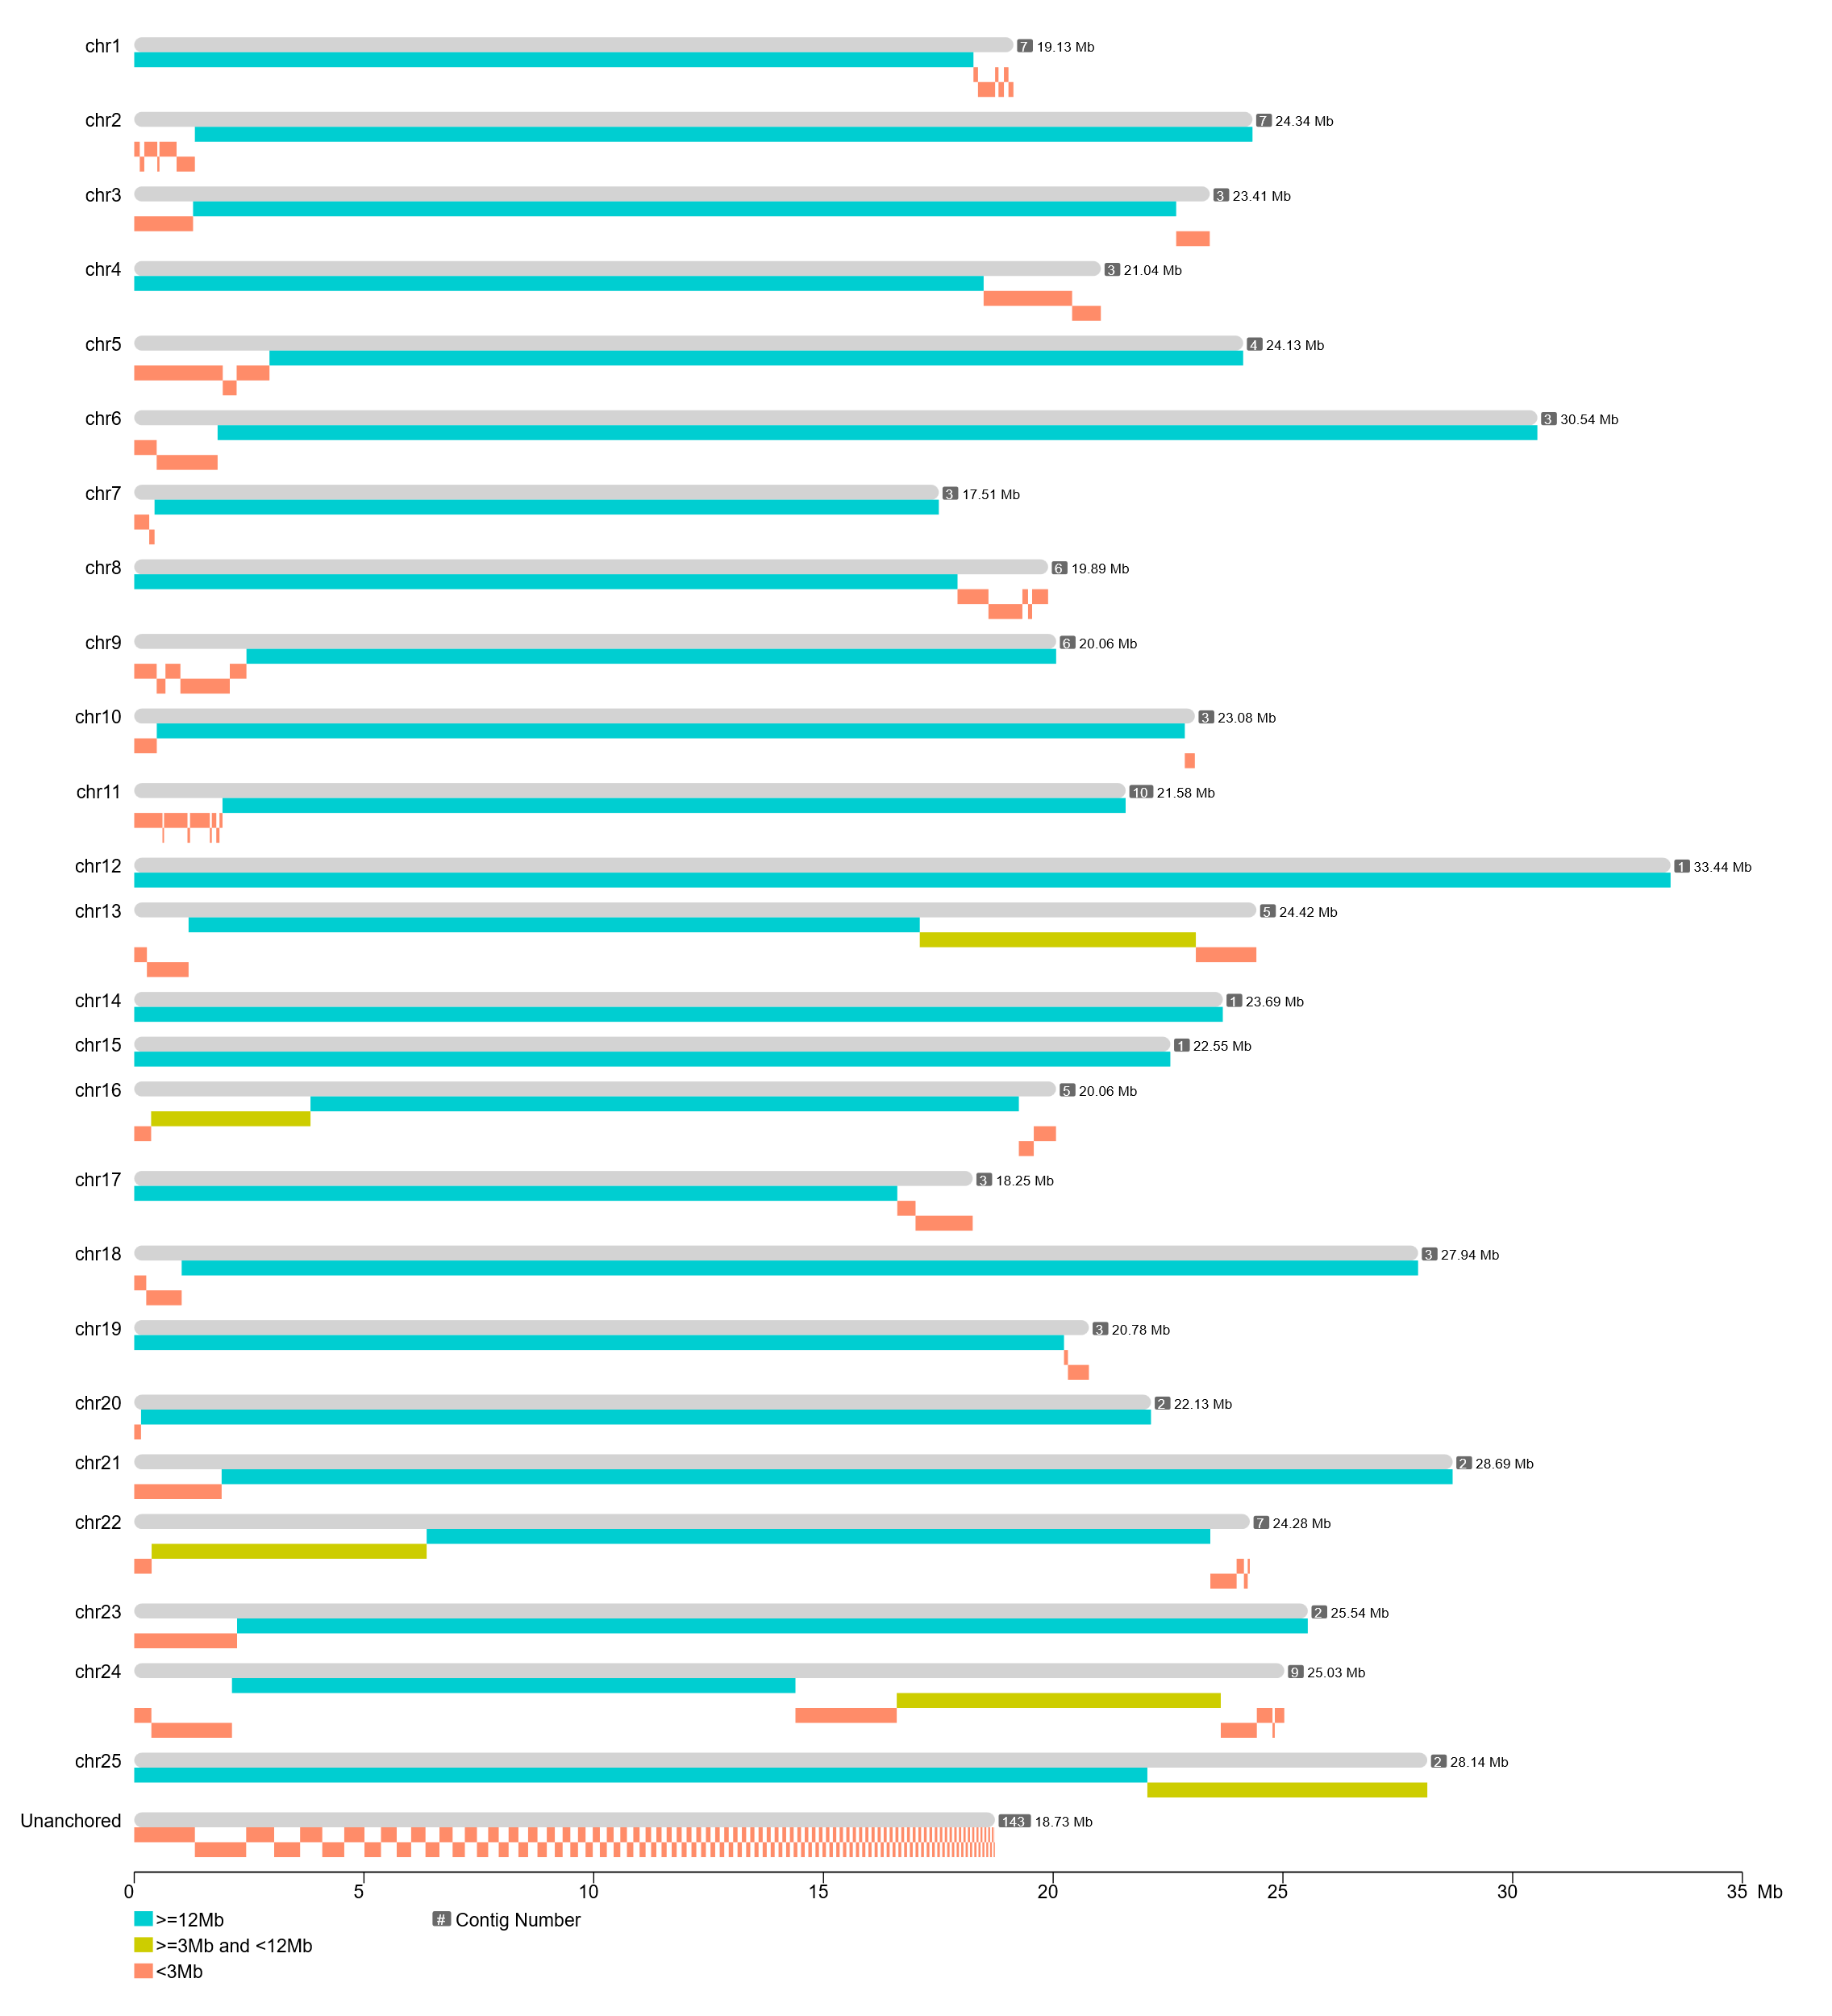
Figure S1 The contigs distribution in each pseudo-chromosome.

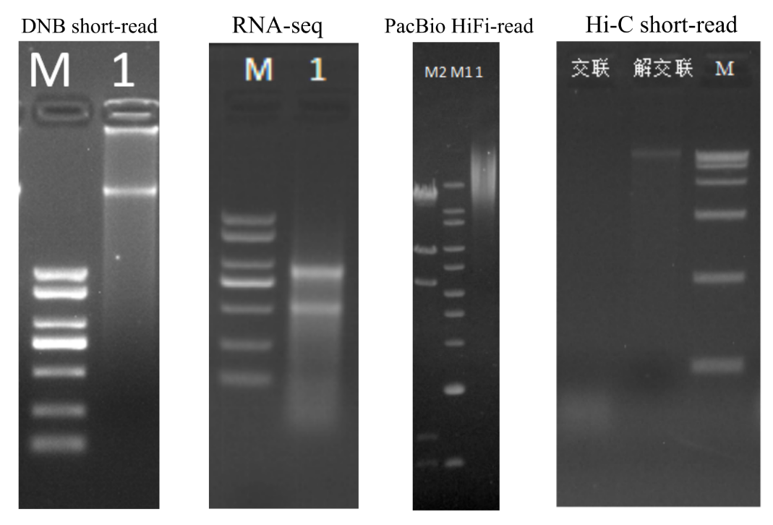
Figure S2 The electrophoresis images of the nucleic acid quality evaluation.

