Supplementary materials
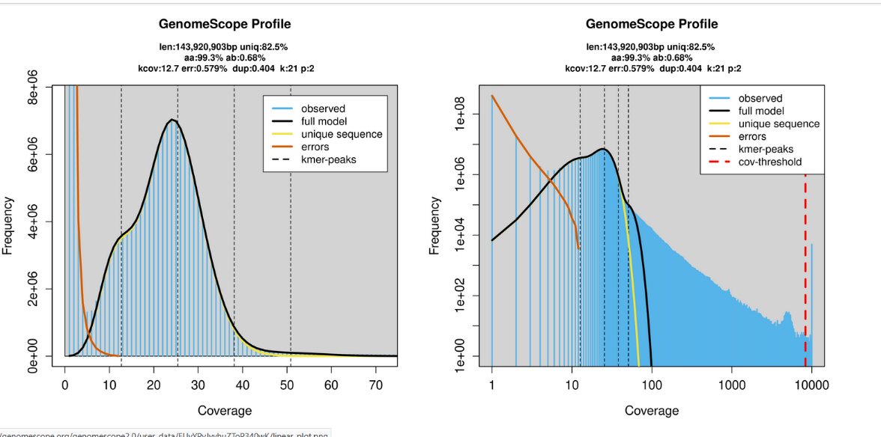

Supplementary figure 1. The estimated genomes size. The estimated genome size as calculated using Jellyfish software and GenomeScope2.0 to plot.
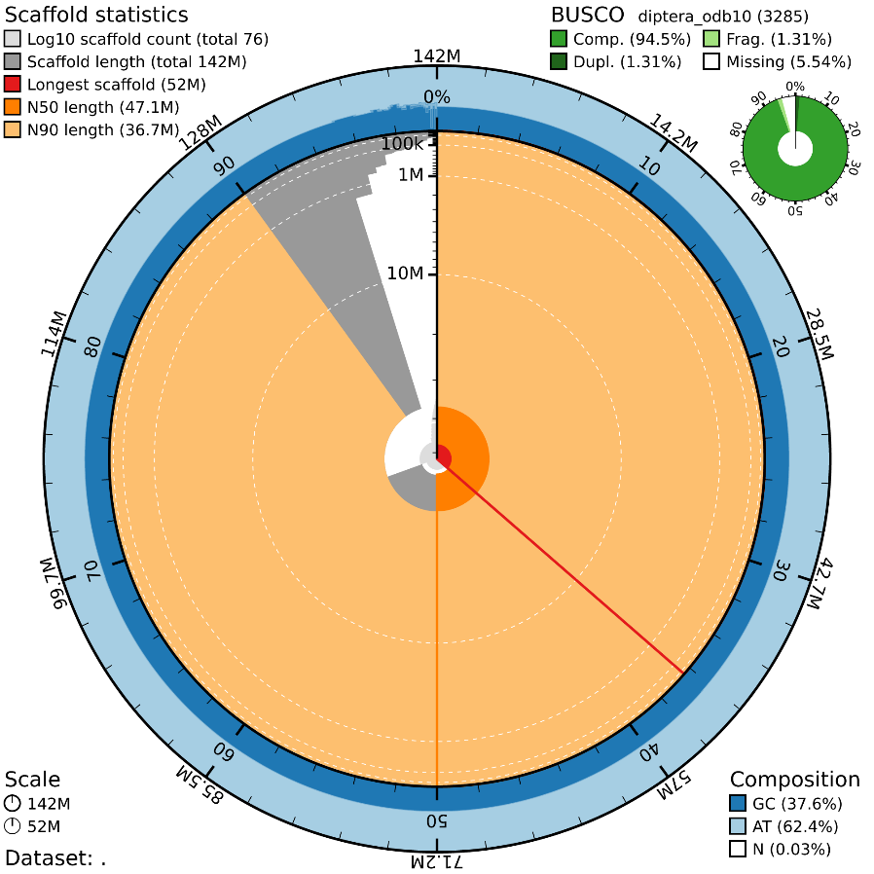
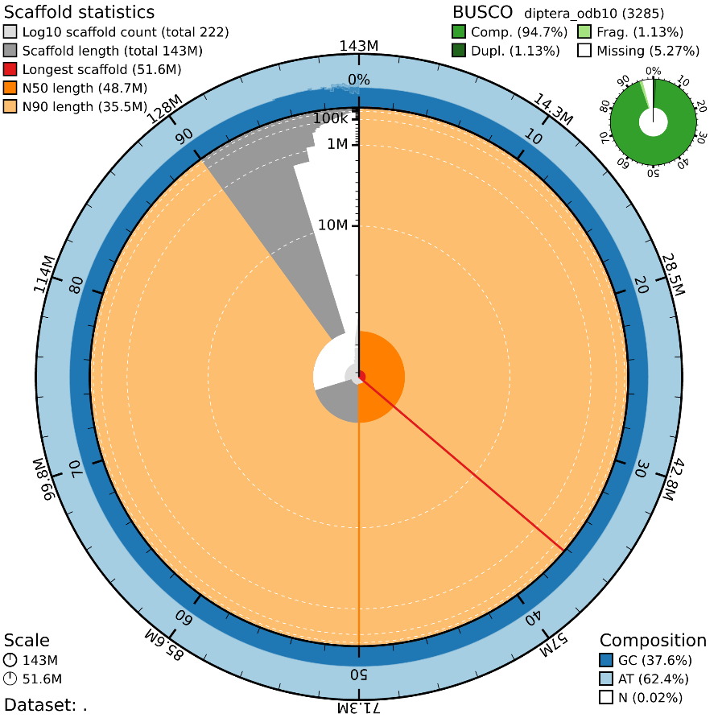
Supplementary figure 2. Snail plot of BUSCO scores. Snail plot created using the blobtoolkit software. A. Canu BUSCO results B. Flye BUSCO results.

Supplementary Table 1. Assembly Performance and Computational Resource Comparison between Canu and Flye.
 | Canu | Flye
Time taken | 844 minutes | 126 minutes
N50 | 47Mb | 48MB
Busco score | 94.5% | 94.7%
Total alignment length | 142461568 | 142614609
Number of scaffolds | 76 | 222
Largest scaffold | 51.9Mb | 51.6MB
Percentage gaps | 0.025% | 0.017%
N’s per 100kbp | 25.34 | 16.86
Maximum memory used | 64MB | 64MB
CPU threads used | 32 | 32
Disk space used | 145G | 4.7G
Assembler version used | 2.2 | 2.9.5

Supplementary Table 2. Mitochondria assembly assessment.

 | P. perniciosus mitochondria
Length | 15,253
Circular | Yes
Closely related species | P. papatasi
Assembly software used | Flye
Total genes found | 38
Protein coding genes found | 13
tRNA genes found | 23
rRNA genes found | 2
Duplicate genes found | 6

