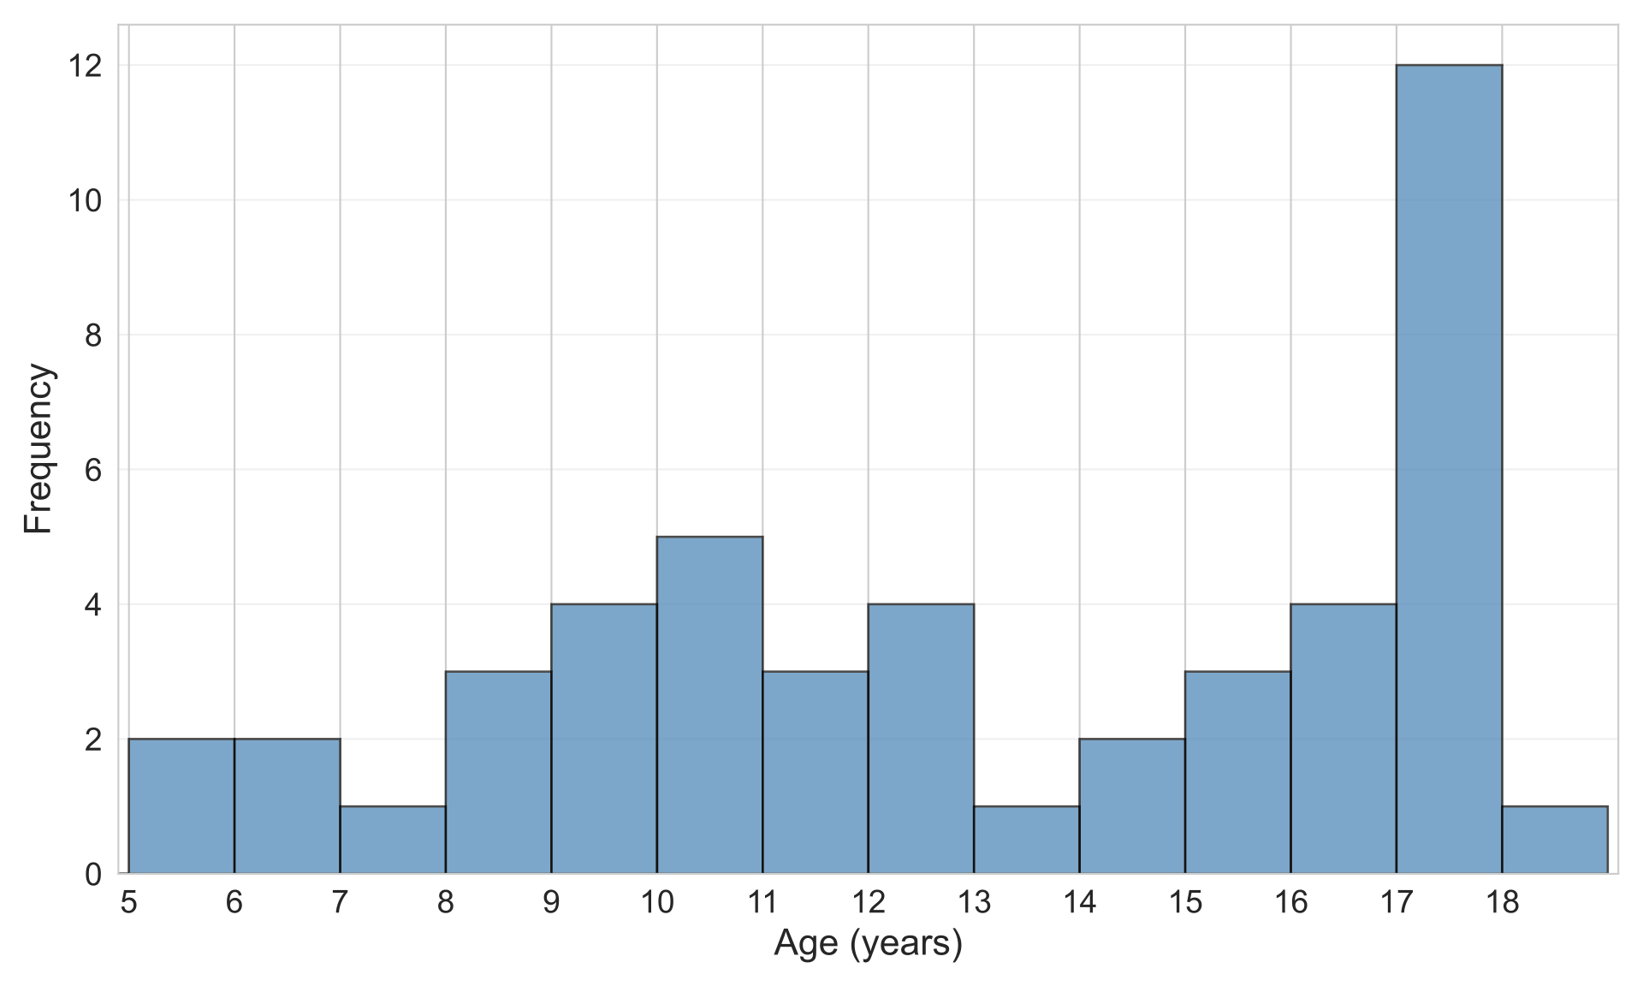
Figure S1. Histogram displaying the distribution of participant ages (N = 47).

