Appendix
Additional analyses examine calibration-year sensitivity, multiscale agreement with independently collected official reference observations, sensitivity to the daily-to-monthly weight ratio, calendar-type sample composition, model benchmarking, feature importance, and ablation behavior.

Calibration-Year Sensitivity
Two models were trained independently using the 2024 and 2025 MoT observations and applied to the dates in 2020 for which BMI was available. Across 10,656,377 matched OD–date records, the median absolute and relative differences between the two reconstructions were 5 person-times and 2.75%, and the corresponding 95th-percentile differences were 218 person-times and 10.2% (Supplementary Figure 1). This analysis indicates limited output sensitivity to the choice of calibration year, but it is not direct validation of pandemic-era mobility or of the assumed temporal transferability of the calibration relationship.
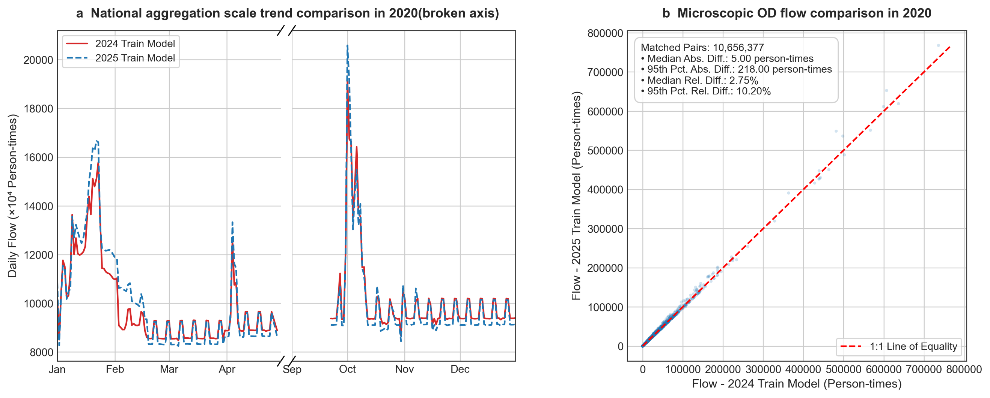
Supplementary Figure 1. Sensitivity of 2020 OD mobility estimates to the choice of calibration year.

Weight-Ratio Sensitivity
Daily-to-monthly per-sample weight ratios of 0.2, 0.5, 1, 2, 3, 5, 8, and 10 were tested while the CatBoost configuration and train–validation split was held fixed. (Supplementary Figure 2) Metrics were calculated exclusively against the same held-out directly observed daily MoT records. Although 0.2 produced the best numerical metrics, it assigned less weight to directly observed records than to monthly-derived constraints. While preserving greater per-record influence for directly observed daily data, the adopted 3:1 ratio remains within the best-performing range.
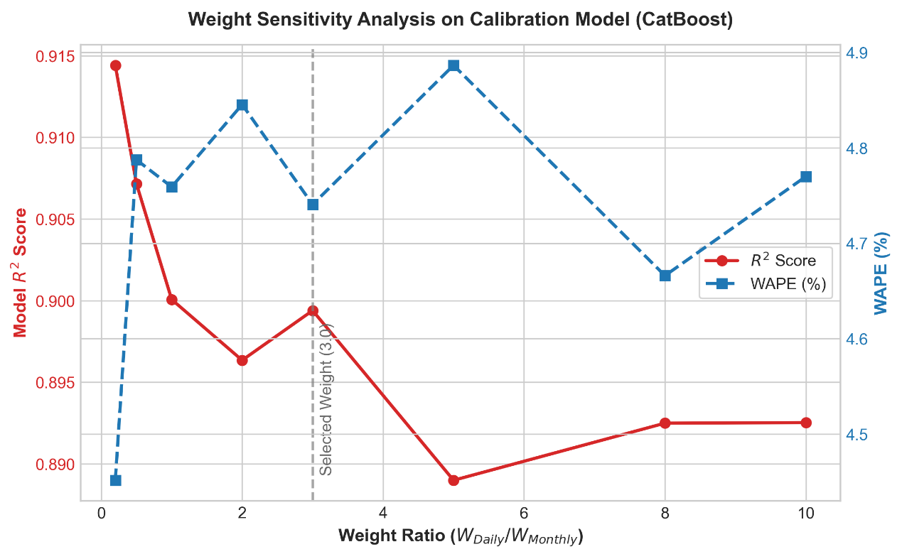
Supplementary Figure 2. Sensitivity of CatBoost hold-out performance to the daily-to-monthly per-sample weight ratio.

Calendar-Type Coverage
The 88 directly observed daily training records include 34 statutory holidays, 39 ordinary workdays, four compensatory workdays, and 11 ordinary weekends. The 22 held-out records include seven statutory holidays, 10 ordinary workdays, one compensatory workday, and four ordinary weekends. Because several strata contain very few held-out observations, separate performance metrics for each calendar type would be unstable. The sample composition is reported transparently, and the available ordinary-workday observations are acknowledged to be concentrated before or after major holidays rather than representative of ordinary weekdays throughout the year.

