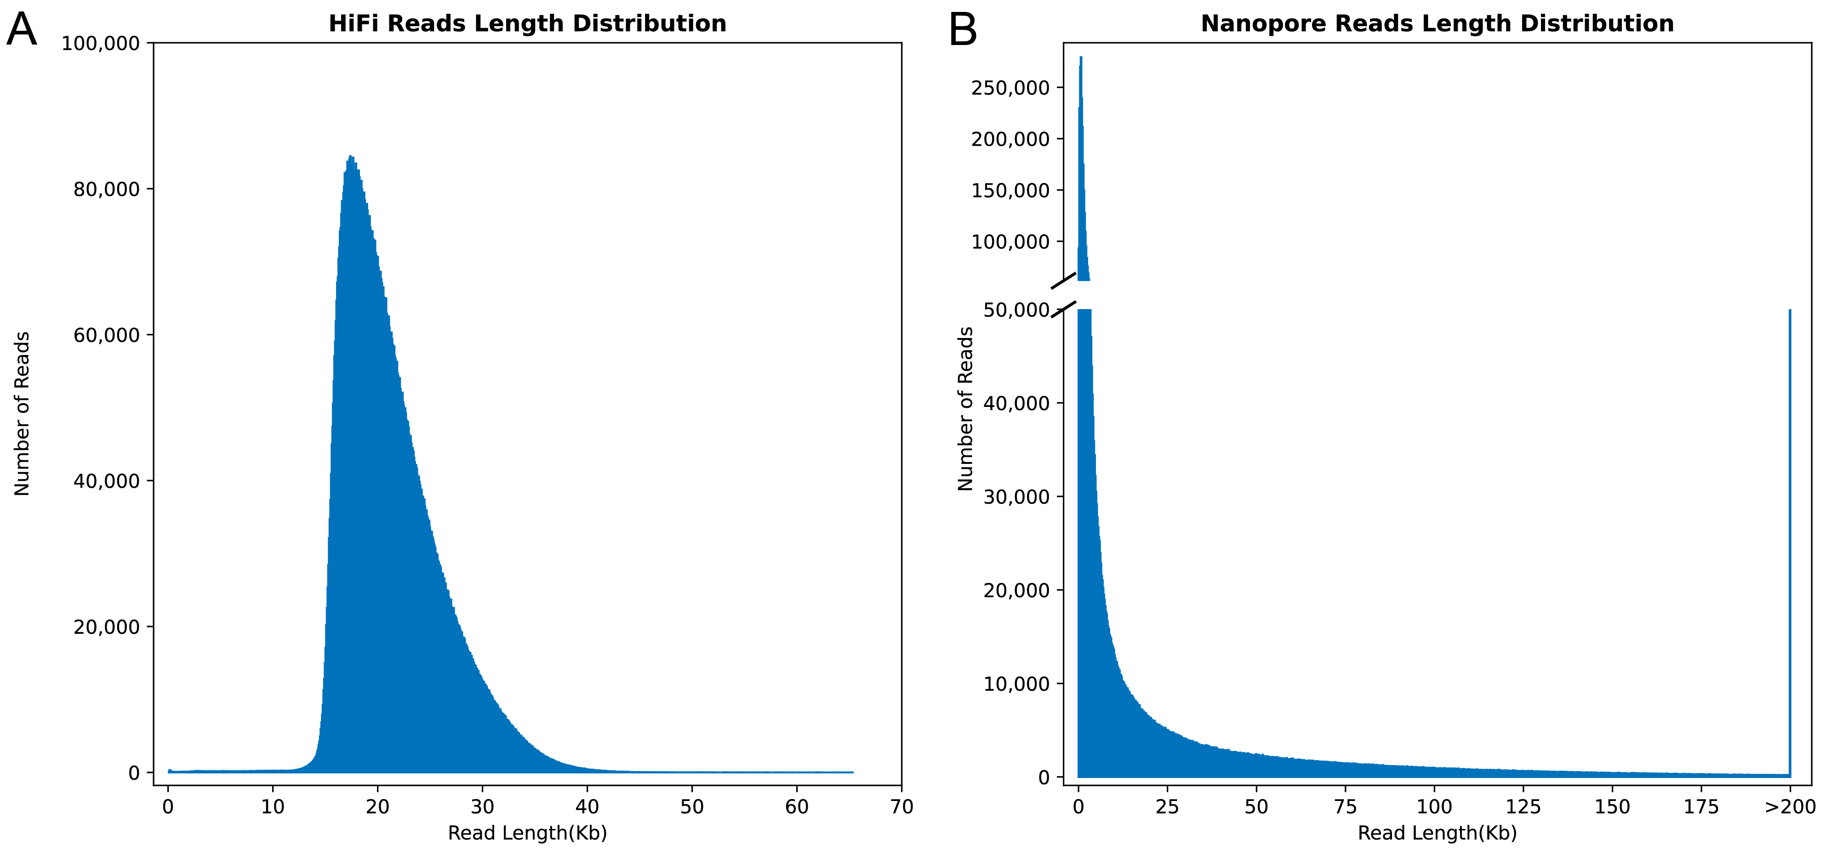
Fig. S1 Length distribution of PacBio HiFi reads and Nanopore ultra-long reads for the M. dahurica genome.

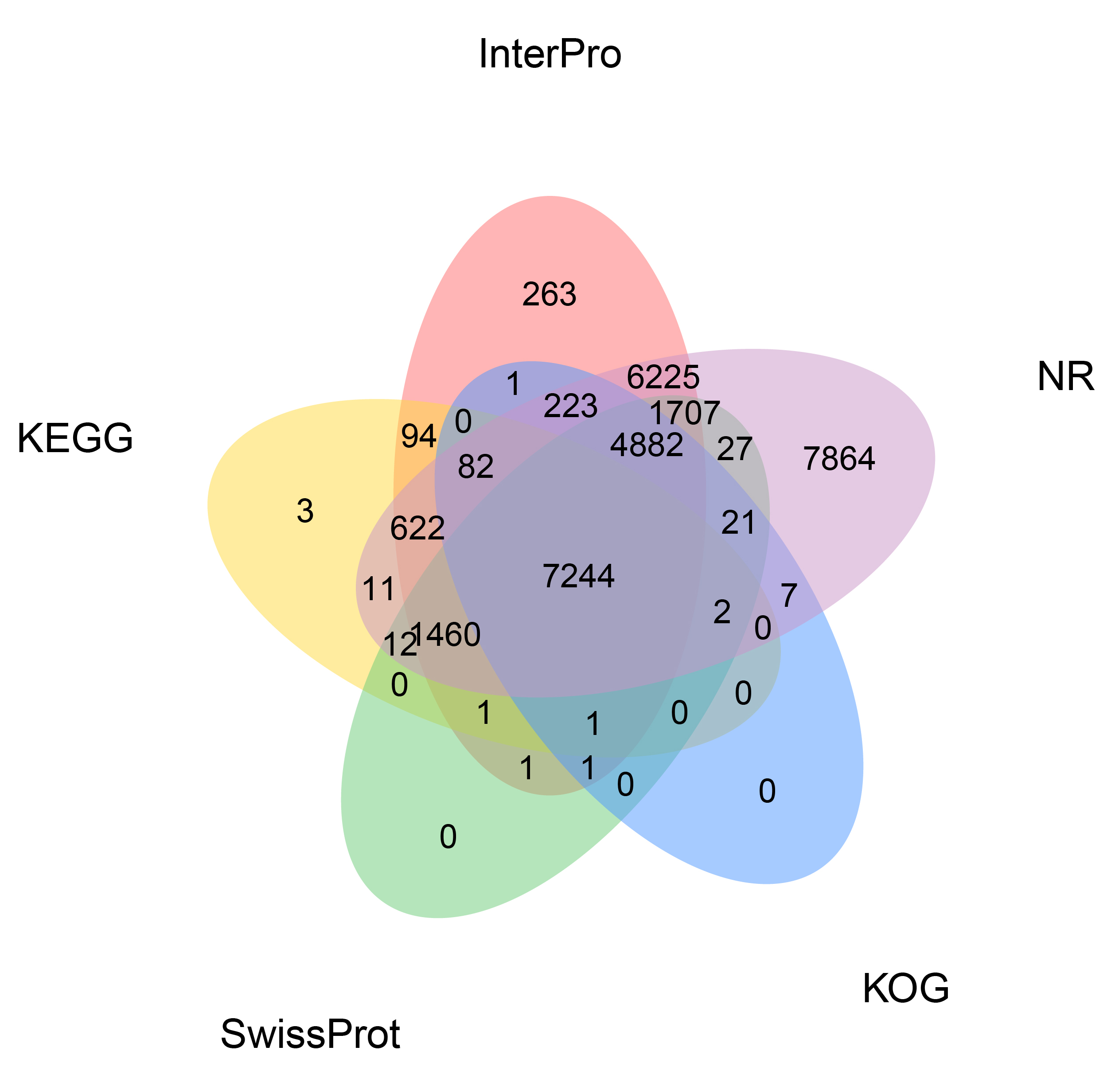
Fig. S2 The venn diagram of annotation results of five databases for M. dahurica genome.

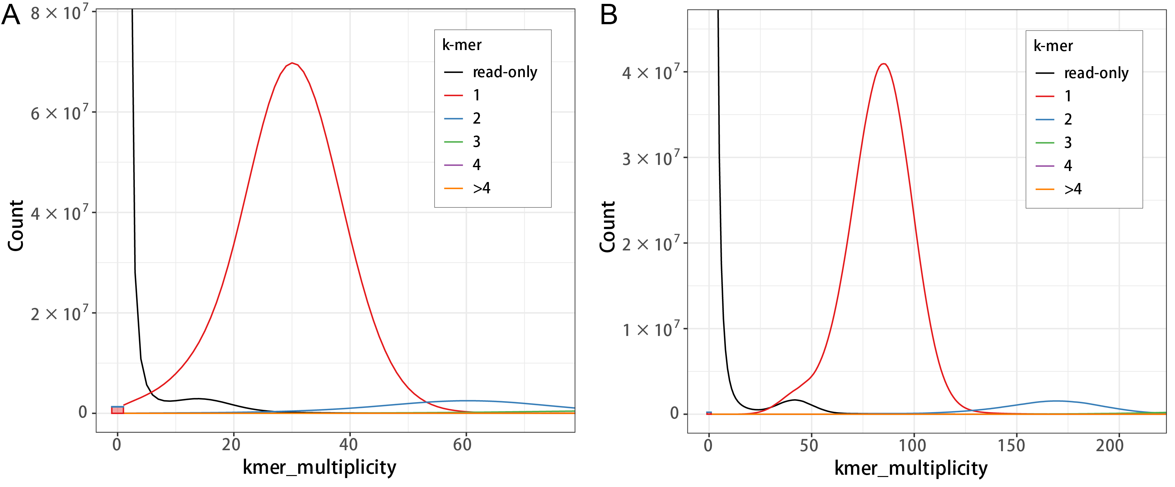
Fig. S3. Kmer distribution of different copy numbers in the assembled sequence of M. dahurica genome.
A. Short read length data. B. PacBio HiFi read length data.

Table S1. Statistics of Hi-C data alignment against the initial genome assembly.
Mapping Category | Read 1 |  | Read 2
Mapping Category | Number | Percentage (%) | Number | Percentage (%)
Unique Alignments | 519,564,779 | 48.81 | 488,537,226 | 45.89
Multiple Alignments | 271,592,315 | 25.51 | 271,690,704 | 25.52
Too short to align | 7,146,056 | 0.67 | 7,357,472 | 0.69
Failed To Align | 266,262,553 | 25.01 | 296,980,301 | 27.9
Paired | 376,114,417 | 35.33 | 376,114,417 | 35.33

Table S2. Statistics of Hi-C interaction pair classification and filtration for the M. dahurica genome assembly.
Category | Di-Tag Count | Percent in Paired (%) | Percent in Total Reads(%)
Same Circularised | 433,097 | 0.12 | 0.04
Same Fragment Dangling Ends | 9,332,871 | 2.48 | 0.88
Same Fragment Internal | 91,300,767 | 24.27 | 8.58
Re-ligation | 14,445,877 | 3.84 | 1.36
Contiguous Sequence | 0 | 0 | 0
Wrong Size | 0 | 0 | 0
Invalid Pairs | 115,512,612 | 30.71 | 10.85
Valid Pairs | 18,728,919 | 4.98 | 1.76
Valid Pairs (de-duplication) | 18,673,445 | 4.96 | 1.75

Table S3. Statistics of assembled genomic sequences.
Genome version | Sequence length (bp) | Sequence number | N50 (bp) | N90 (bp) | Sequence length (bp) | Sequence number | N50 (bp) | N90 (bp)
Initial genome | 3,064,501,230 | 964 | 80,428,856 | 9,014,469 | 3,064,501,230 | 964 | 80,428,856 | 9,014,469
Anchored genome | 3,059,450,514 | 847 | 151,057,683 | 111,576,553 | 3,059,439,114 | 961 | 71,714,700 | 9,083,269
Anchored chromosome | 2,858,007,457 | 19 | 152,563,522 | 130,484,637 | 2,858,001,657 | 77 | 74,024,000 | 18,280,908
Free sequence | 201,443,057 | 828 | 553,869 | 86,861 | 201,437,457 | 884 | 521,122 | 81,726

Table S4. Chromosome-level assembly statistics and telomere identification in M. dahurica.
Chromosomes | Length (bp) | Number of contigs | Number of gaps | Number of telomeres (Front) | Number of telomeres (End)
chr1 | 199,977,113 | 1 | 0 | 0 | 16
chr2 | 188,648,379 | 1 | 0 | 105 | 0
chr3 | 181,079,874 | 2 | 1 | 67 | 598
chr4 | 172,474,927 | 2 | 1 | 0 | 0
chr5 | 166,067,045 | 2 | 1 | 0 | 1,976
chr6 | 157,365,540 | 1 | 0 | 0 | 81
chr7 | 154,577,346 | 1 | 0 | 2,865 | 2,653
chr8 | 153,232,083 | 1 | 0 | 83 | 2,294
chr9 | 152,678,332 | 2 | 1 | 59 | 0
chr10 | 151,152,916 | 1 | 0 | 70 | 3,055
chr11 | 138,893,480 | 2 | 1 | 3,198 | 0
chr12 | 138,898,721 | 1 | 0 | 13 | 2,392
chr13 | 139,205,371 | 1 | 0 | 289 | 0
chr14 | 137,871,030 | 2 | 1 | 0 | 20
chr15 | 137,273,996 | 2 | 1 | 132 | 2,623
chr16 | 133,867,103 | 1 | 0 | 115 | 0
chr17 | 130,459,036 | 1 | 0 | 0 | 0
chr18 | 116,490,694 | 1 | 0 | 0 | 83
chr19 | 111,571,151 | 1 | 0 | 0 | 2,094

Table S5. Classification and statistics of repeat sequences in the M. dahurica genome.
Type | Repeat Size (bp) | % of genome
Trf | 527,435,689 | 18.43
Repeatmasker | 259,987,059 | 9.08
Proteinmask | 205,677,808 | 7.19
De novo | 1,626,251,520 | 56.82
Total | 1,978,139,542 | 69.11

Table S6. Blast-based taxonomic origin assessment of the genome assembly.
Genus | Kingdom | Blast number | Genome split number | Hit number | Percentage of genome (%) | Percentage of hits (%) | Median identity (%)
Sinohyriopsis | Metazoa | 36,180 | 286,227 | 91,702 | 12.64 | 39.45 | 82.18
Eretmochelys | Metazoa | 4,903 | 286,227 | 91,702 | 1.71 | 5.35 | 90.48
Amblema | Metazoa | 4,182 | 286,227 | 91,702 | 1.46 | 4.56 | 81.93
Chrysemys | Metazoa | 3685 | 286,227 | 91,702 | 1.29 | 4.02 | 93.17
Margaritifera | Metazoa | 2529 | 286,227 | 91,702 | 0.88 | 2.76 | 99.34

Table S7. Mapping statistics of multi-platform sequencing reads against the M. dahurica genome assembly.
Reads type | Mapping rate (%) | Paired mapping rate (%) | Average depth (X) | Coverage (%) | Coverage  (≥4X, %) | Coverage  (≥10X, %) | Coverage  (≥20X, %)
Illumina short reads | 99.83 | 96.46 | 76 | 99.91 | 99.63 | 98.83 | 96.83
PacBio HiFi reads | 99.94 | - | 87.03 | 99.97 | 99.96 | 99.95 | 99.89
ONT ultra-long reads | 98.01 | - | 36.25 | 100 | 99.98 | 99.86 | 96.7

Table S8. The consensus quality (QV) assessment of M. dahurica genome.
Reads type | K_asm | K_total | QV | Error rate
Illumina short reads | 1,331,767 | 2,862,168,685 | 46.5439 | 2.21621e-05
PacBio HiFi reads | 233,969 | 2,862,168,685 | 54.0974 | 3.89E-06

Table S9. Homozygous and heterozygous rates of assembly for M. dahurica genome.
Sample name | Homozygous SNP rate (%) | Homozygous InDel rate (%) | Heterozygous SNP rate (%) | Heterozygous InDel rate (%)
Margaritiana dahurica | 0 | 0.001 | 0.056 | 0.019

