Supplementary information of
A dataset of biomass burning emissions from multiple sources in China covering 1980 to 2024
Xuehong Gong^{1,2}, Zeyu Liu^{1,3}, Linyi Wei¹, Dongna Yan¹, Guohui Li¹, Yongming Han^{1,2,4*}
¹ State Key Laboratory of Loess Science, Institute of Earth Environment, Chinese Academy of Sciences, Xi’an 710061, China
² State Key Laboratory of Geohazard Prevention and Geoenvironment Protection, Chengdu University of Technology, Chengdu 610059, China
³ School of Environmental and Municipal Engineering, Xi’an University of Architecture and Technology, Xi’an 710055, China
⁴ School of Human Settlements and Civil Engineering, Xi’an Jiaotong University, Xi’an 710049, China
Correspondence to: Yongming Han (yongming@ieecas.cn)

Contents of this file
Figs. S1 to S13
Tables S1–S4 and S7–S8
Tables S5–S6 are provided as separate machine-readable Excel files
References (1 to 71)

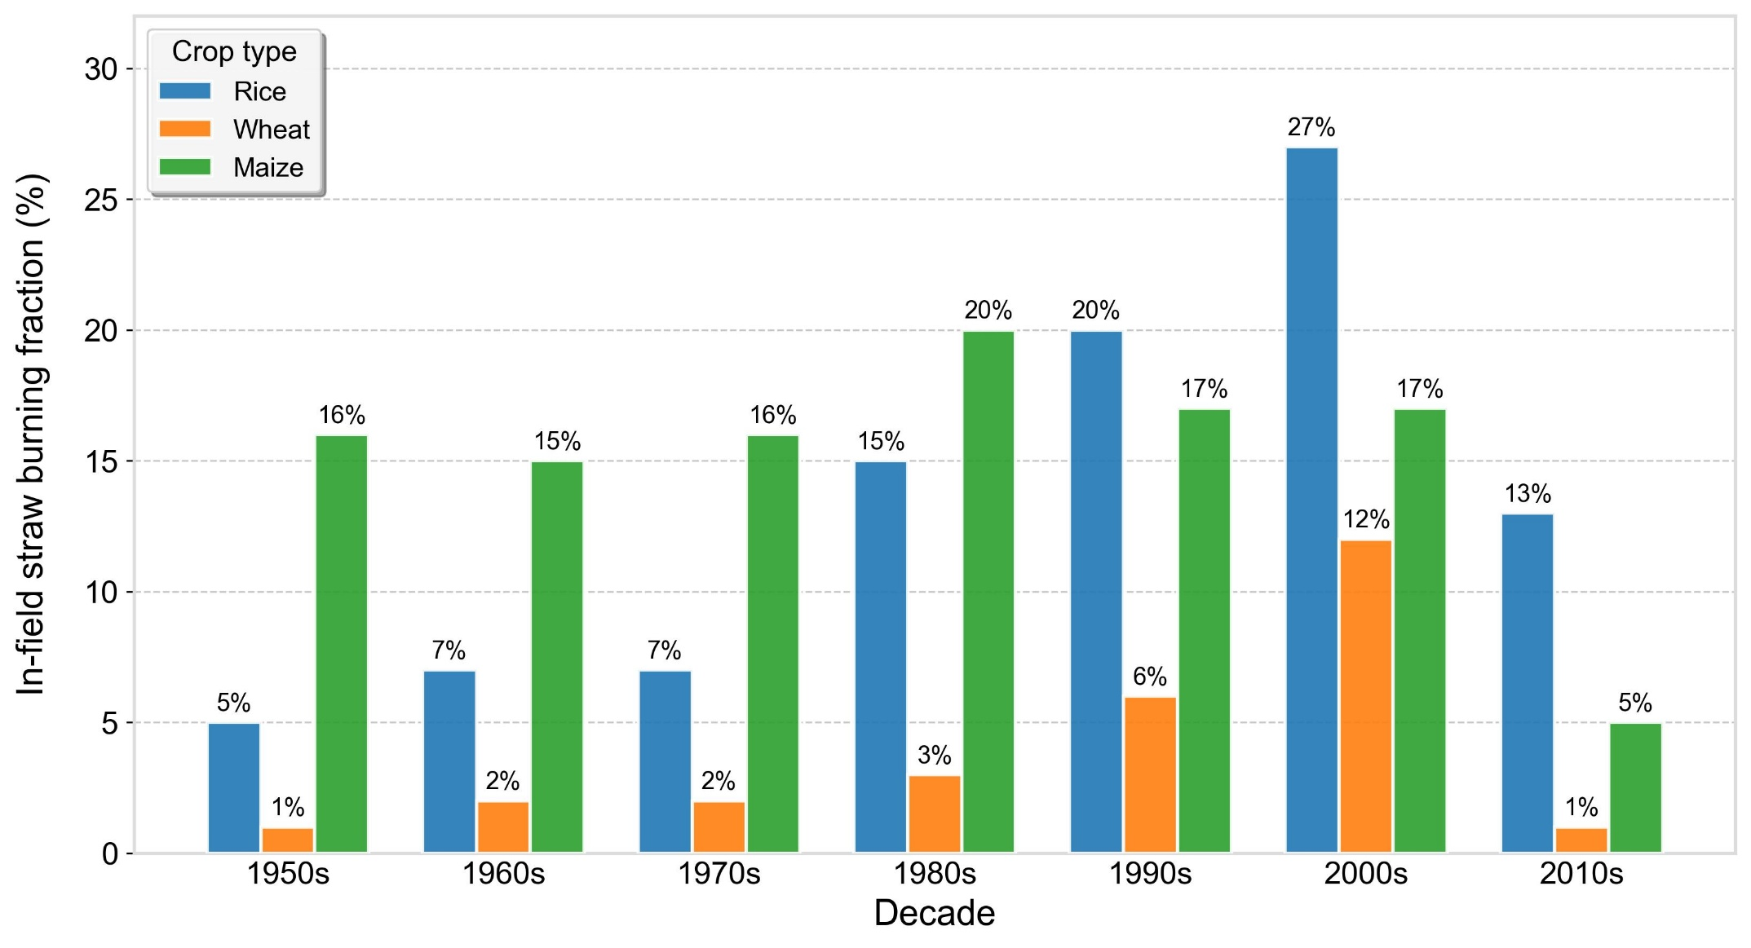

Fig. S1. Decadal variation in the national in-field straw-burning fractions of major crops in China. Bars show the crop-specific fractions adopted as temporal anchors for rice, wheat, and maize from the 1950s to the 2010s; numerical labels give the corresponding percentage values.

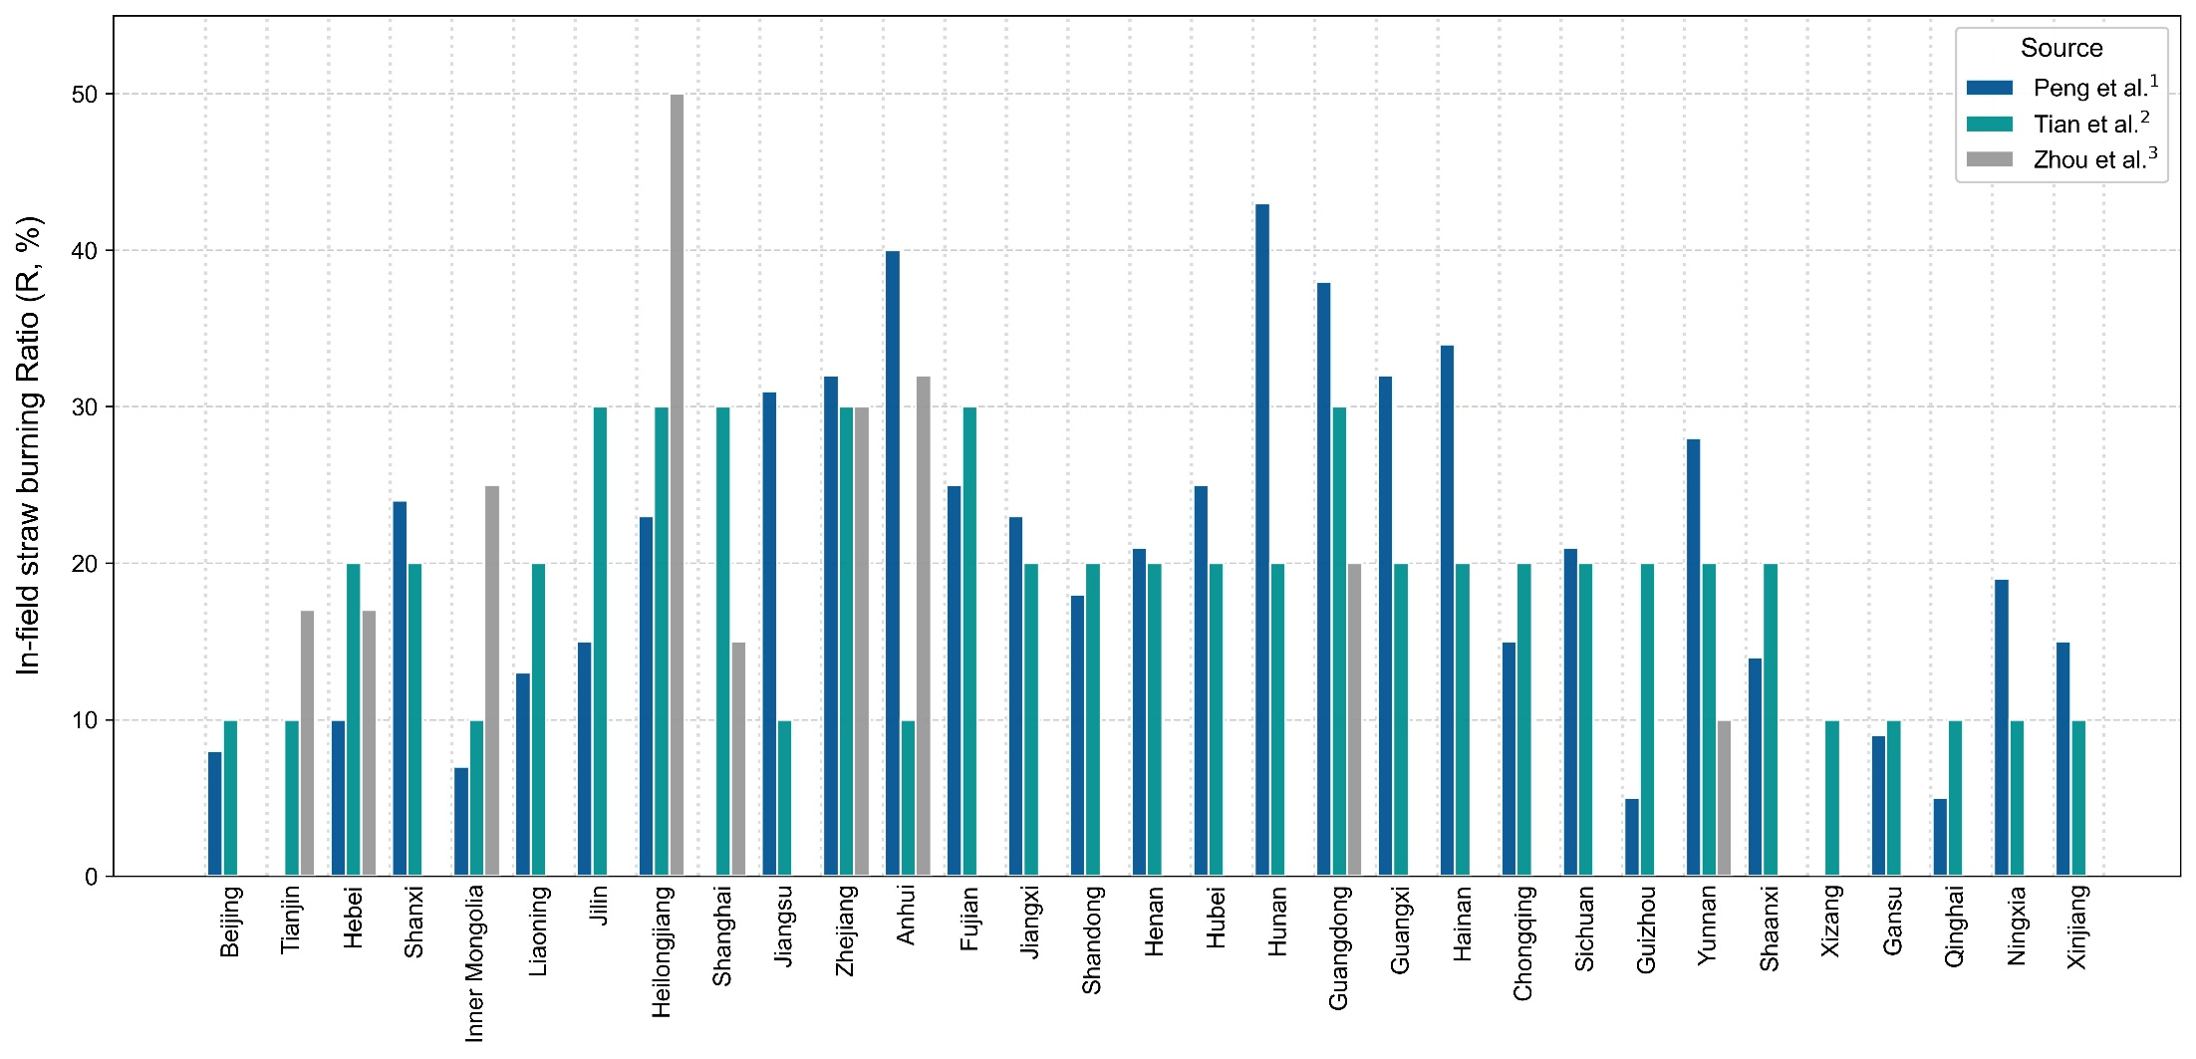

Fig. S2. Comparison of provincial in-field straw-burning ratios reported in published studies. Bars show the province-level ratios reported by Peng et al.¹, Tian et al.², and Zhou et al.³. The y-axis is expressed as a percentage; a missing bar indicates that the corresponding study did not report a value for that province.

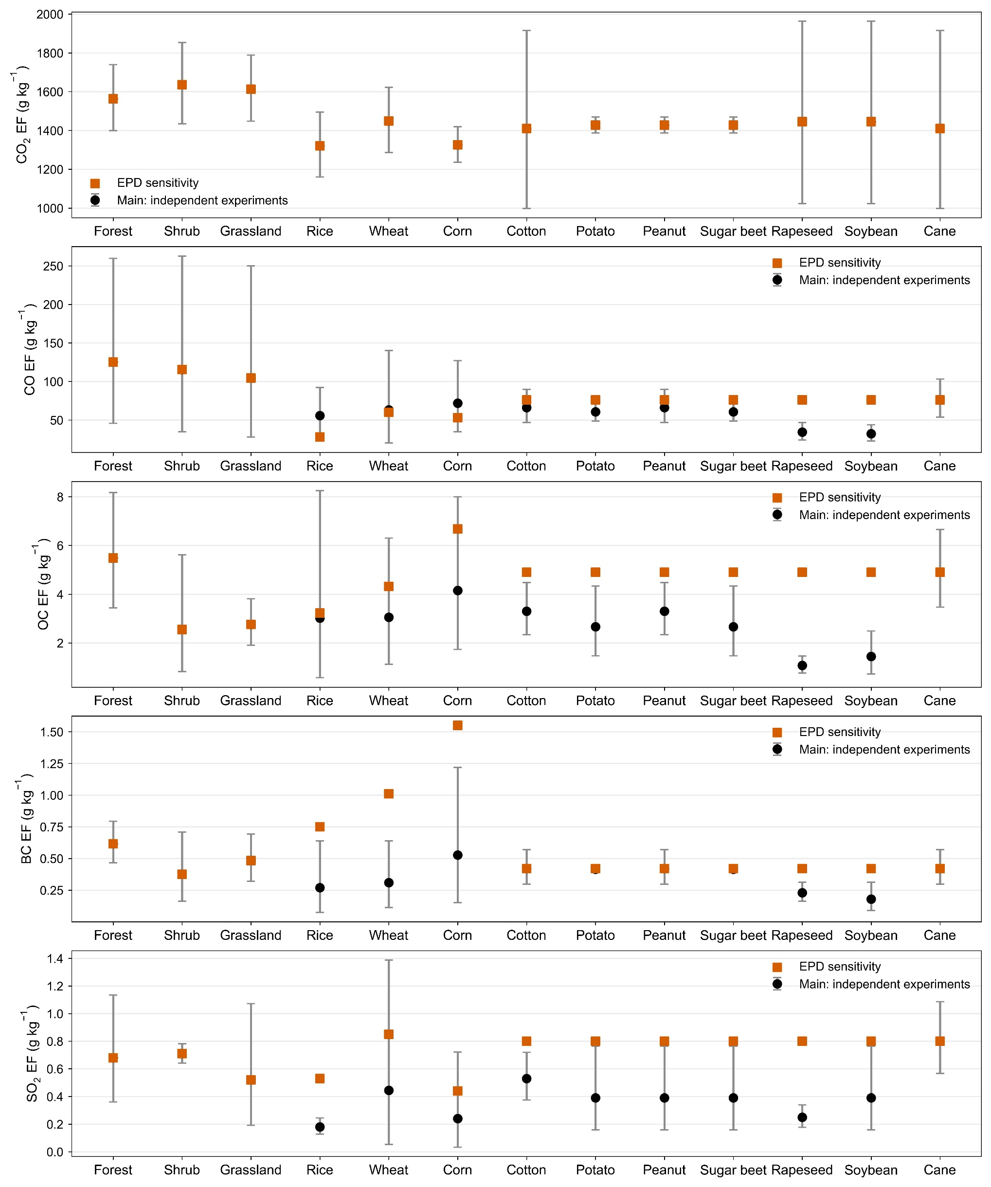

Fig. S3. Comparison of the emission factors (EFs) adopted in the main inventory and the EPD-based sensitivity scenario for open biomass burning. From top to bottom, the panels show EFs for CO₂, CO, OC, BC, and SO₂ across forest, shrub, grassland, and in-field straw burning categories. Black circles represent the main estimates derived from independent combustion experiments, whereas orange squares represent the EPD-based sensitivity estimates. Gray error bars indicate the corresponding 5th–95th percentile uncertainty ranges derived from the literature-based emission factor distributions and used in the Monte Carlo uncertainty analysis.

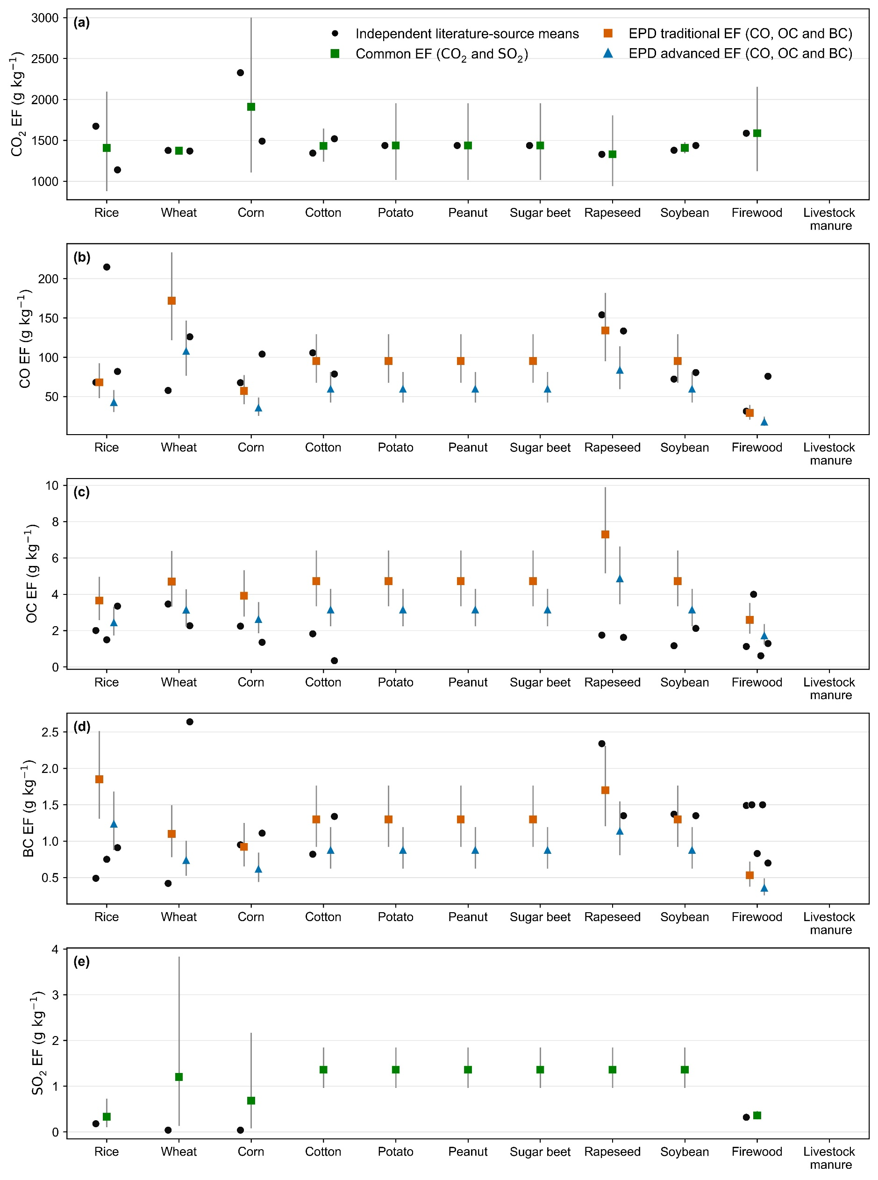

Fig. S4. Comparison of emission factors (EFs) used for domestic biomass burning with values from independent literature sources. Panels (a–e) show EFs for CO₂, CO, OC, BC, and SO₂, respectively. Black circles represent the means reported by individual literature sources. Orange squares and blue triangles denote the EPD-based EFs for traditional and advanced stoves, respectively, for CO, OC, and BC. For CO₂ and SO₂, green squares indicate the common EFs applied to both stove types. Gray error bars represent the corresponding 5th–95th percentile uncertainty ranges derived from the assumed 20% coefficient of variation and used to parameterize the Monte Carlo uncertainty analysis.
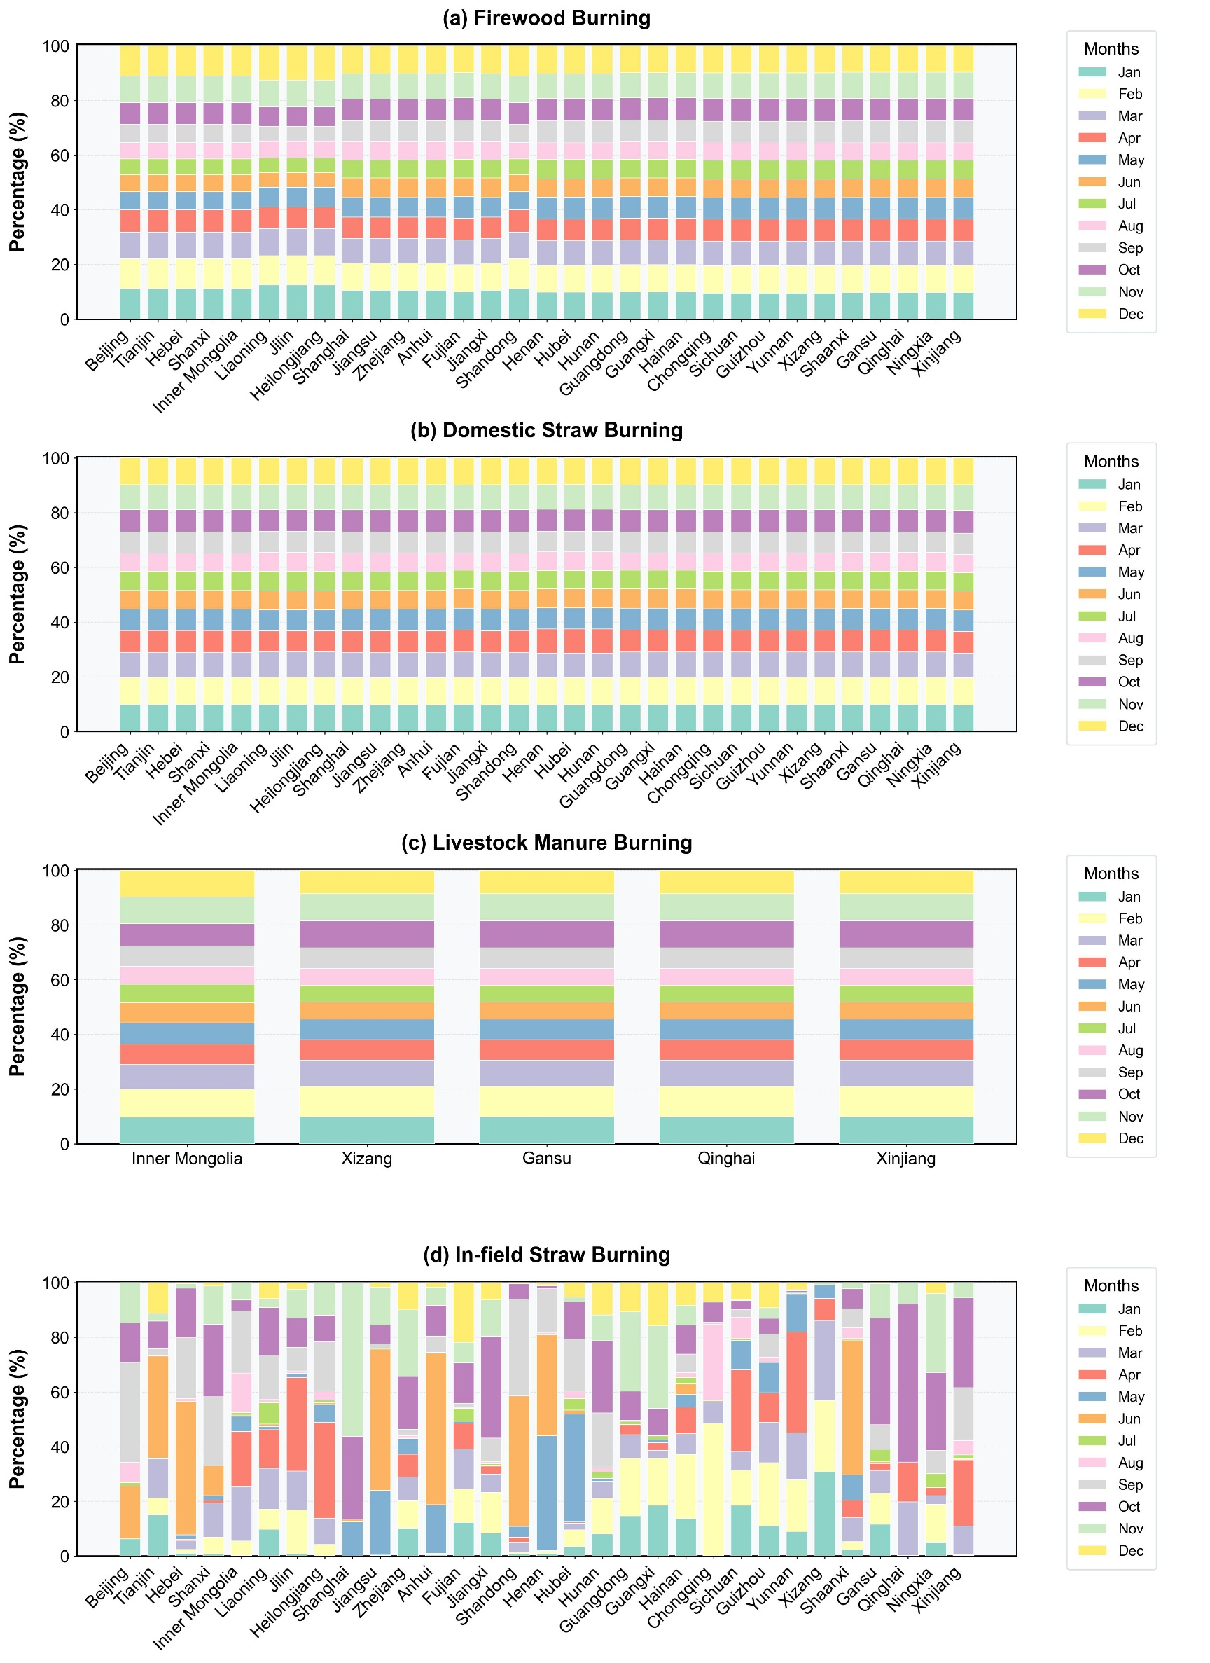

Fig. S5. Province-specific monthly allocation profiles for biomass burning sources in China. Panels show (a) firewood burning, (b) domestic straw burning, (c) livestock-manure burning, and (d) in-field straw burning. Each stacked bar gives the percentage of the annual total allocated to each calendar month and sums to 100% for a province and source.

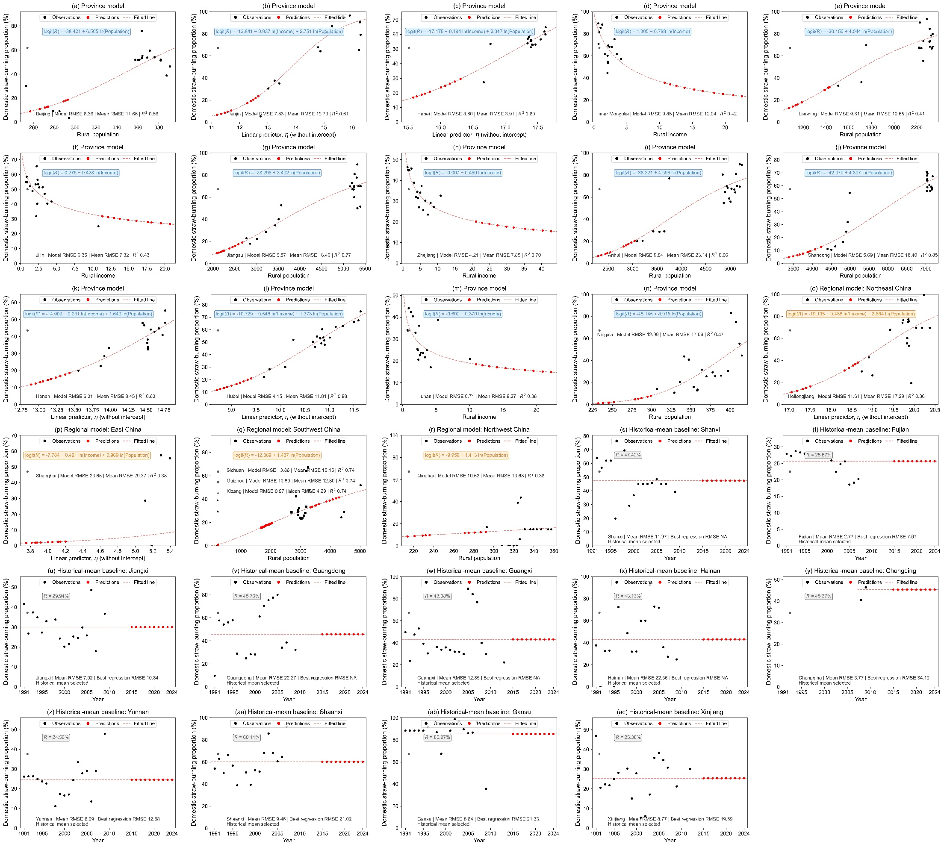

Fig. S6. Reconstructed provincial fractions of in-field straw burning in China during 1980–2024. The solid blue line represents the median estimate under the Base scenario, and the blue shading denotes its 5th–95th percentile uncertainty interval derived from Monte Carlo simulations. The gray shading indicates the overall plausible envelope, defined by the minimum 5th percentile and maximum 95th percentile across the Constant, Base, and Accelerated-decline scenarios. Squares, circles, and triangles show the temporally matched province-level constraints reported by Peng et al.¹, Tian et al.², and Zhou et al.³, respectively. The years shown after the cited studies indicate the years represented by the reported emission estimates, rather than the publication years of the studies. The vertical dashed line marks 2015; values after 2015 were extrapolated under the alternative post-2015 trajectory assumptions.

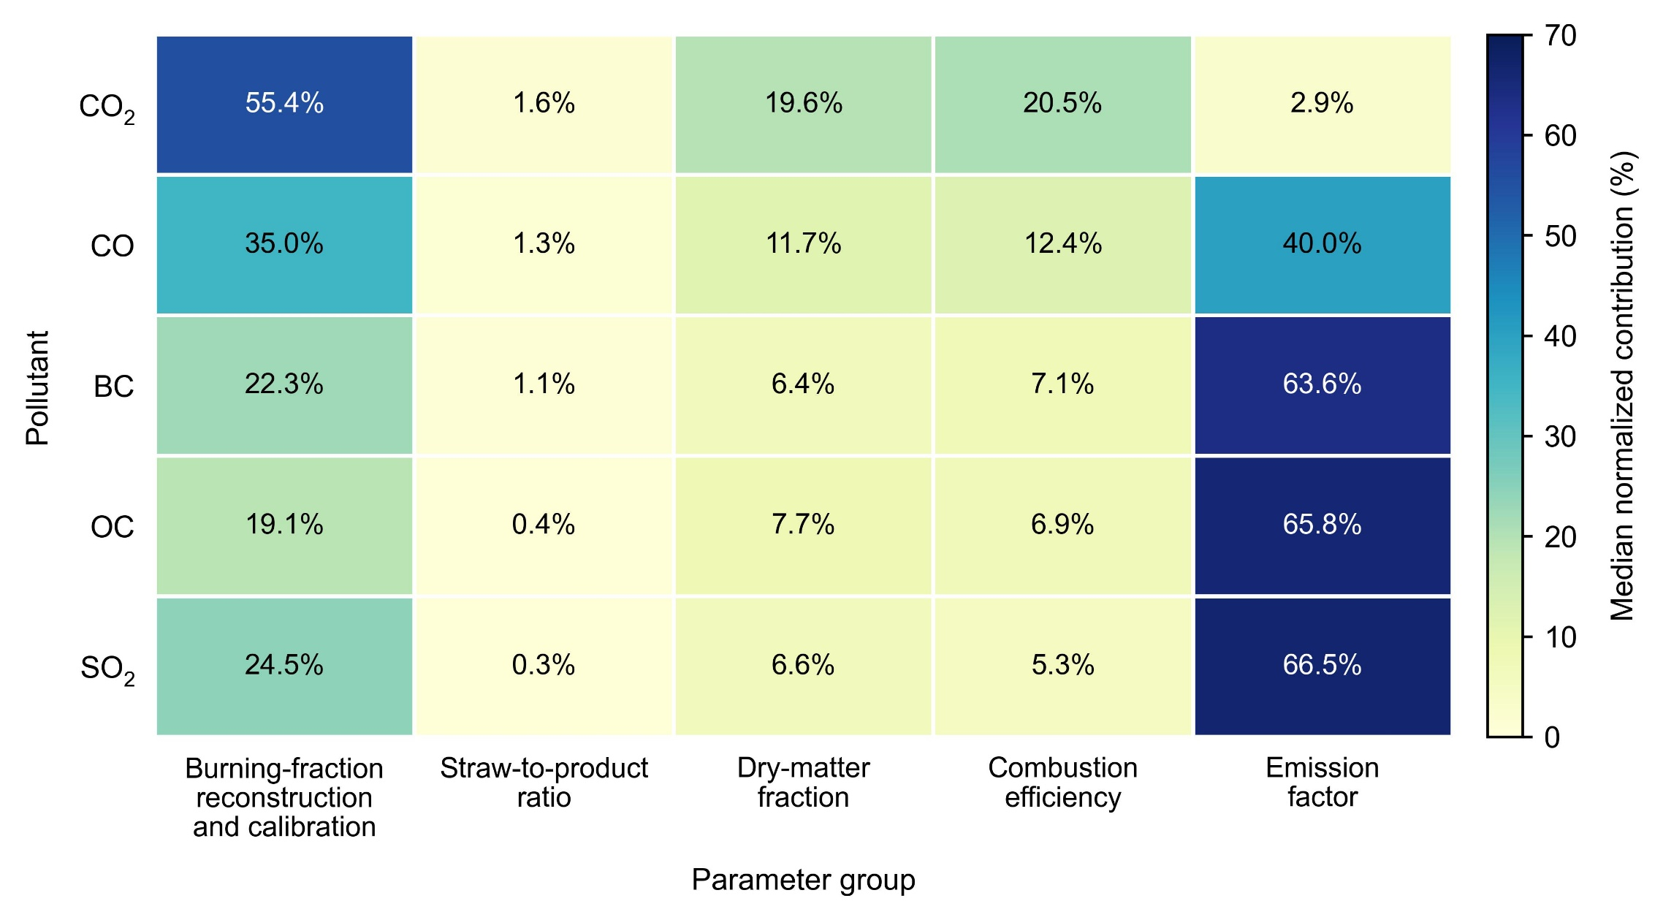

Fig. S7. Contributions of grouped input parameters to the uncertainty in national in-field straw-burning emissions during 1980–2024. Rows correspond to CO₂, CO, BC, OC, and SO₂, and columns represent burning-fraction reconstruction and calibration, straw-to-product ratio, dry-matter fraction, combustion efficiency, and emission factor. Cell values are the median annual normalized contributions over 1980–2024; contributions sum to 100% for each pollutant.

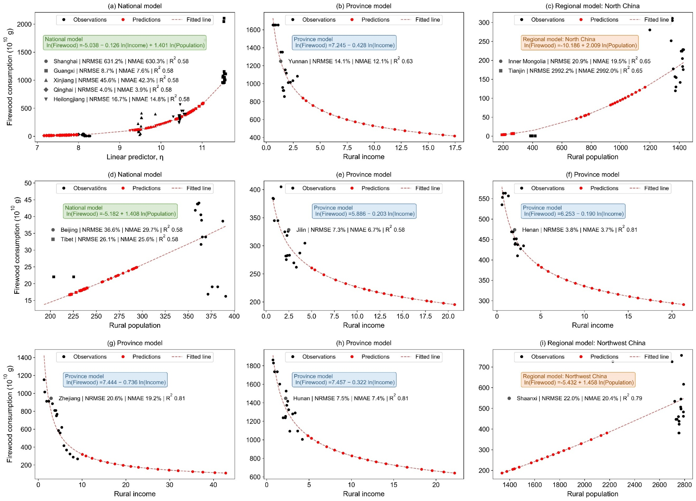

Fig. S8. Province-specific reconstruction models selected for domestic straw-burning proportions. Black points represent available provincial observations, red points represent reconstructed or projected values for 2015–2024, and red dashed lines show the fitted response of the selected model. Province-level, regional-level, and national-level logit regression models are identified by blue, orange, and green equation boxes, respectively. Provinces assigned to the same regional or national equation are combined within a common panel and distinguished by different marker shapes. For models containing both rural income and rural population, the horizontal axis represents the linear predictor $η$, excluding the intercept. Model annotations report the median cross-validation RMSE of the selected regression model, the corresponding RMSE of the province-specific historical-mean baseline, and the training R² on the logit scale. Panels labeled as historical-mean baselines show the observed provincial time series, the constant mean estimate selected through cross-validation, and projected values for 2015–2024.

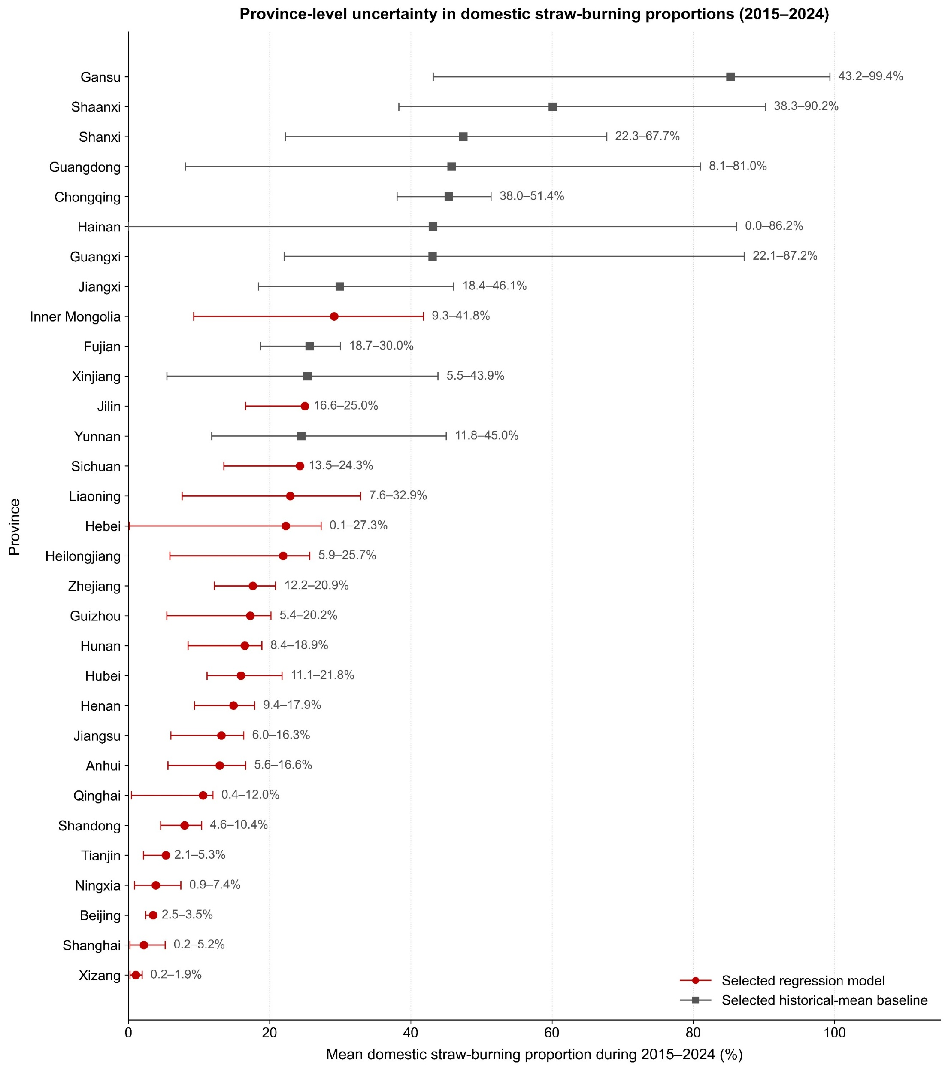

Fig. S9. Province-level uncertainty in reconstructed domestic straw-burning proportions during 2015–2024. Points represent the mean annual domestic straw-burning proportion predicted for each province over 2015–2024. Horizontal error bars indicate the mean lower and upper bounds of the annual 5th–95th percentile predictive intervals, and numerical labels report the corresponding [P05, P95] range. Red circles denote provinces for which the selected logit regression model outperformed the historical-mean baseline in repeated cross-validation, whereas gray squares denote provinces for which the historical-mean baseline yielded a lower validation error and was retained.
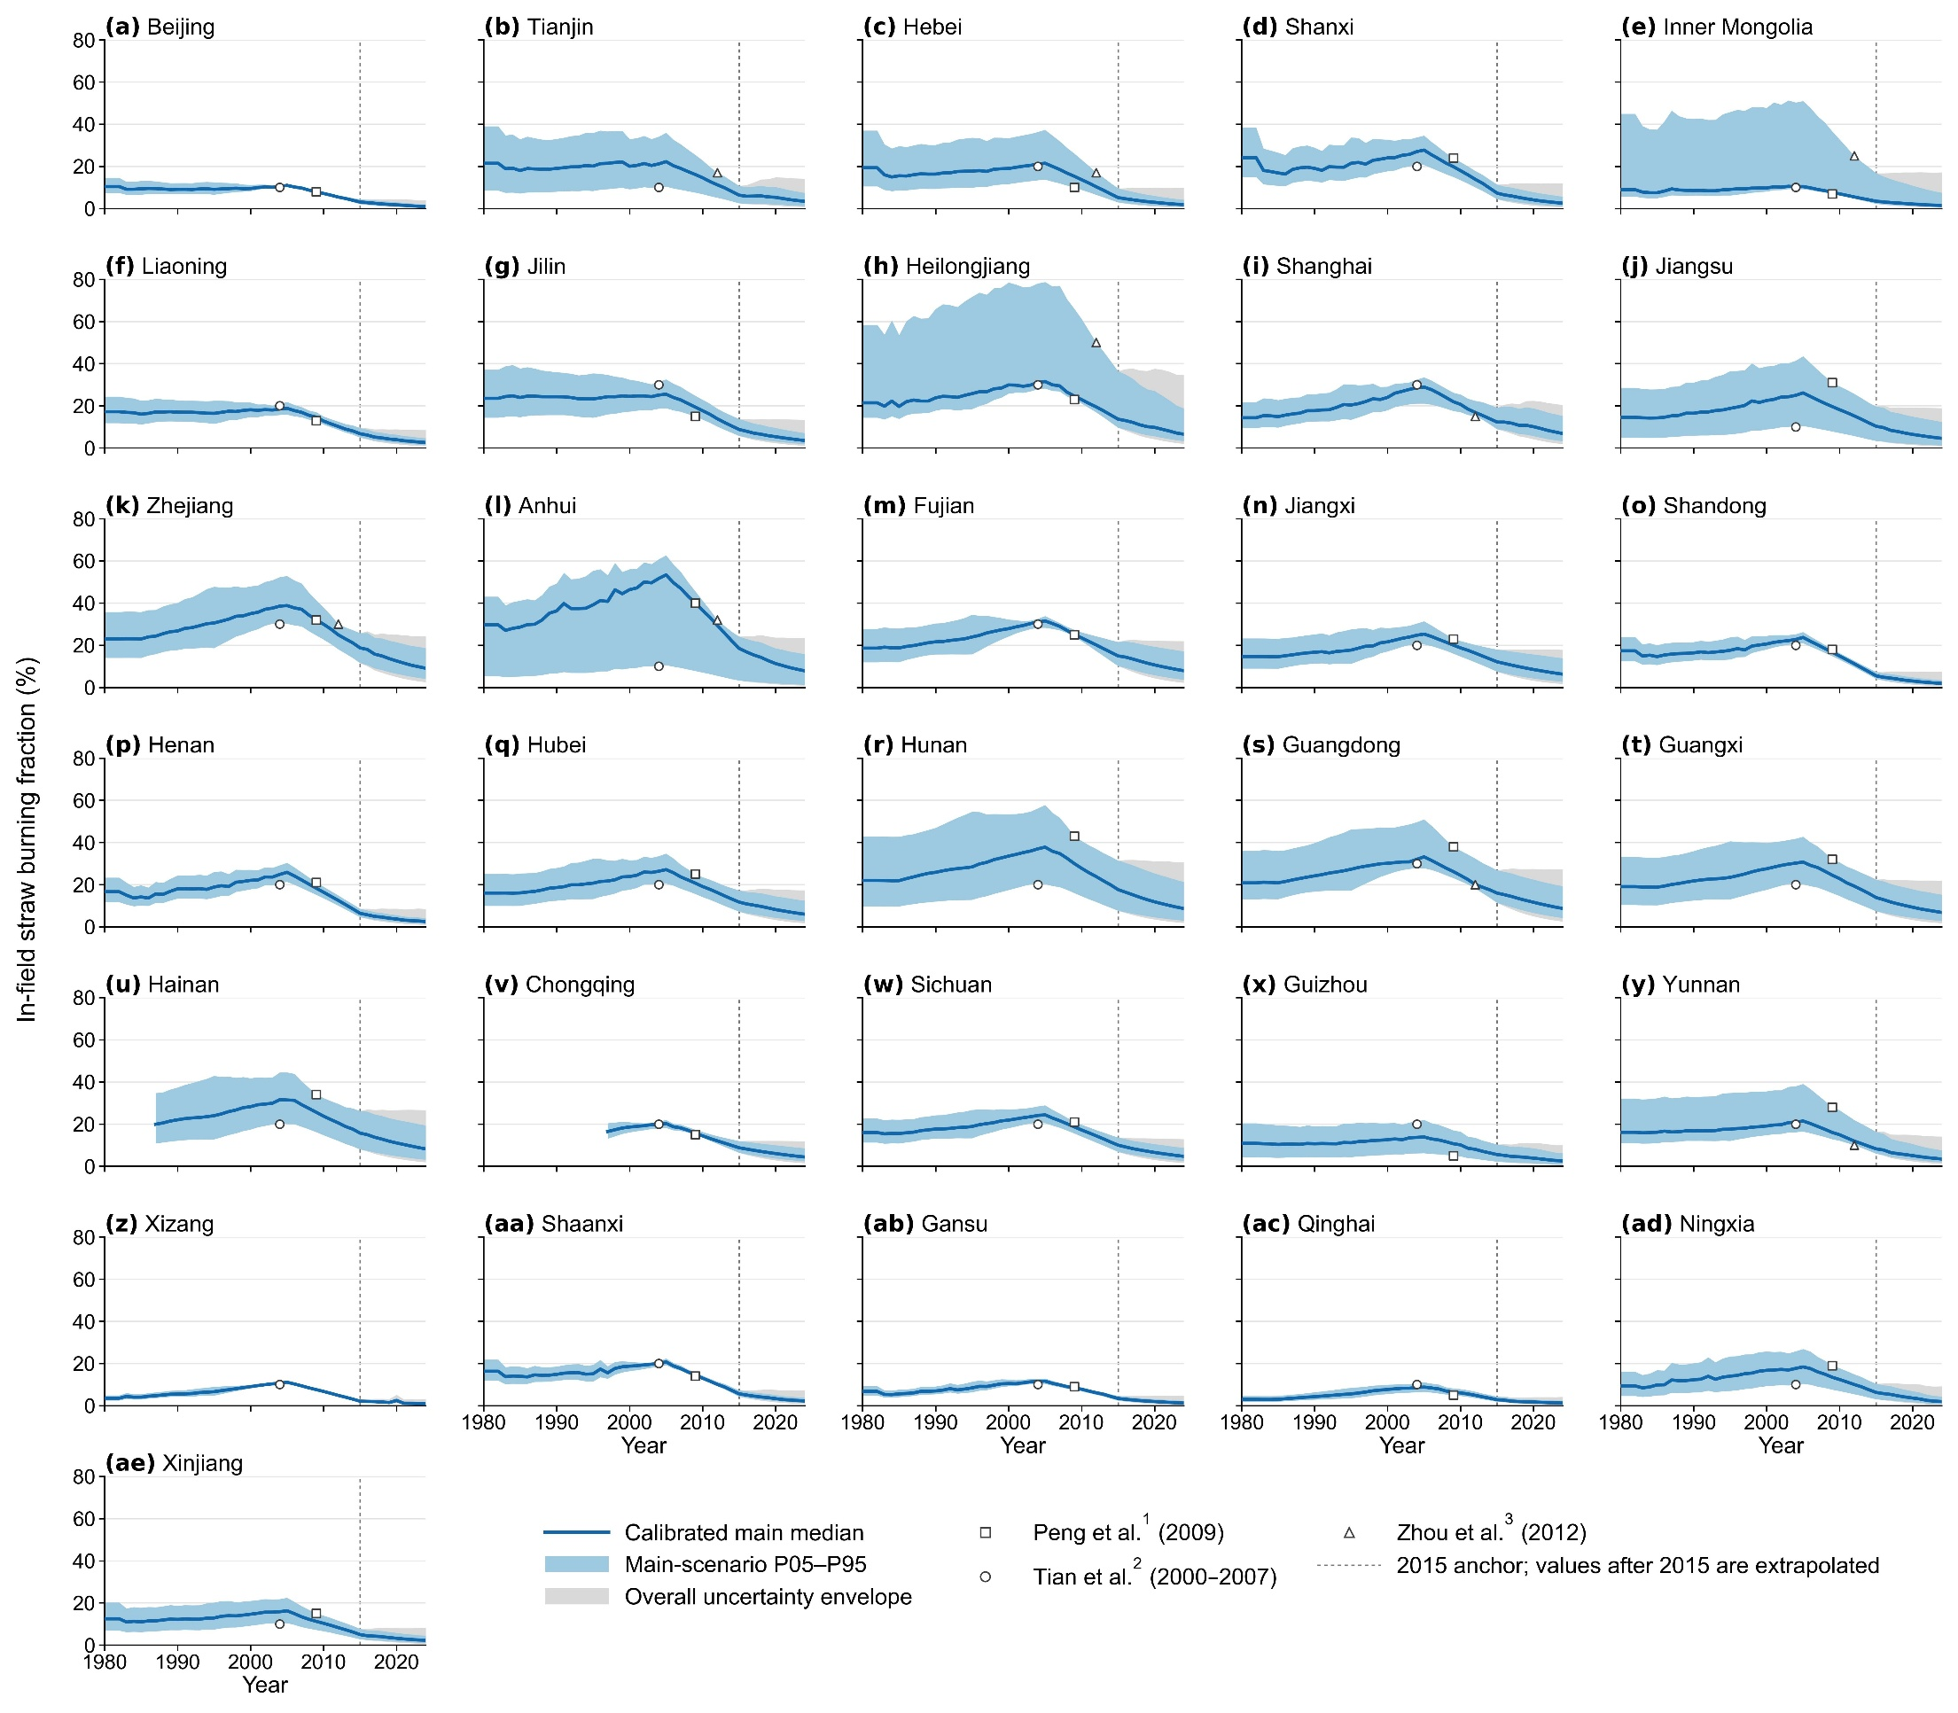

Fig. S10. Best-performing province-level, regional-level, and national-level models for provincial firewood consumption. Black symbols represent observations for 1991–2007, red symbols represent predictions for 2008–2024, and red dashed lines indicate the fitted relationships. Only models with training R² ≥ 0.50 are shown; annotations report CV-NRMSE, CV-NMAE, and R². Different symbols distinguish provinces sharing the same model. In panel (a), the x-axis is the national-model linear predictor; the equation box defines its combination of rural income and rural population.

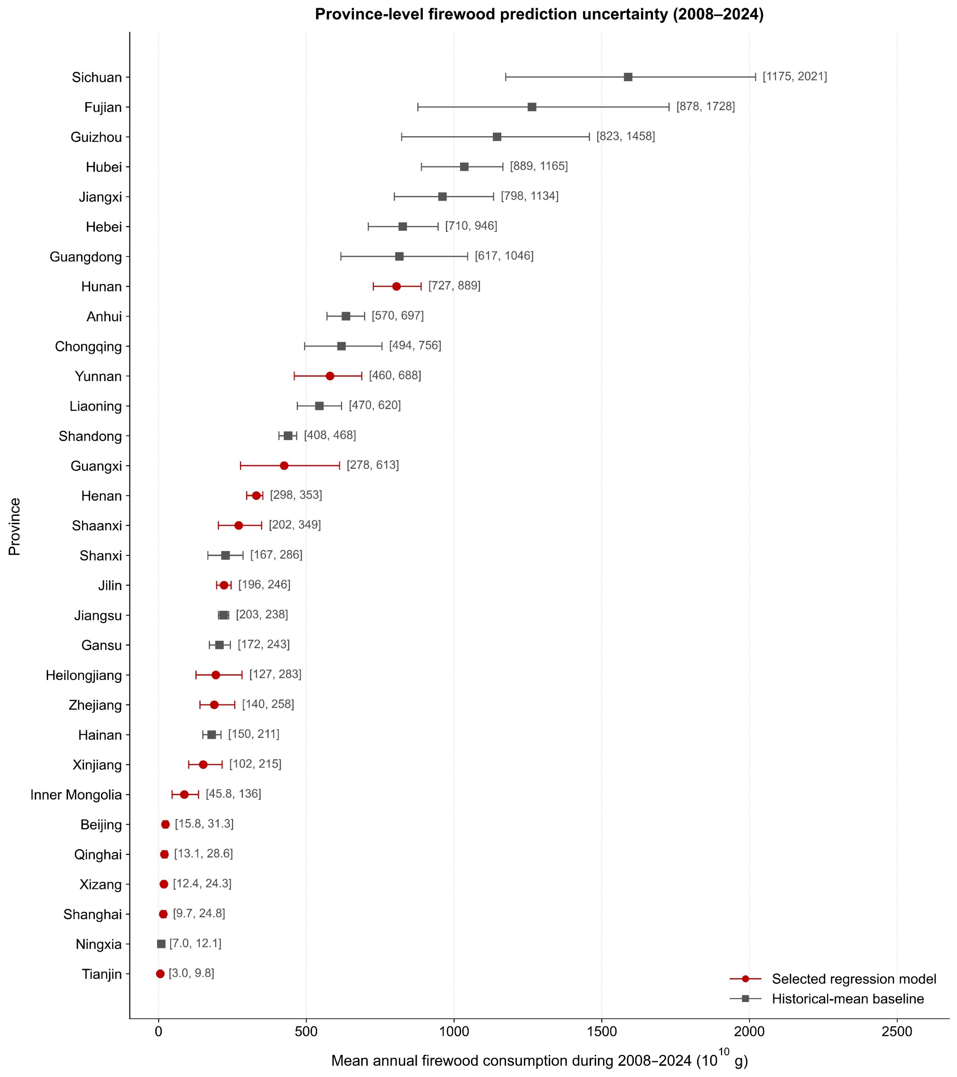

Fig. S11. Province-level uncertainty in reconstructed firewood consumption during 2008–2024. Points represent mean annual firewood consumption for each province over 2008–2024. Horizontal error bars indicate the mean lower and upper bounds of the annual 5th–95th percentile predictive intervals, and numerical labels report the corresponding [P05, P95] range. Red circles denote provinces for which the selected regression model outperformed the historical-mean baseline in repeated cross-validation, whereas gray squares denote provinces for which the historical-mean baseline yielded a lower validation error and was retained. Consumption is expressed in 10¹⁰ g.

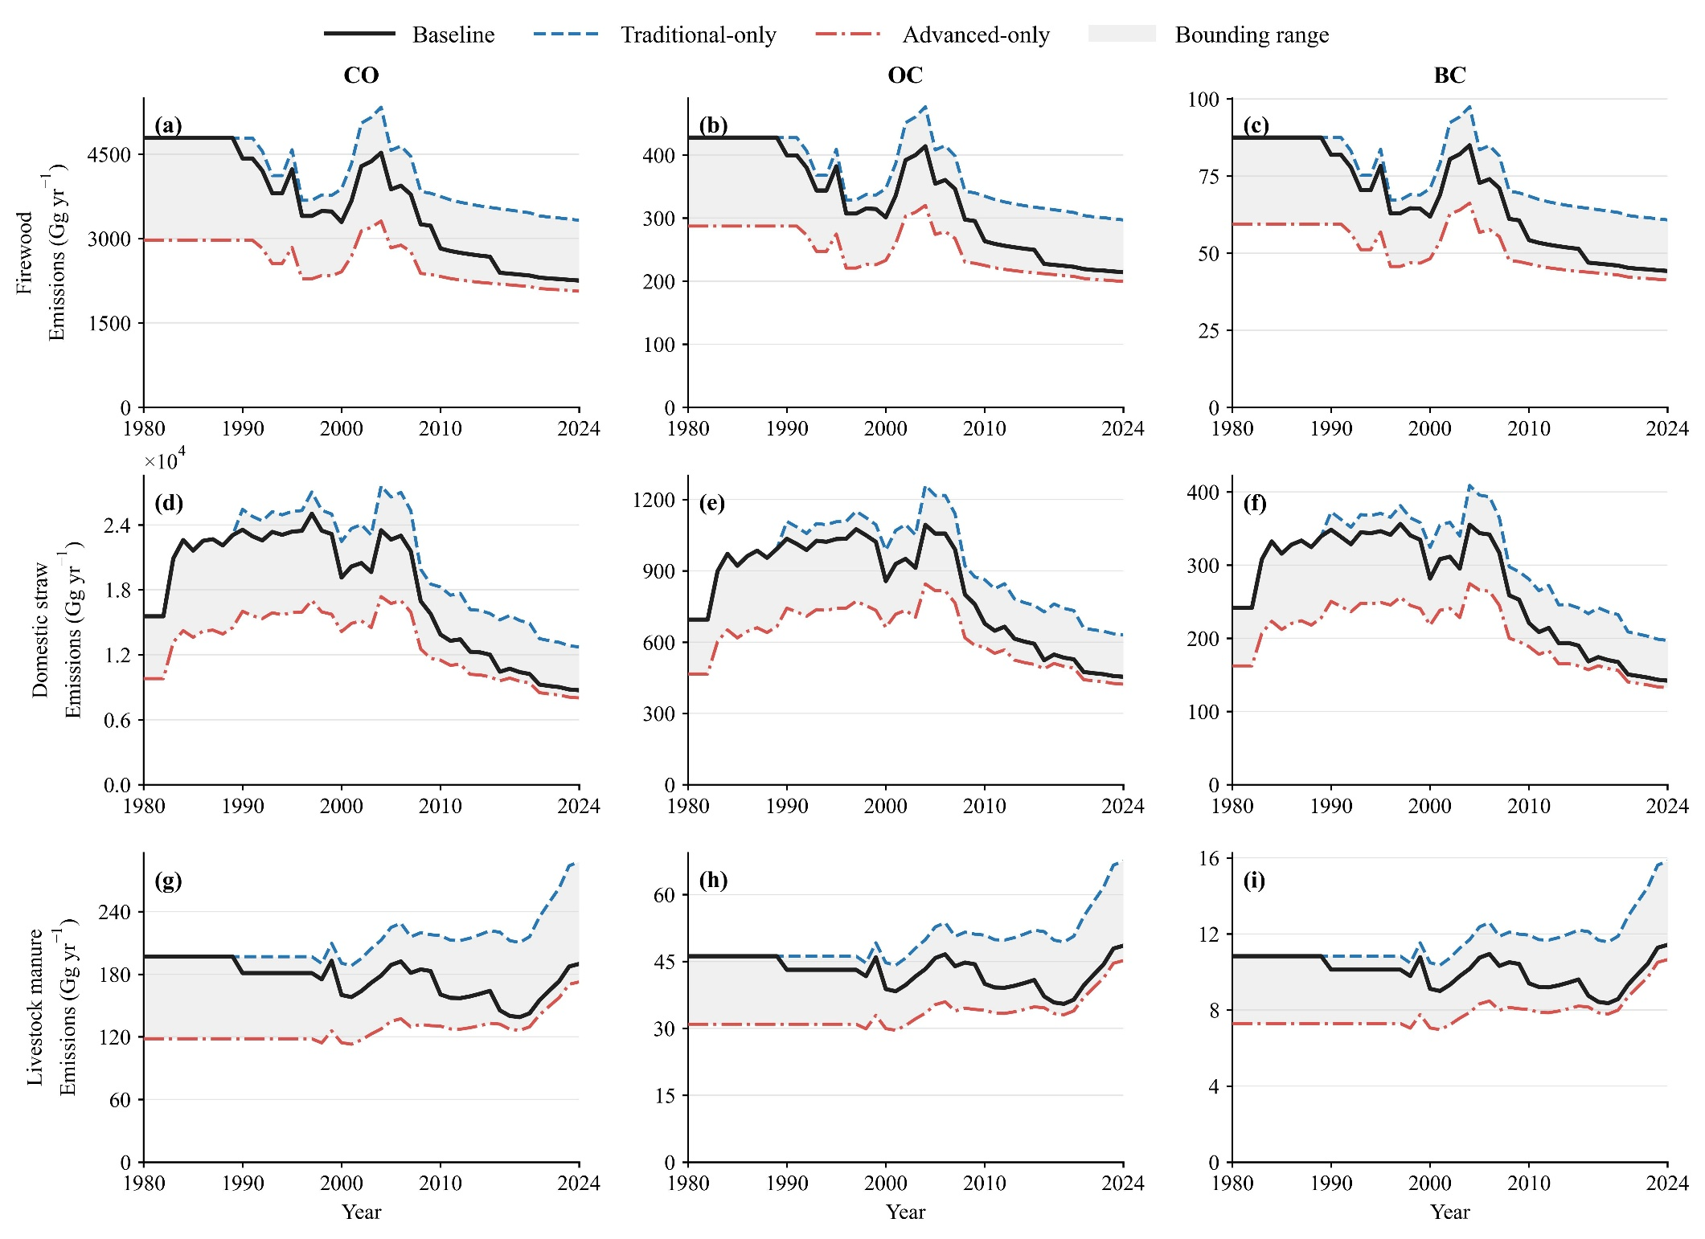

Fig. S12. Sensitivity of annual national emissions from domestic biomass combustion to stove-technology and emission-factor assumptions during 1980–2024. Rows represent firewood, domestic straw, and livestock-manure combustion, while columns represent CO, OC, and BC emissions. The baseline scenario represents the assumed historical transition from traditional to advanced stoves, whereas the Traditional-only and Advanced-only scenarios assume exclusive use of the corresponding stove type. Shaded areas show the range bounded by the two alternative scenarios. Deterministic estimates are shown to isolate scenario effects.

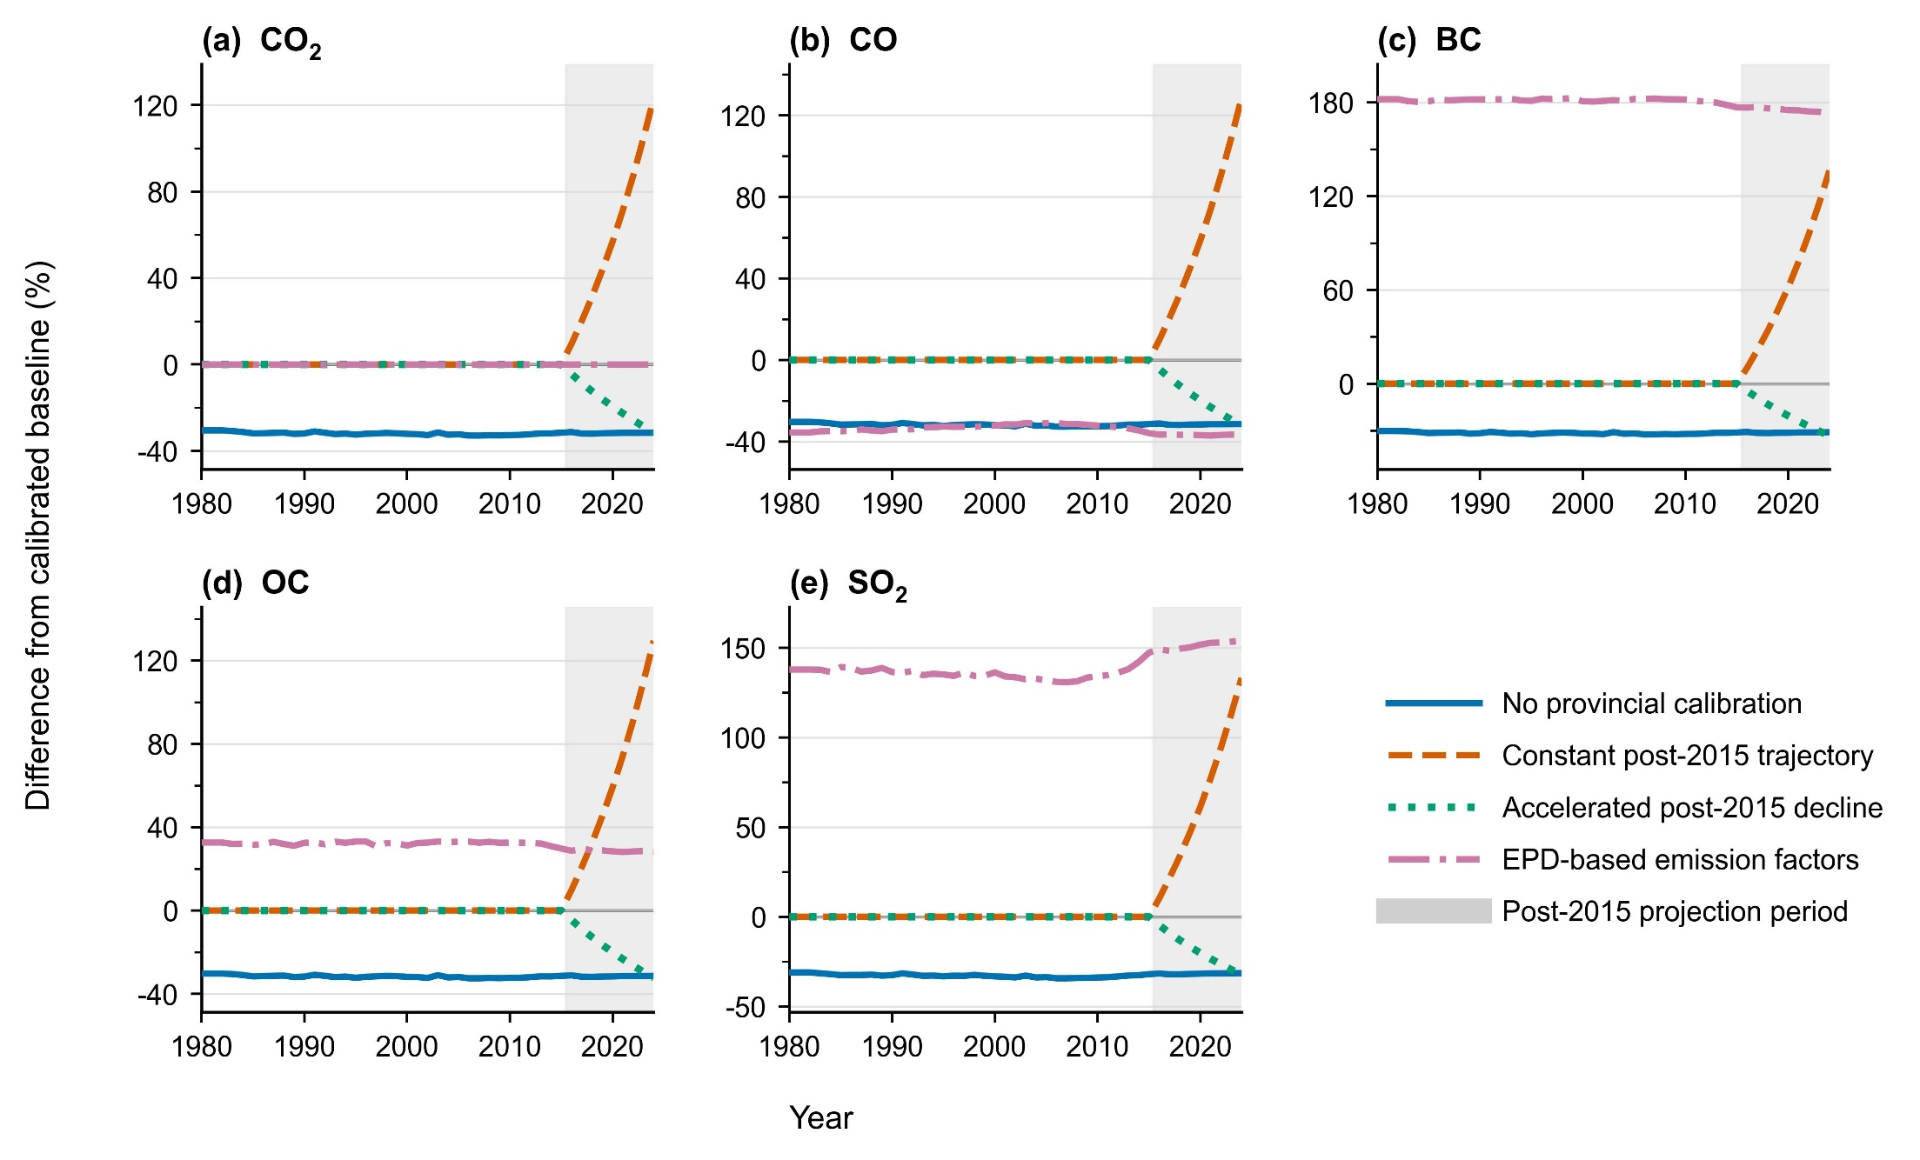

Fig. S13. Sensitivity of annual national in-field straw-burning emissions to alternative reconstruction assumptions during 1980–2024. Differences in (a) CO₂, (b) CO, (c) BC, (d) OC, and (e) SO₂ emissions are expressed relative to the calibrated baseline. The scenarios examine the effects of removing province-level calibration, assuming a constant or accelerated-decline trajectory after 2015, and replacing the baseline EFs with EPD-based values. Positive (negative) values indicate emissions higher (lower) than the calibrated baseline. Gray shading denotes the post-2015 projection period (2016–2024).

Type | Corn⁴ | Rice⁴ | Wheat⁵ | Cotton⁵ | Potato⁶ | Peanut⁵ | Rapeseed⁵ | Sugar beet⁷ | Soybean⁶
A | 1.269 | 1.323 | 1.340 | 3.990 | 0.500 | 1.220 | 1.500 | 0.100 | 1.360
B | 1.269 | 1.323 | 1.230 | 3.670 | 0.500 | 1.500 | 1.500 | 0.100 | 1.360
C | 1.269 | 1.323 | 0.930 | 3.000 | 0.500 | 1.500 | 1.500 | 0.100 | See note
D | 1.269 | 1.323 | 1.380 | 3.320 | 0.500 | 1.500 | 2.050 | 0.100 | 1.520
E | 1.269 | 1.323 | 1.380 | 3.000 | 0.500 | 1.650 | 1.500 | 0.100 | 1.520
F | 1.269 | 1.323 | 1.310 | 3.000 | 0.500 | 1.500 | 2.000 | 0.100 | 1.520
Note: The Type in the table is classified according to the consistency of province-level straw-to-grain ratios. Group A includes Beijing, Tianjin, Hebei, Shanxi, Inner Mongolia, Shandong, and Henan; Group B includes Shaanxi, Gansu, Qinghai, Ningxia, and Xinjiang; Group C includes Liaoning, Jilin, and Heilongjiang; Group D includes Shanghai, Jiangsu, Zhejiang, Anhui, Jiangxi, Hubei, and Hunan; Group E includes Fujian, Guangdong, Guangxi, and Hainan; Group F includes Chongqing, Sichuan, Guizhou, Yunnan, and Xizang. Within Group C, the soybean straw-to-grain ratios for Jilin, Liaoning, and Heilongjiang are 1.500, 1.290, and 1.130, respectively.

Table S1 Straw-to-product ratios of different straw types by province.

Straw type | CE | D
Rice | 0.93 | 0.93
Corn | 0.92 | 0.92
Wheat | 0.92 | 0.92
Cotton | 0.91 | 0.90
Potato | 0.68 | 0.68
Peanut | 0.82 | 0.82
Rapeseed | 0.91 | 0.90
Sugar beet | 0.91 | 0.90
Soybean | 0.68 | 0.68
Note: Values are compiled following Xing et al. ⁸, with original data sourced from He et al. ⁹.

Table S2 Combustion efficiencies (CE) and dry matter fractions (D) of different straw types.

Province | 2006 | 2007 | 2008 | 2009 | 2010 | 2011 | 2012 | 2013 | 2014
Beijing | 20.6¹⁰ |  |  |  |  | 9.2¹¹ | 9.2¹² |  | 3.5¹³
Tianjin | 12.3¹⁴ |  |  | 35.1¹¹ | 37.5¹⁵ | 30.5¹⁶ |  |  | 5.3¹³
Hebei | 22.5¹⁷ |  |  | 27.3¹¹
Shanxi | 12.3¹⁴ |  |  | 39.3¹¹
Liaoning | 46.6¹⁸ | 39.6¹⁹ |  | 36.3¹² |  |  | 32.9²⁰
Jilin | 46.6¹⁴ |  |  |  |  |  |  |  | 25.0²¹
Heilongjiang | 46.6¹⁴ | 50.0²² |  |  |  | 26.5²³ | 42.8²⁴ |  | 30.0²⁵
Jiangsu | 49.7²⁶ |  | 40.0²⁷ | 34.5²⁸ | 28.4²⁹ | 22.0³⁰ |  | 17.8³¹ | 22.6²⁷
Zhejiang | 49.7¹⁴ |  |  | 32.6¹¹
Anhui |  |  | 29.0³² | 28.6¹¹ | 29.0³³ |  | 20.4³⁴ |  | 20.0³⁵
Fujian | 49.7¹⁴ |  |  | 30.8¹¹
Jiangxi |  |  |  | 36.7¹¹
Shandong |  |  |  | 24.5¹¹ | 16.5³⁶ |  | 13.0¹² | 10.5³⁷ | 11.1¹³
Henan | 28.9¹⁴ | 30.0³⁸ | 28.4³⁹ | 22.7¹¹ |  |  |  | 19.9⁴⁰
Hubei | 28.9¹⁴ |  |  | 30.1¹¹ |  | 28.3⁴¹ | 22.0⁴²
Hunan | 28.9¹⁴ |  |  | 38.8¹¹ |  |  |  |  | 20.9⁴³
Guangdong | 28.9¹⁴ |  |  | 32.3¹¹ |  |  |  | 7.8⁴⁴
Guangxi | 28.9¹⁴ |  | 40.0⁴⁵ | 29.8¹¹ |  |  |  | 22.2⁴⁶
Hainan | 28.9¹⁴ |  |  | 25.0¹¹
Chongqing | 29.6¹⁴ |  | 40.5⁴⁷ | 46.4¹¹ | 49.2⁴⁸
Sichuan |  | 53.6⁴⁹ |  | 51.9¹¹ |  |  |  | 29.0⁵⁰ | 24.4⁵¹
Guizhou | 30.0⁵⁰ |  |  | 46.4¹¹
Yunnan | 30.0¹⁴ | 40.0⁵² |  | 47.8¹¹
Xizang | 29.6¹⁴ |  |  | 39.0¹¹
Shaanxi | 28.2¹⁴ | 27.0⁴⁹
Gansu | 28.2¹⁴ |  |  | 35.6¹¹
Qinghai | 28.2¹⁴ |  | 43.7⁵³ | 39.0¹¹ |  |  |  |  | 17.0⁵⁴
Ningxia | 28.2¹⁴ |  |  | 20.4¹¹ | 10.7⁵⁵ |  |  |  | 14.0⁵⁵
Xinjiang | 28.2¹⁴ |  |  | 21.2¹¹ |  |  | 30.2⁵⁶
Note: Values represent literature-reported estimates of provincial domestic straw burning ratios. Data were compiled from Xing et al. ⁸ and references

Table S3 Literature-based estimates of provincial domestic straw burning ratios (𝑅) in China.

Province | Geographical region | Region code
Beijing | North China | NC
Tianjin | North China | NC
Hebei | North China | NC
Shanxi | North China | NC
Inner Mongolia | North China | NC
Liaoning | Northeast China | NE
Jilin | Northeast China | NE
Heilongjiang | Northeast China | NE
Shanghai | East China | EC
Jiangsu | East China | EC
Zhejiang | East China | EC
Anhui | East China | EC
Fujian | East China | EC
Jiangxi | East China | EC
Shandong | East China | EC
Henan | Central China | CC
Hubei | Central China | CC
Hunan | Central China | CC
Guangdong | South China | SC
Guangxi | South China | SC
Hainan | South China | SC
Chongqing | Southwest China | SW
Sichuan | Southwest China | SW
Guizhou | Southwest China | SW
Yunnan | Southwest China | SW
Xizang | Southwest China | SW
Shaanxi | Northwest China | NW
Gansu | Northwest China | NW
Qinghai | Northwest China | NW
Ningxia | Northwest China | NW
Xinjiang | Northwest China | NW

Table S4 Geographical classification of Chinese provinces used in the regional models.

Category | Reference | CO₂ | CO | OC | BC | SO₂
Forest | Akagi et al. ⁶³ | 1568.33±87.83 | 108.50±36.67 | 4.71±2.73 | 0.52±0.28 | 0.40±0.19
Forest | Andreae et al. ⁶⁴ | 1574.50±110.50 | 105.50±28.50 | 7.18±1.03 | 0.61±0.25 | 0.79±0.12
Forest | Burling et al. ⁶⁵ | 1668.00±72.00 | 72.00±26.00 | -- | -- | --
Forest | Jin et al. ⁶⁶ | 1392.54±248.53 | 249.56±40.39 | 4.57±3.00 | 0.72±0.42 | --
Forest | Prichard et al. ⁶⁷ | 1613.27±154.57 | 90.64±31.71 | -- | -- | 0.85±0.28
Shrub | Akagi et al. ⁶³ | 1710.00±39.00 | 67.00±13.00 | 3.70±0.00 | 0.50±0.20 | 0.68±0.13
Shrub | Jin et al. ⁶⁶ | 1487.80±18.05 | 205.71±5.40 | 1.40±0.04 | 0.25±0.08 | --
Shrub | Prichard et al. ⁶⁷ | 1707.96±192.21 | 73.50±17.00 | -- | -- | 0.74±0.60
Grassland | Akagi et al. ⁶³ | 1686.00±38.00 | 63.00±17.00 | 2.62±1.24 | 0.37±0.20 | 0.48±0.27
Grassland | Andreae et al. ⁶⁴ | 1613.00±95.00 | 65.00±20.00 | 3.40±1.40 | 0.48±0.18 | 0.25±0.16
Grassland | Jin et al. ⁶⁶ | 1465.84±60.45 | 221.24±18.06 | 2.25±0.31 | 0.60±0.29 | --
Grassland | Prichard et al. ⁶⁷ | 1685.82±81.19 | 68.17±27.16 | -- | -- | 0.83±0.34
Rice | Cao et al. ⁵⁸ | -- | 67.98±25.58 | 2.01±0.67 | 0.49±0.21 | 0.18±0.31
Rice | Wei et al. ⁶⁸ | 1248.80±8.70 | 70.30±2.30 | -- | -- | --
Rice | Tang et al. ⁵⁷ | -- | 27.70±1.00 | 0.75±0.18 | 0.11±0.03 | --
Rice | Ni et al. ⁶⁹ | 1393.00±91.00 | 57.20±26.00 | 6.30±3.60 | 0.21±0.13 | --
Rice | EPD ⁶⁰ | -- | 28.00 | 3.23 | 0.75 | 0.53
Wheat | Cao et al. ⁵⁸ | -- | 57.78±24.75 | 3.46±2.05 | 0.42±0.23 | 0.04±0.04
Wheat | Wei et al. ⁶⁸ | 1454.20±12.00 | 51.60±3.10 | -- | -- | --
Wheat | Zhang et al. ¹⁰ | 1557.90±85.80 | 141.20±14.80 | -- | -- | --
Wheat | Tang et al. ⁵⁷ | -- | 20.60±3.60 | 0.97±0.23 | 0.12±0.02 | --
Wheat | Li et al. ⁷⁰ | 1470.00±46.00 | 60.00±23.00 | 2.70±1.00 | 0.49±0.12 | 0.85±0.57
Wheat | Ni et al. ⁶⁹ | 1311.00±181.00 | 47.90±13.50 | 5.10±3.00 | 0.21±0.12 | --
Wheat | EPD ⁶⁰ | -- | 60.00 | 4.32 | 1.01 | 0.85
Corn | Cao et al. ⁵⁸ | -- | 67.64±13.01 | 2.25±0.74 | 0.95±1.08 | 0.04±0.04
Corn | Zhang et al. ¹⁰ | 1261.50±59.90 | 114.70±12.40 | -- | -- | --
Corn | Li et al. ⁷⁰ | 1350.00±16.00 | 53.00±4.00 | 3.90±1.70 | 0.35±0.10 | 0.44±0.20
Corn | Ni et al. ⁶⁹ | 1365.00±147.00 | 52.10±17.70 | 6.30±3.60 | 0.28±0.09 | --
Corn | EPD ⁶⁰ | -- | 53.00 | 6.68 | 1.55 | 0.44
Cotton | Zhou et al. ³ | 1410.00 | 66.10 | 3.30 | 0.42 | 0.53
Cotton | EPD ⁶⁰ | -- | 76.00 | 4.90 | 0.42 | 0.80
Potato | Zhou et al. ³ | 1410.00 | 66.10 | 3.30 | 0.42 | 0.53
Potato | Li et al. ⁷¹ | 1445.00±46.00 | 55.13±15.10 | 2.03±1.05 | 0.41±0.18 | 0.25±0.02
Potato | EPD ⁶⁰ | -- | 76.00 | 4.90 | 0.42 | 0.80
Peanut | Zhou et al. ³ | 1410.00 | 66.10 | 3.30 | 0.42 | 0.53
Peanut | Li et al. ⁷¹ | 1445.00±46.00 | -- | -- | -- | 0.25±0.02
Peanut | EPD ⁶⁰ | -- | 76.00 | 4.90 | 0.42 | 0.80
Sugar beet | Zhou et al. ³ | 1410.00 | 66.10 | 3.30 | 0.42 | 0.53
Sugar beet | Li et al. ⁷¹ | 1445.00±46.00 | 55.13±15.10 | 2.03±1.05 | 0.41±0.18 | 0.25±0.02
Sugar beet | EPD ⁶⁰ | -- | 76.00 | 4.90 | 0.42 | 0.80
Rapeseed | Li et al. ⁷¹ | 1445.00±46.00 | 34.30±1.69 | 1.08±0.50 | 0.23±0.09 | 0.25±0.02
Rapeseed | Tang et al. ⁵⁷ | -- | 34.30±0.20 | 1.08 | 0.23±0.09 | --
Rapeseed | EPD ⁶⁰ | -- | 76.00 | 4.90 | 0.42 | 0.80
Soybean | Li et al. ⁷¹ | 1445.00±46.00 | 32.30±1.10 | 1.84±1.50 | 0.23±0.10 | 0.25±0.02
Soybean | Tang et al. ⁵⁷ | -- | 32.30 | 1.05 | 0.13 | 0.53
Soybean | EPD ⁶⁰ | -- | 76.00 | 4.90 | 0.42 | 0.80
Soybean | Tian et al. ² | 1445.76 | -- | -- | -- | --

Table S7 Emission factors for open biomass burning compiled from the literature (g kg⁻¹)
Category | Reference | CO₂ | CO | OC | BC | SO₂
Rice | Tang et al. ⁵⁷ | -- | 82.00±2.40 | 3.35±0.57 | 0.91±0.28 | --
Rice | Cao et al. ⁵⁸ | 1674.12±452.26 | 67.98±25.58 | 2.01±0.67 | 0.49±0.21 | 0.18±0.31
Rice | Shen et al. ⁵⁹ | 1140.00±2.00 | 215.00±0.20 | 1.50±0.16 | 0.75±0.43 | --
Rice | EPD_a⁶⁰ | -- | 68.00 | 3.65 | 1.85 | 0.48
Rice | EPD_b⁶⁰ | -- | 43.00 | 2.45 | 1.24 | 0.48
Wheat | Cao et al. ⁵⁸ | 1377.72±431.12 | 57.78±24.75 | 3.46±2.05 | 0.42±0.23 | 0.04±0.04
Wheat | Shen et al. ⁵⁹ | 1370.00±9.00 | 126.00±5.00 | 2.27±1.30 | 2.64±1.01 | --
Wheat | EPD_a⁶⁰ | -- | 172.00 | 4.70 | 1.10 | 2.36
Wheat | EPD_b⁶⁰ | -- | 108.00 | 3.15 | 0.74 | 2.36
Corn | EPD_a⁶⁰ | -- | 57.00 | 3.92 | 0.92 | 1.33
Corn | EPD_b⁶⁰ | -- | 36.00 | 2.63 | 0.62 | 1.33
Corn | Cao et al. ⁵⁸ | 2327.14±709.57 | 67.64±13.01 | 2.25±0.74 | 0.95±1.08 | 0.04±0.04
Corn | Shen et al. ⁵⁹ | 1490.00±25.00 | 104.00±19.00 | 1.36±0.29 | 1.11±0.08 | --
Cotton | Cao et al. ⁵⁸ | 1345.42±108.02 | 105.82±6.02 | 1.83±0.54 | 0.82±0.20 | --
Cotton | Shen et al. ⁵⁹ | 1520.00±6.00 | 78.70±1.20 | 0.35±0.04 | 1.34±0.58 | --
Cotton | EPD_a⁶⁰ | -- | 95.20 | 4.72 | 1.30 | 1.36
Cotton | EPD_b⁶⁰ | -- | 59.80 | 3.16 | 0.88 | 1.36
Potato | EPD_a⁶⁰ | -- | 95.20 | 4.72 | 1.30 | 1.36
Potato | EPD_b⁶⁰ | -- | 59.80 | 3.16 | 0.88 | 1.36
Potato | Tian et al. ² | 1437.97 | -- | -- | -- | --
Peanut | EPD_a⁶⁰ | -- | 95.20 | 4.72 | 1.30 | 1.36
Peanut | EPD_b⁶⁰ | -- | 59.80 | 3.16 | 0.88 | 1.36
Peanut | Tian et al. ² | 1437.97 | -- | -- | -- | --
Sugar beet | EPD_a⁶⁰ | -- | 95.20 | 4.72 | 1.30 | 1.36
Sugar beet | EPD_b⁶⁰ | -- | 59.80 | 3.16 | 0.88 | 1.36
Sugar beet | Tian et al. ² | 1437.97 | -- | -- | -- | --
Rapeseed | Tang et al. ⁵⁷ | -- | 133.50±45.00 | 1.63±0.72 | 1.35±0.06 | --
Rapeseed | Shen et al. ⁵⁹ | 1330.00±16.00 | 154.00±23.00 | 1.75±0.63 | 2.34±0.92 | --
Rapeseed | EPD_a⁶⁰ | -- | 134.00 | 7.29 | 1.70 | 1.36
Rapeseed | EPD_b⁶⁰ | -- | 84.00 | 4.88 | 1.14 | 1.36
Soybean | Tang et al. ⁵⁷ | -- | 80.70±23.60 | 2.12±1.04 | 1.35±0.06 | --
Soybean | Shen et al. ⁵⁹ | 1380.00±13.00 | 72.30±0.50 | 1.17±0.18 | 1.37±0.04 | --
Soybean | EPD_a⁶⁰ | -- | 95.20 | 4.72 | 1.30 | 1.36
Soybean | EPD_b⁶⁰ | -- | 59.80 | 3.16 | 0.88 | 1.36
Soybean | Tian et al. ² | 1437.97 | -- | -- | -- | --
Firewood | Tang et al. ⁵⁷ | -- | 31.40 | 1.29 | 1.50 | --
Firewood | Roden et al. ⁶¹ | -- | -- | 4.00±0.90 | 1.50±0.30 | --
Firewood | Shen et al. ⁵⁹ | -- | -- | 0.62±0.64 | 0.83±0.69 | --
Firewood | Li et al.⁶² | -- | -- | 1.13±0.40 | 1.49±0.69 | --
Firewood | Tian et al. ² | 1587.24 | 75.93 | -- | 0.70 | 0.32
Firewood | EPD_a ⁶⁰ | -- | 29.00 | 2.59 | 0.53 | 0.40
Firewood | EPD_b ⁶⁰ | -- | 18.00 | 1.74 | 0.36 | 0.40
Livestock manure | EPD_a ⁶⁰ | -- | 20.00 | 4.69 | 1.10 | 0.28
Livestock manure | EPD_b ⁶⁰ | -- | 12.00 | 3.14 | 0.74 | 0.28
Livestock manure | Tian et al. ² | 1060.00 | 53.50 | -- | 0.53 | --
Note: EPD_a refers to emission factors associated with traditional stove technologies, while EPD_b refers to those associated with advanced stove technologies.

Table S8 Emission factors for domestic fuel combustion compiled from the literature (g kg⁻¹)

References
- Peng, L. Q., Zhang, Q. & He, K. B. A survey-based emission inventory of open burning of crop residues in China. Res. Environ. Sci. 29, 1109–1118 (2016).
- Tian, H. Z., Zhao, D. & Wang, Y. Atmospheric pollutant emission inventory from biomass burning in China. Acta Sci. Circumstantiae 31, 349–357 (2011).
- Zhou, Y. et al. A comprehensive biomass burning emission inventory with high spatial and temporal resolution in China. Atmos. Chem. Phys. 17, 2839–2864 (2017).
- Zhang, F. & Zhu, Z. Harvest index of crops in China. Sci. Agric. Sin. 23, 83–87 (1990) (in Chinese).
- National Development and Reform Commission (NDRC). Reference data of grain-to-straw ratios for major crops in different agricultural regions of China. https://www.ndrc.gov.cn/xxgk/zcfb/tz/201512/W020190905506500681746.pdf (2015) (in Chinese).
- National Agro-Tech Extension and Service Center (NATESC). Agricultural Technical Guidelines (China Agriculture Press, 1999) (in Chinese).
- Bi, Y. Study on assessment and utilization of crop straw resources. PhD thesis, Chinese Academy of Agricultural Sciences (2010) (in Chinese).
- Xing, X. et al. Spatiotemporal variation of domestic biomass burning emissions in rural China based on a new estimation of fuel consumption. Sci. Total Environ. 626, 274–286 (2018).
- He, M., Wang, X., Han, L., Feng, X. & Mao, X. Emission inventory and spatiotemporal characteristics of pollutants from open burning of crop residues in Sichuan Province. China Environ. Sci. 36, 1208–1216 (2015) (in Chinese).
- Zhang, H. et al. A laboratory study of agricultural crop residue combustion in China: Emission factors and emission inventory. Atmos. Environ. 42, 8432–8441 (2008).
- Cai, Y., Qiu, H. & Xu, Z. Evaluation on Potentials of Energy Utilization of Crop Residual Resources in Different Regions of China. J. Nat. Resour. 26, 1637–1646 (2011) (in Chinese).
- Fang, F. et al. Analysis on distribution and use structure of crop straw resources in Huang-Huai-Hai Plain of China. Trans. Chin. Soc. Agric. Eng. 31, 228–234 (2015) (in Chinese).
- Yang, H. Current status and suggestions for comprehensive utilization of straw in the Huang–Huai–Hai Plain. Agric. Mach. Technol. Ext. 23–26 (2016) (in Chinese).
- Gao, L. et al. Analysis of crop straw resources and its current status of utilization in Hebei Province. J. Anhui Agric. Sci. 37, 11079–11083 (2009) (in Chinese).
- Zhang, B., Wang, W., Gao, X. & Liu, Y. Investigation and utilization status of straw resources in Dagang District. Mod. Rural Sci. Technol. 55–56 (2010) (in Chinese).
- Pan, J., Xiao, H. & Lu, W. Estimation of Nutrient Resource of Crop Straw and Its Utilization Modes in Tianjin. Shanxi Agric. Sci. 43, 596–598, 616 (2015) (in Chinese).
- Gao, X., Wang, Y., Ma, W., Ma, C. & Zhang, F. Analysis on the Current Status of Utilization of Crop Straw in China. J. Huazhong Agric. Univ. 21, 242–247 (2002) (in Chinese).
- Mei, X., Wu, J. & Liu, R. Evaluation and energy utilization analysis on the crop stalk resource in Liaoning Province. Renew. Energy Resour. 26, 97–100 (2008) (in Chinese).
- Yu, B. Strategies for energy utilization of crop straw in Liaoning Province. PhD thesis, Chinese Academy of Agricultural Sciences (2013) (in Chinese).
- Cao, Y. et al. Study on Utilization of Crop Residue and Prospect of Biomaterial Carbonized-Taking Zhangwu of Liaoning as an Example. Crops 9–12 (2012) (in Chinese).
- Xu, X., Yu, D., Zhang, X. & Zhu, S. Current status and development strategies for comprehensive utilization of crop straw in Baicheng City. China Agric. Inf. 45 (2015) (in Chinese).
- Yao, Z., Zhao, L., Tian, Y. & Meng, H. Utilization status and medium and long-term forecast of crop straw in Heilongjiang Province. Trans. Chin. Soc. Agric. Eng. 25, 288–292 (2009) (in Chinese).
- Pan, Y., Ma, J. & Sun, D. Discuss Present Situation of Comprehensive Utilization of Crop Straw Resource in Heilongjiang Province and Suggest. Res. Agric. Mech. 36, 253–257 (2014) (in Chinese).
- Tong, S. Development status and prospects of comprehensive straw utilization in Heilongjiang Province. Agric. Mach. Technol. Ext. 39, 42 (2014) (in Chinese).
- Huang, Y. Investigation and policy recommendations on comprehensive straw utilization in Heilongjiang Province. Contemp. Rural Finance Econ. 45–48 (2015) (in Chinese).
- Jiang, Y., Cao, H., Ni, B. & Ling, P. Current status and development strategies of crop straw utilization in Funing County, Jiangsu Province. Agric. Environ. Dev. 27, 29–32 (2010) (in Chinese).
- Zhang, M. Comprehensive Utilization Status and Strategies of Crop Straw in Xinghua City. Mod. Agric. Sci. Technol. 215–216, 220 (2016) (in Chinese).
- Gu, G. Current status and countermeasures for straw utilization in Jintan City. Mod. Agric. 50–51 (2010) (in Chinese).
- Wang, X. & Gao, J. Investigation and evaluation of straw resources in Wujiang City, Jiangsu Province. Sci. Technol. Inf. 1031–1033 (2010) (in Chinese).
- Wang, S. Research on Rural Householders’ Comprehensive Utilization in Jiangsu Province. PhD thesis, Nanjing Agricultural University (2012) (in Chinese).
- Ji, Y., Yin, Z., Wang, Y., Wang, G. & Xu, J. Status of crop straw resources and considerations for rational utilization in Huai’an City. Jiangsu Agric. Sci. 43, 330–333 (2015) (in Chinese).
- Tao, W. & Wei, F. Current Situation of Comprehensive Utilization of Rural Straw in Anhui Province. J. Anhui Agric. Sci. 38, 15194–15196 (2010) (in Chinese).
- Xie, H. Research on the Policy Support System of the Crop Straw Resource Utilization. MSc thesis, Nanjing Forestry University (2013) (in Chinese).
- Jin, Z. & Jin, Y. Current status and countermeasures for crop straw utilization in Anhui Province. Mod. Agric. Sci. Technol. 253–254 (2014) (in Chinese).
- Lu, H. Dilemmas and Countermeasures of Crop Straw Utilization in Chuzhou City of Anhui Province. Hortic. Seedlings. 41–42, 50 (2014) (in Chinese).
- Sun, Y. Current status and countermeasures of crop straw utilization in Qingdao City. Agric. Environ. Dev. 28, 34–36 (2011) (in Chinese).
- Cheng, B., Qiao, X. & Xue, S. Current status and development strategies for straw utilization in Jining City. Mod. Agric. Sci. Technol. 253–254 (2014) (in Chinese).
- Chen, W. & Chen, S. Investigation of Comprehensive Utilization and Research of Utilization Mode of Corp Stalks Waste in Sanmenxia City. J. Anhui Agric. Sci. 39, 11682–11683, 11686 (2011) (in Chinese).
- Chen, X. Utilization Status and Countermeasures of Crops Straw Resources in Nang yang. Mod. Agric. Sci. Technol. 257–259 (2010) (in Chinese).
- Nie, S., Guo, Z., Zhang, Q., Zhang, Y. & Lü, S. Analysis of the Utilization Status of Crop Straw Resources and Resolve Methods in Henan Province. Shanxi Agric. Sci. 43, 599–602 (2015) (in Chinese).
- Liu, X. A Study of Comprehensive Utilization of Crop Straws in Jingzhou. MSc thesis, Yangtze University (2013) (in Chinese).
- Wang, Y. Straw utilization status and countermeasures in Xianning City. Hubei Agric. Mech. 44–46 (2013) (in Chinese).
- Ministry of Agriculture of the People’s Republic of China (MOA). Study on comprehensive utilization of crop straw in Hunan Province. http://www.tuliu.com/read-40120.html (2016) (in Chinese).
- Liang, Q. Progress evaluation and policy recommendations for straw utilization in Yangjiang City. Mod. Agric. Sci. Technol. 282, 285 (2014) (in Chinese).
- Lu, B., Kong, S., Han, B., Wang, X. & Bai, Z. Inventory of atmospheric pollutants discharged from biomass burning in China continent in 2007. China Environ. Sci. 31, 186–194 (2011) (in Chinese).
- Li, Q. Study on comprehensive utilization of straw in Guangxi. MSc thesis, Guangxi University (2013) (in Chinese).
- Wei, X., Li, P., Gao, L., Cai, M. & Long, H. Current status and recommendations for resource utilization of rural organic waste in Chongqing. South China Agric. 4, 75–76, 80 (2010) (in Chinese).
- Li, M., He, W., Li, Z. & Zeng, R. Distribution characteristics and utilization status of crop straw in Chongqing. South China Agric. 7, 32–34 (2013) (in Chinese).
- Liu, J. et al. The Analysis of China’s Utilization Technology of Agricultural Straw and Development of Biomass Industry. Ecol. Econ. 136–141 (2011) (in Chinese).
- Hu, X., Zhang, W. & Yin, F. Comprehensive Utilization of Straw Resources in Yunnan Province. J. Anhui Agric. Sci. 37, 11167–11169, 11175 (2009) (in Chinese).
- He, S. & He, J. Current status, problems and countermeasures of crop straw utilization in Mianyang City. Agric. Sci. Technol. Commun. 173–174, 265 (2014) (in Chinese).
- Wang, X. Distribution and comprehensive utilization of crop straw resources in Dazhou City. Mod. Agric. Sci. Technol. 215–216 (2016) (in Chinese).
- Wu, J. Investigation of straw resources in Qinghai Province. Qinghai Pratac. 20, 45–47 (2011) (in Chinese).
- Ma, R. Problems and countermeasures of crop straw utilization in Qinghai Province. Agric. Technol. 36, 25 (2016) (in Chinese).
- Cao, G., Zheng, F. & Wang, Y. Inventories of TSP, PM₁₀ and PM_{2.5} Emissions from Biomass Burning in China. J. Process Eng. 4, 710–714 (2004) (in Chinese).
- Zhang, L. & Pang, M. Quantity estimation and utilization of main crop straws nutrient resources in Xinjiang. Phosphate Fertil. Compd. Fertil. 31, 47–50 (2016) (in Chinese).
- Tang, X. et al. Emission Factors and PM Chemical Composition Study of Biomass Burning in the Yangtze River Delta Region. Environ. Sci. 35, 1623–1632 (2014).
- Cao, G., Zhang, X., Gong, S. & Zheng, F. Investigation on emission factors of particulate matter and gaseous pollutants from crop residue burning. J. Environ. Sci. 20, 50–55 (2008).
- Shen, G. et al. Emission Factors of Particulate Matter and Elemental Carbon for Crop Residues and Coals Burned in Typical Household Stoves in China. Environ. Sci. Technol. 44, 7157–7162 (2010).
- Ministry of Ecology and Environment of the People’s Republic of China (EPD). Technical guideline for the compilation of integrated emission inventories of air pollutants and greenhouse gases (trial). https://www.mee.gov.cn/xxgk2018/xxgk/xxgk06/202401/W020240130539574113045.pdf (2024) (in Chinese).
- Roden, C. A., Bond, T. C., Conway, S. & Pinel, A. B. O. Emission Factors and Real-Time Optical Properties of Particles Emitted from Traditional Wood Burning Cookstoves. Environ. Sci. Technol. 40, 6750–6757 (2006).
- Li, X., Wang, S., Duan, L., Hao, J. & Nie, Y. Carbonaceous Aerosol Emissions from Household Biofuel Combustion in China. Environ. Sci. Technol. 43, 6076–6081 (2009).
- Akagi, S. K. et al. Emission factors for open and domestic biomass burning for use in atmospheric models. Atmos. Chem. Phys. 11, 4039–4072 (2011).
- Andreae, M. O. & Merlet, P. Emission of trace gases and aerosols from biomass burning. Glob. Biogeochem. Cycles 15, 955–966 (2001).
- Burling, I. R. et al. Airborne and ground-based measurements of the trace gases and particles emitted by prescribed fires in the United States. Atmos. Chem. Phys. 11, 12197–12216 (2011).
- Jin, Q. et al. Dynamics of pollutant emissions from wildfires in Mainland China. J. Environ. Manage. 318, 115499 (2022).
- Prichard, S. J. et al. Wildland fire emission factors in North America: synthesis of existing data, measurement needs and management applications. Int. J. Wildland Fire 29, 132 (2020).
- Wei, W. et al. Emissions of carbon monoxide and carbon dioxide from uncompressed and pelletized biomass fuel burning in typical household stoves in China. Atmos. Environ. 56, 136–142 (2012).
- Ni, H. et al. Emission characteristics of carbonaceous particles and trace gases from open burning of crop residues in China. Atmos. Environ. 123, 399–406 (2015).
- Li, X. et al. Particulate and Trace Gas Emissions from Open Burning of Wheat Straw and Corn Stover in China. Environ. Sci. Technol. 41, 6052–6058 (2007).
- Li, B. et al. Development of a finer-resolution multi-year emission inventory for open biomass burning in Heilongjiang Province, China. Sci. Rep. 14, 29969 (2024).

