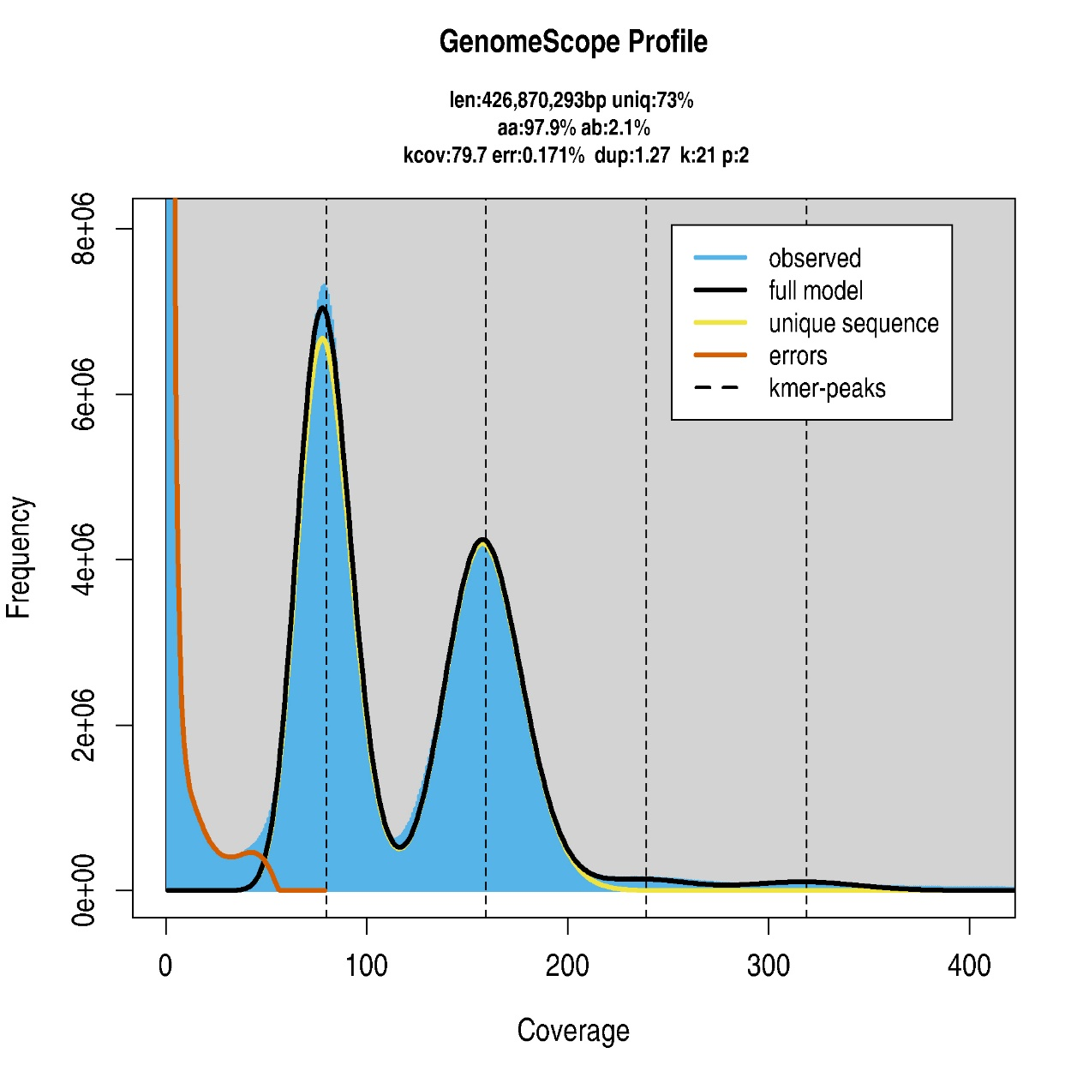

Figure S1. GenomeScope 2.0 profile based on 21-mer frequency analysis of Illumina reads. The estimated haploid genome size was 426.87 Mb, with a heterozygosity rate of approximately 2.1% and an estimated repeat content of approximately 27%. The two major k-mer peaks occurred at approximately 80× and 160× coverage.

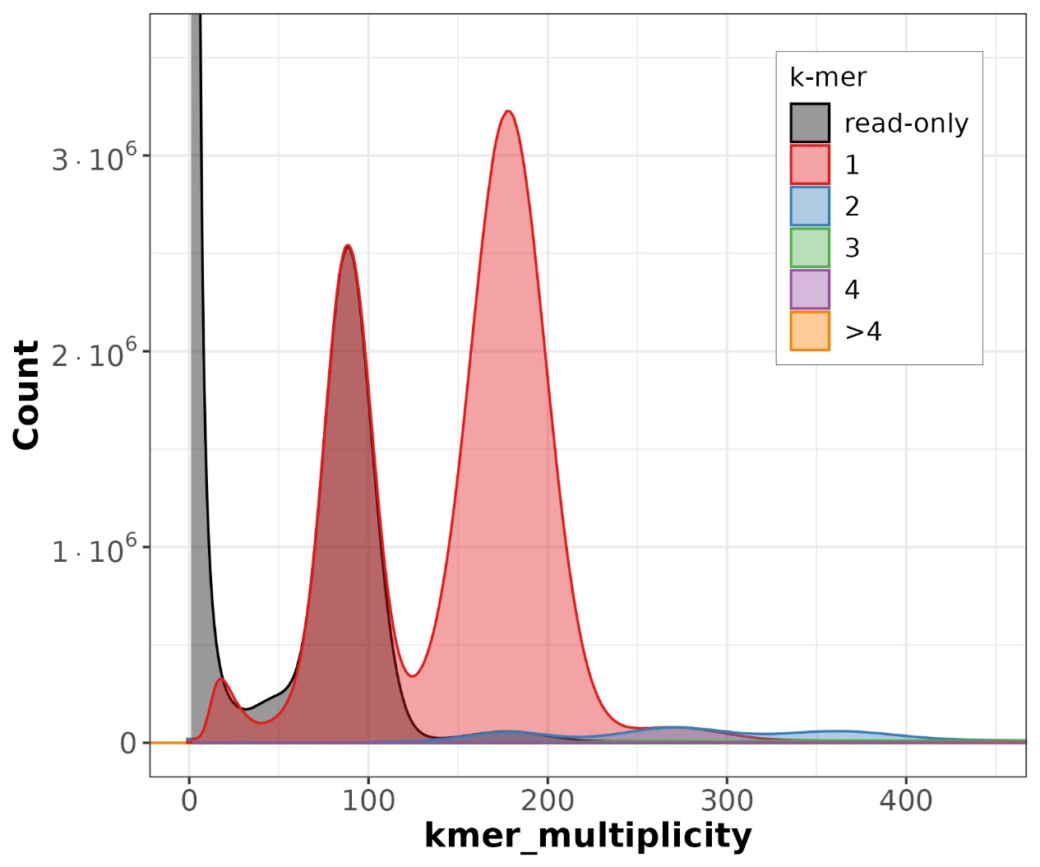

Figure S2. Merqury spectra-cn profile of the primary assembly. The peaks at approximately 88× and 177× are consistent with heterozygous and homozygous k-mer peaks, respectively. Gray areas represent read-derived k-mers absent from the assembly, whereas colored areas represent k-mers occurring at different copy numbers in the assembly. At the respective peak maxima, read-only k-mers accounted for 49.876% of distinct k-mers at 88× but only 1.715% at 177×. Only solid 19-mers with read multiplicities ≥36 were included in the completeness calculation. The concentration of read-only k-mers around the heterozygous peak indicates that the completeness of 75.783% predominantly reflects alternative-haplotype-specific k-mers not retained in the primary assembly.

