Supplementary Information

In-Situ Stretching Patterned Graphene Nanoribbons in the Transmission Electron Microscope
Zhongquan Liao ^{1,2,3}*, Leonardo Medrano Sandonas ^{2,4}, Tao Zhang ⁵, Martin Gall ¹, Arezoo Dianat ², Rafael Gutierrez ², Uwe Mühle ¹, Jürgen Gluch ¹, Rainer Jordan ⁵, Gianaurelio Cuniberti ^{2,3,6}, and Ehrenfried Zschech ^{1,3}
¹ Fraunhofer Institute for Ceramic Technologies and Systems (IKTS), 01109 Dresden, Germany
² Institute for Materials Science and Max Bergmann Center of Biomaterials, Technische Universität Dresden, 01069 Dresden, Germany
³ Center for Advancing Electronics Dresden (cfaed), Technische Universität Dresden, 01062 Dresden, Germany
⁴ Max Planck Institute for the Physics of Complex Systems, 01187 Dresden, Germany
⁵ Professur für Makromolekulare Chemie, Department Chemie, Technische Universität Dresden, 01069 Dresden, Germany
⁶ Dresden Center for Computational Materials Science, TU Dresden, 01062 Dresden, Germany
* Zhongquan.liao@ikts.fraunhofer.de

Figure S1. (a) and (c) Optical microscopy images of the transferred CVD graphene on different substrates (SiO₂/Si in (a) and TEM lacey grid in (c)), and (b) and (d) the corresponding Raman spectra.

Figure S2. TEM study on a single layer CVD graphene transferred to a lacey TEM grid. (a) Low-magnification TEM image; (b) the corresponding diffraction pattern, and the intensity profile plots taken between the blue arrows (inset); (c) high resolution TEM image, and the corresponding fast Fourier transform pattern (inset); and (d) a false color 3D image originated from the Fourier enhanced TEM micrograph of the marked area in (c).

Figure S3. Optical microscopy images of two PTP devices with unsuccessfully transferred graphene (the entangled graphene crap is shown by red arrows).

Figure S4. (a) BF TEM image of a monolayer graphene membrane on the 2.5 µm wide target gap of a PTP device; (b) the SAED pattern of the graphene membrane shown in (a); (c) BF TEM image of a monolayer GR on the 2.5 µm wide target gap of the PTP device, which was patterned by using a Ga⁺ ion beam (30 kV, 1 pA/10 s for both sides, the GR was not irradiated by the ion beam in the whole patterning experiment); (d) the SAED pattern from the patterned GR shown in (c); and (e) Raman spectrum from the patterned GR shown in (c).

Figure S5. Representative TEM images of a GNR patterned by focused electron beam in the in-situ stretching experiment. (a) At the original state, (b) at the maximum strain state, and (c) at the state right after the breakdown. The GNR is indicated by a blue arrow in (a). The graphene membrane breaks earlier than the GNR due to not optimized patterning geometry in this special case.

Figure S6. Optimized patterning geometry of the experimental sample. (a) Schematic picture, and (b) high angle annular dark field (HAADF) STEM image of a patterned sample on the PTP device by focused electrons. Two large cutting lines were introduced in the optimized patterning geometry to ensure the GNRs break firstly.

Figure S7. The measured electron energy spread at 80 kV with a smallest monochromator slit acquired for 1 s.

Figure S8. Low-loss EELS of the GNRs with and without strain for a tested sample. Although a very high energy resolution (about 0.15 eV) is achieved, the tail of the ZLP extends to more than 1 eV. No noticeable signal of the bandgap from the stretched GNRs could be directly detected in the spectrum.

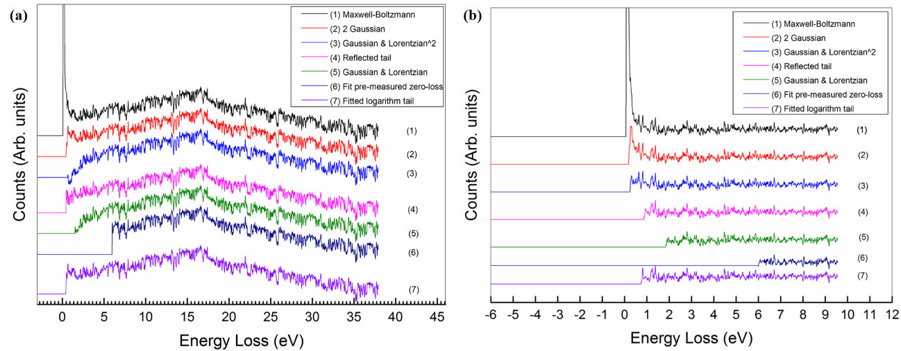
Figure S9. Comparison in several ZLP subtraction methods. EELS after ZLP subtraction for GNRs (a) without strain, and (b) at 1.25 % strain. Unfortunately, no data sets of the onset number from unstrained and strained GNRs can be used to extract bandgap data.

Table S1. The onset of the low-loss EELS after ZLP subtraction with several methods (summarized from Fig. S9).
ZLP subtraction method | Maxwell-Boltzmann | 2 Gaussian | Gaussian & Lorentzian^2 | Reflected tail | Gaussian & Lorentzian | Fit pre-measured zero-loss | Fitted logarithm tail
No strain (eV) | 0.08 | 0.44 | 0.62 | 0.44 | 1.50 | 5.98 | 0.40
1.25 % strain (eV) | 0.07 | 0.18 | 0.25 | 0.87 | 1.84 | 5.99 | 0.74

Video S1. The movie from the in-situ stretching experiment in the TEM.

