Cytomegalovirus infection exacerbates autoimmune mediated neuroinflammation
Marjan Vanheusden, Bieke Broux, Suzanne P.M. Welten, Liesbet M. Peeters, Eleni Panagioti, Bart Van Wijmeersch, Veerle Somers, Piet Stinissen, Ramon Arens, Niels Hellings

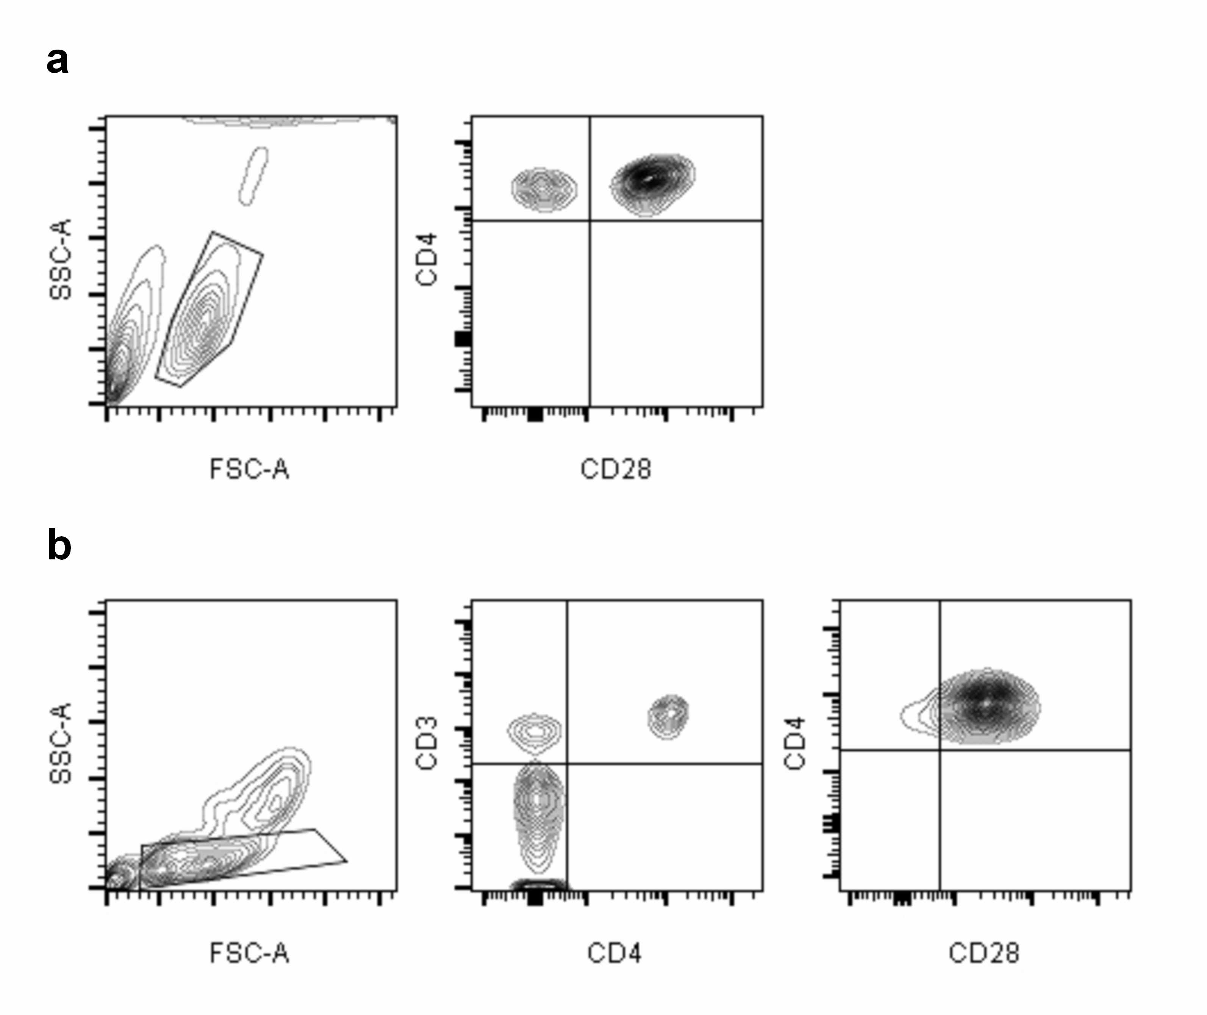
Supplementary figure 1: Gating strategy. (A) In human samples, the gating strategy consists of a lymphocyte gate using the forward and side scatter signal, after which CD4⁺ cells were gated and subsequently CD28 expression was monitored within this gate. (B) In mouse samples, the lymphocytes were gated, after which CD3⁺CD4⁺ cells were targeted and CD28 expression was monitored within this gate.
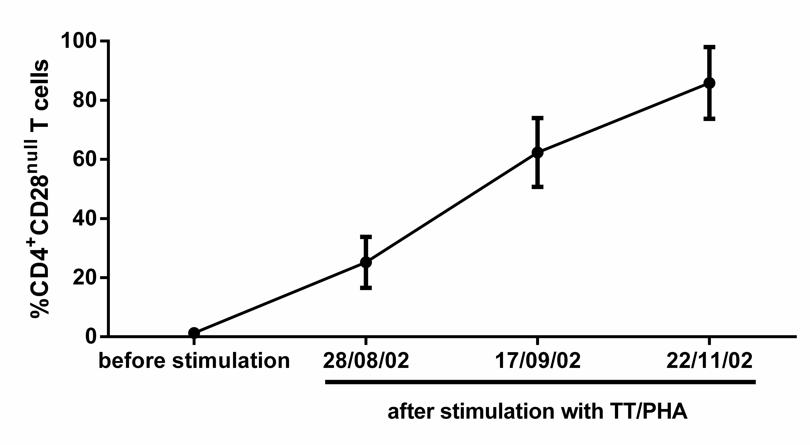
Supplementary figure 2: Historical human tetanus toxoid (TT) specific T cell clones repeatedly stimulated with TT/PHA (n=5) were thawed and analysed for the number of CD4⁺CD28^{null} T cells via flow cytometry.

