Co-fermentation using Recombinant Saccharomyces cerevisiae Yeast Strains Hyper-secreting Different Cellulases for the Production of Cellulosic Bioethanol

Cho-Ryong Lee ^{1,2,*}, Bong Hyun Sung^{1,2,*}, Kwang-Mook Lim¹, Mi-Jin Kim¹, Min Jeong Sohn¹, Jung-Hoon Bae¹, and Jung-Hoon Sohn^{1,2}

¹Cell Factory Research Center, Korea Research Institute of Bioscience and Biotechnology (KRIBB), Daejeon 34141, Republic of Korea
²Department of Biosystems and Bioengineering, KRIBB School of Biotechnology, Korea University of Science and Technology (UST), Daejeon 34113, Republic of Korea

Supplementary Information

Table S1. Primers used in this study for plasmid construction
Figure S1. Secretion of ClCBH2 by 24 TFP vectors.
Figure S2. Cellulose hydrolysis activity of secreted CBHs according to the culture time.
Figure S3. SDS-PAGE analysis for the secreted cellulases from recombinant yeast during fed-batch fermentation.
Table S1. Primers used in this study for plasmid construction
Primerª | Sequence (5’ – 3’)
ClCBH2-NS-F | GAATTTTTGAAAATTCAAGAATTCATGGCCAAAAAGTTGTTCATTACC
ClCBH2-F | GGCCGCCTCGGCCTCTGCTGGCCTCGCCTTAGATAAAAGAGCACCAGTAATAGAAGAAAGAC
ClCBH2-R | GTCATTATTAAATATATATATATATATATTGTCACTCCGTTCAAGTCGACTTAGAATGGTGGATTTGCG
CtCBH1-ss-F | GAATTTTTGAAAATTCAAGAATTCATGATGTATAAGAAGTTTGC
CtCBH1-F | GGCCGCCTCGGCCTCTGCTGGCCTCGCCTTAGATAAAAGACAACAAGCGTGTTCCCTC
CtCBH1-R | GTCATTATTAAATATATATATATATATATTGTCACTCCGTTCAAGTCGACTTACAGACACTGAGAATACC
HgCBH1-NS-F | GAATTTTTGAAAATTCAAGAATTCATGCGTACCGCCAAGTTTGC
HgCBH1-F | GGCCGCCTCGGCCTCTGCTGGCCTCGCCTTAGATAAAAGACAGCAAGCGTGTAGTCTCACC
HgCBH1-R | GTCATTATTAAATATATATATATATATATTGTCACTCCGTTCAAGTCGACTTACAAACATTGAGAGTACC
NfCBH1-F | GGCCGCCTCGGCCTCTGCTGGCCTCGCCTTAGATAAAAGACAACAGGTCGGTACTTCC
NfCBH1-R | GTCATTATTAAATATATATATATATATATTGTCACTCCGTTCAAGTCGACTTACAGGCATTGAGAGTAAAAG
TeCBH1-NS-F | GAATTTTTGAAAATTCAAGAATTCATGCTTAGAAGAGCTCTTTTGC
TeCBH1-F | GGCCGCCTCGGCCTCTGCTGGCCTCGCCTTAGATAAAAGACAACAAGCAGGCACTGCAACG
TeCBH1-R | GTCATTATTAAATATATATATATATATATTGTCACTCCGTTCAAGTCGACTTACGAAGCGGTAAAGGTCG
TrCBH1-F | GGCCGCCTCGGCCTCTGCTGGCCTCGCCTTAGATAAAAGACAGTCGGCCTGCACTCTC
TrCBH1-R | GTCATTATTAAATATATATATATATATATTGTCACTCCGTTCAAGTCGACTTACAGGCACTGAGAGTAG
TrCBH2-F | GGCCGCCTCGGCCTCTGCTGGCCTCGCCTTAGATAAAAGACAAGCTTGCTCAAGCGTCTG
TrCBH2-R | GTCATTATTAAATATATATATATATATATTGTCACTCCGTTCAAGTCGACTTACAGGAACGATGGGTTTG
PaCel1-F | GGCCGCCTCGGCCTCTGCTGGCCTCGCCTTAGATAAAAGACAGCAAGTGGGCACGCTC
PaCel1-R | GTCATTATTAAATATATATATATATATATTGTCACTCCGTTCAAGTCGACTTAGGAGGTGAAGGTGGAG
PaCel2-F | GGCCGCCTCGGCCTCTGCTGGCCTCGCCTTAGATAAAAGACAGGCTCCCGTGTACGG
PaCel2-R | GTCATTATTAAATATATATATATATATATTGTCACTCCGTTCAAGTCGACTTACAGCGGCGGGTTCG
CfCex-F | GGCCGCCTCGGCCTCTGCTGGCCTCGCCTTAGATAAAAGAGCGACCACGCTCAAGGAG
CfCex-R | GTCATTATTAAATATATATATATATATATTGTCACTCCGTTCAAGTCGACTCAGCCGACCGTGCAGG
SfBGL1-NS-F | ATTTTTGAAAATTCAAGAATTCATGTTGATGATAGTACAGCTTTTGG
SfBGL1-F | GGCCGCCTCGGCCTCTGCTGGCCTCGCCTTAGATAAAAGAGTCCCAATTCAAAACTATACC
SfBGL1-R | GTCATTATTAAATATATATATATATATATTGTCACTCCGTTCAAGTCGACTTAAATAGTAAACAGGACAG
TrEGL2-NS-F | ATTTTTGAAAATTCAAGAATTCATGAACAAGTCCGTGGCTCC
TrEGL2-F | GGCCGCCTCGGCCTCTGCTGGCCTCGCCTTAGATAAAAGACAGCAGACTGTCTGGGG
TrEGL2-R | GTCATTATTAAATATATATATATATATATTGTCACTCCGTTCAAGTCGACCTACTTTCTTGCGAGACACG
ªF: forward primer for TFP system, NS-F: forward primer of native signal sequence for protein secretion, R: reverse primer

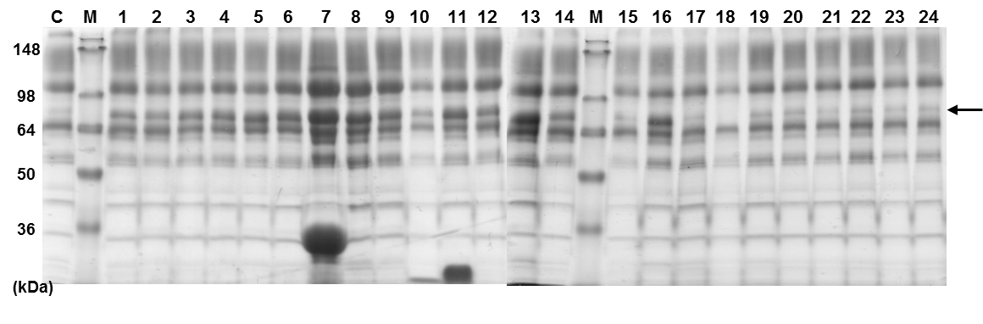
Figure S1. Secretion of ClCBH2 by 24 TFP vectors. SDS-PAGE analysis of ClCBH2 expressed by 24 selected TFPs. A 0.6-mL aliquot of the culture supernatant was analyzed on a 12% Tri-glycine gel after precipitation with acetone. M: standard protein size marker, C: host strain carrying a mock vector, lanes 1–24: each TFP (Table 2). The arrow indicates ClCBH2 secreted to the culture supernatant.

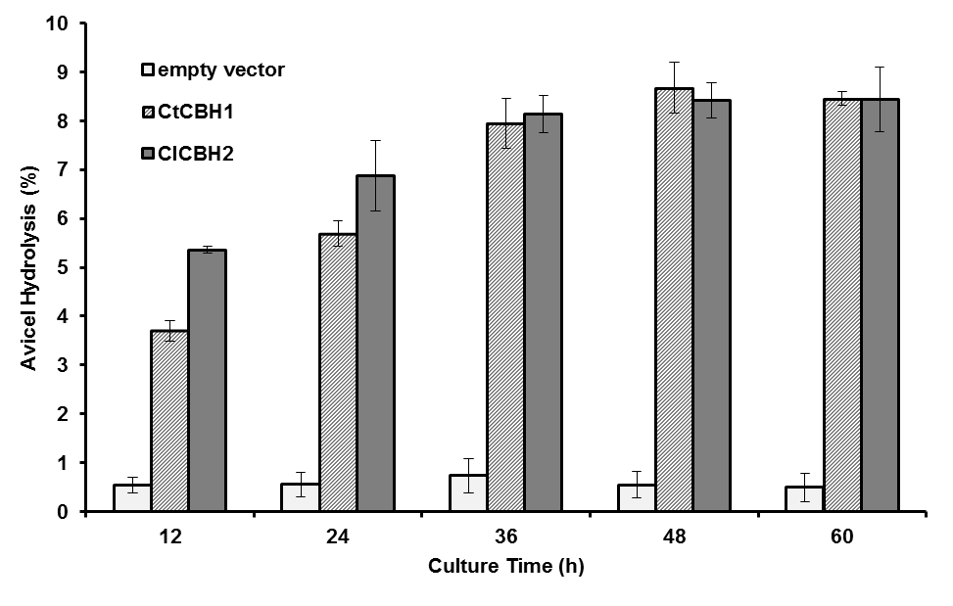
Figure S2. Cellulose hydrolysis activity of secreted CBHs according to the culture time. The activity of Avicel hydrolysis was detected based on the amount of glucose (g/L) released after 36 h by secreted CBHs up to 60 h with 0.5% (v/v) Novozyme A188.

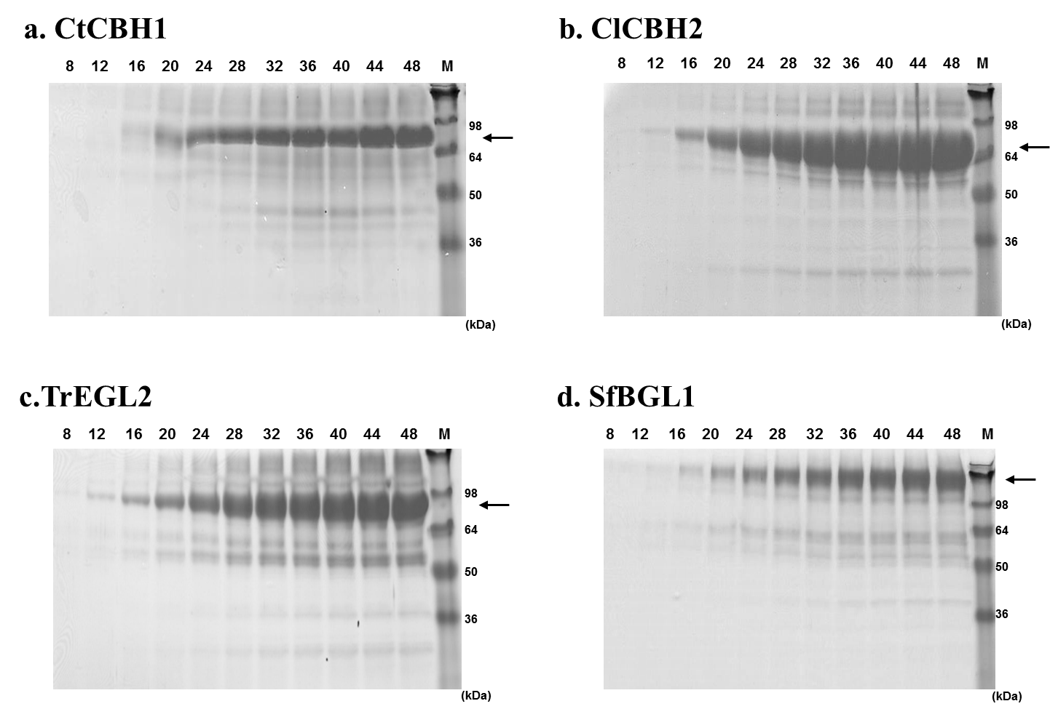
Figure S3. SDS-PAGE analysis for the secreted cellulases from recombinant yeast during fed-batch fermentation. Ten microliters of the culture supernatant was analyzed on a 12% Tri-glycine gel at a specific time of fermentation. M: standard protein size marker, lanes 8–48: supernatant of fermentation with 4-h time intervals during the 48-h culture.

