Supplementary Information

Journal: Scientific Reports

Title: Effects of chloride ions on corrosion of ductile iron and carbon steel in soil environments

Authors: Yarong Song^{a,b}, Guangming Jiang^{b}, Ying Chenª, Peng Zhao^{a*}, Yimei Tian^{a,c*}

ª School of Environmental Science and Engineering, Tianjin University, Tianjin 300350, China

^{b}Advanced Water Management Centre, The University of Queensland, St. Lucia, Brisbane QLD 4072, Australia

^{c} Tianjin Engineering Center of Urban River Eco-Purification Technology, Tianjin 300350, China

*Corresponding author. Tel: +86 13920975826.

E-mail address: zhpeng@tju.edu.cn (P. Zhao).

*Corresponding author. Tel: +86 15122638980.

E-mail address: ymtian_2017@163.com (Y.M. Tian).

Parameters | Value | Parameters | Value
pH | 6.98 | Electrical conductivity (μs/cm) | 2.8
Turbidity (NTU) | 0.00 | Total dissolve solids (mg/L) | 35
NH₃-N | 0.0006% | Chloride | 0.0002%
Table S1. Main parameters of distilled water quality.

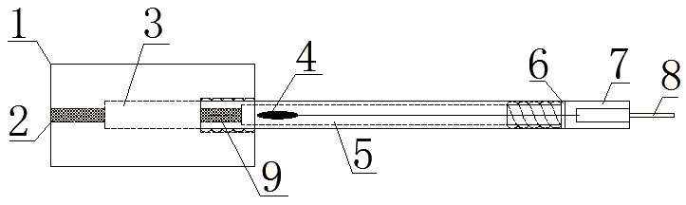
Figure S1. The reference electrode (1&7: polytetrafluoroethylene cover; 2&9: porous sand core; 3: saturated electrolytic cavity; 4: Ag-AgCl; 5: electrolyte cavity; 6: seal ring; 8: copper conductor).

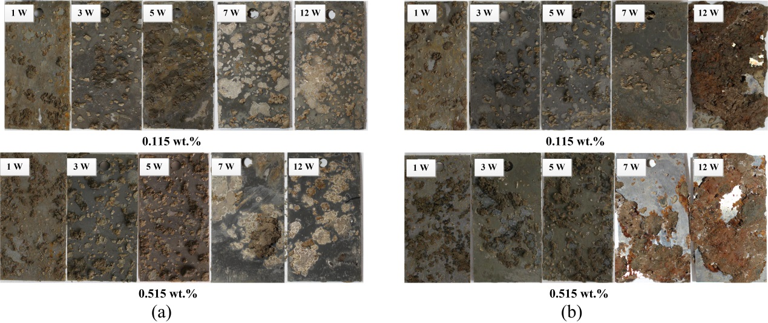
Figure S2. Ductile iron (a) and carbon steel (b) coupons exposed to soils of different chloride concentrations, i.e. 0.115%, 0/515% (wt.%) after 1, 3, 5, 7, 12 weeks.

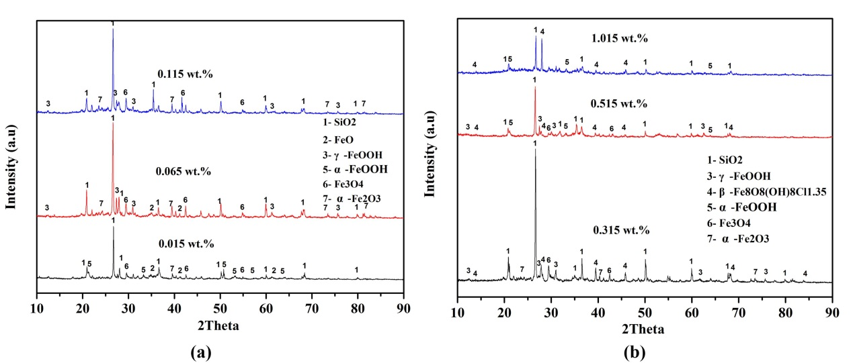
Figure S3. XRD analysis of ductile iron coupons exposed to soils of different chloride concentrations, i.e. (a) 0.015%, 0.065%, 0.115%, (b) 0.315%, 0.515%, 1.015% (wt.%) after 12 weeks.

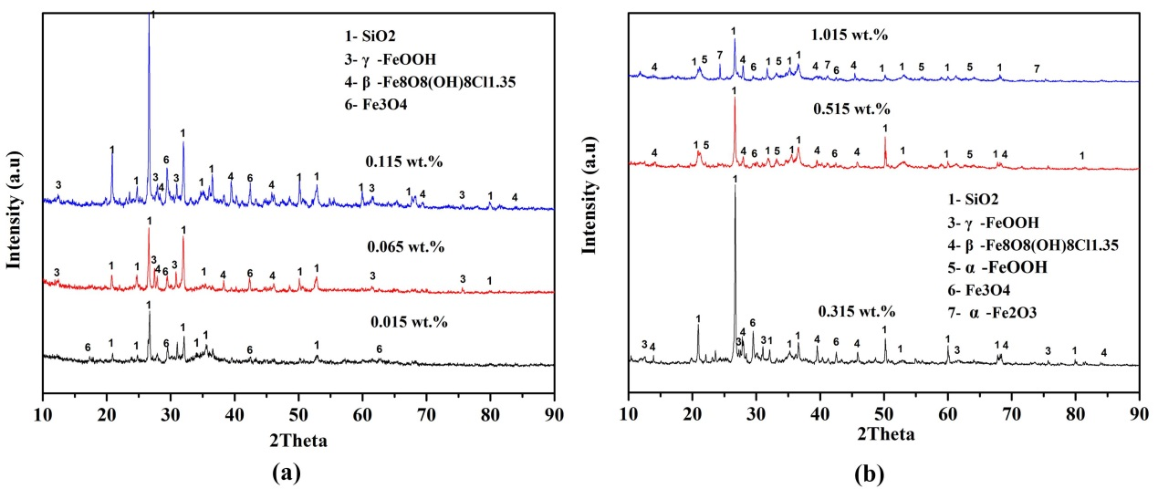
Figure S4. XRD analysis of carbon steel coupons exposed to soils of different chloride concentrations, i.e. (a) 0.015%, 0.065%, 0.115%, (b) 0.315%, 0.515%, 1.015% (wt.%) after 12 weeks.

Chloride contents | Ductile iron |  |  | Carbon steel
wt.% | k | n | R2 | k | n1 | n2 | R2
0.015 | 1.178 | 0.142 | 0.982 | 0.482 | 0.538 | 0.0467 | 0.968
0.065 | 1.362 | 0.118 | 0.995 | 0.465 | 0.575 | 0.101 | 0.939
0.115 | 1.227 | 0.209 | 0.950 | 1.172 | 0.296 | 0.0959 | 0.986
0.315 | 1.118 | 0.295 | 0.944 | 1.298 | 0.310 | 0.113 | 0.880
0.515 | 1.322 | 0.517 | 0.995 | 1.216 | 0.322 | 0.105 | 0.966
1.015 | 1.147 | 0.650 | 0.985 | 0.799 | 1.025 | 0.216 | 0.942
Function | $$D=kt^{n}$$ |  |  | $$D=k{t_{1}}^{n_{1}-n_{2}}t^{n_{2}}$$
Table S2. Regression coefficients of the corrosion data for ductile iron and carbon steel.

