Supplemental Information

SDE5, a putative RNA export protein, participates in plant innate immunity through a flagellin-dependent signaling pathway in Arabidopsis

Mohammad Nazim Uddin¹ , Salina Akhter^{2,}, Rupak Chakraborty¹, Ji Hyeong Baek¹, Joon-Yung Cha³, Su Jung Park⁴, Hunseung Kang⁴, Woe-Yeon Kim³, Sang Yeol Lee², David Mackey^{5,*}, Min Gab Kim^{1,*}

¹College of Pharmacy and Research Institute of Pharmaceutical Science, PMBBRC, Gyeongsang National University, Jinju 660-701, Republic of Korea.
²Division of Applied Life Sciences (BK21 Plus program), Graduate School of Gyeongsang National University, Jinju 660-701, Republic of Korea.
³Division of Applied Life Science (BK21Plus), PMBBRC & IALS, Gyeongsang National University, Jinju 660-701, Korea
⁴Department of Plant Biotechnology, College of Agriculture and Life Sciences, Chonnam National University, Gwangju 500-757 Korea
⁵ Department of Molecular Genetics, Ohio State University, Columbus, Ohio 43210. USA.

Correspondence Author

Min Gab Kim
E-mail : mgk1284@gnu.ac.kr
Or
David Mackey
E-mail : mackey.86@osu.edu
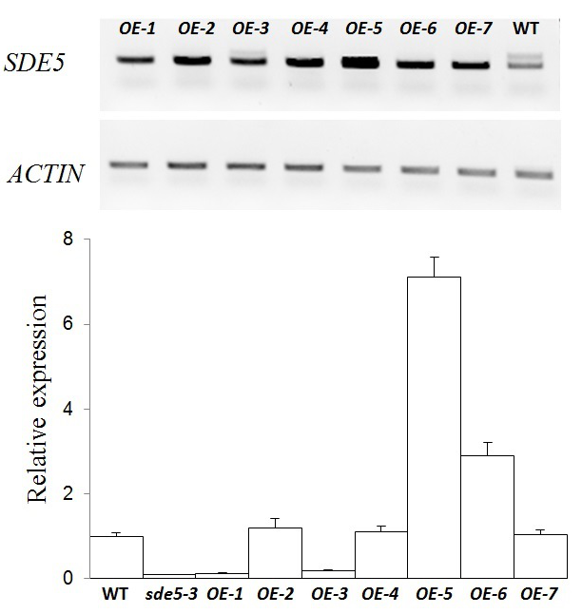
Supplemental Figure 1. Identification of SDE5 overexpressing lines. RT-PCR (upper panel) and qRT-PCR (lower panel) analysis of the SDE5 expression in the WT, sde5-3 and several 35S::SDE5-RFP transgenic plants. ACTIN served as an internal control.

Supplemental Figure 2. Pto DC3000 induced symptoms after SA treatment in sde5 mutants and transgenic lines over-expressing the SDE5 gene. Symptoms in leaves of WT, sde5-2, sde5-3 and SDE5 overexpressing line (OE-5) treated with 0.5 mM SA followed by Pto DC3000 infiltration. Leaves of five-week-old plants were syringe infiltrated with a concentration of 2x10⁶ cfu mL⁻¹ of Pto DC3000, and photographs were taken 4 dpi. Representative leaves are shown. Similar results were obtained in three independent experiments.
Supplemental Figure 3. Enhanced bacterial growth is observed in transgenic overexpressing plants upon non-host pathogen, Pph infection. Quantification of bacterial growth 0 or 7 dpi on five-week-old plants after syringe inoculation with concentrations of 2x10⁵ cfu mL⁻¹ of the virulent bacterial strain Pph. The bars indicate the mean ±SD for each set of three independent experiments with significant difference at *P < 0.05.

Supplemental Figure 4. Expression analysis of flg22-associated marker genes. A to B, qRT-PCR analyses of FRK1 (A) and WRKY29 (B) of seedlings WT, sde5-3, OE-5 and the fls2 pretreated for 3 h with 1 μM flg22 treatment. ACTIN was used as loading control. Values below each section represent relative abundance of transcript normalized to ACTIN control.The bars indicate the mean ±SD for each set of three independent experiments with significant difference at *P < 0.01.

