Combining Biomarkers with EMR Data to Identify Patients in Different Phases of Sepsis

Authors: Ishan Taneja^{1,3,4}, Bobby Reddy Jr. ^{1,3,4}, Gregory Damhorst^{1,3}, Dave Zhao², Umer Hassan^{1,3}, Zachary Price^{1,3}, Tor Jensen^{1,3}, Tanmay Ghonge^{1,3}, Manish Patel^{1,3}, Samuel Wachspress^{1,3,4}, Jackson Winter^{1,3,4}, Michael Rappleye^{1,3}, Gillian Smith^{1,3}, Ryan Healey^{1,3}, Muhammad Ajmal³, Muhammad Khan³, Jay Patel³, Harsh Rawal³, Raiya Sarwar³, Sumeet Soni³, Syed Anwaruddin^{3,} Benjamin Davis³, James Kumar³, Karen White³, Rashid Bashir^{1,3*}, Ruoqing Zhu^{2*}

Supplementary Information

Figures

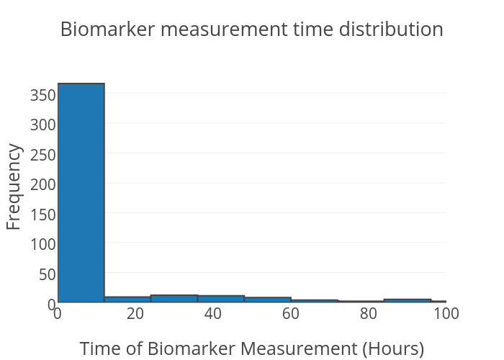

Figure S1. Biomarker measurement time distribution. Majority of sample measurements (80%) are within the first 6 hours of admission.

Figure S2. Patient disease state categorization as a function of sepsis severity. The blue/orange/red curve represents a hypothetical patient’s severity of sepsis/severe sepsis/septic shock respectively as a function of time, where the apex of the curve corresponds to their worst case state. The vertical lines partition the course of the disease into various categories. 1 corresponds to not septic, 2 corresponds to approaching the peak state of sepsis/severe sepsis/septic shock, 3-5 corresponds to within the peak state of sepsis/severe sepsis/septic shock respectively, 6-8 corresponds to recovering from sepsis/severe sepsis/septic shock respectively, and 9-11 corresponds to significantly recovering from sepsis/severe sepsis/septic shock respectively.

Tables

Feature | LASSO coefficient | SVM coefficients | Random Forest | Adaboost
TNF-α | 0 | -.06 | -1.31 | .55
IL-1β | 0 | -.03 | .38 | .29
GCSF | 0 | -.04 | -.28 | 1.04
IL-6 | 1.93 | -.26 | 6.81 | 38.07
PCT | 0 | -.11 | -2.86 | 5.96
sTREM1 | 0 | .02 | -2.15 | 1.15
IL18 | 0 | -.01 | -.11 | .73
MMP9 | 0 | -.12 | -2.33 | 1.49
TNFR1 | 0 | -.01 | -3.16 | 1.11
TNFR2 | 0 | -.06 | -4.96 | 3.15
IP10 | 0 | -.07 | -1.98 | 1.56
MCP1 | 0 | -.07 | 1.48 | 2.90
IL-1ra | 0.19 | -.14 | 2.94 | 12.37
NGAL | 0 | -.02 | 1.10 | 2.35
CD64 | 0.37 | -.13 | .98 | 4.25
WBC | 0.22 | -.20 | 1.11 | 4.05
Lactic Acid | 0 | -.04 | -.04 | .15
Systolic Blood Pressure | 0 | .02 | -1.84 | .017
Diastolic Blood Pressure | 0 | .00 | -.96 | .74
Pulse | 0.25 | -.14 | 2.17 | 9.40
Temperature | 0 | -.08 | 3.04 | 3.50
Respirations | 0 | .00 | -.04 | 1.91
PCO₂ | 0 | .11 | 2.78 | 2.51
Age | 0 | .00 | 2.11 | 1.11
Gender | 0 | .03 | -1.71 | .12
Bilirubin | 0 | .00 | -2.30 | .15
Glasgow Coma Scale | 0 | .05 | .33 | .26
Creatinine | 0 | .05 | -1.00 | .15
Platelet | 0 | -.05 | -1.09 | .29
SOFA score | 0 | -.05 | 1.92 | 1.06
qSOFA score | 0 | -.03 | 2.44 | 1.55

Table S1. Feature coefficients/importance for clinical adjudication label set

Feature | LASSO coefficient | SVM coefficient | Random Forest | Adaboost
TNF-α | 0 | .03 | .05 | .42
IL-1β | 0 | -.05 | -.49 | .57
GCSF | 0 | .04 | -1.15 | .75
IL-6 | 0 | .10 | -1.21 | .37
PCT | 0.65 | .14 | 3.99 | 15.44
sTREM1 | 0.10 | .21 | 5.52 | 4.53
IL18 | 0 | -.03 | -2.93 | .20
MMP9 | -0.14 | -.17 | 3.69 | 6.62
TNFR1 | 0.76 | .19 | 4.21 | 13.94
TNFR2 | 0 | .13 | 3.80 | 1.40
IP10 | 0 | .02 | -2.42 | 3.24
MCP1 | 0 | .06 | -.92 | 6.80
IL-1ra | 0 | -.09 | -.36 | .55
NGAL | 0 | .01 | -.64 | .10
CD64 | 0.41 | -.01 | -4.11 | 8.16
WBC | 0.23 | -.01 | .87 | 1.11
Lactic Acid | 0.28 | .13 | 2.49 | 12.92
Pulse | 0 | -.07 | 1.57 | .11
Temperature | 0 | .03 | -1.49 | .03
Respirations | 0.26 | .32 | 14.36 | 9.35
PCO₂ | -1.57 | -.19 | 13.27 | 8.65
Age | 0 | .01 | 1.50 | 5.53
Gender | 0.007 | .02 | .28 | .007

Table S2. Feature coefficients/importance for SOFA label set

Algorithm | All features | EMR | Biomarkers
Logistic Regression | (.75,.03) | (.83,.09) | (.74,.03)
Logistic Regression w/ feature selection | (.70,.02) | (.83,.08) | (.66,.02)
SVM | (.67,.02) | (.78,.08) | (.73,.02)
SVM w/ feature selection | NA | (.78,.06) | (.60,.01)
Random Forest | (.71,.03) | (.81,10) | (.83,.06)
Random Forest w/ feature selection | (.69,.03) | (.78,.09) | (.75,.04)
Adaboost | (.47,-.001) | (.73,.06) | (.64,.02)
Adaboost w/ feature selection | (.45,-.002) | (.69,.05) | (.56,.01)
Naive Bayes | (.80,.04) | (.87,.11) | (.77,.04)
Naive Bayes w/feature selection | (.62,.01) | (.79,.08) | (.65,.01)

Table S3. Percentage of paired AUC differences above 0 and mean value of paired AUC differences between our final chosen model (SVM w/ feature selection amongst all features) and all other combinations of algorithms and feature sets.

Feature Set Comparison | Percentage of paired AUC difference values above 0
Biomarker + EMR vs. EMR only | (.78,.06)
Biomarker + EMR vs. Biomarker only | (.60,.01)
Biomarker only vs. EMR only | (.72,.05)

Table S4. Percentage of paired AUC differences above 0 and mean value of paired AUC differences between specific pairs of feature sets.

Biomarker | Mean CV (%)
TNF-α | 5.52
IL-1β | 4.72
GCSF | 8.87
IL-6 | 5.16
PCT | 5.46
sTREM1 | 4.97
IL18 | 4.68
MMP9 | 4.96
TNFR1 | 5.36
TNFR2 | 6.40
IP10 | 6.70
MCP1 | 5.17
IL-1ra | 7.37
NGAL | 5.18
CD64 | 5.37

Table S5. Mean CV for each biomarker across all measurements.

Methods

Lasso:
LASSO fits a generalized linear model with a L1 norm regularization term to augment the sparsity of coefficients. Specifically, the following penalized logistic regression problem is being solved:
$$\min_{\left(β_{0},β\right)∈R^{p+1}}-\left[\frac{1}{N}\sum_{i=1}^{N}{y_{i}⋅\left(β_{0}+x_{i}^{T}β\right)}-⁡log\left(1+e^{\left(β_{0}+x_{i}^{T}β\right)}\right)\right]+λ||{β||}_{1}.$$

Feature transformation for vitals:

Let x be the time of the biomarker measurement. Let a represent the time window used before the biomarker measurement and let b represent the time window used after the biomarker measurement. Let j represent the particular vital (i.e pulse). Let T_{j} be the set of discrete measurement times for vital j between [x-a, x+b], specifically restricted to times where the particular value of the measurement was considered abnormal. Let $f_{j}\left(t\right)$ represent the value of vital j at time t. Let Δt represent the time difference between the measurement at time t and the next corresponding measurement for vital j (note that the next corresponding measurement does not necessarily need to be in T_{j}). Let $g({j,f}_{j}\left(t\right))$ be a function outputting the particular threshold value for a given vital j and its corresponding value $f_{j}\left(t\right)$. For example, white blood cell count (WBC) measurements are considered abnormal if they are greater than 12E9/L or less than 4E9/L, so g(2E9,WBC) = 4E9 and g(16E9, WBC) = 12E9. So, for a given vital for a particular patient, their particular feature can be calculated as follows:

$$\frac{\sum_{t ∈T_{j}}{\frac{{|f}_{j}\left(t\right)-g({j,f}_{j}\left(t\right))|}{g({j,f}_{j}\left(t\right))}*∆t }}{b-a}$$

