Supplementary Information

Comprehensive transcriptome profiling of Salvia miltiorrhiza for discovery of genes associated with the biosynthesis of tanshinones and phenolic acids

Wei Zhou^{c, a+}, Qiang Huang^{b+}, Xiao Wu^{b}, Zewen Zhou^{b}, Mingquan Ding^{c}, Min Shi^{b}, Fenfen Huang^{b}, Shen Li^{c}, Yao Wang^{b}, Guoyin Kai^{a,b}*

ªCollege of pharmacy, Zhejiang Chinese Medical University, Hangzhou, Zhejiang 310053, China.
^{b}Laboratory of Plant Biotechnology, College of Life and Environment Sciences, Shanghai Normal University, Shanghai 200234, China;
^{c}The Key Laboratory for Quality Improvement of Agricultural Products of Zhejiang Province, School of Agriculture and Food Science, Zhejiang A&F University, Linan, Hangzhou, Zhejiang 311300,China.

⁺ These authors contributed equally to this work
*Corresponding author: Guoyin Kai, Ph.D, Professor; Address: Laboratory of Plant Biotechnology, College of Life and Environment Sciences, Shanghai Normal University, 100 Guilin Road, Shanghai 200234, P.R.China; Tel/Fax: 86-21-64321291; E-mail: guoyinkai@yahoo.com, gykai@hotmail.com

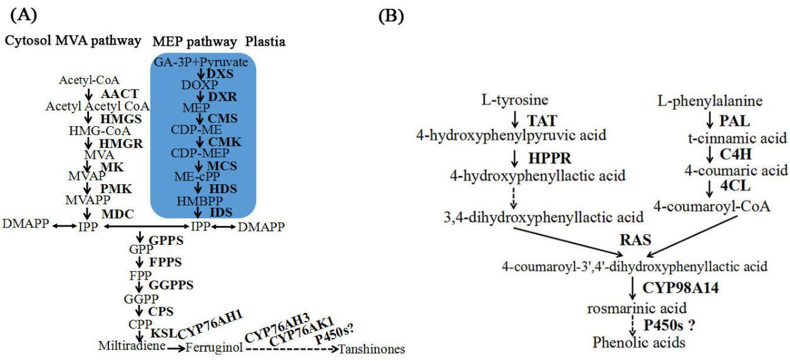

Supplementary Figure S1. The biosynthesis pathway of tanshinones and phenolic acids. (A, Tanshinones biosynthesis pathway; B, Phenolic acids biosynthesis pathway)

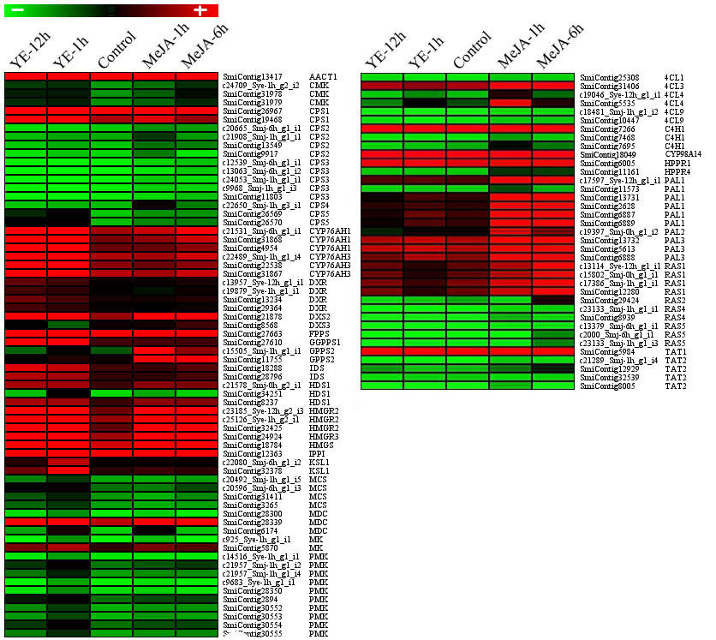

Supplementary Figure S2. Summary of unigenes involved in the biosynthesis of tanshinones and phenolic acids induced by MeJA and YE.

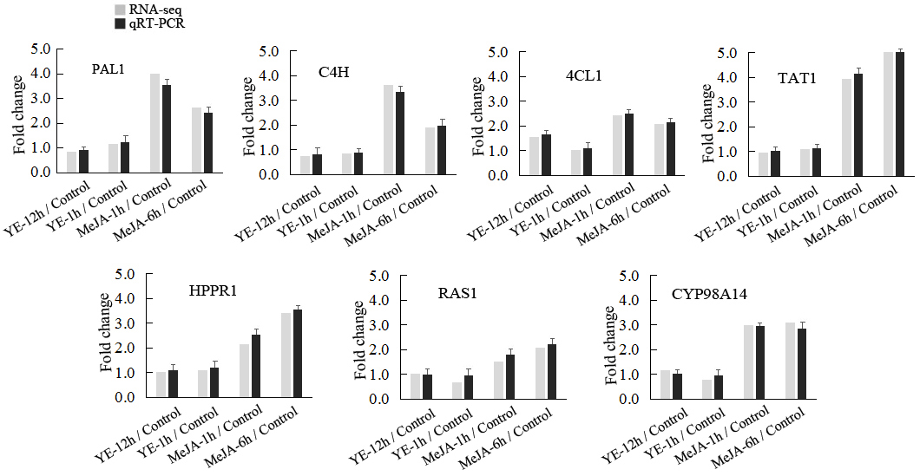

Supplementary Figure S3. qRT-PCR validation of differently expressed genes involved in the biosynthesis of phenolic acids in RNA-seq dataset

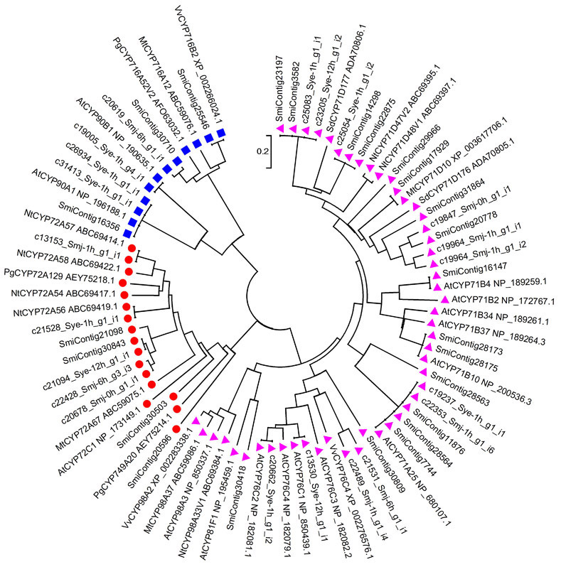

Supplementary Figure S4. Phylogenetic analysis of the P450s which co-expressed with genes involved in the biosynthesis of tanshniones. (red solid circle, denotes cytochrome CYP76 clan; blue solid square, denotes cytochrome CYP85 clan; pink solid triangle, denotes cytochrome CYP71 clan)

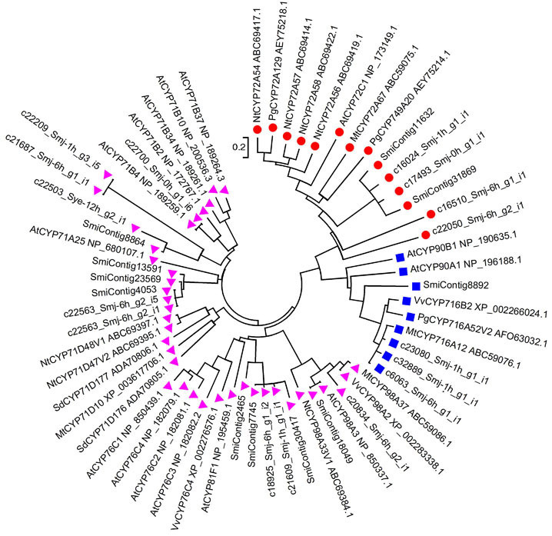

Supplementary Figure S5. Phylogenetic analysis of the P450s which co-expressed with genes involved in the biosynthesis of phenolic acids. (red solid circle, denotes cytochrome CYP76 clan; blue solid square, denotes cytochrome CYP85 clan; pink solid triangle, denotes cytochrome CYP71 clan)

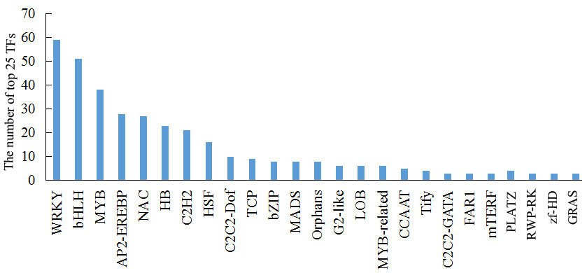
Supplementary Figure S6. Summary of top 25 transcription factor families in S.miltiorrhiza transcripts

