Supplementary file

Title: Psilocybin for treatment-resistant depression: fMRI-measured brain mechanisms

Robin L Carhart-Harris^{a1}, Leor Roseman^{a,b}, Mark Bolstridgeª, Lysia Demetriou^{e}, J Nienke Pannekoekª, Matthew B Wall^{e}, Mark Tanner^{e}, Mendel Kaelenª, John McGonigle^{e}, Kevin Murphy^{c}, Robert Leech^{b}, H Valerie Curran^{d}, David J. Nuttª
ª Psychedelic Research Group, Centre for Psychiatry, Department of Medicine, Imperial College London, W12 0NN, London, UK
^{b} Computational, Cognitive and Clinical Neuroscience Laboratory (C3NL), Department of Medicine, Imperial College London, W12 0NN, London, UK
^{c} Cardiff University Brain Research Imaging Centre (CUBRIC), Department of Psychology, CF10 3AT, Cardiff, UK
^{d} Clinical Psychopharmacology Unit, University College London, WC1E 6BT, London, United Kingdom
^{e} Imanova Centre for Imaging Sciences, Burlington Danes Building, Hammersmith Hospital, Du Cane Road, London, W12 0NN, UK
¹ To whom correspondences should be addressed. Email: r.carhart-harris@imperial.ac.uk
The authors declare no competing financial interests.

Supplementary data table

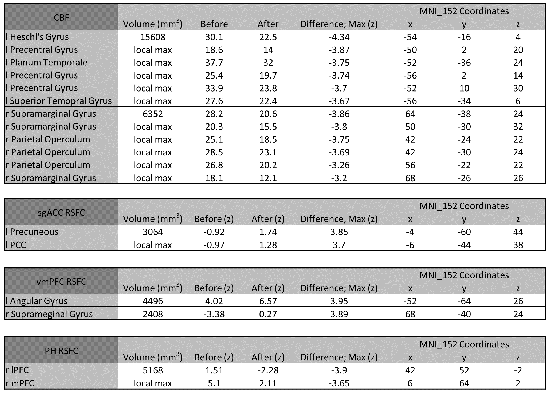

Table 1. Regions showing decreased CBF, increased sgACC RSFC, increased vmPFC RSFC and decreased PH RSFC post treatment. The before (pre) and after (post) treatment columns report the z value of each condition separately in the same point as Max.

Supplementary analysis

Inspired by a reviewers’ request, we looked for correlation between the quality of the acute experience – with a specific focus on the so-called ‘mystical experience’ and changes in RSFC in a whole brain voxel based analysis. The index of mystical experience we used here was the Oceanic Boundlessness (OB) dimension of the 5D-ASC (Studerus et al., 2010) and the parahippocampus was chosen as the primary region of interest for the RSFC analysis - due to previous work implicating its circuitry in phenomena relevant to the ‘mystical experience’ (Carhart-Harris et al., 2016). We found a negative correlation between OB and the changes in RSFC of parahippocampus with a number of regions (precuneous, frontal pole, insular cortex, putamen and amygdala) (cluster correction, z > 2.3, p < 0.05). The nature of this relationship was such that patients who scored high on OB had the greatest decreases in RSFC. Since PH-PFC RSFC was decreased as a main result (fig of main paper), this finding makes some intuitive sense. We recommend caution in making inferences on this result however; the analysis was conceived post-hoc nature and that the patients who scored lowest on OB actually had an increase in PH RSFC in the relevant regions – which is inconsistent with the main result reported in the manuscript, i.e. decreased PH-PFC RSFC.

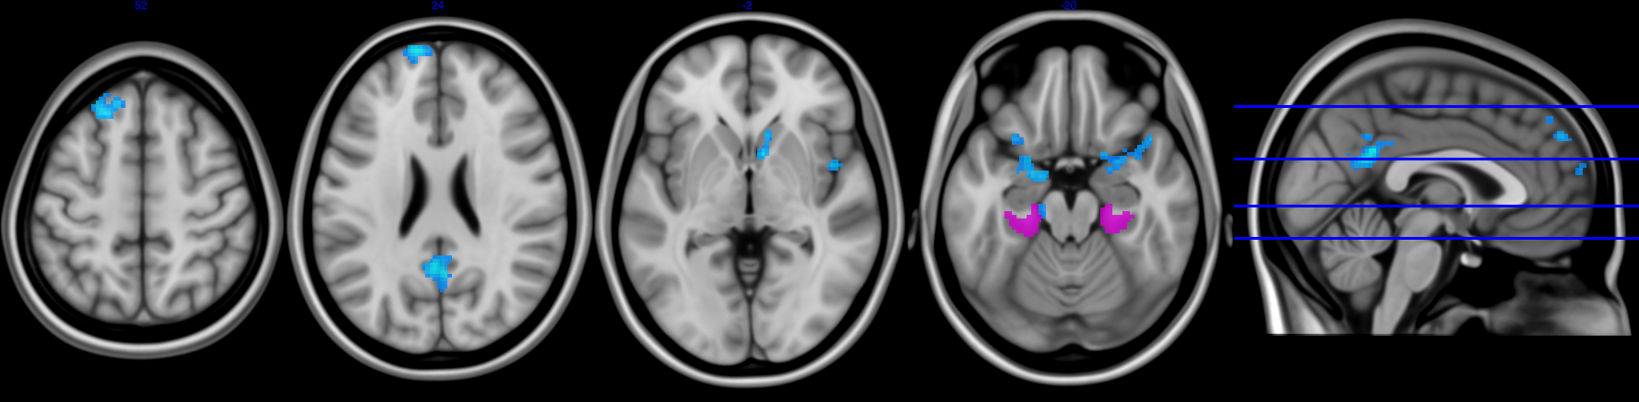

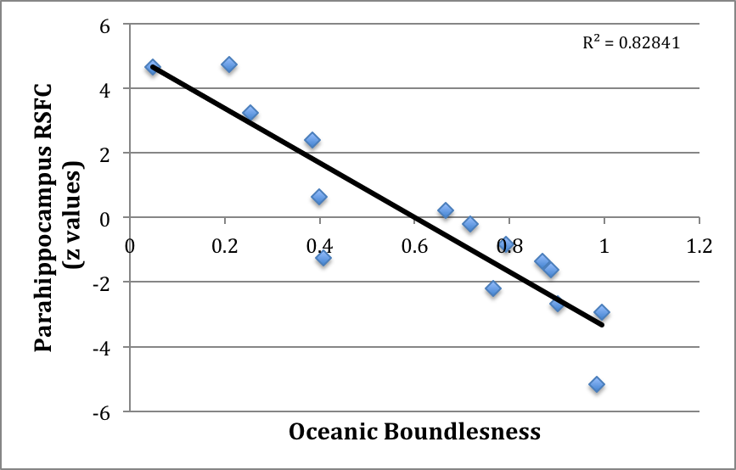

Figure S1. Statistical maps show regions where post-treatment changes in parahippocampal RSFC correlate with ratings of ‘oceanic boundlessness’ (OB) (z = 2.3, p < 0.05). The correlation plot shows the distribution of values. It can be seen that some patients actually had increased PH-RSFC in the relevant regions – and that these had the lowest OB scores.

References

Carhart-Harris RL, Muthukumaraswamy S, Roseman L, et al. (2016) Neural correlates of the LSD experience revealed by multimodal neuroimaging. Proc Natl Acad Sci U S A 113: 4853-4858.
Studerus E, Gamma A and Vollenweider FX. (2010) Psychometric evaluation of the altered states of consciousness rating scale (OAV). PLoS One 5: e12412.

