High Dose Parenteral Ascorbate Inhibited Pancreatic Cancer Growth and Metastasis: Mechanisms and a Phase I/IIa study

Authors: Kishore Polireddy^{1,2}, Ruochen Dong^{1,2}, Gregory Reed¹, Jun Yu^{1,2}, Ping Chen^{1,2}, Stephen Williamson³, Pierre-Christian Violet⁵, Ziyan Pessetto⁴, Andrew K Godwin⁴, Fang Fan⁴, Mark Levine⁵, Jeanne A Drisko^{2,3, *}, Qi Chen^{1,2,*}
Affiliations:
¹ Department of Pharmacology, Toxicology and Therapeutics; ² KU Integrative Medicine; ³ Department of Internal Medicine, Hematology and Oncology Division; ⁴ Department of Pathology and Laboratory Medicine, University of Kansas Medical Center, Kansas City, KS, 66160. ⁵National Institute of Diabetes, Digestive and Kidney Diseases, the National Institutes of Health, Bethesda, MD 20892.

Supplementary Data:

Fig. S1
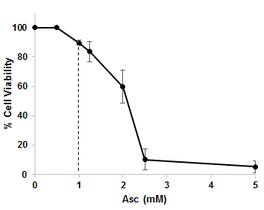
Figure S1. Dose-response curve of ascorbate inhibiting PANC-1 cell viability. PANC-1 cells in log-growth phase were incubated with indicated concentrations of ascorbate for 48 hrs. Cell viability was detected by MTT assay. Data represent average ± SD of 3 independent experiments each done in triplicates.

Fig. S2
Figure S2. qRT-PCR for changes in EMT markers in MIA PaCa2 cells. Cells were treated with 1.25 mM Asc for 6 h. Data was normalized to 18s rRNA, and then compared to untreated MIA PaCa2 cells for fold change. Data represent Mean ± SD of 2-3 independent experiments.
Fig. S2
A
B

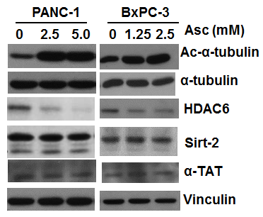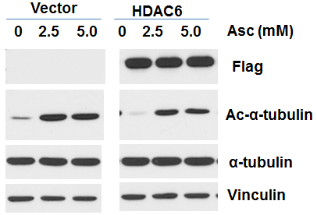

C

Figure S2. Western blots of Sirt-2, HDAC6 and α-TAT after ascorbate treatment. (A) Western blot analysis for Sirt-2, HDAC6 and α-TAT. PANC-1 and BxPC-3 cells were treated with ascorbate for 4 h. (B) Overexpression of Flag tagged HDAC6 in PANC-1 cells and α-tubulin acetylation induced by ascorbate (4 h). Vinculin was a loading control. (C) Sensitivity of PANC-1 cells and PANC-1 cells overexpressing HDAC6 to ascorbate treatment. Stable overexpression clone (#6) was selected using G418 after transfection with pDDNA3.1-HDAC6. Cells were treated for 48 h and viability was detected by MTT assay. Data represent Mean ± SD of 2 independent experiments each done in triplicates.

Fig. S3
A

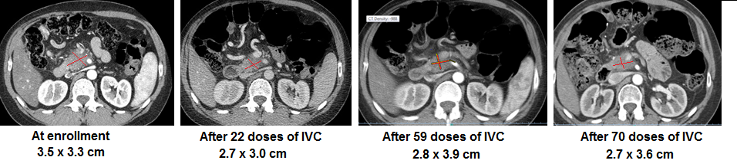
B

Figure S3. Tumor Response of subject #8 to the combination treatment of IVC and gemcitabine. A. PET-CT images. Subject #8 was diagnosed in 10/2013 with Stage III pancreatic ductal carcinoma not eligible for surgical resection. Initially the subject was treated with FOLFIRINOX for 6 months and disease progressed. At enrollment (5/13/2014), imaging showed infiltrating pancreatic mass of 3.5 cm × 3.3 cm. The second image on 7/18/2014 was taken when the subject had 22 doses of IVC at 100 g/infusion and 3 cycles of gemcitabine at the dose of 1,000 gm/m². There was interval improvement in appearance of mass margins, which are less indiscreet. The third image was on 10/28/2014 when patient received 59 doses of IVC and 8 cycles of gemcitabine. The last image was on 1/21/2015 after patient had 70 doses of IVC and 9 cycles of gemcitabine. Patient was considered eligible for surgery removal of the tumor at this point. B. H&E staining of the resected tumor, in comparison to an untreated pancreatic cancer, a FOLFIRINOX treated pancreatic cancer, and a gemcitabine treated pancreatic cancer all from archived pathological slides. Collagen was stained pink/red. Bar graph represents Mean ± SD of % area collagen/cross section, 24 fields from 6 different slices were analyzed for subject #8, and 5 different fields were analyzed for each of the other samples.

Table S1
Cell line | K-Ras | P53 | CDKN2A/p16 | SMAD4/DPC4
BxPC-3 | WT | 220 Cys | WT | HD
AsPC-1 | 12 Asp | 135 Δ1 bp | WT | WT
MIA PaCa2 | 12 Cys | 248 Trp | HD | WT
Su86.86 | 12 Asp | 245 Ser | HD | WT
HPAFII | 12 Asp | 151 Ser | Δ20–25  Δ26–27  Δ29–34 | WT
HS 766T | 61 His | Mut 225–282  Δexons 2–4 | Intron 2 splice site | HD
PANC-1 | 12 Asp | 273 His, 273 Cys | HD | WT
L3.6pl | 12 Asp |  |  | Δ

Table S1 Genotype of the human pancreatic cancer cell lines used, showing the most common genetic alternations in pancreatic cancer (63, 64). WT—wild type, Δ—deletion, bp—base pair, HD—homozygous deletion, Mut225-282— mutations found between codons 225-282
Table S2a Demographics of Study Population

ID | Age | Gender | Prior Therapy before Enrollment |  | Stage Initial Diagnosis | Stage Enrollment | ECOG at Enrollment
1 | 76 | F | None | IV (T2, N1, M1) |  | IV (T2, N1, M1) | 1
2 | 69 | F | Gemcitabine and Kanglaite X 2 months until progression | IV (T3, N1, M1) |  | IV (T3, N1, M1) | 1
3 | 56 | M | FOLFIRINOX X 3 months until progression | IV (T3, N1, M1) |  | IV (T3, N1, M1) | 1
4 | 76 | M | Gemcitabine X 1 month until enrollment in IV C trial | II (T2, N1, M0) |  | IV (T2, N1, M1) | 2
5 | 52 | F | Capecitabine and Radiation X 5 months until progression | IIA (T3, N0, M0) |  | III (T4, N0, M0) | 1
6 | 77 | F | None | III (T2, N0, M1) |  | IV (T2, N0, M1) | 2
7 | 80 | F | None | IIA (T3, N0, M0) |  | IIA (T3, N0, M0) | 0
8 | 41 | F | FOLFIRINOX X 6 months until progression | III (T2, N2, M0) |  | III (T2, N2, M0) | 0
9 | 73 | F | Gemcitabine X 4 months | IV (T2, N1, M1) |  | IV (T2, N1, M1) | 1
10 | 74 | M | None | III (T2, N1, M0) |  | III (T2, N1, M0) | 1
11 | 36 | F | Capecitabin & radiation followed by surgery; FOLFIRINOX, gemcitabine X 19 months until progression | IIA (T3, N0, M0) |  | IV (T2, N1, M1) | 1
12 | 53 | F | Gemcitabine and FOLFIRINOX X 18 months until progression | IV (T3, N1, M1) |  | IV (T3, N1, M1) | 1
13 | 67 | M | FOLFIRINOX, FOLFIRI, surgical resection X 20 months until progression | I (T2, N0, M0) |  | IV | 1
14 | 60 | F | FOLFIRINOX, FOLFIRI X 9 months until progression | IV |  | IV | 1

Table S2b Study Population Treatment Related Information

ID | IVC Dose (g) | Treatment Duration | Phase II # of IVC Infusions | Phase II Gemcitabine Treatment | Endpoint
1 | 75 | 9 weeks | 26 | 4 cycles | Disease progression
2 | 100 | 17 weeks | 48 | 6 cycles | Disease progression
3 | 100 | 7 weeks | 26 | 3 cycles | Disease progression
4 | 75 | 6 weeks | 16 | 3 cycles | Disease progression
5 | 100 | 32 weeks | 92 | 9 cycles | Disease progression
6 | 100 | 18 weeks | 51 | 6 cycles | Disease progression
7 | 100 | 44 weeks | 158 | 13 cycles | Withdrew
8 | 100 | 25 weeks | 70 | 9 cycles | Withdrew after imaging revealed response – tumor shrinkage and became eligible for surgical resection
9 | 100 | 8 weeks | 18 | 2 cycles | Withdrew secondary to hip fracture and inability to continue with protocol requirements
10 | 100 | 4 weeks | 9 | 1 cycle | Death unrelated to study drugs
11 | 100 | 3 weeks | 3 | 1 cycle | Death from opioid overdoses at home
12 | 100 | 1 week | 1 | 0 cycles | Withdrawal for personal reasons
13 | 100 | 0 | 0 | 0 | Withdrew because of cerebrovascular accident
14 | 100 | 0 | 0 | 0 | Withdrew for personal reasons

Table S3 Time schedule of Phase I pharmacokinetic study
 | Week 1 | Week 2 |  | Week 3 | Week 4
Gem | None | None |  | PK | PK for Gem+IVC
IVC | Dose escalation: 25g, 50g and 75g | Dose escalation: 100 g | PK on final dose | None | PK for Gem+IVC

Gem, gemcitabine; IVC, intravenous ascorbate; PK, pharmacokinetics

Table S4 Individual patient dosing
Patient | Gemcitabine dose as single drug (mg/m2) | Gemcitabine in combination (mg/m2) | Ascorbate dose as single drug (g) | Ascorbate dose in combination (g)
1 | 1000 | 1000 | 75 | 75
2 | 1000 | 1000 | 100 | 100
3 | 1000 | 1000 | 100 | 100
4 | 1000 | 1000 | 75 | 75
5 | 1000 | 1000 | 100 | 100
6 | 1000 | 1000 | 100 | 100
7 | 1000 | 750 | 100 | 100
8 | 1000 | 715 | 100 | 100
9 | 1000 | 1000 | 100 | 100
10 | 1000 | 750 | 100 | 100
11 | 800 | 800 | 100 | 100
12 | 1000 | 1000 | 100 | 100

Table S5 Gemcitabine and dFdU pharmacokinetic parameters when gemcitabine was administered as single drug or in combination with IVC
 |  | T ½,  h | Cmax,  µg/mL | Cmax/D’  (µg/mL)/gm | AUC,  h* µg/mL | AUC/D,  (h* µg/mL)/gm
Gem | Single-drug | 0.28 ± 0.04  (0.21 – 0.34) | 16.9 ± 5.6  (8.9 – 24.5) | 0.017 ± 0.005  (0.009 – 0.024) | 10.4 ± 3.3  (6.0 – 16.3) | 0.011 ± 0.003  (0.006 – 0.016)
 | combination | 0.25 ± 0.03  (0.20 – 0.30) | 14.2 ± 4.0  (7.1 – 21.0) | 0.016 ± 0.004  (0.009 – 0.023) | 9.2 ± 2.6  (4.5 – 13.1) | 0.010 ± 0.003  (0.006 – 0.018)
 |  | P =0.003 | P = 0.187 | P = 0.215 | P = 0.327 | P = 0.449
dFdU | Single-drug | 12.2 ± 2.6  (8.1 – 16.7) | 32.9 ± 5.7  (23.9 – 42.0) | 0.033 ± 0.005  (0.026 – 0.042) | 258. ± 73.  (162. – 425.) | 0.262 ± 0.069  (0.174 – 0.425)
 | combination | 12.1 ± 2.2  (7.9 – 15.4) | 31.0 ± 4.8  (21.7 – 38.5) | 0.034 ± 0.003  (0.028 – 0.039) | 240. ± 60.  (155. – 377.) | 0.262 ± 0.056  (0.190 – 0.377)
 |  | P = 0.785 | P = 0.380 | P = 0.779 | P = 0.506 | P = 0.997

