Fluorine-19 nuclear magnetic resonance cytometry to quantify chimeric antigen receptor T cell biodistribution in murine cancer model

Fanny Chapelin, Shang Gao, Hideho Okada, Thomas G. Weber, Karen Messer, Eric T. Ahrens

SUPPLEMENTARY INFORMATION
Supplementary figure S1:
Figure S1. Fluorine-19 NMR limit of detection (LOD) estimation. Panels display the signal to noise ratio (SNR) as a function of fluorine concentration in sodium trifluoroacetate (TFA) reference for a standard 5 and 10 mm probe (left and right, respectively). After a linear fit, the LOD is defined as the ¹⁹F atom count where the extrapolated SNR=2. The results yield a LOD of approximately ~ 10¹⁴ and ~10¹⁵ ¹⁹F atoms for the 5 and 10 mm probe respectively, corresponding to ~7×10³ and ~4×10⁴ cells assuming typical ¹⁹F labeling levels in T cells. All ¹⁹F NMR data were acquired on at 376.3 MHz with a 20 min acquisition time and using a 17 μs pulse, 32,000 points of free induction decay (FID), 100 ppm spectral width, 128 averages, and recycle delay of 10 s.
Table 1:
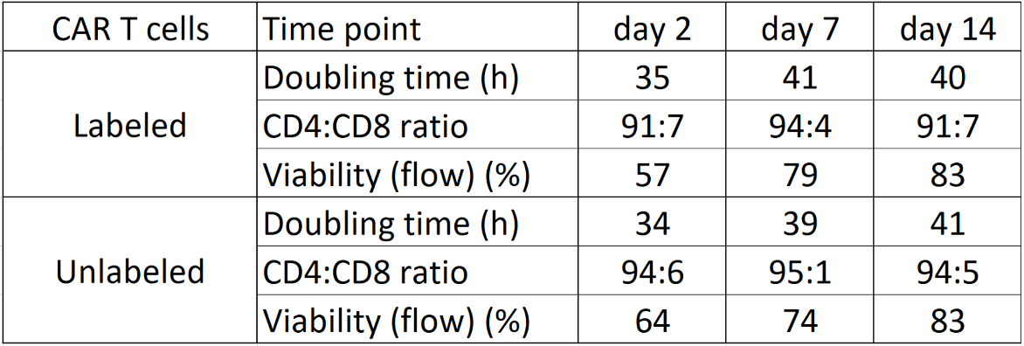

Table 1. Longitudinal characterization of PFC-labeled CAR T cells. Table displays average doubling time, CD4/CD8 ratio and viability as measured by flow cytometry of PFC labeled CAR T cells and control unlabeled CAR T cells at days 2, 7 and 14 after PFC labeling (N=3 replicates). No significant differences were seen between labeled and unlabeled CAR T cells for all criteria.

