Supporting Information

Diversity Modification and Structure-Activity Relationships of Two Natural Products 1β-hydroxy Alantolactone and Ivangustin as Potent Cytotoxic Agents
Jiang-Jiang Tang^{1,*}, Qiu-Rui He¹, Shuai Dong¹, Xin Guo¹, Yu-Gong Wang¹, Bei-Lei Lei², Jun-Mian Tian¹, Jin-Ming Gao^{1,*}

¹Shaanxi Key Laboratory of Natural Products & Chemical Biology, College of Chemistry & Pharmacy, Northwest A&F University, Yangling, 712100, China
²College of Life Sciences, Northwest A&F University, Yangling, 712100, China
*Corresponding authors.
E-mail address: tangjiang11@nwafu.edu.cn (JJT); jinminggao@nwsuaf.edu.cn (JMG).

List of Contents:
Page S2. Table S1. Crystallographic parameters for 1a.
Page S3. Table S2. Crystallographic parameters for 1j.
Page S4. Figure S1. Synthetic mechanism of the desired spirobislactone 1j.
Pages S4. Figure S2. Induction of apoptosis by active compounds 1 and 1i on HepG2 cells.
Pages S5-S27. 1D or 2D NMR spectra.
Pages S28-S36. (HR)-ESI-MS spectra.
Pages S37-S43. HPLC purity determination.
Table S1. Crystal data and structure refinement for 1a.

Identification code | 1a
Empirical formula | C₁₇H₂₂O₄
Formula weight | 290.35
Temperature/K | 293.25(10)
Crystal system | orthorhombic
Space group | P2₁2₁2₁
a/Å | 7.4266(7)
b/Å | 12.6128(12)
c/Å | 16.8409(16)
α/° | 90.00
β/° | 90.00
γ/° | 90.00
Volume/Å³ | 1577.5(3)
Z | 8
ρ_{calc}mg/mm³ | 2.445
m/mm⁻¹ | 1.399
F(000) | 1248.0
Crystal size/mm³ | 0.27 × 0.24 × 0.12
Radiation | ? (λ = 1.54000)
2Θ range for data collection | 10.5 to 141.04°
Index ranges | -9 ≤ h ≤ 8, -15 ≤ k ≤ 15, -20 ≤ l ≤ 15
Reflections collected | 7190
Independent reflections | 2975 [R_{int} = 0.0353, R_{sigma} = 0.0404]
Data/restraints/parameters | 2975/0/194
Goodness-of-fit on F² | 1.054
Final R indexes [I>=2σ (I)] | R₁ = 0.0449, wR₂ = 0.1215
Final R indexes [all data] | R₁ = 0.0472, wR₂ = 0.1254
Largest diff. peak/hole / e Å⁻³ | 0.17/-0.15
Flack parameter | -0.1(3)

Table S2. Crystal data and structure refinement for 1j.

Identification code | K1-17
Empirical formula | C₂₄H₂₆O₆
Formula weight | 410.45
Temperature/K | 293 (2)
Crystal system | tetragonal
Space group | P4(1)
a/Å | 13.1463(8)
b/Å | 13.1463(8)
c/Å | 12.732(7)
α/° | 90.00
β/° | 90.00
γ/° | 90.00
Volume/Å³ | 2200.5(12)
Z | 4
m/mm⁻¹ | 1.239
F(000) | 872
Crystal size/mm³ | 0.34 × 0.15 × 0.14
Radiation | ? (λ = 1.54178)
2Θ range for data collection | 3.36 to 66.18°
Index ranges | -14 ≤ h ≤ 10, -14 ≤ k ≤ 15, -9 ≤ l ≤ 15
Reflections collected | 3957
Independent reflections | 2575 [R_{int} = 0.0467, R_{sigma} = 0.0845]
Data/restraints/parameters | 2575/1/274
Goodness-of-fit on F² | 0.973
Final R indexes [I>=2σ (I)] | R₁ = 0.0541, wR₂ = 0.1188
Final R indexes [all data] | R₁ = 0.0593, wR₂ = 0.0774
Largest diff. peak/hole / e Å⁻³ | 0.139/-0.137
Flack parameter | -0.1(4)

Figure S1. Synthesis of the desired spirobislactone 1j. On the less hindered face, the complexed free-radical A approached α-methylene lactone 1b and the resultant radical B underwent lactonization to provide 1j in a substrate-controlled manner.

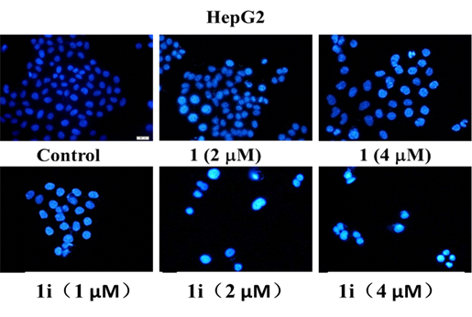
Figure S2. Induction of apoptosis by active compounds 1 and 1i at the indicated concentrations on HepG2 cells. 72 h after the treatment of these compounds at the indicated concentrations, cells were fixed, washed with PBS, stained with Hoechst 33258, and analyzed for morphological characteristics associated with apoptosis by fluorescence microscopic analysis (20×).
NMR spectra
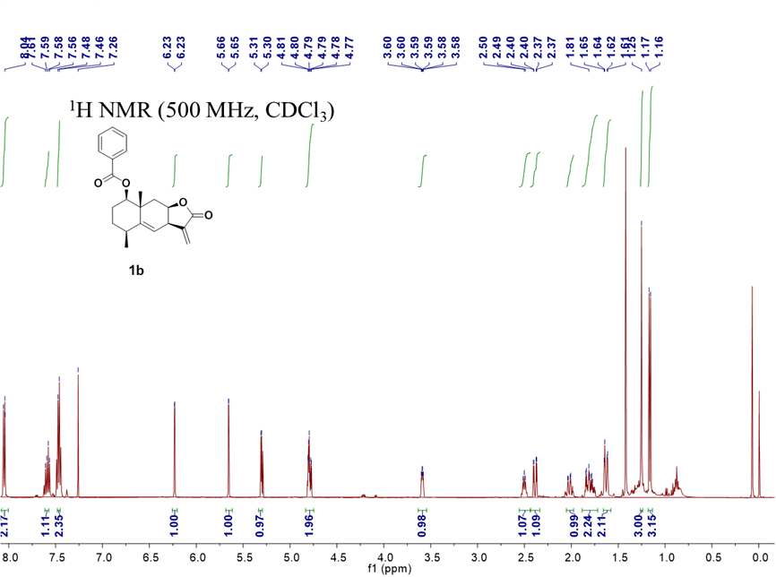

¹H NMR (125 Hz, CDCl₃)
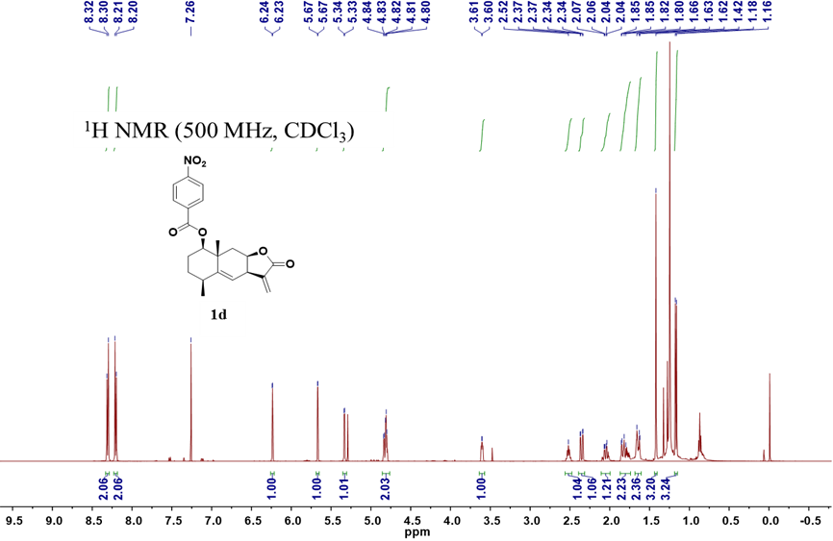

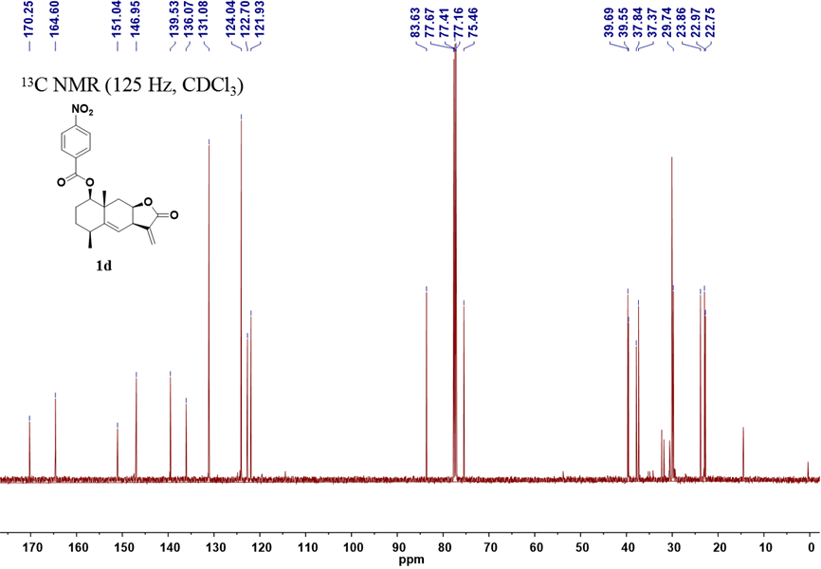

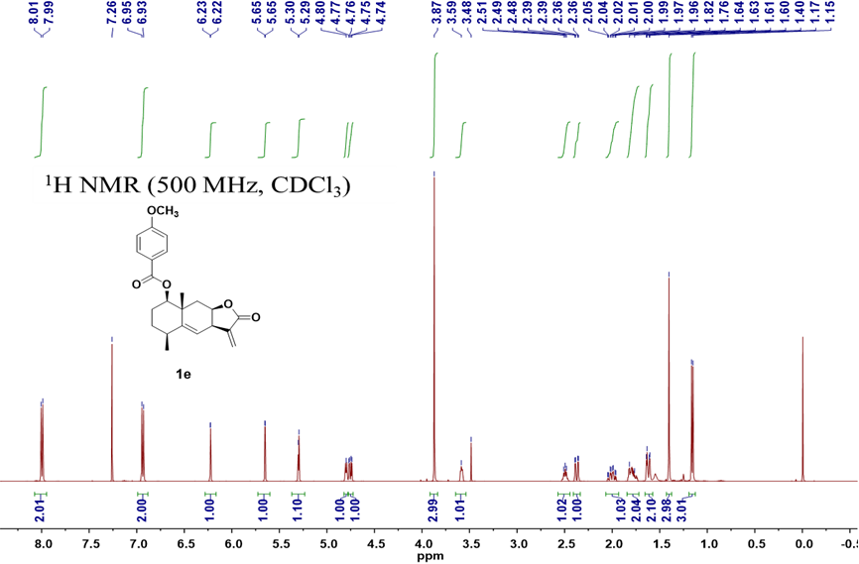

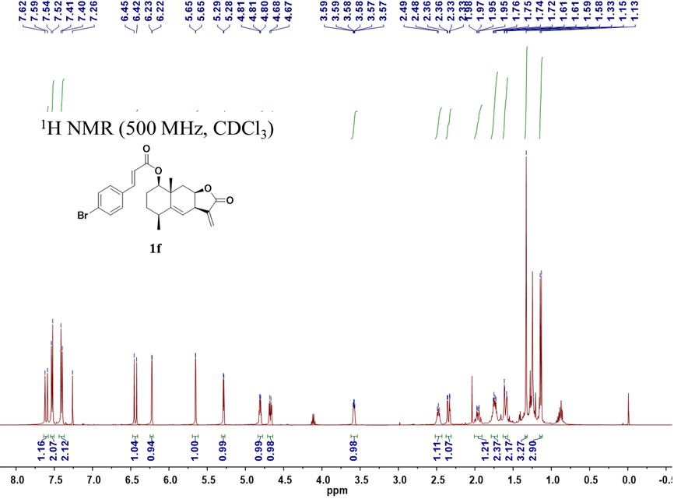
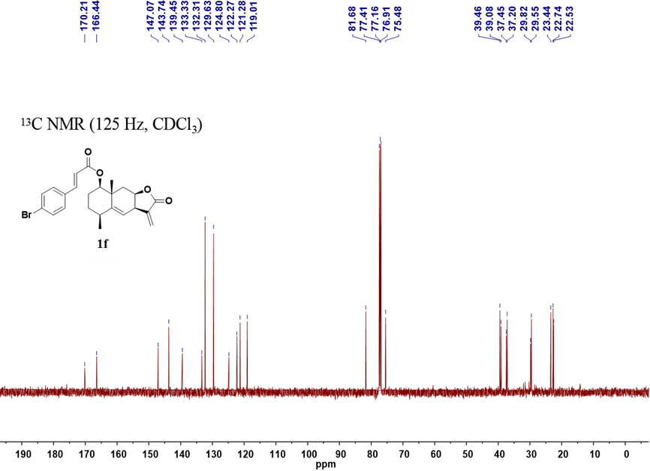

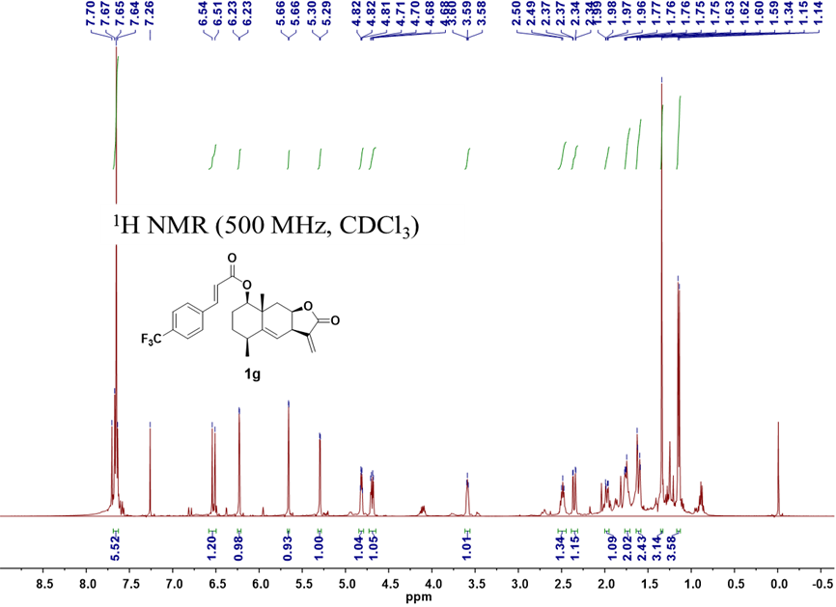

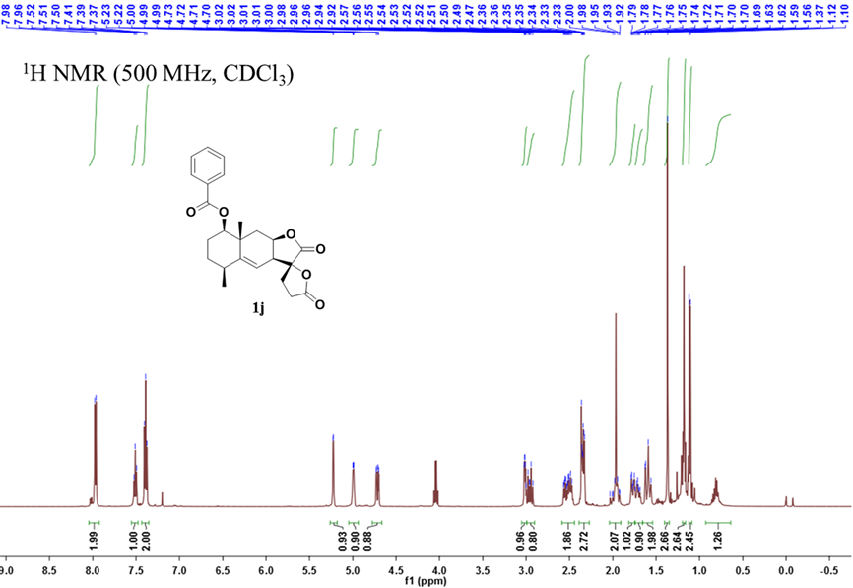
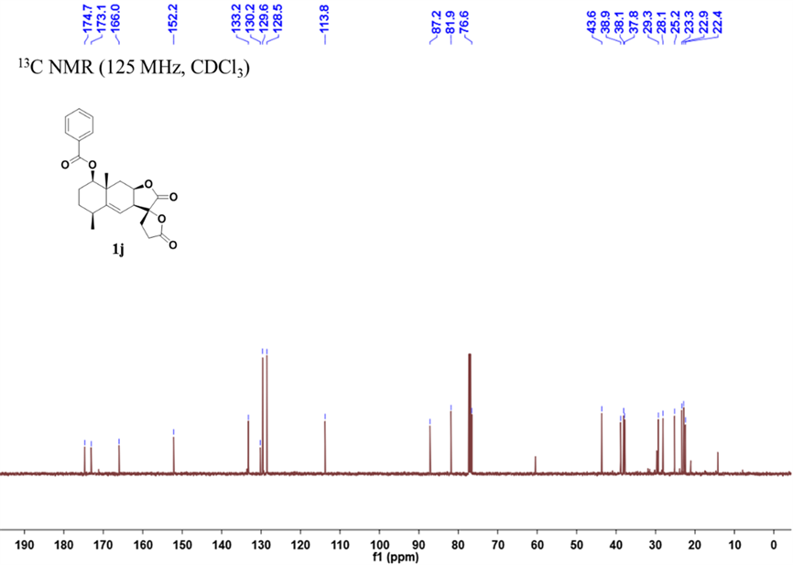

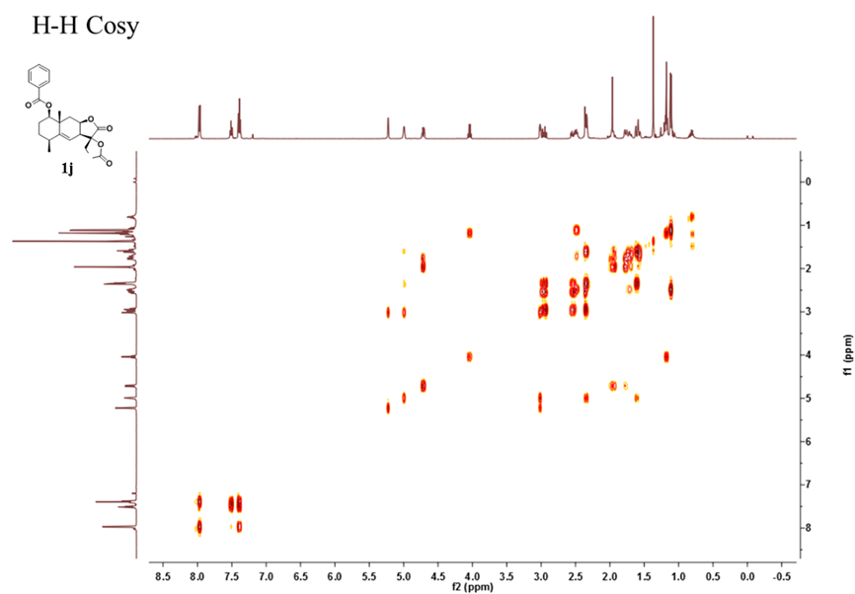
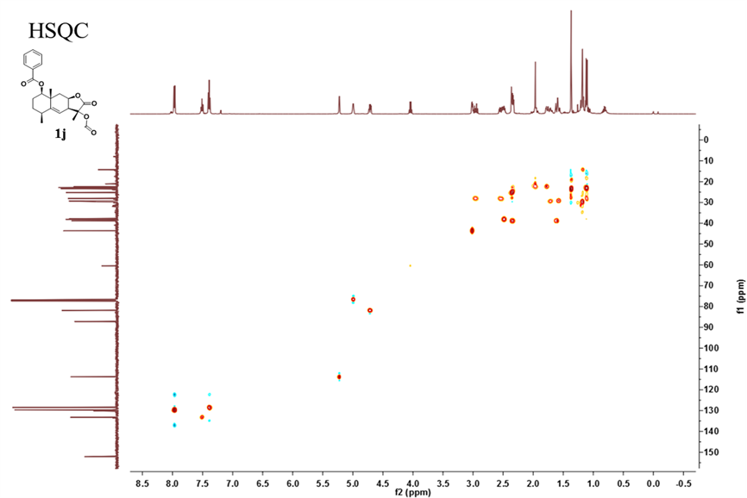
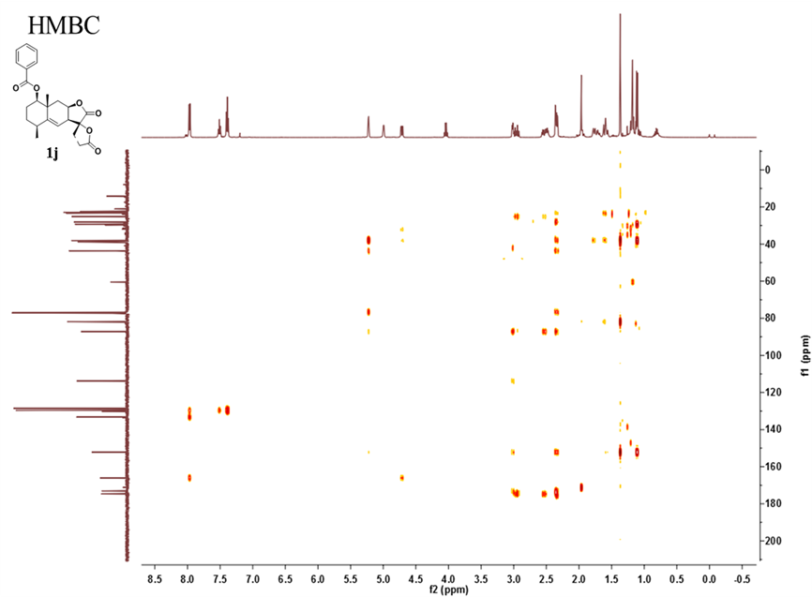

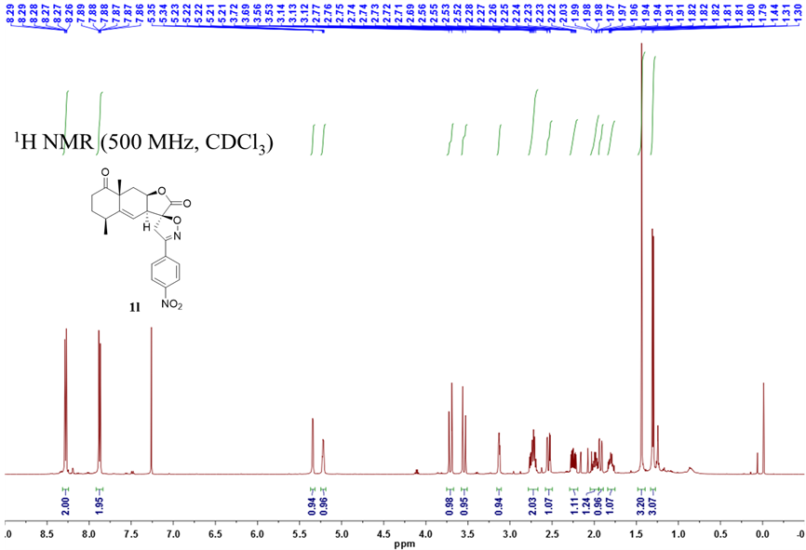
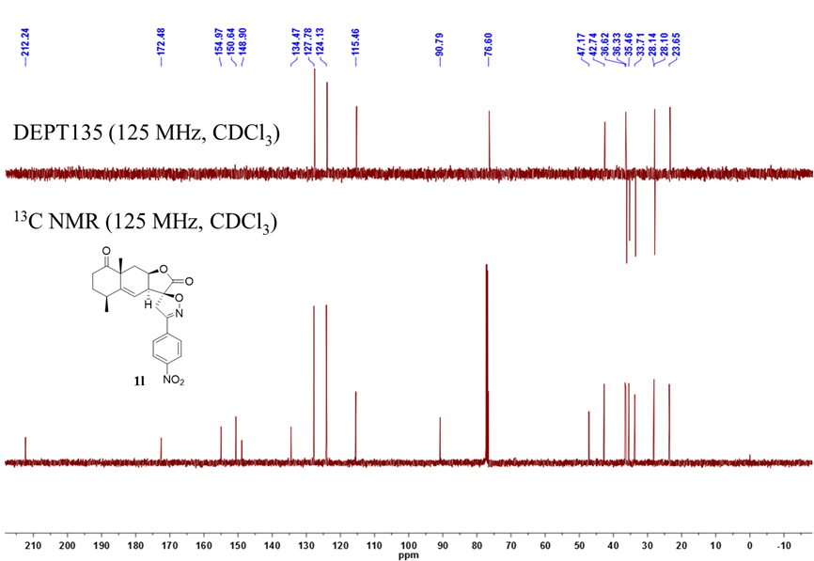
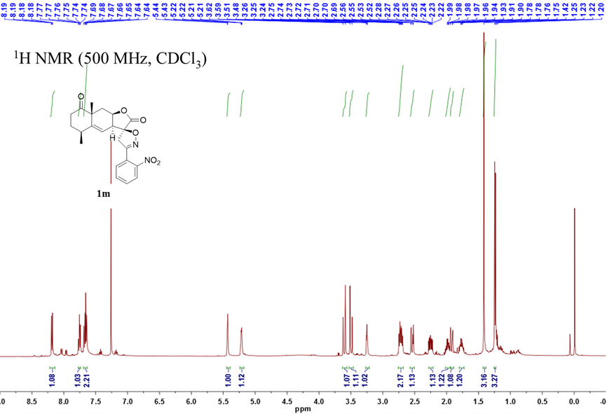
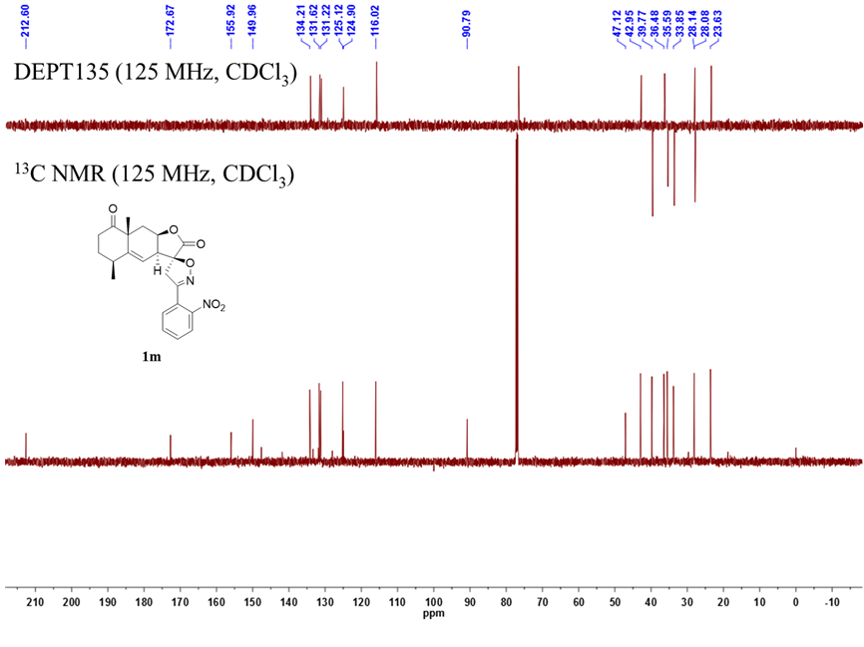

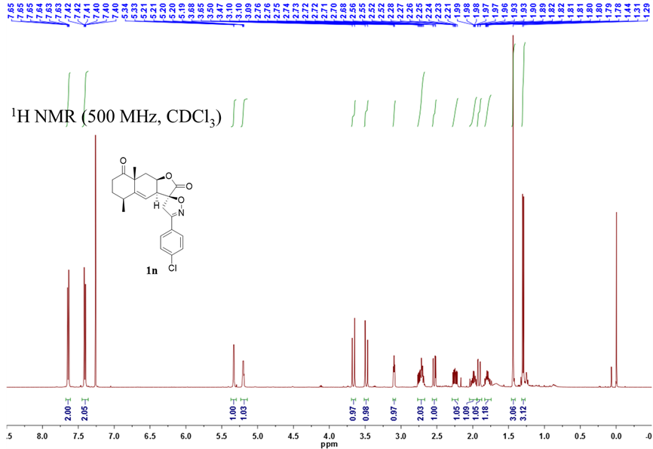
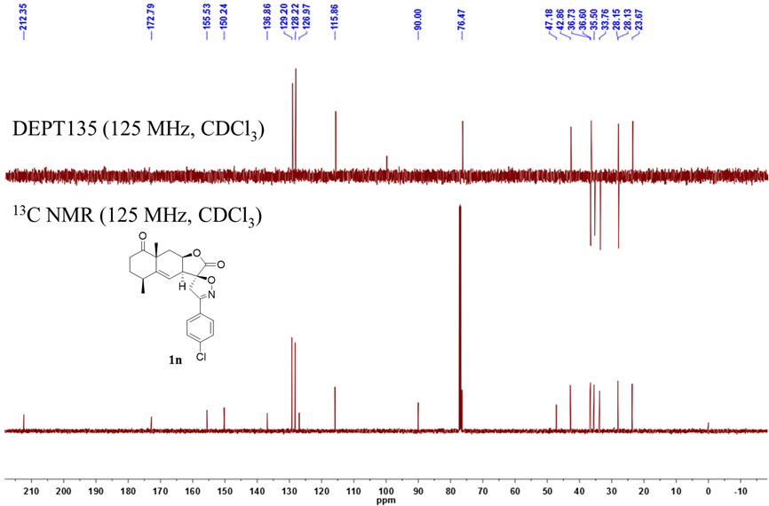

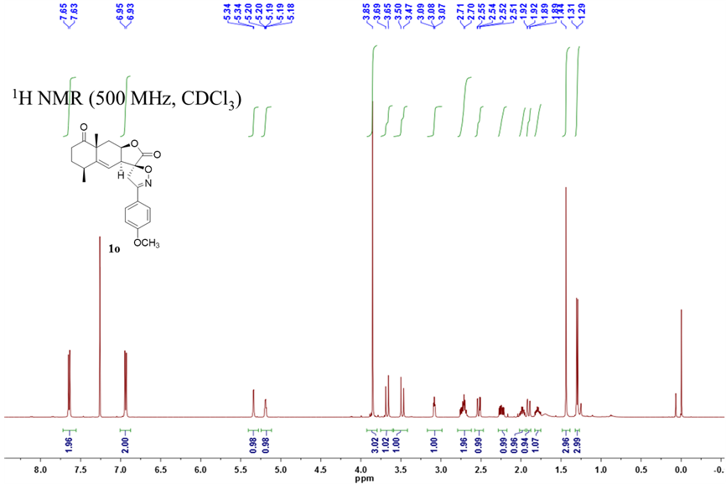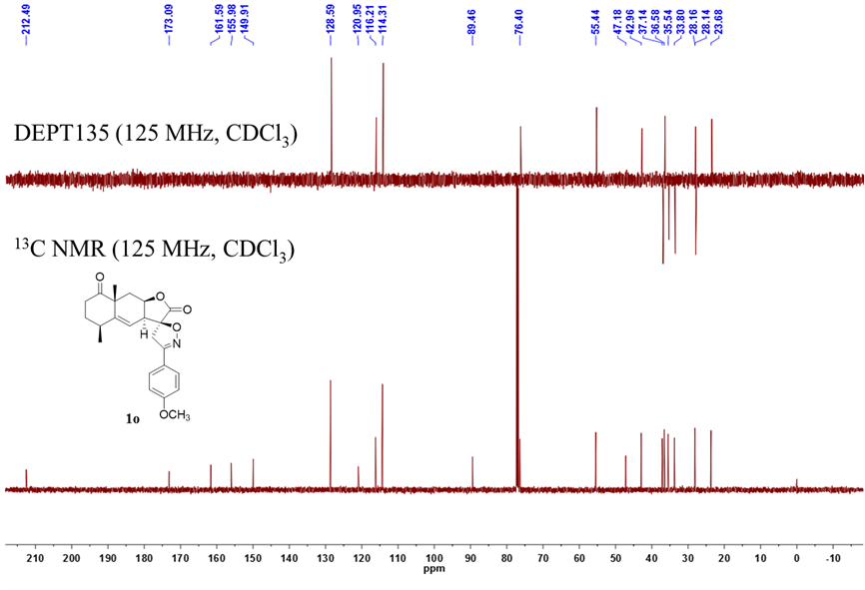
¹H NMR (125 Hz, CDCl₃)

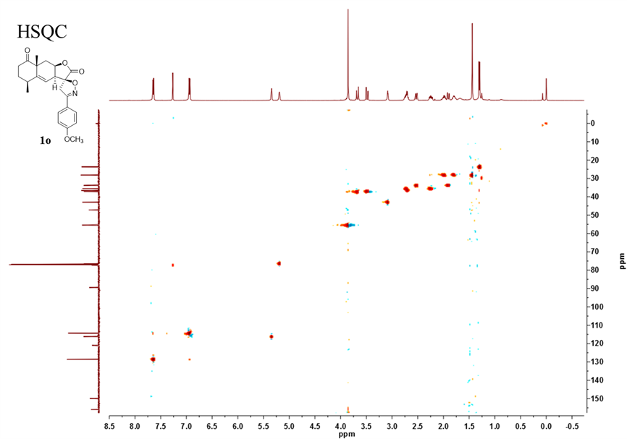

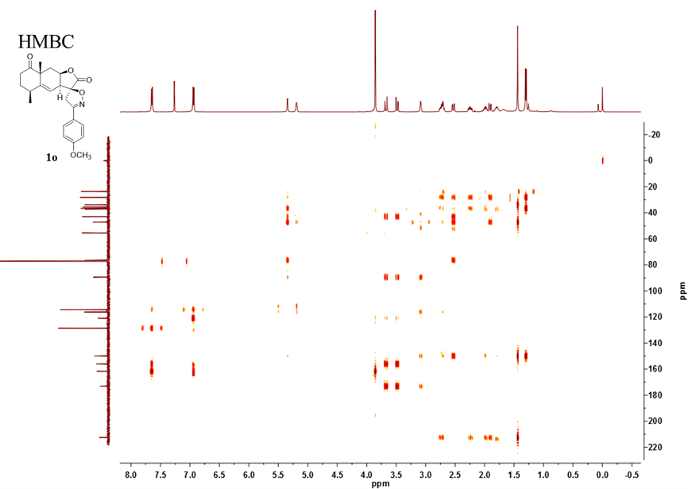

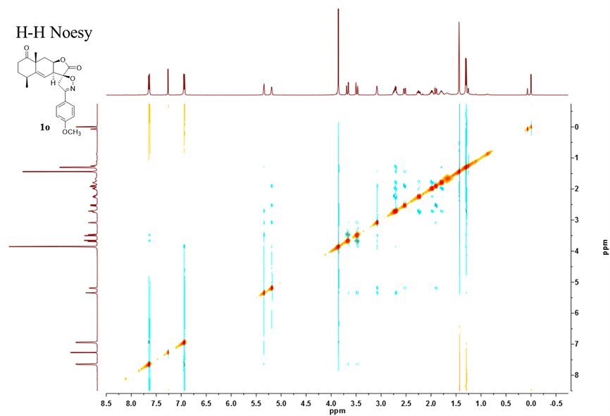

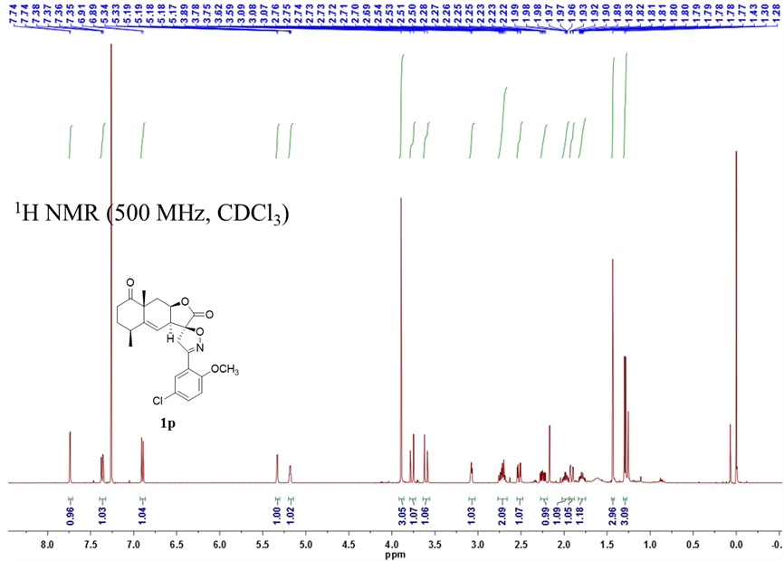

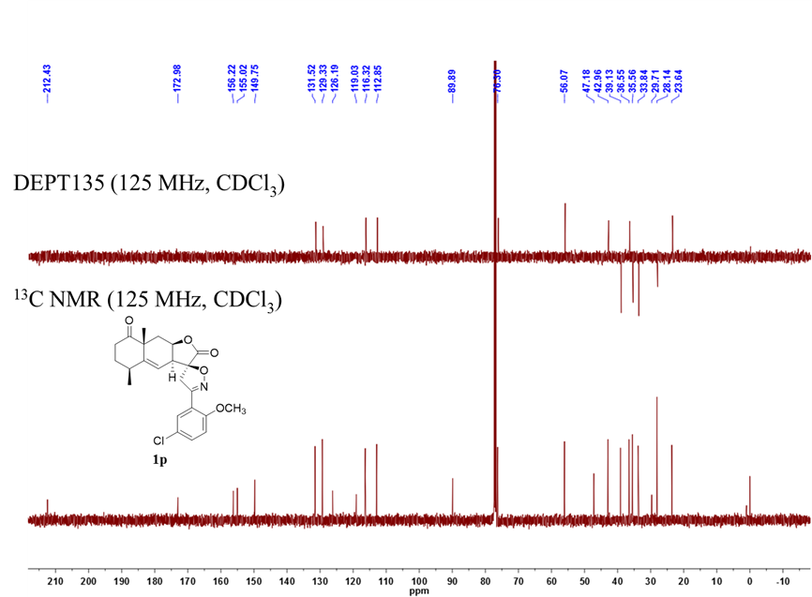

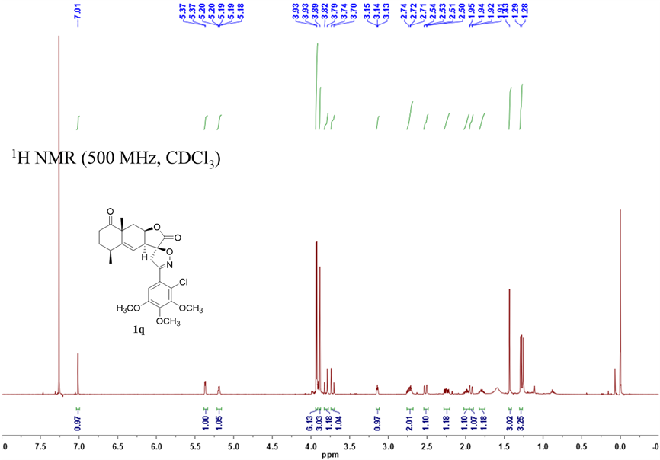
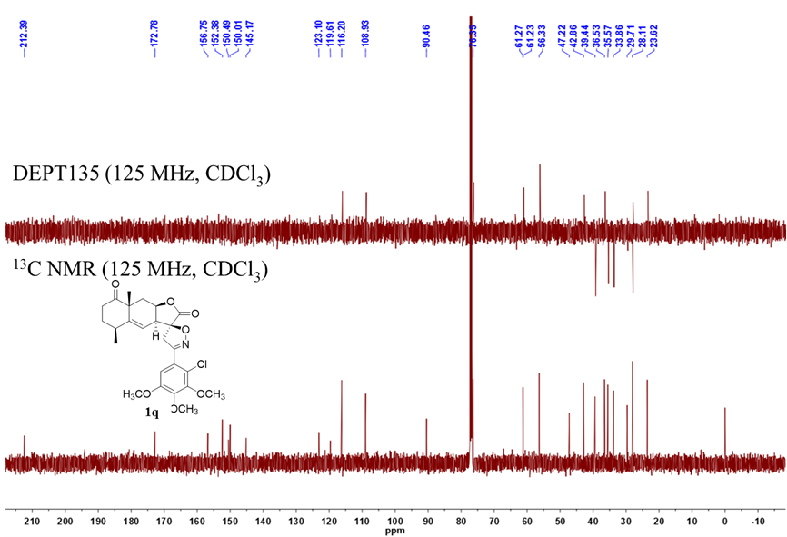

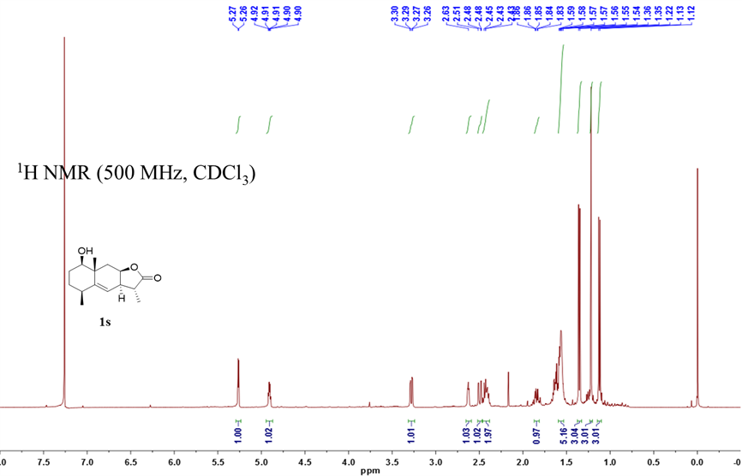
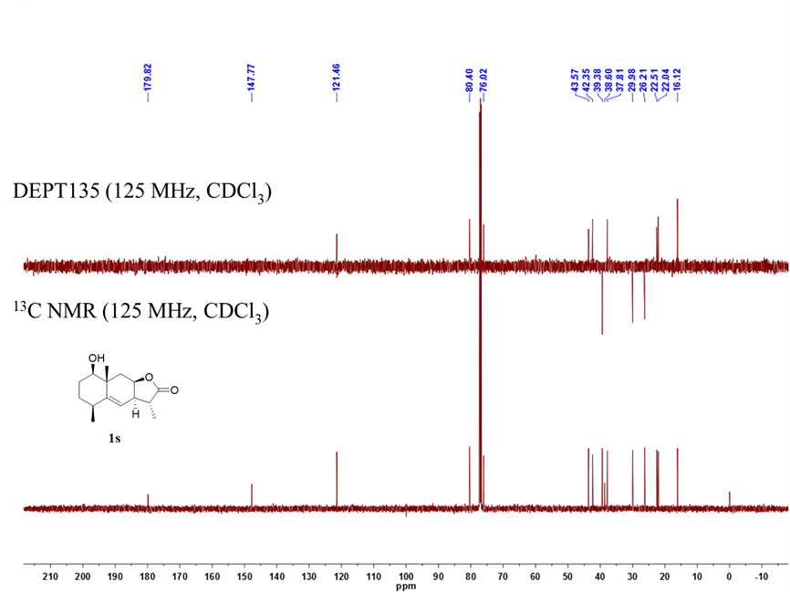
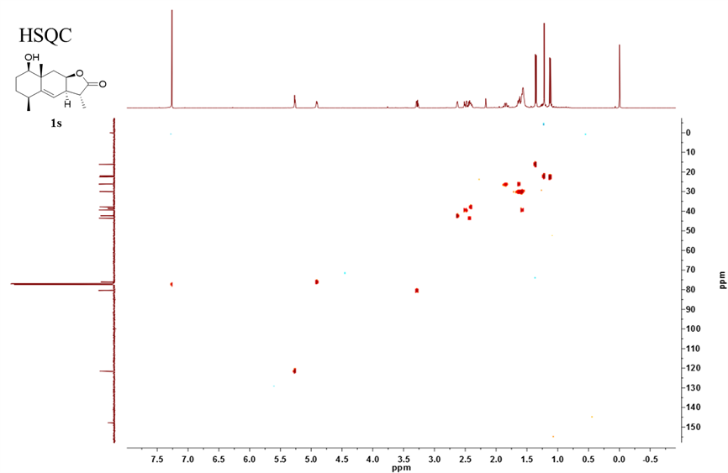
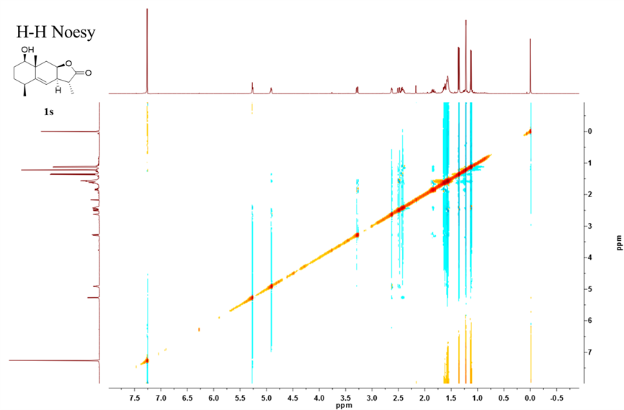

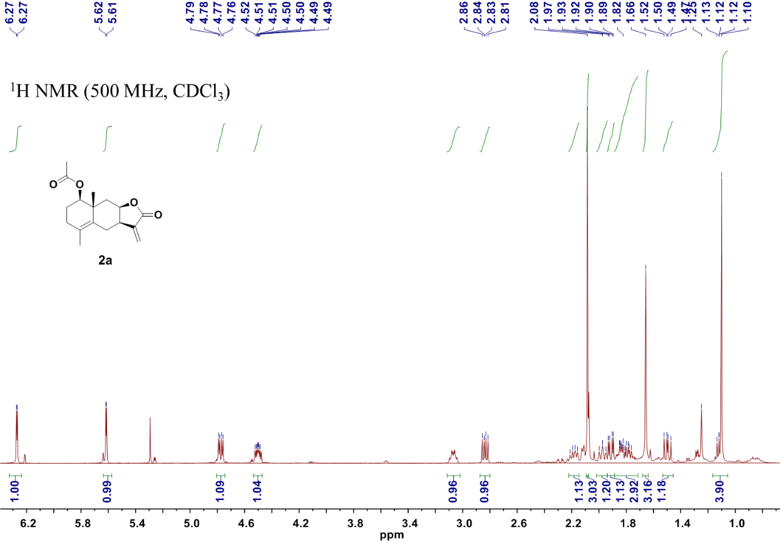

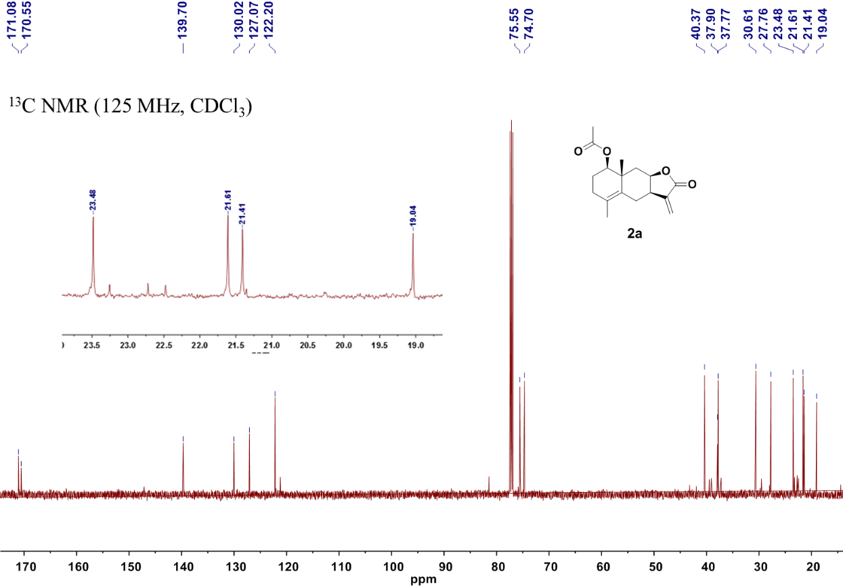

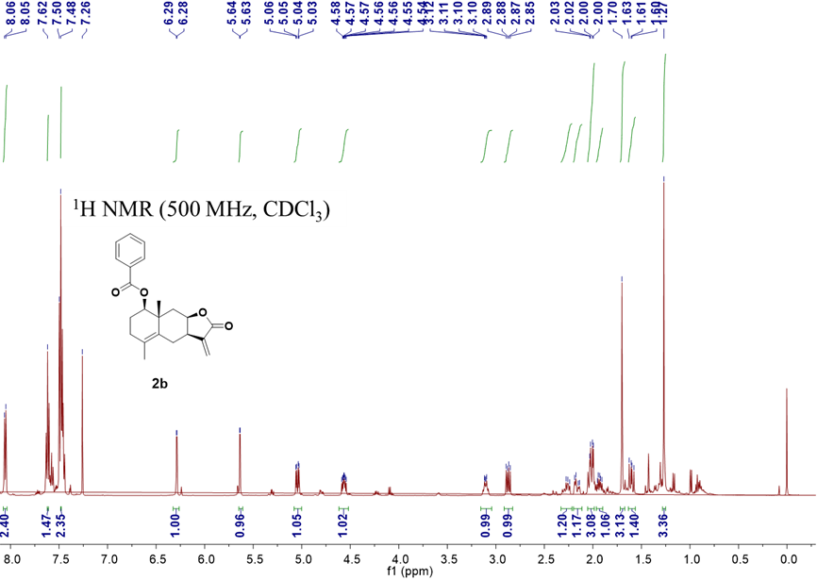

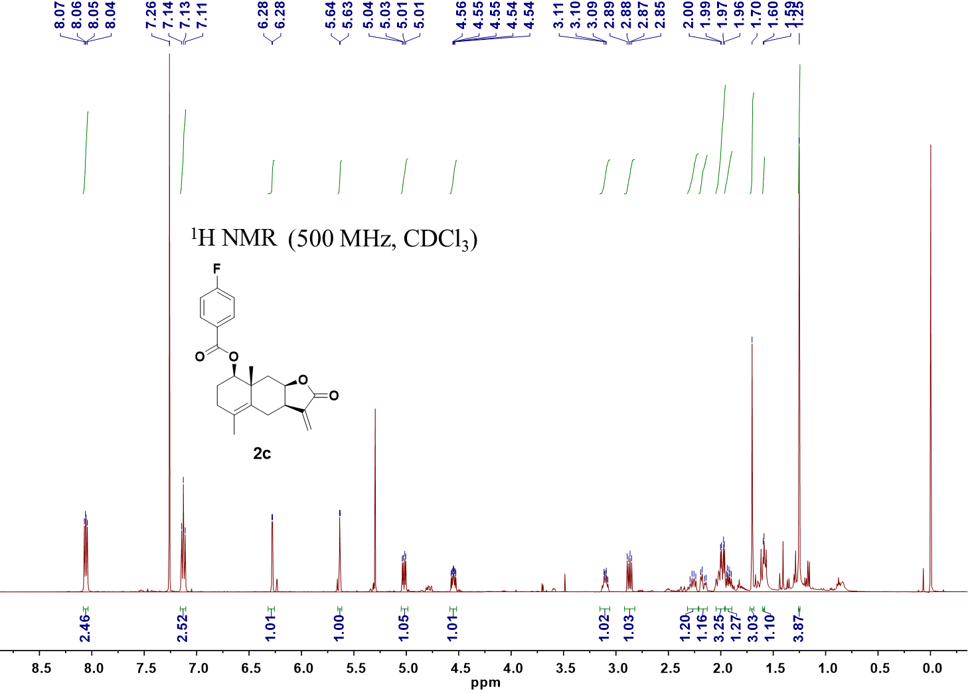

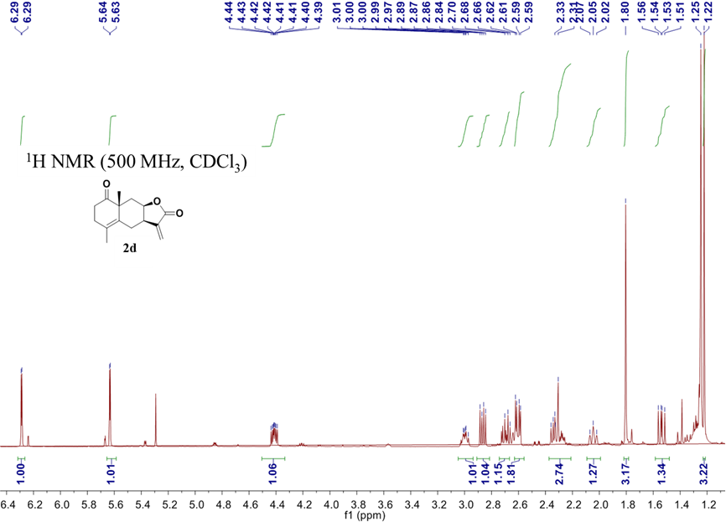
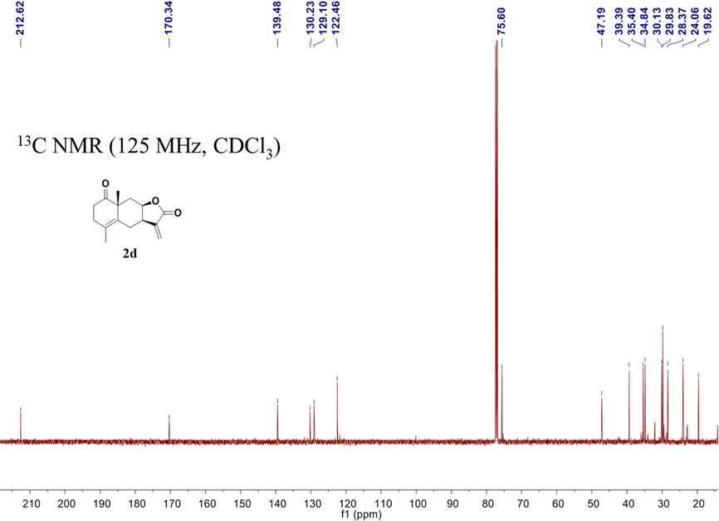

(HR)-ESI-MS spectra
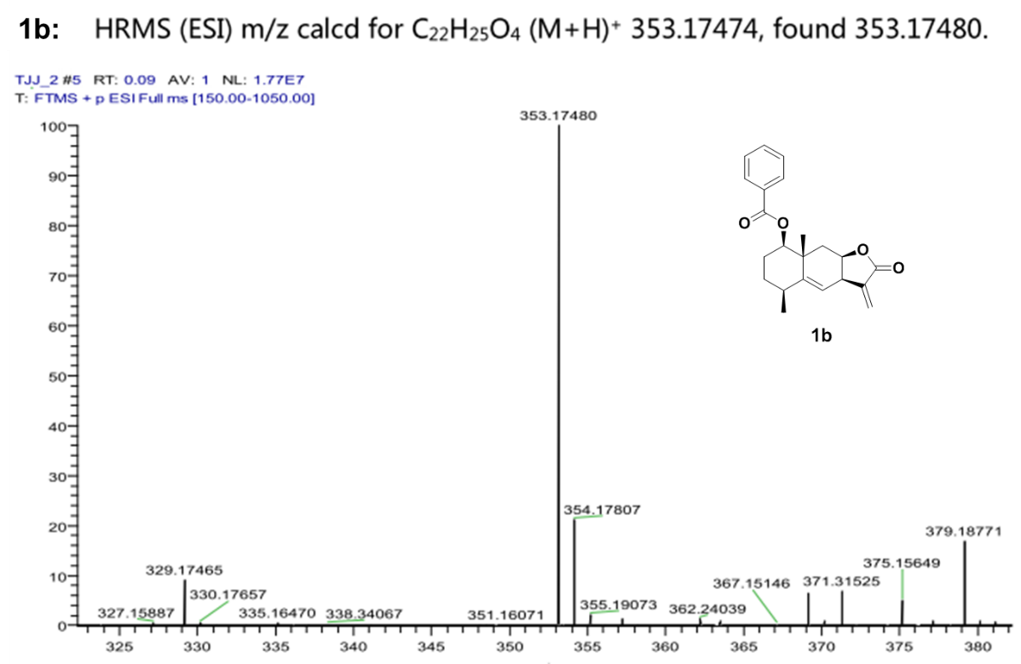

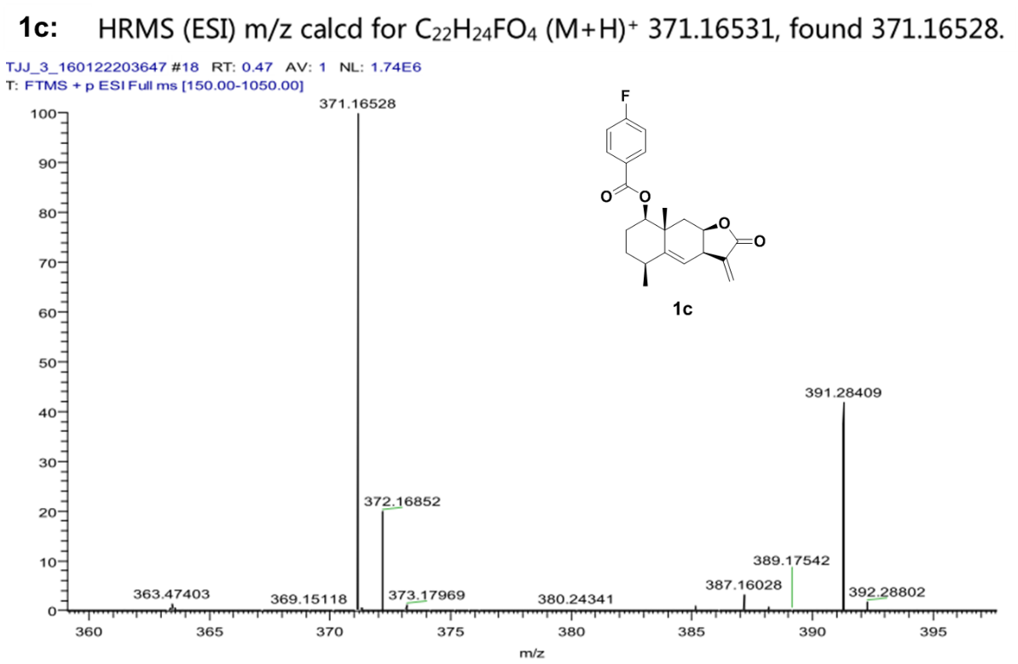

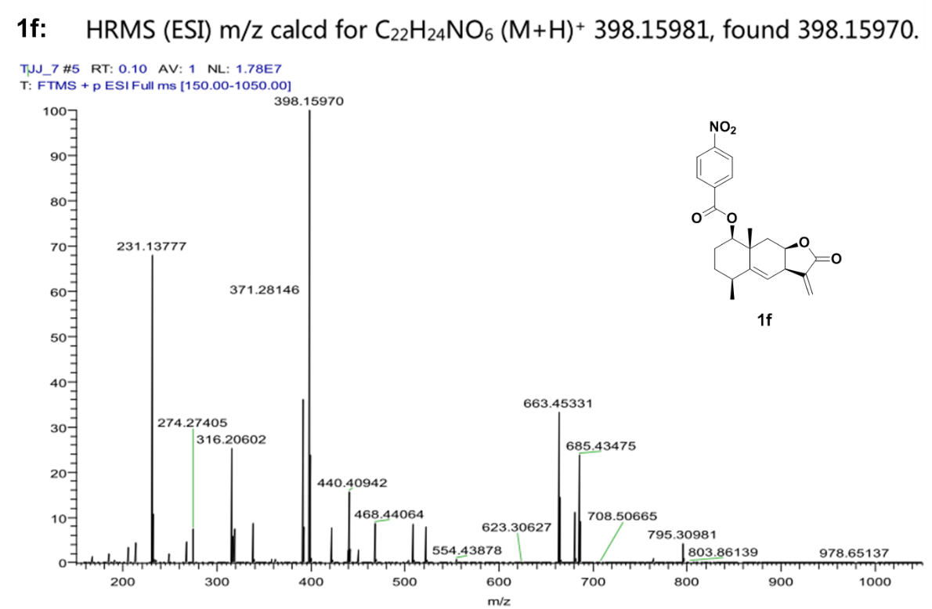
1d：
1d
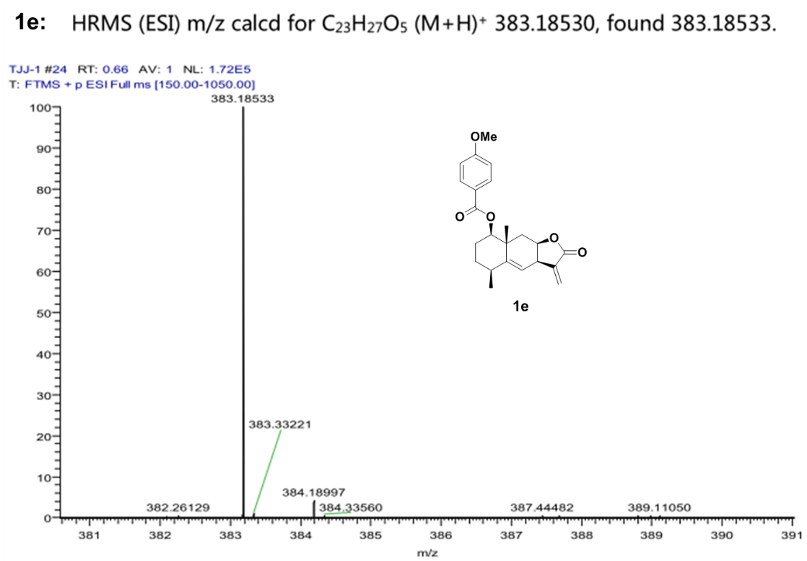
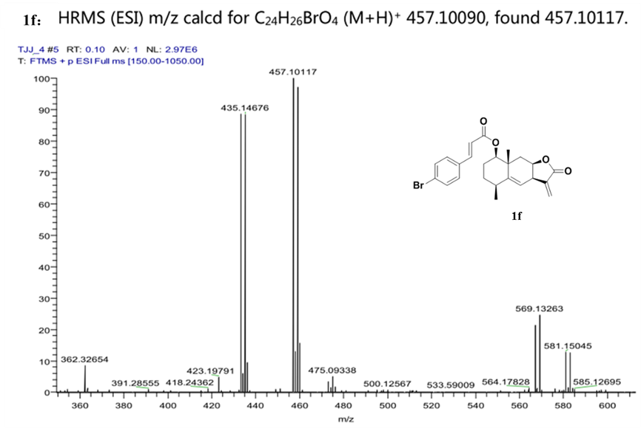

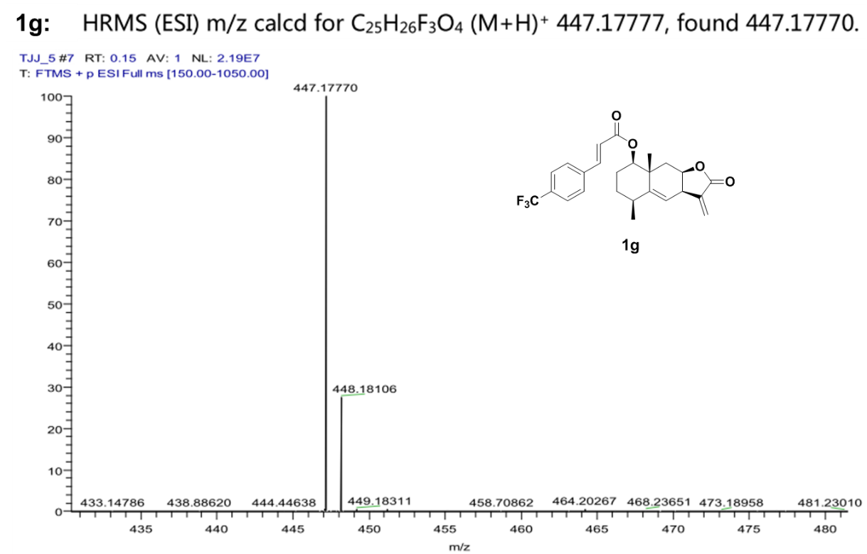

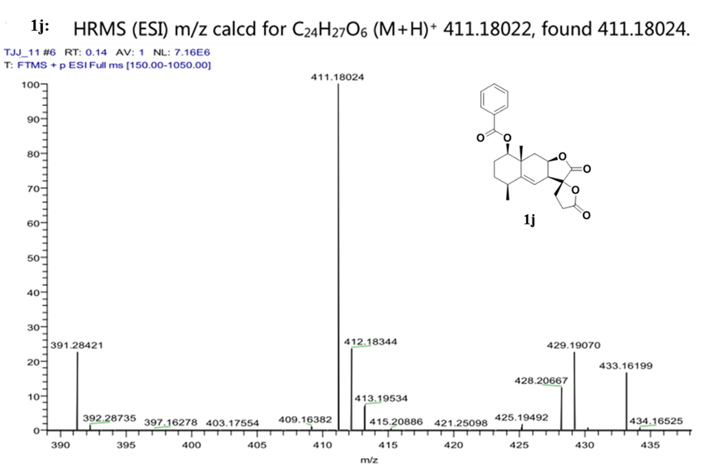

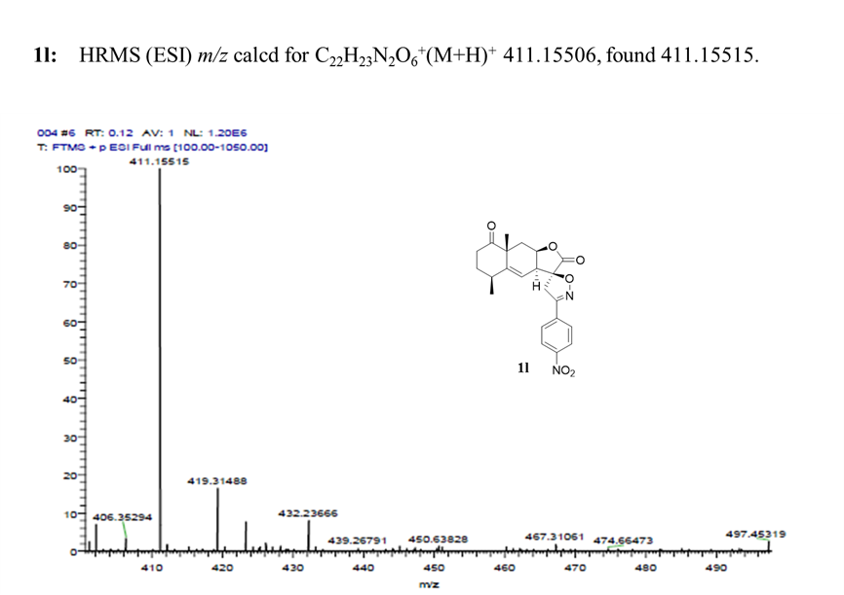

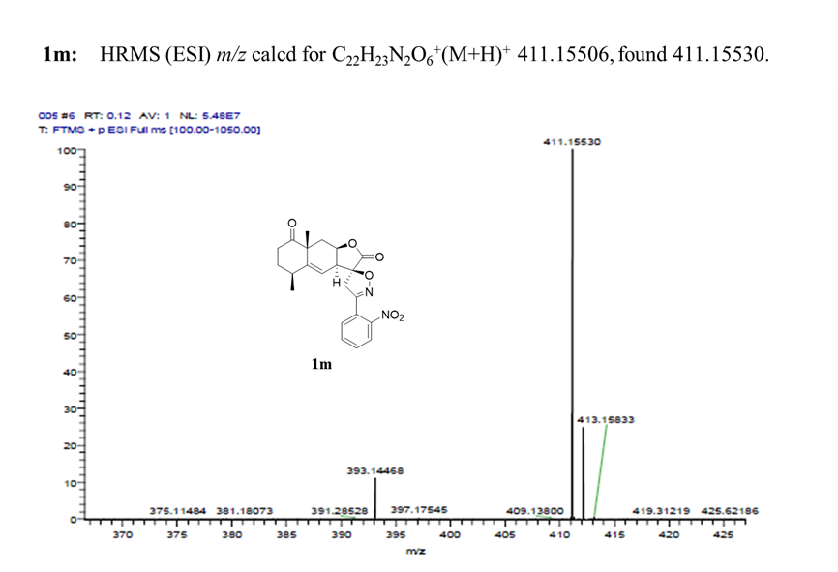

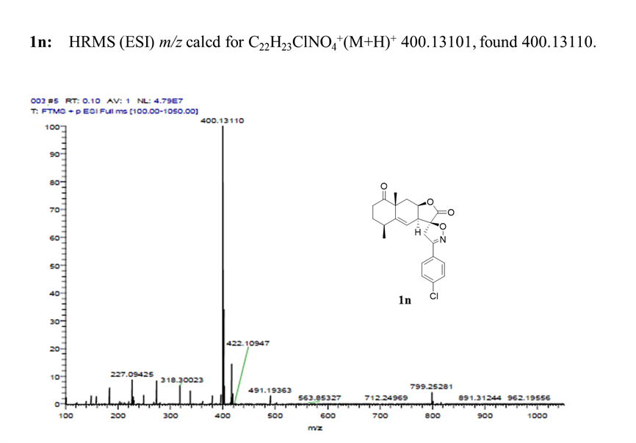

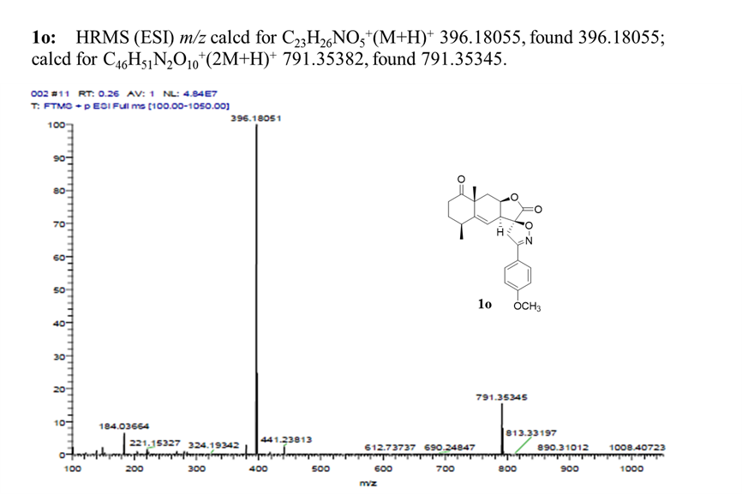

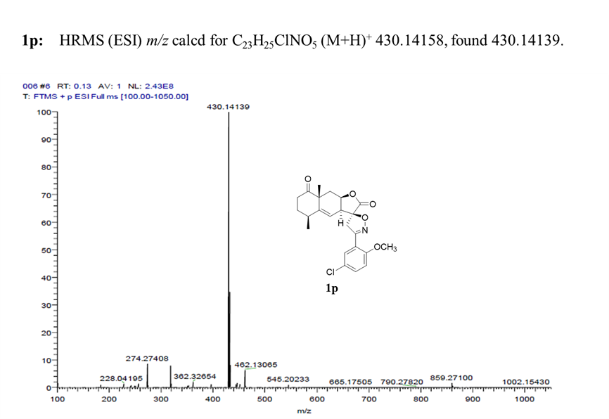

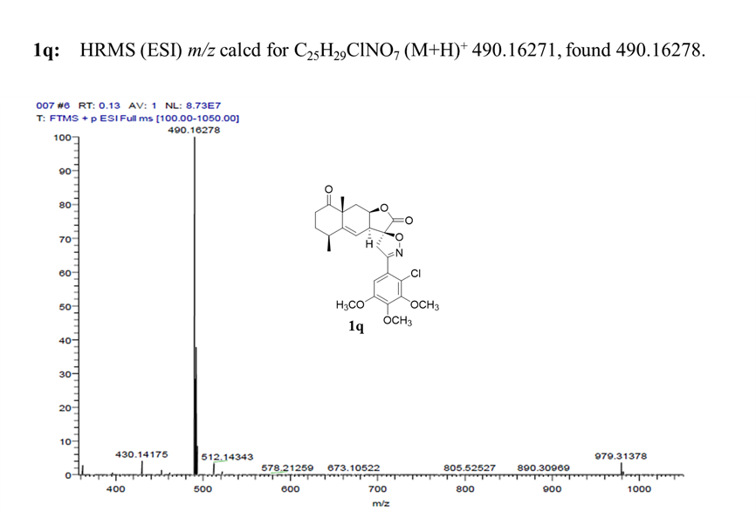

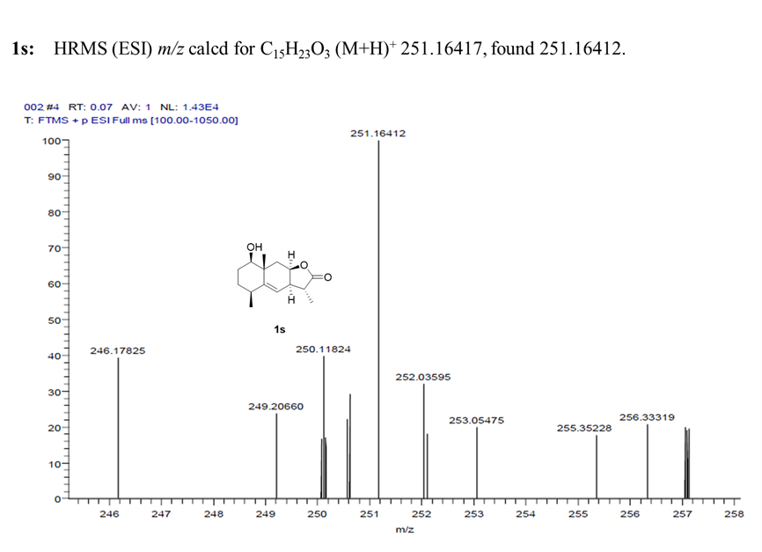

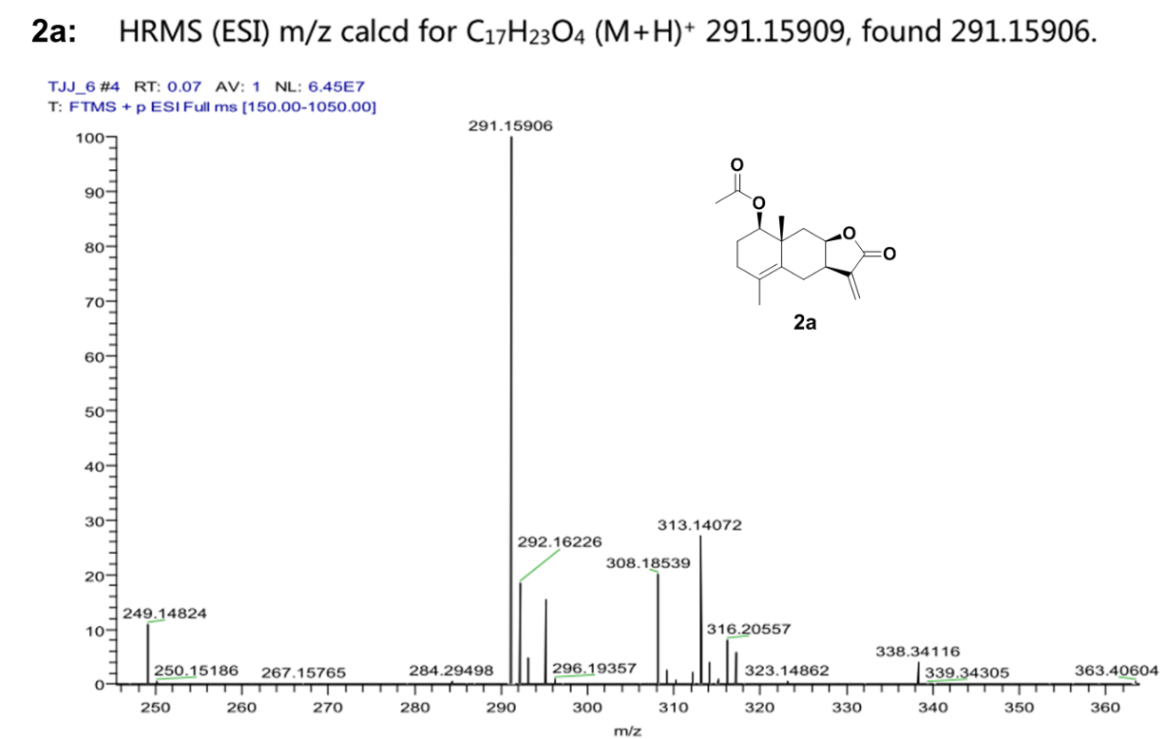

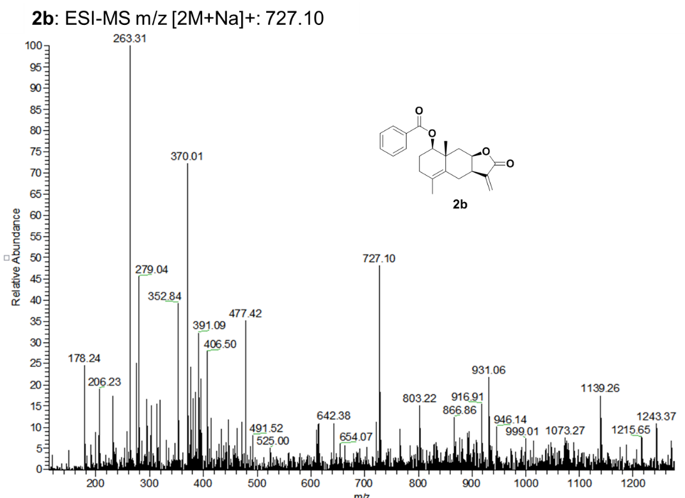
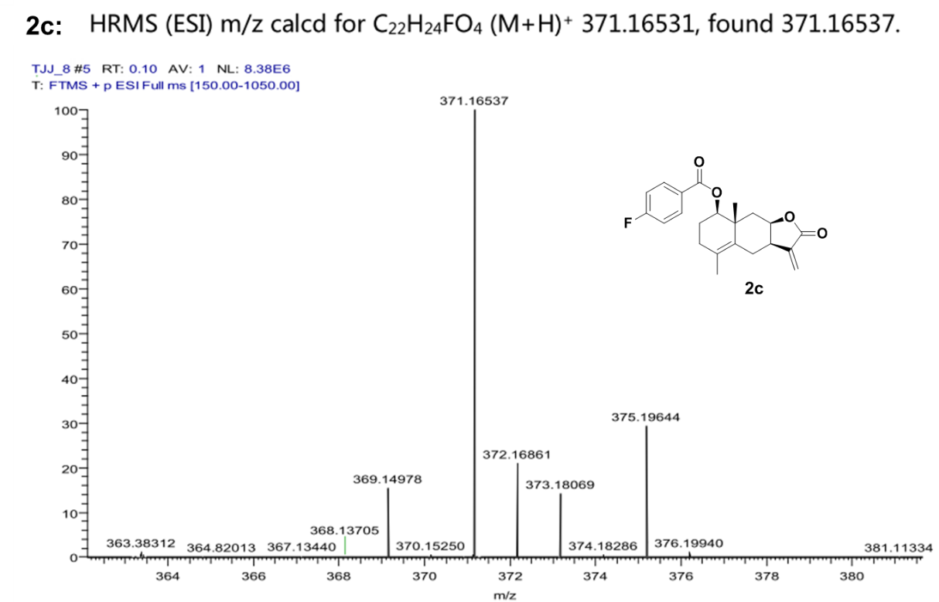

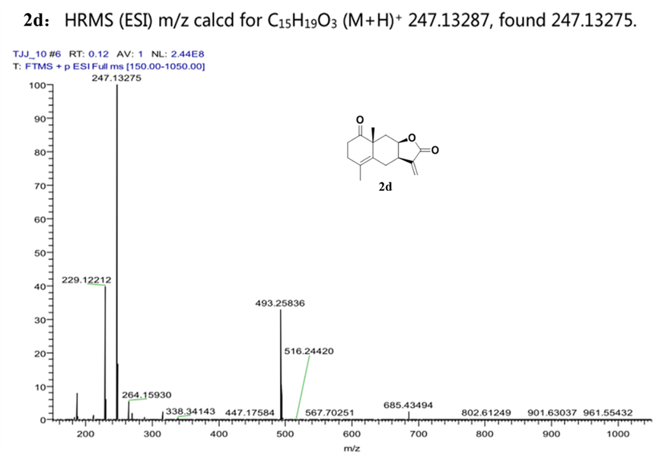
HPLC purity determination

1: Purity 96.1%, t_{R} = 11.9 min at 215 nm by RP-HPLC using 50% methanol in water.

2: Purity 96.9%, t_{R} = 15.7 min at 260 nm by RP-HPLC using 50% methanol in water.

1

1b: Purity 97.3%, t_{R} = 12.4 min at 254 nm by RP-HPLC using 60% methanol in water.

1c: Purity 97.6%, t_{R} = 14.2 min at 235 nm by RP-HPLC using 60% methanol in water.

1d: Purity 98.6%, t_{R} = 13.4 min at 225 nm by RP-HPLC using 60% methanol in water.

1e: Purity 99.0%, t_{R} = 14.1 min at 254 nm by RP-HPLC using 60% methanol in water.

1f: Purity 97.5%, t_{R} = 35.4 min at 285 nm by RP-HPLC using 50 min gradient from 0% to 100% methanol in water.

1g: Purity 95.8%, t_{R} = 36.5 min at 285 nm by RP-HPLC using 50 min gradient from 0% to 100% methanol in water.

1h: Purity 95.4%, t_{R} = 23.1 min at 210 nm by RP-HPLC using 50 min gradient from 0% to 100% methanol in water.

1i: Purity 97.0%, t_{R} = 10.2 min at 230 nm by RP-HPLC using 50% methanol in water.

1j: Purity 99.0%, t_{R} = 32.8 min at 230 nm by RP-HPLC using 50 min gradient from 0% to 100% methanol in water.
1k: Purity 95.1%, t_{R} = 39.0 min at 270 nm by RP-HPLC using 50 min gradient from 0% to 100% methanol in water.
1l: Purity 97.0%, t_{R} = 38.6 min at 299 nm by RP-HPLC using 50 min gradient from 0% to 100% methanol in water.

1m: Purity 95.9%, t_{R} = 43.0 min at 212 nm by RP-HPLC using 50 min gradient from 0% to 100% methanol in water.

1n: Purity 95.3%, t_{R} = 39.8 min at 269 nm by RP-HPLC using 50 min gradient from 0% to 100% methanol in water.

1o: Purity 95.5%, t_{R} = 39.7 min at 278 nm by RP-HPLC using 50 min gradient from 0% to 100% methanol in water.

1p: Purity 96.0%, t_{R} = 40.0 min at 230 nm by RP-HPLC using 50 min gradient from 0% to 100% methanol in water.

1q: Purity 95.2%, t_{R} = 39.7 min at 226 nm by RP-HPLC using 50 min gradient from 0% to 100% methanol in water.

1r: Purity 98.5%, t_{R} = 34.4 min at 210 nm by RP-HPLC using 50 min gradient from 0% to 100% methanol in water.

1s: Purity 98.3%, t_{R} = 34.4 min at 210 nm by RP-HPLC using 50 min gradient from 0% to 100% methanol in water.

2a: Purity 99.9%, t_{R} = 25.5 min at 320 nm by RP-HPLC using 50% methanol in water.

2b: Purity 95.3%, t_{R} = 34.0 min at 254 nm by RP-HPLC using 50 min gradient from 0% to 100% methanol in water.

2c: Purity 99.7%, t_{R} = 10.3 min at 230 nm by RP-HPLC using 60% methanol in water.

2d: Purity 98.6%, t_{R} = 5.8 min at 254 nm by RP-HPLC using 60% methanol in water.

