Ageing potentiates diet-induced glucose intolerance, β-cell failure and tissue inflammation through TLR4

Wei He, Ting Yuan, Dolma Choezom, Hannah Hunkler, Karthika Annamalai, Blaz Lupse and Kathrin Maedler

Centre for Biomolecular Interactions, University of Bremen, Bremen, Germany

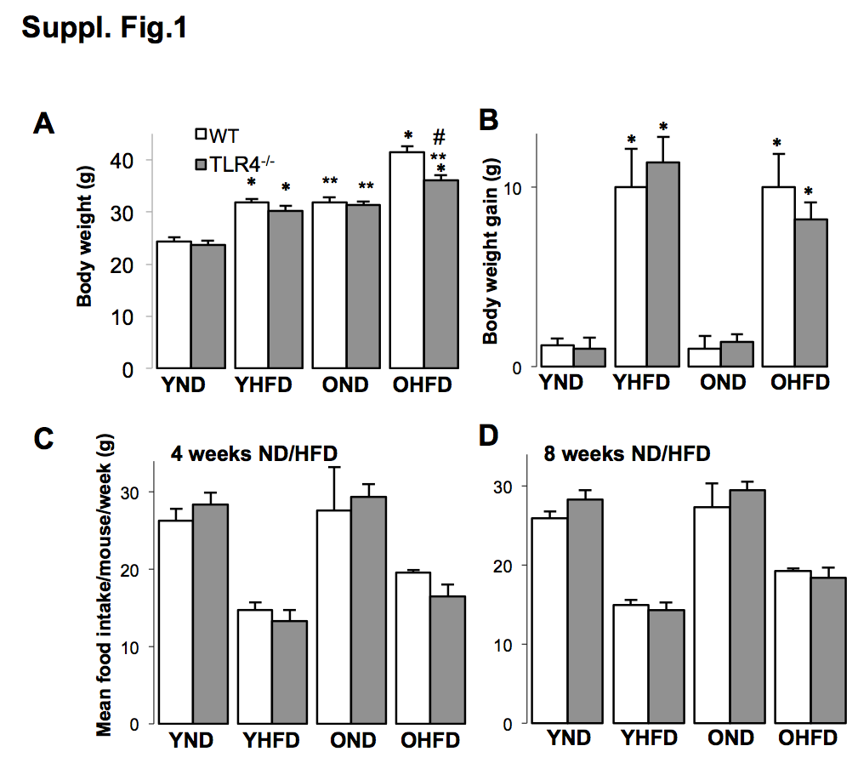
Suppl.Figure 1. HFD induced body weight gain and stable food intake in mice of both ages and genotypes.
(A) Body weight, (B) body weight gain and (C,D) mean food intake/mouse/week after 8-week normal (ND) or high fat/ high sucrose diet (“Surwit”; HFD) feeding of young (6 weeks) and old (12 months) WT and Tlr4^{-/-}mice. (C,D) Food intake was stable among the mice and unchanged with weeks of diet. Mice fed a HFD eat constantly a lesser amount of food. Data are shown as means ±SE. *p<0.05 ND vs. HFD; **p<0.05 young vs. old mice, #p<0.05 WT vs. Tlr4^{-/-}mice. N=12-15 mice per group; data are representative of three independent experiments.

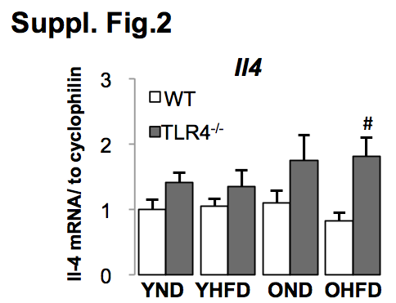
Suppl.Figure 2. Tlr4^{-/-} mice showed higher anti-inflammatory cytokine Il4 expression in liver
Young (6 weeks) and old (12 months) WT and Tlr4^{-/-} mice were fed a normal (ND) or high fat/ high sucrose diet (“Surwit”; HFD) for 8 weeks. RT-PCR analysis of Il4 from RNA extracted from liver. Y, young mice, O, old mice, ND, normal chow diet, HFD, high fat/ high sucrose diet, WT, wildtype mice, Tlr4^{-/-}, TLR4-knockout mice. Results are normalized to the control young-ND condition, which is arbitrarily set as 1. Data are presented as means ±SE from n=5-8 mice. #p<0.05 WT vs. Tlr4^{-/-} mice.

