Detection of multi-tomato leaf diseases (late blight, target and bacterial spots) in different stages by using a spectral-based sensor
Jinzhu Lu ¹*, Reza Ehsani², Yeyin Shi ³ , Ana Isabel de Castro ⁴ and Shuang Wang ¹
¹ School of Mechanical Engineering, Xihua University, 999 Jinzhou Road, Chengdu, Sichuan, 610000, China;
² Citrus Research and Education Center, University of Florida/IFAS, 700 Experiment Station Road, Lake Aflred, FL 33850, United Stataes of America;
³ Department of Biological Systems Engineering, University of Nebraska-Lincoln, 3605 Fair Street, Lincoln, NE 68583, United States;
⁴ Department of Crop Protection, Institute for Sustainable Agriculture (IAS-CSIC), Cordoba, Spain;
* Correspondence: lujingzhu1103@163.com; Tel.: +86-28-87729082
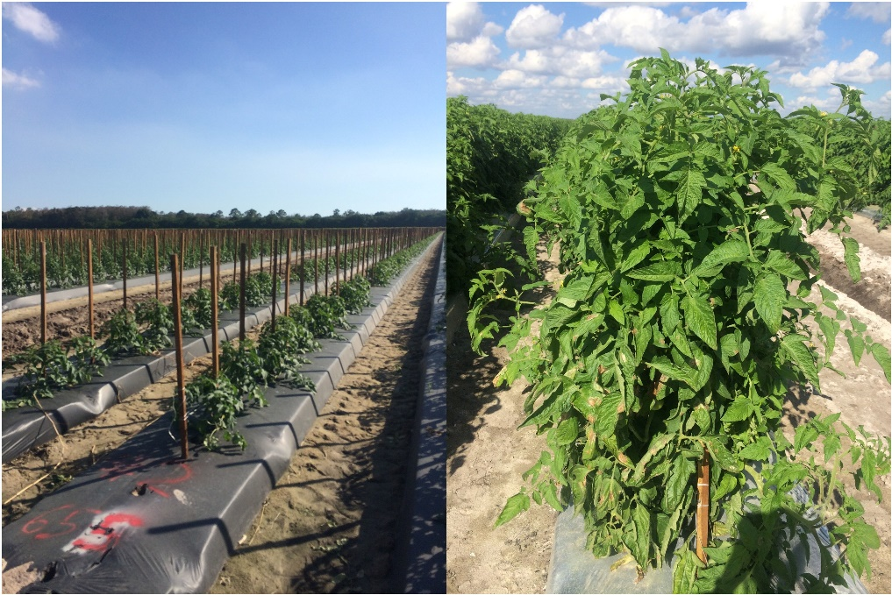
Plant cultivation farm

