Supplementary Information

Rapid Detection of Zika Virus in Urine Samples and Infected Mosquitos by Reverse Transcription-Loop-Mediated Isothermal Amplification

Laura E. Lamb^{1,2*}, Sarah N. Bartolone¹, Maya O. Tree³, Michael J. Conway³, Julien Rossignol^{3,4,5}, Christopher P. Smith⁶, Michael B. Chancellor^{1,2}

¹ Department of Urology, Beaumont Health System, Royal Oak, MI, United States of America
² Oakland University William Beaumont School of Medicine, Rochester Hills, MI, United States of America
³ Foundational Sciences, Central Michigan University, College of Medicine, Mt. Pleasant, MI, United States of America
⁴ Field Neurosciences Laboratory for Restorative Neurology, Central Michigan University, Mt. Pleasant, MI, United States of America
⁵ Program in Neuroscience, Central Michigan University, Mt. Pleasant, MI, United States of America
⁶ Scott Department of Urology, Baylor College of Medicine, Houston, TX, United States of America

*Corresponding author: Laura E. Lamb, PhD laura.lamb@beaumont.org

Supplemental Table S1. RT-LAMP primers alignment with other arboviruses

Virus | GenBank | % Nucelotide Mismatch
CHIKV | AF369024 | 52.5
DENV1 | NC_001477 | 29.6
DENV2 | NC_001474 | 36.4
DENV3 | NC_001475 | 31.5
DENV4 | NC_002640 | 32.1
JEV | AY303791.1 | 34.6
WNV | AY646354.1 | 32.7
YFV | U17066.1 | 34.0

Full-length images of gels presented in Fig 1
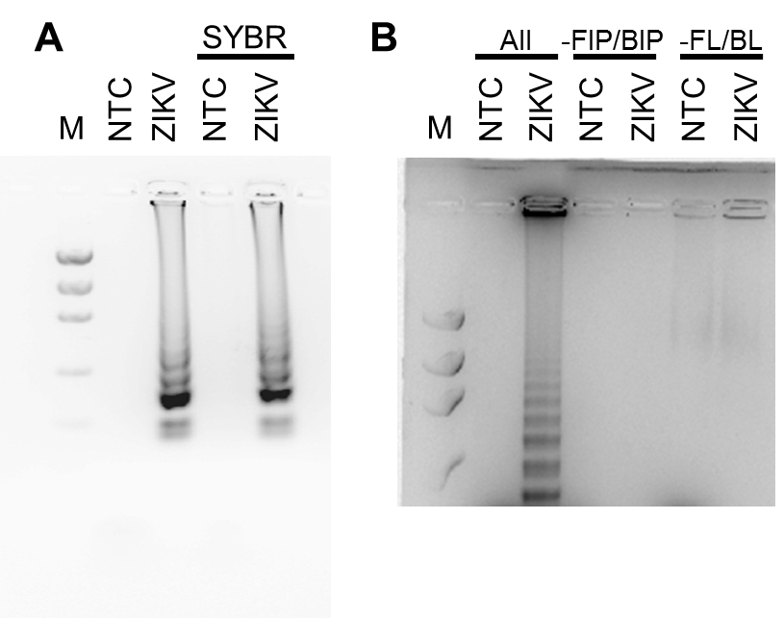

Full-length images of gels presented in Fig 2
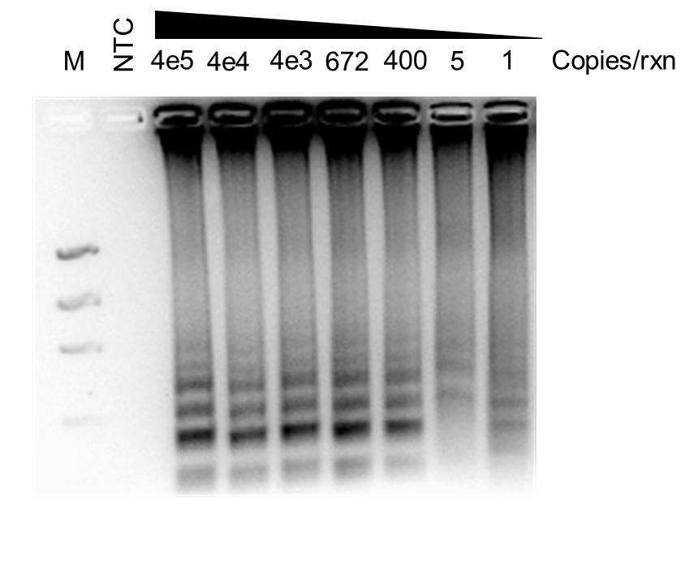

Full-length images of gels presented in Fig 3
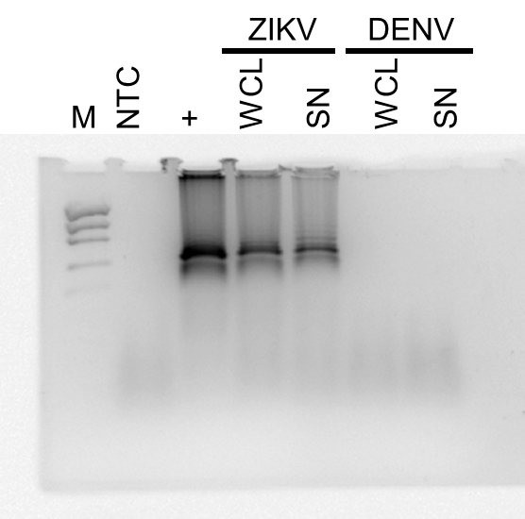

Full-length images of gels presented in Fig 4
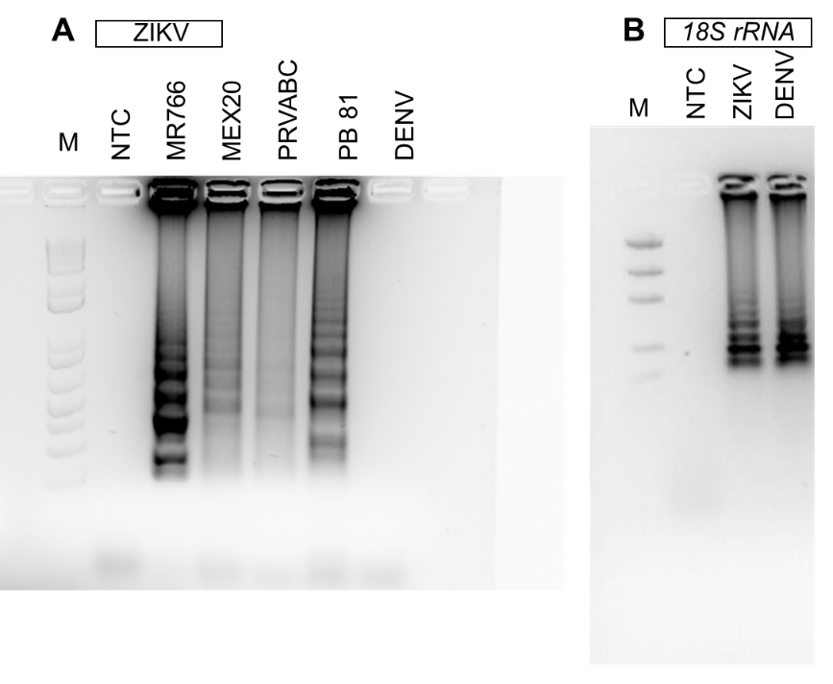

Full-length images of gels presented in Fig 5
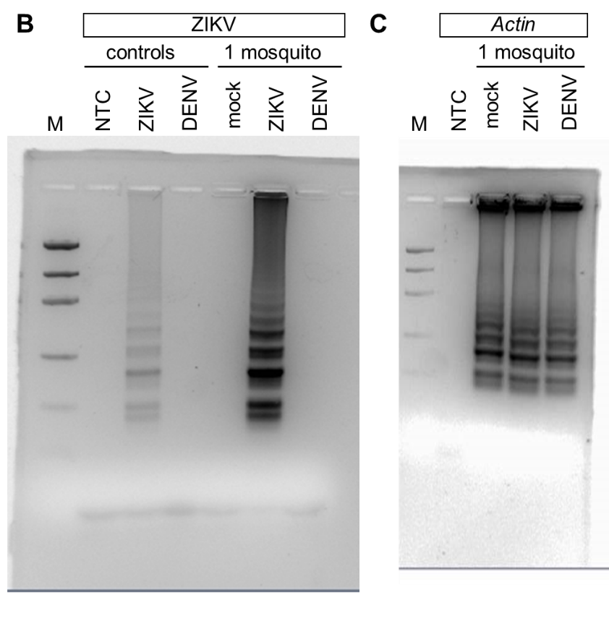
Full-length images of gels presented in Fig 6
