DISTURBANCE REGIMES DRIVE THE DIVERSITY OF REGIONAL FLORISTIC POOLS ACROSS GUIANAN RAINFOREST LANDSCAPES

Stéphane Guitet^{1,2*}, Daniel Sabatier¹, Olivier Brunaux², Pierre Couteron¹, Thomas Denis³, Vincent Freycon⁴, Sophie Gonzalez⁵, Bruno Hérault⁶, Gaëlle Jaouen⁷, Jean-François Molino¹, Raphaël Pélissier¹, Cécile Richard-Hansen³, Grégoire Vincent¹
¹ AMAP, IRD, Cirad, CNRS, INRA, Université de Montpellier, Montpellier, France; ²ONF Guyane, Département Recherche et Développement, Réserve de Montabo, 97307 Cayenne, French Guiana ; ³ONCFS, Direction de la Recherche et de l’Expertise, Campus agronomique, 97379 Kourou, French Guiana ; ⁴CIRAD, UR Forêts et Sociétés, Campus de Baillarguet, 34398 Montpellier, France ; ⁵IRD, Herbier de Cayenne, 97307 Cayenne, French Guiana ; ⁶ CIRAD, UMR EcoFoG, 97379 Kourou, French Guiana, ⁷ AgroParisTech, EcoFoG, 97379 Kourou, French Guiana.
*corresponding author: stephane.guitet@cirad.fr

Supplementary information
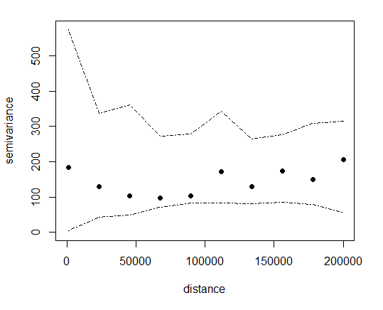
Figure S1. Variogram of the alpha-diversity values on spatial locations with an envelope based on 999 permutations for significance.
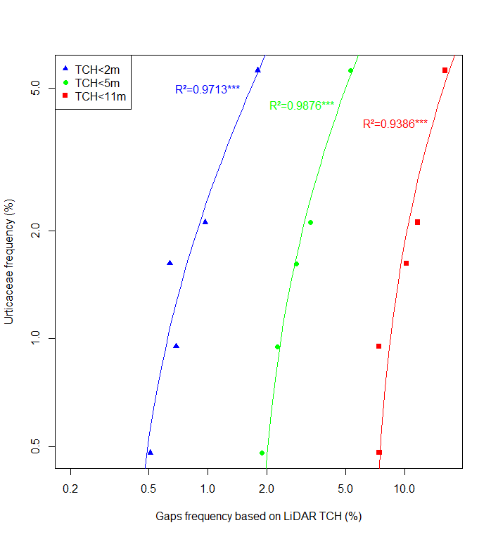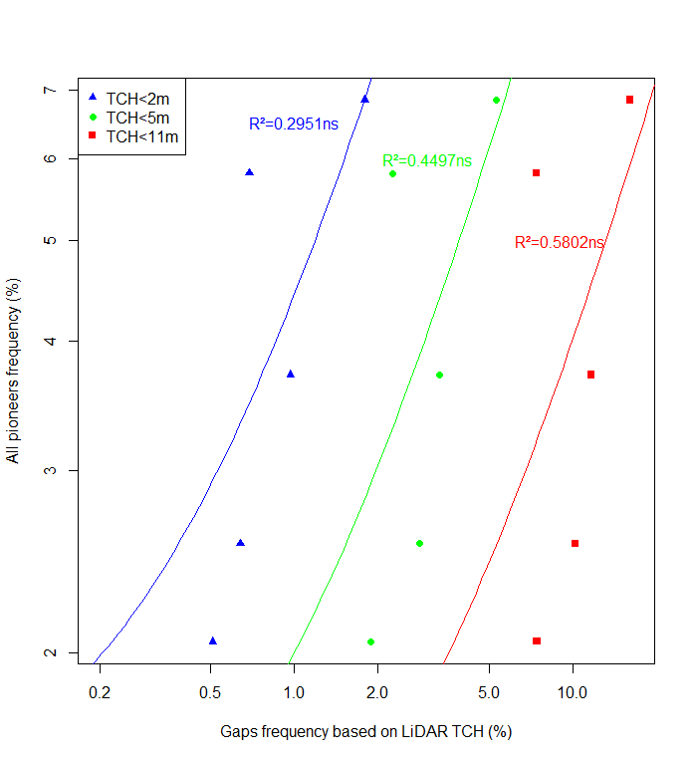
Figure S2: Correlation between pioneer species (All species on the top and only Urticaceae on the bottom) frequency and percentage of gaps in the canopy measured from LIDAR with different threshold on the two focal sites.
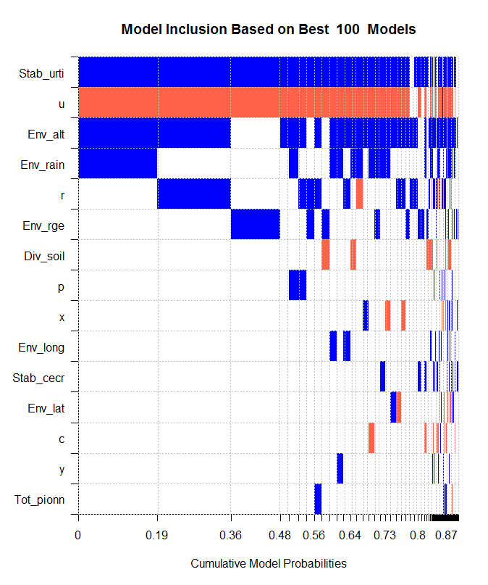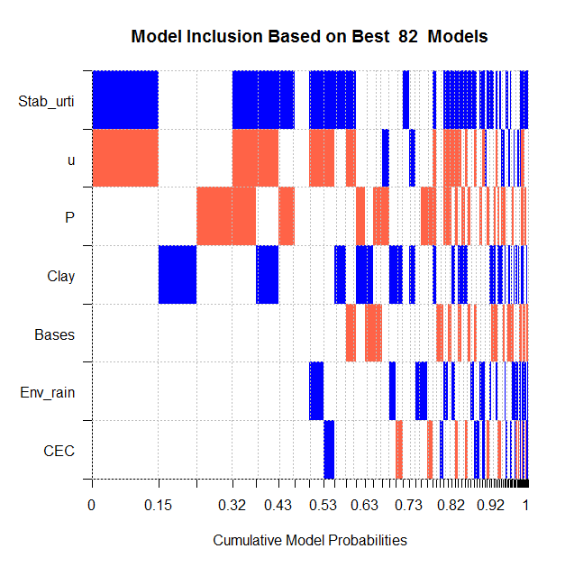
Figures S3: Probability of inclusion of the environmental variables in the diversity prediction models, based on Bayesian approach. Blue indicates a positive effect and red a negative effect. The variables are ranked according to performance. The width of the bars indicates the frequency of inclusion in the best models. The codes for the variables correspond to those in table SI2. u, r, p, c, x and y correspond respectively to the quadratic effect for Urticaceae frequency, rainfall, frequency of all pioneers, cecropia frequency, longitude and latitude. On the top, models with no soil variables, on the bottom, models including soil variables.

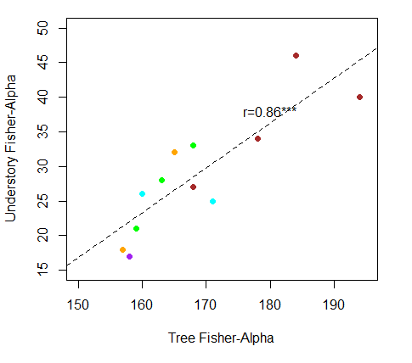
Figure S4: Relationship between tree community alpha diversity and understory vegetation alpha-diversity at the site scale. Colours indicate the relief categories (same codes as previous figures).
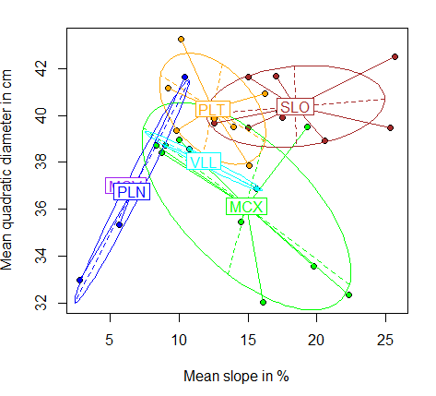
Figure S5. Mean slope and mean quadratic diameter at the site scale in relation with the type of landscape: mountains (SLO) combine the biggest trees with the steepest slopes which may explain larger treefall gaps and hence the regular intermediate disturbance regime.

Table S1: Database with diversity indices (for trees, soil, fauna, understory vegetation) and environmental variables (mean altitude, elevation range, rainfall, landscape type, mean slope, latitude and longitude) for each study site.
Site | Diversity indices |  |  |  | Environmental and spatial variables
Site | Div_  trees | Div_  soil | Div_  fauna | Div_  unders | Env_  alt | Env_  rge | Env_  rain | Env_  land | Env_  slop | Env_  lat | Env_  long
Aima | 163 | 4.62 | 22.36 | 28 | 90 | 67 | 2695 | MCX | 8.39 | 246611 | 516825
Bago | 171 | 3.31 |  | 25 | 110 | 70 | 3142 | VLL | 15.66 | 326441 | 504594
Bast | 135 | 5.02 |  |  | 80 | 87 | 2477 | MCX | 16.07 | 146403 | 579995
Beim | 168 | 3.2 | 22.59 | 33 | 110 | 49 | 2607 | MCX | 10.05 | 153223 | 493702
Cpar | 144 | 5.86 |  |  | 45 | 35 | 2573 | PLN | 7.47 | 285914 | 581976
CriArm | 177 | 2.17 | 25.66 |  | 80 | 79 | 2897 | PLT | 9.86 | 373236 | 404580
Croiss | 156 | 1.85 | 22.58 |  | 130 | 90 | 2847 | PLT | 9.22 | 354390 | 387865
Csgk | 159 | 5.53 | 23.33 |  | 45 | 41 | 2604 | PLN | 5.71 | 295921 | 577069
Eaub | 167 | 5.03 |  |  | 70 | 80 | 2576 | MCX | 14.49 | 226520 | 584187
Gali | 171 | 4.6 | 17.85 |  | 55 | 59 | 3099 | VLL | 10.73 | 312862 | 482893
Grill | 147 | 4.21 |  |  | 30 | 46 | 3147 | PLN | 10.43 | 337150 | 477276
Hmata | 164 | 3.34 | 24.02 |  | 105 | 75 | 2993 | PLT | 12.59 | 368012 | 434516
Iner | 163 | 4.72 |  |  | 115 | 332 | 3156 | MCX | 19.31 | 369698 | 481674
Itou | 194 | 3.81 | 19.73 | 40 | 670 | 556 | 2572 | SLO | 17.22 | 267617 | 334345
Kou | 184 | 3.4 |  | 46 | 85 | 171 | 3143 | SLO | 17.01 | 381820 | 463286
Limo | 170 | 5.2 | 23.66 |  | 225 | 81 | 2606 | SLO | 12.59 | 255676 | 394692
Man | 171 | 2.29 | 21.99 |  | 50 | 77 | 3091 | PLT | 13.99 | 371085 | 450400
Nour | 170 | 3.88 | 24.6 |  | 175 | 151 | 3030 | SLO | 15 | 315113 | 451721
Para | 169 | 2.18 | 22.93 |  | 100 | 116 | 3030 | SLO | 15 | 314907 | 448097
PitArm | 156 | 2.38 | 26.6 |  | 120 | 71 | 2636 | PLT | 10.16 | 352363 | 413243
PitBar | 178 | 2.85 | 23.32 | 34 | 315 | 333 | 2876 | SLO | 25.67 | 268473 | 359560
Plomb | 144 | 7.92 |  |  | 100 | 194 | 2800 | MCX | 19.8 | 285725 | 556402
Quar | 159 | 6.14 |  | 21 | 145 | 188 | 3168 | MCX | 22.29 | 361858 | 478535
Regi | 160 | 5.54 |  | 26 | 60 | 64 | 3149 | VLL | 9.01 | 376890 | 465524
RocK | 157 | 3 | 23.67 | 18 | 205 | 89 | 2554 | PLT | 15.12 | 159359 | 324905
Sabl | 134 | 4.16 |  |  | 30 | 19 | 2380 | PLN | 2.82 | 211555 | 606356
SautPar | 165 | 4.04 | 18.93 | 32 | 130 | 132 | 2878 | PLT | 16.2 | 277668 | 462108
StMi | 168 | 5.42 |  |  | 75 | 239 | 2955 | SLO | 17.5 | 299681 | 540028
Topo | 168 | 4.09 | 23.57 | 27 | 255 | 284 | 2733 | SLO | 20.6 | 310821 | 337081
Tort | 179 | 3.47 |  |  | 250 | 398 | 3149 | SLO | 25.33 | 345280 | 471738
Trini | 168 | 5.35 | 23.5 |  | 155 | 149 | 2666 | MCX | 8.74 | 232445 | 507988
Waki | 158 | 4.54 | 21.7 | 17 | 175 | 47 | 2517 | MCV | 5.19 | 232743 | 340931
Yaro | 155 | 4.2 | 26.27 |  | 170 | 59 | 2574 | MCV | 7.12 | 293103 | 273779

Table S1: Database (continued) with disturbance indices (in order: frequency of Urticaceae pioneer species, only cecropia, all pioneer species, mean quadratic diameter, wood specific gravity) and environmental variables (mean altitude, elevation range, rainfall, landscape type, mean slope, latitude and longitude), resource availability (CEC in cmolc.kg-1, % clay, available phosphorus and sum of base in cmolc.kg-1) and sampling intensity for each site (for soil, trees and understory vegetation).
Site | Disturbance indices |  |  |  |  | Soil analyses |  |  |  | Sampling intensity
Site | Stab_  urti | Stab_  cecr | Tot_  pionn | Str_  diam | Wsg | CEC | Clay | P | Bases | N_soil | N_tree | N_under
Aima | 3.3 | 1 | 6.9 | 38.73 | 0.66 | 6.48 | 23 | 3.29 | 0.4 | 19 | 4568 | 21
Bago | 5.2 | 1.7 | 5.4 | 36.86 | 0.63 |  |  |  |  | 11 | 1980 | 19
Bast | 0.2 | 0.1 | 1.7 | 32.02 | 0.67 |  |  |  |  | 3 | 2608
Beim | 1.6 | 1.6 | 3.6 | 38.98 | 0.66 | 7.62 | 32 | 1.54 | 0.43 | 18 | 5207 | 44
Cpar | 0.4 | 0.1 | 7.2 | 37.07 | 0.67 | 8.74 | 23 | 1.27 | 0.66 | 6 | 2438
CriArm | 1.9 | 1.4 | 4.2 | 39.38 | 0.65 | 10.51 | 66 | 1.12 | 0.63 | 16 | 5183
Croiss | 4.8 | 0.2 | 10 | 41.16 | 0.63 | 8.1 | 47 | 1.05 | 0.41 | 12 | 3986
Csgk | 3.7 | 0.9 | 11.5 | 35.35 | 0.64 |  |  |  |  | 21 | 5007
Eaub | 1.7 | 0.7 | 4.8 | 35.47 | 0.66 | 7.19 | 26 | 1.68 | 0.83 | 18 | 4905
Gali | 5.6 | 1.3 | 17 | 38.58 | 0.63 |  |  |  |  | 16 | 2861
Grill | 1.2 | 0.7 | 2.9 | 41.64 | 0.66 |  |  |  |  | 8 | 1959
Hmata | 1.1 | 0.5 | 3.3 | 39.88 | 0.67 | 9.16 | 55 | 1.12 | 0.89 | 9 | 5463
Iner | 1.7 | 1.4 | 3.9 | 39.51 | 0.66 |  |  |  |  | 5 | 1869
Itou | 4.5 | 2.7 | 8.6 | 40.20 | 0.62 | 14.69 | 53 | 0.63 | 1.45 | 28 | 5516 | 35
Kou | 4.3 | 0.8 | 9.2 | 41.68 | 0.63 |  |  |  |  | 11 | 3419 | 25
Limo | 4.3 | 0.4 | 7.3 | 39.69 | 0.61 |  |  |  |  | 16 | 4004
Man | 2 | 0.6 | 2.7 | 39.53 | 0.65 | 8 | 48 | 1.12 | 0.45 | 14 | 3401
Nour | 2.6 | 1.5 | 2.3 | 41.63 | 0.65 | 10 | 59 | 1.23 | 0.95 | 10 | 2465
Para | 4.1 | 0 | 9.9 | 39.47 | 0.65 |  |  |  |  | 7 | 1985
PitArm | 2.4 | 0.7 | 7.1 | 43.28 | 0.64 | 10.45 | 60 | 0.98 | 0.62 | 12 | 4054
PitBar | 2.3 | 0.2 | 3.7 | 42.50 | 0.64 |  |  |  |  | 16 | 4069 | 16
Plomb | 0.1 | 0.1 | 3.4 | 33.56 | 0.68 | 9.55 | 53 | 2 | 0.75 | 10 | 3998
Quar | 0.2 | 0.1 | 2.4 | 32.34 | 0.69 | 4.6 | 8 | 2.25 | 0.65 | 15 | 2638 | 17
Regi | 3.7 | 3.2 | 4.1 | 38.73 | 0.66 | 6.4 | 21 | 1.3 | 0.7 | 15 | 1958 | 14
RocK | 2.1 | 0.6 | 3.5 | 37.88 | 0.64 |  |  |  |  | 16 | 4411 | 34
Sabl | 0 | 0 | 2.8 | 32.97 | 0.67 | 16.14 | 5 | 3.28 | 3.24 | 1 | 1627
SautPar | 3.9 | 1.1 | 5.8 | 40.95 | 0.64 | 10.54 | 50 | 0.98 | 0.68 | 20 | 4423 | 21
StMi | 3.5 | 3.2 | 3.6 | 39.92 | 0.64 |  |  |  |  | 11 | 3731
Topo | 2.7 | 0.4 | 8 | 38.93 | 0.63 | 12.09 | 59 | 1.12 | 1.89 | 23 | 4603 | 20
Tort | 1.8 | 1.8 | 1.8 | 39.48 | 0.65 | 16.44 | 73 | 0.75 | 0.65 | 7 | 1900
Trini | 1 | 0.3 | 4.3 | 38.42 | 0.66 | 3.29 | 16 | 2.03 | 0.64 | 17 | 5365
Waki | 1.4 | 0.5 | 4.1 | 36.84 | 0.64 | 3.31 | 15 | 4 | 0.46 | 25 | 5106 | 39
Yaro | 6.5 | 1.5 | 15.8 | 37.18 | 0.60 | 4.51 | 26 | 3.4 | 0.62 | 22 | 3965

