Origami-based self-folding

of co-cultured NIH/3T3 and HepG2 cells

into 3D microstructures

Qian He¹, Takaharu Okajima², Hiroaki Onoe³, Agus Subagyo⁴,

Kazuhisa Sueoka² and Kaori Kuribayashi-Shigetomi¹*

¹ Institute for the Advancement of Higher Education, Hokkaido University, Sapporo, Japan

² Graduate School of Information Science and Technology, Hokkaido University, Sapporo, Japan

³ Department of Mechanical Engineering, Faculty of Science and Technology, Keio University, Tokyo, Japan

⁴ Creative Research Institution Sousei, Hokkaido University, Sapporo, Japan

* Corresponding author: kaorik@ist.hokudai.ac.jp

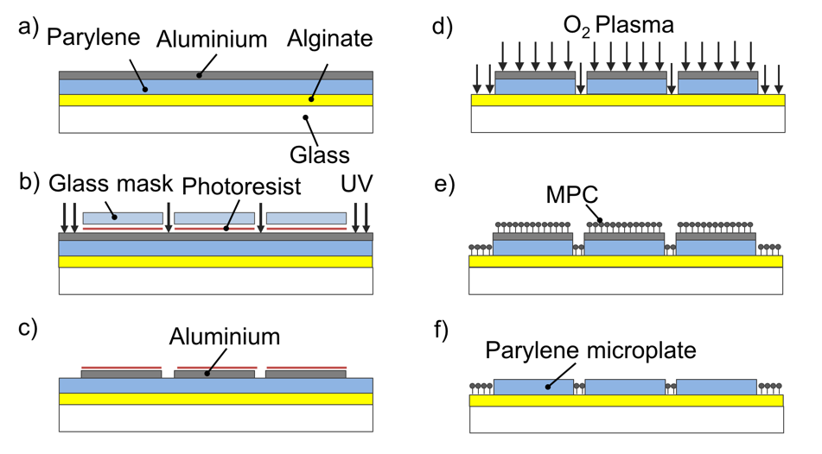
Supplementary Figure 1. The process of producing the microplates with the alginate layer. a) The alginate was coated on the glass substrate followed by parylene and aluminium deposition. b-c) After photoresist coating, the shape of the microplates can be patterned by UV exposure and aluminium etching. d) After the exposed parylene was removed by O₂ plasma, the shape of the microplates was revealed. e) MPC polymer was coated on the entire surface of the glass substrate. f) Finally, the aluminium with the MPC polymer on the microplates was removed to reveal the final parylene microplate.

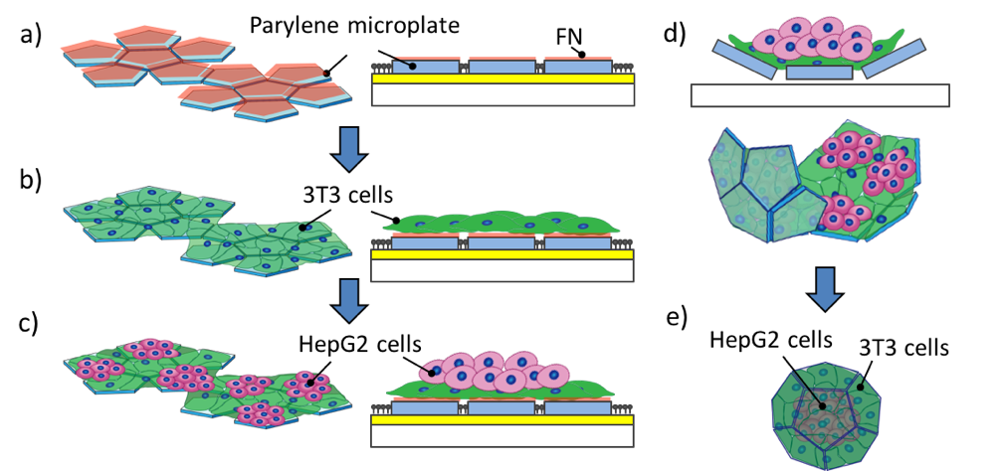
Supplementary Figure 2. Co-culture in folding and unfolding groups. a) Pentagon-shaped microplates were produced by the microfabrication technique. b-c) NIH/3T3 cells were seeded and cultured on the microplates for 24 h followed by HepG2 seeding. d-e) Alginate lyase removes the superficial layer, allowing the co-culture cells on the microplates to form a 3D microstructure.

Optimization of initial cell seeding concentration of HepG2 cells
We performed experiments to detect the secreted albumin from both folding and unfolding groups, using 1×10⁵ cells/ml, 5×10⁵ cells/ml and 2.5×10⁶ cells/ml as C_{H}. The HepG2 cells could not be fully wrapped inside the 3D microstructures when using 2.5×10⁶ cells/ml; therefore, C_{H} should be less than 2.5×10⁶ cells/ml.
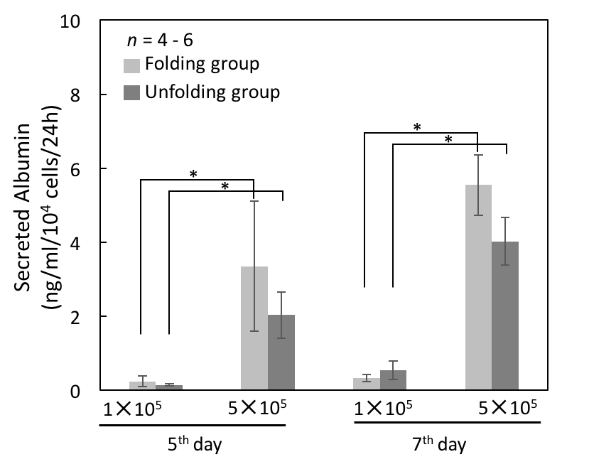
Supplementary Figure 3. Secreted albumin from co-culture cells with different C_{H}. The secreted albumin in both groups was much lower when using 1×10⁵ cells/ml than when using 5×10⁵ cells/ml as C_{H}, and the significant difference in folding and unfolding groups was found on both the 5th and 7th days.

