Bat-mouse bone marrow chimera: a novel animal model for dissecting the uniqueness of the bat immune system

Kylie Su Mei Yong^{1,*}, Justin Han Jia Ng^{2,*}, Zhisheng Her¹, Ying Ying Hey², Sue Yee Tan¹, Wilson Wei Sheng Tan¹, Sergio Erdal Irac², Min Liu¹, Xue Ying Chan¹, Merry Gunawan¹, Randy Jee Hiang Foo², Dolyce Hong Wen Low², Ian Hewitt Mendenhall², Yok Teng Chionh², Charles-Antoine Dutertre^{2,3}, Qingfeng Chen^{1,4, 5,#}, Lin-Fa Wang^{2,#}

Supplementary Information
Genes | Sense | Antisense
P.a. 18S | TACTGCAATTAAGGGTGTAGG | CATAATGGTGATTACACGTTC
M.m. 18S | ACTGCCATTAAGGGCGTGG | CATGATGGTGATCACTCGC
P.a. GAPDH | ACCAGGGCTGCTTTTAACTC | AACTTGCCATGGGTGGAATC
M.m. GAPDH | CAGGGCTGCCATTTGCAG | TGAATTTGCCGTGAGTGGAG
Supplementary Table 1. Primers for qPCR. Primer sequences for bat and mouse genes.
P.a. – Pteropus alecto; M.m. – Mus musculus
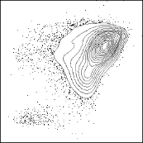
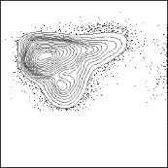
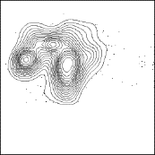
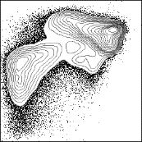
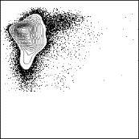
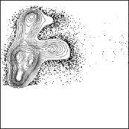
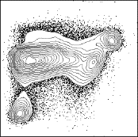
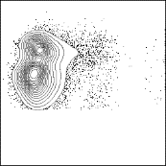
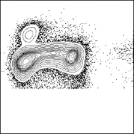
Supplementary Figure 1. Measurement of reconstitution within the blood and organs of Eonycteris spelaea via flow cytometry. E. spelaea was sacrificed; blood and organs such as spleen and bone marrow (BM) cells were isolated, prepared, stained for CD11b, CD44, MHC-II and subsequently analyzed by flow cytometry.
CD44
Blood
CD11b
MHC-II
MHC-II
CD44
CD44
CD44
Spleen
CD11b
MHC-II
MHC-II
CD44
CD44
CD44
Bone marrow
CD11b
MHC-II
MHC-II
CD44
CD44
Mono
DCs
Mono
DCs
Mono
DCs
T/NK cells
B cells
T/NK cells
B cells
T/NK cells
B cells

Supplementary Figure 2. Measurement of reconstitution in organs from bat-mice by flow cytometry. Bat bone marrow (BM) cells were isolated and injected into sub-lethally irradiated NSG pups at 1x10⁵ (100K) cells per mouse (n = 5). Forty weeks later, the bat-mice were sacrificed. Organs such as spleen, BM and liver were prepared, stained for CD45.1, Ter119, CD11b, CD44, and MHC-II and subsequently analyzed by flow cytometry. Concatenated staining profiles are shown.
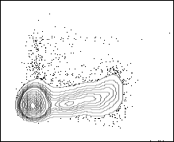
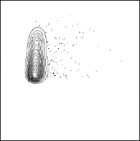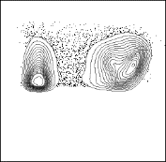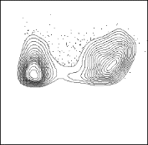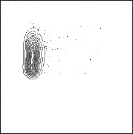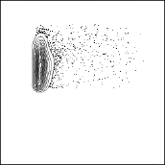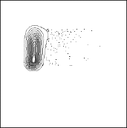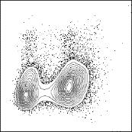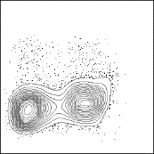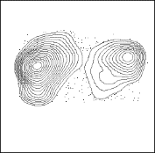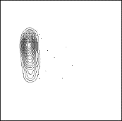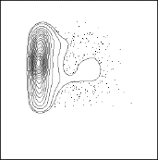
CD45.1
CD44
CD44
CD44
CD11b
MHC-II
MHC-II
TER119
CD44
CD44
CD44
TER119
CD44
CD44
CD44
TER119
Spleen
Bone marrow
Liver
Mono
DCs
T/NK cells
B cells
Mono
DCs
T/NK cells
B cells
Mono
DCs
T/NK cells
B cells
CD45.1
CD11b
MHC-II
MHC-II
CD45.1
CD11b
MHC-II
MHC-II
Supplementary Figure 3. Analysis of bat-specific antibody specificity and response in bat-mice. (a) Pooled bat sera from 2 individuals (E. spelaea) and sera from a C57BL/6 mouse were ran on western blot to determine specificity of bat-specific antibody used. Presence of band on the membrane indicates presence of bat IgG binding. (b) Bat-mice (n = 10) were immunized via intraperitoneal injection with NP-KLH, using IFA as an adjuvant. Sera were collected from bat-mice 2 weeks after the second booster. Shown is the dot blot of representative samples from bat, bat-mice, NSG, BALB/c, C57BL/6 and phosphate buffered saline (PBS) which was used a diluent. Dot on the membrane represents the presence of bat IgG.

a
IgG Heavy Chain
(50 kDa)
IgG Light Chain
(25 kDa)
Pooled
E.s. sera
C57BL/6
Mouse sera


b
Bat
NSG
BALB/c
C57BL/6
PBS
Bat
Bat-mice
Controls
Neat
1:10
1:100
1:1K
1:2K
1:4K
1:8K
1:16K
1:32K
1:64K

