Supplementary Information

Cervical microbiome is altered in cervical intraepithelial neoplasia after loop electrosurgical excision procedure in china

Hongwei Zhang^{1,¶}, Jiaqi Lu^{1,¶}, Yingying Lu¹, Qingqing Cai³, Haiou Liu^{3*}, Congjian Xu^{1, 2,3*}

Correspondence and requests for materials should be addressed to H. Liu (liuhaiou@fudan.edu.cn) or C. Xu (xucongjian@fudan.edu.cn)
Supplementary Table S1. Characteristics of enrolled patients.
ID  Patient | Age | Menopause status | HPV status pretreatment | HPV types at pretreatment | PAP test at Pretreatment | Colposcopy at Pretreatment | CT at Pretreatment | HPV status at 3-month follow up | CT at follow-up
1 | 36 | Pre- | Positive | 18 | HSIL | CIN3 | 1 | Negative | 1
2 | 35 | Pre- | Positive | 16 | HSIL | CIN3 | 1 | Negative | 1
3 | 43 | Pre- | Positive | 16 | LSIL | CIN3 | 1 | Negative | 2
4 | 34 | Pre | Positive | 16 | HSIL | CIN3 | 1 | Negative | 2
5 | 39 | Pre- | Positive | 16 | HSIL | CIN3 | 2 | Negative | 2
6 | 26 | Pre- | Positive | 16 | HSIL | CIN3 | 4 | Negative | 2
7 | 45 | Pre- | Positive | 16 | HSIL | CIN3 | 4 | Negative | 2
8 | 39 | Pre- | Positive | 18 | HSIL | CIN3 | 3 | Negative | 2
9 | 40 | Pre- | Positive | 16 | HSIL | CIN3 | 2 | Negative | 2
10 | 53 | Post- | Positive | 52 | HSIL | CIN3 | 2 | Positive | 2
11 | 26 | Pre- | Positive | 52 | HSIL | CIN3 | 3 | Negative | 2
12 | 45 | Pre- | Negative | - | HSIL | CIN3 | 2 | Negative | 2
13 | 25 | Pre- | Positive | 16 | HSIL | CIN3 | 4 | Negative | 2
14 | 43 | Pre- | Positive | 16 | HSIL | CIN3 | 2 | Negative | 4
15 | 36 | Pre- | Positive | 16 | HSIL | CIN3 | 4 | Negative | 3
16 | 58 | Post- | Positive | 18 | HSIL | CIN3 | 4 | Negative | 4
17 | 60 | Post- | Positive | 58 | LSIL | CIN3 | 4 | Negative | 4
18 | 53 | Post- | Positive | 58 | HSIL | CIN3 | 4 | Negative | 4
19 | 34 | Pre- | Positive | 16 | HSIL | CIN3 | 4 | Negative | 4
20 | 32 | Pre- | Positive | 16 | HSIL | CIN3 | 4 | Negative | 4
21 | 48 | Post- | Positive | 31,52,58 | HSIL | CIN3 | 4 | Negative | 4
22 | 36 | Pre- | Positive | 58 | HSIL | CIN3 | 4 | Negative | 1
23 | 29 | Pre- | Positive | 52 | HSIL | CIN3 | 4 | Negative | 2
24 | 48 | Pre- | Positive | 58 | HSIL | CIN3 | 4 | Negative | 3
25 | 68 | Post- | Positive | 16 | HSIL | CIN3 | 4 | Negative | 2
26 | 38 | Pre | Positive | 16 | LSIL | CIN2 | 2 | Negative | 2

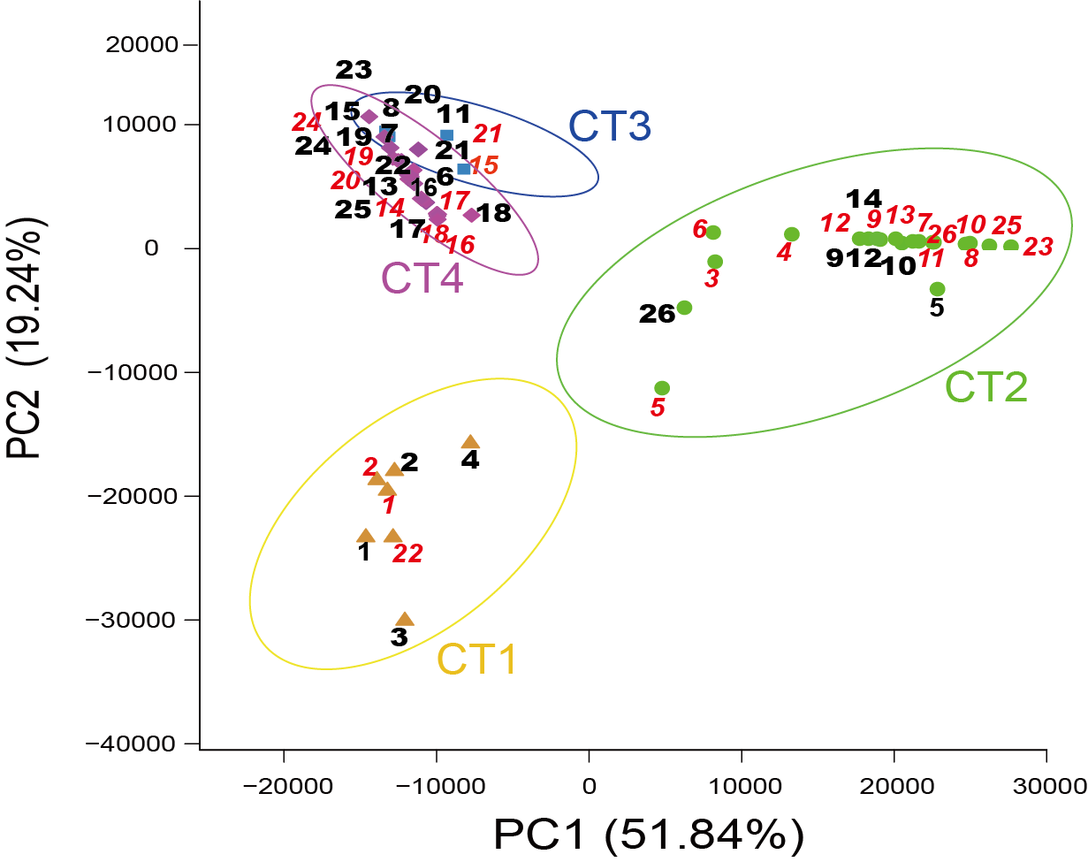
Supplementary Figure S1. Principal component analysis (PCA) plot constructed from 52 samples. The first two principal components (PC1 and PC2) can explain 71.08% of the data variance. Different colors denote 4 distinct Cts. P=0.001 for CTs, sample ID marked before LEEP (black bold number) and after LEEP (red italic number).

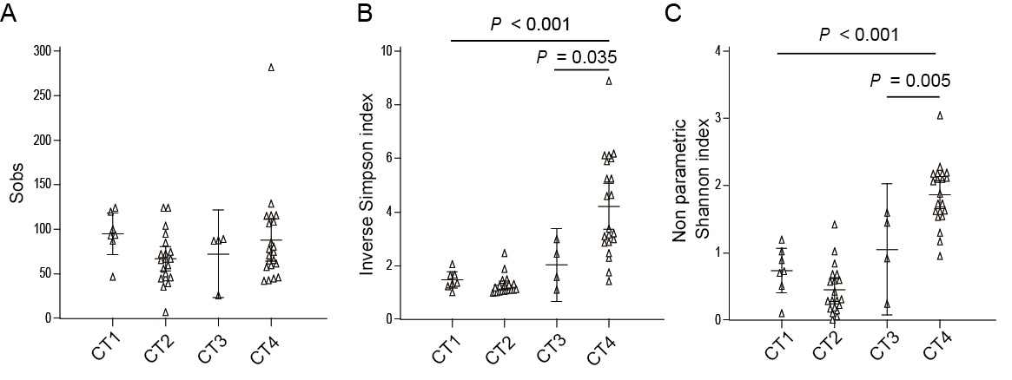
Supplementary Figure S2. Analysis of richness and diversity indices with attributed CTs for the patient cohort. A similar number of species observed in samples classified as different CTs (A). Diversity was significantly higher in CT4 classified samples as assessed by the Inverse Simpson (B) and non-parametric Shannon (C) indices compared to CT1 (P < 0.001) and CT3 (P = 0.035 and P = 0.005). Kruskall-Wallis test (Dunn’s post hoc).

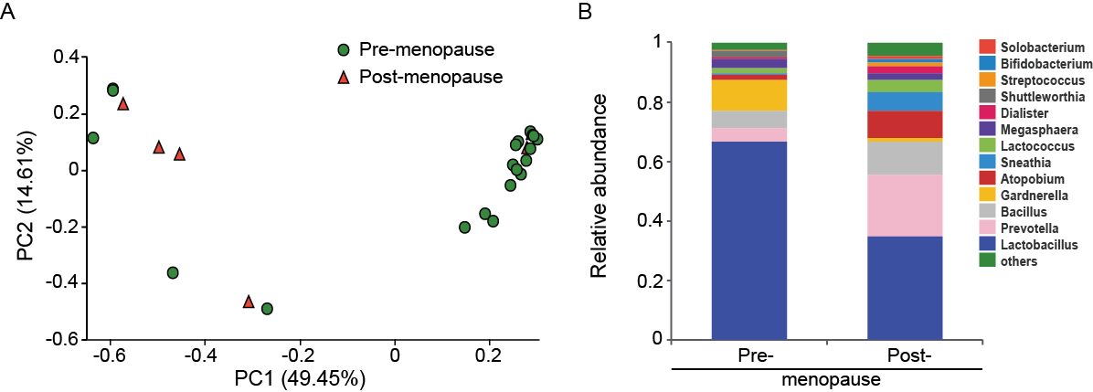
Supplementary Figure S3. Principal coordinates analysis (PCoA) and genus level relative abundance for 26 samples from the patients after LEEP. (A) Bray-Curtis dissimilarity PCoA was used to generate ordination of beta-diversity in two dimensions. Principal coordinates 1 and 2 (PC1 and PC2) explain 49.45% and 14.61% of the variance in Bray-Curtis dissimilarity respectively (x and y axes). Samples are colored according to the menopause status. (B) Relative abundance was shown for the top fifteen genus.

