Supplementary information
Intrinsically-disordered N-termini in human parechovirus 1 capsid proteins bind encapsidated RNA

Shabih Shakeel^{1,3}, Mark Hazelbaker², James D. Evans¹, C. Cheng Kao², Robert C. Vaughan^{2*} and Sarah J. Butcher^{1*}
¹Institute of Biotechnology and Research Programme in Molecular and Integrative Biosciences, Faculty of Biological and Environmental Sciences, University of Helsinki, 00790 Helsinki, Finland
²Department of Molecular and Cellular Biochemistry, Indiana University, Bloomington, IN 47405, USA
³Current address: MRC Laboratory of Molecular Biology, Francis Crick Ave, Cambridge CB2 OQH, UK
*Corresponding authors
Emails: sarah.butcher@helsinki.fi (SJB), robvaugh@indiana.edu (RCV)

Supplementary Table 1. List of all peptides confidently identified in virion RCAP, with the top twelve hits highlighted in yellow for each protein.
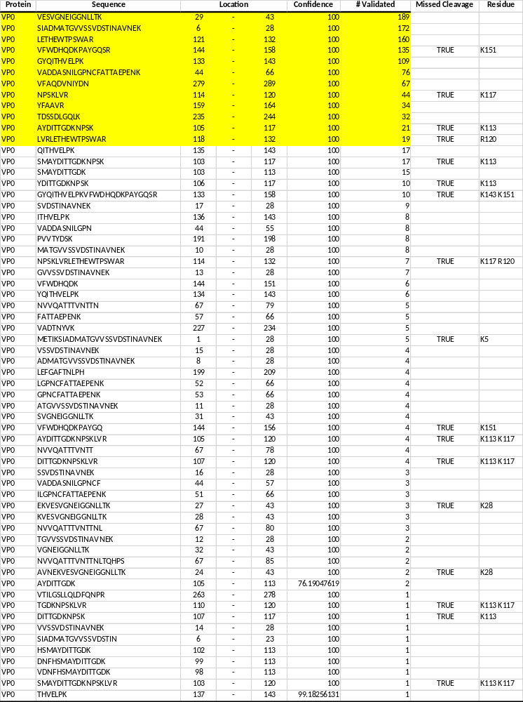
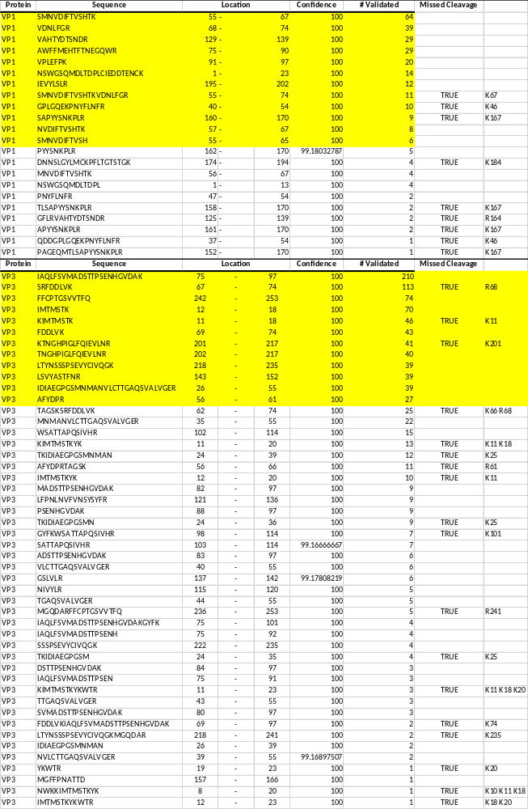

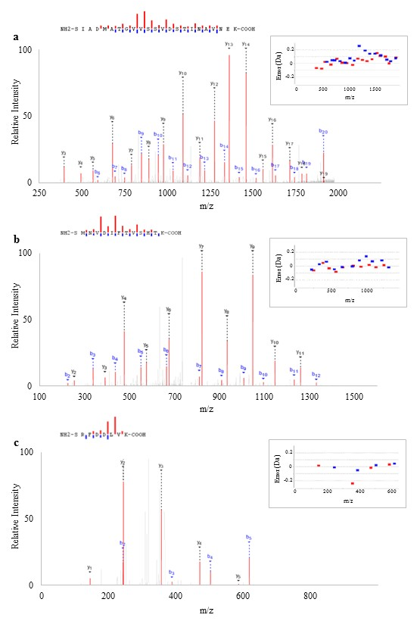

Supplementary Figure 1. Peptides recovered by whole-virion RCAP
Representative MS/MS spectra from the HPeV1 virion RCAP assay. Peptide assignments derived from VP0 (panel A), VP1 (panel B), and VP3 (panel C) are depicted schematically above each spectra. Red bars indicate y ions and blue b ions. The size of each bar is relative to the intensity of the match in each spectra. Images were exported directly from PeptideShaker, and insets represent ms/ms mass error (Da).
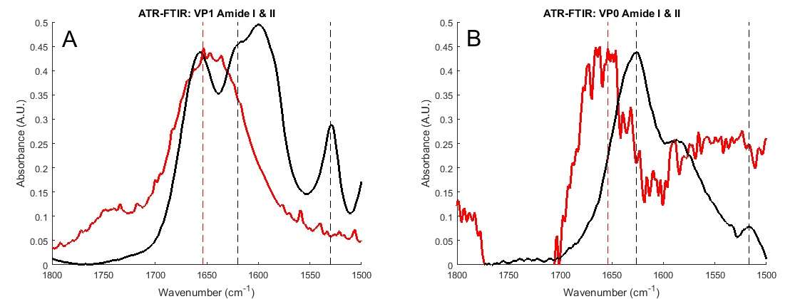

Supplementary Figure 2. ATR-FTIR spectra of purified capsid proteins VP1 and VP0.
The amide I and amide II regions of the infrared spectra of A.) purified VP1 (black trace) and TCA-denatured VP1 (red trace); and B.) purified VP0 (black trace) and TCA-denatured VP0 (red trace). Dashed vertical lines denote peak positions corresponding to secondary-structure dependent amide I absorption: red lines at 1654 cm⁻¹ for unstructured peptide, black at 1620 cm⁻¹ (VP1) or 1626 cm⁻¹ (VP0) for absorption due to β-sheet amides. Amide II peaks are likewise denoted with vertical dashed black lines at 1530 cm⁻¹ (VP1) or 1517 cm⁻¹ (VP0) and are absent in the TCA-denatured samples.

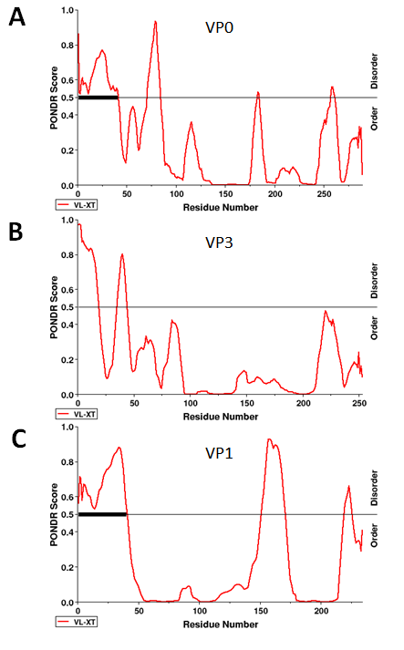

Supplementary Figure 3. PONDR analysis of viral capsid proteins
A.) VP0, B.) VP3, C.) VP1. A score of more than 0.5 predicts disorder. The regions in VP0 and in VP1 which have over 39 residues in a row predicted to be disordered, are marked with a thick black bar.

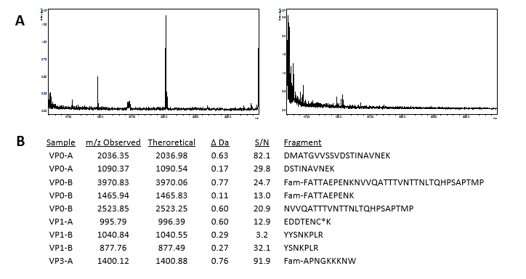

Supplementary Figure 4. Peptide RCAP Mass Assignments.
A.) Representative RCAP MALDI spectra from the peptide RCAP experiment performed with the VP0-B peptide (left), and the control reaction lacking formaldehyde (right). B.) Theoretical digests of all synthesized peptides were performed using GPMAW (Lighthouse Data, Hanstholm, Denmark) and matched against observed masses.

Supplementary Figure 5. RNA and protein gels.
A.) 1% agarose gel stained with SybrSafe DNA gel stain (Invitrogen S33102). Lane 1: HPeV1 subgenomic transcript of 1576 nucleotides; 2: 2335 n.t.; 3: 3037 n.t., and; 4: GeneRuler 1 kb DNA ladder (ThermoScientific SM0312). B.) 4-20% TGX stain-free SDS gel (BioRad; Cat#456-8093) UV exposed for 5 min before imaging. Lane 1: PageRuler broad range unstained protein ladder (ThermoScientific 26630); 2: purified VP0; 3: purified VP1.

Supplementary Movie 1. The inner capsid-surface peptides identified by RCAP.
The movie shows the HPeV1 pentamer (PDB: 4Z92) in ribbon representation. The thicker sections of the ribbon represent the inner capsid-surface peptides recovered in whole virion RCAP analysis. The VP0 is colored cyan; VP1, magenta and; VP3, orange.

