Supplementary materials for manuscript:
Muška, M., Tušer, M., Frouzová, J., Mrkvička, T., Richard, D., Seďa, J., Morelli, F., Kubečka, J.: Real-time distribution of pelagic fish: combining hydroacoustics, GIS and spatial modelling at a fine spatial scale
Supplementary Figure S1. Variograms describing variability of abiotic factors (A - depth, B - distance from the bank, C - bottom steepness) dependent on distance.
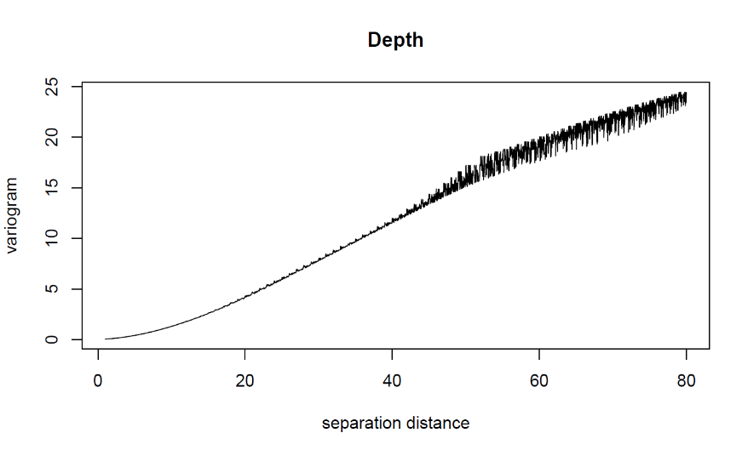
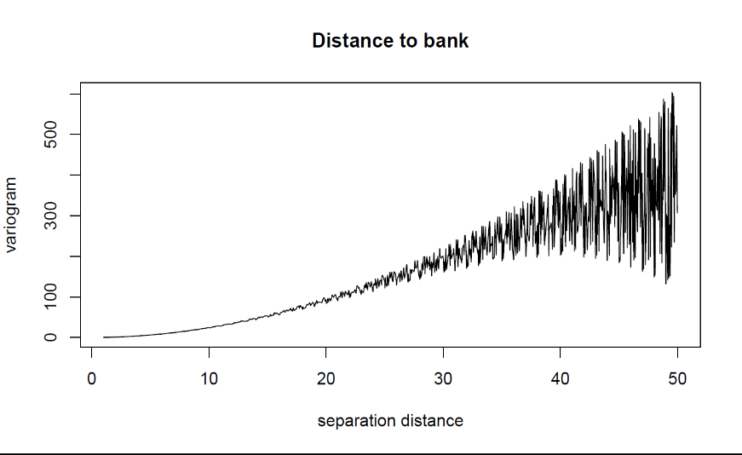
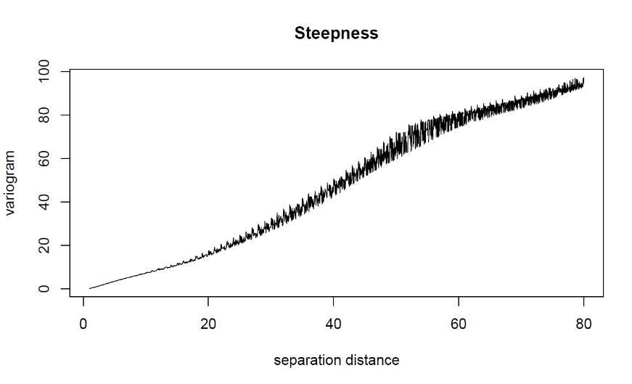
B
C
A
A

