Supplementary Information

Title:
Rapid selection of sulphadoxine-resistant Plasmodium falciparum and its effect on within-population genetic diversity in Papua New Guinea

Full author list:
Toshihiro Mita^{1,*}, Francis Hombhanje², Nobuyuki Takahashi³, Makoto Sekihara¹, Masato Yamauchi¹, Takahiro Tsukahara³, Akira Kaneko^{4,5}, Hiroyoshi Endo³, and Jun Ohashi⁶

¹ Department of Tropical Medicine and Parasitology, Juntendo University School of Medicine, 2-1-1 Hongo, Bunkyo, Tokyo, 113-8421, Japan
² Centre for Health Research & Diagnostics, Divine Word University, P.O. Box 483, Madang, Papua New Guinea
³ Department of International Affairs and Tropical Medicine, Tokyo Women’s Medical University, 8-1 Kawada-cho, Shinjuku-ku, Tokyo 162-8666, Japan.
⁴ Department of Microbiology, Tumor and Cell Biology, Karolinska Institutet, SE-171 77 Stockholm, Sweden
⁵ Department of Parasitology, Osaka City University Graduate School of Medicine, Asahi-cho 1-4-3, Abeno-ku, Osaka, 545-8585, Japan
⁶ Department of Biological Sciences, Graduate School of Science, The University of Tokyo, Tokyo, Japan, 7-3-1 Hongo, Bunkyo-ku, Tokyo 113-0033, Japan
* Corresponding author; tmita@juntendo.ac.jp

Supplementary Fig. S1. Haplotyping of pfcrt, dhfr, dhps, and 10 microsatellite loci in 302 Plasmodium falciparum isolates obtained in 2002, 2003, 2010, and 2011. Capital letters denote amino acid residues at positions 72–76 in pfcrt; 50, 51, 59, 108, and 164 in dhfr; and 436, 437, 540, 581, and 613 in dhps; mutations are underlined. Undetermined haplotypes or microsatellites are shown as ND.

Year | pfcrt | dhfr | dhps | ARA2 | Pfg377 | TA81 | TA60 | TA1 | TA42 | TA109 | TA87 | 2490 | PfPK2
2002 | SVMNT | CNRNI | SAKAA | 72 | 95 | 132 | 87 | 168 | 188 | 163 | 101 | 85 | 170
2002 | CVMNK | CNCSI | SAKAA | 75 | 98 | 132 | 87 | 183 | 188 | 163 | 101 | 82 | 170
2002 | SVMNT | CNCSI | SAKAA | 72 | 95 | 132 | 87 | 171 | 191 | 163 | 107 | 85 | 185
2002 | SVMNT | CNRNI | SAKAA | 78 | 104 | 129 | 84 | 177 | 188 | 163 | 104 | 82 | 170
2002 | SVMNT | CNRNI | SAKAA | 75/72 | 98 | 132/123 | 84 | 171 | 188 | 163 | 107 | 85/82 | 167
2002 | SVMNT | CNCSI | SAKAA | 78 | 95 | 132 | 93 | 180 | 188 | 163 | 107/104 | 82 | 176/173
2002 | SVMNT | CNRNI | SAKAA | 69 | 95 | 132/123 | 90 | 186 | 188 | 163 | 101 | 82 | 182/170
2002 | SVMNT | CNRNI | SAKAA | 81 | 95 | 129/132 | 87 | 177 | 188 | 163 | 107/95 | 82 | 170
2002 | SVMNT | CNRNI | SAKAA | 69 | 98 | 123/132 | 90 | 180 | 188 | 163 | 107/104 | 82 | 167
2002 | SVMNT | CNRNI | SAKAA | 72 | 95/98 | 132/117 | 87 | 177 | 185 | 163 | 104 | 82 | 173
2002 | SVMNT | CNRNI | SAKAA | 72 | 101/95 | 132/120 | 87/81 | 168/177 | 188 | 163/169 | 101/107 | 85/82 | 170/179
2002 | CVMNK | CNRNI | SAKAA | 72 | 95 | 132/117 | 84 | 174 | ND | 163 | 104/101 | 82 | 197
2002 | SVMNT | CNRNI | SAKAA | 75 | 95 | 120 | 87 | 168 | 188 | 163 | 107 | 85 | 173
2002 | SVMNT | CNCSI | SAKAA | 75 | 98 | 123/132 | 78 | 171 | 188 | 163 | 104 | 85 | 185
2002 | SVMNT | CNRNI | SAKAA | 69 | 95/104 | 132 | 87 | 162 | ND | 163 | 113 | 82/70 | 176/173/185
2002 | SVMNT | CNRNI | SAKAA | 72 | 98 | 126 | 84 | 168 | 188 | 187 | 104 | 88 | 170
2002 | SVMNT | CNRNI | SAKAA | 81 | 95 | 129 | 87 | 168 | 188 | 163 | 104 | 82 | 182
2002 | SVMNT | CNRNI | SAKAA | 72 | 98 | 123 | 87 | 174 | 188 | 163 | 104 | 82 | 173
2002 | SVMNT | CNRNI | SAKAA | 72 | 95 | 129 | 84 | 177 | 188 | 163 | 104 | 82 | 173
2002 | SVMNT | CNCSI | SAKAA | 69 | 104 | 117 | 90 | 174 | 191 | 163 | 101 | 82 | 170
2002 | SVMNT | CNRNI | SAKAA | 69 | 95 | 117 | 87 | 171 | 188 | 163 | 101 | 82 | 170
2002 | SVMNT | CNRNI | SAKAA | 84 | 101 | 132/129 | 87 | 171 | 188 | 163 | 101 | 82 | 173
2002 | SVMNT | CNCSI | SAKAA | 69 | 98 | 120 | 81 | 168 | 188 | 163 | 110 | 82 | 170
2002 | SVMNT | CNCSI | SAKAA | 72 | 95 | 132/120 | 87 | 171 | 206 | 163 | 101 | 82 | 173
2002 | SVMNT | CNCSI | SAKAA | 72 | 98 | 120 | 87 | 174 | 188 | 163 | 104 | 82 | 194
2002 | SVMNT | CNRNI | SAKAA | 72 | 98 | 132/129 | 87 | 168/171 | 188 | 163 | 104/107/101 | 82 | 179/173/185
2002 | SVMNT | CNCSI | SAKAA | 75 | 98 | 129 | 84 | 165 | 188 | 163 | 101 | 82 | 176
2002 | SVMNT | CNCSI | SAKAA | 78 | 98 | 129 | 99 | 177 | 188 | 178 | 107 | 82 | 170
2002 | SVMNT | CNRNI | SAKAA | 72/69 | 98/104 | 129 | 84 | 174 | 188 | 163 | 101 | 85/82 | 170
2002 | CVMNK | CNCSI | SAKAA | 69 | 95 | 132 | 87 | 168 | 188 | 163 | 110 | 82 | 173
2002 | SVMNT | CNRNI | SAKAA | 69 | 98 | 135 | 87 | 168 | 191 | 163 | 104 | 91 | 182
2003 | SVMNT | CNCSI | SAKAA | 72/84/69 | 98/95/101 | 120 | 87 | 168 | 188 | 163 | 101/104 | 82/85 | 170/173
2003 | SVMNT | CNRNI | SAKAA | 81 | 95 | 120 | 84 | 171 | 188 | 163 | 104 | 82 | 167
2003 | SVMNT | CNRNI | SAKAA | 72/69 | 98/95/101 | 132 | 84 | 174/171 | 188 | 163/172 | 104/107 | 73 | 170/173/176
2003 | SVMNT | CNRNI | SAKAA | 69 | 95 | 126 | 90 | 168 | 188 | 163 | 107 | 85 | 164
2003 | SVMNT | CNRNI | SAKAA | 84 | 98 | 117 | 84 | 168 | 188 | 163 | 101 | 82 | 170
2003 | SVMNT | CNRNI | SAKAA | 75 | 98 | 132 | 87 | 183 | 188 | 163 | 107 | 82 | 170
2003 | SVMNT | CNRNI | SAKAA | 69 | 98 | 123 | 84 | 171 | 188 | 169 | 104 | 82 | 173
2003 | SVMNT | CNCSI | SAKAA | 81 | 95 | 132 | 87 | 171 | 188 | 163 | 101 | 82 | 176
2003 | SVMNT | CNRNI | SAKAA | 72 | 95 | 126/132 | 84 | 186 | 188 | 163 | 104 | 82 | 170
2003 | SVMNT | CNRNI | SAKAA | 69 | 98 | 117/132 | 93/84 | 171/168 | 188/185 | 163 | 107 | 82 | 167
2003 | SVMNT | CNRNI | SAKAA | 69 | 95 | 132 | 84/93 | ND | 188 | 163 | 107 | 82 | 167
2003 | SVMNT | CNRNI | SAKAA | 75 | 98 | 132/126 | 87 | 183 | 188 | 163 | 107 | 73 | 170
2003 | SVMNT | CNRNI | SAKAA | 72 | 95 | 117 | 90 | 171 | 188 | 163 | 101 | 82 | 179
2003 | SVMNT | CNRNI | SAKAA | 81 | 98 | 129 | 84 | 171 | 191 | 166 | 107 | 82 | 173
2003 | SVMNT | CNRNI | SAKAA | 60 | 98 | 132 | 87 | 174 | 188 | 163 | 98 | 82 | 170
2003 | SVMNT | CNRNI | SAKAA | 69 | 101 | 132 | 87 | 168 | 188 | 163 | 110 | 82 | 179
2003 | SVMNT | CNRNI | SAKAA | 72 | 95 | 123/132 | 75 | 165 | 188 | 163 | 101 | 82/79 | 182
2003 | SVMNT | CNRNI | SAKAA | 78 | 98 | 120 | 84 | 174 | 188 | 163 | 107 | 82 | 170
2003 | SVMNT | CNRNI | SAKAA | 72/78 | 101/98/110 | 132 | 93 | 171 | 188 | 163 | 101 | 82 | 185/176/173
2003 | SVMNT | CNRNI | SAKAA | 78 | 101 | 132 | 87 | 183 | 188 | 163 | 107 | 82 | 164
2003 | SVMNT | CNCSI + CNCNI | SAKAA | 72/78 | 95/98 | 132/119 | 87 | 171 | 191/188 | 166/163 | 104/107 | 82 | 179/176/173
2003 | SVMNT | CNRNI | SAKAA | 69 | 101 | 132 | 87 | 168 | 188 | 163 | 110 | 82 | 179
2003 | SVMNT | CNRNI | SAKAA | 69 | 95 | 132/120 | 87 | 165 | 188 | 163 | 107 | 85 | 173
2003 | SVMNT | CNCSI | SAKAA | 75 | 98 | 126/132 | 90 | 171 | 191 | 163 | 113 | 91 | 170
2003 | SVMNT | CNRNI | SAKAA | 72 | 98 | 138 | 84 | 171 | 188 | 163 | 104 | 82 | 170
2003 | SVMNT | CNRNI | SAKAA | 69 | 104 | 123/132 | 84 | 174 | 188 | 163 | 101 | 82 | 170
2003 | SVMNT | CNRNI | SAKAA | 75 | 98 | 132 | 87 | 183 | 188 | 163 | 107 | 82 | 170
2003 | SVMNT | CNRNI | SAKAA | 69 | 98 | 132 | 90 | 174 | 191 | 163 | 98 | 82 | 167
2003 | SVMNT | CNRNI | SAKAA | 78 | 98 | 123/132 | 87 | 171 | 188 | 163 | 107 | 85 | 170
2003 | SVMNT | CNRNI | SAKAA | 72/81 | 98 | 116 | 84/87 | 171 | 188 | 163 | 104 | 82/91 | 173/176
2003 | SVMNT | CNRNI | SAKAA | 78/72 | 98/101 | 132/129 | 87 | 171/168 | 188 | 163 | 104/101 | 82/79 | 164
2003 | SVMNT | CNRNI | SAKAA | 81/78 | 98/110 | 132 | 87 | 171 | 188 | 163 | 107 | 85 | 185
2003 | SVMNT | CNRNI | SAKAA | 60 | 98 | 132 | 93 | 177 | 188 | 163 | 101 | 82 | 179
2003 | SVMNT | CNCSI | SAKAA | 69 | 98 | 138 | 87 | 171 | 188 | 163 | 101 | 82 | 173
2003 | SVMNT | CNCSI + CNCNI | SAKAA | 69/72 | 95/101 | 132/129 | 87/90/84 | 176 | 188/185 | 163 | 101 | 85/82 | 176/170/167
2003 | SVMNT | CNCSI | SAKAA | 69 | 98 | 132 | 87 | 168 | 188 | 163 | 101 | 82 | 176
2003 | SVMNT | CNCSI | SAKAA | 66 | 98 | 126 | 87 | 189 | 188 | 163 | 104 | 82 | 170
2003 | SVMNT | CNRNI | SAKAA | 75/69 | 98 | 120/132 | 84 | 168 | 188 | 151/163 | 107 | 82 | 173/170
2003 | SVMNT | CNRNI | SAKAA | 72 | 95 | 132/129 | 87/84 | 177 | 188 | 163 | 98/104/101 | 85 | 173
2003 | SVMNT | CNRNI | SAKAA | 72 | 98 | 117 | 84 | 177 | 188 | 163 | 104 | 82 | 173
2003 | SVMNT | CNRNI | SAKAA | 69 | 95 | 126 | 90 | 168 | 188 | 163 | 107 | 85 | 164
2003 | SVMNT | CNCNI | SAKAA | 69 | 98 | 132 | 87 | 168 | 188 | 163 | 101 | 82 | 176
2003 | SVMNT | CNRNI | SAKAA | 75/69/72 | 98/110 | 132 | 84/90/87 | ND | 188/185 | 163 | 107/98 | 82 | 170/185/167
2003 | SVMNT | CNCSI | SAKAA | 69/72 | 98 | 132/120 | 93/84 | 171 | 188 | 163 | 107/104 | 82 | 167
2003 | SVMNT | CNRNI | SAKAA | 69 | 104/101 | 123/132 | 84 | 168 | 188/185 | 163 | 110 | 82 | 170
2003 | SVMNT | CNRNI | SAKAA | 84 | 95 | 132 | 87 | 180 | 188 | 163 | 107 | 82 | 170
2003 | SVMNT | CNRNI | SAKAA | 69/78 | 95 | 123/129 | 87 | 168 | 188 | 163 | 101/107 | 85/82 | 170
2003 | SVMNT | CNRNI | SAKAA | 69 | 95 | 132 | 87 | 171 | 203 | 163 | 104 | 82 | 170
2003 | SVMNT | CNRNI | SAKAA | 72/69/78 | 95/98 | 132/129/117 | 87/84 | 177 | 188 | 163 | 98/95/104 | 85 | 182
2003 | SVMNT | CNRNI | SAKAA | 72 | 98 | 117 | 84 | 177 | 188 | 163 | 104 | 82 | 173
2003 | SVMNT | CNRNI | SAKAA | 69 | 95/98 | 129/132/117 | 87/90 | 171/168 | 188/185 | 163 | 113/107/110 | 82 | 173
2003 | SVMNT | CNRNI | SAKAA | 69 | 98 | 120 | 87 | 177 | 188 | 163 | 110 | 82 | 170
2003 | SVMNT | CNRNI | SAKAA | 78 | 95 | 123 | 84 | 168 | 188 | 163 | 107 | 82 | 173
2003 | SVMNT | CNRNI | SAKAA | 69 | 104 | 123 | 84 | 174 | 188 | 163 | 101 | 82 | 170
2003 | SVMNT | CNRNI | SAKAA | 75/72 | 98 | 132 | 87 | 171/176 | 191/188 | 163 | 104/107 | 82/85 | 185/164
2010 | SVMNT | CNRNI | SAKAA | 75 | 98 | 123 | 87/75 | 174 | 191 | 163 | 101 | 82 | 185/206
2010 | SVMNT | CNRNI | SGEAA | 81 | 98 | 120 | 87 | 165 | 188 | 163 | 107 | 79 | 173
2010 | SVMNT | CNRNI | SAKAA | 75 | 98 | 123 | ND | 168 | 188 | 163 | 101 | 82 | 185
2010 | SVMNT | CNRNI | SAKAA | 69 | 98 | 132 | 84 | 171 | 188 | 163 | 107 | 82 | 170
2010 | SVMNT | CNRNI | SGEAA | 69 | 98 | 120 | 87 | ND | 188 | 163 | 107 | 82 | 179
2010 | SVMNT | CNRNI | SAKAA | 69 | 98 | 132 | ND | 171 | 188 | 163 | 77 | 82 | ND
2010 | SVMNT | CNRNI | SGEAA | 69 | 98 | 120/132 | 99/96 | 186 | 191 | 163 | 98 | 82 | 170
2010 | SVMNT | CNRNI | SAKAA | 75 | 95 | 123/132 | 84 | 174 | 188 | 163 | 107/104 | 85 | 170
2010 | SVMNT | CNRNI | SGKAA | 72 | 95 | 123 | 87 | 174 | 188 | 163 | 98 | 82 | 176
2010 | SVMNT | CNRNI | SAKAA | 69 | 98 | 132 | 84 | 171 | 188 | 163 | 107 | 82 | 170
2010 | SVMNT | CNRNI | SAKAA | 69 | 98 | 120 | 84 | 177 | 188 | 163 | 107 | 82 | 170
2010 | SVMNT | CNRNI | SGEAA | 81/78 | 98 | 123 | 87 | 165 | 188 | 163 | 113 | 82 | 176
2010 | SVMNT | CNRNI | SGEAA | 81/78 | 98 | 123 | 87 | 171 | 188 | 163 | 113 | 85 | 176
2010 | SVMNT | CNRNI | SGEAA | 81 | 101 | 123 | 87 | 165 | 188 | 163 | 113 | 82 | 176
2010 | SVMNT | CNRNI | SGEAA | 72 | 98 | 120 | 81 | 168 | 188 | 163 | 113 | 82 | 170
2010 | SVMNT | CNRNI | SAKAA | ND | ND | 132 | 84 | ND | 185/188 | 163 | 107 | 82 | 191
2010 | SVMNT | CNRNI | SGEAA | 81/78 | 98 | 120 | 84 | 168 | 188 | 163 | 101 | 82 | 173
2010 | SVMNT | CNRNI | SAKAA | 69 | 95 | 120/132 | 87 | 171 | 188 | 160 | 107 | 82 | 173
2010 | SVMNT | CNRNI | SGEAA | 93/90 | 98 | 129 | 87 | 177 | 188 | 160 | 107 | 82 | 170
2010 | SVMNT | CNRNI | SGEAA | 75 | 98 | 120 | 84 | 174 | 188 | 163 | 107 | 82 | 173
2010 | SVMNT | CNRNI | SAEAA | 81/78 | 98 | 132 | 87 | 168 | 188 | 163 | 113 | 82 | 176
2010 | SVMNT | CNRNI | SGEAA | 69 | 98 | 132 | 84 | 168 | 188 | 163 | 101 | 82 | 173
2010 | SVMNT | CNRNI | SGEAA | 72/69 | 95 | 120 | 87 | 174 | 188 | 163 | 95 | 82 | 176
2010 | SVMNT | CNRNI | SGEAA | 75 | 98 | 132 | 84 | 174 | 188 | 163 | 107 | 82 | 173
2010 | SVMNT | CNRNI | SGEAA | 81 | 101 | 126 | 81 | 171 | 188 | 163 | 104 | 82 | 206
2010 | SVMNT | CNRNI | SAKAA | 72 | 98 | 123 | 84 | 168 | 188 | 163 | 95 | 82 | 170
2010 | SVMNT | CNRNI | SAKAA | 75 | 98 | 123 | 87 | 168 | 188 | 163 | 98 | 82 | 206
2010 | SVMNT | CNRNI | SGEAA | 75 | 98 | 120 | 84 | 168 | 185 | 160 | 107 | 82 | 173
2010 | SVMNT | CNRNI | SAKAA | ND | ND | 132 | 84/96 | 177 | 188 | 163 | 104 | 82 | 170/188
2010 | SVMNT | CNRNI | SAKAA | 66 | 98 | 120 | 84 | 171 | 188 | 160 | 107 | 82 | 170
2010 | SVMNT | CNRNI | SAKAA | 75/69 | 95 | 123 | 90 | 174 | 188 | 163 | 104 | 82 | 170
2010 | SVMNT | CNRNI | SGKAA | ND | 95 | 132 | 84 | 168 | 191 | 163 | 98 | 91 | 176
2010 | SVMNT | CNRNI | SGEAA | 69 | 98 | 132 | ND | ND | 185 | 163 | 98 | 82 | 185
2010 | SVMNT | CNRNI | SGEAA | 69 | 98 | 120 | 99 | 168 | 188 | 163 | 98 | 82 | 179
2010 | SVMNT | CNRNI | ND | 69 | 98 | 120 | 84 | 171 | 188 | 160 | 107 | 82 | 170
2010 | SVMNT | CNRNI | SAKAA | 69 | 98 | 120 | 84 | 171 | 188 | 163 | 107 | 82 | 170
2010 | SVMNT | CNRNI | SGEAA | 69/75 | 98 | 132/119 | 84 | 168 | 188 | 163 | 107 | 82 | 173/179
2010 | SVMNT | CNRNI | SGEAA | 69 | 98 | 120 | 99 | 168 | 188 | 163 | 98 | 82 | 179
2010 | SVMNT | CNRNI | SGEAA | 69 | 95 | 132 | ND | 168 | 185 | 163 | 104 | 85 | 188
2010 | SVMNT | CNRNI | SGEAA | 69 | 98 | 132 | 84 | 171 | 188 | ND | 107 | 82 | 188/170
2010 | SVMNT | CNRNI | ND | 66 | 95 | 132 | 84 | 171 | 188 | 169 | 104 | 82 | 173
2010 | SVMNT | CNRNI | SGEAA | 72/81 | 95 | 132 | 87 | ND | 179 | 163 | 107 | 82 | 173
2010 | SVMNT | CNRNI | SAKAA | 72 | 95 | 132/120 | 78 | ND | 188 | 163 | 98 | 82 | 173/167/185
2010 | SVMNT | CNRNI | SGEAA | ND | 98 | 132 | 84 | ND | 188 | 163 | 101 | 82 | 173
2010 | SVMNT | CNRNI | SAKAA | 69 | 98 | 120 | 84 | 171 | 188 | 163 | 107 | 82 | 170
2010 | SVMNT | CNRNI | SGEAA | 69 | 98 | 120 | 99 | 168 | 188 | 163 | 98 | 82 | 179
2010 | SVMNT | CNRNI | SGEAA | 93 | 98 | 129 | 87 | 171 | 188 | 163 | 107 | 85 | 170
2010 | SVMNT | CNRNI | SAKAA | 84 | 98 | 132 | ND | ND | 188 | ND | 101 | 82/96 | ND
2010 | SVMNT | CNRNI | SAKAA | 69 | 98 | 123 | 72 | 174 | 188 | 163 | 104 | 82 | 170
2010 | SVMNT | CNRNI | SGEAA | 75 | 98 | 120 | 78 | 165 | 188 | 163 | 107 | 82 | 173
2010 | SVMNT | CNRNI | SAKAA | 69 | 98 | 132 | 84 | 171 | 188 | 163 | 107 | 85 | 170
2010 | SVMNT | CNRNI | SGEAA | 81 | 98 | 123 | 87 | 165 | 188 | 163 | 113 | 82 | 176
2010 | SVMNT | CNRNI | SAKAA | 75 | 98 | 132 | 87 | 168 | 188 | 163 | 104 | 82 | 173
2010 | SVMNT | CNRNI | SGEAA | 81 | 95 | 132/126 | 96 | 177 | 188 | 163 | 104 | 82 | 185
2010 | SVMNT | CNRNI | SGEAA | 81 | 95 | 123 | 87 | 165 | 188 | 163 | 107 | 85 | 173
2010 | SVMNT | CNRNI | SAKAA | 69 | 98 | 120 | 84 | 171 | 188 | 163 | 107 | 82 | 170
2010 | SVMNT | CNRNI | SAKAA | 69 | 98 | 120/132 | 84 | 171 | 188 | 163 | 107 | 82 | 170
2010 | SVMNT | CNRNI | SAKAA | 69 | 98 | 132 | 84 | ND | 188 | 163 | 107 | 85 | 170/185
2010 | SVMNT | CNRNI | SAKAA | 69 | 98/95 | 120 | 84 | 171 | 188 | 163 | 107 | 82 | 170
2010 | SVMNT | CNRNI | SAKAA | 69 | 98 | 132 | 84 | 171 | 188 | 163 | 107 | 85 | 170
2010 | SVMNT | CNRNI | SGEAA | 69/81 | 98 | 132/120 | 99 | 168 | 188 | 163 | 98/101 | 85 | 170/185
2010 | SVMNT | CNRNI | SGEAA | 78 | 101 | 126 | 75 | 168 | 188 | 163 | 104 | 82 | 206
2010 | SVMNT | CNRNI | SGEAA | 81 | 98 | 123 | 87 | 165 | 188 | 163 | 113 | 85 | 176
2010 | SVMNT | CNRNI | SGEAA | 69/81 | 95 | 120 | 84 | 165/171 | 188 | 163 | 113 | 82 | 176
2010 | SVMNT | CNRNI | SAKAA | 69 | 98 | 120 | 84 | 171 | 188 | 163 | 107 | 82 | 170
2010 | SVMNT | CNRNI | SGEAA | 81 | 101 | 132 | 75 | 168 | 188 | 163 | 101 | 82 | 194
2010 | SVMNT | CNRNI | SGEAA | 72 | 101 | 120 | 81/87 | 171/168 | 188/206 | 163 | 110 | 82 | 170
2010 | SVMNT | CNRNI | SGEAA | 93 | 98 | 132 | 87 | 171 | 188 | 163 | 107 | 82 | 170
2010 | SVMNT | CNRNI | SGEAA | 81 | 95 | 123 | 87 | 165 | 188 | 163 | 107 | 85 | 173
2010 | SVMNT | CNRNI | SGEAA | 81 | 98 | 120 | 84 | 168 | 188 | 163 | 101 | 82 | 173
2010 | SVMNT | CNRNI | SAKAA | 69 | 98 | 120 | 81 | 168 | 188 | 163 | 107 | 82 | 170
2010 | SVMNT | CNRNI | SGEAA | 81 | 101 | 129 | 78 | 171 | 188 | 163 | 101 | 82 | 194
2010 | SVMNT | CNRNI | SGEAA | 81 | 95 | 123 | 96/78 | 177 | 188 | 163 | 104 | 82 | ND
2010 | SVMNT | CNRNI | SGEAA | ND | 98 | 132 | 99 | ND | 188 | 163 | 104 | 82 | 185/179
2010 | SVMNT | CNRNI | ND | 72 | 95 | 132 | 87 | 168 | 188 | 163 | 95 | 82 | 185
2010 | SVMNT | CNRNI | SGEAA | 84 | 95 | 129 | 84 | 165 | 188 | 163 | 95 | 82 | 170
2010 | SVMNT | CNRNI | SGEAA | 78 | 98 | 138 | 90 | 171 | 188 | 160 | 110 | 82 | 176
2010 | SVMNT | CNRNI | SAKAA | 72 | 95 | 132 | 93 | 168 | 188 | 160 | 107 | 82 | 173
2010 | SVMNT | CNRNI | SGEAA | 84/81 | 95 | 129 | 78 | 168 | 188 | 163 | 98/104/95 | 82 | 170
2010 | SVMNT | CNRNI | SGEAA | 75 | 98 | 120 | 84 | 168 | 188 | 163 | 107 | 82 | 173
2010 | SVMNT | CNRNI | SAKAA | 69 | 98 | 120/132 | 84 | 171 | 188 | 163 | 107 | 82 | 170
2010 | SVMNT | CNRNI | SGEAA | 78 | 98 | 132 | 99 | 165 | 188 | 163 | 98 | 82 | 188
2010 | SVMNT | CNRNI | SGEAA | 81 | 101 | 126 | 72 | 165 | 188 | 163 | 101 | 82 | 206
2010 | SVMNT | CNRNI | SGEAA | 81 | 95 | 129 | 84 | 171 | 188 | 163 | 98 | 82 | 170
2010 | SVMNT | CNRNI | SGKAA | 69 | 95 | 123 | 87/99 | ND | 188 | 163 | 95 | 82 | 176
2010 | SVMNT | CNRNI | SAKAA | 72 | 98 | 123 | 84 | 174 | 188 | 163 | 95 | 82 | 170
2010 | SVMNT | CNRNI | SGKAA | 72 | 95 | 123 | 87 | 174 | 188 | 163 | 98 | 82 | 176
2010 | SVMNT | CNRNI | SGEAA | 75 | 95 | 132/129 | 78 | ND | 185/188 | 163 | 110 | 82 | 170/185
2010 | SVMNT | CNRNI | SAKAA | 78 | 98 | 132 | 99 | 165 | 188 | 163 | 98 | 82 | 185
2010 | SVMNT | CNRNI | SGEAA | 78 | 98 | 120 | 99 | 168 | 188 | 163 | 98 | 82 | 206
2010 | SVMNT | CNRNI | SGEAA | 75 | 98 | 120 | 84 | 171 | 188 | 160 | 104 | 82 | 173
2010 | SVMNT | CNRNI | SGEAA | 72 | 95 | 120 | 90 | 171 | 188 | 163 | 101 | 82 | 206
2010 | SVMNT | CNRNI | SGEAA | 75 | 98 | 120 | 84 | 168 | 188 | 163 | 104 | 82 | 173
2010 | SVMNT | CNRNI | SAKAA | 75 | 98 | 132 | 84 | 168 | 185 | 163 | 107 | 85 | 185
2010 | SVMNT | CNRNI | SAKAA | 75 | 95 | 138 | 87 | 168 | 188 | 151 | 95 | 82 | 173
2010 | SVMNT | CNRNI | SAKAA | 69 | 98 | 120/134 | 84 | 171 | 188 | 163 | 107 | 82 | 170/185
2010 | SVMNT | CNRNI | SAKAA | 69 | 98 | 120 | 84 | 171 | 188 | 163 | 104/92 | 82 | 170
2010 | SVMNT | CNRNI | SGEAA | 81 | 98 | 120 | 84 | 168 | 188 | 163 | 101 | 82 | 173
2010 | SVMNT | CNRNI | SGEAA | 81 | 98 | 123 | 87 | 165 | 188 | 163 | 101 | 82 | 176
2010 | SVMNT | CNRNI | SAKAA | 66 | 98 | 117 | 84 | 171 | 188 | 163 | 107 | 85 | 170
2010 | SVMNT | CNRNI | SGEAA | 81 | 98 | 120 | 84 | 168 | 188 | 163 | 101 | 85 | 173
2010 | SVMNT | CNRNI | SGEAA | 69 | 95 | 132 | 84 | 168 | 188 | 163 | 101/98 | 85 | 185
2010 | SVMNT | CNRNI | SGEAA | 81/69 | 101 | 132 | 75 | 168 | 188 | 163 | 101 | 82 | 185
2010 | SVMNT | CNRNI | SGEAA | 78 | 98 | 132 | 90 | 171 | 188 | 163 | 113 | 82 | 185
2010 | SVMNT | CNRNI | SAKAA | 66 | 98 | 132 | 84 | 171 | 188 | 163 | 107 | 82 | 185/170
2010 | SVMNT | CNRNI | SGEAA | ND | 98 | 129 | 87/84 | 171/168 | 188 | 163 | 107 | 82 | 170
2010 | SVMNT | CNRNI | SGKAA | 78 | 98 | 132/123 | 99 | 177 | 188 | 163 | 101 | 82 | 185
2010 | SVMNT | CNRNI | CAKAA | 69 | 98 | 129 | 78 | 165 | 188 | 163 | 110 | 82 | 185/170
2010 | SVMNT | CNRNI | SGEAA | 75 | 98 | 123 | 87 | 174 | 188 | 163 | 101 | 82 | 173
2010 | SVMNT | CNRNI | SGEAA | 78 | 98 | 123 | 99 | 165 | 188 | 163 | 95 | 82 | 206
2010 | SVMNT | CNRNI | SAKAA | 81/72 | 95 | 132/114 | 90 | ND | 191 | 172 | 104 | 82 | 185/176
2010 | SVMNT | CNRNI | SGEAA | 93/90 | 98 | 129 | 87 | 171/168 | 188 | 163 | 107 | 82 | 170
2010 | SVMNT | CNRNI | SGEAA | 66 | 98 | 132 | 84 | 168 | 188 | 163 | 107 | 82 | 185
2010 | CVMNK | CNRNI | SAKAA | 69 | 98 | 132 | 87 | 168 | 188 | 163 | 107 | 82 | 170
2010 | SVMNT | CNRNI | SAKAA | 69 | 98 | 120 | 84 | 171 | 188 | 163 | 107 | 82 | 170
2010 | SVMNT | CNRNI | SAKAA | 75 | 98 | 123 | 87 | 168 | 188 | 163 | 110 | 82 | 173
2010 | SVMNT | CNRNI | SAKAA | 69 | 95 | 120 | 90 | 174 | 188 | 163 | 104 | 82 | 170
2010 | SVMNT | CNRNI | SGEAA | 81 | 98 | 132 | 87 | 165 | 188/191 | 163 | 113 | 82 | 176
2010 | SVMNT | CNRNI | SAKAA | 75 | 98 | 123 | 84 | 168 | 188 | 163 | 107 | 85 | 173
2010 | SVMNT | CNRNI | SAKAA | 69 | 95 | 120 | 87 | 174/171 | 188 | 163 | 107 | 82 | 170
2010 | SVMNT | CNRNI | SGEAA | 81 | 101 | 132 | 87/75/93 | 165/168 | 188 | 163 | 104 | 82 | 185
2010 | SVMNT | CNRNI | SAKAA | 72 | 98 | 132 | 93 | 165 | 206 | 199 | 107 | 82 | 170
2010 | SVMNT | CNRNI | SGKAA | 72/81 | 95 | 132 | 84 | 168/171 | 188 | 163 | 98 | 82 | 173
2010 | SVMNT | CNRNI | SGEAA | 75 | 98 | 132/117 | 78 | 168 | 188 | 163 | 107 | 82 | 173
2010 | SVMNT | CNRNI | SAKAA + SAEAA | 75 | 95/98 | 132/117 | 84 | 168 | 188 | 163 | 98 | 82 | 170
2010 | SVMNT | CNRNI | SGEAA | 69 | 98 | 120 | 87/99 | 186 | 191 | 163 | 98 | 82 | 170
2010 | SVMNT | CNRNI | SAKAA | 72 | 95 | 132 | 99/87 | 171 | 188 | ND | ND | 82 | 173
2010 | SVMNT | CNRNI | SAKAA | 69 | 95 | 132 | ND | 171 | 188 | 199 | 77 | 82 | 176
2010 | SVMNT | CNRNI | SGEAA | 72 | 95 | 132 | 99 | 174 | 188 | 163 | 104 | 82 | 170
2010 | SVMNT | CNRNI | SGEAA | 81 | ND | 120 | ND | ND | 188 | 199 | 77 | 88 | 194/185
2010 | SVMNT | CNRNI | SGEAA | 78 | 98/95 | 120/132 | 99/96 | 165 | 188 | 163 | 98 | 82 | 170
2010 | SVMNT | CNRNI | SGEAA | 75 | 98 | 132/117 | 84 | 168/165 | 188 | 163 | 101 | 82 | 173
2010 | CVMNK | CNRNI | SGEAA | 84 | 101 | 126 | 87 | 171 | 188 | 163 | 101 | 85 | 206
2010 | SVMNT | CNRNI | SAKAA | 69 | 95 | 120 | 87 | 174 | 188 | 163 | 107 | 82 | 173
2010 | SVMNT | CNRNI | SGEAA | 69/66 | 98 | 144 | 98/95 | 168/171 | 188 | 163 | 98 | 82 | 179
2010 | SVMNT | CNRNI | SAKAA | 81 | 95 | 132 | 84 | 171 | 245 | 163/169 | 104 | 82 | 173
2010 | SVMNT | CNRNI | SGEAA | 93 | 95 | 141 | 87 | 171 | 188 | 163 | 107 | 82 | 176
2010 | SVMNT | CNRNI | SAKAA | 69 | 98 | 132/117 | 84 | 171/168 | 188 | 163 | 107 | 82 | 170
2010 | SVMNT | CNRNI | SGEAA | 69 | 98 | 129 | 87 | 171 | 188 | 163 | 107 | 82 | 179
2010 | SVMNT | CNRNI | SAKAA | 69 | 95 | 129 | 90 | 168 | 188 | 163 | 107 | 82 | 170
2010 | SVMNT | CNRNI | CAKAA | 72 | 98 | 132 | 87 | ND | ND | 163 | ND | 82 | 185
2010 | SVMNT | CNCTI | SAKAA | 69 | 101 | 120 | 87 | 165 | 188 | 163 | 107 | 82 | 170
2010 | SVMNT | CNRNI | SGEAA | 84 | 95 | 126 | 84 | 168 | 188 | 163 | 101 | 82 | 176
2010 | SVMNT | CNRNI | SAKAA | 75/69 | 98 | 120/129 | 90/84 | 171/168 | 194 | 163 | 104 | 82 | 173/176
2011 | SVMNT | CNRNI | SGEAA | 81 | 98 | 120 | 84 | 168 | 188 | 163 | 101 | 82 | 173
2011 | SVMNT | CNRNI | SGEAA | 81 | 98 | 120 | 84 | 168 | 188 | 163 | 101 | 82 | 170
2011 | SVMNT | CNRNI | SAKAA | 69 | 95 | 126 | 87 | 171 | 188 | 163 | 107 | 82 | 173
2011 | SVMNT | CNRNI | SGEAA | 81 | 98 | 120 | 84 | 150 | 188 | 163 | 101 | 82 | 152
2011 | SVMNT | CNRNI | SGEAA | 81 | 98 | 120 | 87 | 165 | 188 | 163 | 113 | 85 | 176
2011 | SVMNT | CNRNI | SGEAA | 69 | 95 | 129 | 87 | 165 | 188 | 163 | 104 | 82 | 164
2011 | SVMNT | CNRNI | SGEAA | 69 | 101 | 129/132/120 | 75 | 165 | 188 | 163 | 101/98 | 82 | 194/191
2011 | SVMNT | CNRNI | SGEAA | 81 | 98 | 123 | 87 | 168 | 188 | 163 | 101 | 85 | 173
2011 | SVMNT | CNRNI | SGEAA | 81 | 95 | 132 | 96 | 147 | 245 | 163 | 104 | 82 | 197
2011 | SVMNT | CNRNI | SGEAA | 69 | 95 | 123 | 87 | 168 | 188 | 163 | 101 | 82 | 206
2011 | SVMNT | CNRNI | SGEAA | 93 | ND | 132 | 93 | ND | 188 | 163 | 107 | ND | 170
2011 | SVMNT | CNRNI | SGEAA | 81 | 101 | 132/126 | 75 | 168 | 188 | 163 | 104 | ND | 206/185
2011 | SVMNT | CNRNI | SGEAA | 72/81 | 95 | 132 | 87 | 174 | 188 | 163 | 107 | 82 | 173/169
2011 | SVMNT | CNRNI | SGEAA | 81 | 98 | 120 | 84 | 168 | 188 | 163 | 101 | 82 | 173
2011 | SVMNT | CNRNI | SGEAA | ND | 95 | 123 | 87 | 168 | 188 | 163 | 107 | 85 | 173
2011 | SVMNT | CNRNI | SGEAA | 69 | 95 | 132 | 99 | 165 | 188 | 163 | 98 | 82 | 191
2011 | SVMNT | CNRNI | SGEAA | 81 | 98 | 120 | 87 | 165 | 188 | 163 | 113 | 85 | 176
2011 | SVMNT | CNRNI | SGEAA | 57/72 | ND | 132 | 87 | 174 | 188 | 163 | 107 | 76 | 173/185
2011 | SVMNT | CNRNI | SGEAA | 81 | 101 | 123 | 87 | 165 | 188 | 163 | 107 | 85 | 206
2011 | SVMNT | CNRNI | SGEAA | 72 | 95 | 132 | 84 | 174 | 188 | 163 | 107 | 82 | 173
2011 | SVMNT | CNRNI | SGEAA | 60 | 98 | 129 | 87 | 168 | 188 | 169 | 107 | 82 | 164
2011 | SVMNT | CNRNI | SGEAA | 81 | 98 | 120 | 87 | 165 | 188 | 163 | 113 | 85 | 176
2011 | SVMNT | CNRNI | SAKAA | 84 | 95 | 120 | 84 | 180 | 188 | 163 | 107 | 82 | 164
2011 | SVMNT | CNRNI | SGEAA | 72 | 98 | 132 | 84 | 177 | ND | 163 | 110 | ND | 185
2011 | SVMNT | CNRNI | SGKAA + SGEAA | 69/75 | 98 | 126/120 | 75/93 | 168 | 188 | 163 | 98/107 | 82 | 176/173
2011 | SVMNT | CNRNI | SGKAA | 69 | 98 | 126 | 93 | 168 | 188 | 163 | 98 | 82 | 176
2011 | SVMNT | CNRNI | SGEAA | 69 | 101 | 126 | 87 | 171 | 188 | 163 | 107 | 85 | 206
2011 | SVMNT | CNRNI | SGEAA | 81/78 | 98 | 132 | 93 | 147 | 188 | 163 | 98/95 | 82 | 161
2011 | SVMNT | CNRNI | SAKAA | 81 | 98 | 132 | 81 | 183 | 188 | 163 | 113 | 79 | 170
2011 | SVMNT | CNRNI | SGEAA | 81/78 | 95 | 132/123 | 87 | 165 | 188 | 163 | 107 | 85 | 173
2011 | SVMNT | CNRNI | SGEAA | 69 | 101 | 126 | 87 | 171 | 188 | 163 | 107 | 82 | 206
2011 | SVMNT | CNRNI | SAKAA | 69 | 95 | 132 | 87 | 171 | 188 | 163 | 104 | 82 | 173
2011 | SVMNT | CNRNI | SGEAA | 69 | 98 | 129 | 87 | 171 | 188 | 163 | 107 | 82 | 179
2011 | SVMNT | CNRNI | SGKAA | 57/69/84 | 95 | 132 | ND | ND | 188 | 163 | 104 | ND | 176
2011 | SVMNT | CNRNI | SAKAA | 69 | 95 | 129 | 81 | 171 | 188 | 163 | 104 | 82 | 173
2011 | SVMNT | CNRNI | SGEAA | 81 | 98 | 120 | 87 | 165 | 188 | 163 | 113 | 85 | 176
2011 | SVMNT | CNRNI | SGEAA | 72 | 98 | 120 | 84 | 165 | 188 | 163 | 110 | 85 | 176
2011 | SVMNT | CNRNI | SGEAA | 69 | ND | 132 | 99/90 | 186 | 248 | 163 | 98/101 | ND | 170/185
2011 | SVMNT | CNRNI | SAKAA | 72 | 95 | 120 | 87 | 171 | 188 | 163 | 107 | 82 | 206
2011 | SVMNT | CNRNI | SGEAA | 69/81 | 101 | 132/129/135 | 75/87 | 168 | 188/191 | 163 | 101/104 | 82 | 170
2011 | SVMNT | CNRNI | SGEAA | 81 | 98 | 132 | 87 | 165 | 188 | 163 | 113 | 82 | 176
2011 | SVMNT | CNRNI | SAKAA | 81 | 95 | 123 | 87 | 171 | 188 | 163 | 107 | 82 | 173
2011 | SVMNT | CNRNI | SGEAA | 93 | 98 | 129 | 87 | 171 | 188 | 163 | 107 | 82 | 170
2011 | SVMNT | CNRNI | SGEAA | 81 | 95 | 120 | 90 | 174 | 206 | 163 | 101 | 85 | 173
2011 | SVMNT | CNRNI | SGEAA | 81 | 98 | 120 | 84 | 168 | 188 | 163 | 101 | 82 | 170
2011 | SVMNT | CNRNI | SGEAA | 81 | 95 | 120 | 96 | 168 | 188 | 163 | 104 | 82 | 167
2011 | SVMNT | CNRNI | SGEAA | 81 | 101 | 126 | 87 | 171 | 188 | 163 | 104 | 82 | 170
2011 | SVMNT | CNRNI | SGEAA | 75 | 101 | 120 | 75 | 168 | 188 | 163 | 107 | 82 | 173
2011 | SVMNT | CNRNI | SGEAA | 69 | 98 | 126/132 | 78 | 165 | 188 | 136 | 104 | 82 | 170
2011 | SVMNT | CNRNI | SGEAA | 81 | 95 | 123 | 87 | 165 | 188 | 163 | 107 | 85 | 173
2011 | SVMNT | CNRNI | SGEAA | 81 | 98 | 132/120 | 96 | 177 | 245 | 163 | 104 | 82/76 | 206
2011 | SVMNT | CNRNI | SGEAA | 69 | 95 | 132 | 87 | 168 | 188 | 163 | 104 | 82 | 167
2011 | SVMNT | CNRNI | SGEAA | 69 | 98 | 126/132 | 78 | 165 | 188 | 163 | 104 | 82 | 170
2011 | SVMNT | CNRNI | SGEAA | 81 | 101 | 132 | 87/81 | 165 | 188 | 199 | 107 | 85/82 | 206
2011 | SVMNT | CNRNI | SGEAA | 81 | 98 | 123 | 87 | 171 | 191 | 163 | 107 | 85 | 173
2011 | SVMNT | CNRNI | ND | 57 | 95 | 132 | ND | ND | ND | 199 | 77 | 79 | 185
2011 | SVMNT | CNRNI | SGEAA | 69 | 98 | 132 | 87 | 177 | 188 | 163 | 107 | 85 | 173
2011 | SVMNT | CNRNI | SGEAA | 69 | 98 | 120/132 | 84 | 168 | 188 | 163 | 107 | 85 | 176
2011 | SVMNT | CNRNI | SGEAA | 78 | 101 | 132 | 84 | 165 | 188 | 163 | 98 | 82 | 170
2011 | SVMNT | CNRNI | SGEAA | 78/69/93 | 95 | 132/126 | ND | 165 | 188 | 163 | ND | 82 | ND
2011 | SVMNT | CNRNI | SAKAA | 72/69 | 98 | 123/120 | 99 | 168 | 188 | 163 | 110/98 | 82 | 164
2011 | SVMNT | CNRNI | SGEAA | 69 | 95 | 120 | 81/99 | 177 | 245 | 166 | 107 | 82 | 173
2011 | SVMNT | CNRNI | SGEAA | 69 | 101 | 117/132 | 90/84 | 165 | 191 | 163 | 101 | 85 | 170
2011 | SVMNT | CNRNI | SGEAA | 75 | 101 | 120 | 75 | 168 | 188 | 163 | 107 | 82 | 173
2011 | SVMNT | CNRNI | SGEAA | 69 | 95 | 129/132 | 87 | 165 | 188 | 163 | 104 | 82 | 164
2011 | SVMNT | CNRNI | SGKAA + SGEAA | 75/72 | ND | 132 | 87/75 | 168 | 188 | 163 | 107 | ND | 173
2011 | SVMNT | CNRNI | SGEAA | 72 | 98 | 129 | 84 | 168 | 188 | 163 | 104 | 82 | 179
2011 | SVMNT | CNRNI | SGEAA | 69 | 98 | 132 | 93 | 168 | 191 | 163 | 107 | ND | 179
2011 | SVMNT | CNRNI | SGEAA | 75 | 101 | 120 | 75 | 168 | 188 | 163 | 107 | 82 | 173
2011 | SVMNT | CNRNI | SGEAA | 81 | 95 | 132 | 87 | 168 | 188 | 163 | 104 | 82 | 170
2011 | SVMNT | CNRNI | SGEAA | 78 | 95 | 126 | 99 | 165 | 188 | 163 | 104 | 82 | 170
2011 | SVMNT | CNRNI | SGEAA | 81 | 95 | 123 | 87 | 165 | 188 | 163 | 107 | 85 | 173

Supplementary_FigS2. Pairwise comparisons of expected heterozygosity at each microsatellite locus between the three groups (2002/2003 vs. 2010 vs. 2011) and the permutation distributions under the null hypothesis. The observed differences in expected heterozygosity are indicated by red arrows.

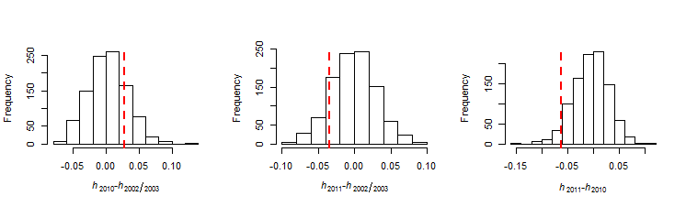
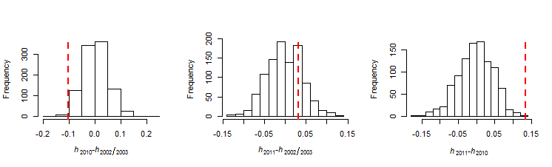
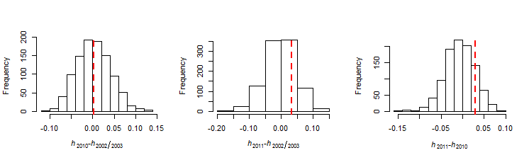
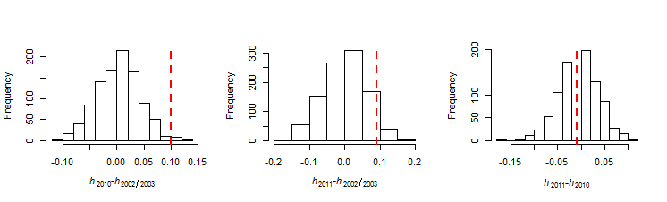
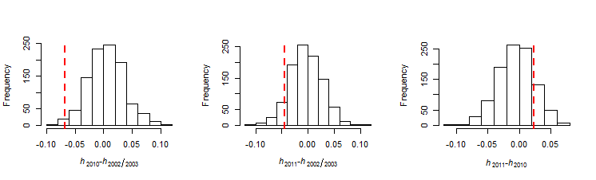
P = 0.408
P = 0.274
P = 0.102
P = 0.010
P = 0.456
P = 0.000
P = 0.986
P = 0.498
P = 0.306
P = 0.018
P = 0.134
P = 0.946
P = 0.014
P = 0.154
P = 0.318
ARA2
Pfg377
TA81
TA60
TA1

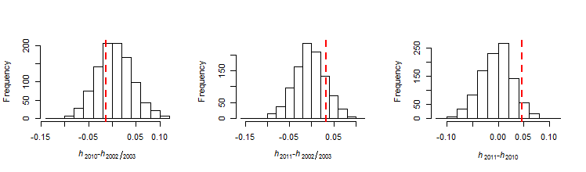
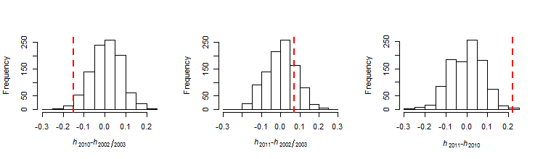
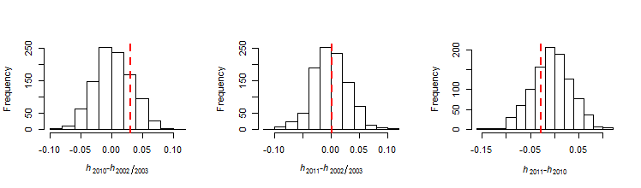
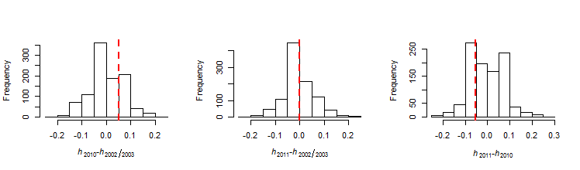
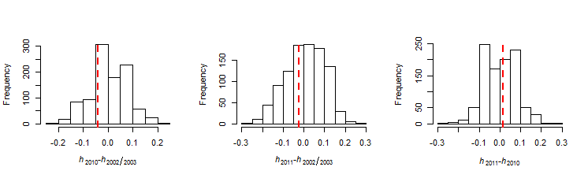
P = 0.662
P = 0.868
P = 0.810
P = 0.534
P = 0.824
P = 0.670
P = 0.386
P = 0.898
P = 0.558
P = 0.048
P = 0.384
P = 0.002
P = 0.638
P = 0.298
P = 0.100
TA42
TA109
TA87
2490
PfPK2

Supplementary_FigS3. Principal component and Bayesian population structure analysis of single-clonal Plasmodium falciparum isolates. (a) STRUCTURE was used to calculate the most probable number of clusters (K) in the sample set and then assign probabilities of membership to each cluster for each individual. The highest value of ΔK occurred at K = 3. Each individual is represented by a vertical bar displaying proportion of membership to each of clusters. (b) A total of 171 isolates with complete allele typing at 10 microsatellite markers were included in the analysis (46 in 2002/2003, 79 in 2010 and 46 in 2011). Each point represents an isolate. Proportions of variance are described in parenthesis under principal component (PC).

