Dietary and Physical Activity Interventions for Colorectal Cancer Survivors:
A Randomized Controlled Trial
CF Lee¹, Judy WC Ho², Daniel YT Fong³, Duncan J Macfarlane¹,
Ester Cerin^{1,4}, Antoinette M Lee⁵, Sharron Leung⁶, Wynnie YY Chan⁷, Ivy PF Leung⁸,
Sharon HS Lam², Natural Chu², Aliki J Taylor⁹, Kar-keung Cheng⁹

Affiliations
- School of Public Health, The University of Hong Kong, Hong Kong
- Department of Surgery, The University of Hong Kong, Hong Kong
- School of Nursing, The University of Hong Kong, Hong Kong
- Institute for Health & Ageing, Australia Catholic University, Australia
- Department of Psychology, The University of Hong Kong, Hong Kong
- School of Nursing, Hong Kong Baptist Hospital, Hong Kong
- School of Professional and Continuing Education, The University of Hong Kong, Hong Kong
- Department of Dietetics, Queen Elizabeth Hospital, Hong Kong
- Institute of Applied Health Research, University of Birmingham, United Kingdom

Correspondence author
Dr Daniel Yee Tak Fong
School of Nursing, The University of Hong Kong
4/F, William MW Mong Block, 21 Sassoon Road, Pokfulam, Hong Kong
Email: dytfong@hku.hk
Tel: +852 3917 6645
Fax: +852 2872 6079

Supplementary Table 1. Number of patients meeting, not meeting and did not assess the dietary and PA targets at various time points
Outcomes† | Group A  Dietary & PA |  |  | Group B  Dietary only |  |  | Group C  PA only |  |  | Group D  Usual care
 | Meeting | Not meeting | Did not assess | Meeting | Not meeting | Did not assess | Meeting | Not meeting | Did not assess | Meeting | Not meeting | Did not assess
Red/processed meat target
Baseline | 14 | 41 | 0 | 16 | 40 | 0 | 10 | 46 | 0 | 16 | 40 | 0
Month 6 | 28 | 21 | 6 | 31 | 17 | 8 | 15 | 37 | 4 | 14 | 34 | 8
Month 12 | 29 | 17 | 9 | 32 | 10 | 14 | 18 | 32 | 6 | 15 | 28 | 13
Month 18 | 35 | 14 | 6 | 32 | 14 | 10 | 15 | 34 | 5 | 20 | 32 | 4
Month 24 | 30 | 16 | 9 | 28 | 17 | 11 | 20 | 30 | 6 | 13 | 34 | 9
Refined grain target
Baseline | 6 | 49 | 0 | 7 | 49 | 0 | 7 | 49 | 0 | 5 | 51 | 0
Month 6 | 24 | 25 | 6 | 33 | 15 | 8 | 18 | 34 | 4 | 16 | 32 | 8
Month 12 | 20 | 26 | 9 | 28 | 14 | 14 | 21 | 29 | 6 | 17 | 26 | 13
Month 18 | 21 | 28 | 6 | 23 | 23 | 10 | 20 | 31 | 5 | 20 | 32 | 4
Month 24 | 20 | 26 | 9 | 25 | 20 | 11 | 14 | 36 | 6 | 16 | 31 | 9
PA general health target
Baseline | 47 | 4 | 4 | 46 | 3 | 7 | 46 | 3 | 7 | 50 | 4 | 2
Month 6 | 40 | 0 | 15 | 33 | 3 | 20 | 41 | 1 | 14 | 39 | 0 | 17
Month 12 | 34 | 2 | 19 | 25 | 2 | 29 | 35 | 0 | 21 | 28 | 2 | 26
Month 18 | 38 | 1 | 16 | 29 | 3 | 24 | 37 | 1 | 18 | 34 | 1 | 21
Month 24 | 34 | 1 | 20 | 27 | 2 | 27 | 37 | 0 | 19 | 37 | 0 | 19
PA cancer outcome target
Baseline | 41 | 10 | 4 | 34 | 15 | 7 | 37 | 12 | 7 | 42 | 12 | 2
Month 6 | 36 | 4 | 15 | 30 | 6 | 20 | 40 | 2 | 14 | 34 | 5 | 17
Month 12 | 31 | 5 | 19 | 22 | 5 | 29 | 30 | 5 | 21 | 27 | 3 | 26
Month 18 | 37 | 2 | 16 | 26 | 6 | 24 | 34 | 4 | 18 | 28 | 7 | 21
Month 24 | 32 | 3 | 20 | 22 | 7 | 27 | 35 | 2 | 19 | 33 | 4 | 19
Abbreviations: PA, physical activity; MVPA, moderate-to-vigorous intensity physical activity.
† Red/processed meat target: <5 servings of red and processed meat per week, including <2 servings of processed meat
Refined grain target: <2 servings of refined grain per day
PA general health target: ≥30 minutes of MVPA 5 days a week
PA cancer outcome target: ≥60 minutes of MVPA 5 days a week

Supplementary Table 2. Mean and standard deviation of the dietary and PA targets at various time points
Outcomes | Group A  Dietary & PA | Group B  Dietary only | Group C  PA only | Group D  Usual care
 | Mean (SD) | Mean (SD) | Mean (SD) | Mean (SD)
Dietary targets
Red and processed meat intake (servings/week)
Baseline | 9.2 (6.5) | 8.3 (5.0) | 7.7 (4.3) | 8.8 (7.1)
Month 6 | 4.2 (3.9) | 4.4 (4.3) | 7.0 (5.2) | 7.5 (6.5)
Month 12 | 4.1 (4.4) | 3.3 (3.0) | 7.0 (4.9) | 7.1 (4.4)
Month 18 | 4.6 (4.8) | 4.3 (4.0) | 8.4 (6.5) | 7.0 (4.6)
Month 24 | 4.3 (3.3) | 4.8 (3.9) | 6.3 (4.4) | 7.7 (4.6)
Refined grain intake (servings/day)
Baseline | 3.0 (1.1) | 2.7 (0.9) | 2.8 (1.1) | 2.7 (0.8)
Month 6 | 2.0 (0.9) | 1.8 (0.6) | 2.6 (1.3) | 2.5 (1.0)
Month 12 | 2.2 (1.1) | 1.7 (0.6) | 2.4 (1.0) | 2.3 (0.9)
Month 18 | 2.2 (0.8) | 1.9 (0.7) | 2.4 (1.0) | 2.8 (0.8)
Month 24 | 2.1 (0.7) | 1.9 (0.6) | 2.4 (0.9) | 2.4 (0.7)
PA targets
PA level (accumulated minutes/week of MVPA)
Baseline | 534.2 (329.3) | 498.1 (316.8) | 460.8 (239.6) | 473.3 (267.3)
Month 6 | 680.5 (334.6) | 583.1 (319.7) | 641.7 (303.2) | 639.5 (333.2)
Month 12 | 618.6 (268.2) | 535.9 (268.5) | 570.1 (204.2) | 616.6 (310.0)
Month 18 | 730.6 (331.4) | 608.4 (411.4) | 631.8 (281.4) | 676.2 (367.4)
Month 24 | 730.9 (382.6) | 576.2 (354.4) | 680.5 (259.8) | 642.4 (294.7)
Abbreviations: SD, standard deviation; PA, physical activity; MVPA, moderate-to-vigorous intensity physical activity.

Supplementary Table 3. Potential adverse events due to the dietary interventions
 | Mean (SD) |  | Difference | (95% CI) | P
 | Groups A+B | Groups C+D | Dietary interventions
Daily caloric intake (Kcal)
Baseline | 1524 (382) | 1534 (452)
Month 6 | 1366 (386) | 1472 (403) | -93 | (-185 to -0.5) | 0.049
Month 12 | 1504 (351) | 1520 (356) | -34 | (-129 to 62) | 0.489
Month 18 | 1531 (448) | 1566 (400) | -22 | (-115 to 70) | 0.633
Month 24 | 1534 (378) | 1531 (385) | 17 | (-77 to 111) | 0.726
Daily protein intake (g)
Baseline | 72.0 (20.5) | 75.1 (27.4)
Month 6 | 69.3 (17.7) | 71.2 (22.9) | -0.02 | (-5.07 to 5.03) | 0.994
Month 12 | 70.3 (20.8) | 71.3 (21.0) | 0.25 | (-4.95 to 5.45) | 0.926
Month 18 | 68.6 (20.3) | 72.1 (22.3) | -1.29 | (-6.34 to 3.75) | 0.615
Month 24 | 71.5 (17.6) | 69.4 (21.5) | 4.31 | (-0.83 to 9.45) | 0.100
Hemoglobin level (g/dL)
Baseline | 2.8 (1.0) | 2.7 (0.9)
Month 6 | 1.9 (0.8) | 2.5 (1.1) | -0.04 | (-0.39 to 0.31) | 0.821
Month 12 | 2.0 (0.9) | 2.4 (1.0) | -0.11 | (-0.47 to 0.24) | 0.527
Month 18 | 2.1 (0.8) | 2.3 (0.9) | -0.13 | (-0.47 to 0.21) | 0.458
Month 24 | 2.0 (0.7) | 2.4 (0.8) | 0.08 | (-0.27 to 0.42) | 0.670

Supplement Figure 1. Effects of dietary interventions on achieving (a) Red/processed meat target and (b) Refined grain target, and effects of physical activity interventions on achieving (c) PA general health target and (d) PA cancer outcome target
(a)
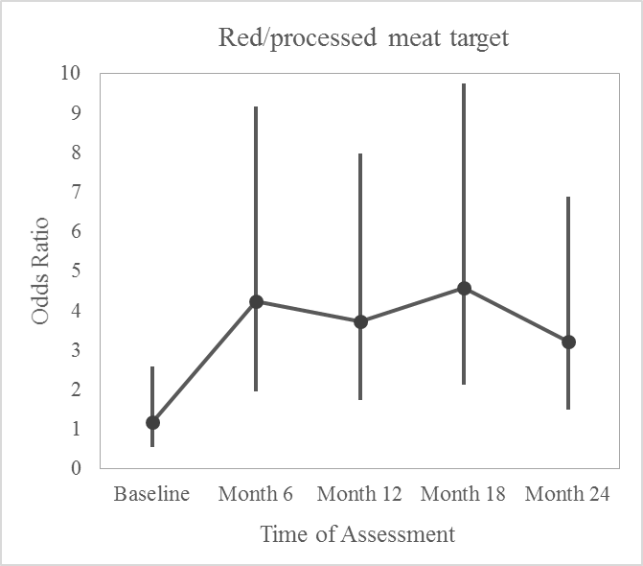
(b)

Supplement Figure 1. Effects of dietary interventions on achieving (a) Red/processed meat target and (b) Refined grain target, and effects of physical activity interventions on achieving (c) PA general health target and (d) PA cancer outcome target (continued)
(c)

(d)

Supplementary Figure 2. Effects of dietary interventions on mean changes in (a) Red and process meat intake and (b) Refined grain intake, and effects of physical activity interventions on mean change in (c) MVPA
(a)

(b)

Supplementary Figure 2. Effects of dietary interventions on mean changes in (a) Red and process meat intake and (b) Refined grain intake, and effects of physical activity interventions on mean change in (c) MVPA (continued)
(c)

