SUPPLEMENTARY INFORMATION

A FIREFLY LUCIFERASE DUAL COLOR BIOLUMINESCENCE REPORTER ASSAY USING TWO SUBSTRATES TO SIMULTANEOUSLY MONITOR TWO GENE EXPRESSION EVENTS

Bruce R Branchini,^{1,*} Tara L Southworth,¹ Danielle M Fontaine,¹ Dawn Kohrt,² Catherine M Florentine,¹ & Martha J Grossel²

¹ Department of Chemistry, Connecticut College, New London, Connecticut, 06320, USA.
² Department of Biology, Connecticut College, New London, Connecticut, 06320, USA.

*Correspondence and request for materials should be addressed to B.R.B. (brbra@conncoll.edu).

TABLE
Supplementary Table 1: Bioluminescence emission maxima (nm)ª at pH 7.8
Enzyme | LH₂ | BtLH₂ | LH₂/BtLH₂ mix
PpyWT | 562 (74) | 525 (60) | 562 (74)
PLR1 | 620 (57) | 569 (58) | 620 (56)
PLG3 | 549 (74) | 518 (57) | 528 (75)
ªThe full width at half-maximum is shown in parentheses. Proteins (5 μL, 1 μg) were added to 0.5 mL of assay mix containing 0.48 mM ATP-Na, 18 mM DTT, 1.8 mM MgSO₄, and either 0.12 mM LH₂, 0.24 mM BtLH₂, or a mixture of 0.12 mM LH₂ and 0.24 mM BtLH₂. Bioluminescence spectra were taken 1 min after mixing using a Horiba Jobin-Yvon iHR imaging spectrometer equipped with a liquid N₂ cooled CCD detector.

SUPPLEMENTARY FIGURE 1

Supplementary Figure 1. Amino acid substitutions (compared with Photinus pyralis luciferase) in the PLG3 and PLR1 luciferase sequences. The predominant changes introduced by the substitutions are color-coded: purple, enhanced thermostability; green, increased Luc affinity ratio BtLH₂/LH₂; red, red-shifted bioluminescence emission; blue, increased specific activity and resistance to red-shifting at pH 6.0.

SUPPLEMENTARY FIGURE 2

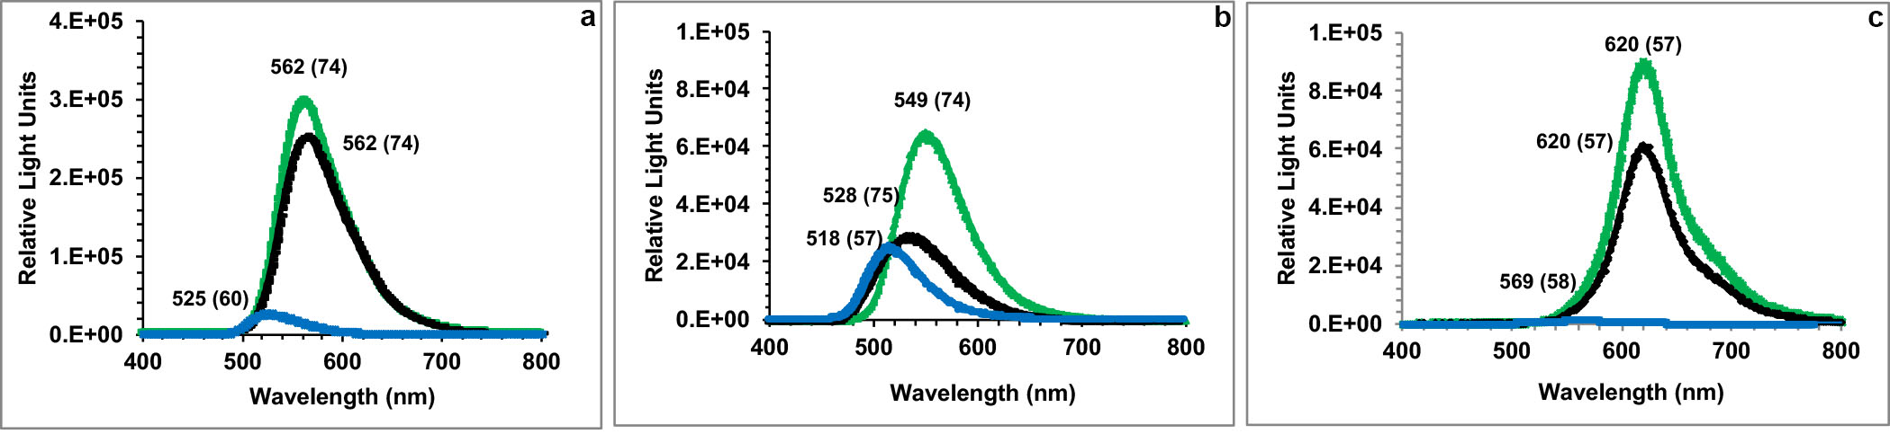

Supplementary Figure 2. Bioluminescence emission spectra of purified Lucs (a) PpyWT, (b) PLG3, and (c) PLR1 with LH₂ (green), BtLH₂ (blue), and a mixture of both substrates (black). The emission maxima and bandwidths are indicated above each spectrum. Proteins (1 μg) were added to 0.5 mL of assay mix containing 0.48 mM ATP-Na, 18 mM DTT, 1.8 mM MgSO₄, and either 0.12 mM LH₂ (green), 0.24 mM BtLH₂ (blue), or a mixture of 0.12 mM LH₂ and 0.24 mM BtLH₂ (black). Bioluminescence emission spectra were measured 1 min after mixing using a Horiba Jobin-Yvon iHR imaging spectrometer equipped with a liquid N₂ cooled CCD detector.

SUPPLEMENTARY FIGURE 3

Supplementary Figure 3. Stability of PLG3 and PLR1 in cell lysates with DSM added manually or by automatic injection. (a) Semi-log plot of the % remaining Luc activity over time in lysates of equivalent numbers of HEK293T cells. Cells were dually transfected with plasmids expressing PLR1 under control of the MEF/TATA promoter (pMEF/TATA-PLR1) and PLG3 under control of the thymidine kinase promoter (pTK-PLG3). Lysates (20 μL) were added to the wells of 96-well plates and assayed using the DART method. Activity was monitored over 5 h using a Synergy™ 2 microplate luminometer equipped with the indicated filters. (b) Stability of DART enzymes expressed from pMEF/TATA-PLR1 and pTK-PLG3 over 1 h assayed without the use of an injector. HEK293T cells were dually transfected as described above. Lysates (20 μL) were added to the wells of 96-well plates. The DSM reagent was manually pipetted into the wells and bioluminescence was monitored 2 min after the addition of the reagent using the equipment described above.
SUPPLEMENTARY NOTE

Qualitative comparison of DART to prototypical commercial reporter systems
 | DART | Promega Dual-Luciferase Assay | Promega  Chroma-Glo
Number of Substrates | 2 | 2 | 1
Types of Enzymes | 1 (2 FLucs) | 2 (Rluc, FLuc) | 1 (2 CBLucs)
Gene Identity | >99% | very low | >99%
Simultaneous Detection of 2 Signals | Yes | No | Yes
Data Calculations Required | No | No | Yes
Luminometer Filters Required | Yes | No | Yes
Single Reagent Solution | Yes | No | Yes
Autoinjector Required | No | No | No
Emission Signals Well-Separated | Yes | Yes | No
Background | Low | High | Low

