An Implantable Peripheral Nerve Recording and Stimulation System for Experiments on Freely Moving Animal Subjects

Byunghun Lee^{1,3}, Mukhesh K. Koripalli², Yaoyao Jia¹, Joshua Acosta², M. S. E. Sendi¹, Yoonsu Choi², and Maysam Ghovanloo^{1*}
¹Georgia Institute of Technology, School of Electrical and Computer Engineering, Atlanta, 30308, USA
²University of Texas, Rio Grande Valley, Department of Electrical Engineering, Edinburg, 78539, USA
³Incheon National University, Department of Electrical Engineering, Incheon, 22012, South Korea
*mgh@gatech.edu

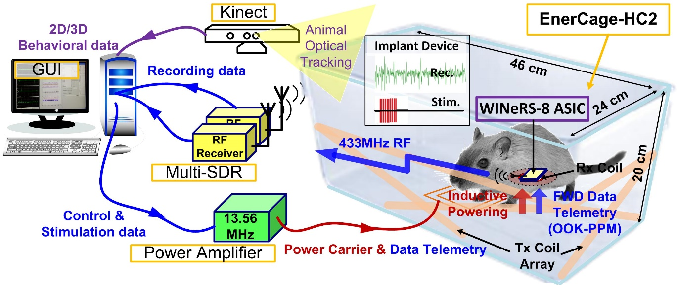

Figure S1. A conceptual view of power and data flows for inductively-powered wireless implantable neural recording and stimulation (WINeRS-8) system within the EnerCage-HC2 system, allowing for experiments involving long-term peripheral nerve recording and stimulation on small freely behaving animal subjects.

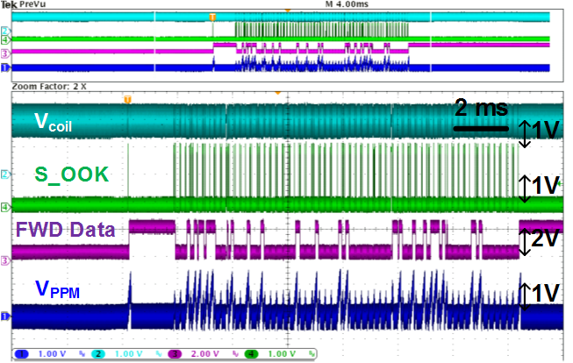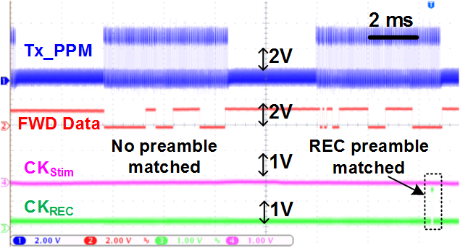
- (b)
Figure S2. Measured waveforms of OOK-PPM near-field downlink data telemetry between WINeRS-8 and EnerCage-HC2 systems. (a) V_{coil}, S_OOK, FWD Data, and V_{PPM} in WINeRS-8 system (see Fig. 4a), and (b) Tx_PPM from EnerCage-HC2 system to trigger CKREC in WINeRS-8 system with matched preamble (see Fig. 4b).
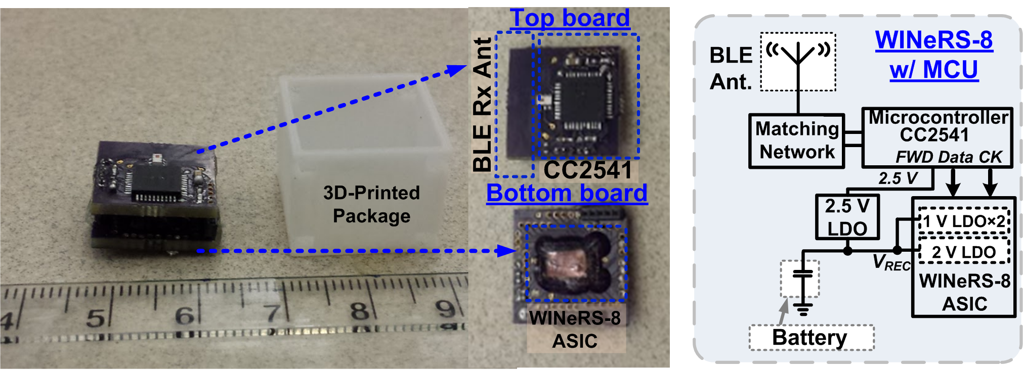
Figure S3. A battery-powered WINeRS-8 headstage equipped with a microcontroller (CC2541) for 2.4 GHz Bluetooth Low Energy (BLE), replacing OOK-PPM downlink data telemetry outside the EnerCage-HC2 system for an animal study to be conducted on a treadmill (Fig. 8b). An external 2.5 V LDO regulator is utilized to supply CC2541. A PCB antenna is implemented for the BLE communication at 2.4 GHz.
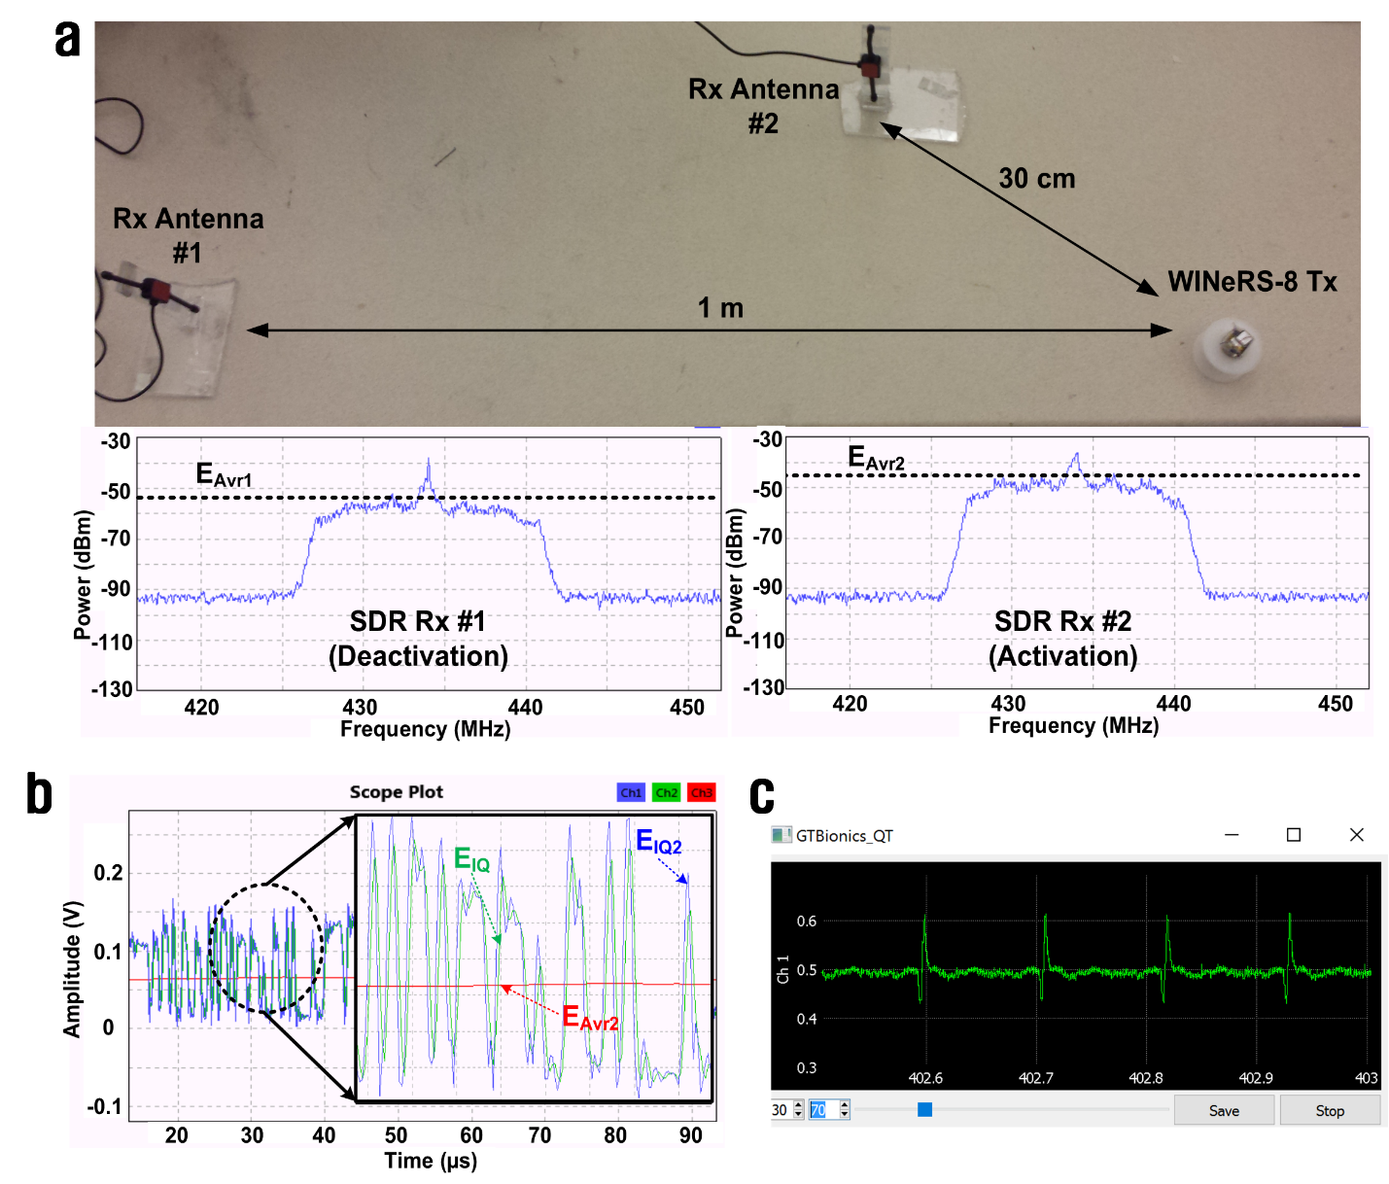
Figure S4. (a) Benchtop measurements on dual-SDR receivers with WINeRS-8 RF transmitter (Top) and received average power at two antennas, E_{Avr1} and E_{Avr2} (Bottom), (b) 36 MHz over-sampled transient RF signals after 1st and 2nd moving average filters in Fig. 5b, and (c) real time recovered and visualized signal of recording channel #1 in the customized GUI, developed in C++.

